Fourteenth International Conference on Input-Output Techniques
10-15 October 2002, Montreal, Canada

Modeling the effect of alternative production technologies using IO tables with sector specific units

Steven Kraines*, Yoshikuni Yoshida**

*Department of Chemical System Engineering
The University of Tokyo
7-3-1 Hongo, Bunkyo-ku
Tokyo 133-8656, Japan
steven@prosys.t.u-tokyo.ac.jp

**Department of Geosystem Engineering
The University of Tokyo

Abstract

Input output analysis is often based on tables of accounts that are expressed in common (usually monetary) units. However, total input coefficients and multipliers can also be calculated from a table of accounts in what are commonly termed physical units, although they can be thought of more generally as “industry” or “commodity” specific units that do not actually have to correspond to any real physical unit. This paper argues that tables of accounts in sector dependent units are more useful for evaluating the effectiveness of new production and recycling technologies on reducing energy use and CO₂ emissions because one can consider the effect on total input coefficients and pollutant emission multipliers of changes in direct input coefficients for a particular sector without having to worry about the other direct input coefficients. A simple analysis method for calculating the total industrial outputs from a new technology matrix together with the new relative prices for each sector output based on the Leontief price model is presented and used to study the effect of changing the technology used by the iron and steel making industry in the Liaoning Province, China on prices, energy use, and CO₂ emissions.

Introduction

Input output analysis offers an elegant tool for assessing the overall impact of industrial and consumer activities in a system of interconnected industrial sectors. In this paper, we develop a simple analysis method for assessing the impacts of changes in the technologies that are used to manufacture the products of some of the industrial sectors in the system. In input output analysis, production technologies are expressed by the matrix of direct input coefficients. We identify the conditions under which these coefficients can be changed in order to express a change of the production technology used by a given industrial sector. The method that we present here will form a core component of an Internet-based collaborative model integration platform that evaluates different technologies for making an urban region more sustainable (Kraines et al. 2002, Kraines and Wallace, in press).

Most Input-Output tables of accounts seen in the literature are constructed in monetary units (for some notable exceptions, see the price model in chapter 9 of Miller and Blair 1985, chapters 9 and 10 of Dorfman et al. 1958, Arrous 2000, and Strassert 2000). One possible reason for having tables of accounts in monetary units might be thought to be that the row totals for each industry must equal the column totals, and that therefore it must be possible to calculate the column totals. In other words, because we must be able to calculate the total value of inputs into that industrial sector needed to produce the required total output, the units of each input must be the same, which is the not the case with physical units. Therefore, the conclusion is that prior to conducting any form of input-output analysis, such as calculating the direct input coefficients matrix A or the total input coefficients matrix (I - A)⁻¹, the tables of accounts must first be expressed in a common unit, such as a unit of monetary currency. In fact, this is the basis for the commonly used RAS method where direct input coefficients are selected so that both the column sums and the row sums are equal to a given set of total intermediate inputs and outputs for each sector (Miller and Blair 1985).

Actually, total input coefficients and multipliers can be calculated from a table of accounts in non-monetary units without ever converting to some common unit (Miller and Blair 1985, Dorfman et al. 1958). Furthermore, we will show in this paper that, in addition to the commonly cited reasons for using tables in physical units such as not having to consider changes in prices and deflation of value over time (see for example Strassert 2000 and Braibant 2000), it is more useful from a product life cycle assessment and process analysis point of view to consider tables of accounts in non-monetary or sector specific units. “Physical units” can be thought of more generally as “industry” or “commodity” sector specific units that do not actually have to correspond to any real physical unit. By using tables of accounts in sector specific units, it is possible to consider the effect on total input coefficients and pollutant emission multipliers of changes in direct input coefficients for a particular sector without having to worry about the other direct input coefficients. The new relative prices for each sector output that must hold for the new technology matrix can be easily calculated from the requirement that the monetary flows into an industrial sector must equal the monetary flows out of that sector (Leontief 1985).

In the following sections, first we present the concepts that form the basis for our analysis method. We then describe the method itself, giving a step-by-step algorithm for the calculation of the effect of changes in production technology. We apply this method to the assessment of changing iron production in Liaoning Province, China, from an industry dominated by conventional blast furnace to the production of 90% of total iron output from recycling of scrap steel using electric arc furnaces. Finally, we discuss the effectiveness of the method and some topics for future work.

The concepts

From a process system point of view, the set of tables used in input output analysis (figure 1a) can be represented as a directed graph of flows between all of the industrial sectors (figure 1b). The table of accounts (Z) is equivalent to a set of flows to and from each pair of industries in the directed graph, the final demand vector (Y) is equivalent to a set of flows from each industry to some demand outside of the system of industrial sectors being considered, and the value added vector (V) is equivalent to a set of flows to each industry from outside the considered system. For a typical regional input-output table, Y corresponds to all purchases made by households, government, and other countries (in the form of exports minus imports). However, for a limited IO table, such as an IO table for a single enterprise or for a specific sector of the industry, Y may include outputs to other regions, enterprises, or industrial sectors that are not considered within the system of analysis. V is usually labor, but V can also include other raw material and capital investments that are outside the system of interconnected industrial activities that are being considered (see for example Pan and Kraines 2001). A key point here is that, without some form of external model that connects inputs and outputs of processes that are outside the system such as the inclusion of a household model, recursive effects where a change in the inputs or outputs of a process (or industrial sector) leads to changes in the inputs and outputs to and from other processes will only occur in those processes within the boundary of the system considered.

The total output of a particular industrial sector j, x_{j}, is just the total of the outflows from that sector to each of the other sectors and to itself, plus the demand external to the system. Furthermore, the direct input coefficients (sometimes called technical coefficients because they express the technology of the product manufacture process), a_{ij} = z_{ij}/x_{j} (i = 1 to n for total of n industrial sectors), are the same as the set of unit production coefficients in process system modeling (figure 2). The set of unit production coefficients also includes the coefficient for the flow of inputs from outside of the system, which we will define here as w_{j} = v_{j}/x_{j}. It is easy to see that this representation of IO analysis as a directed graph results in the same basic set of equations that are used in IO analysis (figure 2b):

Outflows from industrial sector j:
x_{j} = y_{j} + z_{j1} + z_{j2} + … + z_{jj} + … + z_{jn}
x_{j} = y_{j} + a_{j1}x₁ + a_{j2}x₂ + … + a_{jj}x_{j} + … + a_{jn}x_{n} for j = 1 to n (1)
Inflows to industrial sector j:
x_{j} = v_{j} + a_{1j}x_{j} + a_{2j}x_{j} + … + a_{jj}x_{j} + … + a_{nj}x_{j} for j = 1 to n (2)

Here the direct input coefficient a_{ij} is the requirement of output from industrial sector i per unit production of industrial sector j in units [(sector i unit) / (sector j unit)].

Equations (1) and (2) are usually written in matrix form as follows:

Outflows from industrial sector j:
X = Y + AX (1’)
Inflows to industrial sector j
X = V’ + A’X (2’)

If all flows do have a common unit (such as a monetary unit), then the units of the direct input coefficients cancel, the sums given in both equations (1) and (2) can be calculated, and therefore those sums can be equated. If the flows have different units for each sector, then only equation (1) can be calculated, since the summed quantities on the right-hand side of equation (2) will have different units. However, we will see that this does not present a problem when calculating the total input coefficients that form the basis of Leontief Input-Output analysis. In fact, we will show that the inability to compute the summation in equation (2) is an expression of flexibility that will come to our advantage when considering changes in production technologies.

From equation (1), we can write a set of simultaneous equations relating the final demands, y_{j}, to the total outputs, x_{j} as follows:

y_{j} = -a_{j1}x₁ - a_{j2}x₂ … + (1 - a_{jj})x_{j} + … - a_{jn}x_{n} for j = 1 to n (3)

Note that the units of a_{jj} are dimensionless since (sector j unit) = (sector j unit), so we can write 1 – a_{jj} even when treating a table of accounts with sector-specific units. The units of all of the other coefficients cancel with those of the total outputs to give units of product j.

As described in (Leontief 1985), the general solution for the unknown x_{j}’s to the set of equations (3) for n industrial sectors is given by a set of coefficients b_{ij}:

x_{j} = b _{j1}y₁ + b_{j2}y₂ + b_{j3}y₃ + … + b_{jn}y_{n} for j = 1 to n (4)

It can be shown that the coefficients b_{ij} are given by the inverse of the matrix (I – A) where A is the matrix of direct input coefficients a_{ij}. These coefficients are the “total input coefficients”: b_{ij} is the total production requirement of i to produce one unit of j in the final demand that integrates all of the inter-industry ripple effects beyond the direct input requirements. Therefore, b_{ij} functions as a multiplier coefficient that “amplifies” the impacts of production of one unit of j on the total outputs of all of the industrial sectors i in the region or system. Note that, like a_{ij}, b_{ij} will have dimensions of [(sector i unit) / (sector j unit)].

Here, we finally arrive at the well-known equation of Leontief Input-Output analysis:

X = (I – A)⁻¹ Y (5)

After introducing equations (1) and (2), it was noted that unless all flows have a common unit, equation (2) cannot be calculated. Equation (2) can be calculated only when we know the prices of each sector unit, p_{j}. Knowing the price vector for the industrial system, as detailed in (Leontief 1985) we can write:

Value inflows to industrial sector j:
p_{j}x_{j} = p_{v}v_{j} + p₁a_{1j}x_{j} + p₂a_{2j}x_{j} + p₃a_{3j}x_{j} + … + p_{n}a_{nj}x_{j} for j = 1 to n

Dividing through again by x_{j}, noting that w_{j} = v_{j}/x_{j}, and setting p_{v} to 1 (i.e. calculating prices relative to the cost of the outside input which is usually labor) gives:
p_{j} = w_{j} + p₁a_{1j} + p₂a_{2j} + p₃a_{3j} + … + p_{n}a_{nj} for j = 1 to n (6)

We can write equation (6) in matrix form (note the similarity to equation (1’)):

P = W + PA (6’)

If we know all of the direct input coefficients, a_{ij}, and the outside input coefficients, w_{j}, we can use equation (6) to find the required set of prices in the same way that we found the total input coefficients, b_{ij}, in equations (3) and (4):

w_{j} = -a_{1j}p₁ - a_{2j}p₂ … + (1 - a_{jj})p_{j} + … - a_{nj}p_{n} for j = 1 to n (7)
p_{j} = b_{1j}w₁ + b_{2j}w₂ + b_{3j}w₃ + … + b_{nj}w_{n} for j = 1 to n (8)

Using B = (I – A)⁻¹ from before and noting that the order of the subscripts for b in equation (8) are opposite of b in equation (4), we have:

P = ((I – A)⁻¹)’ W (9)

It is clear that prices will have units of W, and that W has units of [(outside input unit) / (producing sector unit)]. For example, if the outside input is labor and the producing sector is, for example, cars, then we could have [man-years per car]. If then the cost of labor is known, we can calculate the price of the car from W.

Note that the following identity can be derived from equations (5) and (9’):

X W’ = Y P’ (10)

This equation simply states that the total value of the input from outside the system to produce X is equal to the total value of the production that is sent outside the system to the external demand Y. For a national table of accounts, this means that the national income received from labor and other primary inputs must equal the national income spent for final demands, exports, and other expenditures.

Finally, we note that for a national table of accounts, the price vector P will be in relative units to the cost of labor. As the GNP is given by X P’, for a given change in the economy, we can calculate what the change in GNP will be for a fixed labor wage rate. Alternatively, we can calculate what the wages to labor will be in order to assure that the same GNP is maintained.

The analysis method

We present here a method based on the above concepts that allows a flexible assessment of the effects of changes in technologies of specific sectors in an industrial system. The method should be sufficiently flexible and robust as to make it possible to perform iterative calculations in order to assess gradual changes in direct input coefficients due to, for example, phasing in of new technology or considerations of economies of scale (Ozaki et al. 2000).

There are two important consequences of the previous discussion that will be useful for our analysis of changes in material production technologies such as the production of steel.

First, because the direct input coefficients are given in sector-specific units, we can change the direct input coefficients for a particular industrial sector without having to worry about the balance of accounts for that industrial sector (i.e. we do not have to calculate equation (2)). Rather we use equation (2) to calculate the new price vector that must hold for the new set of direct input coefficients. Note that there is nothing that guarantees that a set of direct input coefficients goes not lead to what is later discovered to be an unreasonable price vector, and this in fact provides a useful way to explore the feasibility of that set of coefficients.

Second, note that the units of sector j do not necessarily have to correspond to any physical unit. It may seem odd at first, but if we have a table in value units, we can still perform changes in the direct input coefficients in the manner described in the previous paragraph by simply assuming that the units for each sector are equivalent to the amount of product costing one unit of currency as expressed in the original table. Each product may be measured in any unit one likes, even a hypothetical unit such as one that could be used for mixed products, because the units disappear at the end of the analysis. When we calculate the new price vector for the altered direct input coefficients, these will be the ratios of the new prices to the old prices for each industrial sector output.

With these two notes in mind, we present the following analysis method:

- Given a process model for a particular industrial sector, calculate the units of each input per unit of output in sector specific units (ex. tonnes coke per tonne steel). Note that this step does not involve the IO table of accounts.
- Given a table of accounts for a particular industrial region in value units: change the units of all sectors that will be considered for changes in direct input coefficients from a process model to the appropriate physical units using suitable prices. All other sectors will be assumed to have units of product or service costing one unit of currency for the original table. At this point, we have converted the IO table to sector specific units.
- Calculate the direct input coefficients, a_{ij}, from the row sums, x_{j}, and inter-industrial flows, z_{ij}. These coefficients will have units that are ratios of the sector-specific units determined in 2 as illustrated in fig. 2b.
- Change the direct input coefficients, a_{ij}, that correspond to the process model to the coefficients calculated in step 1.
- Calculate the total input coefficients, b_{ij}, as described in equation (4).
- Calculate any industrial sector multipliers of interest from the total input coefficients. For example, the total emission of CO₂ per unit of production from sector j is Σ(b_{ij} x c_{i}) summed over i = 1 to n, where c_{i} is the direct emission of CO₂ per unit of production of sector i.
- Calculate the price vector P, noting that these prices are relative to the prices that were established in step 2.

Application of the analysis method to Liaoning Province

Within the context of the “Technology – Energy – Environment – Health” chain project headed by Karen Polenske and funded by the Alliance for Global Sustainability, we are studying the introduction of new technologies in the iron and steel manufacturing industry in Liaoning Province, China. Here, we apply the analysis method described above to the Input-Output table for Liaoning Province developed by Xikang Chen and Cuihong Yang at the Institute of Systems Science in the Chinese Academy of Sciences.

We have modified the table to express total emissions of CO₂ and SO_{x} (not published). Briefly, the methods used are as follows (see Yoshida et al. 1998 for more details). The CO₂ emissions are calculated by determining the amount of coal, crude oil, and natural gas consumed through each transaction expressed in the Input-Output table, converting that amount of fuel into CO₂ emissions, and summing the emissions for each producing sector. In order to reflect the responsibility of sectors consuming coke and refined oil for CO₂ emissions, we reallocate the emissions from the coke-making and oil-refining sectors. For refined oil, we assume that 10% of the oil consumed by the oil-refining sector is consumed by that sector and the rest is consumed by sectors downstream. For coke, 25% of the CO₂ emissions are credited to the coke-making sector with the rest allocated to sectors using the coke. SO_{x} emissions are calculated using data from the 1998 Liaoning Statistical Yearbook on SO_{x} emissions from industrial sectors. The SO_{x} emissions given in the yearbook are reallocated to the sectors in the IO table and used to calculate SO_{x} emissions coefficients for each sector based on that sector's use of oil and coal. These coefficients are then applied to the new total output vector to get the new distribution of SO_{x} emissions for a change in the industrial structure.

The current distributions of SO_{x} and CO₂ emissions from the different industrial sectors in Liaoning Province are shown in figures 3 and 4. Next, we model the introduction of steel recycling using electric arc furnaces by modifying the inputs of coke and electricity to the iron, steel, and alloy iron smelting industry sector. The original table of accounts gives a consumption of 315 kg of coke and 78 kWh of electricity per 1000 RMB of pig iron, which is approximately the cost of a tonne of pig iron (personal communication from plant manager at Fushun Iron and Steel). About 460 kg of coke is required to produce a tonne of pig iron using conventional blast furnaces, and production of one tonne of crude steel from an electric arc furnace requires about 400 to 500 kWh of electricity (personal communication from plant managers at Fushun Iron and Steel and Benxi Iron and Steel). Based on these numbers, it appears that the inputs from the table of accounts can produce only about 850 kg of pig iron – 680 kg from blast furnaces and 170 kg from electric arc furnaces. However, we note that the iron smelting industry also probably produces some blast furnace gas, heating, and possibly electricity which all contribute to the value of the product of using 315 kg of coke and 78 kWh of electricity.

In order to examine a shift to 90% production by electric arc furnaces, we changed the consumptions of electricity and coke by the iron smelting industry to 40 kg coke and 350 kWh of electricity, respectively. Therefore, 90 kg of pig iron is produced by blast furnace, and 760 kg is produced by electric arc furnace. Note that almost certainly other input coefficients will change with this change in production process, and we can use the same methods here to evaluate the effects of those changes.

The changes in prices are shown in Table 1, and the resulting changes in SO_{x} and CO₂ emissions are shown in figures 3 and 4. We calculate a decrease in CO₂ emissions of 2.7% or 1.9 million tonnes carbon per year. The calculated decrease in SO_{x} emissions is 1% or 9000 tonnes SO_{x} per year.

Discussion, Conclusions, and Future Work

We have developed an analysis method for evaluating the effects of changes in product manufacturing technology on relative prices as well as total sector outputs and the environmental impacts of those outputs. We applied the analysis method to the assessment of the effect of replacing conventional blast furnace iron making technology with steel recycling technology using electric arc furnaces. Our preliminary results indicate that a major shift in the production technology can reduce both CO₂ and SO_{x} emissions by a few percent.

The work presented here is a part of an international multidisciplinary project to develop a collaboration platform based on model integration over the Internet. The goal of the platform is to help decision makers and stakeholders to assess the effectiveness and tradeoffs between different technology options for reducing the environmental impact of urban activities and to plan more sustainable cities (Kraines et al. 2002, Kraines and Wallace, in press). Specifically, within the overall project, researchers have been developing models of new technologies for providing energy, transportation, and for manufacturing products and materials. These models represent expert knowledge of the technologies as well as of the important region characteristics (such as land use distributions) and phenomena (such as the transport of pollutants in the atmosphere and ground water). The technology process models are designed to output the unit inputs for production levels meeting demands in the region. The analysis method that we present in this paper will be useful for translating these direct input requirements into industry-wide total production requirements and thereby the emissions of pollutants and consumptions of natural resources by each of the industrial sectors. These pollutant emissions and raw material consumption rates can then be used as inputs to other models that simulate the fates of the pollutants and the effects of the resource depletion on the biosphere.

Acknowledgments

The authors gratefully acknowledge the contributions of Xikang Chen, Karen Polenske, and Cuihong Yang. This research was funded by the Alliance for Global Sustainability and the Industrial Technology Research Grant Program from New Energy and Industrial Technology Development Organization (NEDO) of Japan, Project ID: 01B62010d.
References

Arrous J (2000) Energy Input-Output economics: what's the matter? 13th International Conference on Input-Output Techniques, 21-25 August 2000, Macerata, Italy.
Braibant M (2000) The French experience with satellite accounts. 13th International Conference on Input-Output Techniques, 21-25 August 2000, Macerata, Italy.
Dorfman R, P Samuelson and R Solow (1958) Linear Programming and Economic Analysis. New York: McGraw Hill, pp. 204-264.
Leontief W (1985) Input-Output Analysis, in Encyclopedia of Materials Science and Engineering, Oxford, U.K.: Pergamon Press.
Kraines SB and DR Wallace. Sustainability technology evaluation in a regional context using distributed information technology. Computers, Environment and Urban Systems. In press.
Kraines SB, DR Wallace, Y Iwafune, Y Yoshida, T Aramaki, K Kato, K Hanaki, H Ishitani, T Matsuo, H Takahashi, K Yamada, K Yamaji, Y Yanagisawa and H Komiyama (2002) An integrated computational infrastructure for a virtual Tokyo: concepts and examples. Journal of Industrial Ecology 5(1): 35-54.
Miller RE and PD Blair (1985) Input-output analysis. Prentice-Hall, Inc., Englewood Cliffs, New Jersey.
Ozaki I, M Kuroda and K Nomura (2000) Economics of plant-scale and structural change. 13th International Conference on Input-Output Techniques, 21-25 August 2000, Macerata, Italy.
Pan X and SB Kraines (2001) Environmental Input-Output Models for Life-Cycle Analysis. Environmental and Resource Economics, 20 (1): 61-72
Strassert G (2000) Physical Input-Output accounting and analysis: new perspectives. 13th International Conference on Input-Output Techniques, 21-25 August 2000, Macerata, Italy.
Yoshida Y, H Ishitani and R Matsuhashi (1998) Classifying CO2 emissions from the viewpoint of LCA by reflecting the influence of regional activities. Journal of the Japan Institute of Energy. 77 (859): 1054-1064 (in Japanese).
Table 1: Sector names and relative prices for sectors after the change in iron making technology described in the text. A positive relative price indicates an increase in price of the product following the change in technology.
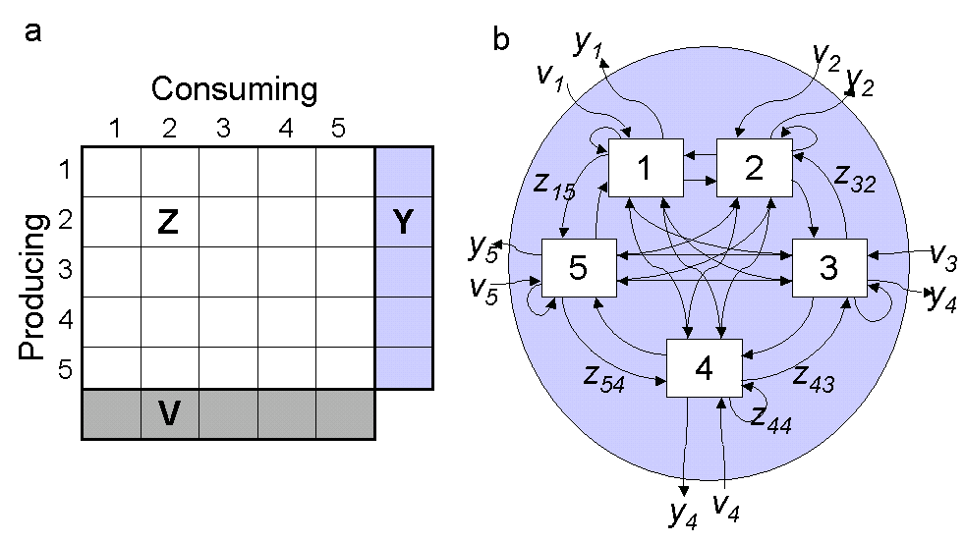Figure 1: Simple illustration of IO table (a) and directed graph (b) expressions of a five sector industrial system.

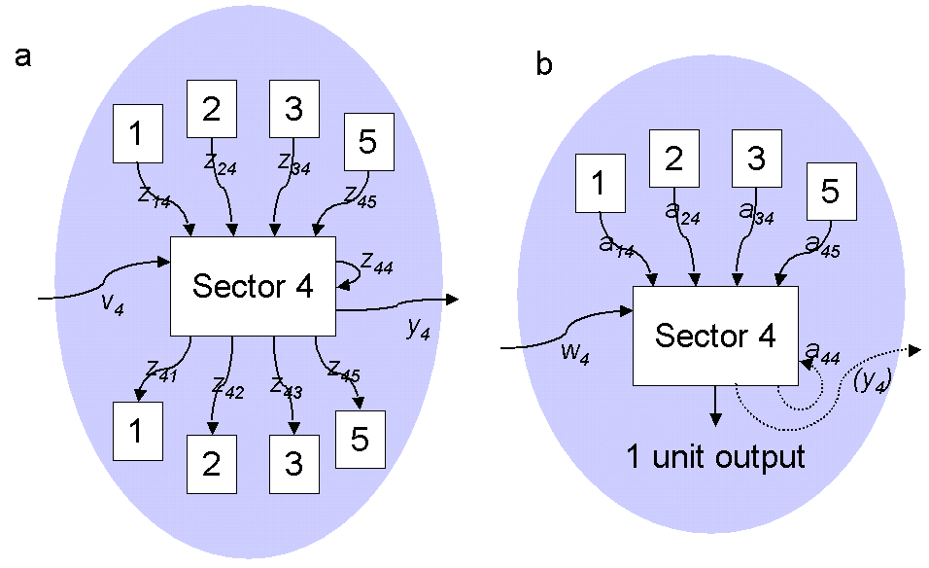
Figure 2: Inputs and outputs into a single industrial sector. a) Actual inflows and outflows. b) Direct input coefficients.
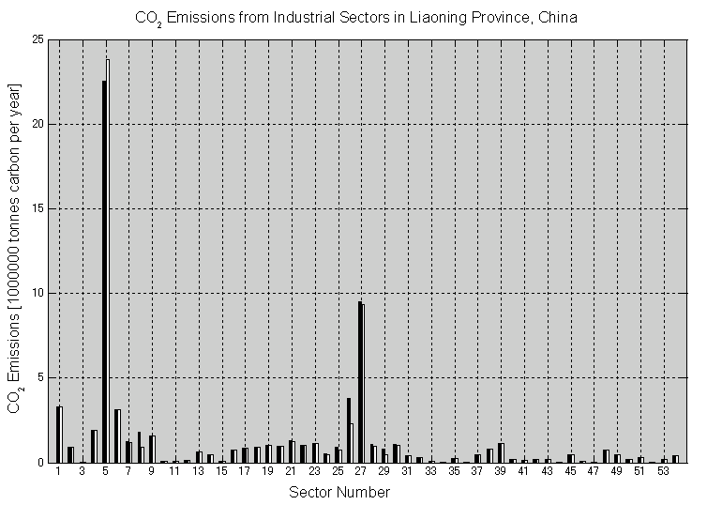

Figure 3: CO₂ emissions from industrial sectors in Liaoning Province, China, before (black bars) and after (white bars) the change in iron making technology described in the text. See table 1 for the sector names corresponding to the numbers on the x-axis.

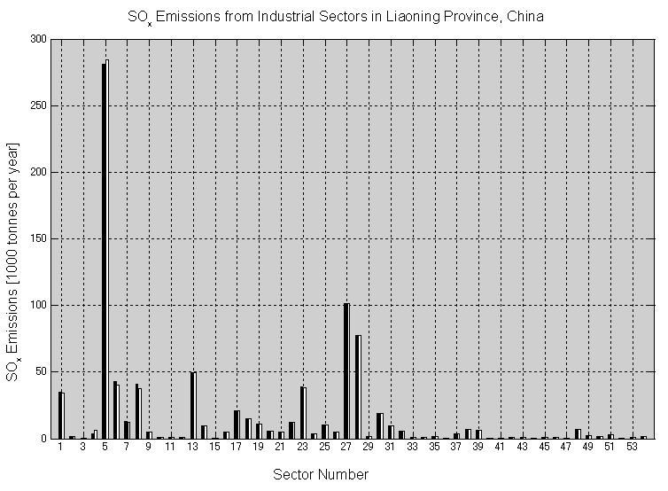

Figure 4: SO_{x} emissions from industrial sectors in Liaoning Province, China, before (black bars) and after (white bars) the change in iron making technology described in the text. See table 1 for the sector names corresponding to the numbers on the x-axis.
Appendix

The following is a short procedure written in Matlab that does most of the analysis described above. The results of running this procedure are shown in figure A1.

% read table of accounts (follows steps 1 & 2)
Z = dlmread('textTablesZ.csv');
V = dlmread('textTablesV.csv');
Y = dlmread('textTablesY.csv');
X = sum(Z')'+Y; % calculate total output X
[size_z,size_z2] = size(Z); % get the size of the Z matrix
A = zeros(size_z); % create an empty A matrix
for i=1:size_z % calculate the direct input coefficient matrix
A(i,:) = Z(i,:)./X'; % (step 3)
end
% modify direct input coefficients for the iron smelting industry
A(8,26) = A(8,26)*0.5; % change coke used by iron smelting (step 4)
A(5,26) = A(5,26)*2; % change electricity used by iron smelting
B = (eye(size_z) - A)^-1; % calculate total input coefficients (step 5)
X = B*Y; % recalculate total output X based on new A
W = V./X; % calculate the wage rate per unit production
P = B'*W; % calculate the modified price vector (step 6)

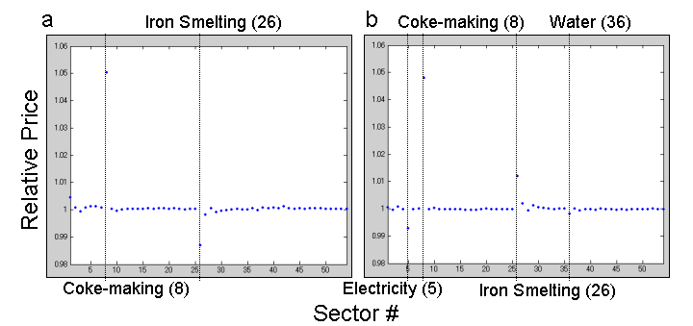
Figure A1: relative prices for a change in a) coke inputs (x 0.5) only and b) both coke (x 0.5) and electricity inputs (x 2.0) to the iron, steel, and alloy iron smelting industry using the Liaoning IO Table.

