**Hybrid methods for incorporating changes in energy technologies in an input-output framework – the case of wind power in the UK**

18th International Input-Output Conference, 20-25 June 2010, Sydney, Australia

Conference Topic 18: Environmental input-output modeling

Thomas Wiedmann1,2)*), Kate Scott1,3), Manfred Lenzen4), Kuishuang Feng1,5) and John Barrett1,2)

1) Stockholm Environment Institute, Grimston House, University of York, York, UK

2) Centre for Sustainability Accounting, Innovation Way, York Science Park, York, UK

3) Sustainable Consumption Institute, School of Earth, Atmospheric and Environmental Sciences, University of Manchester, Manchester, UK

4) Centre for Integrated Sustainability Analysis, A28, University of Sydney, NSW 2006, Australia

5) Sustainability Research Institute, School of Earth and Environment, University of Leeds, UK

*) Corresponding author, tel.: +44 1904 43 2899, fax: +44 1904 43 2898, email: [tw13@york.ac.uk](mailto:tw13@york.ac.uk), web: <http://www.sei.se/reap>

**Abstract**

Future energy technologies will be key for a successful reduction of man-made greenhouse gas emissions. With demand for electricity in particular projected to increase significantly in the future, climate policy goals of limiting the effects of global atmospheric warming can only be achieved if power generation processes are profoundly de-carbonised, leading to a drastic reduction of CO2 emissions in this sector. None of the new electricity generation technologies, however, are carbon free. Upstream production requirements and the infrastructure required to build the new low-carbon electricity system will have a 'carbon burden' of their own, leading to a GHG emissions along the supply chain and during the whole life-cycle of energy technologies.

In this work we explore the methodological options available to account for the indirect GHG emissions of wind power generation. The ultimate goal of the work is to build technology-specific processes into a generalised environmental-economic input-output modelling framework that will enable us to gain an understanding of the magnitude of economy-wide GHG emissions of future energy scenarios. We specifically investigate the effectiveness and suitability of three different hybrid methods for the analysis of the wind power sector in the UK: IO-based hybrid LCA, integrated hybrid LCA and the novel path exchange method. We find that IO-based hybrid LCA, incorporating data from process analysis into a supply and use table framework, is a practical and efficient way of achieving this goal. The variability of the results, however, indicates that there is a need to improve specific data items and method integration to improve the robustness of the results. The novel path exchange method based on structural path analysis is seen as a helpful technique to prioritise the procedures necessary to make these improvements. The comparison of results in this paper provides valuable insight into the uncertainty and reliability of the data and methods for informing energy and environmental policy.

**Keywords**

hybrid life-cycle assessment, electricity production, wind power, input-output analysis, path exchange method, CO2 emissions

# Introduction

To avoid some of the most extreme consequences of climate change there is growing scientific consensus that global temperature rise should not exceed two degrees Celsius (IPCC, 2007). Over 100 countries have adopted this target as a guiding principle for mitigation (Meinshausen et al., 2009). If the total global budget of greenhouse gas (GHG) emissions can be kept to a maximum of 750 Gt CO2-e between 2010 and 2050 there is a 75% probability of achieving the two-degree target. When allocating these emissions to countries based on population, it is already infeasible for the UK to achieve such a target as the existing carbon budgets set under the Low Carbon Transition Plan mean that the UK will exceed their budget by 2022 already. However, there is still a possibility that a global budget of 1,200 Gt CO2-e could be achieved, giving a 50% probability of keeping global warming within two degrees.

For the UK, this would mean a drastic emissions reduction of 14% *annually* from a territorial perspective after the current carbon budgets already in place are achieved by 2022. This would allow the UK to emit a total of only 2.5 Gt CO2-e of GHG emissions between 2023 and 2050.

One area where most radical change is required is in the electricity sector. It is estimated that carbon dioxide emissions from power stations accounted for 32 per cent of the UK's total CO2 emissions in 2007 (DECC, 2009). Many of the scenarios that demonstrate an 80% reduction in UK GHG emissions by 2050 highlight the growing role of the electricity sector in achieving this target (UKERC, 2009). Not only will the current demand for electricity need to be met, but increasingly heat and transport services are likely to be provided through electricity. This could double the demand for electricity in the UK by 2050 from 2000 levels and will require an almost complete decarbonisation of the electricity sector. Many of the scenarios undertaken as part of the UKERC Energy 2050 project suggest that nuclear power, carbon capture and storage (CCS) and wind power will form a major part of the electricity system in the future (UKERC, 2009).

However, in all the scenarios attempting to define a low carbon pathway for the UK, the indirect GHG emissions across the whole life cycle of power stations are not taken into account. In many scenarios it is assumed that technologies such as nuclear power, CCS or wind power are more or less carbon-free. In reality, upstream production requirements and the infrastructure required to build the new low-carbon electricity system will have a 'carbon burden' of their own, leading to a GHG emissions along the supply chain and during the whole life-cycle of energy technologies. Therefore, it is very important to know how much of the remaining 2.5 Gt CO2-e of GHG emissions that the UK has left to emit past 2022 will be used up by providing the new low-carbon electricity infrastructure.

Electricity generation by wind power is currently one of the fastest growing renewable energy technologies worldwide, with a trend towards large-scale production, and has been chosen as the model technology in this study.

Compared to conventional technologies such as gas, coal or nuclear power, electricity generation from renewable energy sources is still very small in the UK (Table 1). In 2010, 255 wind farms with a total capacity of 4.1 GW are operational in the UK; 3.4 GW are installed onshore, 0.7 GW offshore.[1] Further wind parks with a capacity of about 20 GW are planned, most of them offshore. Currently there is no manufacturing of wind turbines in the UK, but both Siemens and General Electric (GE) have announced investment of £80m and £100m respectively to build offshore wind turbine production facilities in the UK.[2] Siemens and GE are both responding to a big policy push in Europe in favour of renewable energy. In the UK, leases were recently granted for 32 GW of offshore wind power, setting Britain on course to become world leader in offshore developments with investments likely to top £100bn.[3] The UK Government’s aim of raising wind power capacity by 32 GW by 2020[4] would mean building between 6,000 and 8,000 offshore windmills. Currently, offshore wind turbines typically produce 2 to 3 MW of power when running at full capacity, but newer models will be able to generate higher loads. Wind turbine manufacturer Vestas has plans to develop a 6-MW turbine.[5]

Table 1: UK wind power statistics (DECC, 2009)

|  |  |  |  |  |  |
| --- | --- | --- | --- | --- | --- |
| Year | 2004 | 2005 | 2006 | 2007 | 2008 |
| **Installed Capacity (MWe)** | | | | | |
| Onshore | 809 | 1,351 | 1,651 | 2,083 | 2,820 |
| Offshore | 124 | 214 | 304 | 394 | 586 |
| **Electricity production (GWh)** | | | | | |
| Onshore | 1,736 | 2,501 | 3,574 | 4,491 | 5,792 |
| Offshore | 199 | 403 | 651 | 783 | 1,305 |
| Share of total UK electricity production (%) | 0.5% | 0.7% | 1.1% | 1.3% | 1.8% |
| **Load factors (%)** | | | | | |
| Onshore wind | 26.6 | 26.4 | 27.2 | 27.5 | 27.0 |
| Offshore wind | 24.2 | 27.2 | 28.7 | 25.6 | 30.4 |

In this paper we explore the methodological options available to account for the indirect GHG emissions of wind power generation. The ultimate goal of the work is to build technology-specific processes into a generalised environmental-economic input-output modelling framework that will enable us to gain an understanding of the magnitude of economy-wide GHG emissions of future energy scenarios. We specifically investigate the suitability and effectiveness of three different hybrid methods for calculating life-cycle inventories which we introduce in Section : IO-based hybrid LCA, integrated hybrid LCA and the novel path exchange method. In Section we describe the data used and in Sections we present the results. In the discussion (Section ) we focus on the differences between results from the various methods and consider the question how best to build the results into the SUT modelling framework. Section 6 concludes.

# Methodologies

Methodologically, a full 'life-cycle' or 'footprint' perspective of emissions accounting has been addressed from two directions: bottom-up, based on process analysis (PA), and top-down, based on (environmental) input-output analysis (IOA). Both methods have their specific shortcomings. While PA can lead to significant truncation errors due to boundary settings, IOA is restricted by aggregated sector representation. Hybrid methods combining the strengths of both methods have therefore developed early to reduce the limitations of both approaches and increase the accuracy of the analysis. Comprehensive energy analyses starting in the 1970s (e.g. Bullard and Herendeen, 1975; Bullard et al., 1978; see also Chapman, 1974; van Engelenburg et al., 1994; Wilting, 1996) and later life cycle assessment (LCA) studies successfully employed a combination of process and input-output analysis (Moriguchi et al., 1993, Lave et al., 1995, Hendrickson et al., 1998, Joshi, 1999, Matthews and Small, 2000, Lenzen, 2002, Heijungs and Suh, 2002, Suh and Huppes, 2005, Heijungs et al., 2006). Nowadays, integrated hybrid LCA is seen as state of the art in life cycle assessments and carbon footprint analyses (Suh, 2003; Suh et al., 2004; Minx et al., 2008; Wiedmann, 2009).

Life-cycle inventories (LCI) calculated using input-output-based hybrid LCA techniques are likely to yield higher results compared to process analysis because the latter systematically truncates inputs from higher upstream production processes due to the setting of system boundaries. Lenzen and Treloar (2002; Fig. 7 therein) demonstrate that GHG emission LCIs for alternative renewable electricity generation technologies may converge toward system completeness at different speeds and that crossovers occur at production layers of second and higher order. Truncating the analysis at too few production layers may lead to erroneous rankings of alternative functional units and to invalid conclusions and recommendations for decision makers.

In this work we employ three different methods: IO-based hybrid LCA, integrated hybrid LCA and the novel path exchange method. Before describing these approaches in detail, we briefly outline the basic modelling framework.

## SUT modelling framework

The basic layout of the model framework is depicted in and described in Equation 1. Two regions, the UK and the rest of world (ROW) are represented with supply, use and trade tables, respectively.

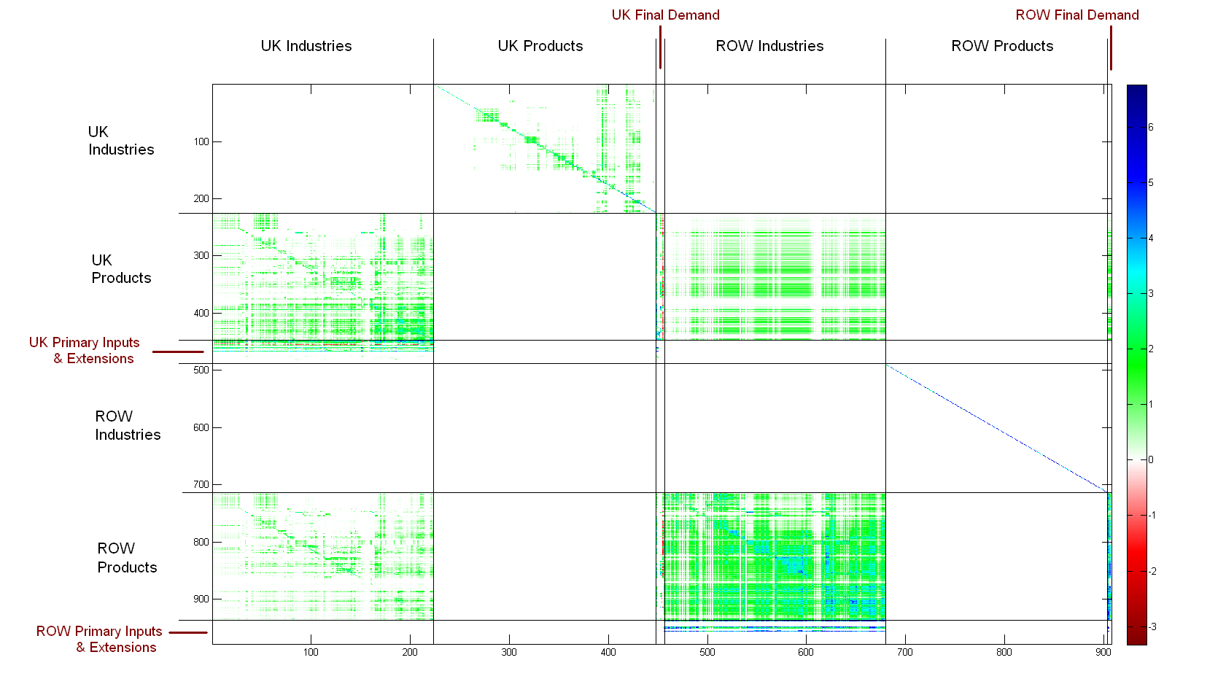

Figure 1: Topographical representation of the two-region social accounting matrix in SUT format used in this work (generated using Aisha software developed at the Centre for Integrated Sustainability Analysis, University of Sydney).

Technical coefficient matrices for region r and s are defined as A*rs* with  and as B*rr* with  where  is an element of the use or the imports/exports table, indicating the input of commodity *i* from region *r* into industry *j* of country s, and  is an element of the supply table, indicating the output of commodity *j* by industry *i* in country r. and  are the total output of industries and commodities in country r, respectively. The supply, use and trade tables can be transformed into a compound direct requirements matrix A* (the term 'compound' refers to maintaining the representation of supply and use tables, rather than a symmetric input-output table):

Equation 1: with u standing for UK and r for ROW.



The final demand and gross output vectors are given as:

Equation 2:

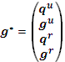

with y*uu* and y*rr* being domestic final demand in UK and ROW and y*ur* and y*ru* being foreign final demand for UK and ROW products, respectively.

The basic input-output relationship is satisfied by:

Equation 3:



where ***I*** is a suitable unity matrix. Column totals of the compound Leontief inverse **(I-A*)-1** represent Leontief type I output multipliers which describe increases in inputs for industry n (left block) or commodity n (right block) per unit increase in final demand for industry n or product n.

## IO-based hybrid LCA

Following the suggestions made by Joshi (1999; in his EIO-LCA Models III to VI), we disaggregate an existing economic sector and approximate the actual input requirements of the desired sub-sector by using information from process analysis. Here we disaggregate the power generation sector in the UK into several sub-sectors, one of which represents electricity generated by wind power. More precisely, in our SUT framework we create an industry column that explicitly and exclusively represents the production requirements of wind power companies as well as a product row that exclusively represents the product of electricity generated by wind power in the UK. In the supply table, we set the principal product to 100%, i.e. we assume that there is no co-production. From an environmental analysis point of view such a simplification makes sense as environmental burdens can be unambiguously linked to the underlying production processes. In the reality of a modern economy, however, electricity from wind power will not only be generated by wind-farm-operating companies but also by other electricity companies as a by-product. Hence, our wind power sector represents all wind power operations rather than all wind power companies.

The sector disaggregation proceeds in two major stages, allowing us to distinguish two models. In the first stage, we split the electricity industry and product sectors in eleven sub-sectors by using data on total turnover and amount of electricity generated (see data section for details). All sub-sectors still have the same input and sales structure, i.e. in the coefficient matrix A, all elements aij and aij~ of main industry sector j and sub-sector j~ are identical (so are elements aij and ai~j in rows of main (i) and sub-product (i~)).

In the sub-industry sector of wind power generators we make a few basic adjustments which reflect the specificities of this sector. These corrections are purely based on common knowledge of the sector's technology and do not require extra data. We assume that, as a first approximation, the wind power sector does not directly require any of the following fuels for its operations: coal, crude oil and nuclear fuel. Therefore, inputs of these products in the use table can be set to zero. We also set direct emissions of the sector to zero. Although rather crude, these approximations without doubt are a better reflection of the true industry input and emissions profile than that from the main electricity sector which, in the UK, is still dominated by mature fossil fuel technologies. We call the result of these basic adjustments the ***IO-based LCA*** model (yellow column in Figure 2).

The second stage of developing an adapted IO model is to replace the whole input bundle of the UK wind power industry, including imports, with 'real' data reflecting the 'true' requirements. Ideally, these data would be compiled from financial accounts data of all companies forming the sector in the actual year of analysis. In the real world, however, it is very unlikely that these data can be obtained and hence they need to be approximated from other data sources. Due to a lack of any company data, we revert to the following procedure, depicted in Figure 2.

Inventories of materials, electricity and products in physical units for the manufacturing, operating and decommissioning of wind turbines are derived from process LCI data and converted into equivalent expenditure using the unit prices of production for domestic and imported manufactured goods (derived from the PRODCOM database and converted to basic prices; see data section). In the ***IO-based hybrid LCA****[6]* model, these data (orange in Figure 2) replace original transactions. However, we keep most of the inputs from the use table, especially for all service sectors, so as to account for flows that have been excluded from the process analysis. For some of the inputs of materials and goods a decision has to be made whether or not to include them. For example, it can be assumed that 'furniture' has not been included in the process inventory, but that 'structural metal products' are likely to have been included under one of various steel products. Transactions in the former category have therefore been included whereas those from the latter category can be set to zero (white cells in Figure 2). We employ a common-sense approach although more sophisticated methods have been suggested to guide the process of including missing inventory elements (Suh and Huppes, 2002; Strømman and Solli, 2008). Also, we set expenditure on transmission and distribution of electricity to zero in the first approximation, for reasons discussed below.



Figure 2: Schematic of monetary transactions used as input recipes for the wind power industry in different model approaches   
(see text for explanation)

## Integrated Hybrid LCA

For ***Integrated Hybrid LCA*** we follow the approach described by various authors (Suh, 2004; Heijungs and Suh, 2002 and Heijungs et al., 2006; see also Suh and Huppes, 2005). A m*m matrix Acp describing the commodity inputs to processes in physical units is linked to a n*n compound requirements matrix A*ss derived from financial transactions between economic sectors (SUT, see Section 2.1) by adding commodity flows in monetary terms from the IO product sectors to the processes in a n*m matrix Cu. The latter represents the additional inputs that have been cut off in the process data, i.e. the 'upstream' data, which are recorded with a negative sign (-Cu). The IO coefficient matrix takes on the form of I-A*ss.

Equation 4



Matrix Cd represents downstream cut-off flows to the IO system from the process-based LCA system. In most cases these flows will be small or zero (see Peters and Hertwich, 2006a). and are vectors representing CO2 emissions from each process and CO2 emission intensity of each economic sector, respectively. is the function unit of the process system, representing final demand in physical unit (here: 1 kWh of electricity by wind power). is the total amount of CO2 emissions to produce the functional unit of electricity, including the emissions from each process as well as the emissions from production processes higher upstream. Details of this model setup have also been described in (Feng et al., 2010).



The upstream data for matrix Cu have to be approximated if, as in our case, no real company data are available. We employ the following approach (see last three columns in Figure 2). Requirements not covered by the process inventory are taken from the disaggregated industry-average input recipe, e.g. furniture or insurance (yellow cells). Higher upstream requirements associated with the materials and goods covered by the process analysis can be approximated by using input requirements of industries supplying these products. We assign an appropriate sector in the use and imports tables and multiply expenditure on these materials and products with elements aij in columns of the A*-matrix for each matching industry j. The resulting expenditure profiles for each process input are added up and used as a proxy for the total bill of goods and services for the identified process (in basic prices). Finally, we summed all input recipes derived in this way for all processes involved in the life cycle of wind farms (blue cells in Figure 2). Combined with the non-process requirements of the wind power sector, this results in the approximated upstream data for matrix Cu, representing the additional incoming flows of commodities from the IO sectors to the processes, that are neglected from the process data (green cells). A similar method has been adopted by Crawford (2009) for an analysis of energy and greenhouse emissions of wind turbines and by Mattila et al. (2010) in a life-cycle assessment of an industrial park in Finland. The latter study also provides a comprehensive comparison of hybrid LCA methods, very similar to the work presented here.

## Path Exchange Method

The Path Exchange Method as introduced by Lenzen and Crawford (2009) goes back to work by Treloar (1997) and is based on the technique of structural path analysis (SPA) (Defourny and Thorbecke, 1984; Sonis et al., 1997; Lenzen, 2003; Peters and Hertwich, 2006b; see also Suh and Heijungs, 2007; Strømman et al., 2009 and Wood and Lenzen, 2009). Factor multipliers mi, representing total environmental impact of one unit of final demand for product i, can be decomposed with SPA by using the series expansion of the Leontief inverse:

Equation 5:



where ej is the emission intensity of industry j and elements anm represent transaction coefficients between sector n and m. In a SUT framework the interpretations of individual paths are slightly different than in a symmetric IO framework. A path with the structure A_i > B_p > C_i > D_p > household consumption, for example, would read (in the case of carbon footprint analysis): "Greenhouse gas emissions in industry A which produces product B that is bought by industry C to produce product D which is bought by households". Furthermore, evaluating structural paths for one unit of final demand of a particular product X leads to the same results as an SPA of all inputs (treated as final consumption) to the industry producing product X if, and only if, the industry only produces this one product (principal product in supply table = 100%, no co-production).[7] The only difference between the SPA results is that all paths in the product analysis are two nodes longer because they have the additional segments "Industry X > Product X >". Path orders in the product analysis are hence path orders in the industry analysis plus two.

Once structural paths have been enumerated, the path exchange method proceeds by finding process data that correspond with an individual structural path *S* = *ei aij ajk* ... *alm ym* and by replacing either the intensity *ei*, or a node coefficient *aij*, in the path (Lenzen and Crawford, 2009; Baboulet and Lenzen, 2010). The adjusted life-cycle inventory *E*′ is then the sum of all initial and adjusted paths, i.e. equal to the initial input-output-based factor inventory *E* plus all (positive and negative) adjustments. Process data coverage can be smaller or larger than structural path coverage. Whilst in the first case a proportion of *e* or *a,* to which the process data applies, needs to be estimated, structural paths can be bundled in the latter case to correspond the process data coverage. The latter case applies in our example where numerous paths referring to the electricity sector can be replaced with one process data item (see below). We refer to this method as the ***PXC LCA***.

# Data

## Input-output and environmental data

The basis for our two-region EE-IO modelling framework are supply, use and imports tables of the UK economy in 2004 with a sector resolution of 123, extended with sectoral greenhouse gas emissions derived from national environmental accounts. The tables were generated in a previous project; details are provided in (Wiedmann et al., 2008), see also (Wiedmann et al., 2010). For the rest-of-world region (ROW) we use data from the GTAP 7 database.[8]

For the purpose of this work we have disaggregated industry and product sectors from 123 sectors in the UK and and 57 sectors in the ROW to 224 sectors each. The model is kept in SUT format with data arranged as shown in . A disaggregation of economic sectors requires the separation of both supply and use of products data into two or more parts, each of which is an adequate representation of the desired sub-sector. Ideally, this information would come from original data based on surveys of companies. In most cases, however, this data is confidential and is therefore not released by the Office for National Statistics (ONS). It is therefore necessary to use proxy methods to achieve a breakdown of sectors that is accurate enough and fit for the envisaged purpose.

Initial disaggregation is achieved by using data for the total turnover of sub-sectors at a 4-digit level of the Standard Industrial Classification (SIC 2003) provided by the UK Annual Business Inquiry (ONS, 2008) plus further specific information in cases where ABI data is not sufficient. Figure 3 depicts the example of the electricity sector: total turnover data were used to disaggregate sector 40.1 into 40.11, 40.12 and 40.13. The 'Production of electricity' sector (40.11) is further broken down by using data on total electricity production by technology (in GWh).



Figure 3: Data used to disaggregate the electricity sector in UK SUT (year 2004, sources: ONS, 2008, DECC, 2009)

After disaggregation, supply matrices were rebalanced to comply with constraints on principal product by industry sector. As ROW data from GTAP is in symmetrical (industry by industry) format, it is assumed that each industry produces only one product (100% principal products). Grand row totals are constrained to match with grand column totals and with published data for totals of 123 aggregated sectors (monetary data only; not including environmental extensions). The method used for matrix balancing is described in (Lenzen et al., 2009). CO2 emissions per sub-sector where taken from UK Environmental Accounts (ONS, 2009); broken down further for renewables and transmission/distribution by using total economic output. Direct emissions for the wind power sector were derived from Ecoinvent data (see below); emissions from biomass were estimated. Key results from the disaggregation are shown in Table 2.

Table : Total economic output and direct CO2 emissions of electricity sub-sectors   
(UK, 2004)

|  |  |  |  |  |  |  |  |  |  |  |  |
| --- | --- | --- | --- | --- | --- | --- | --- | --- | --- | --- | --- |
| **Sector number** | **UK-I 151** | **UK-I  152** | **UK-I 153** | **UK-I 154** | **UK-I 155** | **UK-I 156** | **UK-I 157** | **UK-I  158** | **UK-I 159** | **UK-I  160** | **UK-I  161** |
| **Sector name** | Coal power | Gas power | Oil power | Nuclear power | Hydro power | Wind power | Electri-city by biomass | Geother-mal, solar, tidal or wave power | Electri-city by other fuels | Trans-mission of electricity | Distribution and trade in electricity |
| **SIC 2003 code** | 40.11 | 40.11 | 40.11 | 40.11 | 40.11 | 40.11 | 40.11 | 40.11 | 40.11 | 40.12 | 40.13 |
| **Total economic output at basic prices (£ million)** | 2,518 | 3,831 | 117.7 | 1,488 | 110.8 | 42.0 | 163.5 | 5.7 | 74.4 | 4,560 | 21,378 |
| **Direct CO2 emissions  (kt CO2)** | 115,357 | 56,394 | 517.3 | 39.8 | 5.0 | 1.95 | 5,000 | 0.30 | 843 | 374.5 | 1,709 |
| **Direct emission intensity (kg CO2/£)** | 45.8 | 14.7 | 4.39 | 0.027 | 0.045 | 0.046 | 30.5 | 0.052 | 11.3 | 0.082 | 0.080 |

Results in Section are presented in g CO2/kWh. The following approach was adopted in the IO-based models to convert from monetary units to physical units. The Leontief multiplier showing total emissions per unit of final demand for electricity from wind power was calculated and multiplied with the gross product output in basic prices. This results in total life-cycle CO2 emissions of wind power. Dividing by the total wind power electricity output in GWh results in LCI values in g CO2/kWh.

## Ecoinvent process LCI data

Three datasets from the Ecoinvent database[9] were used for the analysis (Burger and Bauer, 2007):

* electricity, at wind power plant 2 MW, offshore,
* wind power plant 2 MW, offshore, fixed parts,
* wind power plant 2 MW, offshore, moving parts.[10]

The first dataset is already a complete gradle-to-gate life-cycle inventory, including the production of fixed and moving parts. However, we have subtracted LCI results for the second two datasets from the first in order to derive the impacts associated with the operation of the power plant alone. Thus we obtain three mutually exclusive processes that collectively result in the full process-based life-cycle inventory of a 2 MW offshore wind turbine park.

The LCI is based on the offshore wind park Middelgrunden close to Copenhagen comprising 20 individual wind turbines with a nominal power output of 2 MW each (Burger and Bauer, 2007). The 'fixed parts' include the concrete foundation, the tower, the transformer and the assemblage. 'Moving parts' consist of the rotor blades and mechanical and electronic components within the nacelle. The assumed life time for both fixed and moving parts is 20 years. The operation includes the change of gear oil every two years and associated transport emissions. A capacity factor of 30% is assumed. Waste incineration is assumed to be the method of disposal for plastics, oil and glass components.

Table 3: Input requirements of 2 MW offshore wind power plant   
(from Burger and Bauer, 2007; note that same data depicted here have been superseded by updates of the Ecoinvent database)

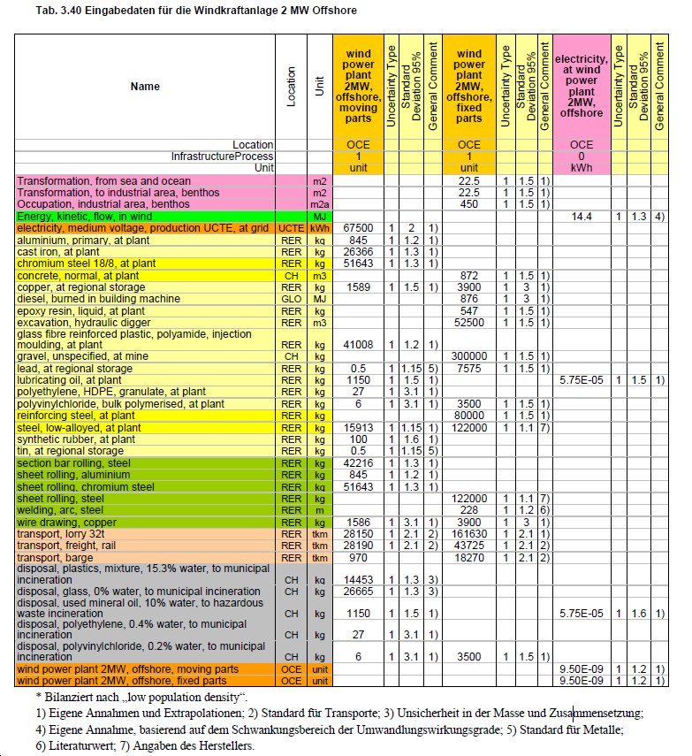

## PRODCOM data

PRODCOM is the Survey of PRODucts of the European COMmunity and is collected across the EU for publication of product statistics.[11] It is compiled annually in the UK. Data include the value and volume of UK manufacturers’ product sales (from which the unit prices of production are calculated), merchanted goods, work done, sales of waste products, all other income and total turnover for the industry. Trade data are published alongside PRODCOM data differentiating between sales, imports from within and outside the EU and exports to the EU and outside the EU, providing a complete picture of the market for each product. The data are also used by ONS in the construction of input-output balances to reconcile the income, expenditure and output components of Gross Domestic Product (GDP).

# Results

## Modelling results from this study

Life-cycle CO2 emissions of electricity produced by wind power as calculated by the different methods are presented in Table 4. This includes the cradle-to-grave CO2 emitted for the construction, operation, and decommissioning, per unit of output of electrical energy over the lifetime of the device.

Table 4: Results for life-cycle inventory data of CO2 emissions from the UK wind power sector in 2004

|  |  |  |
| --- | --- | --- |
| **Abbreviation** | **Model description** | **Life-cycle inventory of CO2 (g CO2/kWh)** |
| ***IO-based LCA*** | Pure IO model with minor adjustments to disaggregated industry sector; direct emissions set to zero | 59.8 |
| ***IO-based hybrid LCA*** | Pure IO model with inputs of materials & goods derived from process LCI data and inputs of services from IO data; direct emissions from process LCI data | 30.2 |
| ***Pure PA LCA*** | Pure process analysis; data from Ecoinvent | 13.3 |
| ***Integrated Hybrid LCA*** | Integrated Hybrid LCA with additional monetary inputs and higher upstream inputs of suppliers derived from process LCI data | 16.3 |

A life-cycle assessment of a 2-MW offshore wind power plant using process analysis and data from the Ecoinvent database is reported by Burger and Bauer, 2007 to yield a LCI for CO2 of 13.3 g/kWh (listed under ***Pure PA LCA*** in Table 4). Adding inputs from IO sectors not covered by the process analysis, including those from suppliers, in an ***Integrated hybrid LCA*** model increases this value by 3.0 g/kWh (25%) to 16.3 g/kWh.

In a pure IO model the result depends much on the input structure of the wind power sector, i.e. the transaction coefficients in the industry column in the domestic use table and the imports table. If the wind power sector is only crudely disaggregated from the main electricity sector with only a few basic adjustments – such as setting some fossil fuel use and direct emissions to zero as a first approximation – then the result is about 60 g CO2/kWh (***IO-based LCA***). Of course this is an insufficient analysis and the result is only presented here in order to provide a comparison to the more sophisticated methods. The relatively high value can be explained with the fact the disaggregated sector in the ***IO-based LCA*** model essentially inherits the input structure of the electricity sector as a whole which is dominated by expenditure on fossil fuels and on generation, transmission and distribution of electricity (within-sector transactions) – probably not an adequate representation of the wind power industry ( and illustrate by how much this influences the results).

In the ***IO-based hybrid LCA*** model we therefore exchanged the original inputs in sectors that represent materials and products covered by the process analysis (e.g. steel, cement, etc.) with values that were derived by converting the physical units in the process data to monetary units in basic prices (see also Figure 2). The result of 30 g CO2/kWh is almost twice as high as that from ***Integrated hybrid LCA***, mainly due to the much higher impacts from steel and concrete. Steel is the main contributor in both hybrid methods, whereas concrete is much more prominent in the IO-based hybrid method. Plastics come second in the integrated hybrid method (Figure 4). A plausible explanation of this discrepancy is the ability of ***IO-based hybrid LCA*** to represent production and emissions patterns specific to the UK in 2004, including the impacts from imported steel. The process data, on the other hand, are based on a mix of Danish, Swiss and European technologies (Burger and Bauer, 2007).

Table 5: Breakdown of CO2 LCI results (g/kWh) for wind power by main input category as calculated by different methods (UK, 2004)

|  |  |  |  |
| --- | --- | --- | --- |
|  | **IO-based  LCA** | **IO-based hybrid LCA** | **Integrated hybrid LCA** |
| Electricity | 34.3 | 0.88 | 0.35 |
| Transmission/Distribution | 19.4 | - | - |
| Steel | 0.22 | 13.7 | 7.39 |
| Metals (excl. steel) | - | 0.77 | 0.30 |
| Cement/concrete | 0.02 | 10.6 | 2.33 |
| Plastics | 0.004 | 1.13 | 2.99 |
| Fuels | 4.03 | 0.07 | 0.07 |
| Services (incl. transport) | 0.69 | 0.66 | 0.58 |
| Onsite emissions | - | 1.01 | 1.01 |
| Other | 1.20 | 1.45 | 1.27 |
| **Total** | **59.8** | **30.2** | **16.3** |



Figure : Relative contributions of main inputs to the total CO2 LCI for wind power calculated by different methods  
(1) incl. transport, (2) excl. steel

In our analysis, the hybrid methods do not show the impact of transmitting and distributing the electricity generated by the wind turbines – one of the processes that features prominently in the ***IO-based LCA*** results. In the terminology of the GHG Protocol (WRI and WBCSD, 2004) the emissions associated with this process would be classified as 'downstream' emissions. Although the connection of the wind turbines to the national grid is included in the process analysis, the distribution of electricity to the final consumer is not. Adding this specific input requirement from the IO data to the hybrid methods would increase the results from both ***IO-based hybrid LCA*** and ***Integrated hybrid LCA*** by about 19 g/kWh. A simple combination of Ecoinvent LCIs for transmitting high and medium-voltage electricity yields a value of about 0.9 g CO2 per transmitted kWh of electricity. Because of this large discrepancy, we have therefore chosen not to include transmission/distribtution until a more accurate estimate of the actual costs is available.

In order to explore opportunities of the path exchange method (***PXC LCA***), a structural path analysis of the wind power sector was undertaken first by using the input (use) bundle from the ***IO-based LCA*** model as final consumption. The full results for both IO-based methods are shown in the Appendix. Table 5 shows an aggregated version of the results where all paths representing the purchase of the same commodity (or commodity group) are combined. Rows in Table 5 can therefore be interpreted as showing 'all paths ending in electricity', 'all paths ending in transmission or distribution', etc.

The purpose of this study is to explore the question in which way PXC can be used if the input recipe is *not* known. We therefore focus our attention on the ***IO-based LCA*** where paths ending with electricity make up more than half of the total LCI with over 34 g CO2/kWh alone. Because the input structure has not been changed, these paths represent the electricity requirements of the whole electricity sector in the UK from which the wind power sector was disaggregated. The input recipe created through this disaggregation, however, does not represent the real requirements of the wind power sector. The power sector as a whole in UK in 2004 was based on mature technologies – mainly requiring two commodities: fuels and distribution. The actual wind power sector, on the contrary, is a fast growing sector requiring relatively more material inputs in the form of concrete, steel, etc. to build its infrastructure.

The ***PXC LCA*** can now be used to bulk-replace all the electricity paths by using process data for the actual electricity requirements. Scaling up actual electricity requirements as reported by Ecoinvent (see Table 3) to the total sector output of 1,935 GWh, results in 1,166 MWh of actual electricity requirements which, multiplied by the conversion factor for UK Grid Rolling Average electricity use (533.18 g CO2/kWh; DEFRA, 2009), equate to 0.32 g per kWh. Neglecting higher upstream impacts, this value would then replace the electricity paths total of 34 g/kWh. [12]

Other significant contributions come from paths ending in distribution or transmission of electricity. These stem from (probably overestimated) payments of the wind power sector to other companies for the service of transmitting and distributing the electricity produced by wind turbines. As mentioned above, an estimated 0.9 g CO2/kWh from PA data would be a lower-limit replacement for these path values in the ***PXC LCA***.

Onsite emissions from the operation of wind farms are not included in the initial SPA analysis as direct industry emissions of the wind power sector were set to zero in the ***IO-based LCA*** model (see above). These emissions (1.0 g CO2/kWh) can therefore be added to the PXC results.

## Comparison with other studies

Based on process analysis, the wind turbine manufacturer Vestas reports LCIs for CO2 of about 5 to 8 g/kWh for different sizes of wind turbines (Vestas, 2010). With increasing production volume of wind farms the total emissions per kWh usually decrease (Lenzen and Munksgaard, 2002), which is why offshore wind turbines have slightly lower impacts despite the additional infrastructure necessary.

A review by Lenzen (Lenzen, 2008) reports GHG LCI for wind turbines of around 15-25 g CO2-e/kWh. Varun et al., 2009 cite studies with results from 9.7 to 123.7 g/kWh for CO2 only. Lenzen and Wachsmann's (Lenzen and Wachsmann, 2004) calculations on wind turbines in Brazil and Germany yield 2-81 g CO2/kWh, depending on the type of wind turbine, the location of production and operation and the end of life processes. Their result of 45 g CO2/kWh for coastal Germany is probably the most comparable to offshore wind power in the UK.

An extensive review and regression analysis of CO2 LCI results for wind power was carried out by Lenzen and Munksgaard (Lenzen and Munksgaard, 2002), who report a range of CO2 intensities between 7.9 and 123.7 g CO2 /kWh. The large variation can be explained by various factors. First, the scope chosen for life-cycle analysis varies considerably. Some studies examine only manufacture, whereas other studies include further life-cycle stages such as construction, decommissioning, grid connection, operation and transport. Some are based on process analysis only whereas others employ IO analysis. Apart from differences in analysis methodology and scope, the scatter in carbon intensities can be caused by economies of scale (‘bigger is better’), and by differences in lifetime, load factor, technology (type and maturity), and country of manufacture.

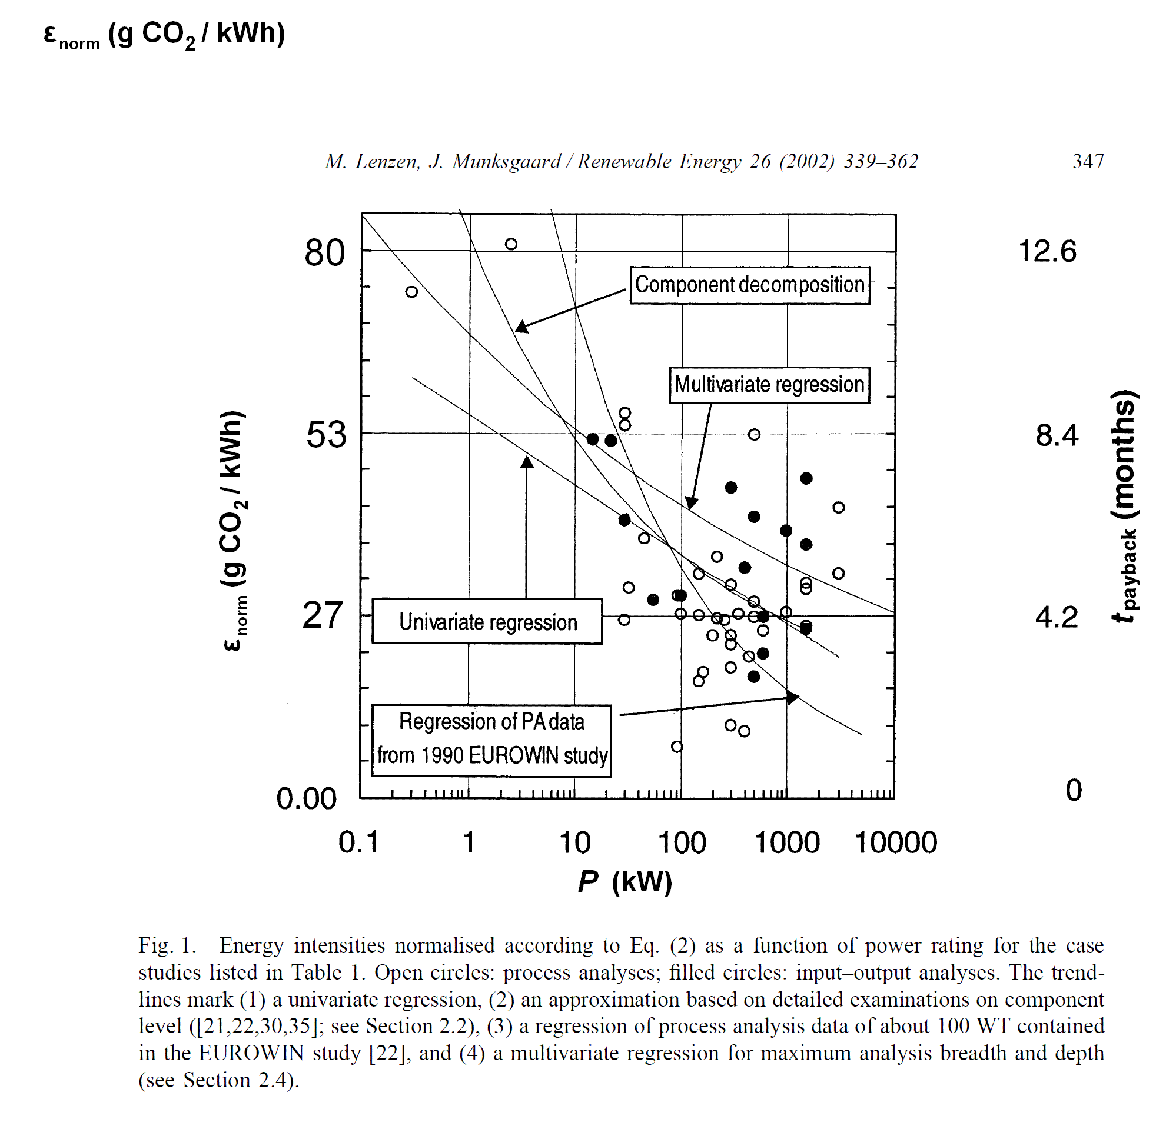

Figure : Normalised CO2 intensity ε as a function of wind turbine power rating obtained from studies reviewed by Lenzen & Munksgaard (Lenzen and Munksgaard, 2002; Table 1 therein). Open circles represent process analyses, while filled circles represent input–output-based analyses. The regression curves were obtained from (1) a univariate logarithmic regression over all points shown in the diagram, (2) an approximation based on detailed examinations on component level, (3) a regression of process analysis data of about 100 wind turbines, and (4) a multivariate regression for maximum analysis breadth and depth. Adapted from Lenzen and Munksgaard, 2002 by multiplying energy intensity *η*norm with 533 g CO2/kWh (UK Grid Rolling Average conversion factor for electricity use; DEFRA, 2009).

shows the results from Lenzen and Munksgaard, 2002, expressed in UK carbon intensity; the mean carbon intensity over all plants examined is 33 g CO2/kWh. Adopting the univariate regression, a 2 MW wind turbine (our example) would therefore have a CO2 LCI of 26 g CO2/kWh.

In a more recent review, Lenzen (Lenzen, 2009a) quotes studies by Roth (Roth et al., 2005) and Pehnt (Pehnt et al., 2008) who take the reduced capacity credit of wind into account and conclude that CO2 emissions arising from the need of additional reserves (i.e. gas power plants starting up when the wind drops) add between 35 and 75 g CO2/kWh to the LCI, thus outweighing CO2 emissions from the turbine life cycle.

# Discussion

Hybrid life-cycle analyses are generally undertaken with the aim to minimise the limitations posed by pure process or IO analysis. Due to the non-availability of real company data, however, all of the hybrid methods that we employ in this study incorporate certain assumptions and practical limitations. This is also reflected in the relatively large variability of the results which would likely be smaller if more accurate data were available.

Two issues stand out. Firstly, the ***IO-based LCA*** method seems to overemphasise transactions of the wind power sector to the electricity sector and the transmission/distribution sector in particular. This is clearly a result of the disaggregation of the main electricity sector in the UK SUTs with the lack of specific sub-sector information. And it was the very reason in the first place why process data were consulted and hybrid methods employed. Finding the most realistic estimate for transmission/distribution coefficients, however, remains the work of future research.

Secondly, the conversion of PA data to monetary inputs for the ***IO-based hybrid LCA*** is straight forward and provides a very useful adjustment of the input requirements in the use table. The fact that the results are almost twice as high as from ***Integrated*** ***hybrid LCA*** might be the result of a desired reflection of UK-specific technologies. Further investigations in a sensitivity analysis should however be undertaken to validate this finding. Both structural path analysis and path exchange will be useful tools in this process as they can guide and prioritise the efforts.

The path exchange method has the potential to be the most efficient in terms of efforts and resources required by the various hybrid LCA methods, because a few crucial adjustments might be sufficient to approximate real input requirements and emission intensities. As the reality of our wind power example shows, however, many adjustments might be necessary to achieve a satisfying outcome, especially if the initial input requirements are very different from the actual ones. Not only would the most significant paths have to be exchanged but also paths that contribute very little in the original input recipe, such as steel which doesn't even rank amongst the first 75 paths. ***PXC LCA*** therefore appears to be more suited to make adjustments *after* a hybrid analysis (IO-based or integrated) has been carried out first. Path exchanges can then be kept to a minimum.

Further issues affecting the accuracy of the results deserve attention:

* The price conversion to calculate the expenditure profile of the wind power sector from the process input requirements data yields costs which appear to relatively low in comparison to the output of electrical energy. To reduce this source of error, access to full expenditure accounts of wind power companies is crucial to increase the accuracy and reliability of results. This is also crucial information when disaggregating sectors in SUT or IO tables because it helps to specify parameters such as:
  + total industry and total product output
  + level of co-production
  + ratio of intermediate purchases versus primary inputs
  + structure of purchases of goods, materials and services
  + structure of sales (for product row)
* Another source of error is the uncertainty in the boundary cut-off of the process data. Our basic understanding follows that service inputs are ignored from process analyses. Increased transparency in the boundary cut-off of process data would help to generate more accurate results.
* We have also not dealt systematically with potential double-counting in hybrid LCA. Our criteria for inclusion or exclusion of monetary flows in addition to process flows have followed common sense; more thorough methods, however, are available (see Strømman et al., 2009; Lenzen, 2009b; Strømman, 2009) and have been left for further research.
* Our hybrid approaches mix up different temporal boundaries. Data from process-based LCA are based on complete life cycle spanning several decades. By using these data for the adjustment of a sector in an annual IO table, it is implicitly assumed that the proportions of manufacturing vs operating vs decommissioning are on average applicable to the sector's actual activities within one year. In reality, manufacturing will be more prominent in the early days of wind power development when the sector is growing fast whereas operation and decommissioning will be dominant once no new wind parks are built any longer. Furthermore, our process data are for offshore wind power which still played a minor role in 2004.
* In the process part of the analysis we directly adopt the assumptions on lifetime of moving and fixed parts, gear box replacement, maintenance etc. from the Ecoinvent database. Both Vestas (Vestas, 2010) and Crawford (Crawford, 2009) also adopt the assumption of a 20-year lifespan for wind turbines, yet maintenance replacement rates differ – in the case of Ecoinvent, exchanging the gear oil every other year is the only maintenance activity assumed to take place (Burger and Bauer, 2007). Furthermore, recycling of wind turbines has not been taken into account in this analysis.
* Capital investments have not been included into the input-coefficients; they have been left as part of final demand in the SUTs.

# Conclusions

In this paper we explore the methodological options available to account for the indirect CO2 emissions of wind power generation. The ultimate goal of the work is to build technology-specific processes into a generalised environmental-economic input-output modelling framework that will enable us to gain an understanding of the magnitude of economy-wide GHG emissions of future energy scenarios. Having investigated the effectiveness and suitability of three different hybrid methods for the analysis of the wind power sector in the UK we conclude that ***IO-based hybrid LCA*** incorporating data from process analysis into a supply and use table framework is a practical and efficient way of achieving this goal. The variability of the results, however, indicates that there is a need to improve specific data items and method integration to improve the robustness of the results. The novel path exchange method based on structural path analysis is seen as a helpful technique to prioritise the procedures necessary to make these improvements. We share Mattila et al.'s (2010) opinion that input-output-based LCA is a useful tool but that "a careful interpretation of the results is necessary in order to understand the influence of aggregation and allocation." The comparison of results in this paper provides valuable insight into the uncertainty and reliability of the data and methods for informing energy and environmental policy.

# Acknowledgement

This work was supported by funding from the UK Energy Research Centre. Special thanks go to Reinout Heijungs from CML Leiden for his advice on Ecoinvent data, the CMLCA tool and hybrid LCA methods.

# References

Baboulet, O. and Lenzen, M. (2010) Evaluating the environmental performance of a University. *Journal of Cleaner Production*, In Press, Accepted Manuscript. http://dx.doi.org/10.1016/j.jclepro.2010.04.006.

Bullard, C. W. and Herendeen, R. A. (1975) The energy cost of goods and services. *Energy Policy*, 3(4), 268-278. http://dx.doi.org/10.1016/0301-4215(75)90035-X.

Bullard, C. W., Penner, P. S. and Pilati, D. A. (1978) Net energy analysis : Handbook for combining process and input-output analysis. *Resources and Energy*, 1(3), 267-313. http://dx.doi.org/10.1016/0165-0572(78)90008-7.

Burger, B. and Bauer, C. (2007) Windkraft, Data v2.0 (2007). In: R. Dones (Ed.) et al.,*Sachbilanzen von Energiesystemen: Grundlagen für den ökologischen Vergleich von Energiesystemen und den Einbezug von Energiesystemen in Ökobilanzen fur die Schweiz. Ecoinvent Report No. 6-XIII*, Paul Scherrer Institut Villingen, Swiss Centre for Life Cycle Inventories, Dübendorf, Switzerland.

Chapman, P. F. (1974) Energy costs: a review of methods. *Energy Policy*, 2(2), 91-103. http://dx.doi.org/10.1016/0301-4215(74)90002-0.

Crawford, R. H. (2009) Life cycle energy and greenhouse emissions analysis of wind turbines and the effect of size on energy yield. *Renewable and Sustainable Energy Reviews*, 13(9), 2653-2660. http://dx.doi.org/10.1016/j.rser.2009.07.008.

DECC (2009) *Digest of United Kingdom Energy Statistics (DUKES) 2009*. Department of Energy and Climate Change, London, UK. http://www.decc.gov.uk.

Defourny, J. and Thorbecke, E. (1984) Structural path analysis and multiplier decomposition within a social accounting matrix framework. *Economic Journal*, 94, 111-136.

DEFRA (2009) *Guidance on how to measure and report your greenhouse gas emissions*. September 2009. UK Department for Environment, Food and Rural Affairs, London. http://www.defra.gov.uk/environment/business/reporting/index.htm.

Feng, K., Barrett, J., Wiedmann, T., Hubacek, K., Minx, J. and Scott, K. (2010) The role of infrastructure in meeting UK climate change targets. *18th International Input-Output Conference of the International Input-Output Association (IIOA)*, 20-25 June 2010. Sydney, Australia. http://www.isa.org.usyd.edu.au/io_2010/.

Gallego, B. and Lenzen, M. (2005) A consistent input-output formulation of shared producer and consumer responsibility. *Economic Systems Research*, 17(4), 365-391. http://dx.doi.org/10.1080/09535310500283492.

Heijungs, R., de Koning, A., Suh, S. and Huppes, G. (2006) Toward an Information Tool for Integrated Product Policy: Requirements for Data and Computation. *Journal of Industrial Ecology*, 10(3), 147-158. http://dx.doi.org/10.1162/jiec.2006.10.3.147.

Heijungs, R. and Suh, S. (2002) *The computational structure of life cycle assessment*. Kluwer Academic Publishers, Dordrecht, The Netherlands,

Hendrickson, C. T., Horvath, A., Joshi, S. and Lave, L. B. (1998) Economic Input-Output Models for Environmental Life-Cycle Assessment. *Environmental Science & Technology*, 32(7), 184A. http://pubs.acs.org/cgi-bin/archive.cgi/esthag-a/0000/32/i07/html/hendrick.html

IPCC (2007) *Climate Change 2007: Synthesis Report - Contribution of Working Groups I, II and III to the Fourth Assessment Report of the Intergovernmental Panel on Climate Change*. Intergovernmental Panel on Climate Change, Geneva, Switzerland. http://www.ipcc.ch/publications_and_data/ar4/syr/en/contents.html.

Joshi, S. (1999) Product Environmental Life-Cycle Assessment Using Input-Output Techniques. *Journal of Industrial Ecology*, 3(2-3), 95-120. http://dx.doi.org/10.1162/108819899569449.

Lave, L. B., Cobras-Flores, E., Hendrickson, C. and McMichael, F. (1995) Using input–output analysis to estimate economy wide discharges. *Environmental Science & Technology*, 29, 420-426.

Lenzen, M. (2002) A guide for compiling inventories in hybrid life-cycle assessments: some Australian results. *Journal of Cleaner Production*, 10(6), 545-572. http://dx.doi.org/10.1016/S0959-6526(02)00007-0.

Lenzen, M. (2003) Environmentally important paths, linkages and key sectors in the Australian economy. *Structural Change and Economic Dynamics*, 14(1), 1-34. http://dx.doi.org/10.1016/S0954-349X(02)00025-5.

Lenzen, M. (2008) Life cycle energy and greenhouse gas emissions of nuclear energy: A review. *Energy Conversion and Management*, 49(8), 2178-2199. http://dx.doi.org/10.1016/j.enconman.2008.01.033.

Lenzen, M. (2009a) *Current state of development of electricity-generating technologies – a literature review*. Report prepared for the Australian Uranium Association. 19 June 2009. Centre for Integrated Sustainability Analysis, The University of Sydney, Australia. http://www.aua.org.au/Content/Lenzenreport.aspx.

Lenzen, M. (2009b) Dealing with double-counting in tiered hybrid life-cycle inventories: a few comments. *Journal of Cleaner Production*, 17(15), 1382-1384. http://dx.doi.org/10.1016/j.jclepro.2009.03.005.

Lenzen, M. and Crawford, R. H. (2009) The Path Exchange Method for Hybrid LCA. *Environmental Science & Technology*, 43(21), 8251-8256. http://dx.doi.org/10.1021/es902090z.

Lenzen, M., Gallego, B. and Wood, R. (2009) Matrix balancing under conflicting information. *Economic Systems Research*, 21(1), 23 - 44. http://dx.doi.org/10.1080/09535310802688661.

Lenzen, M. and Munksgaard, J. (2002) Energy and CO2 life-cycle analyses of wind turbines - review and applications. *Renewable Energy*, 26(3), 339-362. http://dx.doi.org/10.1016/S0960-1481(01)00145-8.

Lenzen, M., Murray, J., Sack, F. and Wiedmann, T. (2007) Shared producer and consumer responsibility - Theory and practice. *Ecological Economics*, 61(1), 27-42. http://dx.doi.org/10.1016/j.ecolecon.2006.05.018

Lenzen, M. and Treloar, G. (2002) Differential Convergence of Life-Cycle Inventories toward Upstream Production Layers. *Journal of Industrial Ecology*, 6(3-4), 137-160. http://dx.doi.org/10.1162/108819802766269575.

Lenzen, M. and Wachsmann, U. (2004) Wind turbines in Brazil and Germany: an example of geographical variability in life-cycle assessment. *Applied Energy*, 77(2), 119–130. http://dx.doi.org/10.1016/S0306-2619(03)00105-3.

Matthews, H. S. and Small, M. J. (2000) Extending the Boundaries of Life-Cycle Assessment through Environmental Economic Input-Output Models. *Journal of Industrial Ecology*, 4(3), 7-10. http://dx.doi.org/10.1162/108819800300106357.

Mattila, T. J., Pakarinen, S. and Sokka, L. (2010) Quantifying the Total Environmental Impacts of an Industrial Symbiosis - a Comparison of Process-, Hybrid and Input-Output Life Cycle Assessment. *Environmental Science & Technology*, in press. http://dx.doi.org/10.1021/es902673m.

Meinshausen, M., Meinshausen, N., Hare, W., Raper, S. C. B., Frieler, K., Knutti, R., Frame, D. J. and Allen, M. R. (2009) Greenhouse-gas emission targets for limiting global warming to 2 C. *Nature*, 458(7242), 1158-1162. http://dx.doi.org/10.1038/nature08017.

Minx, J., Wiedmann, T., Barrett, J. and Suh, S. (2008) *Methods review to support the PAS process for the calculation of greenhouse gas emissions embodied in goods and services. Report to the UK Department for Environment, Food and Rural Affairs* Project Ref.: EV2074, February 2008. Defra, London, UK.. Full report: http://randd.defra.gov.uk/Document.aspx?Document=EV02074_7071_FRP.pdf.

Moriguchi, Y., Kondo, Y. and Shimizu, H. (1993) Analyzing the life cycle impact of cars: the case of CO2. *Industry and Environment*, 16(1), 42-45.

ONS (2008) *Annual Business Inquiry (ABI), 2008 Edition (release data 17/11/2008).* Office for National Statistics (ONS), London, UK. Retrieved April 2009, from http://www.statistics.gov.uk/abi.

ONS (2009) *Environmental Accounts: Greenhouse Gas Emissions for 93 industries, 2009 Edition (last update 11/06/2009).* Office for National Statistics (ONS), London, UK. Retrieved June 2009, from http://www.statistics.gov.uk/statbase/ssdataset.asp?vlnk=5695&More=Y.

Pehnt, M., Oeser, M. and Swider, D. J. (2008) Consequential environmental system analysis of expected offshore wind electricity production in Germany. *Energy*, 33(5), 747-759. http://dx.doi.org/10.1016/j.energy.2008.01.007.

Peters, G. P. and Hertwich, E. G. (2006a) A comment on "Functions, commodities and environmental impacts in an ecological-economic model". *Ecological Economics*, 59(1), 1-6. http://dx.doi.org/10.1016/j.ecolecon.2005.08.008.

Peters, G. P. and Hertwich, E. G. (2006b) Structural analysis of international trade: Environmental impacts of Norway. *Economic Systems Research*, 18(2), 155-181 http://dx.doi.org/10.1080/09535310600653008

Roth, H., Brückl, O. and Held, A. (2005) *Windenergiebedingte CO2-Emissionen konventioneller Kraftwerke*. lfE-Schriftenreihe Heft 50. Lehrstuhl für Energiewirtschaft und Anwendungstechnik, München, Germany.

Sonis, M., Hewings, G. J. D. and Sulistyowati, S. (1997) Block Structural Path Analysis: Applications to Structural Changes in the Indonesian Economy. *Economic Systems Research*, 9(3), 265-280. http://dx.doi.org/10.1080/09535319700000020.

Strømman, A. H. (2009) Dealing with double-counting in tiered hybrid life-cycle inventories: a few comments - response. *Journal of Cleaner Production*, 17(17), 1607-1609. http://dx.doi.org/10.1016/j.jclepro.2009.06.007.

Strømman, A. H., Peters, G. P. and Hertwich, E. G. (2009) Approaches to correct for double counting in tiered hybrid life cycle inventories. *Journal of Cleaner Production*, 17(2), 248-254. http://dx.doi.org/10.1016/j.jclepro.2008.05.003.

Strømman, A. H. and Solli, C. (2008) Applying Leontief's Price Model to Estimate Missing Elements in Hybrid Life Cycle Inventories. *Journal of Industrial Ecology*, 12(1), 26-33. http://dx.doi.org/10.1111/j.1530-9290.2008.00011.x.

Suh, S. (2003) Input-output and hybrid life cycle assessment. *The International Journal of Life Cycle Assessment*, 8(5), 257-257. http://dx.doi.org/10.1007/BF02978914.

Suh, S. (2004) Functions, commodities and environmental impacts in an ecological-economic model. *Ecological Economics*, 48(4), 451-467. http://dx.doi.org/10.1016/j.ecolecon.2003.10.013.

Suh, S. and Heijungs, R. (2007) Power series expansion and structural analysis for life cycle assessment. *The International Journal of Life Cycle Assessment*, 12(6), 381-390. http://dx.doi.org/10.1065/lca2007.08.360.

Suh, S. and Huppes, G. (2002) Missing Inventory Estimation Tool Using Extended Input-Output Analysis. *The International Journal of Life Cycle Assessment*, 7(3), 134-140. http://dx.doi.org/10.1007/BF02994047.

Suh, S. and Huppes, G. (2005) Methods for Life Cycle Inventory of a product. *Journal of Cleaner Production*, 13(7), 687-697. http://dx.doi.org/10.1016/j.jclepro.2003.04.001

Suh, S., Lenzen, M., Treloar, G. J., Hondo, H., Horvath, A., Huppes, G., Jolliet, O., Klann, U., Krewitt, W., Moriguchi, Y., Munksgaard, J. and Norris, G. (2004) System boundary selection in life-cycle inventories using hybrid approaches. *Environmental Science & Technology*, 38(3), 657-664. http://dx.doi.org/10.1021/es0263745.

Treloar, G. J. (1997) Extracting Embodied Energy Paths from Input-Output Tables: Towards an Input-Output-based Hybrid Energy Analysis Method. *Economic Systems Research*, 9(4), 375-391. http://dx.doi.org/10.1080/09535319700000032.

UKERC (2009) *Energy 2050 - Making the transition to a secure and low-carbon energy system: synthesis report*. UK Energy Research Centre, London, UK. http://www.ukerc.ac.uk/Downloads/PDF/09/0904Energy2050report.pdf.

van Engelenburg, B. C. W., van Rossum, T. F. M., Blok, K. and Vringer, K. (1994) Calculating the energy requirments of household purchases : A practical step by step method. *Energy Policy*, 22(8), 648-656. http://dx.doi.org/10.1016/0301-4215(94)90058-2.

Varun, Bhat, I. K. and Prakash, R. (2009) LCA of renewable energy for electricity generation systems - A review. *Renewable and Sustainable Energy Reviews*, 13(5), 1067-1073. http://dx.doi.org/10.1016/j.rser.2008.08.004.

Vestas (2010) *Life Cycle Assessment (LCA).* Various reports. from http://www.vestas.com/en/about-vestas/sustainability/wind-turbines-and-the-environment/life-cycle-assessment-(lca).aspx.

Wiedmann, T. (2009) Carbon Footprint and Input-Output Analysis - An Introduction. *Economic Systems Research*, 21(3), 175-186. http://dx.doi.org/10.1080/09535310903541256.

Wiedmann, T., Wood, R., Lenzen, M., Minx, J., Guan, D. and Barrett, J. (2008) *Development of an Embedded Carbon Emissions Indicator. Final Report to the Department for Environment, Food and Rural Affairs by Stockholm Environment Institute at the University of York and Centre for Integrated Sustainability Analysis at the University of Sydney.* Project Ref.: EV02033, July 2008. Defra, London, UK. Full report: http://randd.defra.gov.uk/Document.aspx?Document=EV02033_7331_FRP.pdf.

Wiedmann, T., Wood, R., Minx, J., Lenzen, M., Guan, D. and Harris, R. (2010) A Carbon Footprint Time Series of the UK - Results from a Multi-Region Input-Output Model. *Economic Systems Research*, 22(1), 19-42. http://dx.doi.org/10.1080/09535311003612591.

Wilting, H. C. (1996) *An energy perspective on economic activities*. Dissertation. Groningen University, Groningen, NL. http://dissertations.ub.rug.nl/faculties/science/1996/h.c.wilting.

Wood, R. and Lenzen, M. (2009) Structural path decomposition. *Energy Economics*, 31(3), 335-341. http://dx.doi.org/10.1016/j.eneco.2008.11.003.

WRI and WBCSD (2004) *The Greenhouse Gas Protocol - A Corporate Accounting and Reporting Standard*. March 2004. World Resources Institute (WRI) and World Business Council for Sustainable Development (WBCSD). http://www.ghgprotocol.org/standards/corporate-standard.

# Appendix

Table : Structural path analysis of the wind power CO2 LCI obtained by the *IO-based LCA method* (I = industry, P = product)



Table : Structural path analysis of the wind power CO2 LCI obtained by the *IO-based hybrid LCA method* (I = industry, P = product)



1. UKWED Statistics, downloaded from <http://www.bwea.com/statistics/> on 09 April 2010.
2. <http://www.siemens.co.uk/en/news_press/index/news_archive/siemens-to-build-wind-turbine-factory.htm>, <http://www.guardian.co.uk/business/2010/mar/29/siemens-uk-wind-turbine-plant>,  
   <http://www.regen.net/news/ByDiscipline/Business/993310/Siemens-invest-80m-offshore-wind-turbine-plant>,  
   <http://www.regen.net/news/ByDiscipline/Economic-Development/login/993060>.
3. <http://www.telegraph.co.uk/finance/newsbysector/energy/7534595/Siemens-to-build-UK-wind-turbine-factory-create-700-jobs.html>.
4. <http://www.offshore-sea.org.uk/site/index.php>
5. <http://business.timesonline.co.uk/tol/business/industry_sectors/engineering/article7079744.ece>.
6. We follow the terminology used by Suh and Huppes (2005).
7. It should be mentioned that this is only true for the case of full consumer responsibility where the industry input bundle is specified as final consumption. If other shares of responsibility are defined (Gallego and Lenzen, 2005; Lenzen et al., 2007) the paths resulting from a product and an industry analysis will be different.
8. <https://www.gtap.agecon.purdue.edu>.
9. <http://www.ecoinvent.org>; dataset version 2.1 from 2009.
10. In a parallel paper we have disaggregated the three LCI datasets into more than 30 individual processes (Feng et al., 2010).
11. <http://www.statistics.gov.uk/StatBase/Product.asp?vlnk=15281>.
12. A more detailed analysis, however, shows that there are paths that end in electricity but not start with electricity, i.e. they represent emissions from industries that deliver to the power generation sector (in the terminology of the GHG Protocol, paths starting and ending with electricity fall into the category of Scope 2 emissions whereas other paths ending with electricity belong to the upstream Scope 3 category). These paths cannot be replaced by using the average electricity conversion factor because the latter does not cover emissions which are not from power plants. We find two such paths in our analysis, with a total of 0.43 g CO2/kWh ( in Appendix).