Analysing Impacts of Fuel Constraints on Freight Transport and Economy of New Zealand: an Input-Output Analysis

Aline E. Lang and Andre Dantas
Department of Civil and Natural Resources Engineering, University of Canterbury, Christchurch - New Zealand

Abstract
Our society is dependent on enormous amounts of energy, which maintains every aspect of our extraordinary way of living. However, in the past few years, there has been convincing evidence of future fuel constraints due to supply limitations (“Peak Oil”). Various governments have admitted the probability of fuel restrictions in the future and others have also forecasted high likelihoods of increases in fossil fuel prices.

The consequences of shortages or large price increases may include major disruptions to essential and vital systems to society (i.e. industrial, health, agriculture, etc.). Freight transport systems are a special case because they are responsible for making available absolutely everything people buy and sell. Nevertheless, there is limited knowledge about the impacts of reduced fuel availability to the economy and freight transport.

In this research, an Input-Output analysis is used to model the relationship between future fuel constraint scenarios and economic impacts to New Zealand. The results revealed that if no actions are to be taken to mitigate impacts of fuel constraints, and if they persist for several years, the total impacts would greatly affect the New Zealand economy.

Some may argue that there are options to reduce impacts of fuel constraints. Probably the most widespread solution is to enhance the use of alternative and clean energies and reduce fossil fuel exploitation. Even though New Zealand government has been intensively encouraging sustainable research and practice, there is still a long journey to achieve more sustainable freight transport. In order to lead New Zealand towards this path, several mitigation options to reduce fuel consumption of freight transport are investigated. Amongst numerous alternatives, new technologies such as regenerative brake systems, wheel motor technology and the skysail had promising results. Conversely, popular technologies used nowadays and labelled as sustainable (e.g. biodiesel and electrification) did not perform as well as normally expected.

Introduction
It is widely acknowledged that freight transport systems are dependent on fossil fuels availability. Goods movement is mainly performed by fuelled engines, predominantly with petroleum and some biodiesel. Fossil fuel consumption is involved in most of the processes of the extended supply chain, from the extraction of raw materials to the final disposal of the produced goods, in particular on the transport stages of the supply chain. Every day decisions are made, in private and public levels, based on the assumption that oil and natural gas will remain plentiful and affordable.

However, there are signs of future fuel price increases and shortages. In the past few years, convincing evidence about the global world peak production of conventional oil (“Peak Oil”) and the oil depletion issue (Campbell, 1997; Deffeyes, 2001) confirmed future fuel supply restrictions. The data suggests that “Peak Oil” is likely to happen soon. Many fuel specialists all over the world are completely convinced that in the next 20 years oil will become more difficult to find, locations will become more remote, drilling will be deeper and prices will rise, making cheap oil disappear (Lee, 2006). Additionally, the levels of carbon dioxide emissions and green house gases in atmosphere became an evident issue after the Kyoto Protocol. The solution for both problems is pointed to an urgent decrease of fossil fuel consumption, by means of shortages (Peak Oil) or reduction policies (Climate Change).

Despite the high risk of fuel constraints, there is limited knowledge about their real impacts. Passenger transport has received plenty of attention and some progress is noticed in this area (Krumdieck et al., 2010; Schafer, 2000). However, freight transport has been mostly neglected by planning and policy making and little genuine progress is observed. The overall impact of reduced fuel availability on the freight transport sector and the economy has never been comprehensively evaluated. This lack of a systematic assessment of economic impacts contributes to a disregard of freight in the regional transportation planning (Seetharaman et al., 2003).

The approach taken in this paper is focused on long-term continuous fuel shortages and assumes that the future of world oil supply is more critical than the challenges imposed by climate change. Without adequate energy supply, the world will not be able to cope with the negative effects of the latter (Lightfoot, 2006). Additionally, it is more likely that reductions in fuel availability will happen before effective policies to reduce fuel consumption are instituted as the effects of climate change become more pronounced. Recent disruptions to fuel supply have confirmed their heavy impact on the economy and people’s well-being and indicates a lack of resilience and preparation (Lyons and Chatterjee, 2002). However, there is little knowledge on the quantitative impacts of fuel constraints to economy. Some have argued that there is a 1:1 relationship between percent decline in world oil supply and world GDP (Hirsch, 2008), but this estimate is not realistically proved.

This paper introduces a method to estimate the broader impacts of fuel constraints to the freight transport and the economy. A supply constrained Input-Output (IO) analysis is used to model the relationship between scenarios of fuel constraint and economic impacts. Also, traditional IO models, supply constrained IO and supply driven IO models are compared. The New Zealand economy is studied and more specifically the freight transport sector is investigated. This paper also examines mitigation options of vehicle and energy technologies for the New Zealand freight transport system, based upon the options’ energy consumption and implementation costs.

Method
Economic impact analysis is used to measure changes in economic activity resulting from specific program or projects (Hudson, 2001). It estimates potential economic benefits of interventions and helps in determining best value projects. It has been widely used in transportation decision making due to its ability to systematically quantify impacts to different kinds of resources, including scarce and valued resources.

There are many techniques to analyse economic impacts and among them Input-Output (IO) models have the lowest data requirements. Besides it still takes into account the interrelationship between sectors and markets, more specifically allowing for the simulation of the fundamental feedbacks between economy and transport. IO models also suit well this research’s objectives as they do not involve a great number of secondary data. Moreover it has been widely applied to transportation analysis.

Input-Output Analysis
The input-output model, developed by the Nobel Prize winner Wassily Leontief (1941), is a well established technique to undertake an economic impact analysis. It is, in fact, the most commonly used tool to do such analysis. Even though the traditional IO is the conventional model, it has assumptions that are not consistent with analysis of supply constraints. The traditional IO can only be applied when factor-supply curves are very elastic and there is spare capacity in all industries of the economy (Giarratani, 1976). On the face of it, traditional IO models should not be applied to analyse fuel constraints, since there is not unused supply of fuel and fuel supply curves are quite inelastic.

Hence, variations of IO analysis were studied. An alternative is the supply driven IO, which was first formulated by Ghosh (1958). It is also called sales-coefficient or allocation model. This model was designed to evaluate economic impacts when there is a scarce input in the system. It assumes that there is no unused capacity and that resources may be scarce. Even though the model has potential to be applied, it has some assumptions that do not match the particular characteristics of the fuel shortage problem. The assumptions include a stable output distribution pattern in the economic system; unchanged vector of final payments for the unconstrained sectors; altered vector of final payments for the constrained sector; and perfect substitutability between factors. However, it is not possible to assume a perfect substitutability of factors for traditional fuels, because fossil fuels have no perfect substitute (Lightfoot, 2006). Also, there is an uncertainty regarding its plausibility. While Oosterhaven (1988,1989,1996) concluded this model is implausible and should not be used, other authors reckon it might be plausible in practice (Davar, 2005; Dietzenbacher, 1997). Hence, the model shows some drawbacks and potentials.

The last alternative reviewed was the supply constrained or mixed IO model. It was initially proposed by Stone (1961) to improve the evaluation of economic impacts in a case of supply constraint. Mixed IO was designed to trace the economic implications of a reduction in productive capacity on one or more industries of the final demand. It is based on the purchase coefficients $A$, which shows how one sector is dependent on the others, calculating how much each sector needs to purchase from the other sectors to produce one dollar of output. It has similar characteristics to the traditional IO Models, both taking into account the backward linkages to the economy. This model has demonstrated to be more appropriate to the specific objective of this endeavour, and for this reason is the main model applied in this paper. Nevertheless, it was considered to be pertinent to apply and compare the different alternatives.

Previous analysis of the alternative models can be found in Davis and Salkin (1984). The authors applied and compared the Purchase Coefficients model with the Sales Coefficients model for the case of a curtailment of State-supplied water to agricultural production in Kern County, California. Kerschner and Hubacek (2009) applied the supply constrained IO model to the problem of Peak Oil. Both papers showed that the supply constrained IO model, here called interchangeably as mixed IO have better assumptions to account for supply constraints. Figure 1 shows the three IO alternative approaches to analyse supply constraints, emphasizing their key assumptions.

Figure 1 – IO Models and assumptions regarding analysis of supply constraints.

As observed, even though the supply constrained IO approach is a demand side model, it has different assumptions and formulations. The mixed IO allows the final demand of the constrained sectors and the gross output of the remaining sectors to be specified exogenously. The model is then partitioned in constrained and unconstrained sectors. For details on how to calculate the impacts using the mixed IO and for the equations on how to apply the sales coefficients model refer to Davis and Salkin (1984).

ANALYsING FUEL SUPPLY CONSTRAINTS ON NEW ZEALAND
New Zealand has been chosen as a case study to analyse fuel constraint impacts. The country is small, isolated and extremely reliant on fossil fuels. It is greatly dependent on international trade, mainly with Australia, the USA and Japan. Also, there are not many options to shift from traditional fuels to alternative options, such as biofuels. In addition, due to the country’s geography and the long standing subsidy of road based transport, the rail and maritime networks are underused. At last, 95% of fossil fuels used internally are imported from three main locations: the Middle East, the Far East and Australia. Thus, instabilities in fuel supplies in any of the core fuel suppliers would probably cause disruptions to the national economy.

The current distribution of goods in New Zealand is mostly made by roads. In 2006/2007 approximately 92% of tonnage and 70% of tonne-km was transported by the roading network (Paling, 2009). Rail has contributed to 6% of tonnage and 15% of tonne-km, and coastal shipping has a corresponding share of 2% of tonnage and 15% of tonne-km. The primary industries are agriculture, forestry, milk and livestock. These four industries have a significant share of total freight movements, corresponding to approximately 25% of the total tonne-km.

The trip-end-estimated total freight in tonnes occurs over 71% in North Island. Only the regions of Auckland, Waikato, Bay of Plenty and Manawatu-Wanganui correspond to more than 50% of tonnage. There are several courier and freight companies spread throughout the country and the goods distribution system is considered inefficient, mostly in terms of delays and operational costs; and unsustainable.

Current Economy
New Zealand’s economy can be represented by its transaction table. The economy is dominated by the service and manufacturing industries, together they represent more than 63% of the total economy. Even though, New Zealand is not a major manufacturing economy comparing to other international patterns, but an agricultural economy. The final demand and final payment sectors are predominant in the country’s transaction table. A table of 2005/2006 was roughly updated to the year 2009 using national accounts and other statistical data (Infometrics, 2009; SNZ, 2009). It was considered that the technology available in 2006 is the same as in 2009, and that it represents the most efficient technology to produce the goods and services in New Zealand. Therefore, it is assumed that the purchase coefficients will remain constant (or optimal) even if there are variations in the composition of final demand in the near future, because the production recipe would not be able to quickly change.

The original table of 53 sectors was reduced to 51 sectors to better adapt to the data availability and also to the purpose of this analysis. A fuel sector was created by combining two initial sectors oil and gas extraction, production and distribution; and petroleum refining and product manufacturing. Also, the fuel sector’ imports were included as domestic transactions due to the fact that when studying peak oil, both sources of petrol (domestic and imported) will be constrained. In addition, transport sectors were separated in a way that there is one sector for each freight transport mode. This separation was made by using proportional coefficients, which corresponds to the mode share of freight tonne-km moved, i.e. road, rail, water and other freight transport. Following, the sectors of electricity transmission and electricity distribution were combined as one electricity sector, due to statistical data limitations. For the same reason, the real state sector and the ownership of owner-occupied dwellings sector were joined as a housing sector.

The Fuel Constraints Impacts
Past oil crisis, such as the Iranian revolution, the Persian Gulf War and the Suez Crisis created a reduction of world oil output of between 7.2% and 10.1% (Hamilton, 2003). To determine the real fuel constraint of peak oil, it would be necessary to know the exact world oil’s reserves. However, OPEC’s true reserves are unknown (Tverberg, 2008). Albeit the exact fuel constraint caused by peak oil is unknown, the constraint analysed here is assumed as a disruption on the main New Zealand fuel supplies and an international oil scarcity. Two scenarios were investigated, a 5% reduction in fuel availability, named optimistic scenario, and a 10% fuel constraint, named realistic scenario. Thus, the total output of the fuel sector (constrained sector) would be subject to a five or ten percent cutback. The final demands of the unconstrained sectors would remain stable after the fuel constraint for the mixed IO; and the final payments of the unconstrained sectors are kept constant after the fuel constraint for the supply driven IO. Unconstrained sectors mentioned here denote the sectors not directly impacted by the fuel constraint, but indirectly affected through purchase and sales linkages.

The three alternative IO models used to calculate economic impacts were applied to estimate the total impacts of 5 and 10% fuel constraints. The results presented that if the fuel sector were subject to a 10% reduction in total output, the total economy would shrink 0.24% for the Mixed IO model and for the traditional model, but it could diminish by 0.47% for the supply drivel IO model. Analysing the optimistic scenario, the economy would decline by 0.12% for the Mixed IO model and for the traditional model; and would decrease by 0.24% using the supply driven IO model. Total impacts calculated by the sales coefficients approach were about twice the impacts using the supply constrained approach. The fact that the supply driven IO had higher impacts is caused by the stronger sales linkages that the fuel sector has with the rest of the economy, than its purchase linkages.

The IO model and its variations are intrinsically linear in their formulations, which subsequently generates impact results linearly dependent on the levels of fuel shortages. It was observed that the 5% fuel reduction scenario produced results 50% smaller than the 10% scenario for the traditional IO model. The results of the optimistic scenario were nearly half of the realistic scenario for the mixed IO model and for the supply driven IO model. The differences amongst these models can only be observed in the third digit of the results. The supply constrained IO and the traditional IO model produced very similar results, both for relative and absolute changes, in the two scenarios. Hence, only the results of the supply constrained IO model will be showed in order to facilitate the visualization of the data.

Table 1 shows the results of the relative sectoral changes for the 15 sectors that had the greatest variations when the economy was subject to the fuel constraint of 5% and 10% respectively. It compares the supply constrained IO to the supply driven IO models. Similarly, Table 2 demonstrates the results for the absolute changes. Table 3 displays the names of the sectors abbreviated in Table 1 and 2, in an alphabetical order

Table 1 – Percentage sector changes for the 5% and 10% fuel reduction
Sector | Supply Constrained IO |  | Sector | Supply Driven IO
Fuel | -5.00% | -10.00% | Fuel | -5.00% | -10.00%
OMIN | -0.549% | -1.098% | COAL | -0.549% | -1.868%
WFRT | -0.479% | -0.957% | OMIN | -0.479% | -1.510%
SRCS | -0.095% | -0.185% | WFRT | -0.095% | -1.306%
COAL | -0.087% | -0.173% | CHEM | -0.087% | -1.245%
NMMP | -0.080% | -0.160% | Electricity | -0.080% | -1.021%
Electricity | -0.052% | -0.104% | OTTR | -0.052% | -0.661%
CONS | -0.039% | -0.078% | OFRT | -0.039% | -0.659%
EHOP | -0.039% | -0.078% | FOLO | -0.039% | -0.593%
MAEQ | -0.038% | -0.076% | RDFR | -0.038% | -0.579%
CHEM | -0.037% | -0.074% | FISH | -0.037% | -0.577%
OBUS | -0.036% | -0.073% | RDPS | -0.036% | -0.553%
FABM | -0.036% | -0.072% | PPRM | -0.036% | -0.551%
RDFR | -0.035% | -0.070% | RFRT | -0.035% | -0.545%
RFRT | -0.034% | -0.067% | SAHF | -0.034% | -0.521%

Table 2 – Absolute sector changes for the 5% and 10% fuel reduction (Million $)
Sector | Supply Constrained IO |  | Sector | Supply Driven IO
Sector | 5% | 10% | Sector | 5% | 10%
Fuel | 308.102 | 616.204 | Fuel | 308.101 | 616.203
CONS | 11.378 | 22.937 | Electricity | 56.734 | 114.091
SRCS | 7.887 | 15.418 | CONS | 51.173 | 102.691
TRDE | 5.903 | 11.880 | TRDE | 44.939 | 90.373
OBUS | 5.901 | 11.852 | OTTR | 25.358 | 50.802
Electricity | 5.817 | 11.642 | CHEM | 16.635 | 33.299
FIIN | 4.609 | 9.274 | DAIR | 15.010 | 30.116
OMIN | 4.085 | 8.169 | RDFR | 14.467 | 28.953
MAEQ | 3.297 | 6.617 | MEAT | 12.434 | 24.953
WFRT | 3.293 | 6.586 | OFOD | 11.402 | 22.875
NMMP | 1.852 | 3.692 | PPRM | 10.523 | 21.080
OTTR | 1.847 | 3.690 | SBLC | 10.010 | 20.068
RDFR | 1.758 | 3.523 | WOOD | 9.825 | 19.685
COMM | 1.749 | 3.494 | GOVC | 9.433 | 19.053
FABM | 1.737 | 3.479 | FOLO | 8.820 | 17.669

Table 3 – Industry Classification for 2005/06 IO Table
Acronym | Industry Grouping
CHEM | Fertiliser and other industrial chemical manufacturing
COAL | Coal mining
COMM | Communication services
CONS | Construction
DAIR | Dairy manufacturing
EHOP | Equipment hire and investors in other property
Electricity | Electricity generation transmission and distribution
FABM | Structural, sheet and fabricated metal product manufacturing
FIIN | Finance and insurance
FISH | Fishing
FOLO | Forestry and logging
Fuel | Oil and gas extraction, production & distribution + Petroleum refining, product manufacturing
GOVC | Central government administration and defence
MAEQ | Machinery and other equipment manufacturing
MEAT | Meat manufacturing
NMMP | Non-metallic mineral product manufacturing
OBUS | Other business services
OFOD | Other food manufacturing
OFRT | Other freight transport (pipeline) and freight transport services
OMIN | Other Mining and quarrying
OTTR | Other passenger transport and transport services
PPRM | Printing, publishing and recorded media
RFRT | Rail freight transport
RDFR | Road freight transport
RDPS | Road passenger transport
SAHF | Services to agriculture, hunting and trapping
SBLC | Livestock and cropping farming
SRCS | Scientific research and computer services
TRDE | Wholesale and retail trade
WFRT | Water freight transport
WOOD | Wood product manufacturing

It is observed from Table 1 and 2 that the reductions of output of the unconstrained sectors would not be too significant in relative and in absolute impacts. The percentage changes are important to be analysed on an industry by industry case, because they show how the constraint is absorbed by each sector and how it could harm one specific sector and impacts its operability. In relative terms the most affected sectors are the Other Mining (OMIN) and Water Freight Transport (WFRT), which equally appear in the top three impacted sectors for both supply constrained IO and supply driven IO models. Other greatly impacted sectors would be Coal Mining (COAL), Electricity, Industrial Chemical Manufacturing (CHEM), Rail Freight Transport (RFRT) and Road Freight Transport (RDFR). Interestingly, industries related to the freight transport had relatively high impacts, especially the water freight transport, confirming what was stated before, i.e. the reliance of the transport sectors on fuel is critical. Among the transport sectors, water freight transport had the largest impact for both IO models, using forward and backward linkages. This result mostly points the fact that water transport depends on fuel, as well as the fuel sectors depends on water transport, as most fuel transported to and in New Zealand is moved by coasted shipping and international shipping.

On the other hand, absolute effects demonstrate which sectors will impact more on the total economy, in terms of lost of GDP (Gross Domestic Product). Thus, the impact on the national economy of a sector such as the Construction Sector, that is a significant contributor to the total GDP, is larger than a sector that had higher percentage variations but does not represent a great deal to the total economic production. In absolute values, the sectors that had significant impacts were the Construction, the Trade and the Electricity sector. Again transport related sectors appeared in Table 2, particularly other passenger transport and transport services, and road freight transport. Water freight transport was also included in the supply constrained IO Model. It is concerning the appearance of the electricity sector in the two tables and for both IO models. This result indicates that the electricity industry in New Zealand is also greatly dependent on the fuel sector and is likely to be considerably impacted by fuel constraints.

Analysing the Different Models
The results observed from the sales coefficient model were more appealing than the mixed IO model. It is expected that a fuel constraint would affect the economy in a greater manner than what was observed in the case study. A 10% reduction in fuel availability would probably have bigger impacts than merely 0.24%, as noticed by the application of the mixed IO model. Nevertheless, the supply constrained IO model is the best model to analyse fuel constraints, assuming Peak Oil happens.

When “Peak Oil” happens, there would be no excess capacity on the economy; neither there would be a perfect substitute to fuel in a short or medium term due to technology limitations. Available renewable energy sources, such as solar, wind and biofuels would not produce enough energy to economically and environmentally substitute the use of traditional fossil fuels (Lightfoot, 2006). Also, the reduced fuel supply will not be instantly adjusted within the economic system. A probable scenario would see existent stocks of fuel being initially consumed. Subsequently, the production of the other sectors will be affected. Finally, the reduced production of goods and services will impact on the whole economic system. The mixed IO model accounts for economic impacts in cases of supply constraints and assumes that supply is inelastic for some sectors (Miller and Blair, 1985). It considers the sector causing the disruption as exogenous to the system. After estimating the reduction on the constrained sector, the impacts on the unconstrained sectors could be computed.

The assumptions that support the supply constrained IO model are an unchanged matrix of purchase coefficients, and unchanged vector of final demand for the unconstrained sectors. The first assumption means that the input distribution patterns are constant in an economic system even after an initial constraint. The second assumption implies that the unconstrained sectors will keep the same level of sales to final markets (households, government, private investments and exports). Even though earlier applications of the model have not indicated any problems regarding its use and have validated the technique (Davis and Salkin, 1984; Giarratani, 1976; Hubacek and Sun, 2001; Subramanian and Sadoulet, 1990), these assumptions underpin some of the model’s limitations.

The first assumption indicates that there would be no input substitution and technology change, which are likely to occur as a result of an increase in fuel prices relative to other inputs. However, input substitutions and technological innovations take a long time to be developed and implemented. The second assumption suggests that the final demand of products would remain constant even after a fuel constraint, meaning that there would be no substitution effects (buying less fuel and more of other commodities, because the relative price of fuel rises) or income effects (changing households consumption pattern in face of having less money available to spend in total due to higher fuel costs).

If one is studying the impacts of increases in fuel prices this assumptions would be more concerning. Yet, this paper aims to analyse the impacts of reduction in the availability of fuel to the production processes, as stated before. It is expected that a reduction in fuel quantity would lead to an increase in fuel prices (normal supply-demand behaviour). However, oil prices have oscillated widely over the last few years, and mostly in response to short term factors such as wars, crisis, natural disasters and speculations (Williams, 2008). Amongst these causes, probably the most relevant are the geopolitical tensions and uncertainties in the OPEC’s countries (Brook et al., 2004) and the natural disasters, which are almost unpredictable. Thus, the discussion on how prices will behave when fuel constraints occur and how fuel prices will impact on the economy and transport system is likely to become a fierce debate, which is not of the interest of this paper. Therefore, it is argued that fuel prices will remain constant or the effect of price variations to the economy can be ignored for the sake of generalization.

Future Analysis
The analysis done so far focused on the present economic conditions. To analyse policies it would be necessary to determine future consequences of decisions made today. In addition to analysing the current situation, future impacts of fuel constraints are also computed. To calculate the long term impacts it is necessary first to forecast the future economic system. The changes and adjustments of the economy could happen in terms of people’s tastes, technologies, productivity, international markets, and the relative size of sectors etc, which are called structural changes. However, for a certain period of time the coefficients can be expected to remain roughly static, because changes occur slowly and relatively stable. Therefore, the model can be used, even though it may appear outdated (Carter, 1970). In previous studies, the forecast error of economic impacts for 22 years analysis was approximately 3% and the 14 years results had a 0.6% error (Miller and Blair, 1985). Thus, although individual elements can be poorly estimated, forecasts at high levels of aggregation can be reasonably precise (Parikh, 1979).

Considering a business as usual (BAU) scenario it is assumed a stable economic structure. Inferring that after the original 10% fuel constraint no changes were made to the present system and lifestyles, the subsequent years would be also subjected to 10% fuel constraints. Considering that this pattern would persist for the next 20 years, the impacts of this conjecture are shown in Figure 2, which displays total impacts, impacts on the fuel sector and on freight transport, including rail, road and water freight and other freight transport utilising the supply constrained IO model. This analysis assumes that for every year after the constraint occur the final demand of the unconstrained sectors would reduce by the same percentage as the total output of that sector condensed the year before.

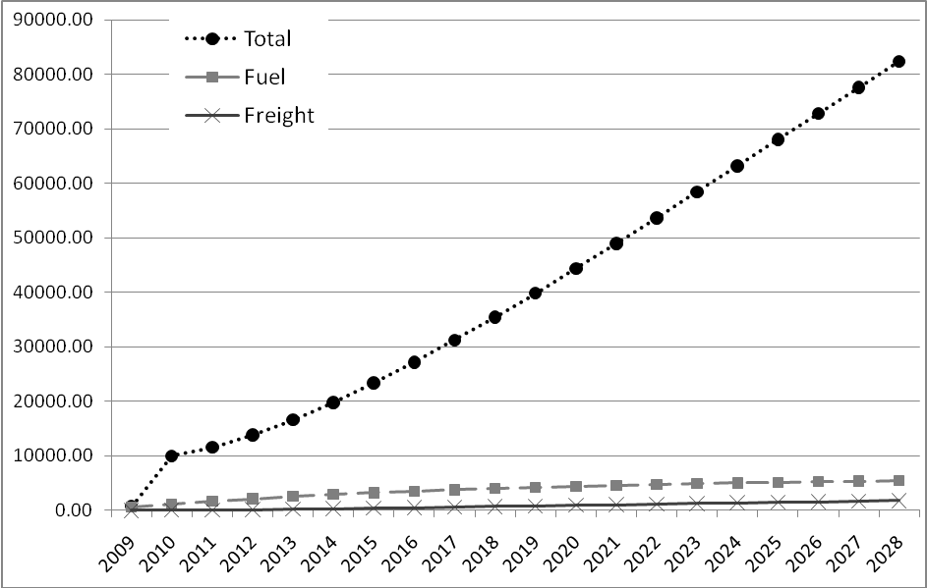
Figure 2 – Impacts of 10% Fuel Constraint for the BAU Scenario.

As displayed in Figure 2, the impacts of the 10% fuel constraint have a linear temporal evolution. The total impact on the economic output after 20 years is about NZD 82.4 billion and the reduction of output of the fuel sector compared to the initial year of analysis is NZD 5.4 billion.

Comparing the BAU to an unconstrained scenario in which the economy follows a growth pattern, the impacts could be enormous. The growth for the initial five years were forecasted by using the production-based GDP growth projected by Infometrics (Infometrics, 2009). The other ten years were estimated by using an average growth of 2.1%, which is the same average of the five years forecast. The difference between these two scenarios for the fuel sector is shown in Figure 3.

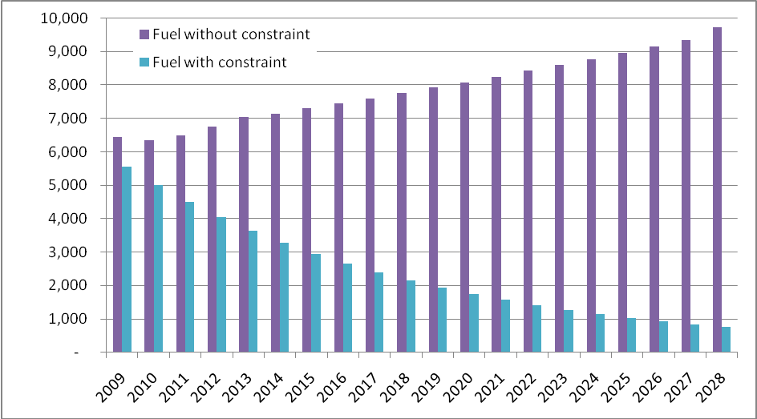
Figure 3 – Difference of Total Inputs between BAU with Fuel Constraint and without Fuel Constraints for the Fuel Sector (NZD million).

As displayed in Figure 3, if fuel constraints do not happen for the next 20 years, the fuel sector would have a constant growth and the total output would reach approximately NZD 9.7 billion at the end of 2028. However, if continuous fuel constraints were observed, the long term impacts would be exacerbated. For instance, the 2023 total input of the fuel sector with the 10% fuel constraint would be NZD 1.27 billion, compared to NZD 8.6 billion without constraints. From the year 2009 to 2010 there is a small reduction of the fuel sector output, for the scenario without constraints. This fall is due the forecast of economic contraction between the 2009 and 2010, which has been observed in real life. The same pattern can also be observed for the total New Zealand economy, as displayed in Figure 4.

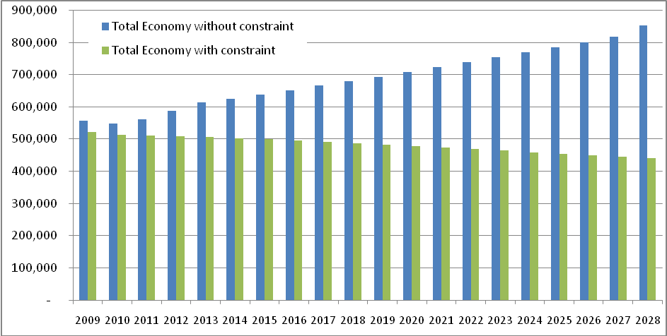
Figure 4 – Total Economic Output with and without Fuel Constraint (NZD million).
Figure 4 shows the difference between the constrained and non-constrained total economies of New Zealand. The total economy would be subject to a slight reduction over time when fuel constraints are imposed. However the longer term total impact of the fuel constraint scenario compared to the non-constrained scenario is significant. At the end of the analysis period, the total difference between these two scenarios would be NZD 412 billion, meaning that the economy could shrink for more than half of the size it could have if no constraints here imposed.

Mitigation Options
There are alternatives that could help to reduce the impacts of fuel constraints. Mitigation Options (MO) could be implemented at all economy levels to reduce fuel consumption. MOs to reduce fuel use of freight transport may include: reduction of vehicle speed, increasing loading rates and space utilisation, reducing empty-running, advancing vehicle routing, changing the delivery times, changing the supplier of the products to more locally produced, using alternative fuels, information technology, using more efficient vehicles (engine), enhancing vehicle technology (aerodynamics, tires, lubricants, etc), improving driver behaviour (through training and monitoring programs), using vehicles with greater capacity (less vans and small trucks), changing the land-use, adopting superior logistical trends (such as reverse logistics, rationalization of the supply chain, etc). Some of these MOs can reduce not only the fuel consumption of the freight transport but also help other sectors.

The mitigation options investigated in this study were mechanical and technological alternatives: biofuels (for ships, trucks and trains), regenerative brake (for trains and trucks), wheel motor technology (for trucks), electrification of the rail network, electric hybrid vehicles, fuel cells and hydrogen engines and skysail technology. The selection of the best alternatives should include an analysis of their energy savings as well as availability and cost. Thus, the data collected was vehicles energy consumption, price of energy, EROI (Energy Return On Investment), Mton-km carried per year and implementation costs of the mitigation options. The EROI is the ratio of the energy delivered by a process to the energy used directly and indirectly in that process. This case study also considers geographical and geopolitical characteristics of New Zealand.

Some of the proposed mitigation options would require significant infrastructure investments. However, the implementation costs were disregarded due to the lack of specific data.

Biofuels
Biofuels offer the possibility of producing energy without a net increase of carbon into the atmosphere. The biggest advantage of biofuels is that they can be used with all classic engines and many trucks manufacturers explore various fuel types, and pride theirselves for being able to produce trucks to run on biofuels such as biodiesel, biogas, a biodiesel/biogas combo, DME (dimethyl ether), hydrogen/biogas and methanol/ethanol. On the other hand, existing biofuels alternatives are controversial due to the use of food crops and soil resources to produce fuel.

The production of biofuels can be made by different ways, being the most common growing crops high in sugar and produce ethanol through fermentation, as it is observed in the USA with their corn ethanol and the sugar cane ethanol produced in Brazil. Another common method is to grow plants that contain high amounts of vegetable oil, after these oils are heated they can be burned directly in a diesel engine, or they can be chemically processed to produce fuels such as biodiesel.

The literature review studied showed that biodiesel is not an option for New Zealand, since it would require a great amount of effort to improve the efficiency of this fuel. For instance, it was found that the energy return in one MJ (Mega Joule) of biodiesel is 0.334, or when one MJ of biodiesel is used, three MJ of energy have been consumed through the process. Because of this 0.334 EROI, the price of one litre of biodiesel is about 1.76 times higher than the price of diesel, even though diesel has higher taxes. The average fuel efficiency of a biodiesel truck is similar with a diesel one. Therefore, biodiesel uses the same amount of energy than the normal diesel engine, but it costs about 45% more. Finally, even though New Zealand has a strong potential for biofuels, its current infrastructure to produce it is almost non-existent (Clark et al., 2001).

Electrification
The topography of New Zealand dictates that both rail and road networks features many sinuous and hilly sections. This characteristic suggests that electric rail systems would not be very efficient and quite slow. Additionally, it is important to consider the nature of the electricity production in New Zealand, mostly supplied by hydraulic dams (52.3%). The remaining electricity generation comes from gas (23.7%), coal (10.5%), geothermal (9.4%) and wind (2.5%), the residual includes wood, biogas, oil and waste heat (MED, 2009). New Zealand is nuclear free (it is prohibited to produce electricity from nuclear sources) leaving the country only with the current sources of energy. All the hydro generation is already currently exploited and the government does not intend to approve new dams to mass electricity production because of the environmental impacts they create. Thus, New Zealand would have to use other means in order to generate energy to electrify its rail network, which would probably have to include fossil fuels.

Another daunting point is the cost of the network electrification. For this calculation, the costs of a 50km electrification project of the Auckland rail network were extrapolated for the 3898 km of the New Zealand rail network. This analysis has shown that electrification would cost about NZD 10 billion/km. Thus, considering only the electrification costs, this alternative would take an absurd amount of time to pay off and would require a huge investment. For the financial reasons above added to the implementation costs of a new power plant not included here, electrification of New Zealand railway network was also found not to be a good option. However, this analysis has not taken into account the benefits of pollution and congestion reduction, which indicated that further analysis is required for a more accurate conclusion.

Regenerative breaks and In-Wheel motor technology
A regenerative brake is a mechanism that reduces vehicle speed by converting some of its kinetic energy into a storable form of energy instead of dissipating it as heat, as with a conventional brake. The captured energy is normally stored for future use in battery packs, but may also be stored by compressing air or by a rotating flywheel. Regenerative brakes have already been applied in cars and trucks and can also be used in trains.

Two types of regenerative brake are currently employed on vehicles; the KERS (Kinetic Energy Regenerative System) is a hydraulic system and the other is a electric system with storage of energy in a battery pack. Both systems are applied on few new trucks such as the Class8 Volvo truck and the USB Hybrid Truck, and also on hybrid trains. The KERS is an extremely efficient process, enabling over 70 percent of the energy normally wasted during braking to be used, minimising the load on the engine and reducing fuel consumption. Previous applications in rubbish collection trucks showed that the fuel reduction could be over 40 percent, plus lower brake wear. It is also possible to reduce the size of the vehicle engine as this can be sized for peak speeds, by up to 25 percent. For original equipment manufacturers, hydraulic hybrid systems can be incorporated into existing vehicles without major modifications, minimising the cost of new technology while adding value to the product. Similarly, for end users, the technology can deliver real savings in fuel consumption and brake use while reducing both emissions and noise pollution.

The other type of regenerative brake is the electric system. This system is currently used on electric vehicles such as the Toyota Hybrid and the Venturi fetish. The hybrid electric vehicles (HEVs) are vehicles that combine a conventional propulsion system with a Rechargeable Energy Storage System (RESS) to achieve better fuel economy than a conventional vehicle. Modern mass-produced HEVs prolong the energy stored in their batteries by capturing kinetic energy by means of regenerative braking.

The electric regenerative brakes could easily be coupled with another technology, the wheel motor. The wheel motor is an electric motor that is incorporated into the hub of a wheel, eliminating the need for the normal internal combustion engine. These wheels, with motors, contain not only the braking components, but also all of the functionality that was formerly performed by the engine, transmission, clutch, suspension and other related parts. With In-wheel technology, more batteries can be installed in the space, which would otherwise be occupied by the transmission and differential gear. It provides a significant weight and manufacturing cost economy by eliminating mechanical transmission, gearboxes, differentials, drive shafts and axles. The in-wheel motor technology is only effective for electric vehicle or hybrid vehicle. However, there are no hybrid trucks on the current freight transport fleet. Thus, the analysis is based comparing the efficiency of the wheel motor system with the conventional truck engine. The conventional truck has an efficiency of 33% and the in-wheel motor engine has efficiency between 85% to 92%.

The regenerative breaking which can be associated with the wheel motor technology can also save in average 25% of energy. The price of applying this system on a vehicle has not been set precisely by the supplier, but some publications suggest that it would cost about NZD 75 thousand to implement the KERS system on a truck. Implementation costs of the in wheel motor could not be calculated as the technology is not yet available in the market.

Hydrogen and fuel cells
Hydrogen systems are considered by many an important energy solution (Veziroglu and Barbir, 1999). Hydrogen is the most abundant chemical element of the universe and produces energy when combined with oxygen. The energy stored in the hydrogen can be harnessed with the help of technologies such as fuel cells. A fuel cell is an electrochemical conversion device which converts the chemical energy of fuel to electricity. However, hydrogen is not an energy resource, except if nuclear fusion could be commercially deployed. To use hydrogen as a fuel, it first has to be generated, normally by electrolysis of water or obtained from fossil fuel. The process of producing hydrogen normally consumes more energy than the energy released when it is used as a fuel. Some key factors prohibit the hydrogen engines from being available, such as the costs of producing the vehicles, developing the product that meets customer’s demands for power and fuel savings, finding ways to directly converse the chemical energy in the form of hydrogen into mechanical energy and integrating the technology into vehicle mass production. In addition it would be necessary to adapt the fuel stations to hydrogen and produce hydrogen in large scale.

The Hytruck is a hydrogen-powered prototype truck, based on a Mitsubishi Canter 7.5-tonner, but its manufacturer says its technology can be mated to other makes and models. To create the vehicle, the company replaced the existing diesel motor, gearbox, differential and fuel tanks with a completely new-concept driveline, called the Hytruck H2E (Hytruck, 2009). It has fuel cells mounted under the cab producing 16kW that draw hydrogen from the 227-litre fuel tank containing 5.8kg of hydrogen at a pressure of 350bar. The energy from the fuel cells is transferred to the batteries, which are mounted where the diesel fuel tanks used to be. The fuel cells provide continuous charge to the batteries. Yet, the Hytruck is just a prototype and it is very expensive (around NZD 4million). Finally, the EROI of the Hytruck was estimated as 0.25, meaning that 4 MJ of energy are required for each MJ of energy used in the Hytruck, making this only technological dream at the moment.

Wind for ships
Ships are the most common transport mode used to move goods between the countries. Nevertheless, it has so far been exempt from emissions restrictions. Cargo ships emit about 2.7% of the global total of greenhouse gases. This equates to 800 million tones of emissions per year, which could double by 2030 as global trade increases. Yet, there are ways to make shipping more efficient. One of the easiest ways would be to slow down the ships. Fuel consumption increases rapidly with speed: doubling a ship's speed means using eight times as much fuel. But, with the amount of freight to be shipped on the rise, and shippers demanding quick transit times, ship owners are under pressure to accelerate their vessels (Corbett and Koehler, 2003).

Another option to increase shipping efficiency would be to use the wind as a source of energy. Wind is a free energy source and is the most economic and environmentally sound source of energy on the high seas. Yet, shipping companies are not taking advantage of this attractive savings potential at present. The reason for this is that, so far, no sail system has been able to meet the requirements of today’s maritime shipping industry.

Skysail is a product developed by a German company that consists of a large kite that is affixed to large ships. It is based in the same system developed to kite surfing and other kite sports. The SkySails propulsion system consists of a large foil kite, an electronic control system for the kite and an automatic system to retract the kite. The control system is on the tower of the boat (super structure) and the towing rope is connected close to the bow, the system is designed in such a way that optimal aero-dynamic efficiency can be achieved. A multi-level security system and redundant components guarantee the highest possible safety during operation of the SkySails propulsion. The optional weather routing system provides shipping companies with a means to guide their ships to their destinations on the most cost-effective routes and according to schedule.

The profile of the towing kite is designed in such a way that optimal aero-dynamic efficiency can be achieved. Their double-wall profile gives the SkySails towing kites aerodynamic similar to the wing of an aircraft. Thus, the SkySails-System can operate not just downwind, but at courses of up to 50° to the wind as well. In case of very strong winds, the power of the towing kite is reduced by changing its position in the wind window (relative to the horizon), without having to minimize the towing kite area. Presently, SkySails is offering towing kites for cargo ships with kite areas of approx. 150 to 600m². An experience with a container cargo ship (MS Beluga Skysails) from Germany to Venezuela, then to the United States, and ultimately arriving in Norway have show that high propulsion power can be achieved on half-wind, reaching and downwind courses from 90° to 270°. While the kite was in use, the ship saved an estimated 10-15% fuel. Depending on the prevailing wind conditions, a ship’s average annual fuel costs can be reduced by 10 to 35% by using the SkySails-System and under optimal wind conditions fuel consumption can be cut by up to 50%.

Even though the idea of having a huge kite attached to a ship seams odd at first sight, this options has showed to be very efficient. The technology was studied for the New Zealand coastal shipping network, using the average speed and energy consumption of ships in the coastal waters. The analyses showed that the costs of implementing a Skysail to a ship were almost paid off in the first year of use of the system, only through the energy saved.

Final remarks for Mitigation Options
We have observed that is very difficult to collect data for the mitigation options, even general values, especially in terms of costs of the technologies and implementation costs. Also, mitigation options have to take in account the country’s geographical, political and economical situation. Therefore, some alternatives that had poor results in this study might have better performance if applied in other countries.

After studying the mechanical and technological mitigation options, it has been observed that the available expertise of the alternatives is probably not enough to reduce fuel constraint impacts in a timely manner, so it is also important to study other types of mitigation options that could probably be put in practice in a shorter time frame and with reduced investments.

Finally, after studying several mitigation options it would be necessary to include them into the IO analysis framework. Each MO could be explored in several fashions. For example, a MO that focuses on the use of an alternative fuel could take scenarios of high, moderate or no improvements. To analyse MOs it would be necessary to use either a dynamic model or integrated IO and econometric models. When dealing with future years where mitigation options and policies are implemented, probably major changes on the structure of the economic system would occur. These changes would have to be modelled on a case by case basis. Hence, the characteristics of the mitigation options should be previously defined.

In this study the mitigation options were not studied in a more detailed manner due to the lack of specific data. It is important to emphasize that structural changes and calculation of future impacts are particularly important for the analysis of mitigation options. These MOs will change the economic systems by means of application of new technologies, behavioural changes, production patterns and changes on the international trade market.

CONCLUSIONS
A supply constrained Input-Output analysis is used to model the relationship between scenarios of fuel constraint and economic impacts. The New Zealand economy is studied and more specifically the freight transport sector is investigated. Scenarios of 5% and 10% of fuel availability reduction were analysed. Also, traditional IO models, supply constrained IO and supply driven IO models are compared. According to IO models, one of the most affected sector in relative terms is the freight transport sector due to its high dependence on fossil fuels. Two main findings can be drawn from a comparative analysis against a business as usual (BAU) scenario using the supply constrained input-output, the standard input-output and the so called supply driven input-output. Firstly, the state of the art of modelling techniques is likely to underestimate total impacts of fuel constraints. This is particularly concerning, giving the long term implications of transport policies. Secondly, it was observed that if no actions were taken to mitigate impacts of fuel constraints, the total impacts on the national economy on medium to long term tend to be significant.
Mitigation options to reduce the impacts of fuel constraints could be put in place. The most commonly argued alternatives are the enhancement of the use of alternative and clean energies and reduction of fossil fuel exploitation. Considering the transportation sector in New Zealand, passenger transport is well positioned, as walking and cycling are promoted and encouraged. Yet, when it comes to freight transport, the nation has still a long journey to achieve sustainability. Thus, technological and mechanical mitigation options that could help to reduce the energy consumption of New Zealand’s freight activities were investigated. The results indicated that improvements of the existing technologies are necessary to provide a positive balance of energy saved. The analysis also revealed the complexity of implementation of alternatives, in view of the economic and geographic contexts. Among the studied alternatives, the best were regenerative brake systems for trucks and trains, wheel motor technology for trucks and the skysail for ships. Biodiesel and electrification emerged as weak alternatives, due to their high production costs.

Bibliography

