An Input-Output Framework for Assessing Hurricane Impact on Regional Workforce Productivity
Joost Santos, Assistant Professor
The George Washington University
Washington, DC, USA

Abstract

Natural disasters, like hurricanes, bring damage to properties and critical infrastructure systems, disrupt economic productivity, and cause mortalities in extreme situations. Workforce disruptions in the aftermath of a hurricane can significantly degrade regional productivity because the majority of business operations are labor-dependent. This paper develops a workforce recovery model based on input-output analysis to estimate sector inoperability and economic losses. A decision analysis tool is developed to study the interdependent effects of various hurricane intensities on Virginia’s workforce productivity. Results of the study will help identify the critical workforce sectors and can ultimately provide insights to formulating preparedness decisions to expedite disaster recovery.

1. Introduction

The immense physical, economic, and social consequences caused by recent disasters have prompted federal, state, and local agencies to develop policies for preparedness and recovery. The extensive focus of the United States on protecting critical infrastructure has grown since the establishment of the President’s Commission on Critical Infrastructure Protection (PCCIP) as stipulated in Executive Order 13010 [The White House 1996]. Several federal directives have been issued to underscore the need for disaster planning and management. Such directives [see, for examples, Department of Homeland Security (DHS) 2003a, 2003b] call for the development of risk analysis tools to prepare the nation against disruptive events, prevent the occurrence of dire consequences, and ensure efficient response and recovery in the aftermath of such events. The National Response Framework [DHS 2008] and National Infrastructure Protection Plan [DHS 2009], among others have been formulated to support the realization of such goals. In particular, hurricane events have been explicitly identified within the fifteen planning scenarios developed in conjunction with the DHS [see Howe, 2005].

Hurricanes can damage physical infrastructure systems, disrupt the flow of traffic, and can cause substantial economic losses. In addition to the disruptions to infrastructure systems, hurricanes can trigger a variety of economic effects including the inability of many workforce sectors to commute to work as well as the disruptions to shipments of commodities. Workforce absence translates to productivity losses. Delayed commodity shipments also adversely impact productivity because local businesses are unable to operate at full capacity without the necessary resources. A case in point, Hurricane Katrina’s landfall on August 29, 2005 unleashed devastating damage to the Gulf Coast region. It affected 138 counties and resulted in an estimated damage of $96 billion—making it the most destructive hurricane on record in terms of economic losses [Garber et al. 2006]. Crowther et al. [2007] studied the interdependent effects of several sector disruptions following from Hurricane Katrina. Han et al. [2009] employed a statistical estimation method to predict spatial distribution of post-hurricane outages in the Gulf Coast region. Legg et al. [2010] developed a mixed-integer formulation to assess long-term economic losses from hurricanes.

Since the models, data, and case studies in this paper are demonstrated for the state of Virginia, the following narratives pertain to some of the adverse effects of a hurricane scenario in the region. On September 19, 2003, Hurricane Isabel brought massive flooding and destruction to the Hampton Roads region of Virginia. Although it had weakened to a category one hurricane, the Commonwealth still sustained $625 million of damage and a death toll of 36 people [Smith and Graffeo 2005, Virginia Department of Emergency Management 2007]. Furthermore, 90% of households and businesses lost electricity [Dominion Virginia Power 2003]. These power outages prevent traffic lights, interstate cameras, and variable messaging signs from functioning properly, making it difficult for the Virginia Department of Transportation (VDOT) to perform its essential functions. In addition, VDOT closed the Midtown Tunnel for 28 days due to flooding [VDOT 2003]. Road debris, traffic light outages, and detours around the tunnel caused congestion throughout the Hampton Roads region. These factors not only affected the ability of the workforce to commute, but also made it difficult for businesses to ship and receive supplies. This example shows that in addition to physical damage, economic losses intensify the initial impact of a hurricane. Since Virginia is one of the top 10 states with highest number of hurricane landfalls [Blake et al. 2005], this study will generate significant insights on preparedness and recovery.

In light of the above motivations, this paper seeks to develop an input-output model extension to explicitly identify workforce perturbations pursuant to hurricane scenarios. Historical data pertaining to the impacts of hurricane on different workforce sectors are utilized as input scenarios to a dynamic input-output model. The model is capable of estimating the distribution of losses across regional sectors in Virginia and provides a visualization capability to identify the critical sectors.

2. Review of Supporting Methods

This section provides an overview of underlying input-output models, which serve as the foundation to the workforce impact analysis developed in this paper. Section 2.1 describes the original input-output model and its applications. Section 2.2 discusses the inoperability input-output model (IIM), which is used to assess the productivity disruptions of interdependent systems due to disasters. Section 1.3 provides a discussion of the dynamic IIM extension and how they will be applied to hurricane scenarios.

Input-Output Modeling

Input-output (I-O) modeling views the economy as a set of interconnected sectors, which both produce goods as well as consume goods in the process of production. When the intermediate consumption is combined with the final consumer demand for products, the result is a model, which is useful for understanding the interdependent nature of an economy [Leontief 1936]. The Leontief model is a system of equations that describe the output of each sector as a combination of intermediate consumption and final demands. Leontief’s model has been extended and applied to myriad problems, including the effect of new technologies or taxes on the energy industry, and pollution creation and elimination [Miller and Blair 1985]. Understanding the interdependencies and resulting cascading impacts from an emergency event is essential in developing an effective security plan [TISP 2006]. The I-O model is a method for modeling interdependencies across multiple sectors of a given regional economy [Leontief 1951a and 1951b, Miller and Blair 1985, Isard 1960]. The National Cooperative Highway Research Program [NCHRP 2001] recognizes the I-O method in its guidebook for assessing the social and economic factors in infrastructure management domain. Extensions and current frontiers on I-O analysis can be found in Dietzenbacher and Lahr [2004]. The original input-output model has also been extended to incorporate spatial explicitness, which is increasingly becoming prevalent in land-use and transportation planning applications. The seminal work by Lowry [1964] paved way for the integration of random utility and location preference models to the I-O framework (e.g., MEPLAN [Echenique 1985; Hunt and Simmonds, 1993; Abraham and Hunt, 1999] and TRANUS [de la Barra, 1995]. The availability of high-resolution economic data and social accounting matrices enables the application of I-O model and its hybrids for analysis of relatively small regions (e.g., analysis of infrastructure disruptions in Portland [Rose and Liao 2005]). Other I-O based models can be found in USDOT [2009] and Zhao and Kockelman [2004].

2.2 Inoperability Input-Output Model

One of the strengths of the Leontief model is that it can utilize data collected by major statistical agencies. In the United States, for example, extensive I-O data are published by the Bureau of Economic Analysis (BEA) to generate the technical coefficient matrix A [Santos and Haimes 2004a]. This methodology is coupled with the BEA’s Regional Input-Output Multiplier System (RIMS II) to provide a useful framework for evaluating economic interdependencies [U.S. Department of Commerce 1997]. Haimes and Jiang [2001] revisited the Leontief model and expanded it to account for inoperability, or the inability for sectors to meet demand for their output. This model, the Inoperability Input-Output Model (IIM) has been featured in several applications. Examples include modeling of infrastructure interdependencies and risks of terrorism [Santos 2006, 2008], regional electric power blackouts [Anderson et al. 2007], and inventory management [Barker and Santos 2010]. The IIM was also applied to problems with sequential decisions and multiple objectives, such as the biofuel subsidy analysis explored by Santos et al. [2008]. Santos et al. [2007] have also formulated a conceptual framework for bridging I-O analysis with agent-based simulation for interdependent infrastructure systems. The IIM, which looks structurally similar to Leontief’s model in Eq. (1), is formulated as follows.

(Eq. 1)

Details of model derivation and an extensive discussion of model components are found in Santos and Haimes [2004a] and also in Santos et al. [2008]. In summary, the terms in the IIM formulation in Eq. (1) are defined as follows:
- q is the inoperability vector expressed in terms of normalized economic loss. The elements of q represent the ratio of unrealized production (i.e., ideal production minus degraded production) to the ideal production level of the industry sectors.
- c* is a perturbation vector expressed in terms of normalized degraded final demand (i.e., ideal final demand minus degraded final demand, divided by the ideal final demand level).
- A* is the interdependency matrix which indicates the degree of coupling of the industry sectors and can be constructed from I-O tables. The elements in a particular row of this matrix can tell how much additional inoperability is contributed by a column industry to the row industry. When combined with regional multipliers, BEA’s detailed input-output matrices can be customized for desired geographic resolutions.

2.3 Dynamic Extension to the IIM

This research extends the IIM. In particular, the theoretical formulation to accommodate the analysis of interdependent effects of a hurricane on infrastructure inoperability and the ripple effects to a regional economy. The formulation takes into account the resilience of sectors to model their recovery over time Lian and Haimes [2006]:

(Eq. 2)

The term K is a sector resilience coefficient matrix that represents the rates with which sectors recover to their nominal levels of production following a disruption. The model suggests that the inoperability level at the following time step, q(t+1), is equal to the inoperability at the previous stage, q(t), plus the effects of the resilience of the sector. The values of K tend to be negative or zero, thereby detracting from the overall level of inoperability. As seen in Eq. (2), K is multiplied with the indirect inoperability resulting from other sectors, A*q(t), plus the degraded final demand, c*(t), minus the current level of inoperability, q(t). Although the resilience coefficient, K, is assumed to be an inherent characteristic of a particular sector, multiplying it with the inoperability product term, A*q(t), will result in coupled resilience across directly related sectors. This is particularly relevant when analyzing a sector that heavily depends on another sector for achieving its as-planned productivity levels. Regardless of how inherently resilient a sector is, its productivity will be significantly compromised when another sector it heavily depends on becomes largely inoperable in the aftermath of a disaster, such as a hurricane.

Each element of K is denoted by k_{i}, which represents the sector-specific resilience coefficient for sector i. In Eq. (3), the value of k_{i} is determined from the initial inoperability levels of each sector and the time it takes, (T_{i}), the sector to return to a predefined level of inoperability q_{i} (T_{i}) from an initial level of inoperability, q_{i} (0).

(Eq. 3)

Where determines the recovery rate and the term indicates the reliance of the sector on itself. A higher value of the resilience metric for a particular sector corresponds to a faster pace of recovery from a disaster. Hence the resilience metric relates to the current state of the system within the recovery process. The formulations in Eqs. (2) and (3) have been demonstrated by Lian et al. [2007], Santos [2006], Lian and Haimes [2006], and Haimes et al. [2005].

In this paper, sector resilience is modeled as a time varying function instead of a static, predetermined value as formulated previously. What is not addressed in any of the previous formulations is an extension to capture time varying resilience that adapts to some a priori and current levels of inoperability within the perturbation and recovery period. The matrix K represents the ability of a sector to recover from some level of inoperability to a final level of inoperability in a given period of time. As a regional economy and its associated sectors recover from a large-scale disruption, the nominal resilience coefficients are expected to fluctuate. The reasoning behind this is that as sectors utilize their capital and other resources to recover and mitigate the impacts of a disaster, they consume these resources and thus are less able to recover. The pace of recovery is further compounded by sector interdependencies—creating indirect effects that continue to disrupt regional productivity. The new formulation of the values of K includes a variety of factors, including the current inoperability value, previous inoperability values (giving measures of trends and duration) and nominal sector recovery rates to determine a baseline scenario. This formulation would create a time dependent value, K(t), to better account for the impact of different intensities and durations of a hurricane, as longer ones would tend to further stress the sectors impacting their ability to recover. Historical hurricane recovery functions such as the full-time daily equivalents lost (FDEL) data from by Burrus et al. [2002] can be used to formulate the time-varying resilience function.

To incorporate the time varying inoperability inputs, the model must be reformulated to allow the initial inoperability vector q(0) to be time-dependent, reflecting the changing inoperability levels as the hurricane progresses. To accomplish this, q_{h}(t) is introduced which replaces the initial inoperability vector, q(0) in the previous formulation in Eq. (3), and represents the direct inoperability resulting from the hurricane. The subscript “h” simply denotes that this inoperability vector refers to a hurricane scenario. This transition is represented in Figure 1. The term q_{h}(t) is a vector within the NT matrix (where N is the number of sectors and T is the recovery duration from the hurricane), associated with time t.

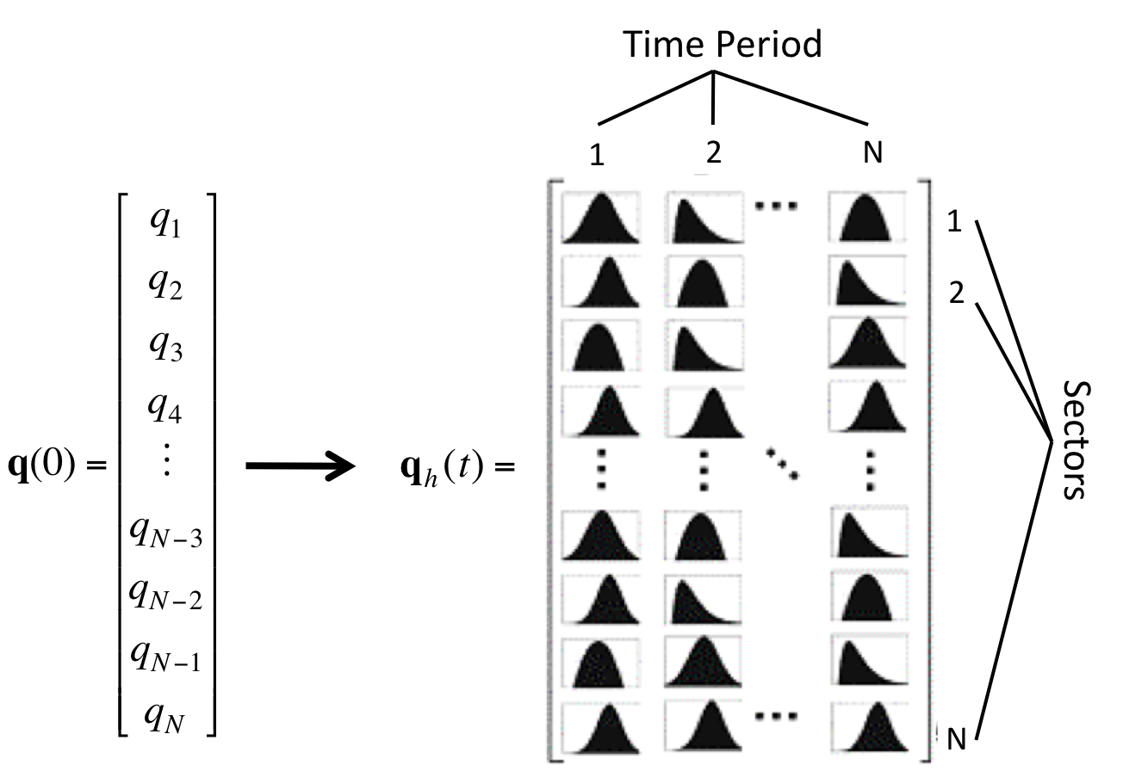 | 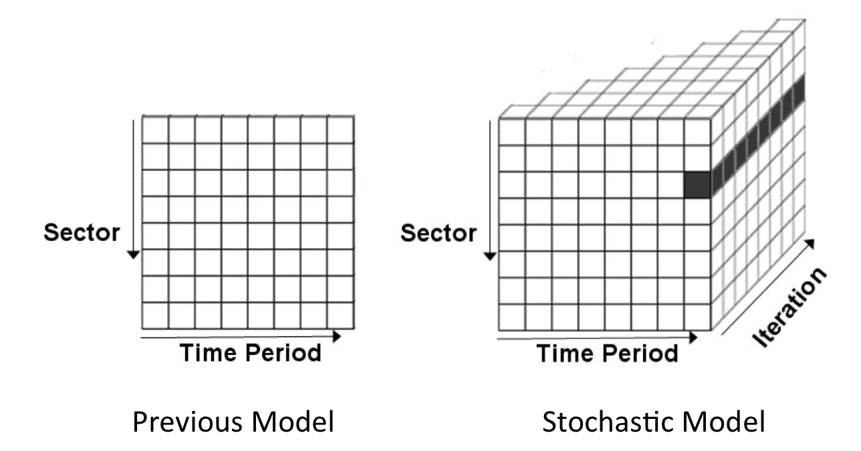
Fig. 1: Transition from scalar inoperability vector to a probabilistic time-varying inoperability matrix | Fig. 2: Comparison of data structures generated by previous model and proposed stochastic formulation

In the previous formulation, all values of inoperability were calculated from the initial inoperability vector q(0). Given this one input, inoperability values were calculated for all sectors for each time period. With the new formulation, the input is now a matrix, with stochastic values of inoperability being calculated for each time period. The new formulation is solved in multiple iterations, one iteration for each time period of the hurricane, corresponding to each column of q_{h}(t). By having multiple iterations, a three-dimensional data set is created, as depicted in Figure 2. Reconciling this data into a usable output will be explained by stepping through the first few iterations of the process.

At time t = 1, an inoperability vector is generated from the hurricane scenario, q_{h}(1), which then serves as input to the stochastic IIM. With this first inoperability vector, the first iteration of model is run to generate inoperability values for all sectors for as long as it takes for the sectors to recover (represented by the exponentially decaying dashed curves in Figure 3). For the second iteration, the calculations start at t = 2. The direct inoperability resulting from the hurricane, q_{h}(2), is compared with the residual inoperability calculated from the first iteration.

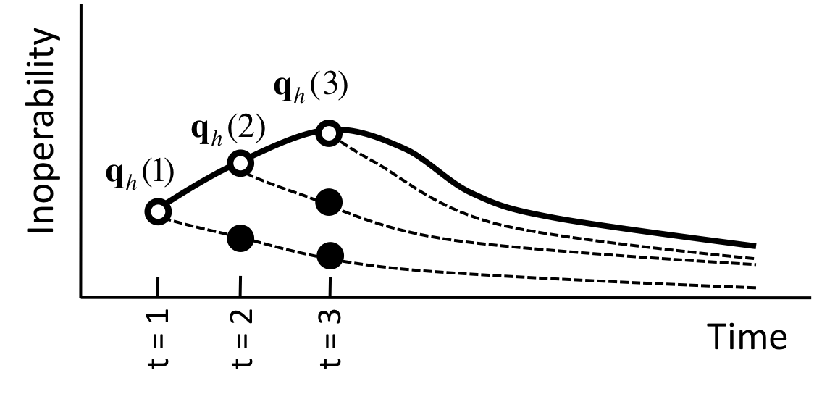
Fig. 3: Graphical depiction of a hurricane inoperability function and sample trajectories of recovery

At t = 2, we need to consider the residual inoperability from t = 1, which is represented in Figure 3 as the bold dot underneath q_{h}(2). The same logic is applied at t = 3 where we enumerate the direct inoperability for that period, q_{h}(3), and the residual inoperabilities (bold dots) from previous periods. Combinatorial functions are developed to relate direct inoperability with residual inoperability values.

3. Data Sources

A region expects substantial disruptions to workforce availability and mobility in the aftermath of a hurricane, which in turn can trigger sector productivity degradations. In order to quantify the impact of reduced workforce levels on the economy of Virginia, employment statistics for each sector of the region are collected. This research configures the data collection methodology using the North American Industry Classification System (NAICS). This is done by performing an accounting of the total number of workers in the region and determining the workforce distribution according to the various sectors (e.g., see Fig. 5). RIMS II adopts an aggregated version of the detailed sector classification—comprising of 65 sectors (see Table 1). Workforce accounting is performed to quantify the contribution of the workforce factor to the production requirements of each sector.

Table 1: Sector Classification

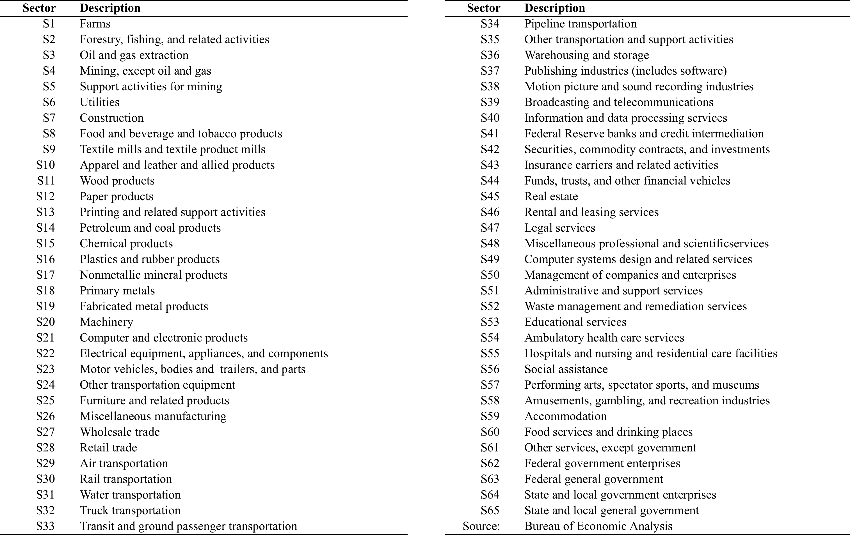
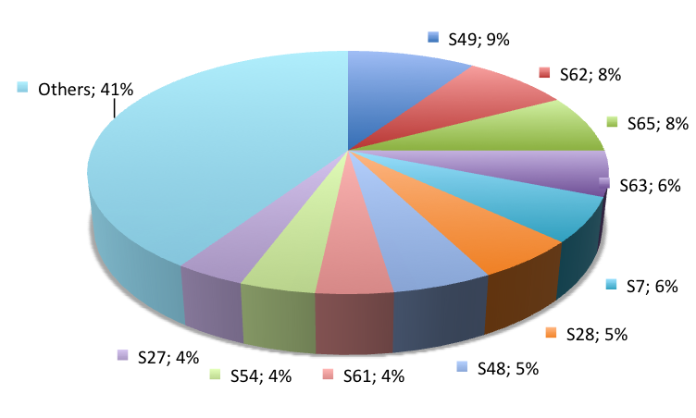
Fig. 5: Workforce Distribution by Sector in VA

To convert the output of hurricane impact into a measure of workforce sector inoperability, there needs to be a way to translate a percentage decrease in workforce availability into a measure of sector inoperability. Arnold et al. [2006] accomplished this through estimates of worker productivity. However, the data used in their calculations are only available for a much smaller set of sectors relative to the RIMS II sector classification system. To generate worker impact for the RIMS II sectors, the ratio of Local Area Personal Income (LAPI) to industry output is computed [BEA 2008]. LAPI provides the value of workforce to the industry (the market value of the laborers' work) and dividing this by the industry output, x_{i}, gives the proportion of output that is dependent on the workforce. This calculation of inoperability for a sector, i, is shown in Eq. (4).

(Eq. 4)

The impact on workers is then multiplied with the number of workers in that sector that are unavailable divided by the number of workers in that sector (giving percentage of workers missing) to determine overall sector inoperability. Burrus et al. [2002] developed a comprehensive survey describing the impact of various hurricane intensities on workforce availability. The sectors included in their survey are similar to the RIMS II classification employed in the study. In addition to the published workforce survey results, this paper utilizes the complete survey data set requested directly from one of the co-authors.

Table 2 shows a portion of the impact of various hurricane intensities on workforce sectors. Workforce impact is measured using full-time daily equivalents lost (FDEL) metric. FDEL provides an estimate of the number of days a worker in each sector missed in the aftermath of various hurricane categories. Data comprising of low, medium, high, and average FDEL estimates are used in populating the parameters of the dynamic IIM.

Table 2: Portion of FDEL Data³
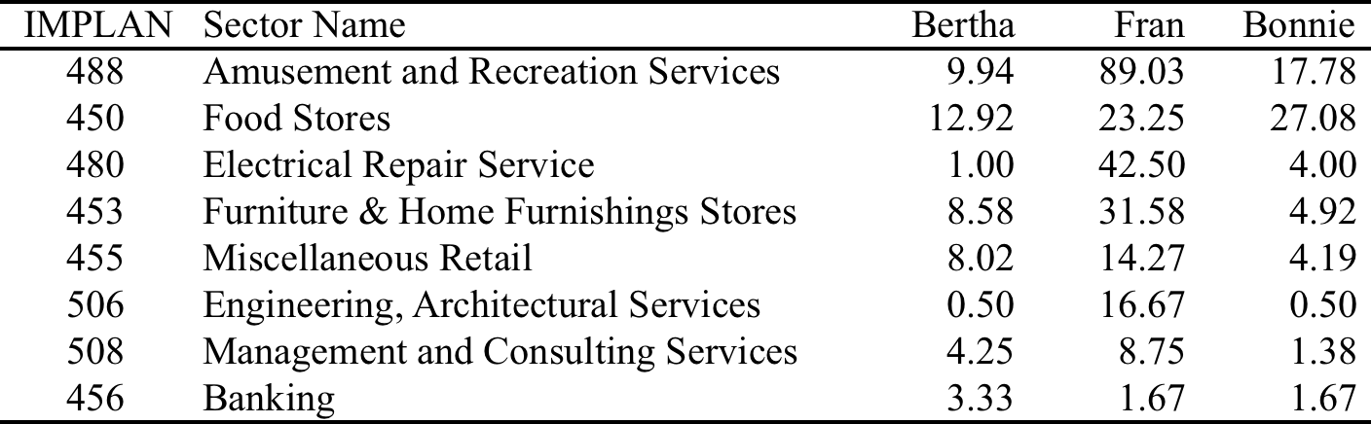

Hurricanes can cause severe damage to existing infrastructure—consequently affecting economic productivity. Closure of roads due to flooding, repair of damaged infrastructure systems, and debris cleanup (among others) can drastically affect workforce and commodity flows for prolonged periods of time. The flooding of a bridge-tunnel in Virginia, which lasted for nearly a month, is one of the many examples of how an infrastructure failure can impair regional mobility [Haggerty et al. 2008]. Reduction in worker flow decreases productivity, reduction in commodity flow results in cascading demand and supply impacts, and social flows will impact business accessibility. Using detailed journey to work data, commodity flow surveys, and social accounting matrices will permit modeling of disruptions to regional productivity. Modeling efforts include the potential for cascading failure, accounting for spatial dependencies and various economic and social travel patterns.

Geographic modeling and decomposition enable a more focused and hence a more accurate analysis of regional characteristics as well as the associated regional interactions. Interdependencies across regions are becoming more and more prevalent due to the increasing trend in interregional transportation and trading activities. Significant segments of the working population commute across regions, as evidenced from the Journey to Work and Place of Work data [US Census Bureau 2007]. The increasing number of commodity shipments across regions bolsters the activities of the freight and trade sectors based on the Commodity Flow Survey [Bureau of Transportation Statistics 2008a]. Several Lowry/Echenique input-output model derivatives are available for analysis of disruptions and their impacts on workforce and supply chain disequilibrium [e.g., Ruiz-Juri and Kockelman 2006]. The benefits of input-output-based models are many, especially with respect to modeling the effect of disruptive events on interdependent regional sectors. There exists a wealth of data that describe the relationships among the many different sectors of the economy, namely provided by the Bureau of Economic Analysis (BEA) and the US Census. Furthermore, input-output data are essential components within the larger social accounting matrices used in computable general equilibrium modeling [see, for example, Minnesota IMPLAN Group, 2008].

Large-scale databases and literature sources exist to guide in estimating the impacts of hurricane scenarios on workforce and commodity flow. The social composition of the regional highway network can be estimated using actual household data using US census samples data [US Census Bureau 2008]. Traffic flows can be estimated by generating trips between each origin (residence) and destination (e.g., places of work, school locations, social activity points). Workforce flows between home and destination, including specific routing, have been estimated by a simple shortest path algorithm [Dijkstra 1959]) in conjunction with the USDOT’s tract-to-tract flow worker flows [USDOT 2008]. The Urban Mobility Study [Schrank and Lomax 2009] measures the current effect of congestion and its impact on the society using a wide range of available data to estimate travel delays. Large scale effects can be accounted for by integrating worker and commodity disruptions (e.g., spatial interaction models [Fotheringham et al. 2001, Fox and Porca 2001, Baradaran and Ramjerdi 2001, Vachal et al. 2004]) to account for regional losses resulting from economic cascades of lost transaction opportunities. Since actual workforce and commodity flows are known, these data can be used to guide the verification of research results.

4. Hurricane Case Study

Hurricane consequences encompass reductions in workforce productivity, loss of lives, and social disequilibrium. Workforce productivity losses can significantly decrease a sector’s output regardless of the efficiency of other production factors. Regional economies, like Virginia, have limited resources to manage hurricane consequences. The objective of the case studies is to manage impacts of various hurricane scenarios in Virginia using available economic and survey data.

This section demonstrates the use of the dynamic inoperability input-output model to assess the impacts of hurricane scenarios on the workforce sectors in Virginia. Data sets assembled from various economic and census agencies include input-output matrices, gross domestic product data, and local area personal income data, among others. By utilizing the detailed workforce survey by Burrus et al. [2002], two scenarios are performed in this paper to contrast the effect of low- and high-intensity hurricane scenarios.

4.1 Low-Intensity Hurricane Scenario

In this paper, a low-intensity hurricane scenario is described as follows:

- Higher probability of occurrence, but with relatively lower consequences
- Includes Categories 1-2 on Saffir-Simpson scale (wind speeds of 74-110 mph)
- Shorter recovery (inoperability), and relatively smaller economic losses

Workforce parameter inputs for the low-intensity hurricane scenario are entered to the dynamic inoperability input-output model and generated the recovery charts in Figures 6 and 7. The top 10 sectors with highest economic loss (Figure 6) are: Miscellaneous professional, scientific, and technical services (S49), Federal general government (S62), State and local government enterprises (S65), Construction (S7), Administrative and support services (S51), Federal government enterprises (S63), Computer systems design and related services (S48), Federal Reserve banks, credit intermediation, and related activities (S41), Retail trade (S28), and Real estate (S45). These sectors are labor-intensive. The total economic loss for the simulated low-intensity hurricane is $410 million. The top-10 sectors account for 52% of this total economic loss. From Figure 6, it can be seen that the recovery plots flatten within 5 days.

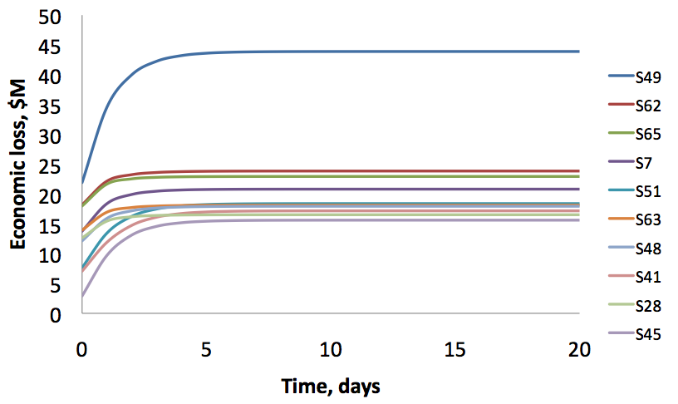
Fig. 6: Top-10 sectors with highest economic losses
(low-intensity case)

For the same low-intensity hurricane scenario, the top 10 sectors with highest inoperability values (Figure 7) are: Social assistance (S56), Hospitals and nursing and residential care facilities (S55), Educational services (S53), Federal government enterprises (S63), Federal general government (S62), Ambulatory health care services (S54), State and local general government (S64), State and local government enterprises (S65), Other services, except government (S61), and Computer and electronic products (S13). The rankings for inoperability are not the same as the rankings for economic loss.

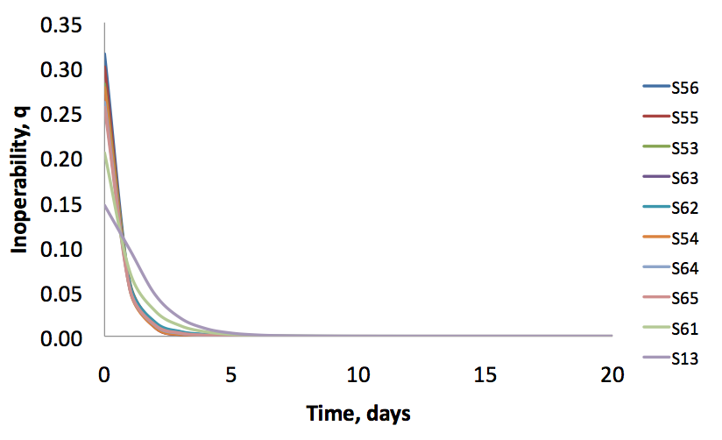
Fig. 7: Top-10 sectors with highest inoperability
(high-intensity case)

4.2 High-Intensity Hurricane Scenario

In this paper, a high-intensity hurricane scenario is described as follows:

- Lower probability of occurrence, but with relatively higher consequences
- Includes Categories 3-5 on Saffir-Simpson scale (wind speeds of 111-155+ mph)
- Longer recovery (inoperability), and relatively larger economic losses

Workforce parameter inputs for the high-intensity hurricane scenario are entered to the dynamic inoperability input-output model and generated the recovery charts in Figures 8 and 9. It can be seen that both low-intensity and high-intensity hurricane scenarios produced the same top-10 sectors (see Figures 6 and 8). Similarly, the rankings generated by the inoperability objective are also the same for the low-intensity and high-intensity hurricane scenarios (see Figures 7 and 9). These results are not surprising since the scenarios are applied to the same region and the same set of sectors. Hence, input-output transactions as well as labor usage in the sectors remain the same. The major difference is with the recovery pace of these sectors. For the low-intensity case, recovery is achieved within approximately 5 days. On the other hand, recovery for the high-intensity case is achieved well-beyond 20 days. Note that the charts are kept to 20 days for easy comparisons between low and high intensity scenarios. It is also evident from the charts that the initial inoperability values for the high intensity case (Figure 9) are higher than those of the low intensity case (see Figure 7). The total economic loss for the high-intensity case is $6.7 billion, which is about 16 times more than the low intensity case.

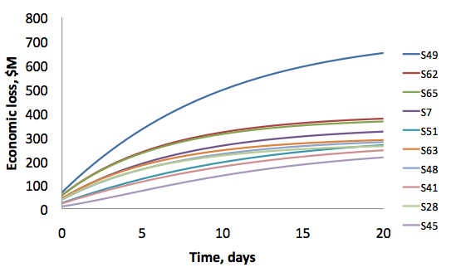
Fig. 8: Top-10 sectors with highest economic losses
(high-intensity case)

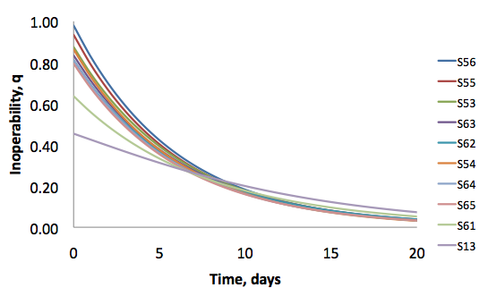
Fig. 9: Top-10 sectors with highest inoperability
(high-intensity case)

5. Summary and Conclusions

Workforce productivity disruptions in the aftermath of hurricanes can cascade across interdependent economic sectors, further delaying recovery. This research develops a workforce recovery model to estimate sector inoperability and economic losses for low and high intensity hurricane scenarios. Sensitivity analysis of inoperability and loss reduction objectives can provide insights on identification and prioritization of critical sectors. Based on the completed case studies, labor-intensive sectors suffer the largest workforce productivity impact. Income losses due to workforce disruptions account for approximately 50% of the total economic losses. Although applied specifically to the state of Virginia, the same methodology can be implemented to other regions. The methodology and decision analysis tool developed in this research can be integrated with other critical infrastructure models.

References

Abraham, J.E. and J.D. Hunt, 1999. Policy analysis using the Sacramento MEPLAN land use-transportation interaction model, Transportation Research Record, 1685: 199–208.

Anderson, C.W., J.R. Santos, and Y.Y. Haimes, 2007. A risk-based input-output methodology for measuring the effects of the August 2003 Northeast Blackout. Economic Systems Research, 19(2): 183-204.

Arnold, R., De Sa, J., Gronniger, T., Percy, A., Somers, J., July 2006. A Potential Influenza Pandemic: Possible Macroeconomic Effects and Policy Issues (Washington, DC: Congressional Budget Office).

Baradaran, S., and F. Ramjerdi, 2001. Performance of accessibility measures in Europe. Journal of Transportation and Statistics, 4(2/3): 31-48.

Barker, K.A., Santos, J.R., July 2010. Measuring the efficacy of inventory with a dynamic input–output model. International Journal of Production Economics, 126(1): 130-143

Blake E.S., Rappaport E.N., Jarrell J.D., and Landsea C.W., August 2005. The deadliest, costliest, and most intense United States tropical cyclones from 1851 to 2004 (and other frequently requested hurricane facts), NOAA Tropical Prediction Center, National Hurricane Center, Miami, Florida.

Bureau of Economic Analysis, 2008, Local Area Personal Income, Available online: <http://www.bea.gov/bea/regional/reis/>

Bureau of Transportation Statistics, 2008a. Commodity Flow Survey. Available online: <http://www.bts.gov/programs/commodity_flow_survey/>

Burrus, R.T., C.F. Dumas, C.H. Farrell and W.W. Hall. (2002). The Impacts of Low-Intensity Hurricanes on Regional Economic Activity. Natural Hazards Review, 3(3):118-125.

Crowther, K.G., Y.Y. Haimes, G. Taub. 2007. Systemic Valuation of Strategic Preparedness with Illustrations from Hurricane Katrina. Risk Analysis, 27(5): 1345–1364.

de la Barra T., 1995. Integrated Land Use and Transport Modeling: Decision Chains and Hierarchies. Cambridge University Press, New York, NY.

Department of Homeland Security, 2003a. Homeland Security Presidential Directive-5: Management of Domestic Incidents. Available online: <http://www.fas.org/irp/offdocs/nspd/hspd-5.html>

Department of Homeland Security, 2003b. Presidential Directive-7: Critical Infrastructure Identification, Prioritization, and Protection. Available online: <http://www.fas.org/irp/offdocs/nspd/hspd-7.html>

Department of Homeland Security, January 2008. National Response Framework (NRF). Available online: <http://www.fema.gov/NRF>

Department of Homeland Security, January 2009. National Infrastructure Protection Plan (NIPP). Available online: <http://www.dhs.gov/files/programs/editorial_0827.shtm>

Dietzenbacher E. and M.L. Lahr Wassily Leontief and Input-Output Economics, Cambridge University Press, Cambridge, UK, 2004.

Dijkstra, E.W., 1959. A note on two problems in connexion with graphs. Numerische Mathematik, 1: 269–271

Dominion Virginia Power, 2003. Dominion on target for completion of Hurricane Isabel restoration effort. Available online: <http://www.dom.com/news/elec2003/pr1003.jsp>

Echenique, M.H., 1985. The use of integrated land use transportation planning models: The cases of Sao Paolo, Brazil and Bilbao, Spain. In: M. Florian, Editor, The Practice of Transportation Planning, The Elsevier, Hague.

Fotheringham, A.S., C. Brunsdon, and M. Charlton, 2001. Quantitative Geography. Thousand Oaks, CA: Sage Publications.

Fox, W. F., and S. Porca, 2001. Investing in rural infrastructure. International Regional Science Review, 24(1): 103-133.

Garber, M., Unger L., White, J., and Wohlford, L., August 2006. Hurricane Katrina’s Effects on Industry Employment and Wages. Monthly Labor Review, 129(8): 22-39.

Haggerty, M., J.R. Santos, and Y.Y. Haimes, 2008. A Transportation-Based Framework for Deriving Perturbations to the Inoperability Input-Output Model, Journal of Infrastructure Systems, 14(4): 293-304.

Haimes, Y.Y. and P. Jiang, 2001. Leontief-Based Model of Risk in Complex Interconnected Infrastructures. Journal of Infrastructure Systems, 7(1): 1-12.

Haimes, Y.Y., B.M. Horowitz, J.H. Lambert, J.R. Santos, K. Crowther, and C. Lian, 2005. Inoperability Input-Output Model for Interdependent Infrastructure Sectors. I: Theory and Methodology. Journal of Infrastructure Systems, 11(2): 67-79.

Han, S., S.D. Guikema, S.M. Quiring, K. Lee, D. Rowowsky, and R.A. Davidson, 2009. Estimating the Spatial Distribution of Power Outages during Hurricanes in the Gulf Coast Region. Reliability Engineering & System Safety, 94(2): 199-210.

Howe, D., April 2005. “National Planning Scenarios.” Available online: <http://media.washingtonpost.com/wp-srv/nation/nationalsecurity/earlywarning/ NationalPlanningScenariosApril2005.pdf>

Hunt, J.D. and D.C. Simmonds, 1993. Theory and application of an integrated land-use and transport modeling framework, Environment and Planning B, 20: 221–244.

Isard, W., 1960. Methods of Regional Analysis: An Introduction to Regional Science. MIT Press, Cambridge, MA.

Legg, MR, Nozick LK, and Davidson RA, 2010. Optimizing the selection of hazard-consistent probabilistic scenarios for long-term regional hurricane loss estimation, Structural Safety, 32(1): 90-100.

Leontief, W., 1936. Quantitative input and output relations in the economic system of the United States, Review of Economics and Statistics, 18(3): 105-125.

Leontief, W.W. Input-Output Economics, Scientific American, pp. 15-21, October 1951a.

Leontief, W.W., The Structure of the American Economy, 1919-1939, Second Edition. Oxford University Press, New York, 1951b.

Lian, C. and Y.Y. Haimes, 2006. Managing the Risk of Terrorism to Interdependent Infrastructure Systems Through the Dynamic Inoperability Input-Output Model. Systems Engineering, 9(3): 241-258.

Lian C., Santos, J.R., Y. Y. Haimes, 2007. Extreme Risk Analysis of Interdependent Economic and Infrastructure Sectors, Risk Analysis, an International Journal, 27(4): 1053-1064.

Lowry, I.S., 1964. Model of Metropolis (RM-4035-RC), Rand Corporation, Santa Monica, CA.

Miller R.E. and P.D. Blair, Input-output Analysis: Foundations and Extensions. Prentice-Hall, Englewood Cliffs, NJ, 1985.

Minnesota IMPLAN Group. 2008. Impact Analysis for Planning (IMPLAN). Available Online: <http://www.implan.com/>

National Cooperative Highway Research Program (NCHRP), 2001. Report 456: Guidebook for Assessing the Social and Economic Effects of Transportation Projects. National Academies Press, Washington, DC.

Rose, A. and S. Liao, 2005. Modeling Regional Economic Resilience to Disasters: A Computable General Equilibrium Analysis of Water Service Disruptions. Journal of Regional Science 45: 75-112.

Ruiz-Juri, N. and Kockelman, K.M., 2006. Evaluation of the Trans-Texas Corridor Proposal: Application and Enhancements of the Random-Utility-Based Multiregional Input-Output Model, Journal of Transportation Engineering, 132 (7): 531-539.

Santos, J.R., 2006. Inoperability Input-Output Modeling of Disruptions to Interdependent Economic Systems. Systems Engineering, 9(1): 20-34.

Santos, J. R., 2008. Inoperability Input-Output Model (IIM) with Multiple Probabilistic Sector Inputs, Journal of Industrial Management and Optimization, 4(3): 489-510.

Santos, J.R. and Haimes, Y.Y., 2004a. Modeling the demand reduction input-output (I-O) inoperability due to terrorism of interconnected infrastructures, Risk Analysis 24(6):1437-1451.

Santos, J.R., Y. Y. Haimes, and C. Lian, 2007. A Framework for Linking Cyber Security Metrics to the Modeling of Macroeconomic Interdependencies, Risk Analysis: An International Journal, 27(4): 1283-1297.

Santos, J.R., K. Barker, and P. Zelinke, 2008. Sequential Decision-making in Interdependent Sectors with Multiobjective Inoperability Decision Trees, Economic Systems Research, 20(1): 29-56.

Schrank, D. and T. Lomax, 2009. Annual Urban Mobility Report. Texas Transportation Institute, College Station, Texas.

Smith C.M. and C.S. Graffeo, 2005. Regional impact of Hurricane Isabel on emergency departments in coastal southeastern Virginia. Academic Emergency Medicine, 12(12): 1201-1205.

The Infrastructure Security Partnership (TISP), 2006. Regional Disaster Resilience: A guide for developing an action plan. American Society of Civil Engineers, Reston, VA. Available online: <www.llis.gov>, document #19458.

The White House, July 15, 1996. Executive Order 13010: Establishing the President’s Commission on Critical Infrastructure Protection (PCCIP). Available online: <http://www.fas.org/irp/offdocs/eo13010.htm>

US Census Bureau, 2007. Journey to Work and Place of Work. Available Online: <http://www.census.gov/population/www/socdemo/journey.html>

US Census Bureau, 2008. Public-Use Microdata Samples. Available online: http://www.census.gov/main/www/pums.html.

US Department of Commerce, March 1997. Regional Multipliers: A User Handbook for the Regional Input-Output Modeling System, Washington, DC: U.S. Government Printing Office.

US Department of Commerce, 1998. Benchmark Input-Output Accounts of the United States, 1992. Washington DC: U.S. Government Printing Office.

US Department of Transportation (USDOT), 2009. Land Use Compendium, DOT-T-99-03: Enhancement of DVRPC's Travel Simulation Models
Task 12: Review of Land Use Models and Recommended Model for DVRPC. Available online: <http://tmip.fhwa.dot.gov/clearinghouse/docs/landuse/compendium/intro.stm>

US Department of Transportation, 2008. Census Transportation Planning Package 2000. Available online: <http://www.fhwa.dot.gov/ctpp/>

Vachal, K., J. Bitzan, and K. Button, 2004. Transportation quality indices for economic analysis of non-metropolitan cities. DP-158, Upper Great Plains Transportation Institute, prepared for Bureau of Transportation Statistics, U.S. Department of Transportation.

Virginia Department of Emergency Management (VDEM), 2007. Virginia hurricane history. Available online: <http://www.vaemergency.com/newsroom/history/hurricane.cfm>

Virginia Department of Transportation (VDOT), 2003. Midtown tunnel has reopened. Available online: <http://www.virginiadot.org/news/newsrelease.asp?ID=HRO-0337>

Zhao, Y. and K.M. Kockelman, 2004. The Random-Utility-Based Multiregional Input-Output Model: Solution Existence and Uniqueness, Transportation Research B, 38(9): 789-807.

Entire survey results were received via e-mail from Prof. Christopher Dumas, University of North Carolina at Wilmington (January 25, 2010).

