**Spillovers and Feedbacks effects in North American. An international and national approach.**

*Marco Antonio Marquez[1]♠*

Abstract.

A national economic strategy has been the formation of trade blocs under the theory of comparative advantage. However, empirical evidence shows that the multipliers of trade on economic structure not all countries are as predicted by theory. This paper analyzes feedback and spillover effects for International Coefficients Matrix in North America constructer with Chenery - Moses model and the UNCTAD data. The results in trilateral matrix, suggest that Canadian economy structure, the Feedback and Spillover effect are significant of demand side, whereas in the case of Mexico are higher by supply side. In regard to the United States, Feedback and Spillover are significant by supply and demand side. Also the results conclude that, spillovers from United States to its partners business by exports and imports, are lower than those from Canada and Mexico to United States.

Keywords: Growth, Exports – Imports, Multi- Regional Input – Output, Structural Spillovers and Feedback effects, North America.

**Spillovers and Feedbacks effects in North American. An international and national approach.**

Introduction

During the nineties, the growth model in some countries was export promotion under assumption of the positive relationship between trade and development. This relationship, come to the Hecksher - Ohlin Model, which means that countries with resource endowments and different levels of development, trade tendency is to intensify industrial relationships between countries. One reason is the comparative advantages and second is the mutual benefits of trade once the price factors equals in the different nations (Samuelson [1983]). Thus, the multipliers generated by the trade made a positive impact on the use of factors and the relationships between input and output proper scope of economies of scale and access to favourable currency (Kruger [1990]).

In Export Promotion Strategy, some countries signed Free Trade Agreements (FTA) with the aim of eliminating trade barriers and increase commerce between the treaty members (Tussie and Lengyiel [2002]). It has been argued that FTAs were favourable for developing countries due to geographical proximity and its reduction in transport costs (Frankel et al [1995]). However, the benefits of FTAs depend on domestic economic strength of each member to generate wealth, the development continues to drive innovation and production of goods with high technological content to respond a production system that allows the integrated sector existence of externalities favorable to economic growth (Tironi [1977]).

North America Free Trade Agreement (NAFTA), was the economic factor that characterized relationship between Mexico - United States and Canada in the late twentieth century. Some work on the trading bloc of North America said disadvantageous role of Mexico's economy compared to its partners. It was felt that the export sector would be more closely linked to sectors that are characterized by the existence of multinational companies but with a limited production for the domestic market, for example in the case of exports from the maquiladora sector, the impact of NAFTA on the Mexican economy would be in reducing the generation of value of domestic inputs used (Cardero [1995]). Also considered the effect of training block in North America, Mexico would have a big advantage because it would depend on the petroleum product, due to the considerable growth of foreign direct investment (FDI) and manufacturing (Rubio [1996 ]).

However, in the years immediately following NAFTA, Mexico experienced rates of growth in FDI, however, that investment generated little impact on the country's economic structure. NAFTA helped Mexico's economy is in the global market chains, but more propensity to import than to their ability to export (Novelo [2006]) regard Gazol [2004] states that the Mexican economy, growth, employment and wages have been disadvantaged by exports as these have limited impact on the imported content. Indeed, export growth has little impact due to the low impact of backward linkages to following in the economic structure of Mexico and because of that trade has specialized in high technology and required less labor than traditional manufacturing. (Ruiz [2006]).

Other authors have found that both private and foreign investment per man employed had a favorable impact on labor productivity (Ramirez [2005]). Has been evaluated for Total Factor Productivity in the manufacturing industry in the post-NAFTA period and has been suggested that the favorable impact on total productivity is due to increased FDI inflows in the country (Mollick and Cabral [2009]).

From an Input - Output Table for North America (IOTNA), one can analyze the degree of integration, articulation, the size of the multiplier, the role and structural position of each sector and each nation of the economic system. It is also possible to analyze the allocation of economic resources between countries. However, when dealing with the theory of resource allocation from Input - Output Table (IOT) is necessary to make hard assumptions about the geographical proximity and production functions between each region (Isard [1951]) or between countries ( Leontief et al [1959]).

The most important conclusion of the Regional Input-Output Model is that growth depends on the strength of the stroke that makes one region over another when purchasing inputs that, and force feedback, where purchases of inputs to this region means output growth for it due to sales, but to sell the inputs required for the purchase of other inputs from outside the region and the region that buy supplies again experience growth by selling their product as an input to the other region ( Miller [1998]).

The methodology of IOM has developed models in the estimation of Regional and International boards from different methods such as export ratios (Chenery [1956], Hewings [1985], Ishikawa and Miyagi [2000]) which involves the construction of coefficients industry shipments region on final demand.

Another method is the location coefficients (Brand [1997], Flegg and Webber [2000]) using the information of the Gross Value of Production. From this method, we construct the gravity model (Cole [1996], Lindall et al [2006]), which measures the distance between economic sectors according to the required inputs per unit of production.

There are other methods for estimating interregional and TIP are the focus of pool in supply and demand (Shaffer and Chu [1969], Stevens et al [1989]) whose base is the parent of supply and use. Regional purchase coefficients (William et al [2002]) that are based on information input ratio by region, total input of regional and sectoral production by region. Finally, the hybrid method (Lahr [1993], Piispala [2000]) using the vector of intermediate demand, the product and intermediate consumption of industry by region.

These methods have helped to diagnose the state of intersectoral relations at regional level to countries like Bulgaria, Canada, China, Finland, U.S., Japan among some international as well as the IOT for the European Union or Asia (Rueda et al [2009], Miller and Blair [2009]).

However, the tradition of regional models from the perspective Input - Output, have only tried the spillover effects and feedback on the demand side, however, using the inverse of Ghosh [1958] to treat these effects by On the supply side and to diagnose the forward spillover effects established by Hirschman [1958], indicating that growth in supply from one sector to another, it stimulates consumption to a third sector. It is important to consider the spillover effects and feedback by supply and demand in the international or regional model for the latter case, it would analyze the impact of exports and imports.

This document is built in three sections, the first model describes the Multi-Regional Input - Output (MRIO) and defines the concept of spillover and feedback. The second section describes the database used and evaluate the spillovers and feedbacks for the North American block. Finally the paper highlights some facts.

**1. Regional Analysis in Input – Output Model**

Input – Output Model at the regional level was developed by the question of allocation of resources in an economy, because the determinants of economic flow between two regions are explained by the difference in the allocation of resources and the pursuit of economies scale (Isard [1951]). However, in literature there have been three fundamental models: the Interregional Model (IRIO) (Isard [1960]), Regional Balance model (Leontief [1953]) and the Multiregional Model (MRIO) (Chenery [1953 ], Moses [1955]).

Although each model has a similar structure, but the interpretation of the tables Interregional and how they are obtained is different, for example, in the case of IRIO and Regional Balance interregional tables are based on, but in the Regional Balance or International product incorporates the proportion of each region or country. THE MRIO is based on the construction of technical coefficients in the region by the proportion of trade between the regions. Even so, the spillover and feedback are issues that are discussed within the models also have shown that the effect sizes for each model differ slightly for the same period (Miller and Blair [2009]).

As stated in the introduction, the work of MIP addressing regional analysis have referred only to "trickle-down effect, and feedback on the demand side, examples of which are found in Sim et al [2007] to make tables interregional two regions of Thailand (Mukdahan and Svannakhet) under the method of proportion of trade coefficients between regions, and show the pooled spillovers and feedback from the model of Isard [1960]. The work carried out simulations of impact on final demand, value added and trade.

QU Meng [2007] estimate the inter-TIP at constant prices for the case of China in 1997 with an array of GRID method (generation of regional input - output tables Decomposition) and also work on spillovers and feedback on the side of the demand. Kim et al [2010] make a regional TIP for the Philippines and breaks down the national matrix for 5 regions, an element that stands out is that we present the calculations of the effects of spills similar to the decomposition of Miyazawa [1971] as regard to external effects.

One of the problems presented by all the work on IPM regional or international level is the database (Pulido [1996]). Although there are several options for generating the inter-TIP, the problem arises when the national accounts and the definition of economic sectors have different criteria in generating the data bases and definitions of economic sectors.

Another international example for the construction of IOT is the case of Asia that includes 10 countries in the Pacific Region for the year 2000 (Miller and Blair [2009]). In this table case, several assumptions have been made for their development by using information generated by national institution and tables available in every country, however the criteria for disaggregation and sectoral aggregation are different. The case of the European Union and this work contains uniform criteria in defining regional accounts due to the sectoral classification Eurostat makes the case for Europe and for North America were used statistics compiled by UNCTAD.

1.1 Multi-Regional Input - Output Models to North America

In this section we formalize the fundamental equations to describe a model of three regions or countries (which will be used interchangeably) and identify spillovers and feedback effects from demand and supply side. To that end, we start with the general structure of a IOT for North America (IOTNA) shown in Table 1.

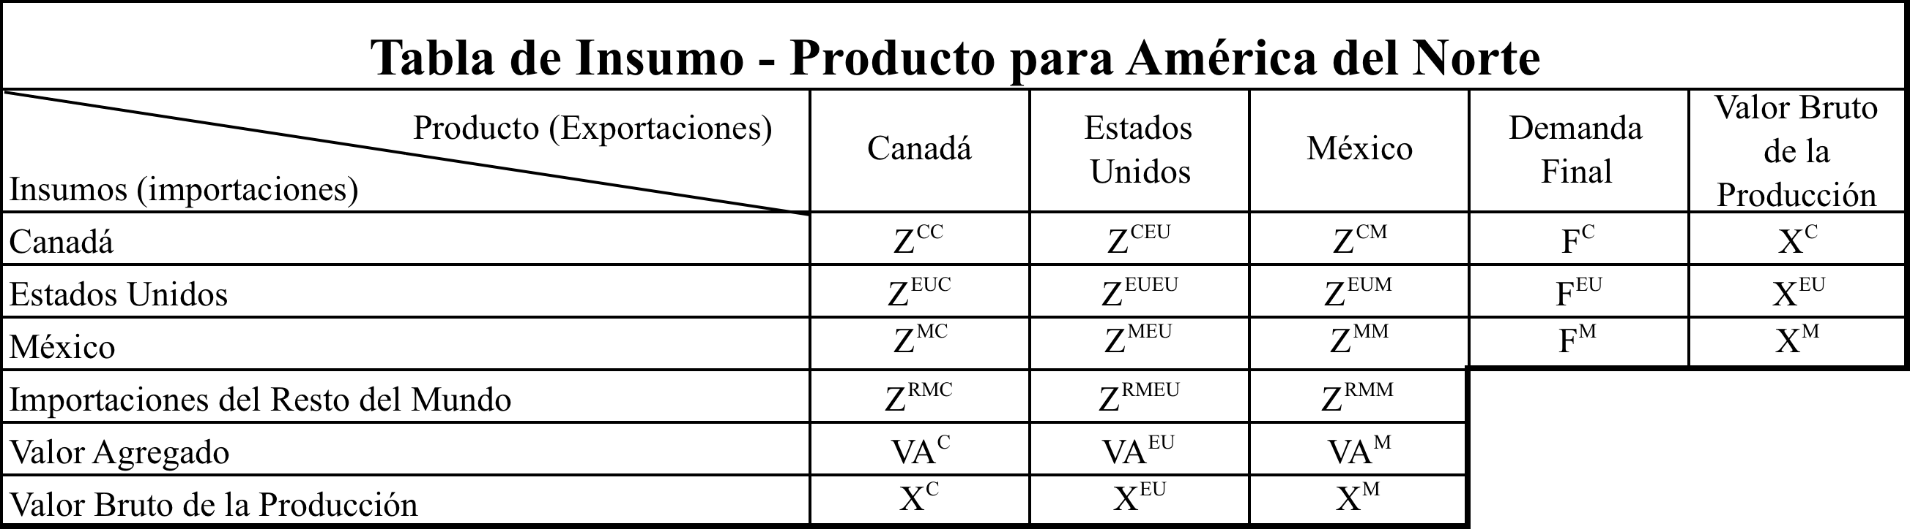

The supra-indices indicate the country in question, for example C is used for Canada, the EU is the United States, M is Mexico and RM for the Rest of the World. "Z is the intermediate transactions, " "F is the final demand", "VA is value added" and "X is the Gross Value of Production. " ZCC, and ZMM ZEUEU are matrices which represent transactions within the country, outside of them are accounted for inputs used in the trade (imports - exports), for example, the array read horizontally ZEUC inputs represents United States exports to Canada or otherwise vertically simultaneously displays inputs imported into Canada from the United States.

Following the model of Isard [1960] Gross Value of Production is the sum of the products of the countries, however this can be expressed from the demand side or supply. In the first case, the Gross Value of Production for North America (XAND) is defined as follows:



where DI is the intermediate demand and final demand F is the supra-index indicates the country. In general, the Gross Value of Production is equal to the sum of intermediate demand more final demand (X = DI + F). However, the supply side the Gross Value of Production (XANO) is:



where "IC is the intermediate consumption" and "VA is value added. " So the supply-side X is equal to IQ VA. By product breakdown by country for each sector of the North American block on the side of demand is:

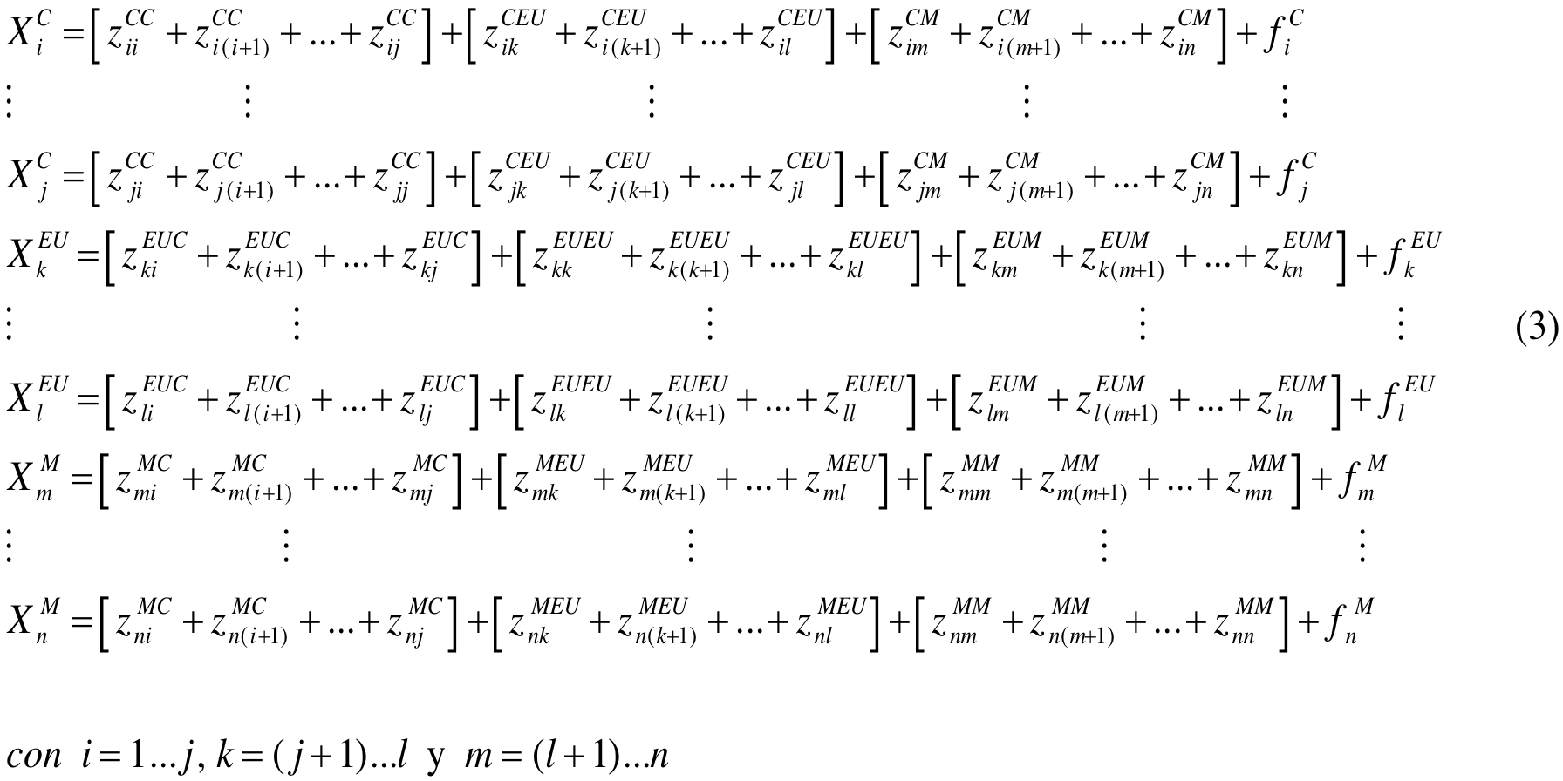 in the system (3), *z* indicates the inputs, the supra-indices indicate sales by region and sub -indices of sales from sector to sector, for example, indicates the sales of sector i in Canada j sector of Canada, as seen when the supra-index is repeated CC, MM indicate EUEU or sales of intermediate inputs within the region, whereas when there is a combination sales indicate interregional intermediate inputs. In our case are intermediate exports from one region to another, for example indicates the sales of sector i to sector l Canada United States in turn are exports from Canada to the United States of sector i to l. Note that the total number of sectors within the trading bloc are i = 1 ... n, which are shaped by the sum of the sectors in each region.

On the supply side, we define the product of sector i like, then the output of each sector per country will be defined as follows:

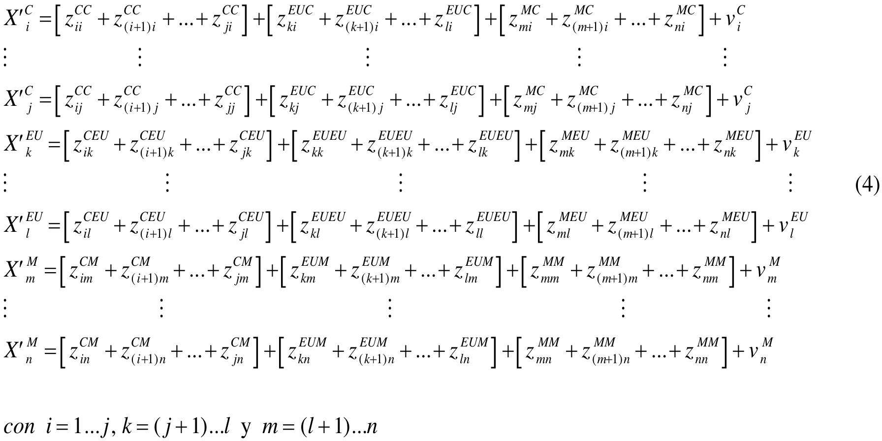Thus, the output of a sector of a region is accounted for by purchases made to other sectors of the region and makes the business of other regions, for example *zCMim* are the purchases made by the sector i of Canada to sector m of Mexico. These are Canadian imports from Mexico of sector i to m.

One of the assumptions of the MIP is that production functions are linear and homogeneous, ie have constant returns to scale, therefore, the coefficients or parameters of it are constant or fixed (Raa [2005]). However, as the TIP is a moment in time, ie it is short term, the technology does not change, only knows the consumption of inputs used for production of an industry. Given the way in which the product is calculated in the TIP is clear that industries by doubling the product doubles the use of inputs.

Since the demand model technical coefficients are defined as the ratio of input per unit of output produced. In this way the production is doubled doubled input use but remains the same proportion of each input in total output of a particular sector (Leontief [1986]).

However, the set of technical coefficients are defined as follows:

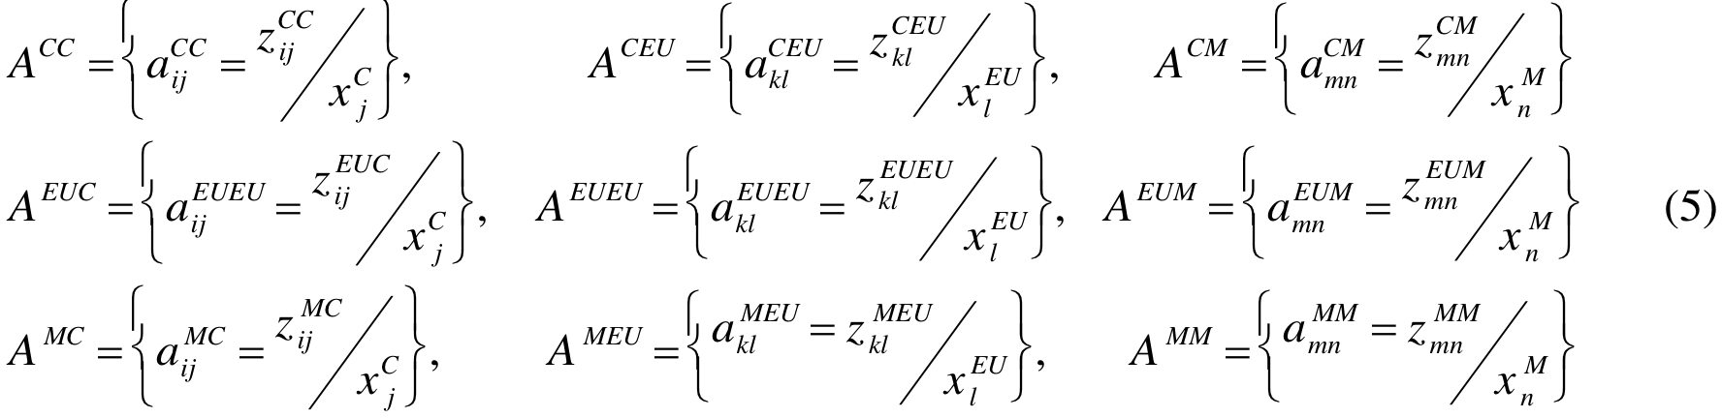each set of technical coefficients describing the consumption of inputs that makes a region of inputs produced in the region and in the other. On the other hand, taking the form of tender, Ghosh [1958] defines the coefficients of deliveries and the proportion of items per unit of output produced, defined as:

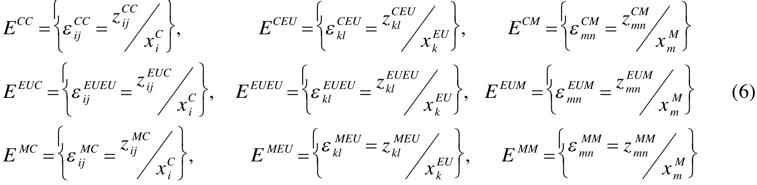then the matrix of technical coefficients matrix A and E are coefficients of delivery matrices partitioned into three regions or countries as follows:

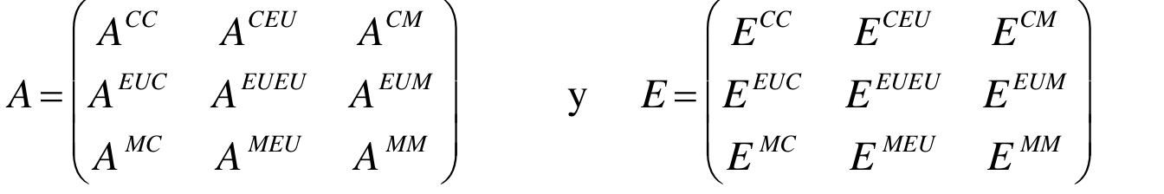

Thus the product of each region using the technical coefficients and deliveries will be:





the system of equations (7) is on the side of demand and (8) on the supply. The solution of the system determines spillover and feedback effects. On the demand side, the product of a region depends on final demand and final demand, in turn, is intertwined by the product of other regions and thus the final demand in those regions. This system senses that the product of a region depends on the product of others. If defined the vectors of final demand, gross value of production and value added like:

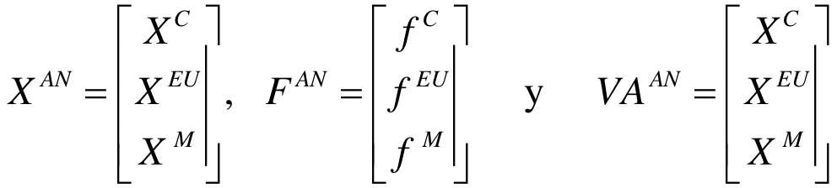

then, the solution of system of North America is:

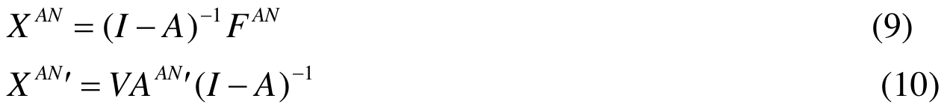

However, the solution for North America, to be partitioned to analyze spillover and feedback effects. A clear expression of the model solution is in Oosterhaven and Stelder [2008] for a table with two regions, the principle of authors is that the feedback effect for a region is composed of the spillover, intra-product, spillover, however in theses cases the solution model is more complex, but it contains the general structure in feedbacks effects. In the appendix shows the solutions for each economy in the North American system.

In the system of equations of the appendix determines the total effects and shows the internal effects, the effects of spills and feedback. For the demand model the feedback effect makes the product of a region depends not only on final demand in the region but of final demand in other regions. The spillovers effects are defined by the intranacional-matrix and international. The size of the spillover is more less than the size of intranacional-effects. The appendix shows that the total effects are greater and the difference between intranational and international impact is due to feedback effects (Miller and Blair [2009])

The solution of output for each country on the offer side, shows that the product depends on the value-added product from other countries and the added value of the other countries. The composition of the feedback consists of symmetrically about the case of demand, however, the entries of matrices A and E are different so that its size is not the same.

2. Empirical analysis

The construction of the IOTNA was made whit IOT for each country published in the February 2009 edition of Input-Output Database, OECD, however, the TIP for Canada and the United States are referred to 2005, while in the case of Mexico is for 2003, although the difference of time between the parent carries a couple of solutions that have to do with the updating of information. The first is to update the entries in the matrix of technical coefficients of Mexico (AMM) to 2005. The second is to consider the constant coefficients and update the components of final demand and value added. However, the difference in timing is marginal for the effect of a structural change in the Mexican economy, since the structure in the short term does not change the proportion of inputs generated by the product but causes structural change on the horizon time (Leontief [1986]). This problem generates a margin of error in statistical calculations for the construction of the IOTNA, but consideration of the theory, the difference in years does not significantly modify the intensity of inter-industry relationships.

Arrays of Canada and Mexico are in local currency and basic prices are in U.S. producer prices. This bill creates another problem on the compatibility of use of the information, when it comes to this kind of price is necessary to convert currencies at the same price system, unfortunately, this is outside the scope of this investigation, however is important to note that for an international array would be more appropriate to have TIP a buyer because prices include transportation costs that affect the amount of imports and exports. With the price system in the TIP of Mexico and Canada, inflate the quantities of inputs of these countries on the United States.

Vectors were used to estimate import and export trade sector-disaggregated by country of origin, according to the database called STAN Structural Analysis Database, which is organized according to ISIC Rev. 3.1 (International Standard Industrial Classification) and is compatible with the classification used in the construction of the TIP for each country. A lack of this database is that only reports the trade flows of goods and not distinguished in some cases as the "mining and quarrying" of "energy" and "energy" as if it is in the IOT. We used a criterion of aggregation of various sectors to ensure that IOT were consistent in all three economies.

Since no figures are reported on services, we calculated the amount of exports and imports using the average of the market share that make the real sector. While it may seem an arbitrary decision for the remaining elements, the solution has been used in some works that do not have the same information (van der Linden and Oosterhaven [1996]).

The next step in the construction of the TiPan was to express the various matrices and vectors in U.S. dollars (USD) as their common currency, such as reflected in the OECD data on trade in goods between countries. The conversion was done with the average exchange rate of Mexican pesos and Canadian dollars.

Having calculated the amount of exports and imports from country A to N, are constructed from trade coefficients defined as shipments (Miller and Blair [2009])

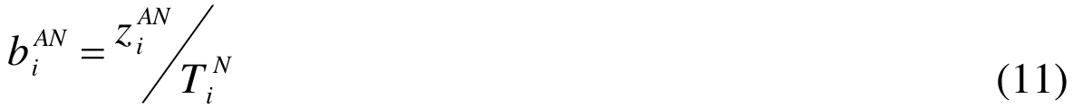

Where *zANi* is the flow of shipments from the region to N sector i "also includes a proportion of shipments to final demand and *TNi* is the sum of its shipments of the product of sector i of the N region. "Having calculated the vector of trade coefficients is transformed by a diagonal matrix of trade coefficients defined as  to which way the interregional system as:



Where

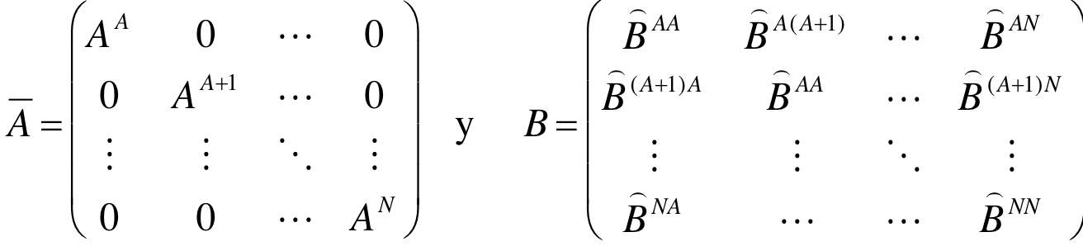

This “ is a diagonal matrix of national technical coefficients matrices”, “B is a matrix of diagonal submatrices of the coefficient of trade” and “F is the vector of final demand.” Thus the technical coefficients interregional or hospitalizations are defined according to .

An extension of this model would be to use the coefficients of trade but with the receipts from sector to sector to generate the matrix of coefficients supplies, such coefficients would be defined as follows:



where “*zANj* is the flow of receipts in the region *A* to N through j sector in region N, which includes information on receipts of value added, “*JNj* is the sum of its receipts of proceeds of sector *i* of the *N* region”. Having calculated the vector of trade coefficients is transformed by a diagonal matrix, defined from the receipts of each sector and region that allows the construction of the coefficient matrices E regional delivery, so that the system is solved as:



where

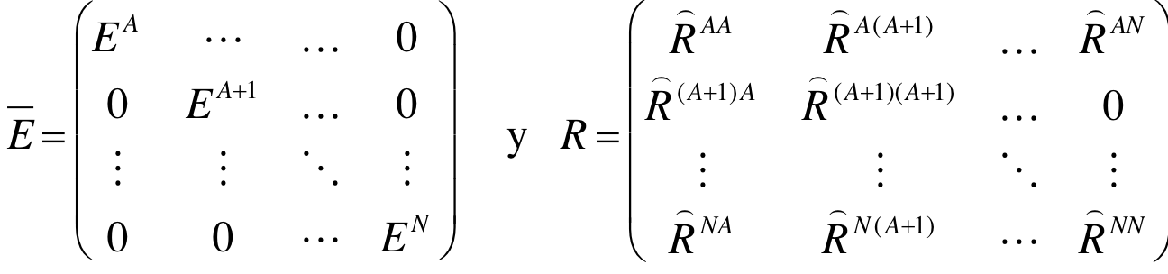

So the coefficient matrices of shipments  by region and trade coefficients calculated by sector receipts (*R*) - generated international tables region calculated by the supply side. In equation (14), the generation of the coefficient matrices are calculated for international deliveries by .

1 and Table 2 shows the aggregated data to the matrix of coefficients sector international supply and demand of the trade bloc in North America. The results in Table 1 show the coefficients defined by the shipping trade, ie, sales of supplies or products inside and outside exports. The data indicate that the United States exported more than exports made between Canada and Mexico. But the United States exports more to Canada than Mexico.

According to equation (12), the technical coefficients to incorporate international trade change size as the product is distributed within and outside the economy. The last part of Table 1 shows, the generation of international technical coefficients between the NAFTA partners. These results identify the size of the national ratio is higher for the U.S. and does not change much compared to the ratio observed in tables. This is explained by the size of U.S. exports to its partners.

Table 2 shows the data and results in the generation of international delivery ratios added to a sector. In this table, is the trade coefficient matrix defined by the receipts from one sector to other regions, in other words, the proportion of purchases of supplies within the country and overseas imports. As exports imports from Canada and Mexico are concentrated in the United States and the country imports more from Canada than from Mexico. These data show that the integration processes that have taken the United States and Canada have been more intense than those that have had those countries with Mexico.

In the coefficients of domestic supplies, the U.S. has a size similar to the technical coefficient. This implies that the contribution of value added and final demand are almost equal to what drives the growth of supply or demand can be almost the same. For its part, Canada and Mexico have very different sizes, technical coefficients and delivery. However, the common feature of all three economies is that the size of the coefficient implies that the product supplies the supply side depends on more than 50% of value added in each country.

|  |  |  |  |
| --- | --- | --- | --- |
| **Cuadro 1**  **Generación de Matriz de Coeficientes Técnicos interregionales para América del Norte** | | | |
| **Coeficientes de Comercio por Envíos** | | | |
| Canadá | 0.7681 | 0.0149 | 0.0026 |
| Estados Unidos | 0.1643 | 0.9850 | 0.1663 |
| México | 0.0677 | 0.0001 | 0.8311 |
| **Matriz diagonal de Coeficientes Técnicos Nacionales** | | | |
| Canadá | 0.5400 | 0 | 0 |
| Estados Unidos | 0 | 0.4120 | 0 |
| México | 0 | 0 | 0.3064 |
| **Matriz de Coeficientes de Técnicos Internacionales** | | | |
| Canadá | 0.3196 | 0.0122 | 0.0028 |
| Estados Unidos | 0.1382 | 0.401 | 0.1101 |
| México | 0.0453 | 0.0006 | 0.2117 |
| Fuente Elaboración propia. | | | |

|  |  |  |  |
| --- | --- | --- | --- |
| **Cuadro 2**  **Generación de Matriz de Coeficientes de Entregas interregionales para América del Norte** | | | |
| **Coeficientes de Comercio por Recibos** | | | |
| Canadá | 0.8959 | 0.0054 | 0.0061 |
| Estados Unidos | 0.1026 | 0.9911 | 0.0927 |
| México | 0.0015 | 0.0036 | 0.9012 |
| **Matriz diagonal de Coeficientes de Entregas Nacionales** | | | |
| Canadá | 0.4815 | 0 | 0 |
| Estados Unidos | 0 | 0.4120 | 0 |
| México | 0 | 0 | 0.4235 |
| **Matriz de Coeficientes de Entregas Internacionales** | | | |
| Canadá | 0.3866 | 0.0045 | 0.0052 |
| Estados Unidos | 0.0862 | 0.4051 | 0.0735 |
| México | 0.0014 | 0.0028 | 0.3441 |
| Fuente Elaboración propia. | | | |

From the data matrices were constructed Figures 1 and 2 represent total exports and exports from North America to the world. Total exports are those that represent trade within the bloc and outside it. The total amount of exports under the IOTN is 1,678,448.7 million U.S. dollars, in Figure 1 shows that participating in further U.S. exports to North America.

Figure 2 shows the trade bloc's exports to the world, amounting to U.S. $ 767,455.2 million. The data show that exports from North America are represented by the United States economy, the data also reported that the U.S. is behaving contrary to their trading partners, for example, in the Mexican economy, inter-regional exports has more weight the block exports out of it, while Canada has the same pattern but to a lesser extent Mexico.

Total imports and the rest of the world trading block are described in Figures 3 and 4. Figure 3 shows the composition of total imports to North America, whose amount is calculated 1,377,702.7 million. In Figure 3 shows that the largest player in the U.S. total imports. It must be said that the information available in the IOT national express trade surplus economies. However, according to Figures 1 and 3, the surplus is only maintained in the United States economy.

Figure 4 depicts the composition of imports from the trade bloc partners. Total imports registered the rest of the world are 1,418,182.2 million. Apparently, no U.S. trade surplus with the rest of the world. This graph concludes North America maintains a trade deficit with the rest of the world.

Table 3 presents the results of the total effects on the side of the supply and demand added to a sector. The data show that the effects of drag and thrust, ie demand and supply in Canada are the largest in North America, but their impact is diminished by the size of the trade that in North America and the participation total output is only 7.7%. The results obtained in Canada say the term is more significant demand for intermediate demand product with trading partners regarding their products, besides the supply side is possible that the size of intermediate consumption is relevant in these results As intermediate consumption in this economy is most significant with regard to its trading partners.

On the supply side Mexico has a total effect greater than America, this is because the composition of the gross value of Offer outweighs the added value of intermediate consumption, also is not significant level of participation of Mexico in trading block since only participates with 4.5%. United States remains almost unchanged between the effects estimated by the demand and supply, this is because the size of the technical coefficient and national deliveries are nearly equal.

|  |  |  |
| --- | --- | --- |
| **Cuadro 3.**  **Efectos Totales de acuerdo a matriz de Coeficientes Internacionales.** | | |
| **País** | **Demanda** | **Oferta** |
| Canadá | 1.96 | 1.89 |
| Estados Unidos | 1.71 | 1.70 |
| México | 1.50 | 1.73 |
| Elaboración propia. | | |

The U.S. economy is the representative of North America because of 26,290,167.5 billion as calculated with the Tablets, 87.8% is generated in the U.S. economy, as well as the impulses generated by supply and demand are more stable this economy. The results show that Canada's economic structure is more impulses for growth and demand that Mexico is more responsive to stimulation by the offer.

The sectoral breakdown is handling the construction of the TiPan was 32 sectors by region due to the nature of the information contained in the tables and information on imports and exports available, and sectors were added in some null entries cases for Mexico and Canada. Annex 1 shows the table with the aggregation criteria to arrays of 32 sectors for North America.

Annex 2 presents the results of the model of Chenery [1953] and Moses [1955] and the extension for calculating the coefficients of international deliveries for the 32 sectors by country. Table 1 of this Annex, presents data on the decomposition of total effect, Intranational, Spill and Feedback to Canada. Overall, the demand side, the spill of imports from Canada are higher on the U.S. economy than Mexico, highlighting the areas of water transport, machinery and equipment Rental, Manufacture of motor vehicles, trailers and semi / Building and repairing of ships and boats / aircraft and spacecraft / Railways and transport equipment nec; the case of imports of goods with high technological content. The flow of imports from Canada over Mexico are less than the feedback effect that Canada gets trilateral trade. The supply model calculations show the same pattern as the results of the application, however comparing the spill and feedback on the models of supply and demand concludes that imports of final demand are more significant in the Canadian economy.

Table 2 of Annex, shows the results for the United States in the demand and supply models. The spill of U.S. imports is very low, on trading partners, however the feedback effect you get from imports is greater than the spill from them. On the supply side, the situation changes since the spill as a result of exports is greater on the Mexican economy on Canada, this is because Mexico's economy is analyzed as an economy capable of impulse response of the offer. On the other hand, feedback U.S. average is higher for exports than imports in the trade bloc. It is worth noting that the largest total effects on the export side are distributed between the primary sector, in the fields of agriculture, hunting, forestry and fishing, food, beverages and snuff, in the manufacture of rubber and plastics; in the secondary sector in the fields of manufacturing of motor vehicles and trailers / Building and repairing of ships and boats / aircraft and spacecraft / Railways and transport equipment nec, water transport and air transport, while the sector services are the branches of Post and telecommunications and machinery and equipment Rental. In these industries using high technology in production processes and according to the TiPan are sectors of high added value.

Finally, in the case of Mexico, the pour calculated by demand shows there is greater effect on the U.S. economy and highlights the clothing sector, textiles, leather and footwear. Mexico has higher feedback effect that the United States and lower Canada in the trade bloc, this means that trade with NAFTA has benefited the Mexican economy, however the position and the role it plays Mexico in the block is not is the best. The sectors with the greatest overall effect on the demand model indicates that is the case in manufacturing where they are located, in addition also has an important role in the construction industry and the hotels and restaurants. For his part in the tender form the Mexican economy has shed more than demand, however, the feedback effect is very similar to that calculated by the demand side. It is important to note that exports of food, beverages and snuff, Manufacture of wood and manufacture of wood and cork, and water transport are the sectors that have greater total effect. However, the transport sector highlighted by the spill water that makes the U.S. economy.

3. Conclusions

The results obtained by this model indicate that the U.S. economy is the leading North American economy and its structure is much stronger than the rest of their partners, because the chains of supply and demand are more homogeneous in size and not as different as their trading partners. One way of looking at this has been for the decomposition of the total effect of the structure within both the supply and demand, although not the United States has the highest average effect, the effects of supply and demand are very close. The feedback obtained from its trading partners is small compared to total or intra multiplier but much larger than the spillovers they generate to Mexico and Canada.

In addition, the effect given by the export side involves sectors that are primary, secondary and tertiary whose characteristic is that they are employing high technology sectors. This reflects a more diversified and more integrated in contrast to its trading partners to areas of technology involves lower-middle and upper middle in the case of Mexico or Canada for medium technology sectors - high and high. However, the production structure reflects that growth impulses are only on offer to Mexico and demand for Canada.

The model was analyzed imports imports in Mexico and Canada are more on the U.S. economy, however, the U.S. imported inputs are higher from Canada to Mexico. As discussed both Canada's economy such as Mexico have a pattern of dependence on the U.S. economy, however, given the structure of the U.S. economy, its partners have specialized in supply or demand effects of which have allowed the United States receive significant levels in the feedback effect of imports or exports, thus complementing the U.S. economy.

In the case of the Canadian economy, the results suggest that it has the highest overall aggregated effect in North America. Nevertheless, given the level of output and trade, the influence on the block is not relevant as in the United States.

In the case of Mexico the results are not much different from those of the Canadian economy, in the sense that the impacts that the United States on the two economies is lower than that caused these economies to the U.S.. The flow is increased by the export side, however these are sectors with low added value and technological level medium - low. Mexico has had benefits of belonging to NAFTA as the calculations suggest that Mexico receives more spillovers of causes, whether of supply and demand. The backward linkage effect caused by imports was lower than that which comes from exports, ie forward linkages have led to greater impacts, as well as the feedback we get both imports and exports are similar.

These results suggest that the economic structures of Canada and Mexico have a large dependence on the U.S. economy, so as long as U.S. economic growth, the economies of Mexico and Canada are favored, otherwise it is when there is a recession the U.S. economy, but the mechanism of transmission of impulses to growth are on the side of imports in Canada and on the side of exports in Mexico.

An instrument of economic policy is to encourage those sectors stimuli that imports have a positive impact on the economic system for Canada and generate a process of integration with its export sectors that generate a positive influence on growth. One measure would be the promotion of small and medium enterprises with export profile, but that link high-impact sectors for imports.

In the case of the Mexican economy, the growth model has led to exports and linkages that cause these have been significant growth in output, however it is necessary that the role of copper imports importance to generate backward linkages, need to stimulate the productive base of the sectors with the greatest impact on imports.

The U.S. economy is the closest example of Canada and Mexico, and these economies will need to promote the integration of the production structure in order to have significant effects on supply and demand.

Bibliography:

Aroche F (1993) *Economic Structures in Brazil, Mexico and South Korea: An Input-Output Application.* Ph.D. Thesis Queen Mary and Westfield College, University of London.

Brand, S. (1997). On the Appropriate Use of Location Quotients in Generating Regional Input-Output Tables: a Comment. Regional Studies, 31(8), pp.791-794.

Cardero María Elena (1996) *Que ganamos y que perdimos con el TLC*. México: Siglo XXI : UNAM, Colegio de Ciencias y Humanidades, Unidad Académica de los Ciclos Profesional y de Posgrado, 338 p.

Chenery, H. B. 1956. “Interregional and International Input-Output Analysis.” In T. Barna, ed., *The Structural Interdependence of the Economy*. New York: John Wiley and Sons, Inc.

Cole (1996) “Across the State and across the Border : Spill-over, Feedback and Agglomeration in Many Regions Economics” . *The Great Lakes Geographer* vol. 3, No. 2, pp 29 – 50.

Curzio L (2009). *La competitividad en América del Norte y el modelo de integración.* Cuadernos de America del Norte 13, Centro de Investigaciones Sobre América del Norte (CISAN), UNAM.

Flegg T. A. & Webber C.D. (2000) “Regional size, regional specialization and the FLQ formula”, *Regional Studies*, 34 (6) pp. 563-569.

Frenkel,J; Stein, E; Wei, S. (1995), “Trading blocs and the Americas: The natural, the unnatural and the supernatural.” *Journal of Development Economics*, vol. 47.

Gazol Sánchez A. (2004) “Un debate necesario: el futuro del TLCAN, en Configuraciones”. *Revista de la Fundación Pereyra y del Instituto de Estudios para la Transición Democrática* (IETD), No. 15, México, otoño-invierno

Ghosh, A. (1958). ‘Input-output Approach in an Allocation System’, *Economica*, 25: 58-64

Hirschman A. (1958). *The Strategy of Economic Development.* Yeild university Press. New Haven, CT.

Ishikawa, Y., y Miyagi T. (2004) “The Construction of a 47-Region Inter-regional Input–Output Table and Inter-regional Interdependence Analysis at Prefecture Level in Japan.” Documento presentado en The 44th European Congress of the European Regional Science Association, Porto, Portugal.

Isard W. (1960) *Methods of Regional Analysis: An introduction of Regional Science.* Cambridge, Massachusetts, The M.I.T. Press.

(1951) “Interregional and Regional Input-Output Analysis: A Model of a Space-Economy”, *The Review of Economics and Statistics*, Vol. 33, No. 4, pp. 318-328.

Kim K.,Secretario F. y Kaneko H(2010) “Measurment of Inter-Regional Differentials and Dependencies in the Philipine Economy Base on a Multi-Regions Inter-Regional Input – Output Table”. Documento presentado en 11th National Convention on Statistic (NCS) , disponible en: [http://www.nscb.gov.ph/ncs/11thNCS/papers/invited%20papers/ips-02/01_Measurement%20of%20Inter-Regional%20Differentials%20and%20Dependencies%20in%20the%20Philippine%20Economy%20Based%20on%20a%20Multi-Region’s%20Inter-Regional%20Input-O.pdf](http://www.nscb.gov.ph/ncs/11thNCS/papers/invited%20papers/ips-02/01_Measurement%20of%20Inter-Regional%20Differentials%20and%20Dependencies%20in%20the%20Philippine%20Economy%20Based%20on%20a%20Multi-Region's%20Inter-Regional%20Input-O.pdf)

Krueger A. (1990) “ Comparative Advantage and development Policy Twenty Years Later” en *Perspectives on Trade and Development, Londres, Harvester Wheatheaf*

Lahr M. [1993], “A Review of Literature Sopporting the Hibryd Approach to constructing Regional Input – Output models”. *Economic System Reseach* vol , No. , pp 277 – 293.

Lazzarus W, Platas D, y Morse G (2002) “IMPLAN´s Weakest Link: Production Function of Regional Purchase Coefficients?”, *Regional Analysis and Policy*, vol. 32, No. 1, pp 34 – 48.

Leontief W.(1986) *Input – Ouput Economics*. Oxford University Press Segunda Edición. pp 436

Lindall S, Olso D y Alward G.(2006) “Driven Multi-Regional Models. Using the IMPLAN, National Trade Flows Model”, *Journal of Regional Analysis and Plicy*, 36, pp 76 – 83.

Meng B. y QU C. (2007) “Aplication of Input – Output Decomposition Technique to China´s Regional Economies.”*Discution Paper No. 102*, Institute of Developing Economies.

Miller R. (1998) “Regional and interregional input output análisis” en Isard W, Azis J, Drennan M, Miller R, Saltzman S y Thordecke, *Methods of Interregional and Regional Analysis.* Publicado por Ashgate Publishing Limited, Grower House, Croft Road, Aldershot, Hants GU11 3HR England, pp 41 – 134.

Miller R. y Blair P.H. (2009) *Input*-*Output Analysis. Foundations and Extentions*, 2º Ed., Cambridge University Press.

Miyazawa, K. (1971), “An analysis of the interdependence between service and goods-producing sectors”, Hitotsubashi Journal of Economics 12, pp. 10-21.

Mollick, A. V. y Cabral, R. (2009). “Productivity Effects on Mexican Manufacturing Employment”, North American Journal of Economics and Finance 20(1): 66-81.

Moses, L. N. 1955. “The Stability of Interregional Trading Patterns and Input-Output Analysis.” *American Economic Review* 45(5) pp 803–26.

Novelo F y Flores, J. (2006) “La encrucijada del ALCA”. *Economía,* UNAM No*.* 7, enero-abril

Oosterhaven J y Stelder E. (2008) “Syllabus. Regional and Interregional IO Analysis” Disponible en: <http://www.iioa.org/pdf/Teaching%20IO/Regional%20IO%20Analysis.pdf>

Piispala, J. (2000). “On Regionalising Input/Output Tables—Experiences from Compiling Regional Supply and Use Tables in Finland.” Paper presented at the 13th International Conference on Input-Output Techniques, University of Macerata, Italy.

Pulido, A. (1996), “Input-output regional: posibilidades y limitaciones”, XXII Reunión de Estudios Regionales, Pamplona. Disponible en <http://www.antoniopulido.es/documentos/con9606.pdf>

Raa T. (2005). *The Economics of Input – Output Analysis.* Cambrige University Press. 197 p.

Ramirez, M.D., 2006. “Is Foreign Direct Investment Beneficial for Mexico? An Empirical Analysis, 1960-2001”, World Development 34(5), 802-17

Rueda J, Beutel J, Neuwahl F, Löschel A y Mongelli I (2009) “A Symetric Input – Output Table for EU27: Lastest Progress” *Economic System Research,*  vol 21, No. 1, pp 59 – 79.

Rubio, Luis, *¿Cómo va a afectar a México el Tratado de Libre Comercio?*, FCE, México, 1994

Ruiz Napoles P. (2006) “Efectos Macroeconomicos de la Apertura y el TLCAN” en Gambrill Mónica (compiladora) *Diez años del TLCAN en México*. México : UNAM, Centro de Investigaciones Sobre América del Norte. pp 19 – 34.

Samuelson P.(1983) *Foundations of Economic Analysis*, Enlarged Edition (Harvard Economic Studies) (Paperback)

Schaffer W. A., y K. Chu (1969), “Nonsurvey techniques for constructing regional interindustry models”. Papers of the Regional Science Association, vol.23, págs. 83-101.

Sim B., Secretaroio F. y Suan E (2007), *Developing and Interregional Input –Output Tables for Cross – Border Economies: An Application of a Laos People´s Democratic Republic and Thailand.* Asia Development Bank.

Stevens B. H., G. I. Treyz y M. L. Lahr (1989), “On the comparative accuracy of RPC estimating techniques”. En Miller, Polenske y Rose, editores, Frontiers of input-output analysis, Oxford University Press, págs. 245-257.

Tironi E. (1977) “*Estrategias de Desarrollo e integración”.* Editorial Corporación de Investigaciones Económicas para Latinoamérica, Santiago, Chile pp.49.

Tussie D. y Lengyel M. (2002), *Developing Countries: Turning Participation into influence*. Development Trade and the WTO. Handbook, Banco Mundial

Van Der Linden, J. y J. Oosternhaven (1996) “European Community Intercountry Input-Output Relations: Construction Method and Main Results for 1965-85”, *Economic Systems Research*, 7(3), pp. 249-269

**Anexo 1**

**Sectores y dimensión final en la matrices de insumo producto homologadas con sus respectivas agregaciones de las tablas originales**

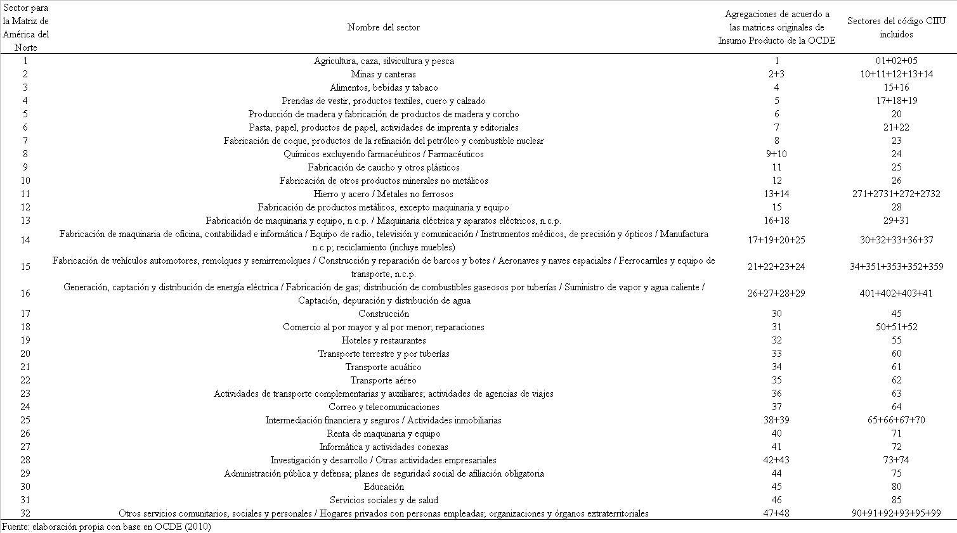

Anexo 2

|  |  |  |  |  |  |  |  |  |  |  |
| --- | --- | --- | --- | --- | --- | --- | --- | --- | --- | --- |
| Cuadro 1 Efectos de Derrama y Retroalimentación de Canadá en América del Norte | | | | | | | | | | |
| Sectores | Demanda | | | | | Oferta | | | | |
| Efectos Totales | Efectos Intranacionales | Derrame | | Retroali. | Efectos Totales | Efectos Intranacionales | Derrame | | Retroali. |
| EU | M | EU | M |
| Agricultura, caza, silvicultura y pesca | 1.940 | 1.575 | 0.128 | 0.056 | 0.366 | 1.708 | 0.875 | 0.011 | 0.005 | 0.832 |
| Minas y canteras | 1.554 | 1.271 | 0.127 | 0.045 | 0.283 | 1.240 | 0.785 | 0.011 | 0.006 | 0.455 |
| Alimentos, bebidas y tabaco | 2.305 | 1.734 | 0.232 | 0.071 | 0.572 | 2.197 | 1.834 | 0.004 | 0.002 | 0.363 |
| Prendas de vestir, productos textiles, cuero y calzado | 1.724 | 1.124 | 0.239 | 0.185 | 0.599 | 0.453 | 0.396 | 0.004 | 0.001 | 0.057 |
| Producción de madera y fabricación de productos de madera y corcho | 2.035 | 1.587 | 0.187 | 0.047 | 0.448 | 1.521 | 1.113 | 0.016 | 0.014 | 0.408 |
| Pasta, papel, productos de papel, actividades de imprenta y editoriales | 1.846 | 1.402 | 0.239 | 0.027 | 0.444 | 1.549 | 1.098 | 0.007 | 0.011 | 0.451 |
| Fabricación de coque, productos de la refinación del petróleo y combustible nuclear | 1.862 | 1.716 | 0.105 | 0.115 | 0.146 | 2.522 | 1.790 | 0.012 | 0.012 | 0.732 |
| Químicos excluyendo farmacéuticos / Farmacéuticos | 1.979 | 1.345 | 0.358 | 0.048 | 0.634 | 1.396 | 1.106 | 0.008 | 0.004 | 0.290 |
| Fabricación de caucho y otros plásticos | 1.959 | 1.276 | 0.365 | 0.068 | 0.684 | 0.842 | 0.606 | 0.021 | 0.010 | 0.236 |
| Fabricación de otros productos minerales no metálicos | 1.797 | 1.317 | 0.231 | 0.081 | 0.480 | 0.881 | 0.321 | 0.010 | 0.005 | 0.561 |
| Hierro y acero / Metales no ferrosos | 1.964 | 1.360 | 0.302 | 0.070 | 0.604 | 1.201 | 0.981 | 0.029 | 0.015 | 0.221 |
| Fabricación de productos metálicos, excepto maquinaria y equipo | 1.836 | 1.270 | 0.293 | 0.062 | 0.566 | 1.044 | 0.695 | 0.014 | 0.009 | 0.349 |
| Fabricación de maquinaria y equipo, n.c.p. / Maquinaria eléctrica y aparatos eléctricos, n.c.p. | 1.783 | 1.148 | 0.355 | 0.078 | 0.634 | 0.776 | 0.695 | 0.005 | 0.003 | 0.080 |
| Fabricación de maquinaria de oficina, contabilidad e informática / Equipo de radio, televisión y comunicación / Instrumentos médicos, de precisión y ópticos / Manufactura n.c.p; reciclamiento (incluye muebles) | 1.579 | 1.106 | 0.241 | 0.103 | 0.473 | 0.706 | 0.657 | 0.003 | 0.002 | 0.049 |
| Fabricación de vehículos automotores, remolques y semirremolques / Construcción y reparación de barcos y botes / Aeronaves y naves espaciales / Ferrocarriles y equipo de transporte, n.c.p. | 1.904 | 1.132 | 0.401 | 0.106 | 0.772 | 1.182 | 1.154 | 0.014 | 0.007 | 0.028 |
| Generación, captación y distribución de energía eléctrica / Fabricación de gas; distribución de combustibles gaseosos por tuberías / Suministro de vapor y agua caliente / Captación, depuración y distribución de agua | 1.495 | 1.147 | 0.235 | 0.016 | 0.347 | 0.889 | 0.625 | 0.003 | 0.003 | 0.264 |
| Construcción | 1.750 | 1.435 | 0.112 | 0.039 | 0.315 | 3.457 | 3.299 | 0.001 | 0.001 | 0.157 |
| Comercio al por mayor y al por menor; reparaciones | 1.512 | 1.288 | 0.106 | 0.027 | 0.224 | 2.422 | 2.111 | 0.003 | 0.003 | 0.312 |
| Hoteles y restaurantes | 1.823 | 1.541 | 0.096 | 0.021 | 0.282 | 1.562 | 1.331 | 0.001 | 0.002 | 0.231 |
| Transporte terrestre y por tuberías | 1.690 | 1.356 | 0.168 | 0.040 | 0.335 | 1.414 | 1.000 | 0.005 | 0.003 | 0.414 |
| Transporte acuático | 2.022 | 1.215 | 0.602 | 0.019 | 0.807 | 0.549 | 0.458 | 0.002 | 0.005 | 0.092 |
| Transporte aéreo | 1.850 | 1.387 | 0.298 | 0.036 | 0.463 | 1.029 | 0.734 | 0.004 | 0.004 | 0.295 |
| Actividades de transporte complementarias y auxiliares; actividades de agencias de viajes | 1.283 | 1.194 | 0.031 | 0.012 | 0.089 | 1.104 | 0.429 | 0.018 | 0.007 | 0.675 |
| Correo y telecomunicaciones | 1.904 | 1.359 | 0.298 | 0.040 | 0.545 | 1.164 | 0.524 | 0.002 | 0.003 | 0.641 |
| Intermediación financiera y seguros / Actividades inmobiliarias | 1.556 | 1.389 | 0.076 | 0.007 | 0.167 | 2.643 | 2.245 | 0.002 | 0.002 | 0.397 |
| Renta de maquinaria y equipo | 1.888 | 1.319 | 0.409 | 0.007 | 0.570 | 0.702 | 0.290 | 0.003 | 0.005 | 0.412 |
| Informática y actividades conexas | 1.573 | 1.336 | 0.109 | 0.018 | 0.238 | 1.287 | 0.556 | 0.006 | 0.035 | 0.731 |
| Investigación y desarrollo / Otras actividades empresariales | 1.627 | 1.350 | 0.154 | 0.009 | 0.278 | 1.363 | 0.607 | 0.006 | 0.007 | 0.755 |
| Administración pública y defensa; planes de seguridad social de afiliación obligatoria | 1.605 | 1.390 | 0.081 | 0.018 | 0.215 | 2.813 | 2.722 | 0.000 | 0.000 | 0.091 |
| Educación | 1.661 | 1.474 | 0.066 | 0.010 | 0.188 | 1.280 | 1.215 | 0.001 | 0.000 | 0.065 |
| Servicios sociales y de salud | 1.601 | 1.387 | 0.087 | 0.015 | 0.214 | 1.430 | 1.103 | 0.001 | 0.002 | 0.328 |
| Otros servicios comunitarios, sociales y personales / Hogares privados con personas empleadas; organizaciones y órganos extraterritoriales | 1.668 | 1.423 | 0.106 | 0.016 | 0.245 | 1.763 | 1.367 | 0.003 | 0.003 | 0.396 |
| Promedio | 1.768 | 1.355 | 0.207 | 0.047 | 0.413 | 2.876 | 2.520 | 0.007 | 0.006 | 0.355 |
| Elaboración Propia | | | | | | | | | | |

|  |  |  |  |  |  |  |  |  |  |  |
| --- | --- | --- | --- | --- | --- | --- | --- | --- | --- | --- |
| Cuadro 2 Efectos de Derrama y Retroalimentación de Estados Unidos en América del Norte | | | | | | | | | | |
| Sectores | Demanda | | | | | Oferta | | | | |
| Efectos Totales | Efectos Intranacionales | Derrame | | Retroali. | Efectos Totales | Efectos Intranacionales | Derrame | | Retroali. |
| C | M | C | M |
| Agricultura, caza, silvicultura y pesca | 1.98 | 1.93 | 0.05 | 0.00 | 0.05 | 3.61 | 1.34 | 0.11 | 0.08 | 2.27 |
| Minas y canteras | 1.61 | 1.51 | 0.18 | 0.00 | 0.10 | 1.78 | 1.45 | 0.24 | 0.23 | 0.33 |
| Alimentos, bebidas y tabaco | 2.34 | 2.27 | 0.02 | 0.00 | 0.07 | 1.87 | 1.38 | 0.06 | 0.03 | 0.49 |
| Prendas de vestir, productos textiles, cuero y calzado | 1.92 | 1.84 | 0.02 | 0.01 | 0.08 | 3.32 | 2.75 | 0.06 | 0.05 | 0.57 |
| Producción de madera y fabricación de productos de madera y corcho | 2.05 | 1.87 | 0.08 | 0.01 | 0.19 | 2.97 | 1.41 | 0.12 | 0.22 | 1.56 |
| Pasta, papel, productos de papel, actividades de imprenta y editoriales | 1.86 | 1.80 | 0.04 | 0.00 | 0.05 | 3.84 | 1.08 | 0.12 | 0.18 | 2.76 |
| Fabricación de coque, productos de la refinación del petróleo y combustible nuclear | 1.88 | 1.76 | 0.06 | 0.00 | 0.13 | 2.78 | 1.01 | 0.29 | 0.32 | 1.76 |
| Químicos excluyendo farmacéuticos / Farmacéuticos | 1.99 | 1.92 | 0.07 | 0.00 | 0.07 | 2.90 | 1.92 | 0.16 | 0.10 | 0.98 |
| Fabricación de caucho y otros plásticos | 2.02 | 1.93 | 0.03 | 0.00 | 0.09 | 2.91 | 1.19 | 0.14 | 0.13 | 1.72 |
| Fabricación de otros productos minerales no metálicos | 1.84 | 1.77 | 0.01 | 0.00 | 0.06 | 3.80 | 1.35 | 0.14 | 0.10 | 2.45 |
| Hierro y acero / Metales no ferrosos | 1.98 | 1.84 | 0.11 | 0.01 | 0.14 | 3.27 | 1.59 | 0.21 | 0.24 | 1.68 |
| Fabricación de productos metálicos, excepto maquinaria y equipo | 1.86 | 1.78 | 0.04 | 0.00 | 0.08 | 2.20 | 1.28 | 0.20 | 0.18 | 0.92 |
| Fabricación de maquinaria y equipo, n.c.p. / Maquinaria eléctrica y aparatos eléctricos, n.c.p. | 1.89 | 1.80 | 0.02 | 0.00 | 0.09 | 1.98 | 1.45 | 0.09 | 0.07 | 0.53 |
| Fabricación de maquinaria de oficina, contabilidad e informática / Equipo de radio, televisión y comunicación / Instrumentos médicos, de precisión y ópticos / Manufactura n.c.p; reciclamiento (incluye muebles) | 1.84 | 1.78 | 0.02 | 0.00 | 0.06 | 2.00 | 1.57 | 0.07 | 0.06 | 0.44 |
| Fabricación de vehículos automotores, remolques y semirremolques / Construcción y reparación de barcos y botes / Aeronaves y naves espaciales / Ferrocarriles y equipo de transporte, n.c.p. | 2.05 | 1.88 | 0.06 | 0.02 | 0.17 | 3.04 | 2.65 | 0.07 | 0.07 | 0.39 |
| Generación, captación y distribución de energía eléctrica / Fabricación de gas; distribución de combustibles gaseosos por tuberías / Suministro de vapor y agua caliente / Captación, depuración y distribución de agua | 1.50 | 1.44 | 0.01 | 0.00 | 0.06 | 1.37 | 0.91 | 0.18 | 0.19 | 0.46 |
| Construcción | 1.76 | 1.72 | 0.00 | 0.00 | 0.04 | 1.76 | 1.58 | 0.02 | 0.02 | 0.18 |
| Comercio al por mayor y al por menor; reparaciones | 1.53 | 1.51 | 0.08 | 0.00 | 0.02 | 1.57 | 1.08 | 0.05 | 0.05 | 0.49 |
| Hoteles y restaurantes | 1.83 | 1.80 | 0.01 | 0.00 | 0.03 | 2.86 | 2.52 | 0.03 | 0.03 | 0.35 |
| Transporte terrestre y por tuberías | 1.71 | 1.66 | 0.09 | 0.00 | 0.06 | 2.18 | 1.26 | 0.12 | 0.09 | 0.91 |
| Transporte acuático | 2.03 | 1.95 | 0.00 | 0.00 | 0.08 | 2.52 | 2.17 | 0.08 | 0.15 | 0.35 |
| Transporte aéreo | 1.86 | 1.79 | 0.00 | 0.00 | 0.07 | 3.13 | 2.57 | 0.15 | 0.12 | 0.56 |
| Actividades de transporte complementarias y auxiliares; actividades de agencias de viajes | 1.28 | 1.26 | 0.01 | 0.00 | 0.02 | 3.23 | 1.63 | 0.11 | 0.09 | 1.60 |
| Correo y telecomunicaciones | 1.94 | 1.92 | 0.01 | 0.00 | 0.02 | 2.01 | 1.24 | 0.24 | 0.10 | 0.77 |
| Intermediación financiera y seguros / Actividades inmobiliarias | 1.56 | 1.55 | 0.05 | 0.00 | 0.01 | 2.91 | 2.19 | 0.04 | 0.05 | 0.72 |
| Renta de maquinaria y equipo | 1.89 | 1.87 | 0.01 | 0.00 | 0.03 | 3.59 | 1.10 | 0.13 | 0.15 | 2.48 |
| Informática y actividades conexas | 1.58 | 1.56 | 0.01 | 0.00 | 0.02 | 3.02 | 2.10 | 0.06 | 0.54 | 0.92 |
| Investigación y desarrollo / Otras actividades empresariales | 1.63 | 1.62 | 0.08 | 0.00 | 0.02 | 1.47 | 1.44 | 0.11 | 0.11 | 0.02 |
| Administración pública y defensa; planes de seguridad social de afiliación obligatoria | 1.61 | 1.59 | 0.01 | 0.00 | 0.03 | 1.35 | 1.22 | 0.01 | 0.01 | 0.13 |
| Educación | 1.67 | 1.65 | 0.00 | 0.00 | 0.02 | 1.18 | 0.93 | 0.02 | 0.03 | 0.25 |
| Servicios sociales y de salud | 1.61 | 1.59 | 0.00 | 0.00 | 0.02 | 2.57 | 2.54 | 0.02 | 0.00 | 0.02 |
| Otros servicios comunitarios, sociales y personales / Hogares privados con personas empleadas; organizaciones y órganos extraterritoriales | 1.68 | 1.65 | 0.04 | 0.00 | 0.02 | 1.54 | 1.02 | 0.07 | 0.08 | 0.53 |
| Promedio | 1.81 | 1.74 | 0.04 | 0.00 | 0.06 | 2.52 | 1.46 | 0.11 | 0.12 | 1.01 |
|  | | | | | | | | | | |

|  |  |  |  |  |  |  |  |  |  |  |
| --- | --- | --- | --- | --- | --- | --- | --- | --- | --- | --- |
| Cuadro 4 Efectos de Derrama y Retroalimentación de México en América del Norte | | | | | | | | | | |
| Sectores | Demanda | | | | | Oferta | | | | |
| Efectos Totales | Efectos Intranacionales | Derrame | | Retroali. | Efectos Totales | Efectos Intranacionales | Derrame | | Retroali. |
| EU | C | EU | C |
| Agricultura, caza, silvicultura y pesca | 1.57 | 1.01 | 0.01 | 0.00 | 0.56 | 1.94 | 1.49 | 0.13 | 0.06 | 0.05 |
| Minas y canteras | 1.47 | 0.91 | 0.00 | 0.00 | 0.56 | 1.55 | 1.03 | 0.13 | 0.04 | 0.19 |
| Alimentos, bebidas y tabaco | 2.93 | 2.75 | 0.00 | 0.00 | 0.18 | 2.31 | 1.66 | 0.23 | 0.07 | 0.21 |
| Prendas de vestir, productos textiles, cuero y calzado | 1.38 | 1.12 | 0.02 | 0.01 | 0.26 | 1.72 | 1.23 | 0.24 | 0.18 | 0.43 |
| Producción de madera y fabricación de productos de madera y corcho | 1.22 | 0.53 | 0.01 | 0.00 | 0.69 | 2.03 | 1.52 | 0.19 | 0.05 | 0.32 |
| Pasta, papel, productos de papel, actividades de imprenta y editoriales | 1.42 | 0.71 | 0.00 | 0.00 | 0.71 | 1.85 | 1.21 | 0.24 | 0.03 | 0.56 |
| Fabricación de coque, productos de la refinación del petróleo y combustible nuclear | 1.67 | 1.24 | 0.00 | 0.00 | 0.43 | 1.99 | 1.86 | 0.11 | 0.11 | 0.06 |
| Químicos excluyendo farmacéuticos / Farmacéuticos | 1.88 | 1.31 | 0.00 | 0.00 | 0.57 | 1.98 | 0.99 | 0.36 | 0.05 | 0.86 |
| Fabricación de caucho y otros plásticos | 1.22 | 0.77 | 0.01 | 0.00 | 0.45 | 1.96 | 0.85 | 0.37 | 0.07 | 0.97 |
| Fabricación de otros productos minerales no metálicos | 1.30 | 0.64 | 0.01 | 0.00 | 0.66 | 1.80 | 1.02 | 0.23 | 0.08 | 0.57 |
| Hierro y acero / Metales no ferrosos | 1.54 | 0.82 | 0.01 | 0.00 | 0.72 | 1.96 | 1.07 | 0.30 | 0.07 | 0.77 |
| Fabricación de productos metálicos, excepto maquinaria y equipo | 1.33 | 0.99 | 0.01 | 0.00 | 0.34 | 1.84 | 0.90 | 0.29 | 0.06 | 0.87 |
| Fabricación de maquinaria y equipo, n.c.p. / Maquinaria eléctrica y aparatos eléctricos, n.c.p. | 1.49 | 1.41 | 0.01 | 0.00 | 0.08 | 1.78 | 1.24 | 0.36 | 0.08 | 0.50 |
| Fabricación de maquinaria de oficina, contabilidad e informática / Equipo de radio, televisión y comunicación / Instrumentos médicos, de precisión y ópticos / Manufactura n.c.p; reciclamiento (incluye muebles) | 1.78 | 1.70 | 0.01 | 0.00 | 0.08 | 1.58 | 1.23 | 0.24 | 0.10 | 0.36 |
| Fabricación de vehículos automotores, remolques y semirremolques / Construcción y reparación de barcos y botes / Aeronaves y naves espaciales / Ferrocarriles y equipo de transporte, n.c.p. | 2.07 | 1.97 | 0.01 | 0.00 | 0.10 | 1.90 | 1.22 | 0.40 | 0.11 | 0.44 |
| Generación, captación y distribución de energía eléctrica / Fabricación de gas; distribución de combustibles gaseosos por tuberías / Suministro de vapor y agua caliente / Captación, depuración y distribución de agua | 1.58 | 0.98 | 0.00 | 0.00 | 0.61 | 1.49 | 1.40 | 0.23 | 0.02 | 0.59 |
| Construcción | 3.51 | 3.43 | 0.00 | 0.00 | 0.08 | 1.75 | 1.46 | 0.11 | 0.04 | 0.24 |
| Comercio al por mayor y al por menor; reparaciones | 2.96 | 2.53 | 0.00 | 0.00 | 0.43 | 1.51 | 1.12 | 0.11 | 0.03 | 0.22 |
| Hoteles y restaurantes | 1.41 | 1.27 | 0.00 | 0.00 | 0.14 | 1.82 | 1.58 | 0.10 | 0.02 | 0.15 |
| Transporte terrestre y por tuberías | 1.90 | 1.62 | 0.01 | 0.00 | 0.28 | 1.69 | 1.11 | 0.17 | 0.04 | 0.36 |
| Transporte acuático | 1.08 | 0.67 | 0.00 | 0.00 | 0.41 | 2.02 | 1.39 | 0.60 | 0.02 | 0.53 |
| Transporte aéreo | 1.18 | 0.88 | 0.00 | 0.00 | 0.30 | 1.85 | 0.94 | 0.30 | 0.04 | 0.90 |
| Actividades de transporte complementarias y auxiliares; actividades de agencias de viajes | 1.11 | 0.62 | 0.01 | 0.00 | 0.48 | 1.28 | 1.15 | 0.03 | 0.01 | 0.22 |
| Correo y telecomunicaciones | 1.43 | 0.90 | 0.00 | 0.00 | 0.53 | 1.90 | 1.07 | 0.30 | 0.04 | 0.41 |
| Intermediación financiera y seguros / Actividades inmobiliarias | 1.87 | 1.52 | 0.00 | 0.00 | 0.35 | 1.56 | 1.35 | 0.08 | 0.01 | 0.08 |
| Renta de maquinaria y equipo | 1.20 | 0.25 | 0.00 | 0.00 | 0.95 | 1.89 | 0.85 | 0.41 | 0.01 | 0.71 |
| Informática y actividades conexas | 1.21 | 1.00 | 0.00 | 0.00 | 0.21 | 1.57 | 1.27 | 0.11 | 0.02 | 0.33 |
| Investigación y desarrollo / Otras actividades empresariales | 1.77 | 0.84 | 0.00 | 0.00 | 0.93 | 1.63 | 1.19 | 0.15 | 0.01 | 0.19 |
| Administración pública y defensa; planes de seguridad social de afiliación obligatoria | 1.91 | 1.90 | 0.00 | 0.00 | 0.01 | 1.61 | 1.38 | 0.08 | 0.02 | 0.00 |
| Educación | 1.19 | 1.17 | 0.00 | 0.00 | 0.02 | 1.66 | 1.50 | 0.07 | 0.01 | 0.35 |
| Servicios sociales y de salud | 1.33 | 1.33 | 0.00 | 0.00 | 0.00 | 1.60 | 1.37 | 0.09 | 0.01 | 0.03 |
| Otros servicios comunitarios, sociales y personales / Hogares privados con personas empleadas; organizaciones y órganos extraterritoriales | 1.41 | 1.34 | 0.00 | 0.00 | 0.07 | 1.67 | 1.39 | 0.11 | 0.02 | 0.00 |
| Promedio | 1.63 | 1.25 | 0.005 | 0.002 | 0.38 | 1.77 | 1.25 | 0.21 | 0.05 | 0.39 |
|  | | | | | | | | | | |

Appendix

Solution of demand side for total effects of NA member countries.

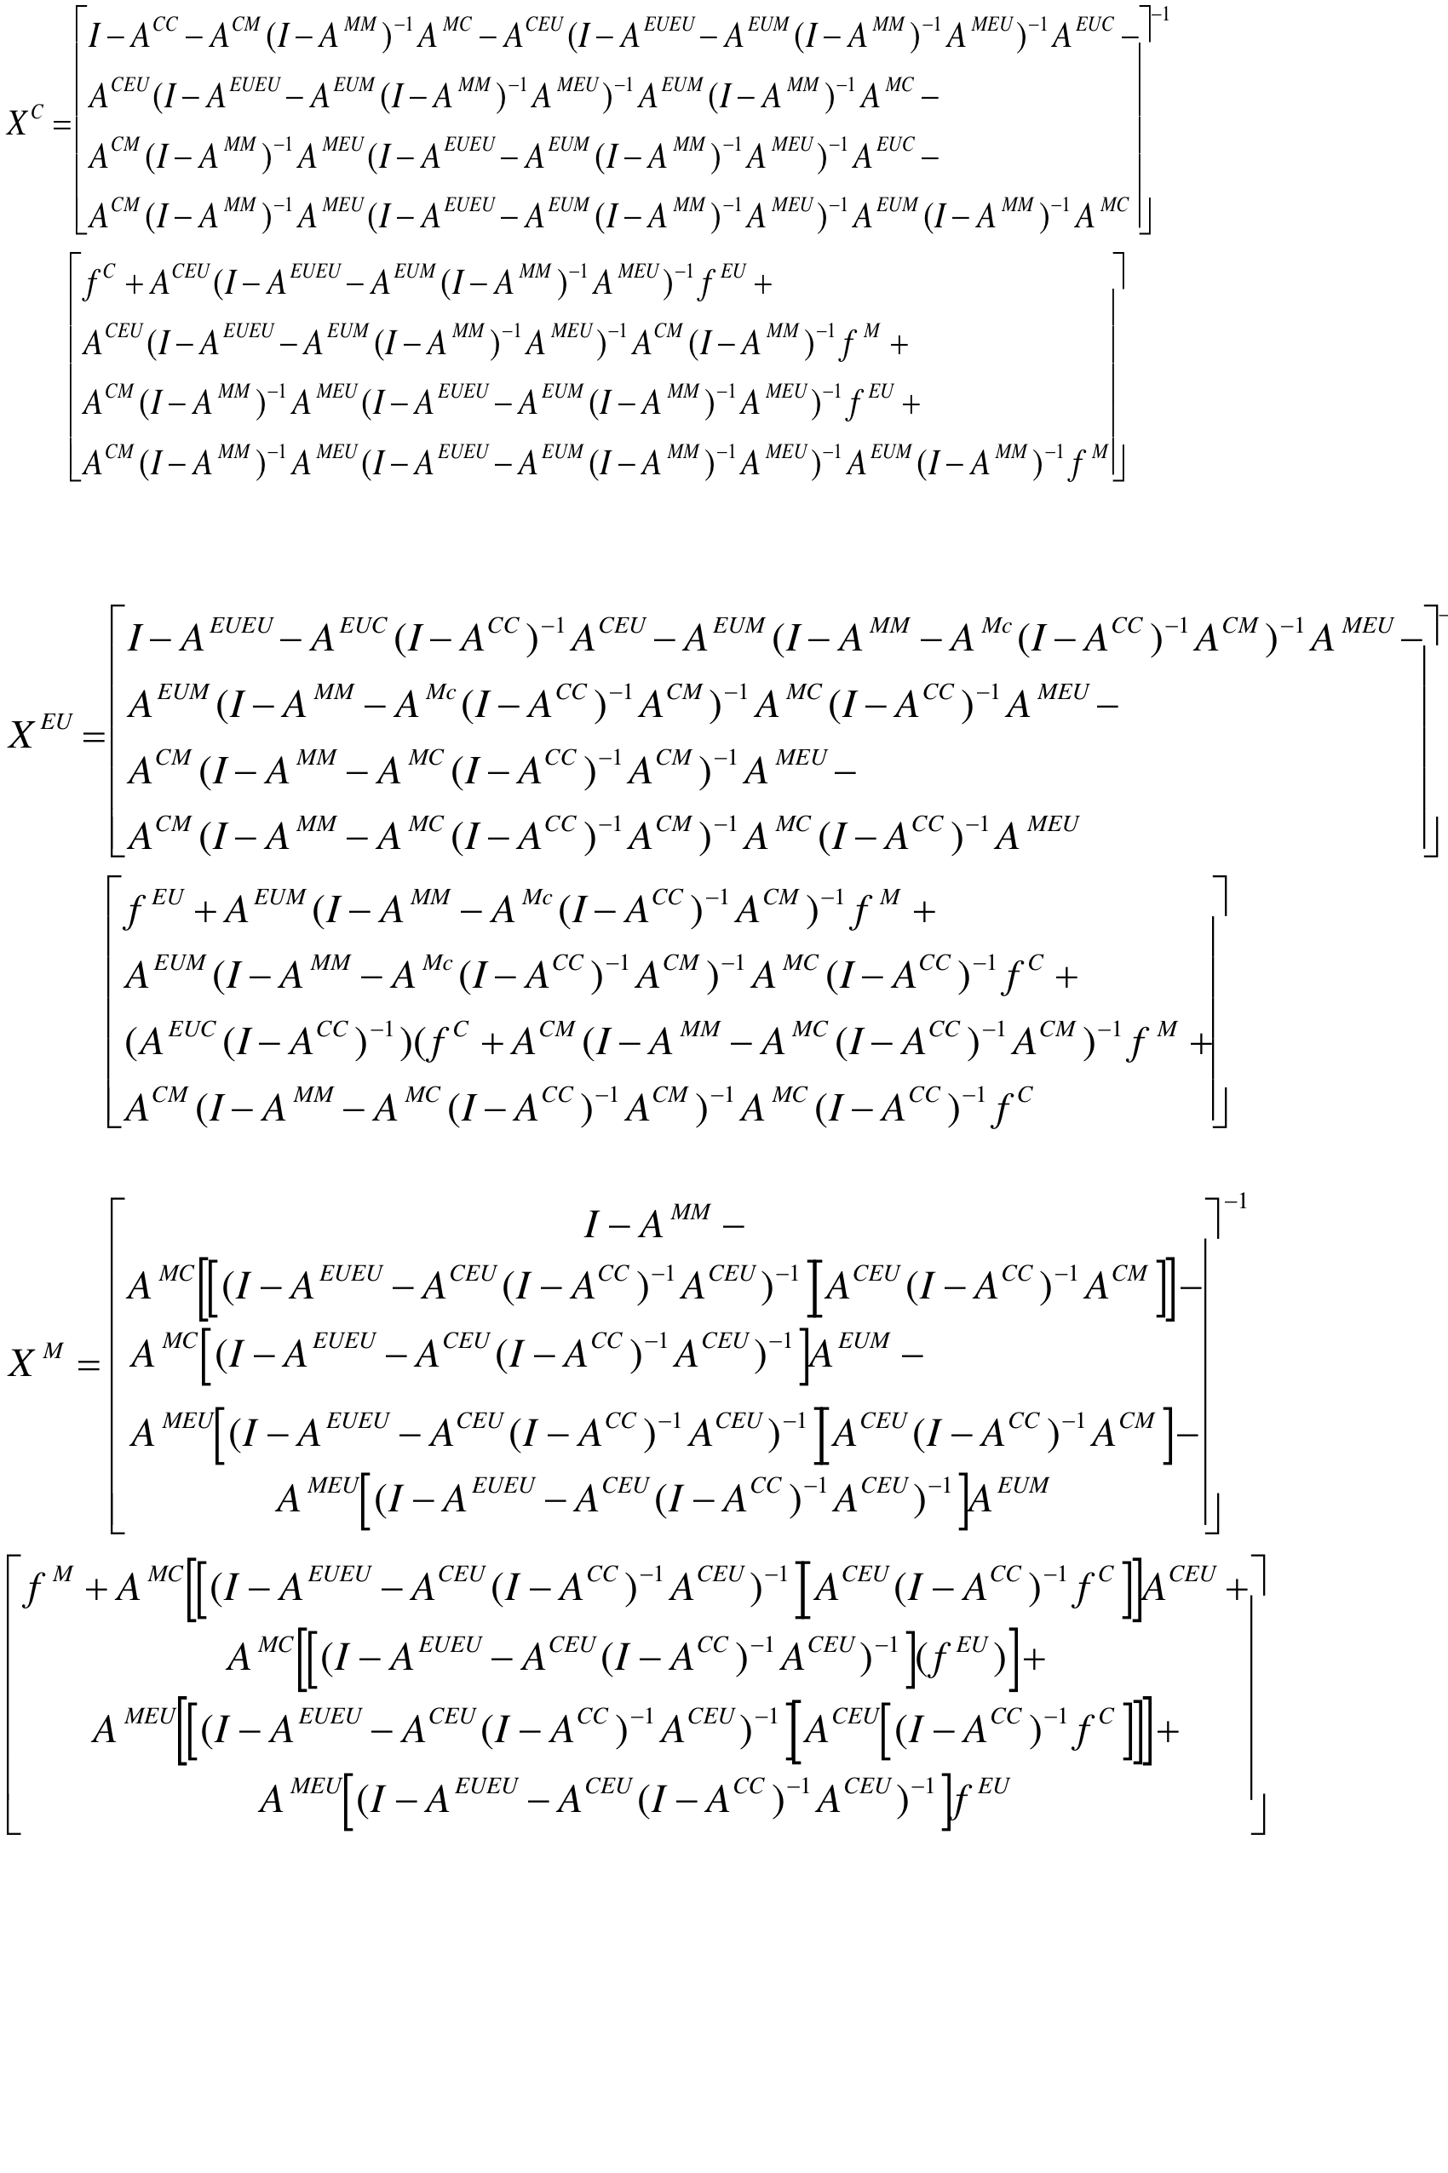Solution of supplie side for total effects of NA member countries.

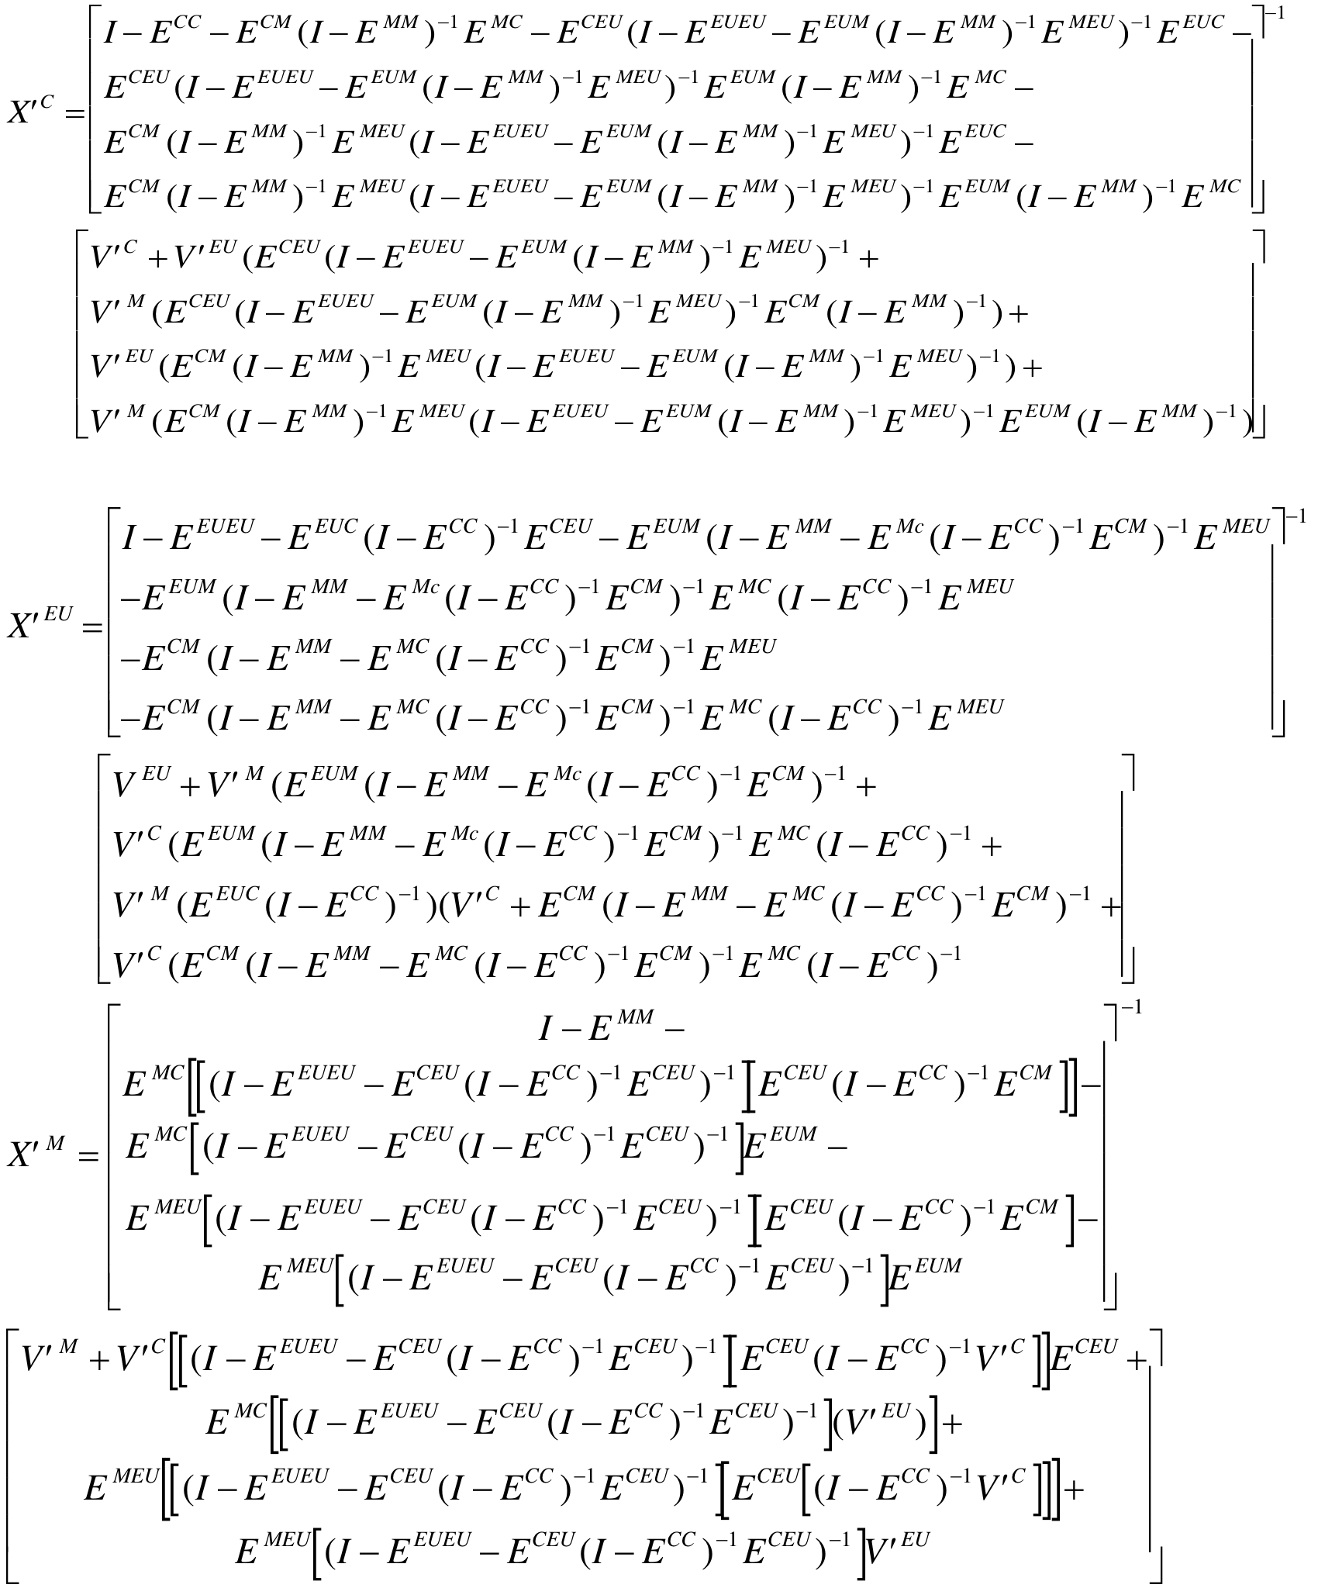

1. ♠ Doctoral student in economics from Universidad Nacional Autónoma de México.