Transaction Costs as Measurement of Institutionally Led Structural Changes
Maria ivanova
Faculty of Economics and Business Administration,
Sofia University “St. Kliment Ohridski”, Bulgaria

This paper aims to bind economic ideas outside of the mainstream with the established techniques of input-output analysis. New Institutional Economics brings out the concept of transaction costs as those costs that economic agents pay in order to exchange the results from their production and thus reap the benefits from the labour division. The process of economic exchange can be easier or more difficult, that is to say costly, depending on the rules for this activity. “Rules of the game” in a society are built in institutions. Therefore institutions and institutional change are as important as technologies and technological change. The paper presents a partial model for analyzing the results from the interactions between institutional and technological changes that happen at economy-wide level. It is is a modification of the original framework of Wallis and North (1994) because it uses nominal data. The input data come from an international database and this allows reliable inter-country comparisons. The model is tested with 20 countries for two 5-years periods. Examples of successful and unsuccessful structural changes are given. The model can identify if the consequences from these different impulses are synchronized and if this led to improvement in the overall efficiency of the economy. Also, it discerns economies with sluggish sectors that might fail the whole system in its future development.

Keywords: transaction costs, institutional change, technological change, efficiency

1. INTRODUCTION

Neoclassical microeconomics examines the problems of efficient transformation of inputs (raw materials, capital, and labour) into new products. The main postulate is that due to comparative advantages it is more productive if people and their economic organizations specialize in different businesses and afterwards exchange the fruits of their labour. The relevant phenomenon here is technological change and the consequent rise in the productivity of this transformational process.
New institutional economics brings out the concept of transaction costs as those costs that economic agents pay in order to exchange the results from their production and thus reap the benefits from the labour division. The exchange process can be easier or more difficult, that is to say costly, depending on the rules for this activity. “Rules of the game” in a society are built in institutions. Therefore institutions and institutional change are as important as technologies and technological change. In successful societies institutional and technological changes lead to those structural changes in the economy that lower all kind of costs, transformational and transactional (Wallis and North 1994).
In 1986 Wallis and North, in their article “Measuring the transaction sector in the American economy, 1870-1970”, try to give shape to the concept of transaction costs estimating their size as a proportion of the total economic activity in an economy. They gain several followers who replicate the measurement methodology using data for different countries, but little is achieved in the field of testing hypotheses or empirical approbation of models of the new institutional economics on macroeconomic level. All efforts remain in the field of the descriptive comparison.
The objectives of this paper are three. The first objective is to adapt a part of a framework for integration of institutional and technological changes (Wallis and North, 1994) so it can be used with easily accessible and standardized nominal data. The second objective is to process international data according to this adapted model and see if they reveal different patterns. The third objective is to define and find examples of successful structural changes in the economy using these data and this model.
The remainder of the paper is structured as follows. Section 2 explains the concept of transaction costs, their connection with institutions, and presents shortly a model of interplay between institutional and technological changes in the economy, as North and Wallis (1994) propose it. Section 3 gives reasons for the used data set, and describes it. Section 4 links this particular data set with part of the aforementioned but now adapted model. Section 5 reports the calculation methodology, and Section 6 discusses the results. Section 7 concludes and summarizes.

2. TRANSACTION COSTS, INSTITUTIONS, INTERACTIONS

2.1. Transaction costs
On the macroeconomic level transaction costs are vaguely defined. This does not mean they are unimportant. When something sounds vague, it is hard to be measured. When it is not measured, it is not possible to test it and the theories and the models connected with it. When a theory is not clashed with the empirics, it cannot develop, and it cannot prove as an important theory and enter the mainstream of economics. In this section I give a simple example of what transaction costs are, how they are influenced by institutions, and why institutional changes are worth keeping an eye on them.
In economy-wide aspect transaction costs are cited as “costs of running the economic system” (Arrow, 1969) and then every researcher plunge into their own comprehension of the matter. I prefer to take my stand from the words of Steven Cheung for whom transaction costs are “all those costs that cannot be conceived to exist in a Robinson Crusoe economy where neither property rights, no transactions, nor any kind of economic organization can be founded” (Wang, 2007). In microeconomics textbooks we can find the Robinson Crusoe economy as an example of how the production possibilities frontier can expand after Crusoe starts to trade with Friday. If Crusoe is better at doing one thing, say picking nuts, and Friday is better at doing another thing, say fishing, then for both of them it is a better solution to specialize in one activity and exchange the surpluses. And that is how the benefits from division of labour due to comparative and absolute advantages are introduced to students.
Now imagine that Crusoe and Friday do not trust each other while making business together. A situation that is typical for big markets with infinite possible contractors with never repeating contacts. Being only two on a desolate island almost precludes any idea for cheating and opportunistic behaviour but imagine that a ship of H. M. the Queen of Britain has discovered Crusoe and Friday and the two islanders have started trade with the British Empire. This is the only way to increase the consumption of the nuts and fish but it also imposes unpleasant consequences like a representative of the Empire being sent on the island. He, or nowadays she, will play the role of a law maker, a judge, a policeman, a soldier, a fireman, a builder of public infrastructure, a public clerk and a producer of all other public services that a developed economy needs in order to regulate the infinite number of transactions between agents that may not have good reasons to behave honestly, or perfectly rationally.

2.2. Institutions
The presence of this judge-policeman-clerk can actually be “pleasant” or “unpleasant”, that is to say in economic terms “efficient” or “inefficient”. If his presence increases the production of nuts and fish well enough to satisfy at higher level the needs of now three people in the insular economy, then the institutions that rule this economy are efficient. In the New Institutional Economics institutions encompass a wide range of rules that guide the economic behaviour of the agents. Starting from inner believes and values to legally set norms. If agents tend to cheat, or if laws are made equivocal, the Crusoe-Friday economy will need more representatives from the Empire to punish the cheaters and to explain the laws, and this will have no direct effect on the ability of Crusoe to pick nuts and the ability of Friday to catch fish. There will be no technological change in the economy, no change in the resources needed for production. There will be more transaction costs – the reward for the judge-policeman-clerks – because of this nature of the institutions. More costs to perform the economic transactions and same costs to transform the resources (fish in the sea) into products (fish in the pan), this is not a successful development of the economy. More transaction costs, combined with bigger drop in the transformation costs, would be another story.

2.3. Interactions
In their paper “Integrating Institutional Change and Technical Change in Economic History: A Transaction Cost Approach” (1994) Wallis and North develop a framework for analysing the relationship between technical and institutional changes. Technical change, which I call here technological, is any change in the composition of inputs that are transformed to products for final use or for intermediate use in further stages of the production process. In my example Crusoe and Friday perform such transformation function in the economy and all resources used for it are transformation costs. Their labour, the capital they may use, the raw inputs like bait for the fish. Institutions set the level of transaction costs – labour, capital, raw materials for the work of the judge-policeman-clerk, who has a transaction function in the economy. Institutional change may increase or decrease the transaction costs but more important is how these changes interact with the changes from the technological innovations. Altogether they may lead to increase in productivity, and then bigger costs will be compensated with even bigger output.
Second point in the paper is that both types of changes can give impulse in the economy. For example the legal construct of the corporate business, once invented, allowed for the collection of huge financial resources from multitude of capital owners with limited responsibility who do not need to know each other or to run directly the company. The financial securing of a production on large scale made reasonable the invention and implementation of technologies for mass production. Of course, it is vain to think we can undoubtfully separate the two processes and put one of them in the beginning: is that first engineers invented the new technologies or that first institutional phenomena took place in the society. It is good enough if the two types of changes happen synchronously with a reasonably small lag in time so that potential benefits from new production technology are not suffocated by inappropriate exchange mechanisms. It is more about the flexibility of the institutions and the rates with which transaction costs change, not their absolute levels. In fact, we cannot judge the efficiency of transaction costs when institutions are at rest because we cannot measure an alternative “what if” state. We can only assess the efficiency of the direction in which they change. Do they lead to bigger productivity or not.
Third point in the paper is that because innovations in one industry spill over the economy through the intermediate consumption, thus technological and institutional changes interact. For example when Alexander Bell invented the telephone, this was a technological change in its own industry. The industry of telecommunications has a transformation function in the economy. It combines raw inputs in such a way that we can transmit information over long distances in order to communicate. The invention of the telephone is called by Wallis and North “a transformation augmenting technical change”. It augmented the transformation function of the telecommunication industry. With the same resources, combined in a new way, we can transmit more quantity of information, and at a better quality. For the other industries, which use the telephone to coordinate the complex net of the modern production process, the invention of the telephone is a transaction augmenting technical change. It supports the increase of productivity of the transaction function in the companies. Now, we have to distinguish types of transaction costs.
In brief, Wallis and North (1986) discern three parts of the transaction function in the economy. There is one that is performed by specialized intermediaries, like financial industry, insurance industry, real estate industry, wholesalers and retailers. The companies in these industries help other industries sell their products. The essential feature of the value added of these industries is the change in the property rights, the change in the legal status of the exchanged products. Second place to find such a function is within the companies from the transformation industries. There is a multitude of professions which single purpose is to sustain the transformation of inputs from the entrance of the firm to its exit. If Robinson Crusoe was to set up the company Crusoe Inc. in order to reach economies of scale, he would have to deal with secretaries, foremen, managers, clerks, accountants, marketing specialists, etc. – all of them people with no direct link to the process of picking nuts from the palms. We cannot say outright that they are all useless. Third, here comes the Government like a big traffic policeman. It is supposed to relieve all tensions that occur in the process of exchange of products where specialized intermediaries (because of market failure) or specialized professions (because of principal-agent conflict) cannot cope with.
The ambition in this paper is only the first type of transaction function to be modelled with input-output tables. It is the type that concerns spillovers from institutional or technological changes through the economy using the linkage of intermediary consumption. Wallis and North (1994) imply eight types of changes, though they do not give historical examples for all of them. First pair, by type of the impulse, they are a technical or an institutional change. If it occurs in the industries with transformation function, it is a technological change; otherwise it is an institutional change. For example the development of investment banking in the financial sector is an institutional change. Second pair of possibilities, is by type of the influenced economic function. If the change influences the transformation function in the economy – this is the ability to transform inputs into outputs – this is a transformation changing innovation. Otherwise it is transaction changing innovation. The third pair is whether the change augments or attenuates the results from the economic performance. The eight possible types of changes, following from the interactions between institutional and technological development, result from these 2 x 2 x 2 permutations.
Last but not the least to mark off, Wallis and North (1994) speak of productivity which presumes data in constant prices while more practical from empirical standpoint it would be to formulate a model in nominal terms.

3. DATA SET

It is one thing to model in constant prices, and another to use what life can give us. The concept of productivity requires use of data at constant prices. But input-output tables at constant prices are not often met, and especially for free in internet. Nominal data would enormously relieve the comparisons in time and space.
The original paper from which the entire endeavour to quantify the transaction costs at macro level started is Wallis and North’s “Measuring the transaction sector in the American economy, 1870-1970”. It uses USA specific statistical data sets and ever after that, when replicated, there are doubts that differences in the results might be explained with differences in the statistical methodologies for creating the data sets. On the other hand, the institutionalist theory for transaction costs needs testing in different contexts and international comparisons are desired. That is why I look for an international database with uniformly created data.
Third, institutions evolve, on general, slowly. A timespan of a century is the most comfortable background for institutional analysis, like in Wallis and North (1986). But this means, on the current stage of history, to compare only developed economies with long statistical records. This disadvantage of less developed or transitional economies may be offset by the fact that, stimulated by globalization, they evolve more rapidly than established market economies. Therefore institutional and technological changes may show up in changing transaction and transformation costs in shorter periods.
The data for this research is from the Organization for Economic Co-operation and Development. STAN benchmark year, industry-by-industry, input-output total tables for 20 counties from mid-1990s to mid-2000s are used. I could have used tables for more countries if I have limited the search only to two points in time but I want to have three dates so that to be able to check the path of development from one 5-years period to another 5-years period. I also exclude countries that have different number of industries in different points in time. That is why I use only the tables for those 20 counties which have information for mid-1990s, early 2000s and mid-2000s and keep the number and types of industries unchanged.

4. MODEL FOR INTERACTIONS BETWEEN INSTITUTIONAL AND TECHNOLOGICAL CHANGES

How can we adapt the example of Alexander Bell’s telephone into a model that uses nominal data?
First, I introduce several notations borrowed from Miller and Blair’s textbook (2009).
Zij: monetary values of the transactions between pairs of industries, from each industry i to each industry j
Xj: monetary value of output of each industry j
Aij = Zij/Xj: technical coefficient, or direct input coefficient
TF ind: industry with mainly transformation function (TF) in the economy
TA ind: industry with mainly transaction function (TA) in the economy
BL: backward linkages

Here I present two possible scenarios for the economy-wide results from the invention and the introduction of the telephone in the production process. The first case is presented in Table 1. The telecommunication industry is the first TF industry in the Z table. We recognize the presence of an adopted innovation by the fact that it is expensive and demanded and that is why its Zij increases in relation to previous period. The output of the telecommunication industry increases too. The telephone is adopted in the production process but first, this does not lead to equal increase in the output of other industries, and second, the transformation and transaction functions do not change. This means that to serve 10 % increase in the output of any industry, 10 % increase in the Zij’s is needed both from supplying TF industries, other than the telecommunication, and from supplying TA industries. The sum of the technical coefficients “from TF ind to TF ind” and “from TF ind to TA ind” will, in general, rise. The sum of the technical coefficients “from TA ind to TF ind” and “from TA to TA ind” will stay the same. The backward linkages in the economy will rise. In the terms of nominal data, this is what we can define as an unsuccessful change. The economy has become more inefficient. It may produce more output but for it the economy uses even more intermediate resources.
Table 2 presents the second case when because of the technical change Alexander Bell’s telephone there will be augmentation in the transaction function of the economy. All those intermediaries – specialized in controlling the cost of purchasing inputs, monitoring the production process, selling outputs, and securing the exchange of property rights in the presence of opportunistic behaviour and bounded rationality – will be able to supply their output with greater efficiency.

Table 1. Links between transaction matrix (Z table) and technical coefficients matrix (A table): technical innovation with no effect on economic functions

Z-table change
 | TF ind | TF ind | TF ind | TF ind | TA ind | TA ind
TF ind | 1.5 | 1.5 | 1.5 | 1.5 | 1.5 | 1.5
TF ind | 1.1 | 1.1 | 1.1 | 1.5 | 1.1 | 1.1
TF ind | 1.1 | 1.1 | 1.1 | 1.5 | 1.1 | 1.1
TF ind | 1.1 | 1.1 | 1.1 | 1.5 | 1.1 | 1.1
TA ind | 1.1 | 1.1 | 1.1 | 1.5 | 1.1 | 1.1
TA ind | 1.1 | 1.1 | 1.1 | 1.5 | 1.1 | 1.1
X | 1.1 | 1.1 | 1.1 | 1.5 | 1.1 | 1.1
A-table change
 | TF ind | TF ind | TF ind | TF ind | TA ind | TA ind
TF ind | 1.36 | 1.36 | 1.36 | 1.00 | 1.36 | 1.36
TF ind | 1.00 | 1.00 | 1.00 | 1.00 | 1.00 | 1.00
TF ind | 1.00 | 1.00 | 1.00 | 1.00 | 1.00 | 1.00
TF ind | 1.00 | 1.00 | 1.00 | 1.00 | 1.00 | 1.00
TA ind | 1.00 | 1.00 | 1.00 | 1.00 | 1.00 | 1.00
TA ind | 1.00 | 1.00 | 1.00 | 1.00 | 1.00 | 1.00
BL | 1.06 | 1.06 | 1.06 | 1.00 | 1.06 | 1.06

Table 2. Links between transaction matrix (Z table) and technical coefficients matrix (A table): technical innovation with positive effect on transaction function
Z-table change

 | TF ind | TF ind | TF ind | TF ind | TA ind | TA ind
TF ind | 1.5 | 1.5 | 1.5 | 1.5 | 1.5 | 1.5
TF ind | 1.1 | 1.1 | 1.1 | 1.5 | 1.1 | 1.1
TF ind | 1.1 | 1.1 | 1.1 | 1.5 | 1.1 | 1.1
TF ind | 1.1 | 1.1 | 1.1 | 1.5 | 1.1 | 1.1
TA ind | 1 | 1 | 1 | 1.4 | 1 | 1
TA ind | 1 | 1 | 1 | 1 | 1 | 1
X | 1.1 | 1.1 | 1.1 | 1.5 | 1.1 | 1.1
A-table change
 | TF ind | TF ind | TF ind | TF ind | TA ind | TA ind
TF ind | 1.36 | 1.36 | 1.36 | 1.00 | 1.36 | 1.36
TF ind | 1.00 | 1.00 | 1.00 | 1.00 | 1.00 | 1.00
TF ind | 1.00 | 1.00 | 1.00 | 1.00 | 1.00 | 1.00
TF ind | 1.00 | 1.00 | 1.00 | 1.00 | 1.00 | 1.00
TA ind | 0.91 | 0.91 | 0.91 | 0.91 | 0.91 | 0.91
TA ind | 0.91 | 0.91 | 0.91 | 0.67 | 0.91 | 0.91
BL | 1.03 | 1.03 | 1.03 | 0.93 | 1.03 | 1.03

The output of the industries may rise but this will not require equal increase in the inputs from the TA industries. The sum of the technical coefficients “from TF ind to TF ind” and “from TF ind to TA ind” will, in general, rise. The sum of the technical coefficients “from TA ind to TF ind” and “from TA to TA ind” will decrease. The backward linkages in the economy may stay the same, or move up or down. It depends on the dominance of the effect from Atf,j’s or from Ata,j’s.
Several notes have to be made here.
In Table 1 we may not deal with an Innovator industry. It may be a Monopolist industry. Of course, every innovator is in the beginning a monopolist, before it’s innovation is copied by competitors. But when working with transaction costs and institutional change, new institutional economists paint on a larger canvas. The technological changes are fundamental and they concern the whole industry, not particular company in it. In this sense, there are no alternatives to bring down their cost. If they bring positive change for the economy, they will allow other industries to increase their output with fewer resources. This will drag down the backward linkages in the economy. If the Innovator industry acts like a monopolist for a long time, if it just redistributes the value added in the economy to itself, if the transaction and transformation functions in the economy do not augment, then the backward linkages in the economy will, in general, increase, showing worsening in the overall efficiency. In this case I would call the monopolist “a racketeer”.
A racketeering transaction industry may emerge from rules and laws that do not serve the productive, value-adding, processes but the processes of redistribution. Take for example the countries from Eastern Europe and the Balkans which left the communist economic system in the end of 1980’s. They all had to adopt new institutions to serve the market economy. But some of them are in NATO and EU now, while others are still outside these unions. And even between EU-members there are differences in the economic performance though they all have passed through more or less same accession period. EU capital markets are opened which means that technological changes can spill over the member countries equally. Formal rules are on the surface adopted by all member countries but their enforcement may drastically differ. If we have a quantitative model which catches the differences in the consequences from institutional change, we may be able to discriminate good practices from bad practices.
I try to model not innovations in particular industry but as a whole in the sector of transaction industries versus the sector of transformation industries. This is done in Table 3 and in this case the issues of different industry shares, magnitude of particular backward multipliers, level of aggregation (whether it is four TF industries versus two TA industries or other combinations) will not be severely important for the working of the model.
Let’s look at the model. We recognize the happening innovations, or call them just changes, by the increase of the output of the TA sector or the TF sector. Because the data are nominal and because generally in the economy there is inflation, the outputs will always increase. But when an industry, or a sector, has the advantage of the innovator (or the racketeer), the nominal value of its output will outjump the inflation in the output of the other sector.
If the two sectors can synchronize their development, we cannot distinguish the first block of results from the third. Just like in real economy, where we can hardly separate chronologically engineering from social innovations, but ultimately we are interested in the final result up to some moment in time, here the model does not discern between types of impulses as long as changes have synchronized during the examined period.
More importance is given to the influence on transaction and transformation functions in the economy, how they combine and the eventual effect on the backward linkages, that is on the efficiency in the economy. Also, such matters like import over export are indirectly concerned. For example if the TF industries’ output does not increase while at the same time the TF function attenuates, then the missing resources will have to be imported in the economy. The same effect, and also inflation, can follow an increase in the value added of TA industries, which is equal to increase in the incomes of the people who work there or invest there, if this increase is not soon enough spilled over to TF industries which provide the goods and services of ultimate interest. Remember that the business of the judge-policeman-clerk in the Crusoe-Friday economy is not end in itself. Nuts and fish are end in itself, and the money in the economy is ultimately chasing them.

Table 3. Interactions between transaction industries sector (TAS) and transformation industries sector (TFS)
the importance of TAS grows
leads to equal growth in TFS | changes in X of TAS and TFS are equal
no change in TF function | Atf,tf | Ata,tf | Atf,ta | Ata,ta | BL | 1995-2000 | 2000-2005
no change in TA function | no change | no change | no change | no change | no change |  | Germany
augmentation in TA function | no change | down | no change | down | down
attenuation in TA function | no change | up | no change | up | up |  | Spain
augmentation in TF function
no change in TA function | down | no change | down | no change | down |  | Belgium, Estonia
augmentation in TA function | down | down | down | down | down | BEST
attenuation in TA function | down | up | down | up | not clear | Estonia
attenuation in TF function
no change in TA function | up | no change | up | no change | up
augmentation in TA function | up | down | up | down | not clear | Hungary
attenuation in TA function | up | up | up | up | up
does not lead to growth in TFS  (at all or it is smaller) | change in X of TAS > change in X of TFS
no change in TF function | Atf,tf | Ata,tf | Atf,ta | Ata,ta | BL | 1995-2000 | 2000-2005
no change in TA function | no change | no change | no change | no change | no change
augmentation in TA function | no change | down | no change | down | down
attenuation in TA function | no change | up | no change | up | up |  | France
augmentation in TF function
no change in TA function | down | no change | down | no change | down | Slovenia | Slovenia
augmentation in TA function | down | down | down | down | down
attenuation in TA function | down | up | down | up | not clear |  | Netherlands
attenuation in TF function
no change in TA function | up | no change | up | no change | up | France
augmentation in TA function | up | down | up | down | not clear
attenuation in TA function | up | up | up | up | up
the importance of TFS grows
leads to equal growth in TAS | changes in X of TAS and TFS are equal
no change in TA function | Atf,tf | Ata,tf | Atf,ta | Ata,ta | BL | 1995-2000 | 2000-2005
no change in TF function | no change | no change | no change | no change | no change
augmentation in TF function | down | no change | down | no change | down
attenuation in TF function | up | no change | up | no change | up
augmentation in TA function
no change in TF function | no change | down | no change | down | down
augmentation in TF function | down | down | down | down | down
attenuation in TF function | up | down | up | down | not clear
attenuation in TA function
no change in TF function | no change | up | no change | up | up
augmentation in TF function | down | up | down | up | not clear
attenuation in TF function | up | up | up | up | up
does not lead to growth in TAS  (at all or it is smaller) | change in X of TFS > change in X of TAS
no change in TA function | Atf,tf | Ata,tf | Atf,ta | Ata,ta | BL | 1995-2000 | 2000-2005
no change in TF function | no change | no change | no change | no change | no change
augmentation in TF function | down | no change | down | no change | down
attenuation in TF function | up | no change | up | no change | up
augmentation in TA function
no change in TF function | no change | down | no change | down | down
augmentation in TF function | down | down | down | down | down
attenuation in TF function | up | down | up | down | not clear
attenuation in TA function
no change in TF function | no change | up | no change | up | up
augmentation in TF function | down | up | down | up | not clear
attenuation in TF function | up | up | up | up | up

5. calculation METHODOLOGY

The industry-by-industry input-output tables use a standard industry list based on ISIC Revision 3. For all countries except Ireland there are 36 industries in all three periods. Ireland does not have the industry “C23 Coke, refined petroleum products and nuclear fuel”.
The transaction industries are:
C50T52 Wholesale and retail trade; repairs
C65T67 Finance and insurance
C70 Real estate activities
C74 Other Business Activities
C75 Public admin. and defence; compulsory social security
This choice is in compliance with the framework presented in Section 2 and with the framework of Wallis and North (1986, 1994). The level of aggregation introduces some problems that are fully discussed in Egbert and Ivanova (2009) and in Egbert et al. (2010). For example the presence of repair services in industry C50T52. The transaction industry of the trade network is slightly “polluted” by the transformation function of the repair services. I prefer not to pay attention and to look at the “big picture” for the sake of international comparisons and easily available data.
All other industries are treated as transformation industries. The essence of their business is to transform inputs into new products and services in the same way they would have done it in a Robinson Crusoe economy or in a Crusoe-Friday economy without the judge-policeman-clerk. It is true that inside these transformation industries some of their resources perform transaction functions. These are the secretaries, foremen, managers, clerks, accountants, marketing specialists from Sub-section 2.3. Transformation industries do not buy all they need for the exchange of their production from the market. There can be substitution between transaction services bought from outside (visible in the technical coefficients) and the transaction services produced inside the firm (partly visible in the types of occupations of the labour factor). I think such a substitution cannot be that great in all of the 20 countries so that to stultify a model for interactions between institutional and technological changes which based only on input-output tables.
Transaction costs are the sum of Zij from the transaction industries. Transformation costs are the sum of Zij from the transformation industries. Backward linkages are the sum of transaction and transformation costs.
Change in costs is calculated as the difference between Aij from new period minus Aij from old period. Because Aij’s are between 0 and 1, their change should be read as “percentage points change” after multiplying by 100. Change in industry output is calculated as index number Xj^{-new}/Xj^{-old}.
6. RESULTS AND INTERPRETATION

The results for the first period, from mid-1990s to early 2000s, are given in Appendix 1. Appendix 2 is for the results from the second period, early 2000s to mid-2000s. All graphs present median changes. In this way outliers – single industries that lie too far away from the central tendency for the economy – are excluded. First, the changes in the transformation costs by types of industries are given. They are expressed as changes in the technical coefficients, or changes in Atf,ta and Atf,tf (see Table 3 for notation). On the second graph, the changes in Ata,tf and in Ata,ta are presented, or the changes in the transaction costs by types of industries expressed in technical coefficients. Last, the change in backward linkages for the whole economies is given. In other words, for example a fall in the transaction costs means that the technical coefficients Ata,j fall. This is equal to augmentation in the transaction function in the economy.

6.1. Countries that fit the model
The model recognizes interactions between the transformation sector and the transaction sector if the changes in one type of costs move in the same direction for both types of industries, or if there are no changes for both types of industries. On this ground, in the first graph in Appendix 1 there are eight countries that are eligible for the model as for the changes in the transformation cost. These countries are Denmark, Estonia, Finland, France, Germany, Hungary, the Netherlands, and Slovenia. In other cases, like in UK, the movements are in different directions, and this means that there is not an economy-wide change in the transformation function. The transaction sector and the transformation sector develop into their own paths without interaction between each other.
From the second graph eligible countries are Austria, Estonia, France, Hungary, Japan, Slovenia, UK. Putting together both types of changes – in transformation costs and in transaction costs, – the model indicates four countries with different patterns of interactions between transformation and transaction sectors. They are marked in Table 3.
Estonia and Hungary have sectors that can synchronize their developments. The difference in the change of outputs of the two sectors is below 10 % points, which I take as a mark line. From mid-1990s to early 2000s Estonia experiences augmentation in the transformation function and attenuation in the transaction function. For Hungary the augmentation is in the transaction function, in trade off for attenuation in the transformation function. The model cannot confirm that there are institutional and technological changes, and what order they happen. It can only show that if there were such changes, the structure of the economy allows the two sectors to grow equally and its functioning is flexible – it can trade off attenuation in one function for augmentation in the other. Still this does not help Hungary from being the country with the biggest growth in the backward linkages among all examined countries.
In Slovenia and France the growth in the output of the transaction sector exceeds the growth in the output of the transformation sector by more than 10 % points. In Slovenia this is combined with augmentation of the transformation function and no change in the transaction function. The importance of the transaction sector grows relatively to that of the transformation sector. This can be interpreted as growing number of economic transactions that have to be served – larger markets, more customers, or more regulations. But at the same time industries raised their productivity as for the transformation process. Maybe it is because of bigger economies of scale after the enlargement of the market. In France the growing importance of the transaction sector does not help the industries to increase their efficiency. Slovenia ends as the only country that has a fall in the backward linkages while France is among the countries with moderate opposite direction.
We can trace Estonia, Slovenia and France in the next period, from early 2000s to mid-2000s. The transaction function on economy-wide level stays the same but the transformation function augments. Maybe this augmentation is due to a technological innovation and the good news here is that the transaction industries do not respond in a limiting way. These relationships are of main interest for institutional economists. As Wallis and North (1994 p. 610) say:
“The framework developed in this paper suggests a new historical perspective on the relationship between technical and institutional change. It questions whether the growth enhancing effects of technical change – driving down transformation costs – are ultimately limited by the rising transaction costs associated with the institutional changes necessary to implement new technologies.”
The behavior of the Slovenian economy is the same, only that the output of the transaction sector keeps on growing more than its transformation counterpart. This may be explained with more exports of transaction services to the rest of the world.
France, after having attenuated its transformation function, now attenuates its transaction function. Certainly the French path of development is not as bright as that of Estonia and Slovenia. It actually is not bright at all.

6.2. Countries that “do not fit” the model
What can be said for the countries that do not fall into the categories of the model?
For example in the second period the Slovak Republic experiences the biggest fall in the backward linkages. With the original data being in nominal terms, this means that the Slovak entities work as the most efficient in the first half of the 2000s. This is due to falling transformation costs throughout the economy but the transaction function does not augment, which means the transaction sector is not supportive enough and in the future its sluggishness may stifle the growth of the economy.
Also in the second period, Taiwan suffers from the biggest drop in efficiency. This because the transformation sector probably undergoes a price shock in its transformation inputs. The median increase is more than 6 % points, and the major signal from my model is that the transaction sector does not react in time, it does not respond with a massive lowering of its output as input in other industries. So Taiwan may not fall into the categories of Table 3 but this missing may be interpreted as inability of the transaction and the transformation sectors to cooperate and synchronize their developments.
The model has to be polished for several things. As for marking lines of changes: is it the 1 % point of change that marks off a statistically significant change, or not? Is it the 10 % points difference in the output growths that put a country in the first block of Table 3, or in the second and the forth? Is it the median change that determines the direction of the change, and shouldn’t we look closer at outlying industries that may have key role in the economy?
The model cannot actually identify institutionally led structural changes, as it came out in the course of the research, but it can identify successfully changing countries and it incorporates matters of institutional character. It works like a “necessary condition” not “sufficient condition” for recognizing institutional changes that lead to more efficient structure of the economy.

7. CONCLUSIONS

In this paper I create a partial model for analyzing the results from the interactions between institutional and technological changes that happen at economy-wide level. It uses nominal data and this is a modification in comparison with the original framework of Wallis and North (1994) for integration of these two types of changes. The core idea of this quantitative model is that the evolution of the institutions – whether they evolve efficiently or not – can be traced with transaction costs. This type of costs is explained with a traditional microeconomics simplification, the Robinson Crusoe economy.
The input data come from an international database and this allows reliable inter-country comparisons. The model is tested with 20 countries for two 5-years periods. The results reveal different patterns in the countries development, and receive their relevant explanation according to the model. The model categories correspond to different interactions between institutional and technological changes in the economy. Examples of successful and unsuccessful structural changes (Slovenia and France) are given. Cases of countries that do not fall in the categories of the model can still be interpreted as lack of interactions between the industries that are responsible for transmitting the technological and the institutional changes in the economy.
The model cannot distinguish between technological and institutional impulses for the structural changes in the economy. It can identify if the consequences from these different impulses are synchronized and if this led to improvement in the overall efficiency of the economy. Also, it discerns economies with sluggish sectors that might fail the whole system in its future development.
More or less, the model works descriptively. It uses quantitative information to cluster economic performances and to ease the institutional analysis coming afterwards. In order to explain and to predict, this partial model should be upgraded into the level of a Social Accounting Matrix. It needs to include information for the types of professions/occupations in the industries and how different types of households earn and spend their incomes. It also needs the Government sector to be introduced.
Beside the analysis of efficiency changes, such a model could explain issues relating to foreign trade and inflation.

References
Arrow, K. (1969) The organization of economic activity: Issues pertinent to the choice of market versus non-market allocation. In: U.S. Joint Economic Committee (eds.), The Analysis and Evaluation of Public Expenditure: The PPB System. U.S. Government Printing Office, Washington, D.C., 59–73.
Chobanov, G. and H. Egbert (2007) The rise of the transaction sector in the Bulgarian economy. Comparative Economic Studies, 49, 683-698.
Dagnino-Pastore, J.M. and P.E. Farina (1999) Transaction costs in Argentina. 3-^{rd} Annual Conference of the International Society for New Institutional Economics, Washington, USA 16-18 September 1999.
Dollery, B.E. and W.H. Leong (1998) Measuring the transaction sector in the Australian economy 1911 – 1991. Australian Economic History Review, 38 (3), 207-231.
Egbert, H., Ivanova, M. and G. Chobanov (2010) New data on the Bulgarian transaction sector: 1997 – 2006. In: Chobanov, G., Plöhn, J. and Schellhaass, H. (eds.), Policies of Economic and Social Development in Europe. Lang, Frankfurt, 115-126.
Egbert, H. and M. Ivanova (2009) Transaction Employment in the USA and Bulgaria 1997 to 2006. 12th International annual conference: Discrepancies in Economic and Social Development in Europe, Sofia, Bulgaria 9-10 October 2009.
Hazledine, T. (2001) Measuring the New Zealand transaction sector, 1956-98, with an Australian comparison. New Zealand Economic Papers, 35 (1), 77-100.
Miller, R. and P. Blair (2009) Input-Output Analysis: Foundations and Extensions (2^{-d} ed.). Cambridge University Press, New York
Sulejewicz, A. and P. Graca (2005) Measuring the transaction sector in the Polish economy, 1996 to 2002. 9^{-th} Annual Conference of the International Society for New Institutional Economics, Barcelona, Spain 22-25 September 2005.
Wallis, J. and D. North (1986) Measuring the transaction sector in the American economy, 1870-1970. In: Engerman S. and Gallman, R. (eds.), Long-Term Factors in American Economic Growth. University of Chicago Press, Chicago and London, 95-148.
Wallis, J. and D. North (1994) Integrating Institutional Change and Technical Change in Economic History: A Transaction Cost Approach. Journal of Institutional and Theoretical Economics, 150, 609-624.
Wang, N. (2007) Measuring transaction costs: diverging approaches, contending practices. Division of Labor and Transaction Costs, 2 (2), 111-146.

APPENDIX 1. PERIOD MID-1990s TO EARLY 2000s
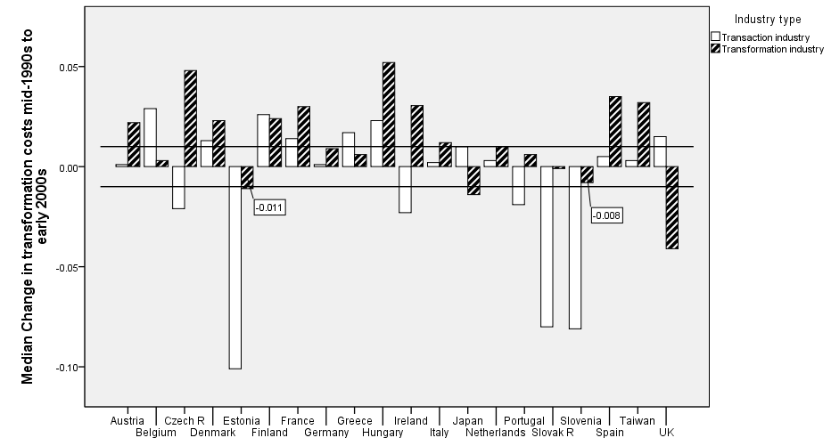
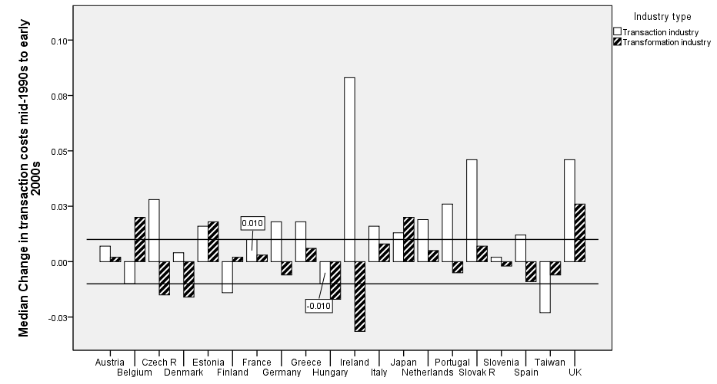
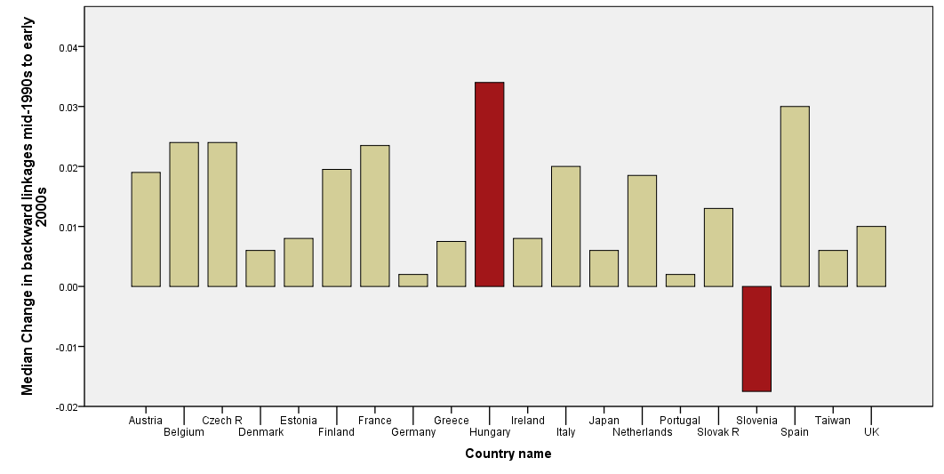
APPENDIX 2. PERIOD EARLY 2000s TO MID-2000s
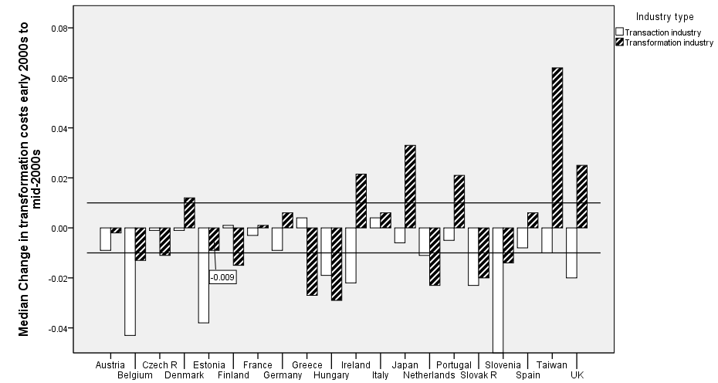
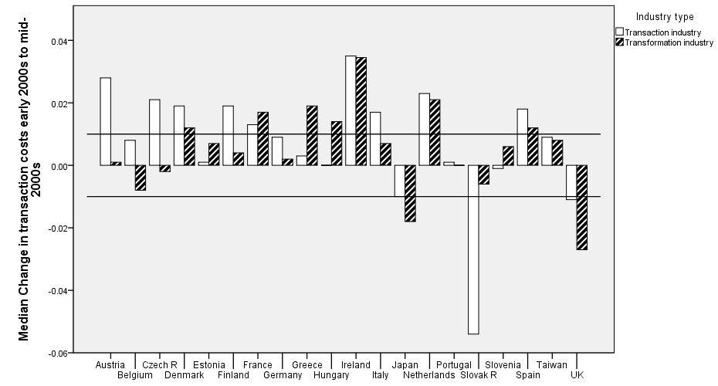
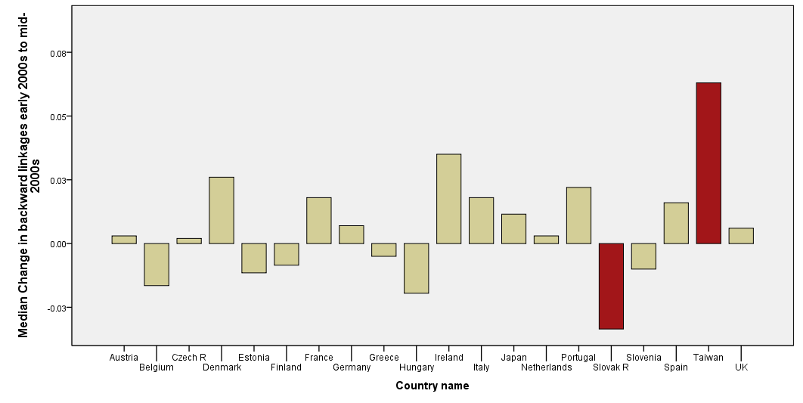

For Australia – Dollery and Leong (1998), for Argentina – Dagnino-Pastore and Farina (1999), for New Zeeland – Hazledine (2001), for Poland – Sulejewicz and Graca (2005), for Bulgaria - Chobanov and Egbert (2007), Egbert, et al. (2010).
Not being an expert on technological spillovers, I feel their success depends on the quality of the human capital in the countries. So differences in human capital might be one explanatory factor here.

