**The Arts and Cultural Production Satellite Account (ACPSA)**

**Paul V. Kern, David B. Wasshausen, and Steven L. Zemanek**

**22nd International Input-Output Conference**

**14-18 July 2014, Lisbon, Portugal**

Abstract

On December 5, 2013, the U.S. Bureau of Economic Analysis (BEA) and the National Endowment for the Arts (NEA) released, for the first time, prototype estimates from the new Arts and Cultural Production Satellite Account (ACPSA). In this satellite account, we used an input-output (I-O) framework to conduct an in‐depth analysis of the arts and cultural sector's contributions to current‐dollar gross domestic product (GDP).

Culture can be defined in a variety of ways to include language, traditions, beliefs, and values. For this new account, we defined arts and cultural production to be largely consistent with definitions used by the United Nations and the European Union. The I‐O framework provides the necessary tools to identify and then estimate the value of the "creative chain" associated with arts and cultural production. This chain captures the economic value as we move from the creation of a cultural product (composing a symphony) to its production (the performance being recorded in a studio), then the distribution (by various modes), and finally the consumption (by the listener). In this paper, we explore the processes and methods used to identify and estimate the value of arts and cultural production, including key findings that enable us to quantify the impact of arts and culture on GDP for the first time.

**1. Introduction**

On December 5, 2013, the U.S. Bureau of Economic Analysis (BEA) and the National Endowment for the Arts (NEA) released prototype estimates from the new Arts and Cultural Production Satellite Account (ACPSA). This was the first U.S. federal government effort to provide an in‐depth analysis of the arts and cultural sector's contributions to current‐dollar gross domestic product (GDP) in the United States. This new satellite account, which used an input-output (I-O) framework, found that, on average, arts and cultural production accounted for about 3.5% of GDP over the years 1998-2011.

The development and subsequent release of preliminary statistics for this new account have been well received by many of BEA’s customers and is consistent with the U.S. Department of Commerce’s goal to provide more data in order to enhance decision-making and better understand the U.S. economy.

“The positive value of arts and culture on society has been understood on a human level for millennia. With this new effort, we are now able to quantify the impact of arts and culture on GDP for the very first time.” -U.S. Commerce Secretary Penny Pritzker

In this paper, we first broadly introduce the concept of satellite accounting presently used in the U.S. economic accounts and then more thoroughly explore the processes and methods used to identify and estimate the value of arts and cultural production in the ACPSA. Next, an analysis of the results is presented, including a section comparing U.S. statistics to that of other countries. In the final section, we present future directions, including planned expansions for the ACPSA.

**2. Satellite accounts overview**

Satellite accounts are supplemental accounts that expand the analytical capacity of the national and industry economic accounts by focusing on a particular aspect of economic activity. These accounts are designed to provide more detailed information within a framework that is conceptually and statistically consistent with BEA’s principal economic accounts, while not interfering with the core accounts.

Satellite accounts may also provide a laboratory for experimenting and developing concepts and methodologies that are not ready for implementation into the core accounts. For example, in 1994 BEA first began experimenting with the concept of recognizing research and development expenditures as capital using the satellite account concept.[1] By first presenting these estimates in this way, BEA was able to publish statistics as “experimental” and solicit important conceptual and practical feedback regarding complex measurement issues. Based on both external and internal feedback, the methodology used to prepare these statistics was improved over time and these statistics were eventually fully implemented into the core U.S. economic accounts during the latest comprehensive revision of the accounts.

Other examples where BEA has successfully developed satellite accounts include transportation, and travel and tourism. The transportation satellite account was first released by BEA in 1998 with estimates for 1992 and was eventually turned over to the Department of Transportation’s Bureau of Transportation Statistics. This satellite account provided important details on how industries produce and consume this important service, including a more comprehensive measure of all transportation activities regardless of the industry that provided it.[2]

The travel and tourism satellite account (TTSA) was first introduced in 1998 and has evolved significantly since then. Initially, the TTSA measures were annual and current-dollar only, and they were not directly tied to the time-series of annual I-O tables (i.e. not fully integrated). Several years later, concordances were created to fully integrate the account into the annual industry accounts rather than to a single benchmark-year I-O table. Next, chain-type volume measures were introduced, which considerably improved the usefulness of these estimates given the price volatility of some of the commodities involved. Lastly, in response to the terrorist attacks on the United States on September 11, 2001 that devastated travel and tourism, BEA developed quarterly TTSA measures in order better analyze the recovery. These statistics continue to be produced today.

**3. Constructing the ACPSA**

**3.1 Conceptual framework**

Culture can be defined in a variety of ways to include language, traditions, beliefs, and values. For this new account, we defined arts and cultural production to be largely consistent with definitions used by the United Nations and the European Union. The I‐O framework provides the necessary tools to identify and estimate the value of the "creative chain" associated with arts and cultural production. This chain captures the economic value as we move from the creation of a cultural product (composing a symphony) to its production (the performance being recorded in a studio), then the distribution (by various modes), and finally the consumption (by the listener).

In order to view the structure of and relationship between cultural industries, the concentric circles model of the cultural industries developed by David Throsby (Macquarie University, Sydney Australia) can be quite helpful. This work provides an illustrative visual for transitioning from the most intuitive part of the account (literature, music, performing arts,…) through the wider cultural industries (publishing, television, computer games,…) and to the outer edge of the model where we find the related industries (advertising, architecture, fashion…).[3] If you place yourself inside the inner-most circle at a live performance and then think about the myriad goods and services provided by dozens of other industries necessary to place you in your seat – you will be on your way to developing a set of industries for a creative arts account. Without a set of backward links to acknowledging the role of supporting industries necessary for the core to function, the ACPSA would not reflect the true impact of arts and culture on employment, income, output and value added within the economy. Figure A in the appendix presents Throsby’s concentric circles.

The concept of a “creative chain” is reflected in the concentric circles model, especially as we look at industries in the outer spheres. These industries primarily serve to disseminate art that is produced in the innermost circles. A ballet is performed and filmed. The disc is produced and distributed. Then it is purchased at a retail store or downloaded from the Internet. Presenting the full scope of transactions in an I-O framework provides the ability to accurately quantify the full value of the creative chain within an economic framework that is consistent with total-economy value added (i.e. GDP).

**3.2 Methodology**

Although the conceptual boundary of art and culture in the U.S. economy is difficult to discern, using the detailed economic transactions from a benchmark I-O account that comprise art and cultural production was considered the best course to produce these estimates. The flexible nature and sound framework offered by a satellite account makes this an ideal fit for estimating the value of arts and cultural production (ACP). This section describes the process and methods used to develop these statistics.

The ACPSA was built from the bottom up using the rich detail provided by BEA’s I-O accounts. Items were identified for inclusion in this account in a highly collaborative effort with economists from the NEA. The U.S. I-O accounts consist primarily of the make and use tables, which present statistics on the production and uses (both intermediate and final) of products by industries. Using existing I-O account statistics, detailed make-table transactions were carefully evaluated and identified for inclusion (or not) into the ACPSA. A full suite of I-O statistics, including gross output, intermediate inputs and value added, was then developed based on this initial list.

***Step one: Identifying ACP commodities***

The make and use tables have detailed information on about 5,000 products within the U.S. economy. These range from agricultural products to professional services to government services. A list of every commodity included in the 2002 benchmark I-O account was generated. BEA staff worked closely with NEA staff to designate each one of these items as either arts and culture related or not related. A commodity was considered for inclusion if its output is intended chiefly as a function of creative or aesthetic engagement and/or its goods and services are intended chiefly to facilitate public access to such output. About 400 of the 5,000 items were selected to be included in the ACPSA.[4]

***Step two: Developing ACP industries***

Once the list of ACP commodities was completed, ACP industries were developed. ACP industries are defined as those industries that produce the commodities that were identified as arts and culture related. Most ACP industries already exist in the I-O accounts and generally follow the 2002 North American Industrial Classification System (NAICS). One exception is the “art support” industry, which is not explicitly recognized in the 2002 benchmark I-O nor in 2002 NAICS. This industry spans a number of different benchmark I-O and 2002 NAICS industries, and produces a number of different ACP commodities, including museums, design services and art education.

***Step three: Identifying the arts and culture portions***

Many of the items selected for inclusion into the ACPSA are not entirely arts and culture-related. For example, book publishing is primarily an arts-related commodity; however, it is not an ACP commodity entirely. Using their industry expertise, BEA industry analysts identified arts-related portions for their respective industries. In order to separate the “arts” portion from the “non-arts” portion, several data sources were used to supplement the information available from the I-O tables, including detailed information from the U.S. Census Bureau’s Economic Census (EC) that is not available as part of the benchmark I-O accounts. In some cases, the Census Bureau provided additional insights that proved invaluable for BEA to split commodities into their arts-related and “other” portion**.** Separating the creative from the repetitive was the goal with respect to detailed goods and services.

The construction industry was somewhat unique. Here, BEA purchased detailed statistics from a private source that identified specific construction projects that were considered to be entirely ACP-related and this information formed the basis of the partials for construction.

***Step four: Estimating ACP output***

ACP commodity output is estimated by applying the portions developed in step three to the output of the items identified in step one. The initial item output is taken from the published I-O accounts. ACP industry output is then derived by aggregating commodity output across industries defined in step two. Table A in the appendix presents the production of ACP commodities by industry for the year 2011.

***Step five: Estimating value added***

Value added is the difference between an industry’s output and the cost of its intermediate inputs. In a fully integrated I-O framework, value added equals the sum of the industry’s compensation paid; taxes on production and imports paid, less subsidies received; and gross operating surplus earned. While we can directly estimate ACP output, we are not able to directly measure ACP intermediate inputs nor the components of value added. As a result, ACP value-added is imputed at a detailed level by exploiting the relationship between ACP industry output and total industry output. That is, the ratio of intermediate consumption associated specifically with ACP industry output is assumed to be the same as the ratio of total industry intermediate consumption to total industry output. Table B in the appendix presents output, intermediate consumption and value added by ACP industry for the year 2011.[5]

***Step six: Estimating employment and compensation***

ACP employment and compensation are estimated using a methodology similar to that used for measuring ACP intermediate consumption, as described above. ACP employment and compensation statistics are derived at a detailed ACP industry working level by applying the ratio of ACP output to total industry output to total industry employment/compensation. Table C in the appendix presents employment and compensation of employees by industry for the year 2011.

***Step seven: Estimating total and indirect output and employment***

As described in the previous steps, the ACPSA includes estimates of output and employment for ACP-related commodities and industries. These are the estimates for “direct” output and employment. The estimates for indirect output and employment begin with the direct measures; total output and total employment equals the sum of the direct and indirect components.

Indirect ACP-related output consists of all the output used as inputs in the process of producing the direct output. For example, the paper used in books is an input into book manufacturing so paper is considered indirect output. Multipliers from BEA’s total requirements tables, which shows the production required (both directly and indirectly) to meet final demand, are used to estimate these values.[6] Estimates for indirect employment are created in a similar manner using a requirements-type table that is specifically for employment, produced as part of BEA’s Regional Input-Output Modeling System (RIMS). [7] RIMS employment multipliers are applied to the direct employment estimates to produce total ACPSA employment, with the difference between total employment and direct employment equal to indirect employment. Indirect ACP-related employment comprises all jobs where the workers are engaged in the production of indirect ACP-related output. Referring back to our example for indirect output, indirect employment includes those employees producing the paper that is used as an input for books.

**4. ACPSA Statistics**

With the release of the preliminary ACPSA report on the December 5, 2013, BEA published annual statistics covering years 1998-2011 for the following items: 1) current-dollar output by detailed ACP industries and commodities, 2) employment and compensation within these industries, 3) current-dollar value added by industry, and 4) commodity-flow details for ACP products. These preliminary statistics were prepared in a fully integrated I-O framework, based on the 2002 Benchmark I-O account. We are currently in the process of updating these statistics to reflect results from the recently released 2007 Benchmark I‐O account.[8]

ACPSA statistics are presented under the two broad headings: 1) core arts and cultural production and 2) supporting arts and cultural production. The core category includes those commodities in which output is identified as primarily contributing to arts and culture, including performing arts, museums, design services and arts education. The supporting category consists of those commodities that support the core category through publication, dissemination of the creative process, or other supportive functions. Supporting commodities include things like event promotion, printing, and broadcasting.

Value added, compensation and employment statistics are presented by producing industry for ten categories, including an “all other” (see tables B and C). Output statistics span both the commodity and industry dimension and as such form the foundation of the ACPSA statistics (see tables A and B). Commodities are presented with slightly more detail, including a split for information that separately identifies print commodities from electronic commodities. The industries and commodities presented are based on the 2002 North American Industrial Classification System (NAICS).[9]

**4.1 Snapshot of the most recent year**

All estimates in the first release were presented in current-dollars (i.e. unadjusted for price change). Table B in the appendix presents output and value added by industry for 2011, the most recent year in which we currently have these statistics. Value added for arts and cultural production was $504.4 billion, which was 3.2 percent of GDP. ACP's share of GDP in 2011 was larger than the share of industries such as mining, utilities, and banking. Gross output for ACP was $915.9 billion in 2011, with employment just under two million people. Compensation for these workers was $290 million, nearly the same size of compensation for all nondurable goods manufacturing ($308 million).

Core arts and cultural production, which includes performing arts, museums, design services, and arts education industries, contributed $135.3 billion to GDP, while supporting arts and cultural production contributed an additional $345.7 billion. Within the “core” group, “design services” led the way, contributing $76.5 billion (see chart below). Value added for this industry category reflects the production of advertising and architectural services. Value added for “performing arts” was $42.5 billion, which includes independent artists, writers and performers. Within the “supporting” group, “information” was the leading contributor to value added, with $198.7 billion. Value added for the information category reflects the production of telecommunications, broadcasting and other related services required to deliver many of the core art and cultural products. The second largest contributor to value added was “art support,” which includes both public and private promoters of the performing arts.

**4.2 Trends and comparisons**

While value added attributable to arts and culture tracks GDP fairly well, it does appear to be more sensitive to the contraction over the recent business cycle than the overall economy. The chart below presents a comparison of current-dollar GDP (scaled to the left axis) and current-dollar value added attributable to arts and culture (scaled to the right axis). The chart illustrates that during the Great Recession, arts and cultural production fell a bit deeper (3.5 percent) than did GDP (2.1 percent). We also see that during the expansion that takes place following the 2001 recession that arts and cultural production grows at a slightly slower pace than GDP; the average annual growth from 2001 to 2007 for GDP and ACP was 5.3 percent and 4.1 percent, respectively.

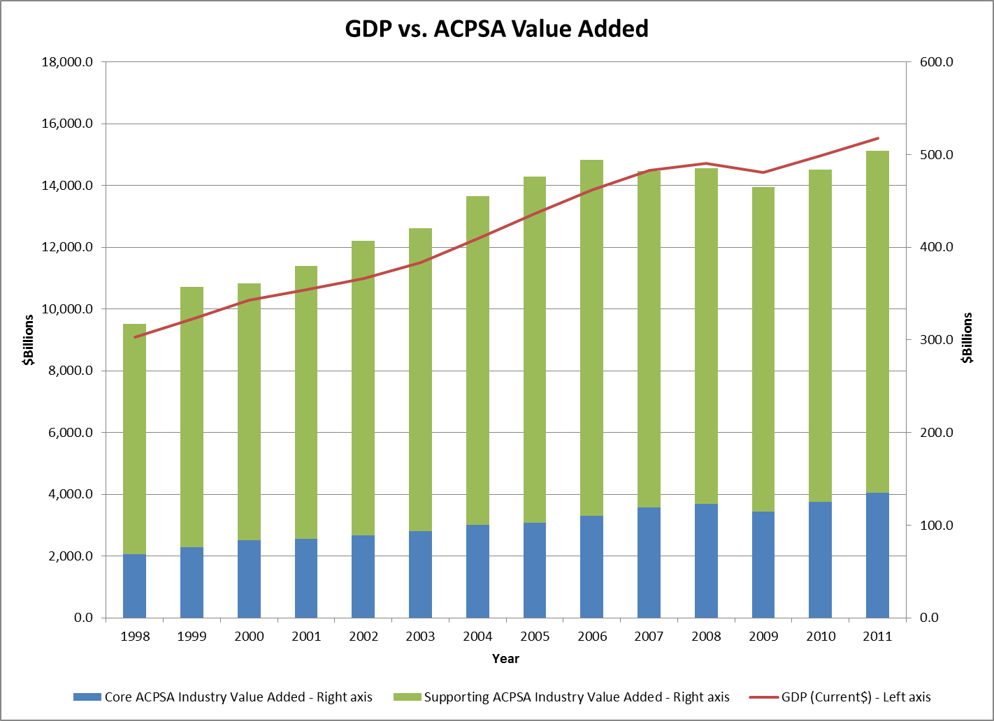

This new account also provides useful insights for trends within the ACP components and underlying detail. For example, the chart below presents output and value added for museums. The pattern for value added is interesting; we observe a notable jump in 2010 and then a flattening out in 2011. Turning to gross output to try to better understand the value added measures, we observe notable increases in both 2007 and 2008 followed by a flattening out beginning with 2009. The notable acceleration in gross output was wide spread in 2007, while the acceleration in 2008 was concentrated in historical site museums. The I-O ratios increase from 2007-2009, then drop notably in 2010 suggesting that museums became more efficient and profitable. Does this suggest that gross output is a leading indicator for value added for museums? Perhaps, but the salient point here is that these are the types of detailed statistics that the ACPSA offers for additional research and analysis.

While the value of ACP construction is relatively small (about three percent of overall ACP value added), there are some interesting trends and comparisons. Value added associated with the construction of ACP-related buildings that support and serve to disseminate art and culture include structures such as theatres, libraries and opera houses. The chart below compares indexed current-dollar value added for all construction (green), for construction associated with all ACP-type buildings (blue), and for construction specifically attributable to ACP (red).[10] All three value added measures trend similarly from 1998 to 2006; however, beginning with 2007 the three measures behave quite differently from one another. Value-added for ACP construction begins to decline in 2007, one year earlier than the decline observed for total construction. In 2008 and 2009, the U.S. economy was contracting and value added for all construction was falling, reflecting notable declines in residential construction. In contrast, value added for construction of all ACP-type buildings increased steadily in 2008 and 2009, before declining in 2010 and then flattening out in 2011. The American Recovery and Reinvestment Act of 2009 included fiscal stimulus for selected construction activity and this likely plays a role in explaining some of these differences in trends. Differences in movements beginning with 2008 between construction specifically attributable to ACP versus construction for ACP-type buildings is somewhat striking.

**5. International Comparisons**

Many countries – and several international organizations – have undertaken efforts to quantify contributions to the economy derived from art and culture and the supporting elements required by them. This section of the paper provides a brief overview of these efforts.

In 1986 the United Nations Educational, Scientific and Cultural Organization (UNESCO) put forth one of the early definitions of cultural production. Since that time, at least thirty seven countries have produced over sixty reports on this subject. These efforts had assorted goals and used a broad array of methodologies to achieve those goals. Some measure “arts and culture” together and some keep the two concepts separate. Others include heritage as a separate category, while some add sports as part of culture. (The U.S. ACPSA specifically excludes sports wherever possible.) Still others look at creative industries by identifying creative occupations. Floral designers are clearly a creative occupation. The majority of occupations within the florist industry are floral designers; therefore florists are a creative industry. Others look to industries that make products reliant on copyright protection. Although the receipt of a copyright for a good or service certainly identifies unique and creative qualities without subjectivity, it does seem overly restrictive when viewed in the context of a complex economy.

The range is even broader when one examines how countries attempt to measure art and culture. On one end of the spectrum, we find countries that have mapped creative industries; others focused on one artistic industry, and still others review trends and make recommendations. On the other end of this spectrum, we find more detailed and systematic construction of estimates. Often these estimates leverage existing statistics from the national or industry accounts, including I-O statistics. (As previously described, the U.S. account is constructed from the most detailed accounting of the economy – the five year benchmark input-output accounts.)

Measuring the arts as a stand-alone account is a relatively new concept and the efforts to develop these statistics spring from a wide variety of methods and definitions.[11] In contrast, tourism accounts benefit from the existence of a single body (United Nations World Tourism Organization) holding meetings with interested parties, and achieving a consensus on what to measure and how to measure these impacts.

Although the System of National Accounts (SNA) discusses satellite accounts briefly, the unique challenges in developing estimates of art and culture could certainly benefit from a specialized set of guidelines similar to those produced by the UNWTO for tourism. The United Nations Conference on Trade and Development in conjunction with the United Nations Development Program has produced the most comprehensive report to date in this area of art, culture and creative economy with their, “Creative Economy Report 2010.” This work does a tremendous job of cataloging the status of these estimates and the broad goals expected to be achieved by them.

Which countries have developed statistics on art and culture? This question is not as simple as it seems. There are several organizations that have developed estimates for entire continents – country by country. As well as many countries producing organic estimates of art and culture within their borders. The very first art and culture account was developed in France, and many European countries have multiple sets of accounts describing these statistics. Most recently the Australian Bureau of Statistics published their cultural and creative activity satellite accounts for 2008-2009. Table D in the appendix presents a listing of countries that we found statistics for art and culture, including a column that shows the average annual percent that arts and cultural comprises of that country's GDP.

What is perhaps surprising is that despite a broad divergence of methods and sources for developing these accounts, the results are coherent. The more complex economies show a higher share of their total economy stemming from art and culture and that share is generally within a fairly tight range. For less developed economies, the share originating from these activities is much lower. Nevertheless, these comparisons can be tricky as the underlying methods can be quite dissimilar.

**6. Future directions**

Satellite accounts at BEA evolve on two broad fronts: First as the user community provides input into the estimates themselves and second as the underlying structure of the U.S. I-O accounts evolve through the five-year revision cycle. The evolution, including underlying motivations for change for other BEA satellite accounts, was described previously in the satellites account section. In this final section, we describe our future plans for the U.S. ACPSA, recognizing that these plans are fluid and subject to change.

Preliminary estimates from the ACPSA were published in December 2013, just prior to the release of the 2007 Benchmark I-O account and corresponding comprehensive revision of BEA's industry economic accounts (February, 2014). These preliminary estimates were developed over the period 2012 - 2013 and were based on the economic structure provided by the 2002 benchmark I-O account. Immediately following the release of the comprehensive revision of the industry economic accounts, BEA began to update the ACPSA to reflect the 2007 benchmark I-O account. BEA will release revised ACPSA estimates later this year that reflect the results of the comprehensive revision.

The largest revisions to the ACPSA will likely stem from incorporating the 2007 benchmark I-O statistics. Revisions to the I-O accounts stem from three sources: 1) changes in definitions, 2) changes to classification, and 3) statistical improvements. Four major changes in definitions were introduced with the 2007 benchmark I-O account. By far the largest impact to the ACPSA is the capitalization of entertainment, literary, and other artistic originals. This newly recognized capital, which is recommended by the SNA, shows that GDP is larger by $74 billion in 2012. In the 2002 structure of the economy this value was not recognized as investment (nor output) and therefore did not appear in value added for any industry. Much of this value is likely to be identified as commodities that should reside in the ACPSA.[12]

The other sources of revision will come from refinements to source data and methods to develop the satellite account itself. For example, architectural services are currently in the ACPSA but only a small percentage resides there due to data limitations. It is expected that by using a broader array of external data, a much larger portion of this industry will be identified as creative and thus placed into the account.

Increased frequency is not envisioned for the ACPSA at this time; however sub-national estimates are. The U.S. NEA is charged with promoting art and culture in all 50 of the United States. To that end, BEA will begin work on developing state-level ACPSA estimates over the next three fiscal years. The relationship between the national GDP estimates and GDP by state is firmly etched in the BEA structure. It is expected that this new regionalization task will be extremely helpful to the arts community when published. BEA also plans to develop chain-type volume measures, which will be helpful for additional cross-industry comparisons and trend analysis.

Finally, a more subtle evolution of the account will take place as the most recent benchmark I-O account is fully linked into the arts account. In particular industry experts at BEA will be asked to review prior work on the ACP ‘partials’ (those industries whose output and value added were not 100% ACP). By comparing the old and new estimates and searching for new evidence of the split between ACP and non-ACP activity, we expect some improvements to stem from this research.



|  |  |  |  |  |  |  |
| --- | --- | --- | --- | --- | --- | --- |
| **Table B. Output and Value Added by Industry, 2011** | | | | | | |
| [Millions of dollars] | | | | | | |
| Industry | Industry output | Intermediate consumption | Value added | ACPSA output | ACPSA intermediate consumption | ACPSA value added |
| **Core arts and cultural production** | **618,737** | **180,392** | **438,345** | **195,827** | **60,576** | **135,251** |
| Performing Arts | 83,099 | 34,575 | 48,525 | 71,567 | 29,064 | 42,503 |
| Museums | 16,539 | 7,095 | 9,444 | 15,127 | 6,485 | 8,643 |
| Design Services | 340,462 | 76,501 | 263,962 | 97,965 | 21,453 | 76,512 |
| Arts Education | 178,637 | 62,221 | 116,415 | 11,167 | 3,574 | 7,593 |
| **Supporting arts and cultural production** | **2,808,398** | **1,197,561** | **1,610,837** | **678,525** | **332,859** | **345,665** |
| Art support | 1,598,413 | 574,256 | 1,024,157 | 145,417 | 52,845 | 92,572 |
| Information | 666,341 | 374,640 | 291,700 | 433,490 | 234,811 | 198,679 |
| Manufacturing | 120,478 | 75,056 | 45,422 | 33,506 | 20,934 | 12,572 |
| Wholesale & Retail Trade | 329,561 | 130,538 | 199,023 | 44,605 | 14,374 | 30,232 |
| Construction | 93,605 | 43,071 | 50,534 | 21,506 | 9,896 | 11,610 |
| **All other industries** | **23,827,708** | **10,801,223** | **13,026,485** | **41,514** | **18,039** | **23,475** |
| **Total** | **27,254,842** | **12,179,175** | **15,075,667** | **915,865** | **411,474** | **504,390** |

|  |  |  |  |  |
| --- | --- | --- | --- | --- |
| **Table C. Employment and Compensation of Employees by Industry, 2011** | | | | |
| Industry | Total employment (thousands of employees) | Compensation (millions of dollars) | ACPSA employment (thousands of employees) | ACPSA compensation (millions of dollars) |
| **Core arts and cultural production** | **3,979** | **300,341** | **622** | **65,576** |
| Performing Arts | 283 | 19,231 | 211 | 16,937 |
| Museums | 130 | 6,450 | 109 | 5,918 |
| Design Services | 1,509 | 174,419 | 283 | 36,789 |
| Arts Education | 2,057 | 100,242 | 18 | 5,931 |
| **Supporting arts and cultural production** | **19,078** | **1,257,038** | **1,335** | **211,611** |
| Art support | 14,653 | 922,925 | 129 | 82,061 |
| Information | 1,615 | 142,533 | 913 | 92,869 |
| Manufacturing | 619 | 33,606 | 81 | 9,446 |
| Wholesale & Retail Trade | 1,727 | 115,944 | 187 | 17,578 |
| Construction | 464 | 42,029 | 25 | 9,656 |
| **All other industries** | **114,944** | **6,745,866** | **1** | **12,313** |
| **Total** | **138,002** | **8,303,245** | **1,957** | **289,500** |

|  |  |  |  |  |  |  |
| --- | --- | --- | --- | --- | --- | --- |
| **Table D. Countries with Published Statistics on Arts and Cultural Production** | | | | | | |
|  |  |  |  |  |  |  |
| **Country** | **Years** | **ACP Share of GDP** |  | **Country** | **Years** | **ACP Share of GDP** |
| Albania | 2007 |  |  | Japan | 2001-2008 |  |
| Argentina | 2003 | 2.60% |  | Latvia | 200-2011 |  |
| Austria | 2003-2010 |  |  | Lithuania | 2010-2011 |  |
| Australia | 2008-2009 | 3.10% |  | Luxembourg | 2003 |  |
| Belgium | 2006 |  |  | Macedonia | 2009 |  |
| Brazil | 2010 | 1.60% |  | Malta | 2011 |  |
| Bulgaria | 2007 |  |  | Mexico | 2004 |  |
| Canada | 200-2011 | 3.80% |  | Netherlands | 2003 |  |
| Chile | 2004-2005 | 1.90% |  | New Zealand | 2002 |  |
| Columbia | 2002-2008 | 1.80% |  | Norway | 2007 |  |
| Croatia | 2008 |  |  | Peru | 2003 | 0.60% |
| Cyprus | 2003 |  |  | Poland | 2009-2010 |  |
| Denmark | 2003-2009 |  |  | Serbia | 2006-2011 |  |
| Estonia | 2010-2011 |  |  | Singapore | 2009 |  |
| Finland | 2005-2010 | 3.10% |  | Slovenia | 2011 |  |
| France | 2005-2008 | 2.80% |  | Spain | 2007-2010 | 3.20% |
| Germany | 2007-2011 |  |  | Sweden | 2006 |  |
| Greece | 2003 |  |  | Switzerland | 2003-2008 |  |
| Hong Kong | 2000 |  |  | United Kingdom | 1999-2011 | 5.8%* |
| Hungary | 2005-2010 |  |  | United States | 1998-2011 | 3.20% |
| Iceland | 2003 |  |  | Uruguay | 2009 | 2.93% |
| Ireland | 2003 |  |  | Venezuela | 2010 | 1.60% |
| Italy | 2006-2009 |  |  |  |  |  |
|  |  |  |  |  |  |  |
| ACP Arts and cultural production | |  |  |  |  |  |
| * Includes sports. |  |  |  |  |  |  |

Figure A. The concentric circles model of the cultural industries

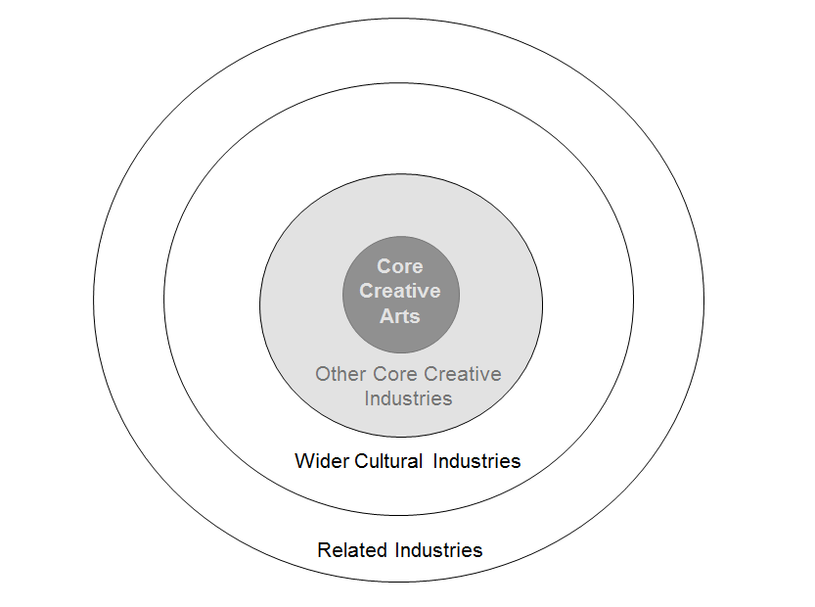

1. For additional details, see Carol S. Carson, Bruce T. Grimm, and Carol E. Moylan, “A Satellite Account for Research and Development,” Survey of Current Business 74 (November 1994): 37-60.
2. For transportation, this was particularly useful because transportation services are often treated as auxiliary services.
3. David Throsby (2008) The Concentric Circles model of the Cultural Industries, Cultural Trends, 17:3 147-164, DOI: 10.1080 / 09548960802361951
4. For the purposes of the U.S. ACPSA all sports were excluded wherever possible.
5. Estimates presented in table B reflect aggregations of detailed items, in which the ratio between intermediate consumption and total output exactly matches between the total and the ACPSA portion of the industry.
6. For additional information on total requirements, see Karen J. Horowitz and Mark A. Planting, “Concepts and Methods of the U.S. Input-Output Accounts,” (2006) at www.bea.gov.
7. For additional information on BEAs Regional Input-Output Modeling System, see “RIMS II User Guide,” at www.bea.gov/regional/rims/.
8. For additional details, see Donald D. Kim, Erich H. Strassner, and David B. Wasshausen, “Industry Economic Accounts: Results of the Comprehensive Revision, Revised Statistics for 1997-2012,” Survey of Current Business 94 (February 2014): 1-18.
9. Additional details regarding the composition of each of these categories may be found here http://www.census.gov/eos/www/naics/index.html.
10. Construction for ACP-type buildings includes all construction that mayor may not be ACP-specific. For example, the construction of educational buildings will include both ACP and non-ACP construction. Shares were developed to identify these partials and are described in more detail in step three of the methodology section.
11. Estimates of tourism are guided by the United Nations World Tourism Organization (UNWTO) headquartered in Madrid, Spain. The UNWTO publishes the International Recommendation on Tourism Statistics (IRTS) and organizes conferences to usher into existence harmonized statistics in the field. For more information, see <http://www2.unwto.org>.
12. For more information on the capitalization of artistic originals, see Rachel H. Soloveichik, “Research spotlight – Artistic Originals as Capital Assets,” Survey 91 (June 2011): 43-51.