CORE-PERIPHERY STRUCTURE IN NORTH AMERICA. A QUALITATIVE INPUT – OUTPUT ANALYSIS

Marco Antonio Marquez Mendoza♦
Draft

Abstract: It was found that the Qualitative Analysis of Input - Output (QIOA) contains information loss and that their method does not show conclusive results because they may be different for the same period. This paper discusses the weaknesses of QIOA again and finding the fundamental economic structure. From Core Periphery Structure (CPS) concept defined in social networks, the paper proposes a method to find such structures. This methodological approach is applied to a trilateral table input - output for members of the North American Free Trade Agreement (NAFTA) that has been developed purposely using the OECD database. The expected result is that at the level of each member, the structures of the center are of those branches related to trade, while in the context of NAFTA, the members of the structure of the center are greater in the case of the United States economy that its trading partners as well as the opposite case for members of the periphery.

Keywords: Economic structure, North America, Qualitative Input – Output, Core –Periphery Structure

CORE-PERIPHERY STRUCTURE IN NORTH AMERICA. A QUALITATIVE INPUT – OUTPUT ANALYSIS
Introduction.
The analysis of economic networks from the MIP, had its development in the early 1970s, when John Campbell (1972) and Ronald Lantner (1972) transformed a matrix of technical coefficients in a matrix of adjacencies and discussed the concept of economic influence. Campbell (1972) applied some algorithms of the properties in the adjacency matrix from graph theory (Harary: 1969) such as the path matrix, the relative centrality and the percentage of centrality. Lantner (1972) analyzed the matrix multiplier, however defined overall direct influences and influences from the entries in the matrix of technical coefficients and multipliers, however, unlike Campbell (1972), the author uses another selection criteria for the entries in the matrix of multipliers to then define the overall influence of transmission occurring after a certain path (c).
Most of the work during the seventies, eighties and nineties of the last century used different criteria to select entries in the matrix of technical coefficients or matrix entries multipliers and working with binary matrices (Aroche: 1996 Campbell, 1974, Bon : 1989 Czamansky and Ablas, Defourny 1974: 1982, Holub, Schnabl and Tappeiner: 1985), however, the Boolean or QIOA topological analysis can play different results, if a selection of different criteria for the same matrix (Aroche is: 2002, Holub, Schnabl and Tappeiner: 1985).
Under this nuance, to make a selection of entries of the matrices of the model, the QIOA aims to find the fundamental structure that reproduces the economic system. A couple of methods highlighted in the QIOA, analysis of IC and the MFA. The MFA has set a weakness because it generates information loss (Mesnard, 1995). This review arouses interest in finding the fundamental structure and ask whether in fact both the IC and the MFA reflect the economic skeleton, or may investigate some other way.
This document rediscute theme skeletal structure to identify ways to contain it from the concept of Core - Periphery Structure (CPS) as proposed by the theory of social networks, a new method is disclosed for identifying the CPS in skeleton.
The loss of information and minimum relative flow
In general, if the economic structure is a group of industries which are interconnected by purchases and sales of inputs and outputs, then this structure can be considered as a graph or a network where nodes are the industries and connections are trade flows. If we consider the flow of trade, then we can analyze those links on the side of supply or demand, then then the networks arising from such activity are digraphs, ie nodes with links directed.
Some authors believe that although there are valid concepts, ie are topologically consistent, when looking for the subset (A1) of the general assembly (IA) -1 implies transitivity not to use a filter for each stratum in the Road Analysis an agent in the (De mesnard: 1995) network.
It is worth noting that both an array of technical coefficients as a binary sets are rational. If it defined as the matrix of technical coefficients and W as adjacency matrix. According to MIP it follows that ${(I-A)}^{-1}=I+A^{1}+A^{2}+A^{3}….+A^{∞}=\sum_{i=0}^{∞}{A^{∞}}$, ie they are the direct and indirect influences between the productive sectors and variations in final demand can be calculated by way of matrix influences Leontief, because this matrix indicates the generation of product in each stratum. An approach to the concept of total direct and indirect from graph theory influences is the number of walks of length n, ie the number of roads to the sector i to sector j, according to the number of connections (Harary; 1969). This means that no matter if some connections and therefore some sections are repeated to reach the destination, for example, if we find the road sector i to j is possible that we have i→k→l→m→k→j, within the graph so $\sum_{i=1}^{∞}{W^{∞}}$ is the number of roads and paths not (as in the case of the vertices paths and connections are unique).
As the concept of multiplier as the total length of roads is seen n are similar, because they measure the total direct and indirect relationships in a structure, however, are different because W⁰ does not exist within the total formulation of the number of roads that are in the graph. And W is not reflective as in the case of A. Many authors have used QIOA have generated the graph without loops, ie, used the diagonal to zero (Aroche, 1996, Aroche, Garcia and Ramos, 2007, Blancas and Solis, 2005, Schnabl, 1994).
Both $\sum_{k=1}^{∞}{W^{∞}}$ as $\sum_{k=0}^{∞}{A^{∞}}$ can save a preorder (≿) so that if $A^{1}≿A^{2}≿A^{3}…≿A^{∞}$then $A^{1}≿A^{∞}$ so if $W^{1}≿W^{2}≿W^{3}…≿W^{∞}$ then$W^{1}≿W^{∞}$, ie both are rational. As is known $\sum_{i=0}^{∞}{A^{∞}}$ is the union of arrays (≥) so $A^{1}>A^{2}>A^{3}…>A^{∞}$ so $A^{1}>A^{∞}$ in this sense if A → W then it should be that $W^{1}>W^{2}>W^{3}…>W^{∞}$ and $W^{1}>W^{∞}$ however shown that $\sum_{i=1}^{∞}{W^{∞}=W^{1}<W^{2}<W^{3}…<W^{∞},}$ and although A∞〗 approaches zero (Miller and Blair 2009) and $W^{∞}$ tends to infinity (Hage and Harary: 1991), both are the total of direct and indirect relationships, ie direct and indirect ways in the transmission of the influences of sector i to j.
However, when working with the adjacency adjacency violation is generated to preorder matrix multiplier, for example if the electricity influences industry machinery and equipment, and industry influence in the service sector and the service industry influence to education, the adjacency adjacency means that the electricity no longer affects education, however, "the loss of information is necessary to simplify the data" (De Mesnard, 1995, pp443), the real loss is that the linkages in stratum 1, 2 disappear, and as you approach the series of power tend to zero, ie that it meets
The proposed minimum flow analysis by Schnabl (1991,1994, 1995), part of the generated impacts of final demand and works with a subsystem generated by the average size of multipliers, mainly with the object of expenditure for research and development (R + D). This approach analyzes the spread of size filtration by multiplying each of the layers of the series approach. Schnabl (1995) shows that the minimum flow the edges of the graph are also lower, ie, it is the case where no topological variant since $A^{1}>A^{2}>A^{3}…>A^{∞}$ and $W^{1}>W^{2}>W^{3}…>W^{∞}$. The MFA denies that $W^{∞}$ tends to infinity.
Although it is binary operations, the filter each stratum links that make it impossible, for example electricity and education influence that these links disappear as advances in strata are lost. With the so-called dependency matrix, the minimum flow level is sought as this to perform binary operations substructure, each of the layers represent a path that can be expressed by aggregating paths complete the structure.
Mesnard (1995) proposed that each layer is filtered by the weighting of the elements of each AK (in relative terms) for the indirect relationship of the electricity industry to education is maintained, then the transitivity is maintained, this implies that$W^{k}=W^{k-1}=W^{k-2}…=W^{1}$ From the standpoint of preorder, Σ_ follows that if $\sum_{k=0}^{∞}{A^{k}}and \sum_{k=1}^{∞}{W^{k}}=\left\{≿\right\}$ implies that the relative flow analysis minimum $W^{1}∽W^{2}∽W^{3}…∽W^{∞}$ so $W^{1}∽W^{∞}$. So the loss of information, once selected some matrix entries IPM not happen.
Although the QIOA make a selection of some matrix elements of the model, for example, technical coefficients, using a filter, no guarantees that in reality they are the skeleton of the structure, then the question arises how to find that item.
The skeleton of the structure
The QIOA, part of the quantitative approach, to define a structure that must be understood as critical, important or skeleton. Another major approaches QIOA network is generated in the search for the IC in which no matter the size but its position within the structure. However, the methods employed, required to maintain the properties of the model because A → W. Since the MIP, A is a reflective assembly as A ~ A; which implies that orderly $A^{0}A=A$. $A^{0}$ is the identity matrix but if this be transferred to a graph would find isolated nodes, which loses meaning in the concept of a graph (nodes but are not relations). Reflexivity within the model means a sector bought and sold himself.
A key concept developed in graph theory is the parent of accessibility, showing access to aj ai if this is a path, this means that there is only one way to points and connections that are not repeated. Then, i and j inputs $w_{ij}^{(k)}\#∈W^{k}\#=1↔∃$ at least one path of length k. Thus it must be $\sum_{k=0}^{∞}{W^{∞}}$ so the total reflective paths are as $W^{0}W=W$ thus $(I-A)^{-1}=$ $\sum_{k=0}^{∞}{A^{∞}}$ so$(I\#-W{\#)}^{-1}=$ $\sum_{k=0}^{∞}{{W\#}^{∞}}$ showing the paths of length k are rational and meet reflectivity. The skeleton of the structure, can be checked through the matrix of accessibility this skeleton has been proposed by the MFA and the CI.
Core - Periphery Structure (CPS)
A productive structure consists of a group of companies, activities, branches or sectors (depending on the level of disaggregation of the database), interconnected by flows of goods demanded by each of the productive agents to carry of its business activities. Of course these flows can also be understood from the supply of goods, the dual role of economic agents, determines the type of dependency relationships between them. However, in this double role of the sectors does not necessarily contains a dual way of relating between sectors as the situation of supplier and demander is simultaneous.
From network theory has it defined the dual relationships between nodes in the network, so that if an agent has a feature no other, for example, if it is good then it is not bad, is a bipartition graph in which each element of a subset is additional to another concept indeed implies that binding of the n subgroups partitions make the whole graph. So CPS, involves dividing the nodes of the network into two groups.
In several studies of network theory it discussed the existence of a relationship of dependency between network members, defined as ECP (Borgatti and Everett, 2005, Harary, 1967). Borgatti and Everret (1999) propose a model to find the ECP in a graph G undirected consisting of "delineate areas of interest", by means of a comparison between a network under study, built with actual data and an ideal network that is, a floor with observed vertices, adding the necessary network edges, so that each vertex of the center is connected with each of the members of the subset C and the peripheral members are connected with the center vertices). The model uses a measure of network proximity between the observed and ideal defined in the following equations:
$$ρ=\sum_{i,j}{w_{ij}δ_{ij}} (1)$$
$$δ=\left\{\begin{matrix}1 if c_{i} is in C ó c_{j} is in C \\ 0 in otherwise\end{matrix}\right\} (2)$$
w_{ij} the elements shown in the graph of the real network, W = {wij}, δ_{ij} refers to the type of nodes, central or peripheral; and ρ is a Pearson correlation coefficient normalized no real matrix comparing the real matrix W with ideal Δ a caveat that omitted the main diagonal of the matrix, thus omitting the relationships that members keep to themselves; in fact from the IP model this methodology has been used to find production centers in Europe incorporating some restrictions the original model (Garcia et al, 2007).
If we assume that a graph (G), representing related network members; those are plotted as vertices (V) or points connected by edges -addressed or not (E). Synthetically one graph G (V, E) is a set of vertices (v1 ... vj, vk, ... vl) interconnected by e₁₂, e_{1l}, … e_{2k}, …, e_{kl} edges. For example, the edge e_{2k} better one if the member 2 is connected to the member k, zero otherwise. If the edges have no explicit address, this also means that the connection member is connected k 2.
By contrast, the directed edges (arcs) imply that relations between members of the network are not necessarily symmetrical, for example, if a branch IP model h inputs to demand, this does not mean that the second inputs to sue first. The value of the edges can be arranged in a matrix of Boolean adjacency -binaria- W, which shows whether two sectors have been connected by an edge showing the direction of demand, in which case it is described as "adjacent" to each other. Therefore W is not a symmetric matrix. In this graph, a subset of vertices are connected if a path forming a sequence which monitors an order between the vertices; when the path is to start and end at the same vertex vi, a cycle is defined.
The question is whether there is an economic structure to a cyclic subgraph in G, which is a structural center C (C ⊂ G) formed by a subset of m ≤ n vertices (vi, vk, ..., vj) connected through relationships mutual between these m sectors: e_{ij}, e_{jk}, …, e_{kl} and e_{lk}, e_{kj}, …, e_{ji},, which transmits impulses across sectors through intermediate demand, spread among all members and perpetuate the cycle pulses demand. In this case, the structure represented by the graph G contains a "center" or core. This is a subgroup of highly cohesive and dense vertices, while the rest of the vertices v_{n}, v_{ñ}, …, v_{p},, which relate to members of the center are located in the "periphery". The CPS in a graph G may contain zero, one or more cycles to its interior, which also may or may not be linked.
In graph theory they have developed various algorithms for finding cycles in directed graphs; for example Gibbons (1994) states that if a directed graph is possible to find a subgraph such that all vertices are connected by edges in one direction and no circuits, a spanning tree is defined. In this tree each pair of vertices are connected via a single path and, if there are n vertices, are required n - 1 to define arcs. We show that the addition of a more directed edge on that path, a circuit defined. Also, adding arches spanning tree a set of core circuits defined; any circuit in the graph can be expressed as a linear combination of the members of this set, forming a space-based circuits. This is also valid for a component in a graph: a subgraph defined a subset of vertices connected by a subset of the edges contained in G.
To use these concepts within the model is transformed to IP technical coefficient matrix A in a Boolean matrix W = {wij} (vid. Supra.). The relationships between the sectors of the economy through a graph not valued in the economic structure G = (V, E), where V is the set of sectors of economic network, linked through intermediate demand, represented represented by the set E, which is necessarily directed arcs or edges. In this graph of the economy can be a CPE, if on one hand there is a subset of sector V forming a center (C) through their terms of trade of inputs, which in turn are associated with the sectors that form the periphery structure.
The subset C is identified with a highly cohesive group of sectors remain the most significant cross-cutting relationships, that it will be easier to spread the impulses to growth or decline-for example between pairs of sectors remain "strong" relations: mutual relations of supply and demand, since in that case the pulses are fed back almost immediately (Gibbons, 1994; Krugman, 1993). In the longer cycles feedback pulse is diluted among the members of the path and the time required for them to return power to the sector expands, while relations between the sectors of the periphery or between them and the central sectors, however not capable of growth feedback pulses.
In general, an IP matrix a very dense graph will be associated, that is, if the matrix is ​​of order nxn is both indecomposable time, the number of zero entries will be relatively small and sectors will be connected by flow demand by nxn nearest number, so that the analysis of the graph becomes very complex and algorithms for solving the problems may not accurately reflect important characteristics of the economic structure. Hence the importance of simplifying the problem from the start as much as possible.
Identify an CPS in a directed graph in a network of n nodes belongs to the class of NP complete problems, because the only way to prove that they have been taken into account all possible circuit size 2 to n is in effect, analyze network direct and indirect connections of each sector. Thus, the algorithm used in this work begins by estimating net output multipliers and use the average of those sectors have greater spillover effects on the structure and push through the characteristic roots and vectors characteristics and μ is the multiplier Average sector momentum, is used to filter the entries of the matrix A. If
a_{ij ≥} μ → w_{ij} = 1
a_{ij ≤} μ → w_{ij} = 0
αij average product multiplier associated technical coefficient aij is an indicator of the potential of the sector j to influence the dynamics of production of sector i if production that expands into a unit-for exogenous causes. The filtro μ represents the average size of the key sectors and separate the entries with the greatest potential of spreading growth impulses. Then, it has built the network of connections in each sector from identifying pairs of sectors strongly cohesive in the economy, that is, those pairs of sectors that have mutual direct connections, around which the centers of the structure are analyzed economy.
The existence of the CPS can be explained from the concept of cyclic graphs, which led networks does not mean that the geodesic space of a cycle is at least three members that it meets the existence of a path that starts from ai and whose point of arrival is the same as starting, so for example a path composed of ai - aj - to - ai is a cycle. If left untreated the geodesic cycle, a graph may have cocycles, ie cycles within other as shown in Figure 1, the network A), the cycle can be defined by the elements {A1, A2, A3, A4 } with a pair of cocycles formed by {A1, A2, A3} and {A1, A3 and A4}. However, in networks directed geodesic cycle concept has at least two elements, for example the path ai - aj - ai, which means that the geodesic is a cycle path to elements with reciprocal relations. In B) network of Figure 1, shown cycles found depend on whether they are for emission or reception of influence because as the circuit formed by the path {A2, A3, A4} can be seen emission is not the same as in For reception, in fact does not exist, geodetic network 2 cycles are formed by cocycles of {A1, A2} and {A1, A3}.
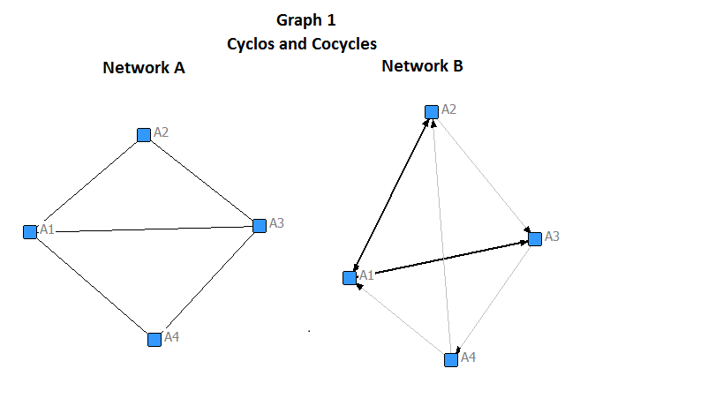
From the notion of cycle suggest find the ECP in directed networks, defining the center as those members of a cycle in which close relations are maintained between the members. However, the cycle can be articulated by a subgroup, that is, it comes to agents which maintain interactions with most members of a cycle, in this sense members of a cycle forming a core of relations, but may be articulated by a subset, in this regard, the cycle belongs to the sectors that articulate. From this perspective the influence of agents receiving a network circuits are defined as the periphery and the circuit as the center.
One way to identify the ECP in networks is directed through the concept of proximity. The problem of proximity in digraphs is identify if the path of ai to aj is or is not equal to the path j to i, and this implies that for a sector to maintain close relationships with other need reciprocal relations, ie the geodesic between a pair of agents must be of length 2. In economic networks do not all sectors can maintain reciprocal relations, for example you may face a boost in demand for the products of the forestry industry, the industry demands products the electronics industry directly and not vice versa. but it is also possible that the pharmaceutical industry demand products agriculture industry when facing a boost demand and that agriculture demands the same impulse products from the pharmaceutical industry; industries and maintain close relationships when reciprocal relations and both have experienced growth impulses.
In the event that the industry could maintain reciprocal relations, a seamless network would involve the maximum closeness. If a digraph is full then the matrix adjacency is a matrix of ones, if we define the nearness as the geodesic path point wi to wj equals wj wi then is of length 2, so that the matrix of reciprocity perfect is an array equal to 2 elements.
Now, to identify the proximity of the sector in the structure we define the matrix of reciprocity whose elements are, and entries take values ​​of 1 and 0, ie 1 + 1 = 1, 0 + 1 = 1 + 0 = 0 and 0 +0 = ∞ which means they are areas close if 1, 0 if there is an issue price of influence and ∞ if there is any relationship. If we want to capture the kind of influences from an array, we can define the matrix characterization of influences that indicates the type of role sectors in spreading the influence, if we define as the matrix characterization of influences with elements, whose values ​​are 2,1,0 and ∞, indicating reciprocity, broadcast, reception and no links respectively.
From the characterization matrix, the column vector indicating influences characterization of each agent is obtained. This is the feature vector i influences agent contains a subset of reciprocating components, ie geodetic cycles, which are obtained by each agent its reciprocal influences feature vector. From this group of vectors common agents in reciprocal relations of the members that have the agent i reciprocal relationships are identified, if there is reciprocal relations among all is because there is a cycle that occupies at least all players with i maintains reciprocal relations. If the agent i has reciprocal relationship with agents Jyly they maintain reciprocal relations between the agent i, j and l form a cycle, however, if other agents in common between j and l, say kyh agent, and the latter two agents do not maintain reciprocal relations with i then the cycle i, j and l is larger and becomes two types of cycles i, j, l, kyi, j, l, h which are not independent but have elements in common, namely that the cycle i, j and l is cocycles of i, j, l, k and i, j, l, h. If kyh have a common agent reciprocal relations, then the cycle grows and grows if agents kyh reciprocal relations of mutual relations maintained between them.
As for cocycles can also arise because not all reciprocal elements of feature vector influences I kept including reciprocal relations, for example, in the above case if the kyh agent had reciprocal relations between them and the agent i then form a single cycle but if not, as shown above form a pair of cocycles, maintaining or no relations with the agent i.
Since WC is also possible to identify the periphery, it is important to note that an agent can influence the center receive from a particular agent rather than the entire group of the center, which makes periphery, however this influence periphery sending another member of the center, then that sector is not periphery but semi-periphery, this implies that when comparing an issue of influence an agent of a center agent with another, also the center, if both emit influence the agent, then it is peripheral. An agent is semi-peripheral if it emits influence the center and receives by an agent of influence center and sends influence to another center agent, because if sends and receives influence of an agent of the center, then it is not peripheral or semi-peripheral but a geodesic center cycle.
In order to expose this methodology to identify CI we proposed a hypothetical case. Table 1 shows the adjacency matrix shown, the array of reciprocity and features matrix influences. Based on the information matrix influences characteristics, we can obtain the column vectors of said matrix to analyze the graph geodetic cycles. Considering the feature vector influences A1 agent is formed by {A2, A3, A4}, now considered the reciprocal agents A1 and compared between them is that A2 is as geodetic cycle A4, while A3 maintains reciprocal relations with all geodetic A1 cycles and center formed by {A1, A2, A3, A4} and Coclico that could be defined as sub-center which is formed by {A1, A2, A3}. This procedure is repeated in order to find all levels of the structure, so it is possible that some cycles are repeated, for example sector 2 have the center and sub-center was identified with the A1 agent, while in the case 3 have the geodetic cycle {A3, A7}. In this example the only peripheral agents are A5, A6, A8 and A9.
Table 1
Hypothetic Matrix
Adjacency W |  |  |  |  |  |  |  |  |  | Reciprocity W_{R} |  |  |  |  |  |  |  |  |  | Characteristics W_{C}
 | A1 | A2 | A3 | A4 | A5 | A6 | A7 | A8 | A9 |  | A1 | A2 | A3 | A4 | A5 | A6 | A7 | A8 | A9 |  | A1 | A2 | A3 | A4 | A5 | A6 | A7 | A8 | A9
A1 | 0 | 1 | 1 | 1 | 0 | 0 | 0 | 0 | 0 | A1 | ∞ | 1 | 1 | 1 | ∞ | ∞ | ∞ | ∞ | ∞ | A1 | ∞ | 2 | 2 | 2 | ∞ | ∞ | ∞ | ∞ | ∞
A2 | 1 | 0 | 1 | 0 | 0 | 0 | 0 | 0 | 0 | A2 | 1 | ∞ | 1 | ∞ | 0 | ∞ | ∞ | ∞ | ∞ | A2 | 2 | ∞ | 2 | ∞ | 0 | ∞ | ∞ | ∞ | ∞
A3 | 1 | 1 | 0 | 1 | 0 | 0 | 1 | 0 | 0 | A3 | 1 | 1 | ∞ | 1 | ∞ | 0 | 1 | ∞ | ∞ | A3 | 2 | 2 | ∞ | 2 | ∞ | 0 | 2 | ∞ | ∞
A4 | 1 | 0 | 1 | 0 | 0 | 0 | 0 | 0 | 0 | A4 | 1 | ∞ | 1 | ∞ | ∞ | ∞ | ∞ | 0 | 0 | A4 | 2 | ∞ | 2 | ∞ | ∞ | ∞ | ∞ | 0 | 0
A5 | 0 | 1 | 0 | 0 | 0 | 0 | 0 | 0 | 0 | A5 | ∞ | 0 | ∞ | ∞ | ∞ | ∞ | ∞ | ∞ | ∞ | A5 | ∞ | 1 | ∞ | ∞ | ∞ | ∞ | ∞ | ∞ | ∞
A6 | 0 | 0 | 1 | 0 | 0 | 0 | 0 | 0 | 0 | A6 | ∞ | ∞ | 0 | ∞ | ∞ | ∞ | ∞ | ∞ | ∞ | A6 | ∞ | ∞ | 1 | ∞ | ∞ | ∞ | ∞ | ∞ | ∞
A7 | 0 | 0 | 1 | 0 | 0 | 0 | 0 | 0 | 0 | A7 | ∞ | ∞ | 1 | ∞ | ∞ | ∞ | ∞ | ∞ | ∞ | A7 | ∞ | ∞ | 2 | ∞ | ∞ | ∞ | ∞ | ∞ | ∞
A8 | 0 | 0 | 0 | 1 | 0 | 0 | 0 | 0 | 0 | A8 | ∞ | ∞ | ∞ | 0 | ∞ | ∞ | ∞ | ∞ | 0 | A8 | ∞ | ∞ | ∞ | 1 | ∞ | ∞ | ∞ | ∞ | 0
A9 | 0 | 0 | 0 | 1 | 0 | 0 | 0 | 1 | 0 | A9 | ∞ | ∞ | ∞ | 0 | ∞ | ∞ | ∞ | 0 | ∞ | A9 | ∞ | ∞ | ∞ | 1 | ∞ | ∞ | ∞ | 1 | ∞

From the qualitative analysis of the IP model, a sector in itself reflects the center to others, since this sector changes the output level changes the level of demand for the inputs required, so can exist as monocentric economy, these influences can be characterized by a tree graph or perhaps the classic form under the star graph (Garcia and Solis, 2013), however this situation would not speak of a developed economy because it would mean that the only growth impulses come from a single channel, which means a path networks, this structure creates dependency by a single hand, so if there are several independent roots, that is not connected monocentros, means you are not taking advantage of economies of scale.
Core – Periphery Structure in North America
When considering the economic structure of North America as a whole, the product of each region depends not only on final demand and value added in the region, but also of those variables from the other regions. It is important, this fact as using unit roots and eigenvectors of the system in North America ends interdependent regions, ie, the analysis considers regional economies as parties on the American system, ie is the economy of Canada, Mexico and the United States regarding the economy of North America.
Graphs 2.3 and 4 show the propagation networks impulse to growth in North America on each of the regions due to the demand, ie, they are directed graphs representing the average size of net multipliers key sectors, as these sectors involve a larger number of sectors if they experience a change in demand, ie generate a higher growth experienced by other sectors.
In the graphs 2,3 and 4, the mutual relations in the most obscure links are represented, these links represent the geodesic cycle, however as shown by the results cocycles are both independent and dependent, that is, when it is inside a cycle and when you are out of it, as in the case of the economies of Canada and the United States. Propagation networks show that the structures of these countries are favorable when the final demand changes, generating structures centers-peripheries and semi-peripheries, and such influences represent the average multiplier effect of measured not by their weight in the sector but by the size of sectoral linkages in these sectors.
Canada's economy in the sectors that have higher backward linkages and forward are distributed mainly in the large primary and secondary sector, as shown in Figure 2; 4 of these sectors generate geodetic centers, while the rest is as semi-periphery, for indeed it is the network of impulses to the growth that is transmitted by the size of the links of those sectors underpinning the economic system In this sense chain reactions arising from those entries that are relative to the size of the net multiplier, ie, the one who believes the product size of the sector on the size of the economy.
United States has only three key sectors from the North American system, these sectors are: 9) Manufacture of rubber and plastics, 11) Iron and steel / Nonferrous Metals and 15) Manufacture of motor vehicles, trailers and trailers / Construction and repair of ships and boats / Aircraft and spacecraft / Railways and transport equipment, nec, unlike Canada as these sectors are different CI center. In fact much of the formation of the CI is due to the impulses of the sectors related to water and land transport and complementary activities (21, 22 and 23 respectively), as well as the impulses of education and health services (30 and 31).
In the Mexican economy results suggest that in the context of the trade bloc, the CI does not produce ECP but hierarchical structures displayed in the form of trees, in fact the case of the Mexican economy shows what the theory predicts, if a graph does not contain cycles, it is because it is a tree graph (Gibbons: 1994). Most likely the CI's in the Mexican structure are more linked to the activities of trade because as it is tested, the structure of the Mexican economy is more integrated into the outside that (Aroche and Marquez, 2012-, and Marquez Ruiz; 2013), however in terms of international trade, the Mexican economy has changed the profile of imports rather than exports, as the bulk of trade continues to do so with the United States. These considerations serve to explain why the structure of the Mexican economy since no network CI impulse to growth in the domestic economy does not have the ECP, when experiencing favorable impact on demand block.
If the CI is identified in the economic structure of Mexico under this methodology, that is, without considering the conditioning of productive relationships that are created with the United States and Canada; CI likely differ from those obtained because, in this paper suggesting is that the spillover effects of the key sectors in North America on the internal structure of Mexico for the creation of CI is weak and that effects of the key sectors in North America on the Mexican structure generates CI with hierarchical structures identified by tree graphs, because as you know the CI have a variation in different ways (Fujita et al, 1999).
The classification of CI according to the methodology of the CCA proposed in this document are presented in Table 2, which shows the position of the sectors in economic networks as a center-periphery and semi-periphery to the regions of Canada and the United States, as in the case of the Mexican economy there is no ECP. The trade economic bloc responds to the structure of the US economy, as the impulses of the three major US sectors are interconnected with major CI of the region. It is evident that the largest number of CI is in the structure of the United States, it is not surprising, since it is the economy more weight in North America, as measured product data 2010 of the Organization for Cooperation Economic development (83%).
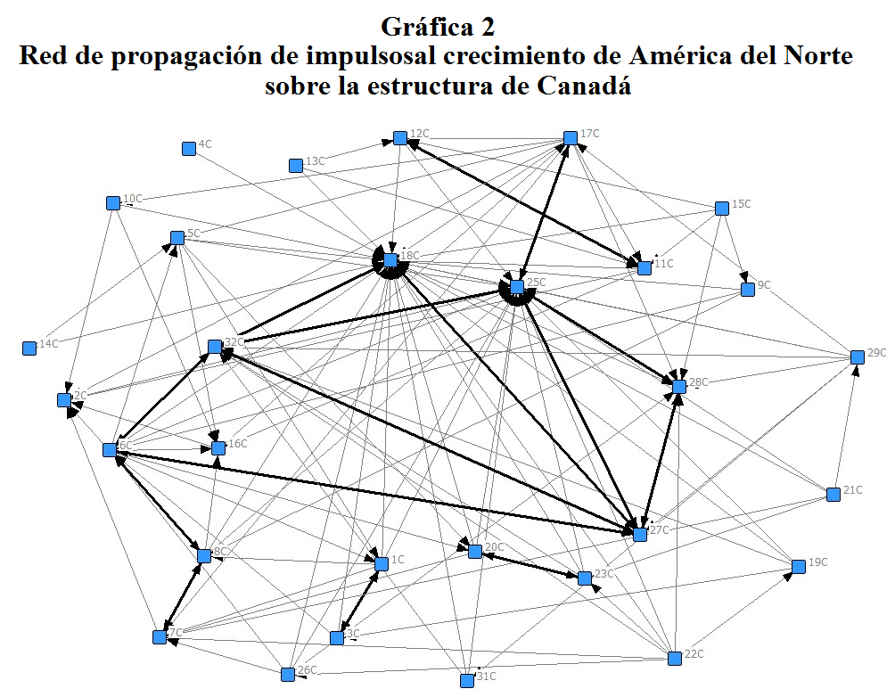
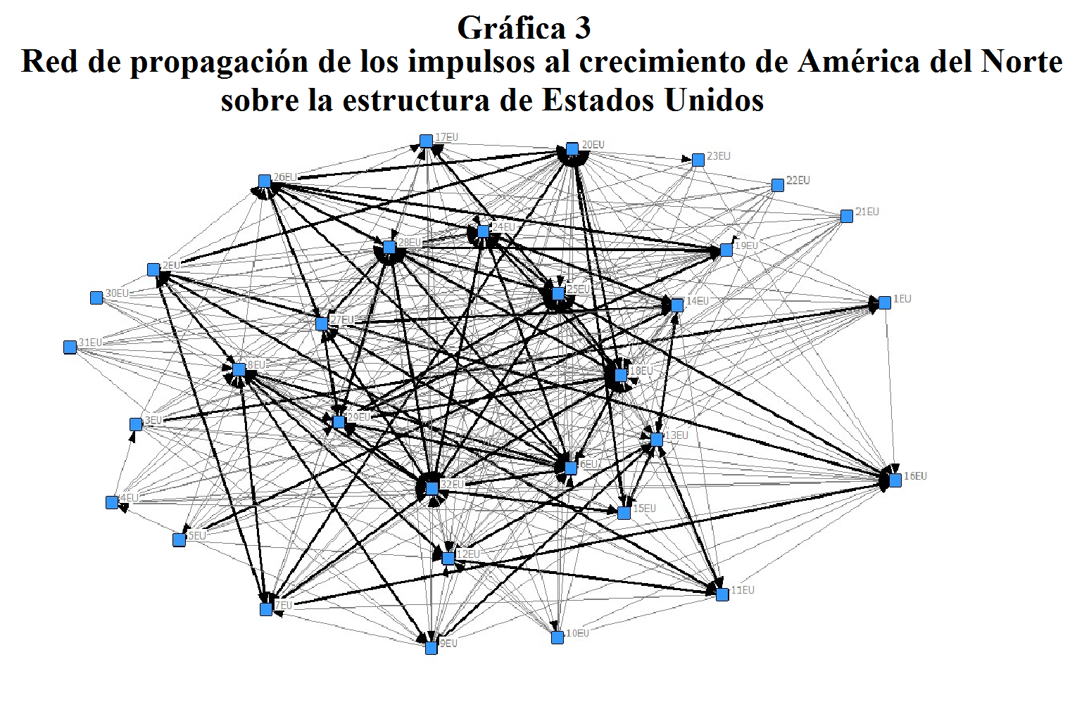
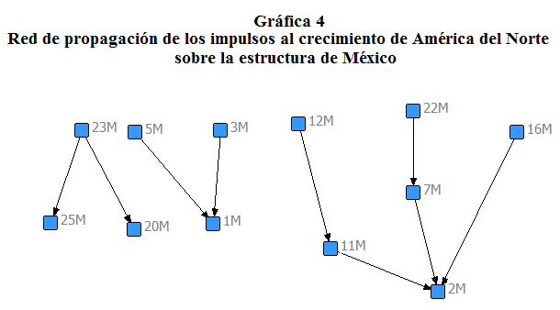
In the data of Table 2 it shows that in Canada the CI with as many members as periphery is formed by the branches 6) Pulp, paper, paper products, printing and publishing activities; and 8) Chemicals excluding Pharmaceuticals / Pharmaceutical, whereas in the case of the United States, the second IC is the one with the largest number of sectors defined as periphery, it is the CI consists of 5) Production of wood and manufacture of wood and cork, and 14) Manufacture of office, accounting and computing machinery / equipment radio, television and communication / medical instruments, precision and optical / Manufacturing nec; recycling (including furniture), this means that when a favorable effect experience any of these centers expand to a larger number of influences.
Given the results obtained, the question that arises is which of the CI is the most important ?. One way to address the serious response considering the size of the center and the periphery, as its members; this allows the CI hierarchy. The results in Table 2 are presented to the CI by the number of members in the sector according to size of the center are listed. because if you notice, in the case of members of the periphery, not necessarily with increasing age the center. The importance of evaluating a CI is precisely assessing the impacts of these on the production structure, both in employment, output and wages, an alternative way is precisely from the location of the sectors that generate growth when experiencing growth higher than that experienced by others in the structure, for example, can be the center of the IC and not the periphery, but maybe if the semi-periphery of a CI and concerned a center in its most basic form, as a star ( Garcia and Solis, 2013). Under this criterion, in the case of Canada correspond to the CI number 7 on the list in Table 2.
In the case of the US, the most important in the CI would 3,5,6,8,11,12 and 22 as their centers are articulated by sectors with greater linkages in the structure in addition to their participation this as semi -perifericos for ICs with more elements in the center as in the CI number 38 and 39.
Table 2
Core – Periphery Structure
Canada
No.de CPS |  | Core | Periphery |  | Semi-periphery
1 |  | {1C,3C} | {7C,8C,18C,25C} |  | {6C,19C}
2 |  | {6C,8C} | {2C,5C,16C,18C,25C} |  | {1C,3C,9C,26C}
3 |  | {7C,8C} | {2C,16C,18C,25C} |  | {1C,17C,20C,21C,22C,26C}
4 |  | {11C,12C} | {2C,16C,18C,25C} |  | {13C,15C,17C}
5 |  | {17C,25} | {7C,10C,11C} |  | {2C,5C,6C,8C,12C,16C,18C-23C,26C,29C,31C}
6 |  | {20C,23C} | {7C,18C,25C,32C} |  | {5C,6C,21C,22C}
7 |  | {6C,18C,27C,32C} | {16C} |  | {1C,3C,5C,9C-15C,17C,19C-23C,26C,29C,31C}
8 |  | {6C,25C,27C,28C,32C} | {7C,16C} |  | {1C-3C,5C,9C,12C,15C,19C,21C-23C,26C,29C,31C
USA
No. de CPS | Core |  | Periphery |  | Semi-periphery
1 | {1EU,3EU} |  | {7EU,8EU,12EU,13EU,16EU,18EU,20EU,25EU,26EU,28EU,29EU} |  | {4EU,5EU,6EU,19EU}
2 | {5EU,14EU} |  | {1EU,4EU,6EU,8EU,9EU,11EU,12EU,18EU,20EU,25EU,26EU,28EU,32EU} |  | {15EU,17EU,29EU,31EU}
3 | {8EU,9EU} |  | {16EU,18EU,20EU,25EU,26EU,28EU} |  | {3EU,4EU,5EU,10EU,11EU,14EU,15EU,17EU,29EU,31EU}
4 | {8EU,12EU} |  | {16EU,18EU,20EU,25EU,26EU,28EU} |  | {1EU,3EU-5EU,10EU,14EU,15EU,17EU,21EU,24EU,29EU,31EU}
5 | {9EU,13EU} |  | {4EU,6EU,7EU,16EU,18EU,20EU,24EU,25EU,28EU,32EU} |  | {1EU -3EU, 17EU,31EU}
6 | {2EU,11EU} |  | {18EU,25EU,26EU,28EU,29EU,32EU} |  | {10EU,14EU,15EU,22EU}
7 | {13EU,14EU} |  | {4EU,6EU,8EU,20EU,25EU,28EU,32EU} |  | {1EU,2EU,17EU,29EU,31EU}
8 | {13EU,15EU} |  | {4EU,6EU,8EU,18EU,24EU,25EU,28EU} |  | {1EU,2EU,17EU,21EU,22EU,29}
9 | {14EU,24EU} |  | {4EU,8EU,9EU,11EU,12EU} |  | 15EU,17EU,19EU,20EU,22EU,29EU-31EU}
10 | {14EU,27EU} |  | {4EU,8EU,9EU,11EU,12EU,18EU,25EU} |  | {15EU,17EU,20EU,31EU}
11 | {15EU,20EU} |  | {23EU-25EU,27EU,28EU} |  | {1EU,3EU-6EU,8EU-12EU,14EU,16EU,17EU,19EU,21EU,22EU,29EU}
12 | {15EU,32EU} |  | {16EU} |  | {1EU,3EU-5EU,9EU-12EU,14EU,17EU,19EU,21EU-23EU,26EU,30EU,31EU}
13 | {16EU,25EU} |  | - |  | {1EU,3EU-6EU,8EU-15EU,19EU-23EU,26EU,27EU,30EU,31EU}
14 | {17EU,25EU} |  | - |  | {1EU-15EU,19EU-23EU,26EU,27EU,30EU,31EU}
15 | {18EU,20EU} |  | - |  | {1EU,3EU-5EU,8EU-14EU,16EU,17EU,19EU, 21EU-23EU,27EU,30EU,31EU}
16 | {20EU,26EU} |  | {23EU-25EU-32EU} |  | {1EU,3EU-5EU,8EU-14EU,16EU,17EU, 21EU,22EU,29EU}
17 | {2EU,7EU,8EU} |  | {18EU,25EU,26EU,28EU} |  | {1EU,3EU-5EU,10EU,13EU,15EU-17EU,21EU-23EU,29EU,31EU}
18 | {2EU,7EU,16EU} |  | {13EU,18EU,26EU,28EU} |  | {1EU,3EU,4EU,6EU,9EU,10EU,12EU,17EU,19EU,21EU-23EU,29EU}
19 | {2EU,7EU,20EU} |  | {25EU,28EU} |  | {1EU,3EU-6EU,9EU,10EU,12EU-14EU,17EU,19EU,21EU-23EU,29EU}
20 | {6EU,8EU,32EU} |  | {16EU} |  | {1EU,3EU-5EU,10EU,11EU,13EU,14EU,17EU,19EU-23EU,30EU,31EU}
21 | {7EU,8EU,32EU} |  | - |  | {1EU,3EU-5EU,10EU,11EU,13EU,14EU,17EU,19EU,21EU-23EU,26EU,30EU,31EU}
22 | {11EU,12EU,13EU} |  | {6EU,7EU,10EU,16EU,18EU,10EU,25EU,28EU,29EU,32EU} |  | {1EU,3EU,5EU,10EU,17EU,21EU,24EU}
23 | {19EU,26EU,28EU} |  | - |  | {1EU-5EU,7EU-17EU,21EU-23EU,30EU,31EU}
24 | {19EU,28EU,29EU} |  | - |  | {1EU-5EU,7EU-17EU,20EU-23EU,30EU,31EU}
25 | {24EU,26EU,28EU} |  | - |  | {1EU-5EU,7EU-13EU,15EU,17EU,21EU-23EU,30EU,31EU}
26 | {26EU,27EU,28EU} |  | - |  | {1EU-5EU,7EU-13EU,15EU,17EU,21EU-23EU,30EU,31EU}
27 | {6EU,24EU,26EU, 28EU} |  | - |  | {1EU-5EU,7EU,9EU-17EU,21EU-23EU,30EU,31EU}
28 | {19EU,26EU,28EU,29EU} |  | - |  | {1EU-5EU,7EU-17EU,21EU-23EU,30EU,31EU}
29 | {24EU,28EU,29EU,32EU} |  | - |  | {1EU-5EU,9EU-13EU,16EU,17EU,20EU-23EU,30EU,31EU}
30 | {25EU,28EU,29EU,32EU} |  | - |  | {1EU-5EU,9EU-14EU,20EU-23EU,30EU,31EU}
31 | {27EU,28EU,29EU,32EU} |  | - |  | {1EU-5EU,9EU-13EU,16EU,17EU,20EU-23EU,30EU,31EU}
32 | {18EU,25EU, 28EU,29EU,32EU} |  | - |  | {1EU-5EU,9EU-14EU,20EU-23EU,30EU,31EU}
33 | {18EU,24EU,25EU,28EU,32EU} |  | - |  | {1EU-5EU,9EU-14EU,20EU-23EU,30EU,31EU}
34 | {6EU,18EU,28EU,29EU,32EU} |  | - |  | {1EU-5EU,9EU-13EU,16EU,17EU,21EU-23EU,30EU,31EU}
35 | {6EU,18EU,24EU,28EU,29EU,32EU} |  | - |  | {1EU-5EU,9EU-14EU,16EU,17EU,21EU-23EU,30EU,31EU}
36 | {6EU,18EU,24EU,26EU,28EU,32EU} |  | - |  | {1EU-5EU,9EU-13EU,16EU,17EU,21EU-23EU,30EU,31EU}
37 | {18EU,24EU,25EU,28EU,29EU,32EU} |  | - |  | {1EU-5EU,9EU-13EU,21EU-23EU,30EU,31EU}
38 | {6EU,26EU,27EU,28EU,29EU,32EU} |  | - |  | {1EU-5EU,9EU-13EU,21EU-23EU,30EU,31EU}
39 | {6EU,18EU,24EU,25EU,27EU,28EU,29EU,32EU} |  | - |  | {1EU-5EU,9EU-13EU,21EU-23EU,30EU,31EU}
Sectors
Agriculture, hunting, forestry and fishing |  |  |  | Construction
Mining and quarrying (energy) & (non-energy) |  |  |  | Wholesale & retail trade; repairs
Food products, beverages and tobacco |  |  |  | Hotels & restaurants
Textiles, textile products, leather and footwear |  |  |  | Land transport; transport via pipelines
Wood and products of wood and cork |  |  |  | Water transport
Pulp, paper, paper products, printing and publishing |  |  |  | Air transport
Coke, refined petroleum products and nuclear fuel |  |  |  | Supporting and auxiliary transport activities; activities of travel agencies
Chemicals excluding pharmaceuticals & Pharmaceuticals |  |  |  | Post & telecommunications
Rubber & plastics products |  |  |  | Finance & insurance & Real estate activities
Other non-metallic mineral products |  |  |  | Renting of machinery & equipment
Iron & steel & Non-ferrous metals |  |  |  | Computer & related activities
Fabricated metal products, except machinery & equipment |  |  |  | Research & development & Other Business Activities
Machinery & equipment, nec & Electrical machinery & apparatus, nec |  |  |  | Public admin. & defence; compulsory social security
Office, accounting & computing machinery & Radio, television & communication equipment & Medical, precision & optical instruments & Manufacturing nec; recycling (include Furniture) |  |  |  | Education
Motor vehicles, trailers & semi-trailers & Building & repairing of ships & boats & Aircraft & spacecraft & Railroad equipment & transport equip nec. |  |  |  | Health & social work
Production, collection and distribution of electricity & Manufacture of gas; distribution of gaseous fuels through mains & Steam and hot water supply & Collection, purification and distribution of water |  |  |  | Other community, social & personal services & Private households with employed persons & extra-territorial organisations & bodies

The evidence indicates that the CI in Mexico after 1994 were growing stronger as it is the electronics industry and automotive (Contreras and Carrillo, 2003, Weintraub, 2004), and further that block North America, Key sectors are related sectors located in all regions (Marquez, 2013), ie the block has Mexicans key sectors, so that these, in terms of trade should have a different role than they do on the effects on internal economic structure.
Table 3 shows the number of CI and the position of its members. This table classifies the structural position of the effects of interregional imports each sector of the regions undoubtedly the CI identified in the table, are sectors that are most likely on the borders of the regions of the block. The results suggest that the formation of CI with ECP in the trade bloc, the center generally corresponds to sectors which are from the United States, since for almost all CI sectors are semi-peripheral EU, but as suggested by CI outcomes identified here, these sectors are part of the center of a CI in the US, such as CI 1 listed in Table 3 the semi-periphery is formed by centers of the US IC 1, when compared with The results in Table 2.
Table 3
Industrial Clusters (IC) by CPS in North América *
No. de CI | Centro | Periferia | Semi-periferia
1 | {1M,1C} | {3C,5C,6C,5EU,5M} | {1EU,3EU,7EU,8EU,16EU,18EU,20EU,25EU,28EU,8M,18M,20M,25M,28M}
2 | {1M,3C} | {3C,5C,6C,5EU} | {1EU,3EU,6EU-9EU,16EU,18EU,20EU,25EU,28EU,1M,18M,20M}
3 | {3C,3M} | {19C} | {1EU,3EU,6EU,9EU,12EU,16EU,18EU,20EU,25EU,26EU,28EU,32EU}
4 | {5C,5EU} | {14C,5M,14M,17M} | {1C,1EU,18EU,1M,18M,20M,25M
5 | {6C.6M} | - | {1EU,6EU,8EU,9EU,14EU,16EU,18EU,20EU,24EU-29EU,32EU,1M,15M,18M,20M,25M,28M}
6 | {2M,7EU} | {1C,2C,7C,8C,10C,11C,16C,17C,20C-24C,11EU,16EU,1M,7M-9M,11M,16M,17M,20M-23M,29M} | {2EU,25EU,26EU,28EU}
7 | {7C,7EU} | {1C,8C,10C,11C,16C,20C-24C,22EU,1M,8M,9M,11M,16M,17M,21M-23M,29M} | {2C,,2EU,8EU,18EU,28EU,18M}
8 | {7C,7M} | {20C-22C,22EU,21M,22M, | {2C,,2EU,8EU,16EU, 18EU,20EU,25EU,28EU,32EU, 18EU,28EU,2M,18M,}
9 | {7C,20M} | {1C,3C,5C,6C,8C,10C-12C,20C,23C,24C,21M,22M} | {2EU,8EU,15EU,18EU,20EU,24EU-26EU,28EU,32EU,2M,18M,20M}
10 | {8C,8M} | {1C,9C,9M} | {2EU,6EU-9EU,12EU,16EU,18EU,20EU,25EU,26EU,28EU,32EU,2M,18M,20M,28M}
11 | {11C,11EU,11M} | {12C-15C,17C,12M-15M} | {2C,2EU,7EU,10EU,12EU,13EU,16EU,18EU,20EU,25EU,28EU,32EU,2M,16M,18M,20M,
12 | {12C,12M} | {17C} | {11C,6EU,8EU,11EU-13EU,16EU,18EU,20EU,25EU,28EU,32EU,11M,18M,20M,25M}
13 | {15C,15EU,15M} | {20C,22C,13M,20M-22M,28M} | {8EU,9EU,11EU-14EU,18EU,20EU,25EU,28EU,32EU,11M,18M,28}
Sectors
Agriculture, hunting, forestry and fishing |  |  |  | Construction
Mining and quarrying (energy) & (non-energy) |  |  |  | Wholesale & retail trade; repairs
Food products, beverages and tobacco |  |  |  | Hotels & restaurants
Textiles, textile products, leather and footwear |  |  |  | Land transport; transport via pipelines
Wood and products of wood and cork |  |  |  | Water transport
Pulp, paper, paper products, printing and publishing |  |  |  | Air transport
Coke, refined petroleum products and nuclear fuel |  |  |  | Supporting and auxiliary transport activities; activities of travel agencies
Chemicals excluding pharmaceuticals & Pharmaceuticals |  |  |  | Post & telecommunications
Rubber & plastics products |  |  |  | Finance & insurance & Real estate activities
Other non-metallic mineral products |  |  |  | Renting of machinery & equipment
Iron & steel & Non-ferrous metals |  |  |  | Computer & related activities
Fabricated metal products, except machinery & equipment |  |  |  | Research & development & Other Business Activities
Machinery & equipment, nec & Electrical machinery & apparatus, nec |  |  |  | Public admin. & defence; compulsory social security
Office, accounting & computing machinery & Radio, television & communication equipment & Medical, precision & optical instruments & Manufacturing nec; recycling (include Furniture) |  |  |  | Education
Motor vehicles, trailers & semi-trailers & Building & repairing of ships & boats & Aircraft & spacecraft & Railroad equipment & transport equip nec. |  |  |  | Health & social work
Production, collection and distribution of electricity & Manufacture of gas; distribution of gaseous fuels through mains & Steam and hot water supply & Collection, purification and distribution of water |  |  |  | Other community, social & personal services & Private households with employed persons & extra-territorial organisations & bodies
*Numbers refer to sectors and letters refer to región Canada (C),United State(US) and Mexico(M)

Conclusions
The CPS from the graph approach to analyze industrial clusters (IC). In the case of AN, the IC largely developed by the IC existing in US. IC in the US point to CPS, however the size of the cross influences makes the effects analyzed generate differentiated structures among members of the American bloc. Considering the AN system, the Mexican economy has IC that have a hierarchical relationship in the spillover effects, the IC that occur in the region form structures trees, this means that the influences that are transmitted through trade of Mexico, not virtuous circuits generate growth.
In the economy of the US the high tech sectors (HTS) does not exist in an IC that includes both those who produce and those who use its role as a center, but within them there are subgroups that are semi-centers, ie but you are two centers influence transmits to another, and their peripheries may be the same sectors in these centers. In the case of the US, the IC of the HTS by two groups, the first one is related to manufacturing activities as the Manufacture of machinery and equipment nec / Electrical machinery and apparatus nec; the Manufacture of office, accounting and computing machinery / equipment radio, television and communication / medical instruments, precision and optical / Manufacturing nec; recycling (including furniture); and the Manufacture of motor vehicles, trailers and semi-trailers / construction and repair of ships and boats / Aircraft and spacecraft / Railways and transport equipment, nec; and secondly it is to activities related to services.
The research and development / Other business activities sector is part of the various centers of the IC that form in the services sectors, however this sector is peripheral to other centers coming from manufacturing activities mentioned above.
For Canada the HTS are located at the center of some IC, however where they are located is in service activities in the sector of research and development has a role as a center. In Mexico HTS their tree structures, activities and auxiliary / activities of travel agencies, transportation are the root of the tree in which the effects of growth is transmitted.
These results suggest that in the case of Mexico requires incorporating the IC's on the inside considered this as a system and not as a region, as existing in the country IC heavily dependent on foreign relations, for though the effects of changes expand in these market conditions tend to drive IC but the effects of a hierarchical manner and is not virtuous circuits. Surely, with this method it is possible to identify the IC born by the effect of imports of the Mexican economy from US.

♦ Professor Facultad de Economía UNAM, Ciudad de México, antoniomrqz@gmail.com

