A Hypothetical Supply Chain with the Disruption of Production Shock: From HEM to Hypothetical APL

Michiya NOZAKI (Gifu Keizai University)

Abstract
This paper develops a methodology to predict the economic impact of major catastrophes, such as earthquakes and tsunamis, by means of the hypothetical extraction method and hypothetical average propagation lengths. The methodology is tested by means of a comparison of the pre-disaster regional economy (base scenario) with a series of post-disaster regional economies (scenarios with regional production shocks) to the Japanese inter-regional, inter-industry economy. Then, we can compile nine hypothetical I-O tables with post-disaster cases with the Japanese interregional economy. Besides, we can also analyze nine hypothetical average propagation lengths. Finally, we share our conclusion, considering the policy implications on the relation between the economic recovery after the major catastrophes and our results.

Keywords: catastrophe analysis, hypothetical extraction method, supply chain, hypothetical average propagation length, disaster

JEL Classification: C67, R15, R53

1. Introduction
This paper develops a methodology to predict the economic impact of major catastrophes, such as earthquakes and tsunamis, by means of the hypothetical extraction method and hypothetical average propagation lengths (Oosterhaven et al. 2013).
Natural disasters, such as the 2011 earthquake and tsunami in Japan, have both short- and long-run socio-economic negative effects. In the short-run, it is plausible that all economic actors (firms, households, various governments) will attempt to return to pre-disaster status as much as possible. To describe this situational status, we use the inter-regional, input-output table for Japan in 2005 (Okuyama, et al. 1999, Okuyama and Chang 2004).
The basic idea is to capture the short-run economic changes that would occur after a major disaster by means of the hypothetical extraction method (HEM). The HEM qualifies how much an economy’s total output would hypothetically decrease if an industry were to be “extracted” from that economy. By extracting the industry, both the local purchases by the industry (i.e., backward linkages), and the local sales from the industry (i.e., forward linkages), are eliminated, or hypothetically transformed from local purchases and sales transactions into imports and exports (Schultz 1977; Paelinck et al. 1965; Strassert 1968).
The methodology is tested by means of a comparison of the pre-disaster regional economy (base scenario) with a series of post-disaster regional economies (scenarios with regional production shocks) to the Japanese inter-regional, inter-industry economy of 2005. Then, we can compile nine hypothetical I-O tables with post-disaster cases for the Japanese interregional economy.
Besides, we can also analyze nine hypothetical average propagation lengths.
In this paper, we use the concept of average propagation length (APL), which was presented by Dietzenbacher, Romero and Bosma (2005) and Dietzenbacher and Romero (2007), to predict the hypothetical supply chain with the post-disaster economy due to the production shocks.

II. Hypothetical Regional Extraction Model
In the full R-regions and n-sectors model, output is as follows:

$x={\left[I-A\right]}^{-1}f$. (1)

$x$: output of the full R-regions and n-sectors, $A$:regional input coefficients matrix of the full R-regions and n-sectors, $f$: final demand of the full R-regions and n-sectors.
The above model is that of the well-known Leontief model.
In Dietzenbacher et al. (1993) it was shown that Strassart (1968) model can be adapted so as to measure regional linkages. Instead of extracting a sector in a multi-sector framework, an entire region was hypothetically extracted within an interregional setting (Dietzenbacher and Van der Linden, 1997, 237).
The objective of the hypothetical regional extraction approach is to qualify how much the total output of an R-region and n-sector economy would decrease if a particular region, say the rth, were removed from the economy. Initially, this was modeled in an input-output setting by deleting row and column n sectors in the region r from the $A$ matrix.
$A$ matrix, they can simply replace by zeros. Decreasing value of trading goods and services due to the disruption of the natural disaster is distributed at the percentage of the trading of the intermediary goods into other industrial sectors in the other regions, and hypothetically transformed from local purchase and sales transactions in the region of the disruption due to the natural disaster into internal and foreign imports and exports in the non-disaster regions¹⁾.

${\overline{A}}^{(r)}$=$\left[\begin{matrix}\left(a_{11}+\hat{a_{11}}\right)\begin{matrix}…\end{matrix} & 0 & \begin{matrix}…\end{matrix}\left(a_{1n}+\hat{a_{1n}}\right) \\ 0\begin{matrix} \end{matrix}\begin{matrix}…\end{matrix} & ⋱ & \begin{matrix}\begin{matrix}…\end{matrix} & \end{matrix} 0 \\ \left(a_{n1}+\hat{a_{n1}}\right) & 0 & \left(a_{nn}+\hat{a_{nn}}\right)\end{matrix}\right]$, (2)

where $\hat{a_{ij}}$=${z_{ij}}/{\sum_{1}^{n}{x_{j}}}$: distributed input coefficient of decreased values from r-region to other regions.

Using ${\overline{A}}^{(r)}$ for the (R-1)n x (R-1)n without region r and ${\overline{f}}^{(r)}$ for the correspondingly reduced final demand, output in the ‘reduced’ regional economy is found as

${\overline{x}}^{(r)}$=${\left[I-{\overline{A}}^{(r)}\right]}^{-1} {\overline{f}}^{(r)}$. (3)

${\overline{f}}^{(r)}=\left[\begin{matrix}{\hat{f}}^{1} \\ \begin{matrix}⋮ \\ \begin{matrix}0 \\ ⋮\end{matrix}\end{matrix} \\ {\hat{f}}^{n}\end{matrix}\right]$ (4)

${\overline{f}}^{(r)}$: column vector of distributed final demand from r-region to other regions.

$\hat{f^{ｎ}}$= $f^{ｎ}*$($f^{ｎ^{post}}$/$f^{ｎ^{pre}}$) (5)
$f^{ｎ}$:final demand of n-sector, $f^{ｎ^{post}}$: final demand of n-sector in the case of post-disaster,
$f^{ｎ^{pre}}:$ final demand of n-sector in the case of pre-disaster.

The deviation between the value of full R-region economy and rth-region reduced economy is as follows:

$x$ - ${\overline{x}}^{(r)}$=$\left\{{\left[I-A\right]}^{-1}f\right\}-\left\{{\left[I-{\overline{A}}^{(r)}\right]}^{-1} {\overline{f}}^{(r)}\right\}$ (6)

$T^{r}=i^{'}x-i^{'}{\overline{x}}^{(r)}$ is one aggregate measure of the economy’s change (increase or decrease in value of gross output) if region r disappears, which is the measure of the “importance” or the total linkage (see, Miller and Blair, 2009, 563; see also Dietzenbacher and van der Linden, 1997). The normalization through division by total gross output ($i^{'}x$) and multiplication by 100 produces an estimate of the percentage changes in total economic activity,
which is $\overline{T_{j}^{r}}=100*\left[i^{'}x-i^{'}{\overline{x}}^{\left(r\right)}\right]/i^{'}x$ (see, Miller and Blair 2009, 563).

We suppose that the base scenario is almost the same as the 2005 Japanese Interregional Economy in the pre-disaster economic structure.

1. A production shock that nullifies all output of region r:
This scenario may be run for each of the nine Japanese regions as follows: Hokkaido (Region 1), Tohoku (Region 2), Kanto (Region 3), Chubu (Region 4), Kinki (Region 5), Chugoku (Region 6), Shikoku (Region 7), Kyushu (Region 8), and Okinawa (Region 9).
In reality, a production shock due to even a major disaster is likely to only partially diminish the production capacity of only a subset of the industries. For testing the plausibility of our modelling approach, however, using an extreme scenario will give a clearer outcome than simulating a more realistic, i.e. less extreme, scenario’ (Oosterhaven, et al.,2013, p.5).

III. Empirical Results of the Japanese Interregional Economy
We first discuss the properties of the short run non-disaster equilibrium, i.e. the base scenario.
- Japanese nine regions have twelve industrial sectors in each region in 2005 Japan interregional input-output table. We aggregate the industrial sectors from twelve to three sectors in every nine Japanese regions. The reason why the aggregation is necessary is that I need to show the results briefly.
- Sector 1 is agriculture, forestry and fishery industries. Sector 2 is mining, manufacturing, and construction industries. Sector 3 is Public utilities, Commerce and transport, Finance and insurance and real estate, Information and communications, Service Industries (See, Table A1).
- Kanto is the economically largest region,
- Possible re-exports of foreign imports are assumed to be zero.
- In 2005 Japan interregional input-output table, we can sum up with the Japanese interregional economy in the pre-disaster case, where the unit of money is million JPY, as follows:
Regions that have net savings are Kanto, Chubu, Kinki, and Chugoku. Besides, net borrowers are Hokkaido, Tohoku, Shikoku, Kyushu, and Okinawa.
The foreign trade balance is positive, and thus value added exceeds regional final demand, i.e. national savings are invested abroad.
Region 3(Kanto) is the economically largest region, Possible re-exports of foreign imports are assumed to be zero, and Total input equals total output for each industry, in each region.

III-1. The scenarios of the production shock due to the disruption of the natural disaster
The short run post-disaster equilibrium of a complete production stop in nine regions with Hokkaido to Okinawa is shown in Table 1.
PS_{i} : Nine scenarios of the Production shocks to the region i due to the natural disaster (i=1,…,9). T^{r}= i' x－i' x ̅^{(r)} is one aggregate measure of the economy’s change (increase or decrease in value of gross output) if region r disappears, which is the measure of the “importance” or the total linkage.
The normalization through division by total gross output (i' x ) and multiplication by 100 produces an estimate of the percentage changes in total economic activity, which is
T_{j}^{r} ̅=100*[i' x－i' x ̅^{(r)} ]/i' x.

Table 1. Normalization to create percentage changes in total outputs with nine cases of the production shocks
Unit: %
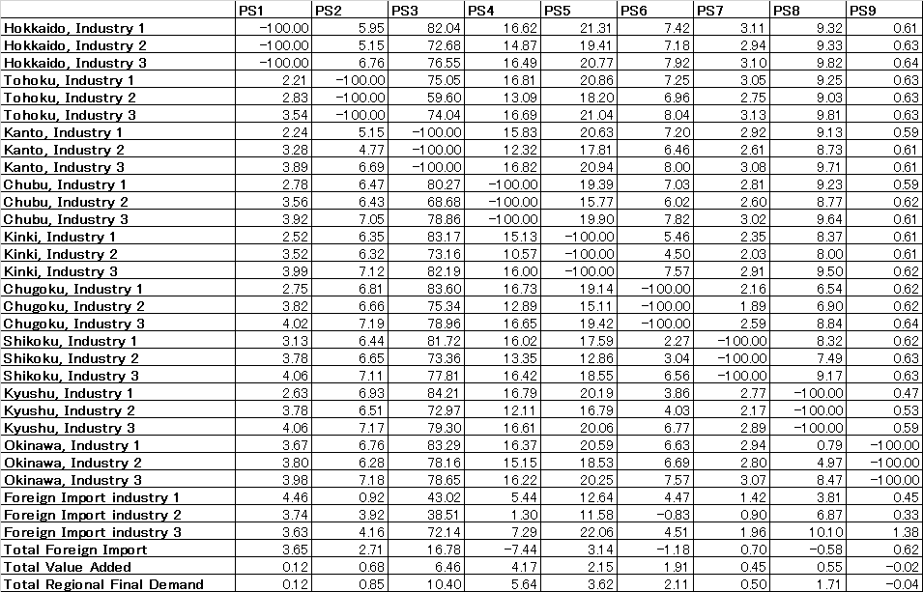

The short-run, post-disaster equilibrium of a complete production stop in the nine regions, Hokkaido to Okinawa, is shown in Table 1.
In Table 1, the cross-pattern of zeros indicates the results of applying the hypothetical extraction method to the nine regions, from Hokkaido to Okinawa (Dietzenbacher et al. 1993; Sonis and Oosterhaven 1996; Oosterhaven et al. 2013). In a production shock to Hokkaido, for example, the non-disaster economy, the eight regions from Tohoku to Okinawa, does not shrink as it compensates for the loss from the production stop in Hokkaido. In addition, in the production shocks to the other eight regions (Tohoku, Kanto, Chubu, Kinki, Chugoku, Shikoku, Kyushu, and Okinawa), the non-disaster economy does not shrink either in the case of the production shock to Hokkaido.
In particular, in the extreme cases, in the production shocks to Kanto, Chubu, and Kinki, the non-disaster economy of these three regions increases more drastically than the other production shock cases, due to the significant size of their economic activities.
At first glance, the volume outcomes of the production shocks of a complete production stop in the nine regions Hokkaido to Okinawa look to be equal qualitatively. Further examination reveals that the rate of regional import in the non-disaster regions is exogenous to the post-disaster economy. In addition, the rate of regional value added in the non-disaster regions is also exogenous to the post-disaster economy.
The import of final goods is supposed to change proportionally with the rate of change of regional final demands in comparison to the pre- and post-disaster economies. In the region hit by production shock, the imports proportionally increase, and in non-disaster regions decrease. Furthermore, the foreign exports in the non-disaster regions show an increase.
In the scenarios of production shocks to Kanto, Chubu, Kinki, and Kyushu, the resulting trade deficits are rather large. As a short-run restriction from a natural disaster, the outcome is possible, but it is clear that with such a large trade deficit it would be impossible to sustain the economy.

IV. Hypothetical Supply Chain with the Disruption of Production Shock
The methodology is tested by means of a comparison of the pre-disaster regional economy (base scenario) with a series of post-disaster regional economies (scenarios with regional production shocks) to the Japanese inter-regional, inter-industry economy of 2005. Then, we can compile nine hypothetical I-O tables with post-disaster cases for the Japanese interregional economy.
Besides, we can also analyze nine hypothetical average propagation lengths.
In this paper, we use the concept of average propagation length (APL), which was presented by Dietzenbacher, Romero and Bosma (2005) and Dietzenbacher and Romero (2007), to predict the hypothetical supply chain with the post-disaster economy due to the production shocks.
A substantial body of literature is devoted to measuring the strength of the links between industries. Many studies address the question of how such interdependencies or linkages can be accurately measured (e.g. Chenery and Watanabe, 1958; Rasmussen, 1956; Miller and Lahr, 2001; Sonis, Guilhoto, Hewings and Martins, 1995). These studies have proposed various alternative measures for such inter-industry linkages.
In this paper, we use the concept of average propagation length (APL), which was presented by Dietzenbacher, Romero and Bosma (2005) and Dietzenbacher and Romero (2007), to study a hypothetical average propagation length due to the disruption of the production shock hypothetically.
These chains differ from product chains, which focus on a single product, and hence, we term them production chains. We adopt the underlying concept of sequencing in supply chains by viewing production as a stepwise procedure. In the analysis of production processes, some industries are placed in the early stage, and others, in a later stage.
Oosterhaven and Bouwmeester (2013) discuss that ‘the average propagation length (APL) has been proposed as a measure of a fragmentation and sophistication of an economy, and for a one-sector economy they show that the APL is strictly proportional to the macro multiplier of that economy’ (Oosterhaven and Bouwmeester, 2013, 481). Chen (2014) also extends the definition of APL to the grouping-APL from the double-counting of APL.
When we define average propagation, we analyse how a cost-push or a demand-pull propagates throughout the industries in the economy. According to Dietzenbacher, et al., (2005, 411-412), an initial demand-pull in industry i increases the output value in industry j by $l_{ij}-δ_{ij}$ (neglecting the initial effects). $δ_{ij}$ is the Kronecker delta; i.e. $δ_{ij}=1$ if i = j and 0 otherwise. The share ${a_{ij}/(l}_{ij}-δ_{ij})$ of this output increase requires only one round, but the share ${{\left[A^{2}\right]}_{ij}/(l}_{ij}-δ_{ij})$ requires two rounds to get from i to j. ${\left[A^{2}\right]}_{ij}$ denotes the element (i,j) of matrix $A^{k}$, which differs from ${(a_{ij})}^{k}$ ( Dietzenbacher, Romero, and Bosma, 2005, 411-412).

The average number of rounds required to pass over a demand-pull in industry i to industry j yields

$v_{ij}=\left\{1a_{ij}+2{\left[A^{2}\right]}_{ij}+3{\left[A^{3}\right]}_{ij}+⋯\right\}/(l_{ij}-δ_{ij})$ (2-1)

Let the numerator of the right-hand side of (2-1) be denoted by $h_{ij}$, with H = $\sum_{k}{k}A^{k}$.

Then the terms $h_{ij}$ can easily be calculated by using

$H=\sum_{k}{k}A^{k}=L(L-I)$.

We can reduced equation (2-1) to (2-2) as the matrix V of APL as follows:

$v_{ij}=\left\{\begin{aligned}{\left\{1a_{ij}+2{\left[A^{2}\right]}_{ij}+3{\left[A^{3}\right]}_{ij}+⋯\right\}/（l}_{ij}-δ_{ij}) if{ l}_{ij}-δ_{ij}>0, when i≠j \\ {\left\{1a_{ij}+2{\left[A^{2}\right]}_{ij}+3{\left[A^{3}\right]}_{ij}+⋯\right\}/(l}_{ij}-1) if { l}_{ij}-δ_{ij}=0, when i=j\end{aligned}\right.$ (2-2)

Alternatively, in the same way, we can define the APL for a cost-push (Dietzenbacher, 1997; Oosterhaven, 1988). Analysing how a one-yen cost-push increase in industry j affects the total output of industry i, we find $b_{ij}$+${\left[B^{2}\right]}_{ij}$+${\left[B^{3}\right]}_{ij}+⋯$=$g_{ij}-δ_{ij}$. The APL for a cost-push yields

$\left\{1b_{ij}+2{\left[B^{2}\right]}_{ij}+3{\left[B^{3}\right]}_{ij}+⋯\right\}/(g_{ij}-δ_{ij})$ (2-3)

Note that input matrix A and output matrix B are related to each other.

We first discuss the inter-regional inter industrial structure of the pre-disaster Japanese economy, i.e. the Base Scenario Case.

According to Dietzenbacher, Romero, and Bosma(2005, 415), in line with the development of the propagation length, the choice for the type of linkage is based on the total size of the cost-push and demand-pull effects. Ignoring the initial effects, these effects can be given by$G-I$ and $L-I$, respectively. Along with the way of analysing of Dietzenbacher, Romero, and Bosma(2005),instead of using the Leontief inverse for the backward linkages and the Ghosh inverse for the forward effects, we take the average. So, the linkages are given by the elements of the matrix F, which is defined as follows (Dietzenbacher, Romero, and Bosma, 2005, 415):
$F=\frac{1}{2}\left[\left(L-I\right)+(G-I)\right]$ (2-4)

“The element f_{ij} gives the size of the linkage and equals the average of the forward effect of a cost-push in sector i on the output in sector j and the backward effect of a demand-pull in sector j on the output in sector I” (Dietzenbacher, Romero, and Bosma, 2005, 416).
A relationship between the figures in matrix V of an interregional APL and the linkages F suggests that there could be an inverse relationship between APLs and elements f_{ij} .of the linkages F.
The computing procedure of the economic distances from industry i to jndustry j is to take APLs into account only if the linkage is sufficiently large, using a threshold value$a$. Further, the APLs are rounded off to the nearest integer. From the matrix V with APLs and matrix F with linkages, we can calculate a new matrix S as follows:

$s_{ij}=\left\{\begin{aligned}int\left(v_{ij }\right) if f_{ij}≥a \\ 0 if f_{ij}<a\end{aligned} \right.$ (2-5)
where int($v_{ij }$) indicates the nearest integer to which $v_{ij }$has been rounded off.
There seems to be an inverse relationship between APLs and elements f_{ij}.

Figure 1. The Interregional, Inter-industrial APL of the pre-disaster base scenario
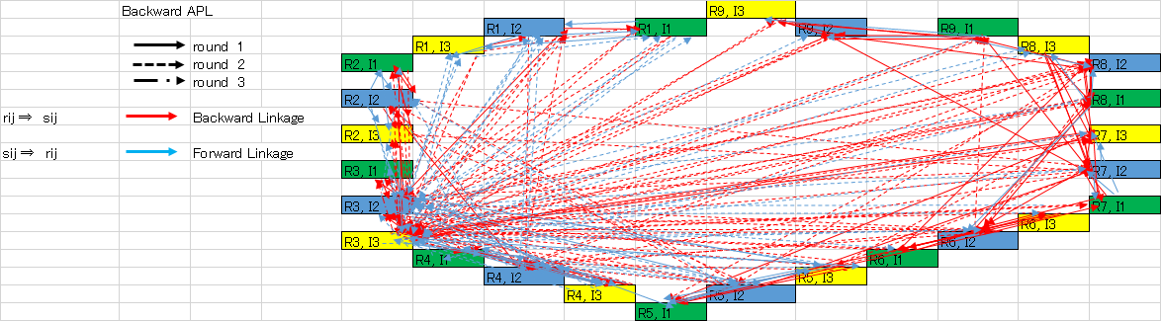
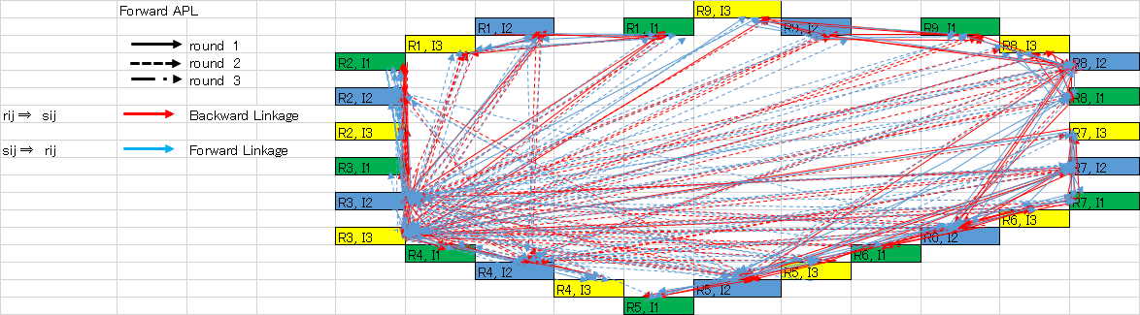
Notes: Ri= Region i(i=1,…,9), and Ij=Industry j(j=1,2,3)
R1=Hokkaido, R2=Tohoku, R3=Kanto, R4=Chubu, R5=Kinki, R6=Chugoku, R7=Shikoku, R8=Kyushu, and R9=Okinawa. I1= agriculture, forestry and fishery industries, I2= mining, manufacturing, and construction industries, and I3= Public utilities, Commerce and transport, Finance and insurance and real estate, Information and communications, Service Industries.

The Pearson correlation coefficient between APL and the matrix F equals -0.47747.
[R,P]=corrcoef(x,y)
x = vij , y = fij,
R = -0.47747, P-value=0.000
Then, we can similarly construct a new matrix S of the Japanese regions as (2-5) where int($v_{ij }$) is used to indicate the nearest integar to which $v_{ij }$has been rounded. For the calculations with the 34 sector classification, we have used a threshold value $a$= 0.02909 (See, Dietzenbacher, Romero, and Bosma, 2005, 416).

The backward and forward APLs will show that Industrial sector 2 and sector 3 in Kanto region, Industrial sector 2 in Chubu region, Industrial sector 2 and sector 3 in Kinki region, have very complex production chains with other regions, and these regions will be the hub-regions with other regional and interregional inter-industrial relationship.

Figure 2. The Interregional, Inter-industrial APL of the production shock to the Hokkaido
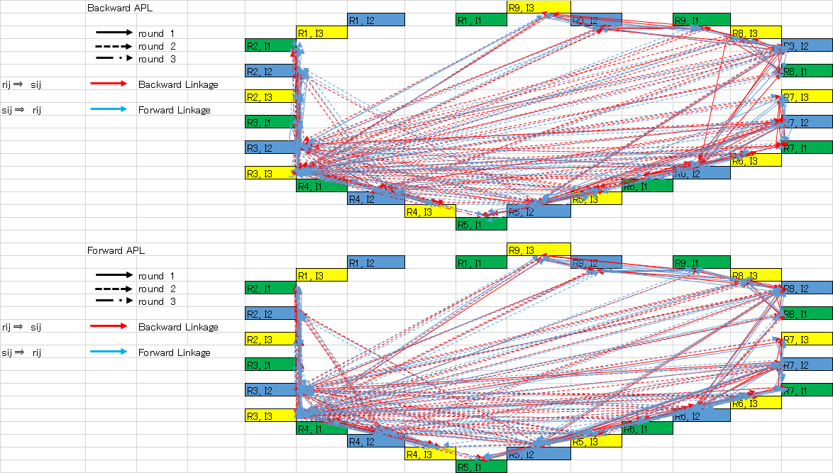
Notes: Ri= Region i(i=1,…,9), and Ij=Industry j(j=1,2,3)
R1=Hokkaido, R2=Tohoku, R3=Kanto, R4=Chubu, R5=Kinki, R6=Chugoku, R7=Shikoku, R8=Kyushu, and R9=Okinawa. I1= agriculture, forestry and fishery industries, I2= mining, manufacturing, and construction industries, and I3= Public utilities, Commerce and transport, Finance and insurance and real estate, Information and communications, Service Industries.
The Pearson correlation coefficient between APL and the matrix F equals 0.0672.
[R,P]=corrcoef(x,y)
x = vij , y = fij,
R =0.0672, P-value=0.0698
We can similarly construct a new matrix S of the Japanese regions where int($v_{ij }$) is used to indicate the nearest integar to which $v_{ij }$has been rounded. For the calculations with the 34 sector classification, we have used a threshold value $a$= 0.02570.
In a production shock to Hokkaido, the non-disaster economy compensates for the loss from the production stop in Hokkaido. So, the interregional and inter-industrial production chains have several hub-regions with other regions, for example, the industrial sector 2 and sector 3 in Kanto region, sector2 in Chubu region, sector 2 and sector 3 in Kinki region, without the disaster region, Hokkaido region.

Figure 3. The Interregional, Inter-industrial APL of the production shock to the Tohoku
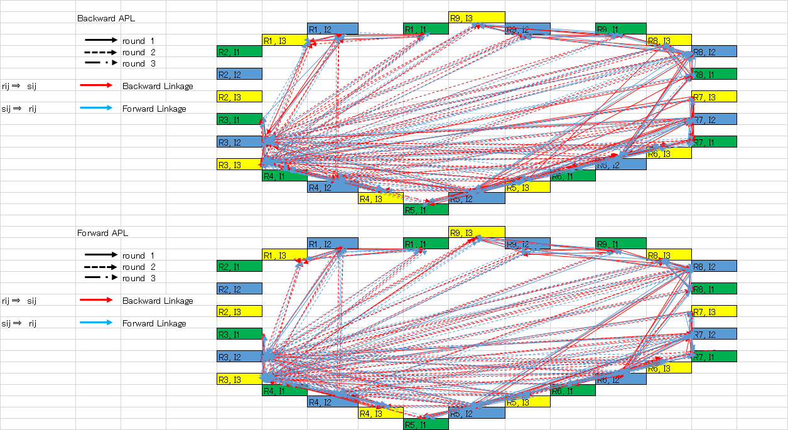
Notes: Ri= Region i(i=1,…,9), and Ij=Industry j(j=1,2,3)
R1=Hokkaido, R2=Tohoku, R3=Kanto, R4=Chubu, R5=Kinki, R6=Chugoku, R7=Shikoku, R8=Kyushu, and R9=Okinawa. I1= agriculture, forestry and fishery industries, I2= mining, manufacturing, and construction industries, and I3= Public utilities, Commerce and transport, Finance and insurance and real estate, Information and communications, Service Industries.

The Pearson correlation coefficient between APL and the matrix F equals 0.0574.
[R,P]=corrcoef(x,y)
x = vij , y = fij,
R = 0.0574, P-value =0.1218
We can similarly construct a new matrix S of the Japanese regions where int($v_{ij }$) is used to indicate the nearest integar to which $v_{ij }$has been rounded. For the calculations with the 34 sector classification, we have used a threshold value $a$= 0.02540.
In a production shock to Tohoku region, the non-disaster economy compensates for the loss from the production stop in Tohoku. So, the interregional and inter-industrial production chains have several hub-regions with other regions, for example, the industrial sector 2 and sector 3 in Kanto region, sector2 in Chubu region, sector 2 and sector 3 in Kinki region, without the disaster region, Tohoku.

Figure 4. The Interregional, Inter-industrial APL of the production shock to the Kanto
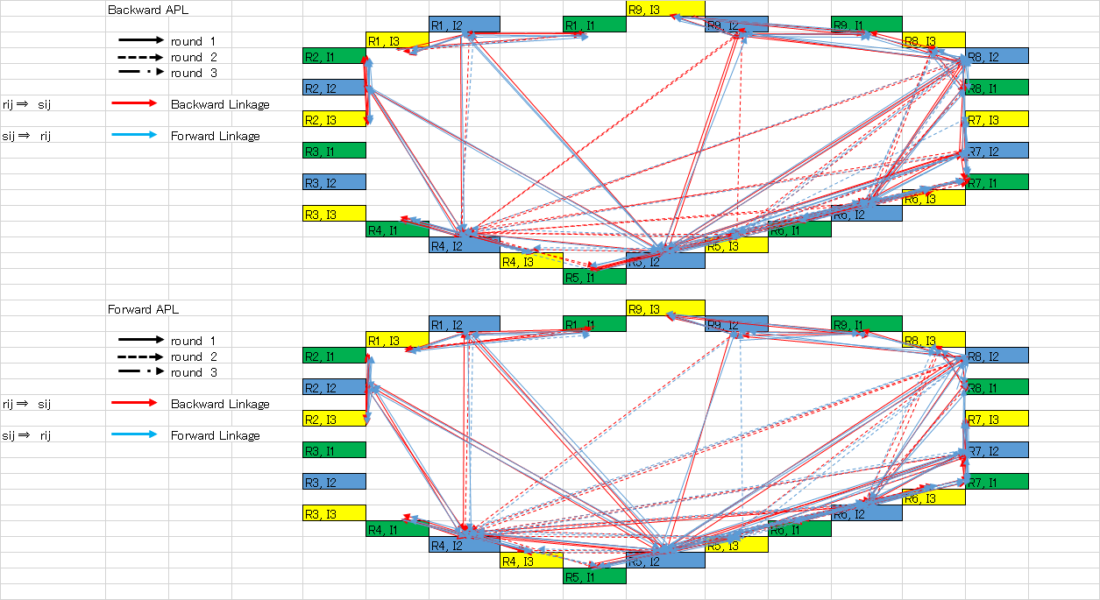

The Pearson correlation coefficient between APL and the matrix F equals 0.0174.
[R,P]=corrcoef(x,y)
x = vij , y = fij,
R = 0.0174, P-value = 0.6390.
We can similarly construct a new matrix S of the Japanese regions where int($v_{ij }$) is used to indicate the nearest integar to which $v_{ij }$has been rounded. For the calculations with the 34 sector classification, we have used a threshold value $a$= 0.02196.
In a production shock to Kanto region, the non-disaster economy compensates for the loss from the production stop in Kanto. Kanto is the economically largest region. As a result, the interregional and inter-industrial production chains have no hub-region with other regions. Due to the fact that there is no economically largest region, which is Kanto, due to the production shock, the interregional and inter-industrial production chains are very sparse with the inter-regional and inter-industrial nework.

Figure 5. The Interregional, Inter-industrial APL of the production shock to the Chubu
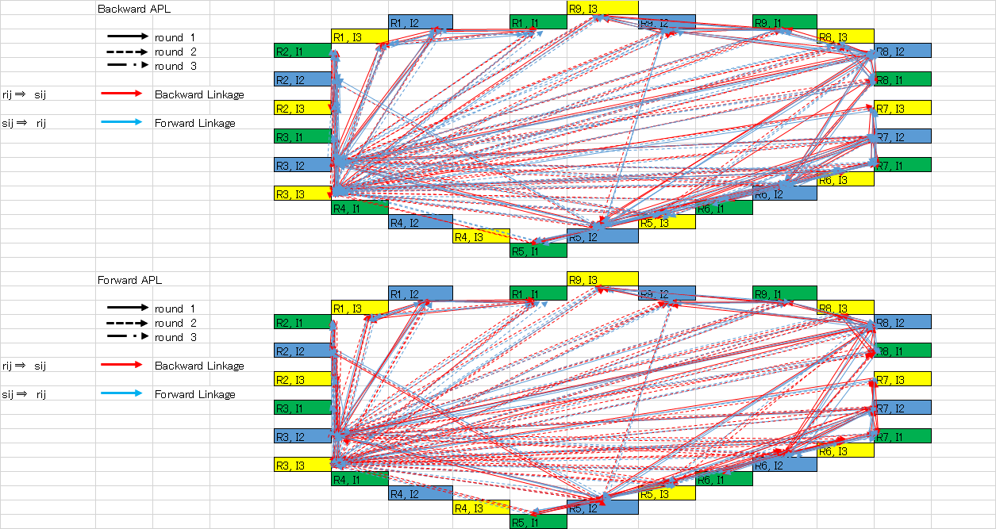
The Pearson correlation coefficient between APL and the matrix F equals 0.045769.
[R,P]=corrcoef(x,y)
x = vij , y = fij,
R = 0.045769, P-value = 0.2171.
We can similarly construct a new matrix S of the Japanese regions where int($v_{ij }$)) is used to indicate the nearest integar to which $v_{ij }$has been rounded. For the calculations with the 34 sector classification, we have used a threshold value a = 0.02400.
In a production shock to Chubu region, the non-disaster economy compensates for the loss from the production stop in Chubu. So, the interregional and inter-industrial production chains have several hub-regions with other regions, for example, the industrial sector 2 and sector 3 in Kanto region, and sector2 in Kinki region, without the disaster region, Chubu. Besides, the production shock to Chubu region will tend to accelerate the over-concentration of population and economy to Kanto region.

Figure 6. The Interregional, Inter-industrial APL of the production shock to the Kinki
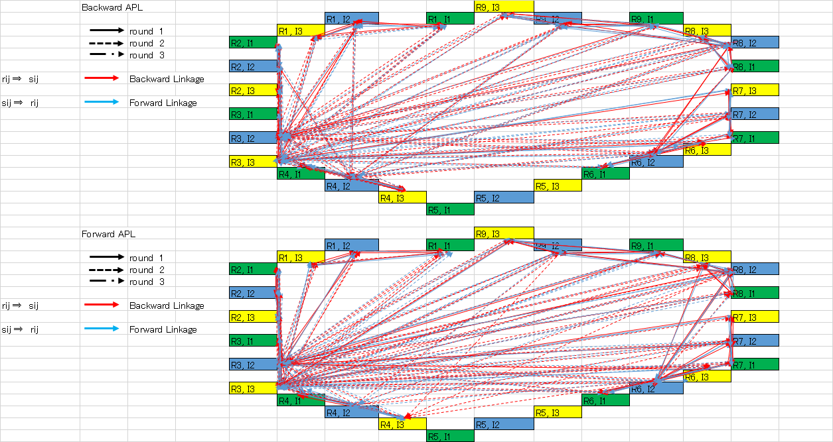

The Pearson correlation coefficient between APL and the matrix F equals 0.039754.
[R,P]=corrcoef(x,y)
x = vij , y = fij,
R = 0.039754, P-value = 0.2838.
We can similarly construct a new matrix S of the Japanese regions where int($v_{ij }$) is used to indicate the nearest integar to which $v_{ij }$has been rounded. For the calculations with the 34 sector classification, we have used a threshold value a = 0.02432.
In a production shock to Kinki region, the non-disaster economy compensates for the loss from the production stop inKinki. So, the interregional and inter-industrial production chains have several hub-regions with other regions, for example, the industrial sector 2 and sector 3 in Kanto region, and sector2 in Chubu region, without the disaster region, Kinki. Besides, the production shock to Kinki region will tend to accelerate the over-concentration of population and economy to Kanto region.

Figure 7. The Interregional, Inter-industrial APL of the production shock to the Chugoku
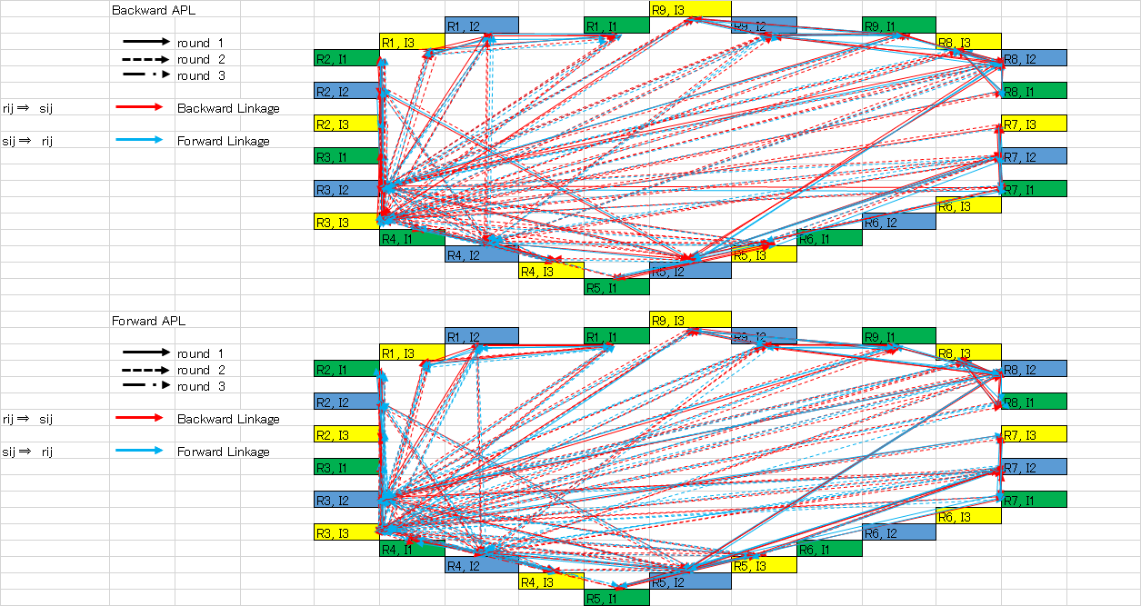

The Pearson correlation coefficient between APL and the matrix F equals 0.051948.
[R,P]=corrcoef(x,y)
x = vij , y = fij,
R = 0.051948, P-value = 0.1611.
We can similarly construct a new matrix S of the Japanese regions where int($v_{ij }$) is used to indicate the nearest integar to which $v_{ij }$has been rounded. For the calculations with the 34 sector classification, we have used a threshold value a = 0.02477.
In a production shock to Chugoku region, the non-disaster economy compensates for the loss from the production stop in Kinki. So, the interregional and inter-industrial production chains have several hub-regions with other regions, for example, the industrial sector 2 and sector 3 in Kanto region, and sector2 in Chubu region, and sector 2 and sector 3 in Kinki region. Besides, the production shock to Chugoku region will tend to accelerate the concentration of population and economy to Kanto, Chubu and Kinki regions.

Figure 8. The Interregional, Inter-industrial APL of the production shock to the Shikoku
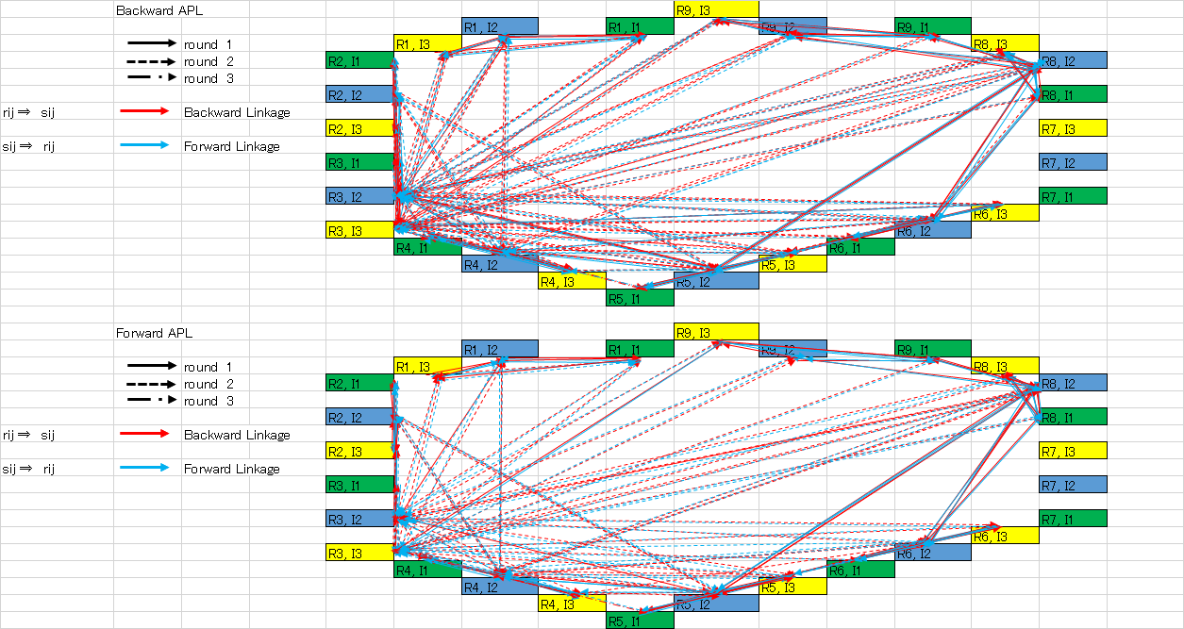

The Pearson correlation coefficient between APL and the matrix F equals 0.050027.
[R,P]=corrcoef(x,y)
x = vij , y = fij,
R = 0.050027, P-value =0.1773.
We can similarly construct a new matrix S of the Japanese regions where int($v_{ij }$) is used to indicate the nearest integar to which $v_{ij }$has been rounded. For the calculations with the 34 sector classification, we have used a threshold value a =0.02570.

Figure 9. The Interregional, Inter-industrial APL of the production shock to the Kyushu
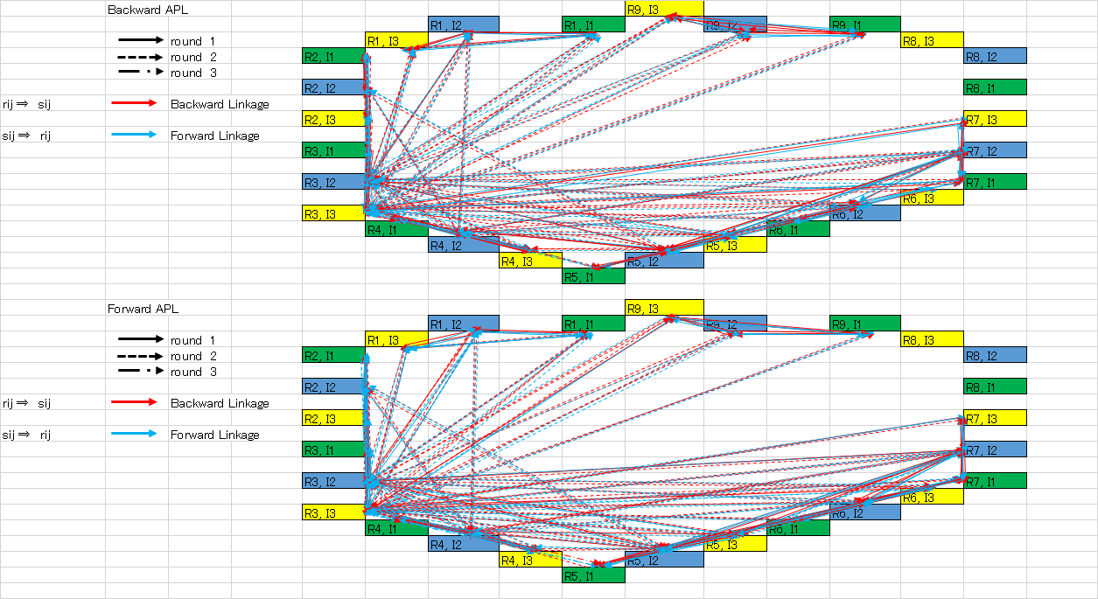

The Pearson correlation coefficient between APL and the matrix F equals 0.055033.
[R,P]=corrcoef(x,y)
x = vij , y = fij,
R = 0.055033, P-value =0.1377.
We can similarly construct a new matrix S of the Japanese regions where int($v_{ij }$) is used to indicate the nearest integar to which $v_{ij }$has been rounded. For the calculations with the 34 sector classification, we have used a threshold value a =0.02479.

Figure 10. The Interregional, Inter-industrial APL of the production shock to the Okinawa
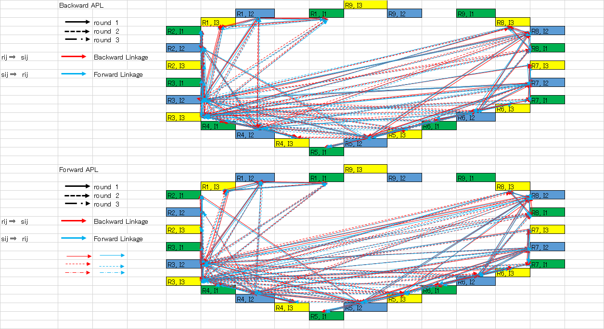

The Pearson correlation coefficient between APL and the matrix F equals 0.06531.
[R,P]=corrcoef(x,y)
x = vij , y = fij,
R = 0.06531, P-value =0.0780.
We can similarly construct a new matrix S of the Japanese regions where int($v_{ij }$) is used to indicate the nearest integar to which $v_{ij }$has been rounded. For the calculations with the 34 sector classification, we have used a threshold value a =0.02289.
In a production shock to Shikoku, Kyushu, and Okinawa regions, the interregional and inter-industrial production chains have several hub-regions with other regions, for example, the industrial sector 2 and sector 3 in Kanto region, and sector2 in Chubu region, and sector 2 and sector 3 in Kinki region. And, the production shock to each region will tend to accelerate the concentration of population and economy to Kanto, Chubu and Kinki regions. Besides, a production shock to Kyushu and Okinawa region will tend to accelerate the economic trade of goods and services with Honshu area.

V. Concluding Remarks
We tested the hypothetical regional extraction model by pushing out the impact due to the hypothetical shocks, which are the production and infrastructure shocks of the disruption of the natural disaster, at each three sector per nine regions in the Japanese interregional economy. Then, we can compile nine hypothetical I-O tables with post-disaster cases with the Japanese interregional economy. Besides, we can also analyze nine hypothetical average propagation lengths.
In a production shock to each region, the non-disaster economy of eight regions does not shrink as with the case of compensating for the loss of the production stop with the damaged region. Besides, in the production shocks to other eight regions, the non-disaster economy also does not shrink as well as the case with the production shock to the damaged region due to the natural disaster. The import of final goods is supposed to be proportionally changed to the rate of change of the regional final demands in comparison with the pre- and post-disaster economy. For instance, the resulting trade deficits of the scenarios of the production shocks to Kanto, Chubu, Kinki, and Kyushu regions are rather large. As a short run restriction to a natural disaster, the outcome is possible, but it is clear that such a large trade deficit is impossible to have the sustainability of the economy.
The backward and forward APLs of the pre-disaster base scenario will show that Industrial sector 2 and sector 3 in Kanto region, Industrial sector 2 in Chubu region, Industrial sector 2 and sector 3 in Kinki region, have very complex production chains with other regions, and these regions will be the hub-regions with other regional and interregional inter-industrial relationship.
In a production shock to Hokkaido, the non-disaster economy compensates for the loss from the production stop in Hokkaido. The interregional and inter-industrial production chains have several hub-regions with other regions, for example, the industrial sector 2 and sector 3 in Kanto region, sector2 in Chubu region, sector 2 and sector 3 in Kinki region, without the disaster region, Hokkaido.
In a production shock to Tohoku region, the non-disaster economy compensates for the loss from the production stop in Tohoku. So, the interregional and inter-industrial production chains have several hub-regions with other regions, for example, the industrial sector 2 and sector 3 in Kanto region, sector2 in Chubu region, sector 2 and sector 3 in Kinki region, without the disaster region, Tohoku.
In a production shock to Kanto region, the non-disaster economy compensates for the loss from the production stop in Kanto. Kanto is the economically largest region. As a result, the interregional and inter-industrial production chains have no hub-region with other regions. Due to the fact that there is no economically largest region, which is Kanto, due to the production shock, the interregional and inter-industrial production chains are very sparse with the inter-regional and inter-industrial nework.
In a production shock to Chubu region, the non-disaster economy compensates for the loss from the production stop in Chubu. So, the interregional and inter-industrial production chains have several hub-regions with other regions, for example, the industrial sector 2 and sector 3 in Kanto region, and sector2 in Kinki region, without the disaster region, Chubu. Besides, the production shock to Chubu region will tend to accelerate the over-concentration of population and economy to Kanto region.
In a production shock to Kinki region, the non-disaster economy compensates for the loss from the production stop in Kinki. So, the interregional and inter-industrial production chains have several hub-regions with other regions, for example, the industrial sector 2 and sector 3 in Kanto region, and sector2 in Chubu region, without the disaster region, Kinki. Besides, the production shock to Kinki region will tend to accelerate the over-concentration of population and economy to Kanto region.
In a production shock to Chugoku region, the non-disaster economy compensates for the loss from the production stop in Chugoku. So, the interregional and inter-industrial production chains have several hub-regions with other regions, for example, the industrial sector 2 and sector 3 in Kanto region, and sector2 in Chubu region, and sector 2 and sector 3 in Kinki region. Besides, the production shock to Chugoku region will tend to accelerate the concentration of population and economy to Kanto, Chubu and Kinki regions.
In a production shock to Shikoku, Kyushu, and Okinawa regions, the interregional and inter-industrial production chains have several hub-regions with other regions, for example, the industrial sector 2 and sector 3 in Kanto region, and sector2 in Chubu region, and sector 2 and sector 3 in Kinki region. And, the production shock to each region will tend to accelerate the concentration of population and economy to Kanto, Chubu and Kinki regions. Besides, a production shock to Kyushu and Okinawa region will tend to accelerate the economic trade of goods and services with Honshu area.
The recovery from the great earthquake has faced many difficulties, including the sudden disruption from both the earthquake and the tsunami. The results of this article show that the disruption due to the production shock to each region will influence the major catastrophical changes with the interregional and inter-industrial economic structure, and the supply chains with the interregional and inter-industrial economic network. To recover from such tragic situations we have to implement all policy instruments at our disposal so that all the economic actors in Japan can attempt to return to a status that is as close to pre-disaster as possible.

References
Antràs, P. , D. Chor, T. Fally, and R. Hillberry (2012), “Measuring the Upstreamness of Production and Trade Flows”, American Economic Review: Papers & Proceedings , 102(3): 412–416, http://dx.doi.org/10.1257/aer.102.3.412
Bon, R. (1988) Supply-Side Multiregional Input-Output Models. Journal of Regional Science, 28/1: 41-50.
Chen, Quanrun (2014), “The Average Propagation Length: An Extended Analysis”, presented paper of the 22nd International Input-Output Conference, Lisbon, 2014.
https://www.iioa.org/conferences/22nd/papers/files/1542_20140507101_TheAveragePropagationLength-AnExtendedAnalysis-QuanrunCHEN.
Chenery, H.B. and Watanabe, T. (1958), ‘International Comparisons of the Structure of Production’, Econometrica, Vol. 26, pp.481-521. DOI: 10.2307/1907514
Dietzenbacher, E. (1997), ‘In Vindication of the Ghosh Model: A Reinterpretation as a Price Model’, Journal of Regional Science, Vol.37, No. 4, pp.629-651. DOI: 10.1111/0022-4146.00073
Dietzenbacher, E., Romero, I., and Bosma, N. (2005), ‘Using Average Propagation Lengths to Identify Production Chains in the Andalusian Economy’, Estudios de Economia Aplicada, Vol.23, No.2, pp.405-422. dialnet.unirioja.es/descarga/articulo/1250453.pdf
Dietzenbacher, E., and Romero, I.(2007), ‘Production Chains in an Interregional Framework:Identification by means of Average Propagation Lengths,’ International Regional Science Review, Vol.30, No.4, pp.362-383. DOI: 10.1177/0160017607305366
Dietzenbacher, E. & U. Temurshoev (2008), “Ownership relations in the presence of cross-shareholding,” Journal of Economics, Vol. 95, pp.182-212, DOI 10.1007//s00712-008-0018-y.
Dietzenbacher, E., J.A. van der Linden & A.E. Steenge (1993) The Regional Extraction Method: EC Input–Output Comparisons, Economic Systems Research 5/2: 185-206.
Dietzenbacher, E. & J.A. van der Linden (1997) Sectoral and Spatial Linkages in the EC Production Structure, Journal of Regional Science, 28/2: 235-57.
Japan (2010) The 2005 Interregional Input-Output table for Japan, Ministry of Economy, Trade and Industry (METI), http://www.meti.go.jp/english/statistics/tyo/tiikiio/pdf/2005report.pdf
Kurata, K., M. Yamazaki, J. Chujo and Y. Sone(2013) Estimates of Exposure of Economic Activity in the Great East Japan Earthquake by means of Industrial Statistics Mesh data in Japan (in Japanese), Doboku Keikakugaku Kenkyu, June 2013.
Miller, R.E. & P. D. Blair (2009) Input-Output Analysis: Foundations and Extensions, Cambridge University Press.
Nozaki, M. (2015) Identifying an Interregional Input-Output Framework by Means of Average Propagation Lengths: A Case Study of Tohoku Region, Business Perspectives, 14/2: 1-9.
Okuyama, Y. and S. E. Chang (edited) (2004) Modeling the Spatial and Economic Effencts of Disasters, New York, Springer.
Okuyama,Y., Sonis, M. and Hewings, G.J.D.(1999) Economic Impacts of an Unscheduled, Disruptive Event: A Miyazawa Multiplier Analysis, in Understanding and Interpreting Economic Structure, G.J.D. Hewings, M.Sonis, M.Madden and Y.Kimura(edited), Springer-Verlag.
Oosterhaven, J. (1988) On the plausibility of the supply-driven input-output model. Journal of Regional Science 28/2: 203-17.
Oosterhaven, J. (1996) Leontief versus Ghoshian Price and Quantity Models. Southern Economic Journal 62/3: 750-9
Oosterhaven, J. & K.R. Polenske (2009) Modern regional input-output and impact analyses. in: R. Capello & P. Nijkamp (eds) Handbook of Regional Growth and Development Theories, Edward Elgar, Cheltenham: 423-39.
Oosterhaven, J. (2012) Adding supply-driven consumption makes the Ghosh model even more implausible. Economic Systems Research 24/1: 101-11.
Oosterhaven, J., M.C. Bouwmeester & M. Nozaki (2013) The impact of production and infrastructure shocks: A non-linear input-output programming approach, tested on a hypothetical economy, Research Institute SOM Report 13017-GEM, Faculty of Economics & Business, University of Groningen.
Paelinck, J., J. de Caevel, and D. J. (1965) ‘Analyse Quantitative de Certaines Phénomènes du Développment Régional Polarisé: Essai de Simulation Statique d’itérarires de Propogation’. In: Problèmes de Conversion Éconmique: Analyses Théoretiques et Études Appliquées. M.-Th. Génin, Paris: 341–387.
Rasmussen, P. N. (1956) Studies in Inter-Sectoral Relations. North-Holland, Amsterdam.
Schultz, S. (1977) Approaches to identifying key sectors empirically by means of input-output analysis. Journal of Development Studies 14: 77–96.
Sonis, M. & J. Oosterhaven (1996) Input-Output Cross Analysis: A Theoretical Account. Environment and Planning A 28: 1507-17.
Strassert, G. (1968) Zur bestimmung strategischer sektoren mit hilfe von input-output modellen. Jahrbücher für Nationalökonomie und Statistik 182: 211–215.
Tamamura, C., Y. Uchida and N. Okamoto (2003), Production and Demand Structures and Free Trade in Asian Countries: Asian International Input-Output Analysis (in Japanese), Asia Keizai (in Japanese), 44/5-6:128-148.
Temurshoev, U. & J. Oosterhaven (2014) Analytical and Empirical Comparison of Policy-Relevant Key Sector Measures. Spatial Economic Analysis 9/3: 284-308.
Miller, R.E. and Blair, P.D. (2009), Input-Output Analysis: Foundations and Extensions, Second Edition, Cambridge.
Miller, R.E. and Lahr, M.L. (2001) “A Taxonomy of Extractions,” in Lahr, M.L. (ed) Regional Science Perspectives in Economic Analysis, Elsevier Science B.V., chap. 21, pp. 407-441. DOI:10.1.1.365.7105
Oosterhaven, J. and Bouwmeester, M.C. (2013), ‘The Average Propagation Length: Conflicting Macro, Intra-industry, and Interindustry Conclusions,’ International Regional Science Review, Vol. 36 No.4, pp. 481-491. DOI: 10.1177/0160017613486670
Rasmussen, P. N.(1956), Studies in Inter-sectoral Relations (Amsterdam, North Holland).
Sonis, M., Guilhoto, J. M., Hewings G.J.D., and Martins, E.B. (1995), “Linkages, key sectors and structural change: some new perspectives”, The Developing Economies. Vol.13, pp.233-270.

Appendix
Figure A1. Japan nine regions in the interregional Japan IRIOT
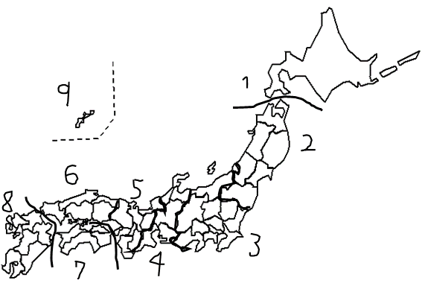

R1. Hokkaido
R2. Tohoku (Aomori, Iwate, Miyagi, Akita, Yamagata, Fukushima)
R3. Kanto (Ibaraki, Tochigi, Gunma, Saitama, Chiba, Tokyo, Kanagawa, Niigata,
Yamanashi, Nagano, Shizuoka)
R4. Chubu (Toyama, Ishikawa, Gifu, Aichi, Mie)
R5. Kinki (Fukui, Shiga, Kyoto, Osaka, Hyogo, Nara, Wakayama)
R6. Chugoku (Tottori, Shimane, Okayama, Hiroshima, Yamaguchi)
R7. Shikoku (Tokushima, Kagawa, Ehime, Kochi)
R8. Kyushu (Fukuoka, Saga, Nagasaki, Kumamoto, Oita, Miyazaki, Kagoshima)
R9. Okinawa

Table A1. Industrial sectors of Japan interregional input-output table
 | Industry
I1 | Agriculture, forestry and fishery
I2 | Mining, Beverages and Foods, Metal products, Machinery, Miscellaneous manufacturing products, Construction
I3 | Public utilities, Commerce and transport, Finance and insurance and real estate, Information and communications, Service Industries

