**Do Exporters' and Non-exporters' Factor Inputs Differ?**

**- A Study Based on Employer-Employee Matched Data for Japan**

**Authors:** Koji Ito, (Kyoto University, Hitotsubashi University and RIETI)

Ivan Deseatnicov (Hitotsubashi University and JSPS)

Kyoji Fukao (Hitotsubashi University and RIETI)

May, 2016

Address correspondence to:

Koji Ito

Kyoto University and RIETI

e-mail: [ito-koji@kier.kyoto-u.ac.jp](mailto:ito-koji@kier.kyoto-u.ac.jp)

**Do Exporters' and Non-exporters' Factor Inputs Differ? -- A Study Based on Employer-Employee Matched Data for Japan**

**Abstract IO conference:** By using employer-employee matched data of Japan (derived from Economic Census and Wage Census) we construct extended Input-Output table for 2011 that takes into consideration heterogeneity in exporting activities of Japanese manufacturing industry.

We split each sector related to Japanese manufacturing industry in the OECD Inter-Country Input-Output (ICIO) table into exporting and domestic shipment sector, based on the information from the matched employer-employee data.

After optimizing the split ICIO table by quadratic programming optimization technique, we compute domestic value added in exports (DVA), foreign value added in exports (FVA), domestic value added and factor inputs (capital, employment, university graduates and non-regular workers) embodied in foreign final demand. The results show that DVA is generally lower for most of industries if we account for firms’ heterogeneity in exporting activities, compared with the estimates of OECD-WTO “Trade in Value Added (TiVA)” indicators. We infer that exporters rely more on foreign intermediate inputs and outsourcing activities.

**JEL Classification Number**: F12, F14, C67, C81

**Key words:** Firms heterogeneity, Input-Output Tables, Export Intensity, Factor Inputs

1. **Introduction**

Global Value Chain (GVC) has become an important topic in the recent literature due to an increased fragmentation of the production within countries and industries. In order to measure GVC, a multi-country input-output table (MIOT) method was suggested. Several initiatives, such as Trade in Value Added (TiVA) produced by joint efforts of OECD and WTO and World Input-Output Database (WIOD) initiated at the University of Groningen within a framework of a European Commission Project, attempted to construct consistently these tables. The idea behind these databases was to link national Supply-Use Tables (SUTs) via international trade flows, and it assumed a representative firm within each industry.

However, as theoretical and empirical evidence suggests there is a substantial amount of heterogeneity in firms’ exporting activity within industries (Melitz 2003, Bernard et al. 2007). A new research has emerged recently to elucidate such heterogeneity. In particular, there were several attempts to produce extended SUTs accounting for firms’ heterogeneity in size, ownership, trade mode etc. (Ahmad et al., 2013, Ma et al. 2014, Fetzer and Strassner 2015). Ignoring the heterogeneity may cause a bias in the result of calculation based on the MIOT.

Our research attempts to contribute to this new initiative. Using employer-employee matched data, we show how performance and factor inputs in Japan’s manufacturing sector differ between exporting and shipment for domestic market sectors. To reflect the difference, we split each sector of Japanese manufacturing industry in the OECD Inter-Country Input-Output (ICIO) table into two activities, exporting and domestic shipment, and calculate domestic value added in exports (DVA), foreign value added in exports (FVA), domestic value added embodied in foreign final demand, and factor inputs induced by foreign final demand to identify the differences between split and non-split versions of the ICIO table. [1]

In our estimation the DVA is generally lower for most of industries than the estimation of TiVA, implying that cross-border fragmentation is higher if we take into consideration firms’ heterogeneity by exporting activity. We also confirm that factor’s intensity induced by foreign final demand varies significantly between and within industries.

The paper is organized as follows. Section II provides a brief literature review. Section III describes data and estimation method followed by the main findings discussion in section IV. Extended IO tables are presented in Section V. Section VI summarizes.

1. **Literature review**

Recent initiatives to extend MIOT led to several micro-level studies aimed at supporting new measurement system. Herewith, we discuss the most recent achievements in the field. A summary of the selected works is given in Table 1.

Table 1: Summary of the selected main previous studies

|  |  |  |  |
| --- | --- | --- | --- |
| **Study** | **Micro-data** | **Considered heterogeneity** | **Main findings** |
| Ahmad et al. (2013) | Turkish firms, 2006 | Foreign/Domestic  Firm size | Intermediate imports/intermediate consumption ratio, value added per unit of output, value added, and exporting firms’ share in total output increase with firms size and for foreign firms |
| Piacentini and Fortanier (2015) | 27 Europe + US, Mexico  2011 | Foreign/Domestic  Firm size | Large firms and foreign firms dominate in exports and imports,  SMEs provide intermediates for exports |
| Ma, Wang, Zhu (2014) | China, 2007 | Processing trade, Traditional export, Domestic | VA/Output ratio is larger for foreign-owned processing firms compared with Chinese-owned firms but smaller for foreign-owned non-processing firms. Intermediate imports/intermediate consumption ratio is larger for foreign owned firms. |
| Fetzer and Strassner (2015) | US, 2011 | US MNE, Foreign-owned affiliate, Domestic firm | VA/output, gross operating surplus/output, and employee compensation/output is higher for non-MNEs. MNEs are more import/export intensive. Foreign-owned US affiliates are more intermediate input intensive. |

Several important works have been conducted at OECD. Ahmad et al. (2013) was the first attempt to account for firms’ heterogeneity within IO framework using Turkish micro-data for year 2006. They examine correlation and distributions of several statistics namely export intensity (export/output ratio), intermediate import ratio (intermediate imports/intermediate consumption ratio), value added per unit of output, value added, and exporting firms’ share in total output. They consider sector heterogeneity by ownership (foreign/domestic) and firm size, and find that on average the observed statistics increase with firm size and for foreign firms.

As a follow up, Ahmad and Ribarsky (2014) suggest various ways to consider heterogeneity supporting their discussion by the trade statistics from OECD Trade by Enterprise Characteristics (TEC) database, and TiVA databases. Such heterogeneity could be relatively standard for majority of countries i.e. ownership and firm size heterogeneity, or it can be peculiar for a particular country i.e. processing trade firms (e.g. China), Global Manufactures (e.g. Mexico), and firms operating from Export Zones (e.g. Costa Rica).

Piacentini and Fortanier (2015) extend this work to a larger number of countries (mainly European plus US and Latin America, limited for Asia and Africa) by linking several micro databases (TEC, OECD Structural and Demographic Business Statistics (SDBS), and OECD Activity of Multinational Enterprises (AMNE) databases)[2]. They also consider firm size and ownership heterogeneity, and find that large and foreign owned firms generally have higher export/turnover, import/turnover, and VA/employment ratios.[3] In addition, they suggest a method to split IO tables and account for intermediate imports in exports and by using the split IO tables identified an important role of Small and Medium Enterprises as providers of intermediate inputs for exports. However, these studies did not discuss explicitly heterogeneity by exporting activity, as well as statistics on capital and human factors’ inputs which is, perhaps, due to data availability, and therefore the results of the studies might include biases

Another trend in literature was to focus on China, and, in particular, address processing trade firms’ behavior. Chen et al. (2012) calculate IO table’s coefficients considering separately “processing exports” and “non-processing exports”. Koopman, Wang and Wei (2012) show that if foreign value added is considered then import content of export doubles. Ma et al. (2014) extend previous works using micro-data, and consider trade regimes and ownership heterogeneity. They found that VA/Output ratio is larger for foreign-owned processing firms compared with Chinese-owned firms but smaller for foreign-owned non-processing firms. Intermediate imports/intermediate consumption ratio was larger for foreign owned firms. These studies focused on intermediate inputs intensity, and they did not discuss explicitly factor inputs for different exporting activity.[4]

Experimental tables to consider firms’ heterogeneity were also created at the U.S. Bureau of Economic Analysis (BEA) (Fetzer and Strassner, 2015). They emphasized characteristics of multinational enterprise (MNE) located in the U.S., namely U.S. MNEs parents, foreign MNEs affiliates and non-MNEs. Their findings are that VA/output, gross operating surplus/output, and employee compensation/output was higher for non-MNEs. Imports/output and exports/output ratios were higher for MNEs. Finally, foreign-owned US affiliates were more intermediate input intensive than local firms (both MNEs and non-MNEs).

Overall, these new approaches suggest various ways to augment IO tables’ fragmentation by considering firms heterogeneity. They mainly focus on ownership, size and trade mode heterogeneity. Our study in contrast emphasizes heterogeneity by exporting activity. Theoretically exporting firms are expected to be larger, more productive and skilled-intensive (Melitz 2003, Bernard et al 2007). Our unique employer-employee matched data allow for estimating factor content statistics of the plants by their exporting activity.

In this sense our work mirrors to some extent the efforts of WIOD team to produce Socio-Economic Accounts that include data on employment (number of workers and educational attainment), capital stocks, gross output and value added at the industry level for 40 countries (Timmer et al. 2015). This paper takes a step further. Thanks to our dataset we are able to produce factor input statistics at the firm level for Japan.

Our study follows the methodology introduced in Koopman, Wang and Wei (2012) to compute input-output linkages in the split IO table. To show the difference between split and non-split IO tables we rely on TiVA database derived by WTO-OECD, and thus we follow an identical method of indicators computation.

Finally, we also analyze the deviation between split and non-split IO table for factor inputs induced by foreign demand. This analyses relies on the methods described in various studies based on WIOD (see for instance Timmer et al. 2015).

1. **Data and estimation method of split IO table**
2. **Data description**

For our analysis, we constructed employer-employee matched data in manufacturing industry using micro data from the following public data implemented by ministries of Japanese Government.

1. **2012 Economic Census for Business Activity(ECBA)**

Economic Census for Business Activity (ECBA), newly conducted in 2012 by Ministry of Internal Affairs and Communications (MIC), aims at identifying the structure of establishments and enterprises in all industries on a national and regional level, and to obtain basic information for conducting various statistical surveys. The target of the survey is almost all establishments and enterprises in Japan as of February 1, 2012. [5]

The data, that we used, cover basic information, such as sales, capital and number of employees of all establishments with four or more employees in manufacturing industry, a total of 332,360 plants.[6] It also includes proportion of direct export value to shipment, which is used to distinguish exporting and non-exporting plant.

1. **Basic Survey on Wage Structure 2012 (BSWS)**

The purpose of Basic Survey on Wage Structure (BSWS), implemented by Ministry of Health, Labour and Welfare (MHLW), is to obtain a clear picture of the wage structure of employees in major industries i.e., wage distribution by type of employment, type of work, occupation, sex, age, school career, length of service and occupational career, etc.

From the survey implemented in 2012, we used 273,377 employee data extracted from 10,616 manufacturing plants.

In order to connect ECBA and BSWS data we employ identification number for prefecture, city and plant. The connection of the three identification numbers enables us to identify each plant. Fortunately, both datasets contain the common identification number. Thus we were able to merge ECBA and BSWS data, and generated employer-employee matched data covering 256,301 employee data extracted from 9,979 plants. [7]

In contrast with ECBA, BSWS is a sample survey. Thus, it is possible to estimate population variables related to employee data (i.e. non-regular worker ratio and share of university graduates) by using sampling ratio. The sampling method of BSWS consists of stratified 2-stage sampling where the plants are the primary sampling unit while the employees are the secondary sampling unit. The plants are stratified by prefecture, industry and size of plant. [8] The sampling ratio for plants is set by plant in these three categories. The sampling ratio for the employees are determined in accordance with industry and size of the plant for the plants with 100 employees or more, while in accordance with size of the plant for the plants with 99 employees or less.

The sampling ratio for employees are disclosed while that for the plants are not. However, the employee-base data we used includes both sampling ratios, which make it possible to estimate population variables. The variables in the later sections indicate estimation of parent population.

1. **Inter Country Input Output Database (ICIO)**

Inter Country Input Output Database (ICIO), issued by the OECD, consists of 62 countries/areas and 34 sectors, based on International Standard Industrial Classification of All Economic Activities (ISIC), rev.3 released from the United Nations Statistics Division. The target of our split is 16 manufacturing sectors in Japanese manufacturing industry.

1. **Estimation method to split sectors of manufacturing industry in ICIO into exporting and domestic shipment activity**

Next, we explain how to split sectors of Japanese manufacturing industry in ICIO table into two activities, exporting and domestic shipment.

1. Meaning of ''Exporting'' and ''Domestic Shipment'' in our split IO table

In our IO table, we define ''exporting'' as a literal meaning; exporting activity in each sector means provision of goods for foreign markets only. In the same way, ''domestic shipment'' activity means input and output activity by exporting plants and non-exporting plants for domestic markets only.

We assume that within firms activity is homogenous. Technology is the same for domestic and export production. Thus we split each manufacturing sector into exporting and domestic shipment sector by percentage of exports using exporting firms’ activities.

1. Sequence of Estimation

The sequence of our calculation is as follows.

1. Make a concordance of industry classification between ICIO table and micro data.

While ICIO uses ISIC rev.3, ECBA adopts Japan Standard Industry Classification (JSIC, Ver.11)[9] which has more segments. The concordance of ISIC rev.3 and JSIC Ver.11 is used to aggregate the micro data to 16 manufacturing sectors in ICIO.

1. Aggregate sales, value added and intermediate input by firms' exporting and domestic shipment activity into 16 manufacturing sectors, using the concordance made in a).
2. Estimate split IO table by quadratic programming method. For the framework of the estimation, please see Appendix 1.
3. **Difference of Exporting and Domestic Shipment: Empirical findings**

Before we start to analyze the split IO table, we confirm how different are the exporting and domestic shipment activities in sectors of Japanese manufacturing industry in term of performance and factor content by using the micro data.

1. Share of Exporting Plants

Table2 indicates number of manufacturing plants in our micro data from ECBA by hierarchy based on export intensity. First of all, non-exporting plants (with 0% of export/sales ratio) accounted for 97.4% of our samples, revealing that exporting plants are very extremely rare (2.6%). It can also be seen that there is a trend that the number of plants decreases with a decrease in exporting intensity.

Table 2 Number of samples by export sales ratio



Source: Authors’ Calculation based on microdata of ECBA

Figure 1 shows the share of exporting and non-exporting plants in each sector. It varies within industries although the number of exporting plants is less than 10% for most of industries (with the exception of Chemicals products industry). The small number of plants' participation in trade has been discussed in the theory suggesting the productivity mechanism (highly skewed distribution of productivity) or high sunk costs restraint (Bernard et al 2007).[10]

Figure 1 Share of plants by exporting activity

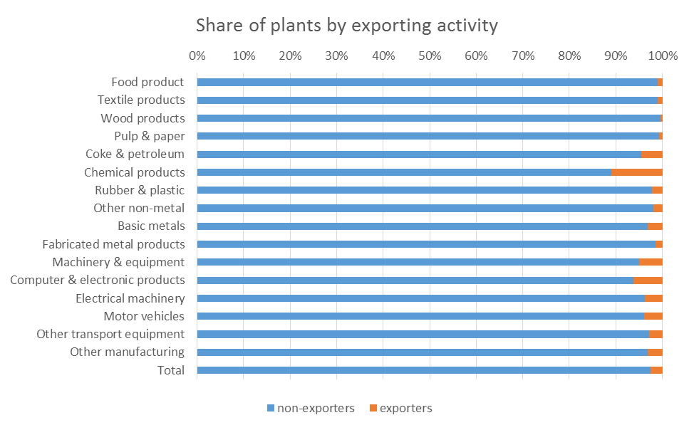

Source: Authors’ Calculation based on microdata of ECBA

1. Share of Exports and Domestic Shipments.

Next we aggregate exports and domestic shipments in each sector. Figure 2 shows the share. Whereas the share of export exceeds 20% in three sectors, (machinery & equipment, motor vehicle and other transport equipment), sales are dominated by domestic shipments in most sectors. Compared with Figure 1, we observe that the share of exports is larger than share of exporters, implying that exporters have comparatively larger size in term of sales.

Figure 2 Share of Domestic Shipments and Exports by sector

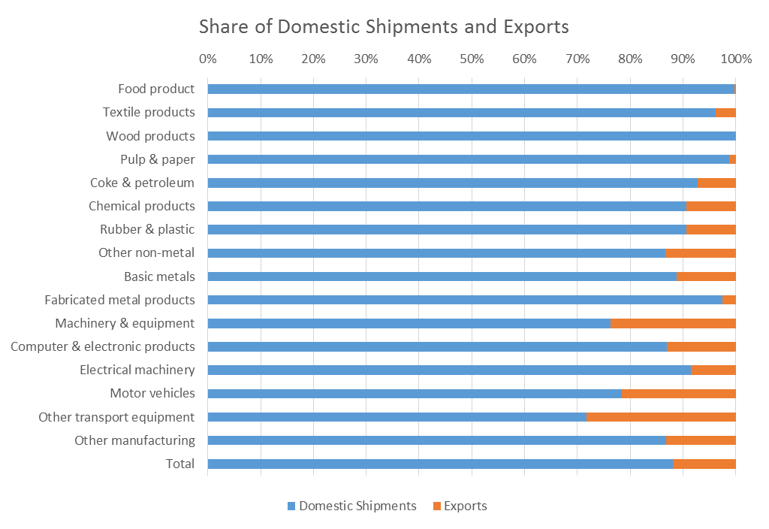

Source: Authors’ Calculation based on microdata of ECBA

1. Heterogeneity of value added-sales ratio and labor productivity by exports and domestic shipments

To see heterogeneity of performance by exports and domestic shipments, we calculate value added-sales ratio and labor productivity. Because micro data of ECBA include plants’ value added but it is not divided by activity, we split exporters’ value added into two parts proportional to the share of exports and domestic shipments, and the value added for domestic shipments are merged into non-exporters’ value added, forming value added generated by domestic shipments. Then we divide value added by sales (exports or domestic shipments). We also divide and merge regular workers in the same way to have labor productivity (sales/regular workers) for domestic shipments and exports.

Figure 3 indicates that in most sectors the difference of value added-sales ratio between domestic shipments and exports is small. Though on average the ratio of domestic shipments is higher, the ratio of exports and domestic shipments is at a similar level in most sectors.

Figure 3 Value added-Sales ratio by exports and domestic shipments

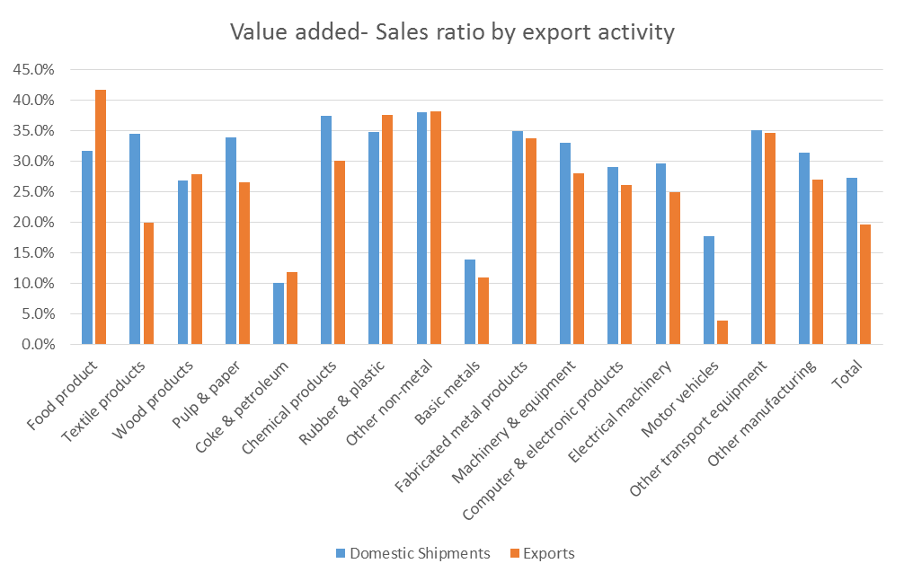

Source: Authors’ Calculation based on microdata of ECBA

On the other hand, Figure 4 tells us that there is large heterogeneity in labor productivity and clear size relation of the two variables in each sector; labor productivity of exporting activity tends to exceed that of domestic shipments’ activity. The trend gives us a reason why we should take into consideration the heterogeneity in exports and domestic shipments. Our findings are in line with the theoretical arguments that more productive firms involve into international trade (Bernard et al. 2007).

Figure 4 Labor Productivity by exports and domestic shipments

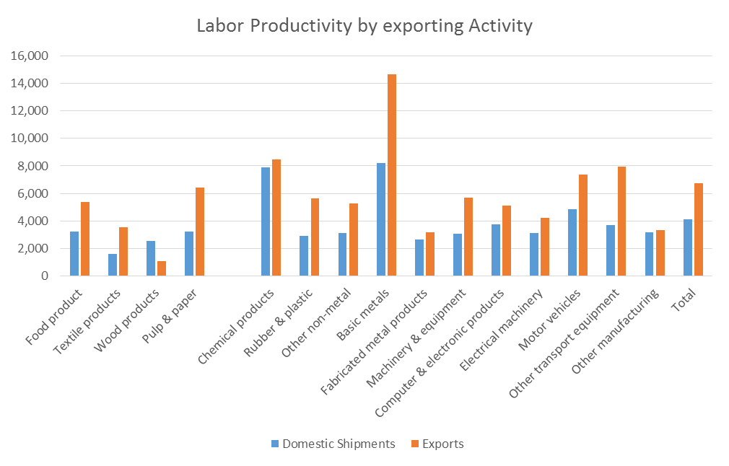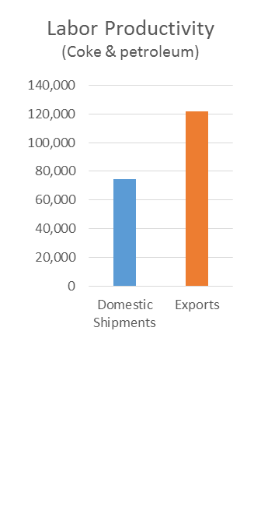

Source: Authors’ Calculation based on microdata of ECBA

1. Heterogeneity of factor content by exports and domestic shipments

A comparison of factor content by two activities reveals a clear difference. Figure 5 shows that exporting activity is more capital intensive than domestic shipments as predicted by trade theories (e.g. Hecksher-Ohlin framework). [11] Particularly high capital intensity is observed for textile products, wood products, and other non-metal industries.

Figure 5 Capital Sales ratio by exports and domestic shipments

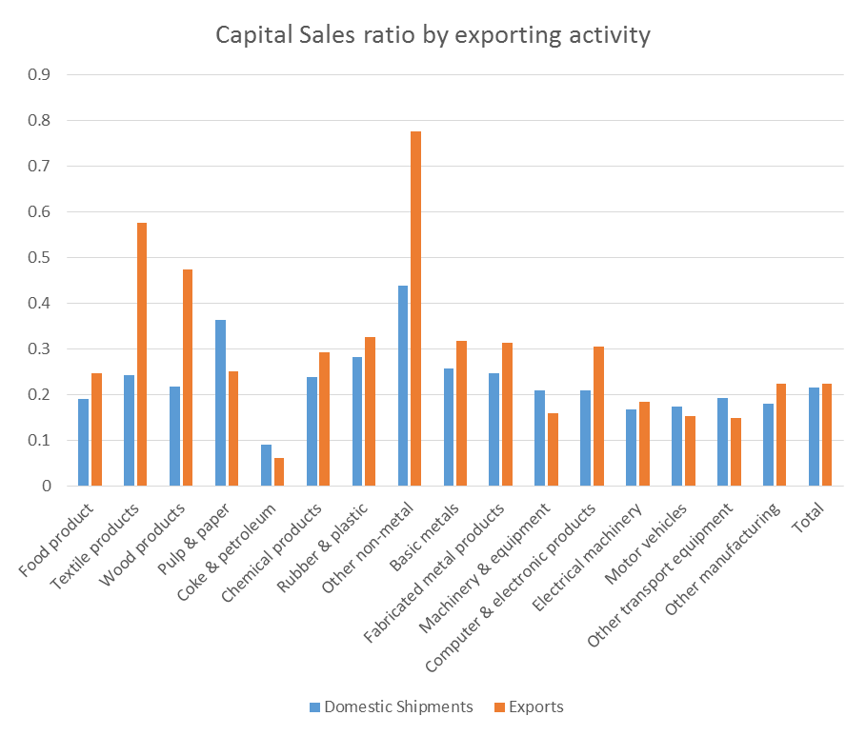

Source: Authors’ Calculation based on microdata of ECBA

Figure 6 Labour Sales ratio by exports and domestic shipments

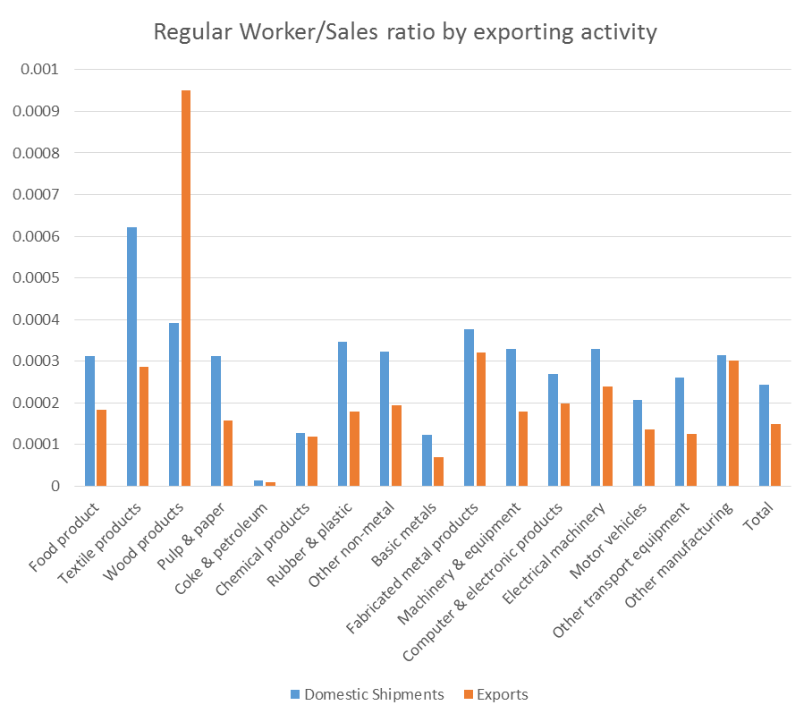

Figure 6 shows that regular worker intensity is higher for domestic shipments activity than for exporting activity. The highest regular worker intensity is observed for domestic shipments’ sector in textile products’ sector. The only exception is exporting activity in wood products’ sector where regular worker intensity is comparatively high.

Finally, we focus on the difference between exporting and domestic shipments activities in labor input. The employer-employee data combined from ECBA and BSWS has the information of the number of university graduates and non-regular workers in each plant. We aggregate the numbers by exporting activity and sector, and divide and merge them in the same way as we calculate value added for exports and domestic shipments. Figure 7 shows that exporting activity is more skilled labor intensive than domestic shipments activity. Share of University Graduates is higher for all industries exporting activity.

Figure 7 Share of university graduates by exports and domestic shipments

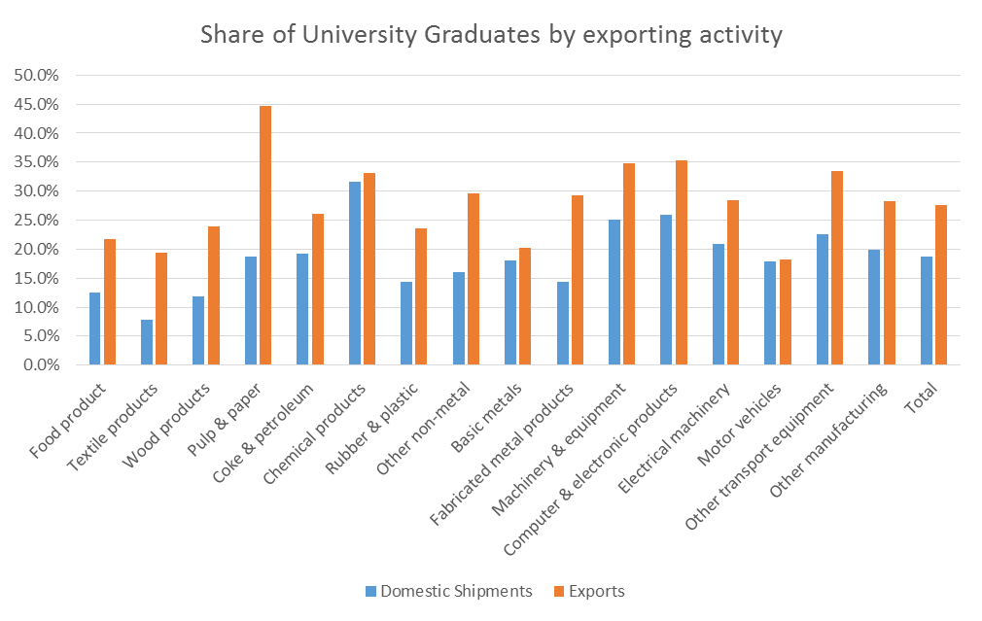

Source: Authors’ Calculation based on employer-employee data from ECBA and BSWS

As can be observed from Figure 8 exporting activity requires less non-regular workers in most sectors. In addition to observation that exporting sector is more skill intensive, it also tends to have labor demand skewed for regular workers implying that they encourage long-term employment strategy.

Figure 8 Share of non-regular worker by exports and domestic shipments

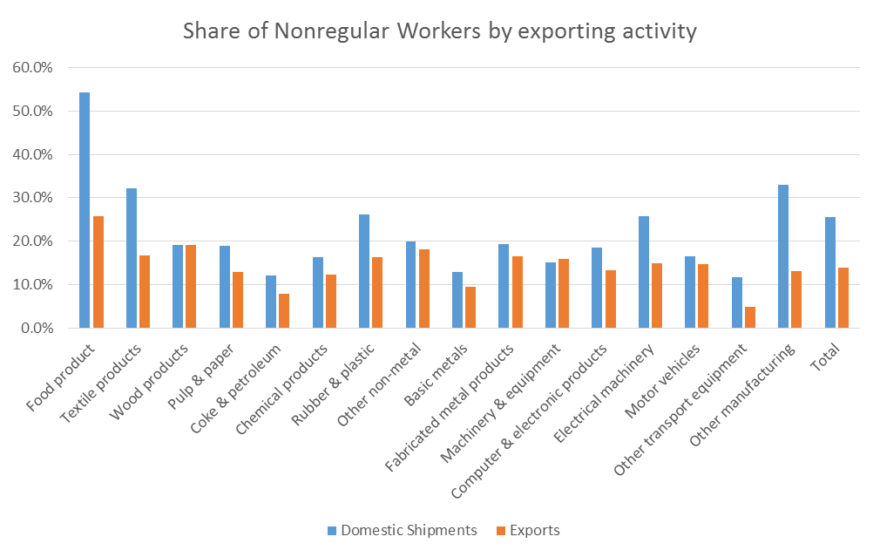

Source: Authors’ Calculation based on employer-employee data from ECBA and BSWS

In sum, the heterogeneity of exports and domestic shipments activities can be confirmed from a variety of perspectives.

**V. Extended Input-Output Tables**

1. **Main indicators**

Now we are ready to identify how heterogeneity by exporting activities affects domestic and foreign value added embodied in Japanese exports and final demand, as well as factor inputs induced by final demand. The indicators we calculate for the purpose are described below.

First, we compute global Leontief inverse matrix L of dimension C*S x C*S (C stands for country, S stands for sector), global Value Added share of output row vector VA’ (C*S x 1) and Factor Input/Output share vector FJP’ for Japan (S x 1).

L = (I-Z/Y’)-1 (1)

V’ = VA’/Y’ (2)

FJP’ = FactorInputJP’/YJP’ (3)

where Z is global technical coefficient matrix (C*S x C*S). The block of Japan’s technical coefficient matrix is split into exporting and domestic shipment activity as explained in section III.2; Y’ is row vector of global output (C*S x 1); VA’ is row vector of global value added (C*S x 1); FJP’ is a row vector of factor input required per unit of output in Japan. We examine the following factor inputs: Capital, Employment, Nonregular workers, and University Graduates. For the purpose of our analysis we employ only the information on Japanese factor inputs.

As a comparative exercise our indicators are identical to OECD TiVA database. In what follows, we give a short definition of the indicators used.

DVAJPWOR= VJP’*LJP* (4)

where VJP’ is a row vector of value added share of output for Japanese industries; LJP is a Japan’s block of global Leontief inverse matrix; $\hat{EX\text{JP}'}$ is a diagonal matrix of Japanese industries’ exports on the diagonal.

DVAJPWOR represents domestic value added in exports of each industry. It includes both direct exports by exporting activity and indirect exports which is domestic shipment activity’s input to exporting activity.

FVAJPWOR= V’*LJP_zero* (5)

where V’ is a row vector of global value added share of output; LJP_zero is a Japan’s column block of global Leontief inverse matrix with the Japan’s row block equal to zero; $\hat{EX\text{JP}'}$ is a diagonal matrix of Japanese industries’ exports on the diagonal.

DVAJPWOR represents foreign value added in exports of each Japan’s industry. It includes direct and indirect inputs of all other countries’ industries.

FFDJP,C = *LJP,global*Dglobal,C (6)

where $\hat{V\text{JP}’}$ is diagonal matrix of value added share of output for Japanese industries on the diagonal; LJP,global is a Japan’s row block of global Leontief inverse matrix; Dglobal,C is a vector of countries C global final demand from all countries-industries.

FFD_DVAJP,C represents each Japan’s industry domestic value added embodied in country C’s final demand. It includes both direct and indirect contribution of Japanese industries via all global input-output linkages to the country C’s final demand. In what follows we report FFD_DVAJP,C for USA, Korea, China and World final demand.

FFD_FJP,C = *LJP,global*Dglobal,C (7)

where $\hat{F\text{JP}’}$ is a diagonal matrix of factor input required per unit of output for Japanese industries on the diagonal; LJP,global is a Japan’s row block of global Leontief inverse matrix; Dglobal,C is a vector of countries C global final demand from all countries-industries.

FFD_FJP,C represents each Japan’s industry factor input embodied in country C’s final demand. It shows the factor input generated by the country C’s final demand via all global input-output linkages.

**2. Results of Calculation**

Now we turn to discussing experimental input-output tables to account for exporting activity’s heterogeneity in Japan. Table 3 presents such tables for the whole manufacturing sector in 2012 considering heterogeneity by exporting activity. This table is based on the micro data.[12] We draw and confirm the following observations:

(1) Sales are higher for domestic shipment activity.

(2) Value added is higher for domestic shipment activity.

(3) Capital stock per worker is higher for exporting activity.

(4) The overall labor productivity is higher for exporting activity. This is consistent with the theory that predicts higher productivity for exporting firms (Melitz 2003).

(5) Number of workers employed in domestic shipment activity is considerably higher.

(6) Share of university graduates is higher for exporting activity.

(7) Share of non-regular workers is higher for domestic shipment activity.

Table 3. Extended input-output tables for the whole manufacturing sector, 2011

|  |  |  |  |  |
| --- | --- | --- | --- | --- |
|  | **Domestic Shipment activity** | **Exporting activity** | **Exports (Billion yen)** | **Total sales (Billion yen)** |
| Domestic Shipment activity |  |  | 0 | 20,744.65 |
| Exporting activity |  |  | 2,809.53 | 2,809.53 |
| **Total value added (Billion yen)** | 6,936.99 | 559.65 |  |  |
| Total capital stock per worker (Mil. yen/worker) | 887.38 | 1494.56 |  |  |
| Labor productivity (Mil. yen/worker) | 4137 | 6757 |  |  |
| Number of workers | 5,032,637 | 419,737 |  |  |
| Share of university graduates | 0.19 | 0.28 |  |  |
| Share of non-regular workers | 0.26 | 0.14 |  |  |
| **Total sales (Billion yen)** | 20,744.65 | 2,809.53 |  |  |

A more detailed picture can be observed if we split the observations by industries. We present an example of two industries (Machinery and equipment, and Computer, electronic and optical products) that are considered to be export oriented in Japan (Table 4). Most of observations are in line with the general pattern.

Table 4. An example of input-output tables for two industries, 2011

|  |  |  |  |  |  |  |  |
| --- | --- | --- | --- | --- | --- | --- | --- |
|  |  | Machinery and equipment | | Computer, electronic and optical products | | Exports (Billion yen) | Sales  (Billion yen) |
|  |  | Domestic Shipment activity | Exporting activity | Domestic Shipment activity | Exporting activity |  |  |
| Machinery and equipment | Domestic Shipment activity |  |  |  |  | 0 | 1586.49 |
| Exporting activity |  |  |  |  | 492.51 | 492.51 |
| Computer, electronic and optical products | Domestic Shipment activity |  |  |  |  | 0 | 22667.63 |
| Exporting activity |  |  |  |  | 423.19 | 2812.32 |
| **Value added**  **(Billion yen)** | | 524.50 | 137.82 | 815.65 | 110.05 |  |  |
| Total capital stock per worker (Mil. yen/worker) | | 5.38 | 8.10 | 3.82 | 6.59 |  |  |
| Labor productivity (Mil. yen/worker) | | 635.22 | 893.59 | 777.48 | 1527.06 |  |  |
| Number of workers | | 3,061 | 5,712 | 3,738 | 5,123 |  |  |
| Share of university graduates | | 522,639 | 87,796 | 757,495 | 84,120 |  |  |
| Share of non-regular workers | | 0.25 | 0.35 | 0.26 | 0.35 |  |  |
| **Sales (Billion yen)** | | 0.151 | 0.159 | 0.18 | 0.13 |  |  |

Note only that share of non-regular workers is similar for exporting and domestic shipment activity in machinery and equipment industry while it is higher for domestic shipment activity in computer, electronic and optical products industry.

In sum, all these observations imply a heterogeneity of factor inputs for exporting and domestic shipment activity which may vary considerably in between and within industries. Thus, our findings suggest that accounting for exporting activity's heterogeneity in the split input-output table may provide a better picture on the factor inputs and value added distribution within industries.

Next, we discuss the differences between main indicators presented in section III.3 that arise when we split IO table into exporting and domestic shipment activity. First, we examine the domestic and foreign value added in Japanese’ industries exports. To present it in a comparative perspective we sum up the obtained results of DVA and FVA for split industries to derive industries’ total DVA and FVA, and compare them with OECD TiVA corresponding result. Table 5 shows our findings for the manufacturing industries that where split using economic census micro data.

Table 5. Domestic and Foreign Value Added in Japan’s Gross Exports (ten thousand Yen)

|  |  |  |  |  |  |  |  |
| --- | --- | --- | --- | --- | --- | --- | --- |
|  | **DVA Split IO (A)** | **TiVA_DVA (B)** | **Deviation, %**  **{(A-B)/[(A+B)/2]}*100** | **FVA Split IO**  **(C)** | **TiVA_FVA**  **(D)** | **Deviation, %**  **{(C-D)/[(C+D)/2]}*100** | **Exports** |
| Food products, beverages and tobacco | 2540.0 | 2662.4 | -4.7 | 511.7 | 389.3 | 27.2 | 3051.7 |
| Textiles, textile products, leather and footwear | 4167.3 | 4931.6 | -16.8 | 2318.8 | 1554.5 | 39.5 | 6486.1 |
| Wood and products of wood and cork | 54.1 | 58.1 | -7.2 | 18.1 | 14.1 | 25.0 | 72.2 |
| Pulp, paper, paper products, printing and publishing | 3242.7 | 3407.1 | -4.9 | 569.6 | 405.2 | 33.7 | 3812.4 |
| Coke, refined petroleum products and nuclear fuel | 7996.4 | 5893.9 | 30.3 | 5636.7 | 7739.3 | -31.4 | 13633.1 |
| Chemicals and chemical products | 47411.2 | 49264.1 | -3.8 | 17222.0 | 15369.2 | 11.4 | 64633.3 |
| Rubber and plastics products | 17033.4 | 17302.1 | -1.6 | 4147.5 | 3878.8 | 6.7 | 21180.9 |
| Other non-metallic mineral products | 8968.2 | 9403.1 | -4.7 | 1974.3 | 1539.5 | 24.7 | 10942.5 |
| Basic metals | 48930.0 | 51885.7 | -5.9 | 17893.3 | 14937.7 | 18.0 | 66823.4 |
| Fabricated metal products | 6064.8 | 6527.1 | -7.3 | 1529.5 | 1067.2 | 35.6 | 7594.3 |
| Machinery and equipment | 82796.8 | 85238.0 | -2.9 | 16741.0 | 14299.8 | 15.7 | 99537.8 |
| Computer, Electronic and optical equipment | 103276.5 | 110970.1 | -7.2 | 30705.1 | 23011.5 | 28.6 | 133981.7 |
| Electrical machinery and apparatus, nec | 20100.9 | 21332.8 | -5.9 | 5148.8 | 3917.0 | 27.2 | 25249.8 |
| Motor vehicles, trailers and semi-trailers | 100491.2 | 102636.5 | -2.1 | 18722.6 | 16576.4 | 12.2 | 119212.9 |
| Other transport equipment | 26742.3 | 28148.7 | -5.1 | 6526.5 | 5120.1 | 24.2 | 33268.8 |
| Total | 489374 | 509574.2 | -4.0 | 132290 | 112088.9 | 16.5 | 609480.9 |

We observe that domestic value added is lower for most of industries as well as for total of industries if we take into consideration heterogeneity of firms and split IO table by exporting and domestic shipments activity.[13] The lower level of domestic value added is compensated by a higher level of foreign valued added. The difference in FVA of more than 15% is clearly observed for almost all industries.[14] This observation implies that Japanese exporters rely more on foreign value added when we take into consideration firms’ heterogeneity. We infer that this result is caused by exports lower Value Added/Sales ratio. For instance, a number of big assemblers (e.g. Toyota) purchases parts and components, and some of them come from abroad. Thus, it generates a leakage of VA abroad. A part of this process is intra-industry trade by Multinationals. As global value chain (GVC) spreads more and more parts and components are being imported from abroad. Lower domestic Value Added/Sales ratio occurs since intermediate inputs are produced abroad. Nevertheless, note, that domestic value added still represents a major part of Japanese exports. In sum, these findings imply, that cross-border fragmentation is higher if we consider firms’ heterogeneity in IO table.

Relative to the value added embodied in foreign final demand we compare our estimations with the ones reported in TiVA database in Table 6.[15]

Table 6. Comparison of results for Domestic value added embodied in foreign final demand between original and extended IO table.

|  |  |  |  |  |
| --- | --- | --- | --- | --- |
|  | USA | China | Korea | World |
|  | Deviation from TiVA, % | Deviation from TiVA, % | Deviation from TiVA, % | Deviation from TiVA, % |
| Food products, beverages and tobacco | -4.74 | 6.05 | -9.89 | -5.66 |
| Textiles, textile products, leather and footwear | -66.77 | -68.78 | -72.95 | -69.48 |
| Wood and products of wood and cork | 15.42 | 18.86 | 16.48 | 11.67 |
| Pulp, paper, paper products, printing and publishing | 8.82 | 15.34 | 11.22 | 7.27 |
| Coke, refined petroleum products and nuclear fuel | 20.62 | 30.10 | 31.80 | 24.93 |
| Chemicals and chemical products | -11.72 | -10.31 | -15.14 | -13.99 |
| Rubber and plastics products | 9.01 | 11.52 | 1.14 | 5.41 |
| Other non-metallic mineral products | 1.16 | 7.18 | -19.15 | -6.36 |
| Basic metals | 12.48 | 9.94 | 1.37 | 1.70 |
| Fabricated metal products | 1.83 | 8.56 | -1.22 | -3.80 |
| Machinery and equipment | -21.60 | -26.25 | -29.14 | -28.33 |
| Computer, Electronic and optical equipment | -44.09 | -43.06 | -32.56 | -45.00 |
| Electrical machinery and apparatus, nec | -19.05 | -29.00 | -23.50 | -23.96 |
| Motor vehicles, trailers and semi-trailers | -29.57 | -25.02 | -17.68 | -29.36 |
| Other transport equipment | -48.45 | -16.00 | -25.76 | -55.85 |
| Manufacturing nec; recycling | -3.88 | 8.57 | -20.30 | -11.15 |
| Total for industries | -0.60 | 1.73 | 2.09 | -3.38 |

Note that relative deviation from TiVA results for DVA embodied in foreign final demand is lower by more than 15% for Textiles, textile products, leather and footwear, Machinery and equipment, Computer, Electronic and optical equipment, Electrical machinery and apparatus, Motor vehicles, trailers and semi-trailers, and Other transport equipment. These industries' companies are known to rely on outsourcing as well as outward FDI activities and intra-industry trade. Thus, when we take into consideration the manufacturing plants’ heterogeneity by exporting and non-exporting activities we can observe that DVA embodied in foreign final demand is relatively lower compared with the results based on ICIO table without heterogeneity considered.

All these stylized facts that we observe are rooted in the differences in between Leontief inverse matrices i.e. the gross output values in all stages of production that are needed for production of one unit of final good. When we split IO table in exporting and domestic shipment activities the output values for one unit of production are lower for exporting activity since it relies more on outsourcing activities. For instance, Table 7 shows the outsourcing share for exporters and domestic shipment activities based on our manufacturing census data.

Table 7. Outsourcing values from manufacturing census data, ten thousand Yen)

|  |  |  |  |  |
| --- | --- | --- | --- | --- |
| ISIC rev.3 | Industry description | Exporter | Non-Exporter | Exporters' Share |
| 1516 | Food products, beverages and tobacco | 208972.19 | 34573102.79 | 0.01 |
| 1719 | Textiles, textile products, leather and footwear | 475522.01 | 22617322.97 | 0.02 |
| 2000 | Wood and products of wood and cork | 21166.78 | 11542766.23 | 0.00 |
| 2122 | Pulp, paper, paper products, printing and publishing | 4374962.00 | 105260240.91 | 0.04 |
| 2300 | Coke, refined petroleum products and nuclear fuel | 687412.01 | 12269106.96 | 0.05 |
| 2400 | Chemicals and chemical products | 5791447.46 | 51949312.46 | 0.10 |
| 2500 | Rubber and plastics products | 3715656.54 | 61303387.47 | 0.06 |
| 2600 | Other non-metallic mineral products | 5065457.01 | 29038567.03 | 0.15 |
| 2700 | Basic metals | 19438562.05 | 118004469.40 | 0.14 |
| 2800 | Fabricated metal products | 2226572.79 | 78899420.26 | 0.03 |
| 2900 | Machinery and equipment, nec | 77045998.53 | 256267238.42 | 0.23 |
| 3033 | Computer, Electronic and optical equipment | 31197311.07 | 196294761.24 | 0.14 |
| 3100 | Electrical machinery and apparatus, nec | 8602748.33 | 72108232.50 | 0.11 |
| 3400 | Motor vehicles, trailers and semi-trailers | 16702914.24 | 127043316.71 | 0.12 |
| 3500 | Other transport equipment | 21717621.97 | 61407845.37 | 0.26 |
| 3637 | Manufacturing nec; recycling | 3742399.72 | 21078410.16 | 0.15 |

Indeed, exporter's share in outsourcing is relatively higher for Machinery and equipment, Computer, Electronic and optical equipment, Electrical machinery and apparatus, Motor vehicles, trailers and semi-trailers, Other transport equipment, Manufacturing; recycling compared to other industries. We also observed lower DVA and Factor Inputs embodied in exports and foreign final demand for these industries.

*Discussion on Factor Inputs differences between exporter and domestic shipment activity.*

Table 8 presents the factor inputs embodied in foreign final demand. First, we observe that Domestic Shipments activity contributes a relatively higher factor content to foreign final demand via indirect linkages to exporting activity. Second, the highest capital input embodied in foreign final demand is observed for exporting activity in Computer, Electronic and optical equipment industry and domestic shipment sector in Basic Metal industry. Third, the highest labor intensity is observed in exporting activity in Motor vehicles, trailers and semi-trailers industry, and in domestic shipment activity in Computer, Electronic and optical equipment industry. The highest demand for university graduates appears in Machinery and equipment exporting activity, and in Computer, Electronic and optical equipment domestic shipment activity. Finally the highest demand for non-regular workers is created in Motor vehicles, trailers and semi-trailers exporting activity and in Rubber and plastics products Domestic Shipments activity.

Thus, we conclude that exporting activity in Computer, Electronic and optical equipment industry and domestic shipment activity in Basic Metal industry are capital intensive, and exporting activity in Motor vehicles, trailers and semi-trailers industry and domestic shipments activity in Computer, Electronic and optical equipment industry are labor intensive. This observation is different from our discussion in Section 4.4.

Table 8. Factor inputs embodied in world foreign final demand by exporting activity.

|  |  |  |  |  |  |  |  |  |
| --- | --- | --- | --- | --- | --- | --- | --- | --- |
|  | Labor (workers) | | Capital (ten thousand Yen) | | Nonregular Workers (workers) | | University Graduates (workers) | |
|  | Export | Domestic Shipment | Export | Domestic Shipment | Export | Domestic Shipment | Export | Domestic Shipment |
| Food products, beverages and tobacco | 2431.3 | 25407.9 | 2086750.0 | 10157127.1 | 449.6 | 9864.9 | 379.2 | 2277.8 |
| Textiles, textile products, leather and footwear | 3875.0 | 35207.2 | 5373035.0 | 4667732.7 | 296.1 | 5204.8 | 345.3 | 1266.9 |
| Wood and products of wood and cork | 44.3 | 26156.7 | 187005.2 | 4265338.7 | 3.3 | 1958.8 | 4.2 | 1217.9 |
| Pulp, paper, paper products, printing and publishing | 3021.1 | 133099.3 | 2825151.8 | 55764792.7 | 158.1 | 10179.2 | 545.9 | 10092.2 |
| Coke, refined petroleum products and nuclear fuel | 525.8 | 3772.7 | 6685973.2 | 16959165.3 | 20.7 | 227.4 | 68.3 | 361.1 |
| Chemicals and chemical products | 27199.0 | 79077.8 | 61600094.5 | 105285963.5 | 2427.0 | 9405.7 | 6553.3 | 18184.6 |
| Rubber and plastics products | 21400.4 | 163228.1 | 33161053.1 | 80058456.6 | 2232.0 | 27222.3 | 3217.3 | 14937.5 |
| Other non-metallic mineral products | 14775.0 | 47579.8 | 44160619.8 | 27493974.1 | 1471.4 | 5216.6 | 2397.6 | 4201.5 |
| Basic metals | 24613.7 | 177182.7 | 79531634.7 | 263876268.3 | 1521.9 | 14861.8 | 3229.0 | 20756.0 |
| Fabricated metal products | 9730.4 | 144101.7 | 6580418.3 | 34730643.5 | 737.8 | 12706.6 | 1300.2 | 9468.0 |
| Machinery and equipment | 134380.5 | 154164.8 | 77268428.6 | 44606526.3 | 10953.9 | 11916.9 | 24004.5 | 19814.7 |
| Computer, Electronic and optical equipment | 119145.4 | 260054.0 | 124360595.8 | 119268474.5 | 7667.8 | 23207.6 | 20346.3 | 32640.2 |
| Electrical machinery and apparatus, nec | 11488.8 | 104174.9 | 13115824.2 | 32157668.9 | 1022.4 | 16095.3 | 1956.6 | 13018.1 |
| Motor vehicles, trailers and semi-trailers | 159286.8 | 231317.7 | 122792961.2 | 133388850.8 | 16544.2 | 26712.7 | 20343.0 | 29152.2 |
| Other transport equipment | 50504.6 | 36839.2 | 24824404.6 | 14959095.9 | 1016.6 | 1812.8 | 7109.0 | 3506.5 |
| Total | 582422.1 | 1621364.5 | 604553949.9 | 947640078.8 | 46522.9 | 176593.5 | 91799.6 | 180895.3 |
| Minimum | 44.3 | 3772.7 | 187005.2 | 4265338.7 | 3.3 | 227.4 | 4.2 | 361.1 |
| Maximum | 159286.8 | 260054.0 | 124360595.8 | 263876268.3 | 16544.2 | 27222.3 | 24004.5 | 32640.2 |
| Median | 14775.0 | 104174.9 | 24824404.6 | 34730643.5 | 1022.4 | 10179.2 | 2397.6 | 10092.2 |

Finally, we discuss the difference between factor inputs embodied in world final demand calculated from split and non-split ICIO tables. The comparison of results is presented in Table 9. [16]

Table 9. Comparison of results for factor inputs embodied in world final demand between original and extended IO table.

|  |  |  |  |  |
| --- | --- | --- | --- | --- |
|  | Labor | Capital | Non-regular workers | University Graduates |
|  | Deviation | Deviation | Deviation | Deviation |
| Food products, beverages and tobacco | -13.01 | -3.70 | -17.57 | -6.91 |
| Textiles, textile products, leather and footwear | -75.90 | -21.63 | -79.71 | -65.07 |
| Wood and products of wood and cork | 11.96 | 15.66 | 11.96 | 12.11 |
| Pulp, paper, paper products, printing and publishing | 6.15 | 8.38 | 5.57 | 8.65 |
| Coke, refined petroleum products and nuclear fuel | -3.34 | 13.54 | -7.05 | 0.29 |
| Chemicals and chemical products | -15.87 | -4.16 | -20.69 | -15.00 |
| Rubber and plastics products | -4.02 | 10.68 | -7.07 | 0.83 |
| Other non-metallic mineral products | -19.68 | 29.82 | -21.40 | -5.74 |
| Basic metals | -0.15 | 5.66 | -1.64 | 0.50 |
| Fabricated metal products | -5.46 | 3.27 | -6.19 | -0.33 |
| Machinery and equipment | -47.83 | -20.85 | -46.01 | -35.76 |
| Computer, Electronic and optical equipment | -50.85 | -28.66 | -57.07 | -43.65 |
| Electrical machinery and apparatus, nec | -33.12 | -16.64 | -36.18 | -30.62 |
| Motor vehicles, trailers and semi-trailers | -7.86 | -0.06 | -10.48 | -7.52 |
| Other transport equipment | -65.29 | -58.67 | -89.96 | -51.37 |
| Manufacturing nec; recycling | -12.57 | 11.93 | -29.17 | -3.12 |
| Total for industries | -3.75 | -6.23 | -27.64 | -22.43 |

Again, note that a significant deviation is observed in Textiles, textile products, leather and footwear, Chemicals and chemical products, Other non-metallic mineral products, Machinery and equipment, Computer, Electronic and optical equipment, Electrical machinery and apparatus, and Other transport equipment industries. Standard IO table analysis overestimates the Employment, Non-regular workers and University graduates induced by foreign final demand. However, it underestimates these factor inputs induced by foreign final demand for Wood and products of wood and cork and Pulp, paper, paper products, printing and publishing industry. This could be explained by the differences in Factor inputs/Output ratios.

Interestingly, capital input in foreign final demand is underestimated in standard IO analysis in a number of industries (Wood and products of wood and cork, Pulp, paper, paper products, printing and publishing, Coke, refined petroleum products and nuclear fuel Rubber and plastics products, Other non-metallic mineral products, Basic metals, and Fabricated metal products) showing a different pattern from labor input.

**VI. Conclusion**

In this paper we attempted to address the heterogeneity of Japanese manufacturing plants by exporting activity using a unique employer-employee matched data from Economic Census for Business Activity (2012) and Basic Survey on Wage Structure (2012). We examined the difference in value added and factor inputs for domestic shipment activity and exporting activity.

Our main findings are generally consistent with the theoretical expectations and several previous studies. We could summarize them as follows:

* Most of Japan’s manufacturing exporting activity is conducted by a relatively small number of large plants, which employ only about 8% of workers in the manufacturing industry.
* Exporting activity tends to be larger and more physical and human capital intensive than domestic shipment activity.
* The labor productivity of exporting activity tends to be much higher than of domestic shipment activity.
* There is no clear pattern of VA/Sales ratio among and within industries.

Based on our results we also presented extended input-output tables accounting for plants heterogeneity by exporting activity where we reported factor inputs statistics for the whole manufacturing industry, and for two sectors: transportation equipment and electronic machinery.

Finally, using the factor inputs shares from the micro data we derived Japan’s Input-Output table as a part of OECD Inter-Country Input-Output table. We computed several indicators and compared the results between split and non-split IO table. We found that if we take into consideration exporting activity’s heterogeneity domestic value added in exports, domestic value added embodied in final demand and factor inputs embodied in final demand is lower compared to the non-split IO table. We infer that this result is due to higher cross-border production fragmentation as well as intensive presence of multinational companies and intra-industry trade in the manufacturing sector.

Our findings suggest that accounting for exporting activity within industries may provide a more complete and better picture of the firm heterogeneity in the IO table and different factor inputs contribution to the trade in value added.

**References:**

Ahmad, Nadim, Araujo, Sonia, Lo Turco, Alessia, and Daniela Maggioni. 2013. “Using Trade Microdata to Improve Trade in Value Added Measures: Proof of Concept Using Turkish Data.” Book "Trade in Value Added: Developing New Measures of Cross-Border Trade" edited by Aaditya Mattoo, Zhi Wang and Shang-Jin Wei, Chapter 8, pp: 187-219

Ahmad, N., and J. Ribarsky, (2014) “Trade in Value Added, Jobs and Investment.” Paper Prepared for the IARIW 33rd General Conference Rotterdam, the Netherlands, August 24-30, 2014

Bernard, A.B., J. Bradford Jensen, S. J. Redding and P.K. Schott, (2007). "Firms in International Trade," CEPR Discussion Papers 6277, C.E.P.R. Discussion Papers.

Chen, X., L. Cheng, K.C. Fung, L. Lau, Y. Sung, C. Yang, K. Zhu, J. Pei and Y. Duan, (2012) “Domestic Value Added and Employment Generated by Chinese Exports: A Quantitative Estimation”, China Economic Review, 23:850-864.

Fetzer, J., and E.H. Strassner, (2015) “Identifying Heterogeneity in the Production Components of Globally Engaged Business Enterprises in the United States,” working paper

Fukao, K., S. Hamagata, T. Inui, K. Ito, H.U. Kwon, T. Makino, T. Miyagawa, Y. Nakanishi, and J. Tokui, “Estimation Procedures and TFP Analysis of the JIP Database 2006,” RIETI discussion paper 07-E-003 (2007).

Ma, H., Wang, Z., and K. Zhu, (2015) “Domestic Content in China’s Exports and its Distribution by Firm Ownership,” Journal of Comparative Economics, 43(1): 3‐18.

Melitz, M. J., (2003) “The Impact of Trade on Intra‐Industry Reallocations and Aggregate Industry Productivity,” Econometrica, 71(6): 1695‐1725.

Kiyota, K., (2012) “A many-cone world?” Journal of International Economics, 86(2): 345-354.

Koopman, R., Wang, Z. & Wei, Shang-Jin, (2012) "Estimating domestic content in exports when processing trade is pervasive," Journal of Development Economics, 99(1): 178-189.

Piacentini, M., and F. Fortanier, (2015) “Firm Heterogeneity and Trade in Value Added,” OECD Working Paper.

Timmer, M. P., Dietzenbacher, E., Los, B., Stehrer, R. and de Vries, G. J. (2015), "An Illustrated User Guide to the World Input–Output Database: the Case of Global Automotive Production", Review of International Economics., 23: 575–605

Appendix 1. Framework of Estimation of Split IO table by quadratic programming methodology

The framework to implement quadratic programming is described below.

1. Set initial elements of the split IO table

First, we must decide an initial value of each element of the split IO table. While some parts are transcribed from the original IO table, some are needed to be based on the information from micro data.

Thus, we put the initial data in the following way (Appendix Figure 1);

1. Japanese manufacturing sector’s output used by Japanese manufacturing sector’s input

By definition, exporting activity’s output is zero. The original element is divided into domestic shipment activity’s output used by exporting and domestic shipment activity, proportional to the share of sales of exporting and domestic shipment activity in demand side, calculated in III. 2. (2) b).

1. Japanese manufacturing sector’s output used by foreign sectors’ input

The original element is transcribed in exporting activity and zero is recorded in domestic shipment activity.

1. Japanese manufacturing sector’s output used by Japanese final demand

The original element is transcribed in domestic shipment activity and zero is recorded in exporting activity.

1. Japanese manufacturing sector’s output used by foreign countries’ final demand.

The original element is transcribed in exporting activity and zero is recorded in domestic shipment.

1. foreign sectors’ output used by Japanese manufacturing sector’s input

The original element is split proportional to the share of input of exporting and domestic shipment activity in demand side, calculated in III. 2. (2) b).

1. Output of exporting and non-exporting sector of Japanese manufacturing sector

Output is equal to the sum of the elements in row of exporting and domestic shipment activity of Japanese manufacturing sector, calculated in a) to d). In case of Figure 1, $Y^{E}=Z^{EF}+D^{EF}$ and $Y^{N}=Z^{NN}+Z^{NE}+D^{NJ}$.

1. Value added of exporting and domestic shipment activity of Japanese manufacturing sector

Value added is equal to output minus sum of input, sum of elements in column of exporting and domestic shipment activity.

Appendix Figure 1 Split of Input-Output Table

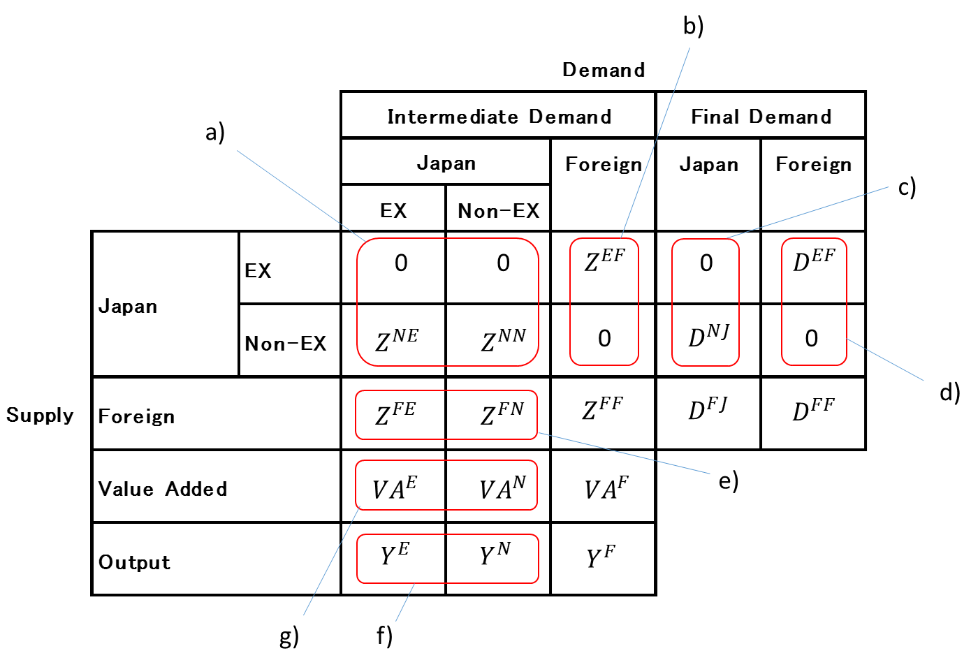

**EX**

**DS**

**DS**

Note: 1) *N, E, F* and *J* represent non-exporting sector of Japanese manufacturing industry, exporting sector of Japanese manufacturing industry, sectors in foreign countries and Japan, respectively.

2) is a matrix of intermediate goods supply from sector *m* to *n* (*m* , *n* = *N, E, F*).

3) is a matrix of *m‘s* final demand for *n* (*m* = *N, E, F,*  *n* =*J, F* ).

4) and are a matrix of *m‘s* output and a matrix *of m‘s* value added, respectively (*m* = *N, E, F*).

5) EX: Exports, DS: Domestic Shipments

1. Implement quadratic programming method

Quadratic programming is a method to estimate a variable under constraints. Now we need to estimate:

$z_{ij}^{NE}$: Elements of matrix $Z^{NE}$ (*i* : index of sectors in supply-side, *j* : index of sectors of Japanese manufacturing industry in demand side)

$z_{ij}^{NN}$: Elements of matrix $Z^{NN}$

$z_{ij}^{FE}$: Elements of matrix $Z^{FE}$

$z_{ij}^{FN}$: Elements of matrix $Z^{FN}$

${va}_{ij}^{E}$: Elements of matrix ${VA}^{E}$

${va}_{ij}^{N}$: Elements of matrix ${VA}^{N}$

The estimated elements should satisfy the following constraints:

For all *i* ,

+ where o means “original” element of IO table before split

$\sum_{j}{\left(z_{ij}^{NE} + z_{ij}^{NN}\right)=}D_{i}^{O,J}+\sum_{f}{D_{if}^{O,F}}-\sum_{j}{\sum_{f}{Z_{ij}^{O,F}}}$

For all *i $∈F$* ,

$z_{ij}^{FE}$ + $z_{ij}^{FN}=z_{ij}^{O,F}$

$\sum_{j}{\left(z_{ij}^{FE} + z_{ij}^{FN}\right)=}D_{i}^{O,J}+\sum_{f}{D_{if}^{O,F}}-\sum_{j}{\sum_{f}{Z_{ij}^{O,F}}}$

For all *j,*

$\sum_{i}{\left(z_{ij}^{NE} + z_{ij}^{FE}\right)=}Y_{j}^{E}-{va}_{ij}^{E}=α_{j}(\sum_{i}{z_{ij}^{O,J}+\sum_{i}{\sum_{f}{Z_{ij}^{O,F}}}) }$

$\sum_{i}{\left(z_{ij}^{NN} + z_{ij}^{FN}\right)=}Y_{j}^{N}-{va}_{ij}^{N}=(1-α_{j})(\sum_{i}{z_{ij}^{O,J}+\sum_{i}{\sum_{f}{Z_{ij}^{O,F}}}) }$

where $α_{j}$ is a the exporting sector’s share of total input in sector $j$, calculated from micro data.[17] [18]

Then, under these constraints quadratic programming estimates elements by minimizing:

$S = \sum_{i}{\sum_{j}{\frac{{(z_{ij}^{NE}-{z0}_{ij}^{NE})}^{2}}{{z0}_{ij}^{NE}}}}+\sum_{i}{\sum_{j}{\frac{{\left(z_{ij}^{NN}-{z0}_{ij}^{NN}\right)}^{2}}{{z0}_{ij}^{NN}}}}$

$+\sum_{i}{\sum_{j}{\frac{{(z_{ij}^{FE}-{z0}_{ij}^{FE})}^{2}}{{z0}_{ij}^{FE}}}}+\sum_{i}{\sum_{j}{\frac{{(z_{ij}^{FN}-{z0}_{ij}^{FN})}^{2}}{{z0}_{ij}^{FN}}}}$

Appendix Table 1. Comparison of results for VA embodied in foreign final demand between original and extended IO table (mln USD. Current price).

|  |  |  |  |  |  |  |  |  |  |  |  |  |
| --- | --- | --- | --- | --- | --- | --- | --- | --- | --- | --- | --- | --- |
|  | USA |  |  | China |  |  | Korea |  |  | World |  |  |
|  | Split IO | OECD TiVA | Deviation (%) | Split IO | OECD TiVA | Deviation (%) | Split IO | OECD TiVA | Deviation (%) | Split IO | OECD TiVA | Deviation (%) |
| Food products, beverages and tobacco | 761.84 | 798.82 | -4.74 | 653.43 | 615.06 | 6.05 | 260.13 | 287.18 | -9.89 | 3683.85 | 3898.43 | -5.66 |
| Textiles, textile products, leather and footwear | 303.67 | 608.03 | -66.77 | 300.88 | 616.29 | -68.78 | 91.74 | 197.09 | -72.95 | 1530.58 | 3160.30 | -69.48 |
| Wood and products of wood and cork | 163.22 | 139.86 | 15.42 | 147.61 | 122.17 | 18.86 | 53.87 | 45.67 | 16.48 | 902.63 | 803.10 | 11.67 |
| Pulp, paper, paper products, printing and publishing | 2871.63 | 2629.03 | 8.82 | 2622.43 | 2248.81 | 15.34 | 757.28 | 676.84 | 11.22 | 13573.04 | 12621.15 | 7.27 |
| Coke, refined petroleum products and nuclear fuel | 2145.56 | 1744.47 | 20.62 | 2585.90 | 1909.37 | 30.10 | 988.85 | 717.53 | 31.80 | 14848.80 | 11557.35 | 24.93 |
| Chemicals and chemical products | 4208.49 | 4732.50 | -11.72 | 4288.39 | 4754.40 | -10.31 | 1596.14 | 1857.55 | -15.14 | 22178.24 | 25515.08 | -13.99 |
| Rubber and plastics products | 3617.16 | 3305.38 | 9.01 | 3081.70 | 2745.90 | 11.52 | 992.37 | 981.13 | 1.14 | 17918.59 | 16974.03 | 5.41 |
| Other non-metallic mineral products | 1522.20 | 1504.61 | 1.16 | 1529.61 | 1423.55 | 7.18 | 814.47 | 986.93 | -19.15 | 8408.75 | 8961.36 | -6.36 |
| Basic metals | 8424.36 | 7434.51 | 12.48 | 9585.01 | 8677.19 | 9.94 | 3671.87 | 3622.02 | 1.37 | 53564.24 | 52659.60 | 1.70 |
| Fabricated metal products | 1869.87 | 1835.93 | 1.83 | 1878.79 | 1724.52 | 8.56 | 526.05 | 532.53 | -1.22 | 9814.79 | 10195.16 | -3.80 |
| Machinery and equipment | 5978.14 | 7425.55 | -21.60 | 7063.60 | 9197.61 | -26.25 | 2365.73 | 3172.83 | -29.14 | 33443.86 | 44484.21 | -28.33 |
| Computer, Electronic and optical equipment | 8974.59 | 14050.36 | -44.09 | 10602.68 | 16421.09 | -43.06 | 1643.54 | 2282.74 | -32.56 | 39420.07 | 62309.57 | -45.00 |
| Electrical machinery and apparatus, nec | 2491.61 | 3016.30 | -19.05 | 2601.83 | 3484.33 | -29.00 | 498.81 | 631.64 | -23.50 | 11839.03 | 15061.50 | -23.96 |
| Motor vehicles, trailers and semi-trailers | 8976.43 | 12091.87 | -29.57 | 4170.38 | 5363.09 | -25.02 | 467.78 | 558.49 | -17.68 | 33829.47 | 45471.82 | -29.36 |
| Other transport equipment | 706.53 | 1158.23 | -48.45 | 274.75 | 322.55 | -16.00 | 107.16 | 138.84 | -25.76 | 7700.49 | 13667.49 | -55.85 |
| Manufacturing nec; recycling | 1134.88 | 1179.79 | -3.88 | 907.55 | 832.99 | 8.57 | 374.50 | 459.11 | -20.30 | 5903.37 | 6600.54 | -11.15 |
| Total for industries | 146663.27 | 147544.6 | -0.60 | 130140.85 | 127910.9 | 1.73 | 37688.271 | 36909.42 | 2.09 | 718307.92 | 743034.1 | -3.38 |

Appendix Table 2. Comparison of results for Factor inputs embodied in world final demand between original and extended IO table.

|  |  |  |  |  |  |  |  |  |  |  |  |  |
| --- | --- | --- | --- | --- | --- | --- | --- | --- | --- | --- | --- | --- |
|  | Employment (workers) | | | Capital (ten thousand yen) | | | Non-regular workers | | | University Graduates | | |
|  | Split IO | OECD TiVA | Deviation (%) | Split IO | OECD TiVA | Deviation (%) | Split IO | OECD TiVA | Deviation (%) | Split IO | OECD TiVA | Deviation (%) |
| Food products, beverages and tobacco | 27839.3 | 31713.4 | -13.0 | 12243877.1 | 12705631.3 | -3.7 | 10314.5 | 12300.7 | -17.6 | 2657.1 | 2847.1 | n-6.9 |
| Textiles, textile products, leather and footwear | 39082.3 | 86888.4 | -75.9 | 10040767.7 | 12475577.1 | -21.6 | 5500.9 | 12790.5 | -79.7 | 1612.2 | 3167.2 | -65.1 |
| Wood and products of wood and cork | 26200.9 | 23245.0 | 12.0 | 4452343.9 | 3805758.5 | 15.7 | 1962.1 | 1740.8 | 12.0 | 1222.1 | 1082.5 | 12.1 |
| Pulp, paper, paper products, printing and publishing | 136120.4 | 127995.8 | 6.2 | 58589944.6 | 53876610.6 | 8.4 | 10337.2 | 9777.2 | 5.6 | 10638.0 | 9756.0 | 8.7 |
| Coke, refined petroleum products and nuclear fuel | 4298.5 | 4444.5 | -3.3 | 23645138.5 | 20646723.3 | 13.5 | 248.0 | 266.2 | -7.1 | 429.5 | 428.2 | 0.3 |
| Chemicals and chemical products | 106276.7 | 124602.4 | -15.9 | 166886058.0 | 173980238.7 | -4.2 | 11832.8 | 14563.3 | -20.7 | 24737.8 | 28748.4 | -15.0 |
| Rubber and plastics products | 184628.6 | 192205.8 | -4.0 | 113219509.6 | 101739002.0 | 10.7 | 29454.3 | 31614.5 | -7.1 | 18154.8 | 18004.1 | 0.8 |
| Other non-metallic mineral products | 62354.8 | 75963.5 | -19.7 | 71654593.9 | 53059076.8 | 29.8 | 6688.1 | 8290.4 | -21.4 | 6599.1 | 6989.0 | -5.7 |
| Basic metals | 201796.3 | 202107.9 | -0.2 | 343407903.0 | 324511947.9 | 5.7 | 16383.7 | 16654.9 | -1.6 | 23985.0 | 23865.4 | 0.5 |
| Fabricated metal products | 153832.1 | 162474.3 | -5.5 | 41311061.7 | 39982753.3 | 3.3 | 13444.4 | 14303.3 | -6.2 | 10768.2 | 10803.8 | -0.3 |
| Machinery and equipment | 288545.2 | 469930.0 | -47.8 | 121874954.9 | 150237387.8 | -20.8 | 22870.8 | 36536.0 | -46.0 | 43819.2 | 62902.0 | -35.8 |
| Computer, Electronic and optical equipment | 379199.4 | 637789.7 | -50.9 | 243629070.3 | 325148095.0 | -28.7 | 30875.5 | 55529.4 | -57.1 | 52986.6 | 82575.4 | -43.7 |
| Electrical machinery and apparatus, nec | 115663.7 | 161575.4 | -33.1 | 45273493.1 | 53492194.8 | -16.6 | 17117.7 | 24679.5 | -36.2 | 14974.8 | 20388.0 | -30.6 |
| Motor vehicles, trailers and semi-trailers | 390604.6 | 422554.0 | -7.9 | 256181811.9 | 256333188.1 | -0.1 | 43256.9 | 48039.2 | -10.5 | 49495.1 | 53363.0 | -7.5 |
| Other transport equipment | 87343.7 | 172015.2 | -65.3 | 39783500.5 | 72814246.8 | -58.7 | 2829.4 | 7455.6 | -90.0 | 10615.5 | 17954.2 | -51.4 |
| Manufacturing nec; recycling | 53880.6 | 61108.7 | -12.6 | 15644723.1 | 13882821.8 | 11.9 | 6913.4 | 9273.9 | -29.2 | 5872.0 | 6058.3 | -3.1 |
| Total for industries | 7343644.5 | 7630072.1 | -3.8 | 1567838751.9 | 1668691253.8 | -6.2 | 230029.7 | 303815.2 | -27.6 | 278566.9 | 348932.7 | -22.4 |

1. In this paper, we distinguish ''industry'', ''sector'' and ''activity''. ''Industry'' is used for large classification of industries such as ''manufacturing industry'' and ''service industry. ''Sector'' is used for sub category under large classification such as ''textile production sector''. We use the word ''activity'' for exporting and shipments for domestic market activities.
2.
3. Piacentini and Fortanier (2015) also compare VA/turnover ratio but the result is mixed.
4. Ma et al (2014) report correlation between domestic content share in final demand and the labor compensation relative to total direct value added (wage/value-added), and the capital labor ratio (K/L).
5. The following establishments are out of the target of the ECBA;

   (i)Establishments of national and local public entities, (ii) Establishments of individual proprietorships that fall under Division A "agriculture and forestry" of Japan Standard Industrial Classification, (iii)Establishments of individual proprietorships that fall under Division B "fisheries" of Japan Standard Industrial Classification, (iV) Establishments that fall under Group 792 "domestic services" in Division N "living-related and personal services, and amusement services" of Japan Standard Industrial Classification, (v) Establishments that fall under Major Group 96 "foreign governments and international agencies in Japan" in Division R "services, n.e.c." of Japan Standard Industrial Classification.
6. We exclude the data of establishments with 3 or less employees, following the Census of Manufacturers, conducted by Ministry of Economy, Trade and Industry (METI) every year.
7. The merged data covers 93.8 % of employee data and 94.0% of establishment data in the original BSWS data.
8. The desired precision is based on an average scheduled cash earnings of a regular employee. And considering the importance in the utilization of the survey results, the standard error rates are 5% for prefecture, industry and size of enterprise in the national scale statistics.
9. In JSIC rev.11, there 637 sectors to which three digit code are allocated.
10. In aggregation, we excluds plants with record of sales only as well as pplants with record of intermediate goods only.
11. Capital (physical fixed asset except land) used for exports and domestic shipments is calculated in the same way as we calculate value added for exports and domestic shipments.
12. A global Inter-Country Input-Output table analysis is presented in the next section.
13. Note that DVA is higher for Coke and petroleum industry. This industry is somewhat exceptional. In total the number of establishments is smaller in this industry, and the share of exporters is relatively high (around 30%). Higher labor productivity of exporters could explain this result of higher DVA.
14. Exceptions are Chemicals and chemical products, Rubber and plastics products, Motor vehicles, trailers and semi-trailers, and Manufacturing recycling industries.
15. Detailed results are given in Appendix Table 1.
16. Detailed results are given in appendix table 2.
17. We assume that $α_{j}$ holds after estimation process. We also implemented the quadratic programming to estimate variables without fixed $α_{j}$ but the solution have unrealistic elements (e.g. some exporting sectors in demand side have larger share of input than non-exporting sector in the same industry).
18. It is also possible to use the share of value added from micro data. However we avoid putting any assumption on value added. Thus, we use share of total input and, as a result, value added ${va}_{ij}^{E}$ and ${va}_{ij}^{N}$ are indirectly calculated from the estimated output and total input.