Information asked for sustainable development policies: the case of the Netherlands
Short introduction to the session

By Annemarth M. Idenburg
Office for Environmental Assessment of the National Institute for Public Health and the Environment (MNP-RIVM)
P.O. Box 1
3720 BA Bilthoven
The Netherlands
Tel. +31 30 2742626
Fax + 31 30 2744417
E-mail Annemarth.Idenburg@rivm.nl

Introduction
In many countries politicians embraced the concept of sustainable development as a guiding principle for environmental policy. Consequently policy makers face the challenge to translate this broad concept into concrete and operational policy objectives. The support of accurate and appropriate information is essential for this process. The Office for Environmental Assessment of the National Institute for Public Health and the Environment (MNP-RIVM) provides Dutch policy makers with information and analysis required for the development of new policies and evaluates the effectiveness of implemented and suggested policies. This cycle of scientific input, policy development, and scientific evaluation is reflected in a sequence of publications. Each National Environmental Policy Plan (NEPP) has been preceded by an Environmental Outlook study by MNP. Each year the MNP published an Environmental Balance, which describes the state of the Dutch environment and evaluates the effectiveness of environmental policies. Sustainability as theme gained in importance in recent NEPP’s and consequently in the work of MNP. The focus on environmental protection and pollution control has been shifted towards a focus on sustainable development. Consequently policy makers require information on indicators for sustainable development.

Two views on sustainability
Figure 1 is used as a point of departure for sustainability analysis within the institute. There are roughly two vsions on the range of the concept of sustainability for Dutch policies. The ‘broad’ vision considers the development of all three domains; the ecological, socio-cultural and economic, and their relationships. The ‘narrow’ vision considers sustainability from the perspective of the ecological domain in which the economic and socio-cultural domain are only taken into consideration in the case of conflicting interests. Many international organisations like UNEP and the Worldbank share the first broad vision. However, at this moment the Dutch government seems to be in favour of the narrow vision on sustainability. The perception of sustainability is important for the type of data required to provide information on the subject as will be explained further down.

Figure 1; Sustainability
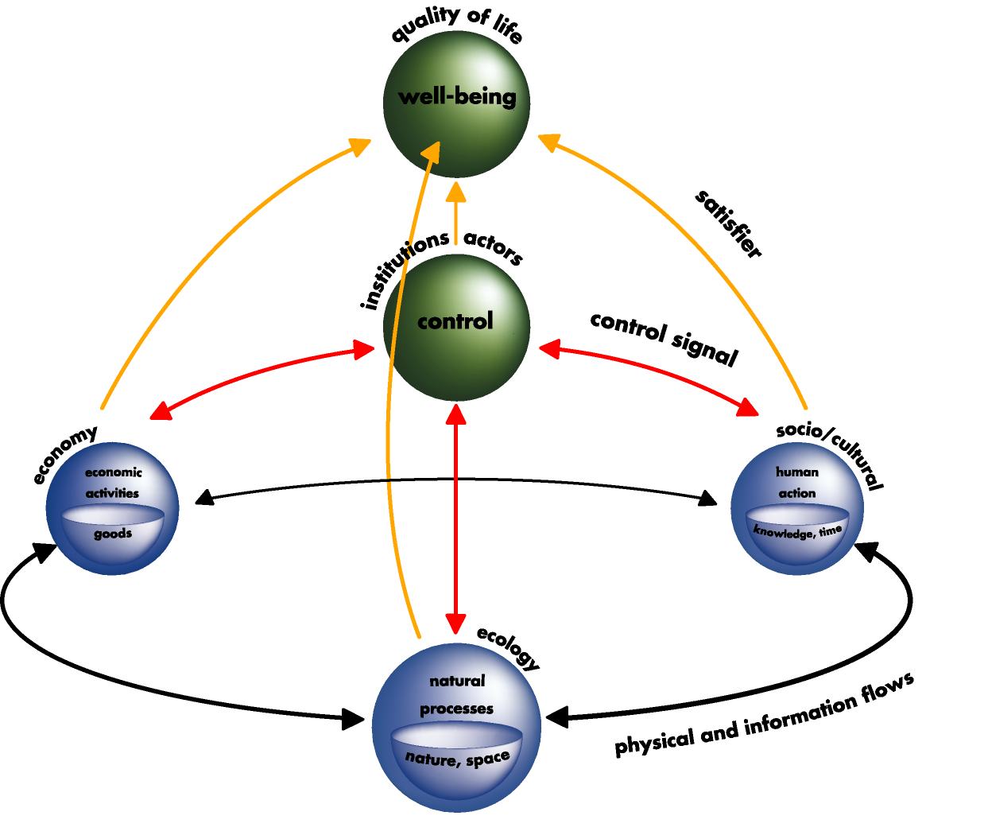
Each of the domains and arrows in this figure could be characterised by a set of indicators. Issues of relevance for the ecological, economic and socio-cultural domains are for example:

Ecological domain | : | Biodiversity, concentrations (of substances in soil, water, air, atmosphere) emissions and deposition
Socio-cultural domain | : | Health, security, education,
Economic domain | : | Production, income, employment, inflation, trade-balance

One of the difficulties with the development of one integral accounting system for sustainability is the diversity of dimensions of time, spatial scales and detail that are of relevance for each domain. In the actual practice relevant indicators for each domain depend on quite different accounting systems. To complicate things, the institutional surroundings of these accounting systems are, at best, poorly linked. To be able to include data from these different accounting systems into one framework often requires the adjustment of the original indicators. Because of these problems there are for instance four ‘official’ figures for CO2 emissions in the Netherlands (see table 1). In relation to figure 1, this means that CO2 emissions in NAMEA are relevant for the arrow between the economic and ecological domain. The relevant figure for the ecological domain, however, is provided by the CO2 emission according the IPCC total definition. Thirdly, the CO2 emissions as accounted by the ‘IPCC total for temperature corrected’ are relevant for the institutional domain. For policy makers these different figures are extremely confusing. So the use of three types of CO₂ emissions figures into one document, for instance an Enivronmental Balance, is not advisable. Even if the different types of analysis in this document would ask for these different figures. A question like ‘How does recent economic developments affect CO₂ emissions?’ should be answered with the NAMEA figure. The analysis of the effects of CO₂ emissions will ask for the IPCC-total figures. And the evaluation of the effectiveness of environmental policies should be performed using the IPCC-total for temperature corrected figures.

Table 1; Official CO2 emissions for the Netherlands, 1990-2000*
 | 1990 | 1995 | 1998 | 1999 | 2000*
 | billion kg

Published totals
CBS, actual emissions | 165 | 178 | 182 | 180 | 183
CBS(NAMEA), emissions¹⁾ in line with the National Accounts | 183 | 194 | 201 | 200 | 205
RIVM, IPCC total | 160 | 173 | 175 | 172 | 174
RIVM, IPCC total for temperature corrected | 166 | 175 | 178 | 177 | 179
Basic elements
1. Stationary sources²⁾ | 135 | 145 | 147 | 143 | 145
2. Short cycle CO2 ³⁾ | 5.0 | 4.8 | 6.0 | 6.1 | 6.1
3. Potential CO2 | 2.1 | 2.8 | 2.8 | 3.2 | 3.2
4. Mobile sources (CBS)⁴⁾ | 29 | 32 | 35 | 36 | 38
5. Mobile sources according to IPCC⁵⁾ | 29 | 32 | 34 | 35 | 35
6. Temperature correction | 6.2 | 2.6 | 3.5 | 5.0 | 5.1
7. Bunkers | 40 | 44 | 50 | 51 | 54
8. Emissions from residents in other countries (+) | 23 | 22 | 25 | 27 | 29
9. Emissions from non-residents in the Netherlands (-) | 2 | 3 | 3 | 3 | 3
Source: CCDM (2001).  CBS is Statistic Netherlands, RIVM is National Institute for Public Health and the Environment, IPCC is the Intergovernmental Panel on Climate Change |  |  |  |  |  |  |  |  | CBS/MC2001
* Figures for 2000 are estimates.
1) Excluding potential CO2 (emissions arising from the use of short-lived products, such as solvents).
2) Including short cycle CO2 from wood-burning stoves and organic waste/biochemical processes
and potential CO2.
3) The CO2 from these sources is assumed to become fixed in biomass and not make a contribution
to the increase in the CO2 concentration in the atmosphere. This concerns the combustion of wood
and biogas, the incineration and decomposition of landfilled waste of organic origin,
and the release of CO2 from urban waste water treatment plants.
4) Emission of CO2 based on fuel consumption in the Netherlands corrected for transboundary traffic.
5) Emission of CO2 based on all motor fuel sold in the Netherlands.

References
· CCDM (2001). Emissiemonitor. Jaarcijfers 1999 en ramingen 2000. Report series Doelgroepmonitoring, no. 11. Coördinatiecommissie Doelgroepmonitoring, The Hague.
· Zonneveld, E.A. (1999). De verschillende kooldioxide-getallen nader bekeken. Kwartaalbericht milieustatistieken 1999/1. CBS, Voorburg/Heerlen.
· IPCC (1996). Revised IPCC Guidelines for National Greenhouse Gas Inventories. 3 Volumes. IPCC (Intergovernmental Panel on Climate Change), Bracknell, UK.
· Spakman, J., M.M.J. van Loon, et al. (1997). Methode voor de berekening van broeikasgasemissies. Series Emisssieregistratie nr.37, The Hague.
· Olivier, J.G.J., J. Spakman and J.C. van den Berg (1999). Greenhouse gas emissions in the Netherlands 1990-1997 (IPCC Tables 7A). . RIVM (reportnr. 728001009), Bilthoven.

Different CO₂ emissions explained
Different publications give different figures for CO2 emissions. These figures are derived from the same basic elements but are based on different premises.  CBS - Actual emissions CBS publishes the emissions from the basic elements 1 (= incl. 2+3) + 4 described in the table above as actual emissions that have taken place in a certain year. These actual emissions are used, amongst other things, as inputs to models (concentrations, transport) and - apart from potential CO2 -by the NAMEA (National Accounting Matrix including Environmental Accounts), the environmental module of the National Accounts.  CBS/NAMEA emissions The NAMEA is based on the principles used in the National Accounts and describes emissions from activities by Dutch residents. The NAMEA figure is the sum of the basic elements 1 (-3) + 4 + 8 - 9. | IPCC total The Intergovernmental Panel on Climate Change (IPCC) has drawn up a proposal for pursuing an international policy to combat the enhanced greenhouse effect, including a system of national reporting (IPCC, 1996+revision). The reported emissions for each country would be comparable and could be added up to give a global total (Olivier et al., 1999). The emission of [shortcycle] CO2 is not included because this is thought to make no net contribution to the greenhouse effect. The IPCC figure is the sum of the basic elements 1 - 2 + 5. The IPCC also asks for the bunker emissions (7) as a separate figure.  RIVM - IPCC temperature corrected total RIVM draws up the Environmental Balance each year. The IPCC figure for CO2 (excluding bunkers) is used to evaluate Dutch CO2 policy. The emission figures are temperature corrected to obtain an emission trend that is relevant to policy (Spakman et al., 1997). The RIVM figure is the IPCC total plus the temperature correction (6).
See also: http://www.rivm.nl/environmentaldata/index.html

I/O as integrating framework?
The I/O framework proved itself suitable to combine different types of data within one structure. Ecological, economic and social data have been put together into I/O tables and I/O models. The I/O framework seems therefore an appropriate tool to provide the information on sustainability required by policy makers. But as illustrated by the CO₂ example, putting data together does not automatically produces relevant information. What does this mean for the ambition to develop one comprehensive accounting system for the concept of sustainability? Within the broad vision on sustainability, in which the economic domain is as important as the ecological domain, it is hard to choose between the different CO₂ emissions figures. But within the narrow perspective of sustainability the IPCC figures of CO₂ are clearly in favour. From this point of view it seems obvious to adjust the economic accounts to the ecological indicators, not the other way around.

This session deals with the question how the I/O system can be used to provide information on sustainability. How are the problems described above tackled in existing integrated accounting systems? And how do policymakers use these systems? Three different types of integrated accounting systems will be presented. Glenn-Marie Lange will share her experiences in Southern Africa with integrating economic, environmental and social accounts. Then Michel Braibant will relate how the French NAMEA has been used in analysing CO₂ emission trends. The last presentation of this session is by Rutger Hoekstra. He will explain how physical input-output tables can improve the description of the relationship between the economic an ecological domain.

