Sergey M.Shvets, director of SMS technologies lab INC,
L.Radchenko, chief mathematician SMStechnologies lab,INC

Devoted to my Dad and to the my colleague, distinguished professor V.Z. Belenky, Ph.D Math, head of lab dynamic model in Central economic and mathematical Institute of Russian Academy of Sciences

Some algorithms of building dynamic regional model based on input-output technique and forecasting matrix direct requirements.
Nowadays, the development of building regional models to forecast for medium-term prospects (about 10 to 15 years) is very appealed topic and should apply input-output technique for carrying out this problem.
There has no effective model of a regional input-output model(RIOM) been worked out yet in Russia , though such attempts had been made (by А.G. Granberg, , and others [1-3]). This paper is one of the first devoted to this topic, and implementation of its concept requires surmounting a lot of difficulties in practice. The first and major of them is that there is no regional statistical database needed for building input-output tables at Russian metropolitan areas. First of all it concerns the matrix of direct requirements (the V.V. Leontiyev matrix). It has been decided to replace the latter with an appropriate matrix (RIOM) of the of Russia as a whole. Such an approach is justified by the fact that matrix coefficients “a(ij)”, are constant during the time, depend only slightly the time and area of application of the (RIOM) model.
The first part of present report outlines the experience of construction of the (RIOM) model on the basis of the statistical data of the State Committee for Statistics of the Russian Federation(SCSRF). Particularly, the required data were taken from the System of Input-Output Tables, officially published by (SCSRF) 1995 (Moscow, 2000 [1]). This experience is assumed to serve as a basis for further application of the developed procedure to construct an medium-term regional model.

1. Preparation of database information
The RIOM (23*35) primary information file. The primary information is contained in Table 3 (pages 16 through 21) of the System of Input-Output Tables, Russia,1995, consumers’ prices [4]. The SCS(23*35) information file was shaped on the basis of this table data. The list of resources-products (sectors) of the matrix includes 22 items, and these 22 rows are maintained in the SCS. The 23rd row in the RIOM is the compensation of employees.
List of industries
1. Electric power 2. Oil-and-gas industry
3. Coal industry 4. Other fuel
5. Ferrous metallurgy 6. Non-ferrous metallurgy
7. Chemical industry 8. Manafactured
9.forestry and 10. Industrial building materials
11. 12. Food industry (1)
13. Other industries 14. Сonstruction
15. Agriculture and forestry 16. Transportation and communications
17. Тrade 18. Other kinds of business activity
19. Housing and public services (HPS) 20. Social services
21. Science 22. Finances, management
The radical difference of the RIOM from the official data, published by SCSRF lies in economic methodology the "Тtransportation" (i=16) and "Тrade" (i=17) rows. The SCSRF exposes corresponding costs interpreted as margins in the form of columns (j=38,39 S). In our new approach we, SMStechnologies suggest these margins as extra spending on delivery of the manufactured products to a final consumer. As we construct input-output accounts in consumers’ prices, we wrote columns j=38,39 SCSRF as rows i=16,17 RIOM (transposing operation). This approach corresponds to the brutto-model.( scientific approach is available for interested readers).
In order to complete the description of the RIOM matrix we have to describe columns 23 through 35. Row i=1-22 of these columns are taken from columns of the SCS table in compliance with the following substitution:
j=23-32 RIOM------ j=26-35 SCS
j=33 RIOM------ j=37 SCS
j=34 RIOM------ (j=40)+(j=41) SCS
j=35 RIOM------ j=42 SCS
Names of the column are taken in accordance with their names in the SCS, particularly, (in the SCS numeration):
j=23 – expenses on final consumption by individual house economies (farms)
24 – expenses of government agencies for collective services
25 - expenses of government agencies for individual goods and services
26 – expenses of nonprofit organization servicing individual house economies (farms)
27 – gross accumulation of fixed capital
28 – change of stocks of material circulating assets of manufacturers
29 – the same of consumers
30 – the same in trading
31 – net acquiring of values
32 - export
33 - import
34 – net taxes on products and import
35 – gross output (total employment of domestic products and services rendered in basic prices).
The scheme (28*27) basic information file. The LAYOUT file serves as a database for shaping the baseline information of the models described below. The file itself, as well as the RIOM remains invariable. The configuration LAYOUT of the matrix is shown on Fig. 1.

I quadrant II quadrant
j = 1 22 23 24 25 26 27

A _{ij}

Q₁
Public
consmuption
c

Q₂
(perso-nal consumption)

S

AC

X

i=1

p
22
III quadrant IV quadrant
23

G
0

Σ
24
25

Compensation of employees
26
savings
27
Σ

X
ΣΣ

Fig.1. Configuration of scheme (database) matrix
The LAYOUT fourth quadrant is zero, while the first quadrant is essentially square matrix A(i,j) flows between industries.
Let us describe the second quadrant.
The j=23 column is a sum of columns j=24-26 of the SCS. This sum is interpreted as the "Public consumption" (preliminary, designated by Q1; the final value of the j=23 LAYOUT column is presented below).
The j=24 column is a sum of columns j=23+(27-31) of the SCS. The exception is made for fund-shaping lines i=8,14,21 in the list (1). Elements of column j=27 of the SCS conform to these lines and are interpreted as capital investments (in our abbreviation as AC- accumulation). These elements form the j=26 LAYOUT column (AC, see Fig. 1; other elements of this column are equal to zero). The j=24 LAYOUT column contains no capital investments in the sum described, and this column is regarded as the "Personal consumption" (designated by Q2 on Fig. 1).
The j=25 LAYOUT column is shaped as a difference between export and import services (foreign trade balance S) of columns j=32,33 of the SCS.
Thus, the j=24-26 LAYOUT columns are described, while columns j=23,27 will be described as soon as we describe the G matrix of the third quadrant and present its classification.
The G matrix of format 3*22 (see Fig. 1) represents flows of capital investmentsin the fund-shaping sectors (8,14,21) calculated by us throughout the SCS information. We consider that in addition to the industry capital investments there are also capital investments of the public purpose. We include the latter in the j=23 LAYOUT column so that each of the fund-shaping lines (i=8,14,21) contains 23 items of flows of capital investments, and their sum in each of these lines is equal to a known appropriate value of column j=26 (AC). We have broken down values AC(i) in these rows proportionally to flows A(i,j) j=1-22 and preliminary value Q1(i) (see above). Due to this very condition, values of flows of capital investments are fully determined.
The public-purpose capital investments are added to the Q1 preliminary column. Thus, the final value of this column is obtained which is written in the LAYOUT matrix as column j=23. Other flows of capital investments (i.е. capital investments of the production purpose form the G(3*22) matrix written in lines i=23 through 25 of the third quadrant of the LAYOUT matrix.
By this means the LAYOUT second quadrant and the G matrix are described. It should be added that the j=27 LAYOUT last column (lines i=1 through 22) is obtained by direct sum of columns j=1 through 26 of the LAYOUT and is regarded as a vector of gross outputs X.
It remains to describe lines i=26,27 of the LAYOUT third quadrant.
Line i=26, being interpreted as sectoral pay-roll funds (PRF), is obtained from line i=23 of the SCS. Line i=27, being interpreted as industry savings, is produced by using the "residual method" as a difference between gross output X and all flows of costs shown in lines i=1-26. So, the sum of all sectoral costs (including savings) of each sector j=1 through 22 is equal to X(j) according to the structure.
Thus, the LAYOUT matrix exposed on Fig.1 is completely described. Its closing limits (column j=27 and row i=28) are obtained as through sums of lines i=1-26 and columns j=1-27, correspondingly. In this case, according to the configuration, one and the same vector of gross outputs X is produced in lines i=1 through 22 of closing column j=27 and in columns j=1 through 22 of closing line i=28. The bottom corner element represents a double sum of all flows.
The matrix described is classified as the Layout (28*27) information file.
2. Dynamic input-output model of exponential growth
The main dynamic model of the manufacturing and distribution of products:includes the foreign trade
X_{t} = a • X_{t+1} +g •ΔX+Q_{t}(full) +S_{t} t=0,1,...T (2a)
l•X_{t} ≤ L_{t} (2b)
where
t – time index in years
T – planning horizon
L – volume of labor resources (to be measured by the total pay-roll fund)
X(n) – vector of output industry, where n – number of sectors
ΔX= X_{t+1}-X_{t} - vector of growth of gross outputs in year t
Q(full) – vector of consumption (equal to sum Q(pers)+Q(public)
S – vector of foreign trade balance
l – of sectoral labour intensity values (its components are measured as sectoral pay-roll funds calculating on a unit of the gross output)
a(n*n) – matrix of coefficients of direct costs
g(n*n) - matrix of coefficients of additional capital costs (this matrix contains only three non-zero rows i=8,14,21 meeting fund-shaping sectors in the list (1)).
Condition а) is essentially a vector (industrial) balance of the manufacturing and distribution of products, while condition b) represents limitation through labour resources.
The latter two summands in (2а) form a final product vector in a sum:
Y = Q(full) +S (3)
Normally, the calculation through the model (2) requires the presetting of forecast of vector Y(t) and the dynamics of the labour resources for the prospect to be planned. Under this condition, the model (2) gives rise to a linear programming problem (LPP) the solution of which (i.е. the trajectory of output X(t)) occurs uneven and jump-like. To eliminate this drawback, V.А.Volkonsky suggested (in the 1960s) that an assumption on exponential growth of sectors should be introduced in the model (2), particularly, the equality condition (2a) should be replaced with the inequality condition
X_{t} ≥ a•X_{t+1} + g•ΔX_{t} +Y_{t} t=0,1,...,T (4)
with an additional assumption (the Volkinsky hypothesis)
X_{t}(i)= X₀(i)·exp(α_{i}t) t=0,1…,T i=1,…,n (5)
The Volkinsky hypothesis eliminates several difficulties at once:
1) Jumps in trajectory X(t) die out, and the solution becomes even.
2) Number of unknowns considerably reduces: only vector α = (α_{i}) of industrial rates becomes unknown instead of the sequence of desired vectors X₀,X_{t},...,X_{T}. It should be pointed out that each sector has its own rate of growth, so rearrangement (by the end of planning period T) of the structure of the vector of industriall outputs is possible are a result of the calculation.
3) The so-called "tail problem" gets solved, i.e. there is no need to set up conditions at the right-hand end of the planning period. The model with the exponential hypothesis (5) suggested by Volkonsky was described for the first time in work [6] wherein a simple and efficient algorithm of its solution was also offered.
3. Stationary model
3.1. Stationary formulation of the problem. Let us formulate the optimization problem in a stationary form. It is assumed in this formulation that all sectors should develop with one and the same rate of growth α, being common for all the sectors, i.е.
X(t) =X·exp(αt) t=0,1..,T , (6)
where vector X and growth rate α are subject to determination.
It is also supposed that the labour resources should be one of the factors of production. This means that components of vector l are regarded as specific coefficients of sectoral labour intensity values. In turn, final product vector Y (see (3)), being divided into the volume of labour resources L, will represent a basket of consumption per head (calculation on one working person:
b=Y/L . (7)
Thereby, we pass from a n-dimensional model to an extended (n+1)-dimensional model, in which the social sphere (vital activity sphere) is the (n+1) sector, while the labour resources represent the (n+1) resource produced by this "product" sector. Vector l is an additional (n+1) line in the extended matrix of coefficients of direct costs a(n+1,n+1), and vector b of the basket of consumption per head is аn additional column (n+1). Components of this column are reviewed as coefficients of direct unit costs on the reproduction of labour resources. The schematically extended matrix of direct costs is shown on Fig. 2 The bottom diagonal element a(n+1,n+1) represent specific labour intensity values in the social sphere (its value of 0.236 has been obtained on the basis of the monitoring for mane years showing that it undergoes no changes).

1 n n+1

a(n,n)

b

a(n+1,n+1) = n
l
0,236

,26
n+1

Fig. 2. Extended matrix of coefficients of direct requirements
To formulate the mathematical problem, let us introduce an extended vector of outputs X =(X,L) of dimensionality (n+1) and designate β:=exp(α). Then, inequalities (4) and (2б) under condition (6) can be written (upon reducing by exponential multiplier exp(αt)) in the form of:
X≥ M(β)•X , (8)
where matrix М(β) is shown on Fig.3.

1 n n+1

βa+(β -1)g

b

M(β)= n
n+1

l
0.236

Fig. 3. Matrix М(β)
Vector X and growth index β are unknown in relation (8). The mathematical problem consists in finding the maximum value, at which inequality (8) allows the nonnegative solution of X. It turns out that (this a mathematical fact) with the maximum value of β inequality (8) gets transformed into an equality (i.е. at β=β_{max} matrix М(β_{max}) has a spectral radius [4, see page 292]) of a unit, and vector X is an appropriate eigenvector). This vector is defined with an accuracy up to a multiplier and, being, 100-% standardized, it is interpreted as a vector structure of the uniform balanced growth with maximum rate α =ln(β_{max}).
By this means the equality is met
X=M(β_{max})•X . (9)
It is known from the linear algebra that dual equality
P=P•M(β_{max}) (10)
also has nonnegative solution of P, determined as well with an accuracy up to a multiplier. Let us standardize vector P so that vector
ξ : ξ_{i}=p_{i}x_{i} i=1,…,23 (11)
becomes structural, i.е. 100-% standardized. We interpret P as indices of optimal prices (relative to the effective prices), while vector ξ is to be regarded as the vector of the national economy structure in optimal prices.
To solve the formulated problem, a program has been composed with the use of the Delphi release 5.0 programming language.
3.2. Information on the model. Thus, the stationary model has got reduced to mathematical problem (9) whose matrix М is shown on Fig. 3. That is why this figure contains the entire baseline information.
Matrices of coefficients а(n*n) and g(n*n) have been obtained from the following formulas:
a_{ij}=A_{ij}/X₀(j) , g_{ij}=G_{ij}/X₀(j) , (12)
where matrices A and G, and vector Х₀ of dimensionality n=22 were taken from the Layout matrix (see Fig. 1). Vector l of labour intensity values was obtained in the same way: l(j)=
L(j)/Х₀(j). Vector b was calculated through formula (7), wherein in compliance with (3), vector Y was obtained as a sum of columns j=23 to 25 of the Layout, while the volume of labour resorces L, as a total pay roll fund in line i=26 of the Layout . This means that taken Y and L are their initial values Y₀ and L₀. In doing so, the model entire information is described as presented on Fig. 3 (let use remind that β=β_{max} is a desired quantity).
3.3. Calculation results. As it has been noted in Item 3.1, the calculation results in finding value β_{max}, vector X (the solution of problem (9)), vector of price indices Р and optimal structure vector ξ. In this case, vectors Х and ξ are 100-% standardized, while the standardization of vector Р is described in Item 3.1.
The results of calculation through the information described are given In Appendix 1. In addition to the enumerated data, Appendix 1 shows the structure of initial (actual) vector Х₀ (i.е. the 100-% standardized pair (Х₀,L), column 4) and a relative deviation of the optimal structure (ξ) from the initial one (Х₀) (column 5). These results provide rich information. It should be only one fact noted here that pay-roll fund L constitutes approximately 32 % in the total amount of the gross output when both in the baseline (Х₀) and optimum (ξ) conditions.

4. Model with variable growth rates( dynamic model)

4.1. Model. The model with industry growth rates has been already given Section 2. The model is described by means of relations (4), (2б) and (5). Let us describe them once more here:

а) X_{t} ≥ a•X_{t+1} + g•ΔX_{t} +Y_{t}
b) l•X_{t} ≤ L_{t} t=0,1,...,T (13)
c) X_{t}(i)= X₀(i)·exp(α_{i}t) i=1,…,n
Industrial growth rates (α_{i}), i=1,2,…,n are unknown in these relations. Final product vector Y_{t} in relation а) is presented in the form of
Y_{t}= Y₀ + λ·t·del , (14)
where del is a vector showing the direction of the desirable modification of the initial vector Y₀. This vector is to be set up by version;
λ - a scalar characterizing a growth rate (in the direction towards del) of the final product vector. This scalar is a subject for determination. Total pay-roll fund L_{t} is also presented in the exponential form:
L_{t} = L₀ ·exp(α_{n+1}t) , (15)
where α_{n+1} – a rate of growth of labor resources (presented by the pay-roll fund) that is also is a desirable value.
By this means model (n+1) contains unknown rates of growth α=(α_{i}), i=1,2,…,n+1 and scalar λ. All these unknown values should be nonnegative. The mathematical problems consists in the fact that to find the maximum value of λ, at which relations (13) through (15) allow a solution with nonnegative rates (α_{i )} , i=1,…..,n+1.
The baseline information includes the following:

- matricies а, g
- vectors X₀,Y₀,
- scalar L₀ ;
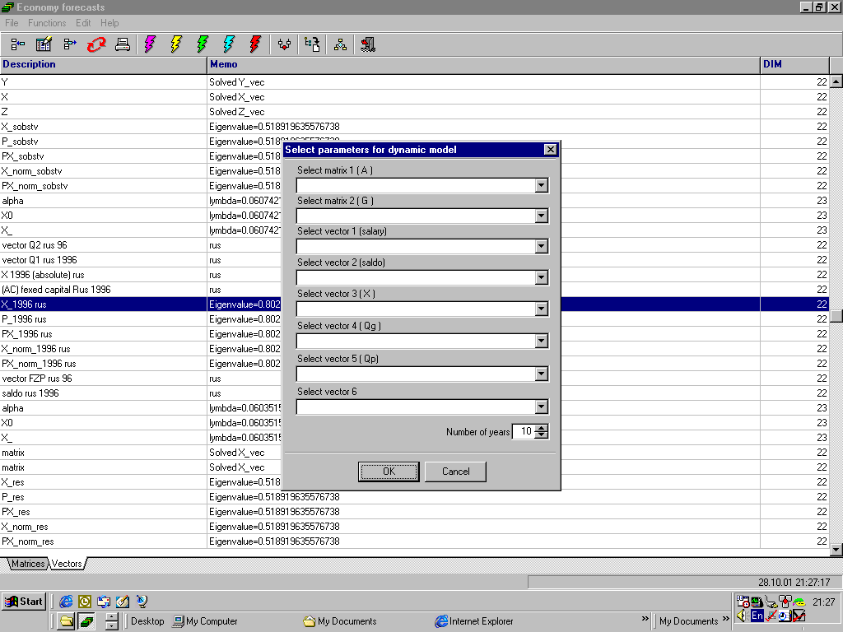
The same information was used in the stationary model of Section 3. The procedure of obtaining it is described in Item 3.2. Besides, vector del is set up by version.
4.2. Method of solution. Let us substitute (13в), (14) and (15) into relation (13а,б), and take the logarithm of them component-by-component. Then, we obtain:
α_{i} ≥ f_{i}(α,t,λ) t=0,1,…,T i=1,2,…,n+1 (16)
where
ln(right-hand part (13а)/X₀(i)) i=1,…,n
ln(right-hand part (13а)/X₀(i)) i=1,…,n
f_{i} =
ln(left-hand part (13б)/L₀) i=n+1 . (17)

Supposing further that
F_{i}(α,λ):= max f_{i}(α,t,λ) i=1,2,…,n+1 , (18)
t=0,…,T
it is possible to express the final mathematical problem in the form of
α_{i} ≥ F_{i}(α,λ) i=1,2,…,n+1 (19)
λ → max .
Problem (19) is formulated in the vector form in the following manner: to find the maximum value of parameter λ, at which the nonempty set takes place
D(λ):= {α∈ R^{n+1} α ≥ F(α,λ) } α ≥0 (20)
Vector-function F(α,λ) is monotonously growing through its arguments. That is why at fixed value λ, set D(λ) possesses the so-called minimum point (see [3]). Work [3] describes the efficient algorithm of finding this point if set (20) is not empty. If set (20) be empty at the given λ, the algorithm gets diverged. Thus, the algorithm specified makes it possible at each fixed λ to determine whether set (20) has a tolerable solution (and if it has, to find the best minimum solution). In doing so, the desirable maximum value of λ can be found by the method of the single-dimensional search through parameter λ. The described algorithm has been implemented in the program with the use of the Delphi release, 5.0 language.

4.3. Calculation results. As it is pointed out in Paragraph 4.1, the baseline information on this model are the same as applied to the stationary model of Section 3. This information is supplemented by vector del (gradient) setting the direction of modification of final product vector Yo.
4.3.1. Basic version. We suppose in the basic version that the direction of the final product vector should fail to get changed in time due to value del = Yo . Results of the basic version calculation are presented in Appendix 2.1

Appendix 1. Results of calculation through stationary model. ( All results were calculated through software Economy forecasting, release 3.5, made by SMStechnologies lab )

No. | Industry name | X | P | ξ | X₀ | δ
1 | Electric power | 3.01 | 1.02 | 3.09 | 2.85 | 8.57
2 | Oil-and-gas industry | 7.90 | 1.02 | 8.09 | 7.55 | 7.192
3 | Coal industry | 0.90 | 1.01 | 0.91 | 0.85 | 7.63
4 | Other fuel | 0.02 | 1.01 | 0.02 | 0.02 | 2.69
5 | Ferrous metallurgy | 2.31 | 1.03 | 2.40 | 2.34 | 2.41
6 | Non-ferrous metallurgy | 2.09 | 1.02 | 2.13 | 2.06 | 3.62
7 | Chemical industry | 2.40 | 1.03 | 2.48 | 2.32 | 7.13
8 | Manufactured | 4.77 | 1.00 | 4.79 | 5.27 | -.9.13
9 | Forestry | 1.56 | 1.02 | 1.61 | 1.53 | 4.86
10 | Industrial building materials | 1.30 | 1.02 | 1.34 | 1.48 | -9.50
11 | Industry | 1.94 | 1.03 | 2.00 | 1.91 | 4.87
12 | Food industry | 6.31 | 1.03 | 6.533 | 6.16 | 6.06
13 | Other industries | 0.74 | 1.03 | 0.76 | 0.70 | 9.79
14 | Сonstruction | 4.22 | 1.00 | 4.26 | 5.46 | -21.63
15 | Agriculture and forestry | 4.95 | 1.02 | 5.07 | 4.73 | 7.16
16 | Transportation and communications | 3.94 | 0.98 | 3.88 | 3.74 | 3.69
17 | Тrade | 8.83 | 0.97 | 8.67 | 8.33 | 4.13
18 | Other kinds of business activity | 0.42 | 0.99 | 0.42 | 0.40 | 5.47
19 | Housing | 2.12 | 0.90 | 1.92 | 2.07 | -7.11
20 | Social activity | 3.51 | 0.91 | 3.22 | 3.51 | -8.20
21 | Science | 0.62 | 0.95 | 0.60 | 0.63 | -4.39
22 | Finances, management | 3.69 | 0.95 | 3.54 | 3.67 | -3.43
23 | Compensation of employees | 32.45 | 0.99 | 32.26 | 32.45 | -0.59
100 100 100
X – stationary vector of the output in primary prices.
P – indices of optimum prices with regard to the effective prices.
ξ - stationary vector of the output in optimum prices.
Xo – output primary vector.
δ - vector of relative deviations of primary outputs from the optimum ones.
β _{max} = 1.0493
α _{max} = ln (β _{max}) = 0.0481
Vectors X, ξ and Xo are 100-% standardized.
Vectors ξ, и δ are found through formulas: ξ =Pi*Xi
δ= (X₀(i)/ξ_{i}-1)*100%

Appendix 2. Results of calculations through model with rates of growth. (All results were calculated through software Economy forecasting, release 3.5, made by SMStechnologies lab )

No. | Industry name | α | Xo | Х_{T} | Del=Y0 | δ_{T} | δ₀
1 | Electric power | 4.65 | 141.88 | 225.84 | 0.00 | -7.73 | -6.79
2 | Oil-and-gas industry | 5.02 | 371.84 | 614.19 | 129.59 | -4.12 | -6.67
3 | Coal industry | 4.13 | 41.96 | 63.39 | 3.36 | -12.37 | -6.74
4 | Other fuel | 3.94 | 0.76 | 1.13 | 0.03 | -9.52 | -1.90
5 | Ferrous metallurgy | 2.70 | 115.31 | 151.13 | 26.47 | -20.34 | -2.27
6 | Non-ferrous metallurgy | 4.69 | 100.95 | 161.32 | 58.52 | -4.49 | -3.90
7 | Chemical industry | 4.82 | 113.89 | 184.36 | 30.65 | -6.15 | -6.78
8 | Manufactured | 1.00 | 259.15 | 286.31 | 23.54 | -24.50 | 9.88
9 | Forestry | 4.63 | 75.49 | 119.98 | 30.55 | -5.77 | -4.67
10 | Industrial building materials | 0.85 | 75.31 | 82.03 | 0.00 | -22.71 | 14.09
11 | Industry | 5.95 | 93.51 | 169.52 | 69.60 | 7.00 | -5.10
12 | Food industry | 6.52 | 301.90 | 579.27 | 200.29 | 12.00 | -6.15
13 | Other industries | 7.12 | 34.15 | 69.61 | 6.66 | 15.20 | -9.14
14 | Сonstruction | 0.00 | 271.76 | 271.76 | 0.00 | -19.48 | 29.47
15 | Agriculture and forestry | 7.71 | 232.03 | 501.49 | 105.90 | 24.84 | -7.13
16 | Transportation and communications | 4.69 | 184.12 | 294.33 | 44.87 | -4.07 | -3.51
17 | Тrade | 5.10 | 418.26 | 696.31 | 0.00 | 1.45 | -2.02
18 | Other kinds of business activity | 5.05 | 19.68 | 32.62 | 2.88 | -1.88 | -4.83
19 | Housing | 5.90 | 101.66 | 183.42 | 61.88 | 20.36 | 7.26
20 | Social activity | 5.86 | 171.70 | 308.57 | 167.30 | 21.06 | 8.32
21 | Science | 4.34 | 30.67 | 47.31 | 19.26 | -0.01 | 4.21
22 | Finances, management | 5.75 | 179.65 | 319.40 | 161.24 | 13.94 | 3.04
23 | Compensation of employees | 4.56 | 535.80 | 845.09
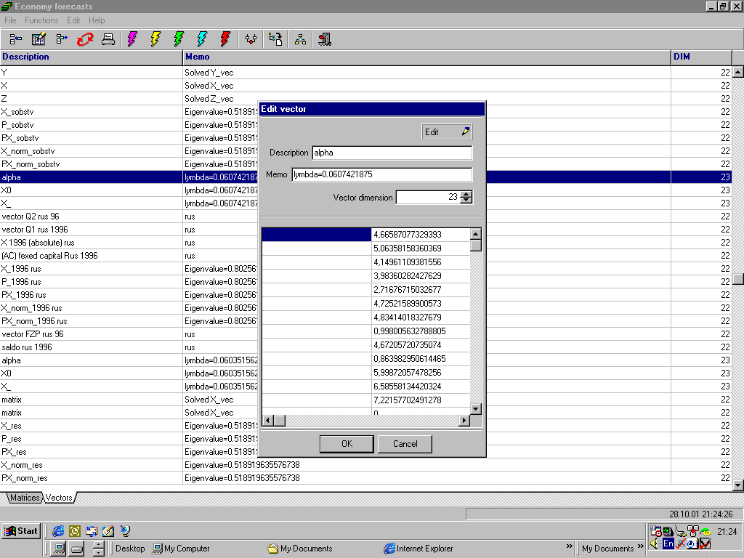

λ=0.06035- parameter characterizing the rate of growth (in the direction towards del) of the final product vector (see formula (14)).
α=4.85– annual stationary growth rate.
α - growth rates in sectors within the planning period.
T-forecasting period: T=10 years.
Xo - primary gross outputs of the primary (1995) year.
Х_{T} - forecasted gross outputs of the final (2005) year.
Del – vector showing the direction of desirable modification of primary vector Y_{0.}
δ_{T} - vector of relative deviations of forecasting outputs (X_{T} from the optimum ones(ξ)
δ₀ - vector of relative deviations of primary outputs from the optimum ones.
δ_{T}= (X_{T}(i)/ξ_{i}-1)*100%
δ₀= (X_{o}(i)/ξ_{i}-1)*100%

5.0 Mathematical algorithm of building forecasting matrix direct requirements.

Let us introduce the following designations.
Known are:
$n$ - number of equations of the forecasting model;
$t$ - initial (basic) year;
$Δt$ - forecasting interval;
$T=t+Δt$;
$X^{t}=\left\{x_{i}^{t}\right\}$ -vector of production output $i$ in year $t$;
$Y^{t}=\left\{y_{i}^{t}\right\}$ - vector of final consumption of products $i$ in year $t$;
$A^{t}=\left\{a_{\text{ij}}^{t}\right\}$- matrix coefficients of direct requirements for year $t$;
${\bar{X}}^{t}=\left\{{\bar{x}}_{i}^{t}\right\}$ - Lower expert estimates of the output production vector $i$ in year $t$;
${\bar{\bar{X}}}^{t}−\left\{{\bar{\bar{x}}}_{i}^{t}\right\}$- Upper expert estimates of the output production vector $i$ in year $t$;
${\bar{Y}}^{t}=\left\{{\bar{y}}_{i}^{t}\right\}$ - Lower expert estimates of the production final consumption $i$ in year $t$;
${\bar{\bar{Y}}}^{t}=\left\{{\bar{\bar{y}}}_{i}^{t}\right\}$ - upper expert estimates of the production final consumption $i$ in year $t$;
${\bar{A}}^{T}=\left\{{\bar{a}}_{i}^{T}\right\}$, ${\bar{\bar{A}}}^{T}=\left\{{\bar{\bar{a}}}_{i}^{T}\right\}$ - estimates of lower and upper ranges of modification of coefficients of matrix direct requirements-$A^{T}$.
It is required to determine matrix $A^{T}$ and vectors $X^{T}$ and $Y^{T}$under conditions of the minimum information available, such at which
- $\sum_{j=1}^{n}{a_{\text{ij}}^{T}x_{j}^{T}+y_{i}^{T}=x_{i}^{T}}$ ,
- ${\bar{a}}_{\text{ij}}^{T}≤a_{\text{ij}}^{T}≤{\bar{\bar{a}}}_{\text{ij}}^{T}$ ,
- ${\bar{x}}_{i}^{T}≤x_{i}^{T}≤{\bar{\bar{x}}}_{i}^{T}$ ,
- ${\bar{y}}_{i}^{T}≤y_{i}^{T}≤{\bar{\bar{y}}}_{i}^{T}$ ,
where $i,j=1\text{.}\text{.}\text{.}n\text{.}$
The problem solution shall provide determination of matrix $A^{T}$with a preset accuracy under conditions when expert estimates of vectors $\bar{X},\bar{\bar{X}},\bar{Y}$и $\bar{\bar{Y}}$are known. In this case, coefficients of matrix $A$ of process coefficients shall be within the framework of assigned vicinities of matrix $A^{T}$ of the accounting period. It is obvious that such requirements meet conditions of the short-term forecast.
To find out tolerable solutions of problem formulated above, let us reduce it to a nonlinear programming problem.
Let us introduce the following designations:
- $z_{k}=a_{\text{ij}}^{T}$,
- $z_{m+i}=x_{i}^{T}$,
- $z_{m+n+i}=y_{i}^{T}$,
- ${\bar{z}}_{k}={\bar{a}}_{\text{ij}}^{T}$,
- ${\bar{z}}_{m+i}={\bar{x}}_{i}^{T}$,
- ${\bar{z}}_{m+n+i}={\bar{y}}_{i}^{T}$,
- ${\bar{\bar{z}}}_{k}={\bar{\bar{a}}}_{\text{ij}}^{T}$,
- ${\bar{\bar{z}}}_{m+i}={\bar{\bar{x}}}_{i}^{T}$,
- ${\bar{\bar{z}}}_{m+n+i}={\bar{\bar{y}}}_{i}^{T}$,
где $k=(i−1)n+j,$ $i,j=1\text{.}\text{.}\text{.}n,$ $m=n^{2}\text{.}$
Then, the problem of forecasting matrix $A^{T}$ will be written in the form of the following nonlinear programming problem with $N=n^{2}+2n$ being unknown:
It is necessary to find
$\underset{z∈Z}{\text{min}}$$F(z)$, where
- $Z=\left\{A^{T},X^{T},Y^{T}\right\}$,
- $F(z)=\underset{i}{\text{max}}|\sum_{j=1}^{n}{z_{(i−1)n+j}z_{m+j}−z_{m+i}+z_{m+n+i}|}$, $i=1\text{.}\text{.}\text{.}n\text{.}$
- ${\bar{z}}_{k}<z_{k}<{\bar{\bar{z}}}_{k}$, $k=1\text{.}\text{.}\text{.}N\text{.}$
To solve the problems assigned, it is very comfortable to use the “$Ψ$- transformation“ method
The economic interpretation of the $Ψ$- transformation“ method is given below.
The main idea of the method consists in the fact that instead of finding the extremum of function $F(z)$ of many variables, we have to find the zero of function $Ψ(ζ)$ of one variable, which is formed as a result of the Lebessque partition of function $F(z)$ into a number of levels.
The Lebessque partition is obtained by Lebessque separation of interval into equal spaces: $F_{\text{medium}}=ζ_{p}<\text{.}\text{.}\text{.}<ζ_{i}<\text{.}\text{.}\text{.}<ζ_{0}=F_{\text{max}\text{imum}}$.
Such partition can be obtained after performing static tests $S$
to define $F_{\text{max}\text{imum}}=\underset{s}{\text{max}}F_{s}(z)$ и $F_{\text{medium}}=\frac{1}{S}\sum_{s=1}^{S}{F_{s}}(z)$, where $s=1\text{.}\text{.}\text{.}S\text{.}$ at random choice
$z∈Z$ ${\bar{z}}_{k}<z_{k}<{\bar{\bar{z}}}_{k}$, $k=1\text{.}\text{.}\text{.}N\text{.}$}.
Then, for each value $ζ_{i},i=1\text{.}\text{.}\text{.}p$ let us determine dimension of $Ψ(ζ_{i})$ of set $Ε_{i}$ $Ε_{i}=\left\{z^{(s)}:F(z^{(s)})≤ζ_{i}\right\},$ where $s=1\text{.}\text{.}\text{.}S\text{.}$ Function $Ψ(ζ_{i})$ is monotonously decreasing at growth of index $i$, and the zero value of this function is reached in point $ζ^{}=\underset{z}{\text{min}}F(z)$. Thus, the problem has been reduced to finding the zero of function $Ψ(ζ_{i})$.
$Ψ(ζ_{k})$$=\frac{\sum_{i=1}^{ξ_{k}}{(F(z^{(s)})−ζ_{k})_{i}^{l}}}{S}$ , where $l=1,2,\text{.}\text{.}\text{.}$ a number depending on a desirable accuracy of solution;
$ξ_{k}$ - number of those static tests at which $F(z^{(s)})≥ζ_{i}$.
To obtain the analytic form of function $Ψ(ζ_{i})$, let us effect the parabolic approximation through values $Ψ_{1},Ψ_{2},\text{.}\text{.}\text{.},Ψ_{p}$ by the method of least squares and find coefficients of the approximating parabola.
We want to approximate function $Ψ(ζ_{i})$ by parabola $ϕ(ζ_{i})$, where
$ϕ(ζ_{i})$=$α_{0}ζ^{2}+α_{1}ζ+α_{2}$
Method of least squares consists in finding coefficients of the approximating parabola $ϕ(ζ)$with who
$$\sum_{i=1}^{p}{[Ψ(ζ_{i}})−ϕ(ζ_{i})]^{2}=\text{min}$$
Minimum may be defined by differentiation of last equation by parameters $α_{0},α_{1},α_{2}$ of parabola $ϕ(ζ)$.
Then
$\frac{∂ϕ}{∂α_{0}}=ζ^{2}$, $\frac{∂ϕ}{∂α_{1}}=ζ$, $\frac{∂ϕ}{∂α_{2}}=1$.
and
$\sum_{i=1}^{p}{\left\{[Ψ(ζ_{i} | | )−(α_{0}ζ_{i}^{2}+α_{1}ζ_{i}+α_{2})]ζ_{i}^{2}\right\}=0}$,
$\sum_{i=1}^{p}{\left\{[Ψ(ζ_{i} | | )−(α_{0}ζ_{i}^{2}+α_{1}ζ_{i}+α_{2})]ζ_{i}^{2}\right\}=0}$,
$\sum_{i=1}^{p}{\left\{[Ψ(ζ_{i} | | )−(α_{0}ζ_{i}^{2}+α_{1}ζ_{i}+α_{2})]ζ_{i}^{2}\right\}=0}$,
After some transformations, considering, that
$\frac{1}{p}\sum_{i=1}^{p}{ζ_{i}}=M_{1}[ζ]$, $\frac{1}{p}\sum_{i=1}^{p}{ζ_{i}^{4}}=M_{4}[ζ]$,
$\frac{1}{p}\sum_{i=1}^{p}{ζ_{i}^{2}}=M_{2}[ζ]$, $\frac{1}{p}\sum_{i=1}^{p}{Ψ(ζ_{i})}=M_{1}[Ψ]$,
$\frac{1}{p}\sum_{i=1}^{p}{ζ_{i}^{3}}=M_{3}[ζ]$, $\frac{1}{p}\sum_{i=1}^{p}{ζ_{i}Ψ(ζ_{i})}=M_{1,1}[ζ,Ψ]$,
$\frac{1}{p}\sum_{i=1}^{p}{ζ_{i}^{2}Ψ(ζ_{i})}=M_{2,1}[ζ,Ψ]$,
let's receive
$M_{4}[ζ]α_{0}$+$M_{3}[ζ]α_{1}$+$M_{2}[ζ]α_{2}$=$M_{2,1}[ζ,Ψ]$,
$M_{3}[ζ]α_{0}$+$M_{2}[ζ]α_{1}$+$M_{1}[ζ]α_{2}$=$M_{1,1}[ζ,Ψ]$,
$M_{2}[ζ]α_{0}$+$M_{1}[ζ]α_{1}$+$M_{0}[ζ]α_{2}$=$M_{0,1}[ζ,Ψ]$,
where $M_{0}[ζ]=1$, solving last system, find coefficients $α_{0},α_{1},α_{2}$ of the approximating parabola $ϕ(ζ)$. The least positive root $ζ^{}$ parabola $ϕ(ζ)$ will coincide with the desirable value of the minimum of function $F(z)$.
To forecast values of coordinates of the minimum of function $F(z)$, let us calculate:

${\tilde{z}}_{\text{jk}}=\frac{\sum_{i=1}^{ξ_{k}}{\left\{z_{j}^{(s)}(F(z^{(s)})−ζ_{k})^{l}\right\}}}{\sum_{i=1}^{ξ_{k}}{(F(z^{(s)})−ζ_{k})^{l}}}$, where $j=1,\text{.}\text{.}\text{.}N\text{.}$
To obtain the analytic form of function ${\tilde{z}}_{\text{jk}}$, let us effect the parabolic approximation through values ${\tilde{z}}_{j1},{\tilde{z}}_{j2},\text{.}\text{.}\text{.},{\tilde{z}}_{\text{jp}}$ by the method of least squares and find out coefficients of approximating parabolas. When values of these approximating parabolas are calculated at point $ζ^{}$, we receive the values of variables $z_{1}^{},\text{.}\text{.}\text{.},z_{N}^{}$, at which the minimum of function $F(z)$ is obtained. To check out calculations, it is possible to calculate the value of function $F(z_{1}^{},\text{.}\text{.}\text{.},z_{N}^{})$ and compare it with value $ζ^{}$. Yje coincidence means correctness of the solution.
The least positive root $ζ^{}$ will coincide with the desirable value of the minimum of function $F(z)$.
To forecast values of coordinates of the minimum of function $F(z)$, let us calculate:

${\tilde{z}}_{\text{jk}}=\frac{\sum_{i=1}^{ξ_{k}}{\left\{z_{j}^{(s)}(F(z^{(s)})−ζ_{k})^{l}\right\}}}{\sum_{i=1}^{ξ_{k}}{(F(z^{(s)})−ζ_{k})^{l}}}$, where $j=1,\text{.}\text{.}\text{.}N\text{.}$
To obtain the analytic form of function ${\tilde{z}}_{\text{jk}}$, let us effect the parabolic approximation through values ${\tilde{z}}_{j1},{\tilde{z}}_{j2},\text{.}\text{.}\text{.},{\tilde{z}}_{\text{jp}}$ by the method of least squares and find out coefficients of approximating parabolas. When values of these approximating parabolas are calculated at point $ζ^{}$, we receive the values of variables $z_{1}^{},\text{.}\text{.}\text{.},z_{N}^{}$, at which the minimum of function $F(z)$ is obtained. To check out calculations, it is possible to calculate the value of function $F(z_{1}^{},\text{.}\text{.}\text{.},z_{N}^{})$ and compare it with value $ζ^{}$. Yet coincidence means correctness of the solution.

References.
- A.G. Granberg. «Models of regional economy». М.2000
2. System of Input-Output Tables. Issue 3, Moscow,Russia: Official edition by State Committee for Statistics( Russia Federation), 1995.
3. V.Z. Belenky “Some models of optimal planning based on the input-output tables”. // Economic-Mathematical methods. Issue 4. М.1967
4. S. Karlin. “Mathematical methods in the theory of games, programming and economy”. М., МIR 1964.

