Resource Intensity in India

Kakali Mukhopadhyay
Department of Agricultural Economics
McGill University, Macdonald Campus
21,111 Lakeshore, SteAnne De-Bellevue
Montreal,Quebec,Canada-H9X3V9
kakali.mukhopadhyay@mcgill.ca
Tel: 15143988651
Fax: 15143987990

Debesh Chakraborty
Former Professor of Economics, Jadavpur University,
Kolkata 700 032, India
Email: debesh_chakraborty@hotmail.com

The paper submitted for the 19th International Input-Output Conference of the International Input-Output Association to be held at the Alexandria VA, USA June11-12, 2011.

Resource Intensity in India
Kakali Mukhopadhyay and Debesh Chakraborty
Abstract
Resources are the basis for the development of any country. India, one of the rapidly developing countries in the world, is endowed with huge resources of fuel and non-fuel minerals. India is the major producers and exporters of iron ore in the world. Demand for minerals is expected to grow very fast, due to increasing levels of consumption, infrastructure development, and growth of the economy. One of the most challenging issues in India's resource sector is the lack of assessment of India's mineral resources. In recent decades, mining industry has been facing environmental issues like pollution and depletion of resources, and so on.
In this background, the study will estimate resource intensity of fuel and non fuel sectors of the Indian economy during 1993-94 to 2006-7 using input-output techniques. It will measure the extent of dependence on the resources. As the role of the information sector has increased significantly in recent period in India, the paper will study the link between Information sector and the resources. The GHG emissions from resources will also be estimated. Finally the study will contribute to the biggest challenge of long term sustainability of resource sectors. Result shows that the accelerated growth of the Indian economy influences the utilization of resources and so also the GHG emissions.
JEL: Q31, Q34, Q38
Key words: Mineral resource, GHG emissions, India, Input-Output

- Introduction
Minerals constitute the vital raw materials for many basic industries and are a major resource for development of a country. Consumption of minerals and their required production has been consistently high in developed countries constituting 20% of the world population. Analysis of current data, however, establishes that the demand in these countries has reached a saturation level. On the other hand demand of the remaining 80% of the global population would increase manifold from the current low levels in the coming years, which may lead to a crisis more serious than the 1970 oil-crisis. This being the background, developing countries including India continues prioritizing the vital activity of updating the National Geoscientific Information and knowledge base for the purpose of identifying new geological domains potential for housing additional mineral resources(GOI,2007).
India having 2.4% of the global area, sustains 16% of the world population. Per capita consumption of minerals and its products in India is one of the lowest in the world. Compared to the pre-independence period in the post independence era, the demand for growth has driven the demand for mineral resources leading to significant expansion and diversification of mineral exploration. New discoveries though made were not enough to fully satisfy the demand. The level of funding for mineral exploration in India has been extremely meager in comparison with the global scene. India’s share in mineral exploration during the IXth Plan was less than 1.0% of global spending (US $ 14,900 million) for the same period. Currently, Indian spending on exploration stands at meager 0.7 to 0.8% of global spending, which should at least be raised to 4.5% of the global spending in view of the size, population and geological potential of the country.
The expenditure on exploration activities in the developed countries is largely met by the Private Sector, while in India this funding comes mainly from the Government. With the recent liberalization of economic policies, it was contemplated that a major share of exploration spending will be borne by the Private Sector but till this time no significant change has been made. Thus it may not be feasible to shift away the entire responsibility of mineral sector from the hold of Public Sector in one stroke, in view of the far-reaching societal impact and overall national interest towards resources build-up. Therefore, it is essential that the country continues to strengthen the resource base through vigorous exploration activities by Public/Private Sector agencies. Currently, the Government’s support to mineral exploration is of the order of about 97% while that of the private sector is only 3%. This is due to the lead role being played by Government in mineral production, accounting for 90% of the value of mineral production in the country, as also to the reservation of several minerals and mineral deposits for exploitation through Government sector (GOI,2007).
The contribution of mineral production (mining and quarrying) to the GDP was 2.04% in 2005-06. The mining and quarrying sector has a share of 10.74% in the overall index of the industrial production (IIP) (GOI,2007).
1.1 Status of Mineral resources in India
India has a total land area of 3.28 million sq. km. of which 2.42 million sq km. comprises hard-rock terrain, while the rest is occupied by a thick alluvial cover. In view of the geological possibilities, only 20-25% of the hard-rock area (approximately 571000 sq km) holds potential for solid fuel and non-fuel schedule mineral resources. In India, 80% of mining is in coal and the balance 20% is in various metals and other raw materials such as gold, copper, iron, lead, bauxite, zinc and uranium. India with diverse and significant mineral resources is the leading producer of some of the minerals. India is not endowed with all the requisite mineral resources. Of the 89 minerals produced in India, 4 are fuel minerals, 11 metallic, 52 non-metallic and 22 minor minerals (GOI, 2007).
At present about 8000 sq. km. is under mineral lease, which forms about 50% of the total area of the known mineral prospects and deposits. Out of the leased area only a small part is under active exploitation and large areas under lease are still awaiting exploration. Thus, there is still a large area left for exploration covering the known mineralized areas and bulk of unknown areas is having favourable geological condition for the localization of mineral prospects. The economic strength of the modern state and accelerated rates of technical progress depend largely on the scale and efficiency of the use of the mineral wealth extracted from the earth. At present there is hardly a single branch of industry that does not make direct or indirect use of mineral raw materials (GOI 2007).
Demand for minerals is expected to grow very fast, due to increasing levels of consumption, infrastructure development, and growth of the economy. For example, powerful thermal power stations, metallurgical production units, railroad and shipping, all consume large quantities of mineral fuels-coal, gas, and oil. Natural gas and oil are also the most important technological raw materials of the modern chemical industry. Uranium has played an essential role in the development of nuclear energy. Every branch of machine building and every means of transport sector, all equipment and instruments of the modern electro technical and radio industries, electronics and space technology, new trends in science and technology, with their dependence on superhigh and ultralow temperatures, high pressure and super high speeds, use as their basic materials large amounts of ferrous and nonferrous, alloyed, and rare metals as well as high temperature, strength, anticorrosive, and other special alloys(GOI,2007).
Management of mineral resources has, therefore, to be closely integrated with the overall strategy of development and exploitation of minerals is to be guided by long-term national goals and perspectives.
Planned efforts for locating minerals over the last several decades have enhanced reserves for various minerals like mica, barytes, chromite (metallurgical), coal (thermal), lignite, bauxite (metallurgical), manganese, iron ore. These has resulted India being placed among the top ten producers for these minerals. India is the largest producer of mica blocks and mica splitting; ranks third in the production of coal & lignite, barytes and chromite; 4th in iron ore, 6th in bauxite and manganese ore, 10th in aluminium and 11th in crude steel. Iron-ore, copper-ore, chromite and or zinc concentrates, gold, manganese ore, bauxite, lead concentrates, and silver account for the entire metallic production. Limestone, magnesite, dolomite, barytes, kaolin, gypsum, apatite & phosphorite, steatite and fluorite account for 92 percent of non-metallic minerals. However, India continue to display significant shortfall in many crucial minerals like fertilizer minerals, diamond, nickel, copper, gold, platinum group and rare metals leaving the country import dependent in these commodities(GOI,2007).
There has not been any significant change in inventory of copper reserves over past five years in India as no major copper deposit was located during this period. Production of copper metal in concentrate [MIC] from mines in last five years was meager and has remained less than 30,000 tonnes per year. The capacity for production of primary copper in India has risen from a mere 47,500 tonnes per year till 1997 to approximately 8, 97,000 tonnes in FY 2006-07(GOI 2007).
After aluminium and copper, zinc and lead are among the most widely used nonferrous metals in the world. There has been progressive capacity build up in zinc smelters during the early years of the Xth Plan through de-bottlenecking and modernization. During 2002 to 2005, world zinc consumption increased at an average annual compounded rate of 4.3%. India recorded an annual average growth of 8.3%. During 2002 to 2005, world lead consumption increased at an average annual compounded rate of 4.6%. India recorded an annual average growth of 7%. The present per capita consumption of zinc in India is about 0.4 kg as against the world average of 1.3 kg. Per capita consumption of lead in India is about 0.24 kg. The lead demand is riding the automotive growth, mainly driven by storage batteries. There was supply deficit of lead during the first four years of the Xth Plan, which was met mainly through imports. This is basically due to inadequate lead resources limiting primary metal production capacity build-up. The demand-supply gap can only be reduced either by enhancing primary metal production once new resources are identified or upsurge in recycling of secondaries.
The production of bauxite in India has increased from 5.06 million tonnes in 1991-92 to 11.69 million tonnes in 2004-05. There is an increase varying from 0.5 million tonnes to more than 1 million tonnes yearly. After slow growth for over a long period, there has been all around growth of aluminium sector. Taking into account the population growth and per capita consumption increasing to 0.8 kg, and the domestic consumption is around 0.92 million tonnes by the end of Xth Plan(GOI 2007). The overall resource position of bauxite in India is over 3 billion tonnes. India occupies 5th place with a share of 7% of world resources. Out of this 80% of resources are of metallurgical grade. India, with 7% of world resources of bauxite, produces only 4.3% of global alumina production and its share in world trade is 3.5%. There is adequate scope for increasing production of alumina and its export.
Highest priority was accorded to industry and mineral sector from second to fifth Five Year Plans and 20-23 percent of total plan outlay was provided to this sector. From sixth Five Year Plan onwards there is declining trend in terms of allocation of outlays. In the ninth Five Year Plan only 7.6 percent of total Public Sector Plan outlays were provided to this sector. As the gestation period of mineral exploration is very large ranging from 10 to 15 years, effect of this is likely to be felt only after 10/15 years. This issue needs serious attention (GOI 2007).
Due to the increase in industrialization, the consumption of minerals has increased tremendously all over the world. The minerals now is short supply will probably be exhausted within next 20 to 100 years. Even the minerals which are relatively plentiful will become extremely expensive because of the depletion of large, rich and easily accessible deposits of these metals. In India, the exploration of mineral is not sufficient. The public private contribution in case of mineral exploration is still not clear in many fields. Though the plan outlay is increasing towards mineral exploration, however, not sufficient to catch up the demand for minerals by different industries in India, so a thorough investigation is needed to capture the intensities of minerals (non fuel) by mineral sectors as well as other sectors of the economy. A study has been done by Chakraborty (1992) on the linkages of the mineral sectors with the Indian economy during 1973-74. It is very hard to find literature in this field for the Indian economy. Towards that end, the paper contributes to estimate the intensities of the mineral sectors of the Indian economy during reforms.
The paper is organized as follows: Section 2 calibrates the model. Section3 outlines data and aggregation scheme. Results for mineral fuel and non fuel sectors’ intensity during the period 1993-94 to 2006-7 are discussed in section 4. Section 5 presents linkage between resource (mineral non fuel) sector and other sector of the economy during the period 1993-94 to 2006-7. Section 6 estimates the GHG emission for the Indian economy during the study period. Section 7 concludes the paper.

- THE MODEL

The Leontief static open Input-Output model is represented as,
X = Ax + f , …………………….(1)
A = (n x n) matrix of input coefficient,
f = (n x 1) final demand vector
X = (n x 1) gross output vector
The solution of the model is given by the equation,

X = (I – A) ^{–1} f ……………………..(2)
where (I – A)⁻¹ is the Leontief Inverse. While the elements of the technical coefficient matrix A indicate only the direct input requirements per unit of output, the elements of the matrix (I - A) ⁻¹ give both direct and indirect requirement by sector per unit of final demand.
Resource model

The basic balance equation of a mineral non fuel I-O model can be expressed as

R_{k} = ∑_{j} R_{kj} + R^_{kf} = ∑_{j} r_{kj} X_{j} + R^_{kf} --------------------(3)

where R_{k} is the total non fuel mineral use by mineral non fuel type, R_{kj} is the total mineral use by mineral non fuel type k in sector j, R_{kf} the mineral use by non fuel type k in the final demand sector, r_{kj} the direct mineral (non fuel) input coefficient of sector j by non-fuel type k and X_{j} the gross output of sector j.
Rewritting equation (3) in matrix form and substituting equation (2) into equation (3) yields:

R=RX + R^ = R(I – A) ^{–1} f + R^ = RBf+R^=GF+ R^ ------------------- (4)

Where G is total non fuel mineral resource intensity. The elements of G represent direct and indirect effects caused by changing one unit of final demand.

Emission model
The direct emission intensity is defined as

E= ∑_{j} e_{ij}/X_{j} ----------------------------(5)
Where e_{i1}, e_{i2}….e_{ij} are the CO2 coefficient matrix.

The total intensity is calculated by multiplying with Leontief inverse (I – A)⁻¹.
- DATA BASE

This study has used India’s Input-Output Tables of 1993-94, and 2006-07 prepared by the Central Statistical Organization, Ministry of Statistics and Programme Implementation, Government of India. The table of 1993-94, is based on 115 sectors, while the table of 2006-07 contains 130 sectors (CSO, Government of India). The original tables have been made comparable by using the concordance table published by the Central Statistical Organization. Further, each table has been aggregated into 41 sectors for comparability. The data for CO2 emission has been collected from GTAP dataset (Lee, 2006).
4. Results and Discussion
Mineral intensity has been defined as mineral consumption per unit of output (in rupees). We have considered six mineral non fuel resources-iron ore, manganese ore, copper ore, bauxite, other metallic mineral and other non metallic mineral. In this section, we shall discuss sector wise direct and total intensity of major minerals during the period 1993-94 to 2006-7.
4.1 Direct intensity
Though very marginal, the direct intensity of minerals non fuel sectors has increased for most of the sectors of the economy during the period 1993-94 to 2006-7. Here we identified some key sectors those are having positive or negative changes in intensity. The intensity of copper ore and bauxite has increased for the sectors such as Bauxite, non ferrous basic metal, miscellaneous metal products and other electrical machinery. While iron ore intensity has increased mainly for iron and steel products and miscellaneous metal products.
The direct intensity changes of key sectors for “other metallic mineral” and “other non metallic mineral’ are captured in figures 4.1 and 4.2. The sectors under the ‘other metallic mineral’ list are aluminium, chromites, lead, zinc, gold, tin and silver. While sectors under ‘other non metallic mineral lists are asbestos, dolomite, limestone, mica, emerald, silica, sandstone, sulphate etc. We observed that ‘other non metallic minerals’ intensity has reduced for fertilizer, iron and steel, structural clay products but increased for bauxite, electrical machinery and Miscellenous manufacturing sector. On the other hand ‘other metallic mineral’ intensity has increased for Bauxite, Iron and steel sector and miscellaneous metal products and reduced primarily for non ferrous basic metal.
Table 4.1 Top sectors identified for direct intensity changes of mineral non fuel sectors during 1993-94 to 2006-7
 | Iron ore |  | Copper ore |  | Bauxite
Iron, steel and Ferro alloys | 0.012 | Bauxite | 0.027 | Bauxite | 0.022
Iron and steel casting & forging | 0.005 | Non-ferrous basic metals | 0.019 | Structural clay products | 0.021
Iron and steel foundries | 0.006 | Miscellaneous metal products | 0.005 | Non-ferrous basic metals | 0.020
Miscellaneous metal products | 0.003 | Other electrical Machinery | 0.002 | Other non-metallic mineral prods. | 0.004
 | Manganese ore | Iron and steel foundries | 0.001 | Miscellaneous metal products | 0.004
Other non-metallic mineral products | 0.005 |  |  | Other metallic minerals | 0.004
Iron, steel and Ferro alloys | -0.001 |  |  | Cement | 0.002
 |  |  |  | Other electrical Machinery | 0.001

Figure 4.1 Top sectors identified for direct intensity changes of Other Non Metallic Mineral sectors during 1993-94 to 2006-7
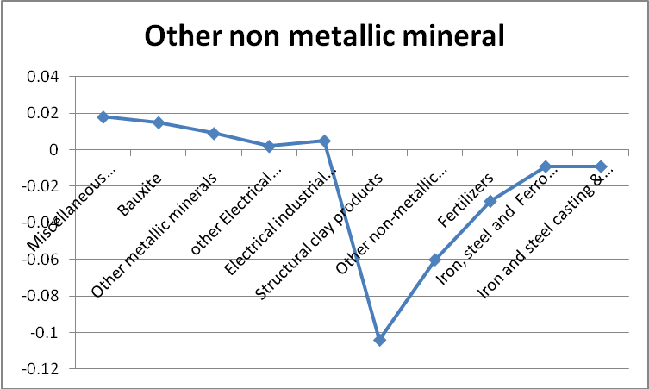
Figure 4.2 Top sectors identified for direct intensity changes of Other Metallic Mineral sectors during 1993-94 to 2006-7
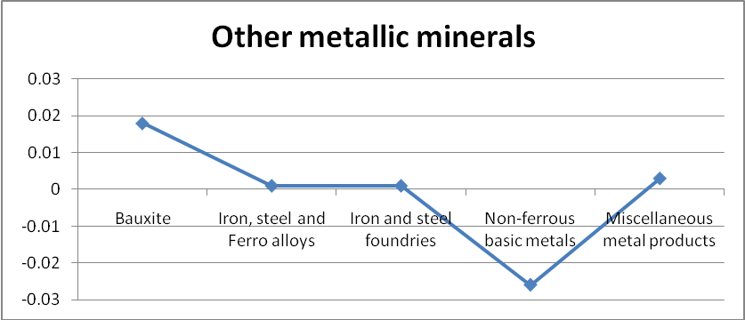
It reveals that Bauxite is common and major among the direct intensity list of six major minerals.
4.2 Total Intensity
The total intensity of iron ore, bauxite, and copper ore has increased primarily for mineral, mineral products, electrical machinery, industrial machinery sectors, transport equipment, construction, and information sector (table 4.2 and figure 4.3). The major intensive sectors in this respect are Bauxite and Iron and steel. The manganese ore intensity has reduced for Iron and steel Ferro alloys and foundries and increased for mineral products.
Table 4.2 Top sectors identified for total intensity changes for Bauxite, Iron ore and Copper ore during 1993-94 to 2006-7
 | Bauxite | Copper ore | Iron ore
Bauxite | 0.0277 | 0.0337 | 0.0011
Structural clay products | 0.0242 | ----
Other metallic minerals | 0.0045 | 0.0014
Iron, steel and Ferro alloys | 0.0044 | 0.0052 | 0.0085
Iron and steel casting & forging | 0.0046 | 0.0054 | 0.0025
Iron and steel foundries | 0.0088 | 0.0106
Non-ferrous basic metals | 0.0259 | 0.0244
Miscellaneous metal products | 0.0097 | 0.011 | 0.0030
Industrial machinery | 0.0047 | 0.0051 | 0.0029
Electrical industrial Machinery | 0.0044 | 0.0046 | 0.0035
Other electrical Machinery | 0.0061 | 0.0067 | 0.0027
Transport equipment | 0.0024 | 0.0025 | 0.0018
Construction | 0.0023 | 0.0015 | 0.0018
Information | 0.0012 | 0.0012
Cement | 0.0039 | -- | -
Other non-metallic mineral prods. | 0.0059 | ---- | --
 | Manganese ore
Other non-metallic mineral prods. | 0.0050
Iron, steel and Ferro alloys | -0.0020
Iron and steel foundries | -0.0012

Figure 4.3 Top common sectors identified for total intensity changes of Iron ore, Bauxite and Copper ore during 1993-94 to 2006-7
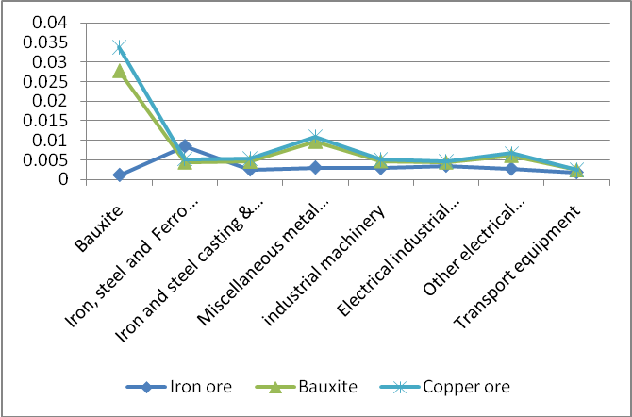

Figure 4.4 Top sectors identified for total intensity changes of other metallic mineral during 1993-94 to 2006-7
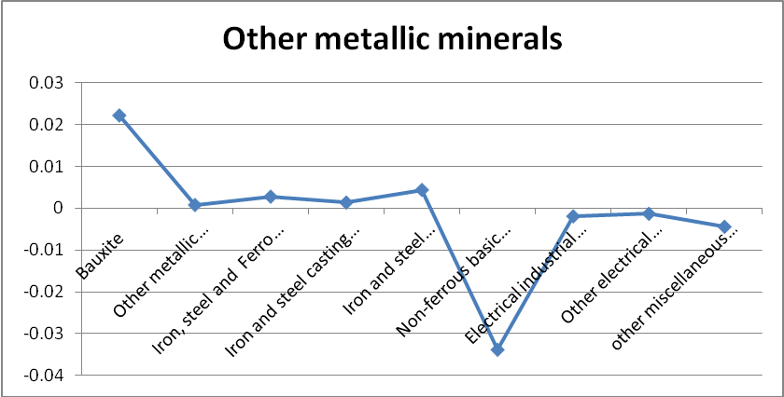
The total intensity of ‘other metallic mineral’ sector has increased for increased mainly from Iron and steel group and bauxite but reduced for electrical industrial machinery, non ferrous basic metal and miscellaneous manufacturing sector (figure 4.4).
Figure 4.4 Top sectors identified for total intensity changes of ‘Other non metallic mineral’ during 1993-94 to 2006-7
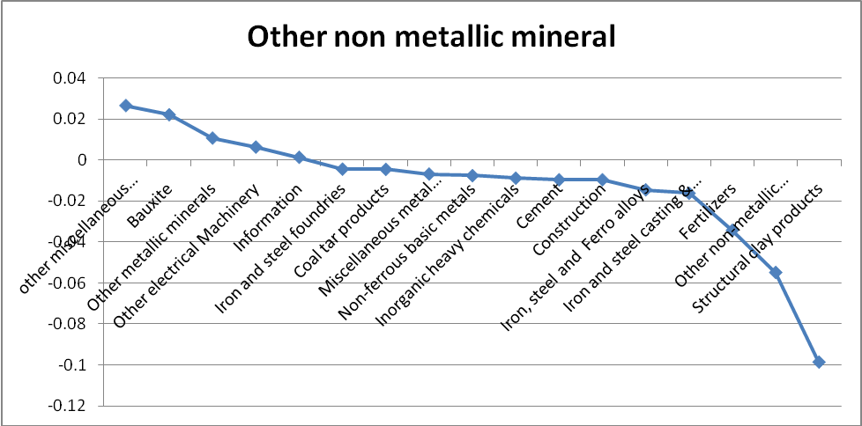
The total intensity of ‘other non metallic mineral’ has reduced for mineral industries such as iron and steel group, non ferrous basic metal, cement, coal tar products, structural clay products, as well as fertilizer, construction and chemicals. While it has increased for bauxite, other metallic mineral, electrical machinery and information (figure 4.4).
From this exercise, it is apparent that mineral sectors are mineral sector as well as mineral product intensive such as Bauxite and iron and steel group respectively.
Most importantly, the total intensity of bauxite, copper ore, and other non metallic mineral has increased for the information sector. In the next section, we will discuss the linkages between mineral, mineral based industries with other sectors of the economy.
Similar to direct intensity, bauxite and iron and steel are the major sectors among the total intensity lists. In this section, we have discussed about the intensity of six major mineral non-fuels in India –bauxite, iron ore, copper, manganese, other metallic mineral and other non metallic mineral. The most important and common sectors we identified under direct and total intensity list are bauxite (i.e. mineral raw /ore) and iron and steel (i.e. mineral product). The intensity of six minerals has increased particularly for these two sectors (except iron and steel intensity declined for other non metallic mineral only). Bauxite sector is mineral intensive i.e. it needs to produce bauxite, copper ore, other metallic mineral (mainly aluminium) and other non metallic mineral directly as well as indirectly. The use of Bauxite by other mineral non fuel sectors’ has increased over the period (1993-94 to 2006-7) in India. The major user of Bauxite is the aluminium industry which is under ‘other metallic minerals’ sector. The iron and steel sector is identified as a major mineral intensive sector over the period. Its positive intensity has seen for four minerals –bauxite, iron ore, copper and other metallic mineral, while the intensity reduced for other non metallic minerals. Almost for all minerals case its intensity has increased except for other non metallic minerals.
Due to the growing demand for construction and manufacturing sector, India has experienced a sharp rise in the demand for steel, aluminium, and cement sector over the years. These industries are heavily energy intensive and they together account for the largest share in the total industrial demand for energy. The demand for energy in these industries varies according to the techniques used in the production process, with some process consuming less energy compared to others. The generation of pollution further depends on the consumption of energy and the efficient technology. These aspects will be developed further in the paper.
Let us discuss about the Iron and steel and Bauxite industry. The Indian Steel Industry is the seventh largest producer of steel in the world. Today, India produces international standard steel of almost all grades or varieties and has been a net exporter for the past few years, underlining the growing acceptability of its products in the global market. However, in March 2008, because of high indigenous demand and inadequate availability of steel, the producers agreed to restrain export. With capital investments of over Rs 100,000 crores, the Indian steel industry currently provides direct or indirect employment to over 2 million people. On the other hand, Indian bauxite, the raw material for aluminium production, is of high quality and reserves of all categories (i.e. proved, probable, and possible) are estimated to be 3037 MT. India’s bauxite reserve is 5 percent of world’s total deposit. The production of Bauxite has increased from 10,414 in 2003 to 19,221 thousand metric tons in 2007(Dutta and Mukherjee, 2010).
The key consumer industries used Bauxite indirectly (through aluminium) in India are power, transportation, consumer durables, packaging and construction. The power and allied machinery sector is the biggest consumer (44 percent of total) along with Infrastructure and transportation sectors (17 percent and 12 percent respectively). As a result of liberalization process trade in aluminium has also gone up significantly. India currently exports 82000 tonnes of aluminium per annum (Dutta and Mukherjee, 2010).
The next section will identify the relation between energy sector, information and mineral non fuel sector particularly along with other key broad sectors of the economy.

5. Linkage of Mineral sectors with the economy
As we know that demand for minerals non fuel is increasing, on the other hand, high energy demand is also observed. Apart from that information sectors’ growth is also observed in India since mid 90s. Is there any linkage between these groups of sectors? How far one influences the other? These basic queries will be answered in this section. To focus on the mineral and mineral product sectors of the Indian economy during the period 1993-94 and 2006-7, the study is compressed the whole economy into seven broad categories of sectors. The basic idea behind is to explore the linkages of mineral and mineral product with energy, information, agriculture, manufacturing and service sectors in the economy during reforms. In order to get a clear picture of the changes in the economy the discussion will focus on changes in the direct and total coefficients of these sectors during 1993-94 to 2006-7. The direct and total coefficient for seven broad group sectors of the economy is presented in Appendix 2.
The technical coefficient gives us a picture of the production processes of the economy in terms of the direct requirements for one unit of output. In table 5.1, the change in the direct requirements of mineral segment output to information segment is negligible. For energy resources and mineral products, it shows a negative change i.e. the use of minerals by energy resource and mineral products has been reduced. On the other hand, manufacturing and mineral itself shows positive contribution. The use of information output to mineral has declined, while large contribution has been by information followed by manufacturing sector. The energy segment of output shows a direct positive contribution to mineral products. It reveals from the result that higher linkages are observed for the sectors itself with the sectors (except mineral product and services). Besides that the higher linkages are noted for mineral and mineral products sector with manufacturing sector, energy resources with mineral products, mineral with mineral products, information with manufacturing and energy resources. This further leads us to estimate the GHG emissions across the sectors of the Indian Economy over the period.

Table 5.1 Changes in direct coefficient during 1993-94 to 2006-7
Sectors | Agriculture and agri food | Energy resources | Mineral | Mineral Products | Manufacturing | Information | Service
Agriculture and agri food | 0.032 | 0.014 | 0.000 | 0.000 | -0.025 | -0.001 | 0.010
Energy resources | 0.012 | 0.085 | -0.015 | 0.039 | -0.002 | -0.008 | 0.016
Mineral | 0.000 | -0.003 | 0.008 | -0.008 | 0.003 | 0.000 | 0.000
Mineral Products | -0.002 | -0.003 | 0.017 | -0.038 | 0.043 | -0.010 | -0.006
Manufacturing | 0.021 | 0.014 | 0.005 | 0.016 | 0.023 | 0.025 | -0.018
Information | 0.006 | 0.004 | -0.005 | 0.001 | 0.023 | 0.092 | -0.006
Service | 0.025 | -0.045 | 0.001 | -0.023 | -0.040 | -0.001 | -0.006
Table 5.2 Changes in total coefficient during 1993-94 to 2006-7

Sectors | Agriculture and agri food | Energy resources | Mineral | Mineral Products | Manufacturing | Information | Service
Agriculture and agri food | 0.058 | 0.035 | 0.001 | 0.006 | -0.033 | 0.000 | 0.014
Energy resources | 0.065 | 0.287 | 0.006 | 0.147 | 0.073 | 0.018 | 0.055
Mineral | 0.002 | -0.004 | 0.010 | -0.013 | 0.007 | 0.001 | -0.001
Mineral Products | 0.014 | 0.012 | 0.030 | -0.060 | 0.083 | 0.005 | -0.005
Manufacturing | 0.059 | 0.061 | 0.017 | 0.042 | 0.063 | 0.060 | -0.011
Information | 0.026 | 0.033 | 0.004 | 0.020 | 0.057 | 0.132 | 0.007
Service | 0.048 | -0.056 | -0.003 | -0.053 | -0.047 | 0.004 | -0.017

6. GHG emission estimates
Further, the study estimates the contribution of GHG emissions from the mineral non fuel sectors as well as other sectors of the economy. It calculates the direct and total CO₂ emission generated in the Indian economy during 1993-94 to 2006-7. The direct CO₂ requirements (intensity) are positive during 1993-94 to 2006-7 for all the sectors in the economy. Though minor, but it reveals that direct CO₂ intensity has increased within the course of the period (Appendix 3). The total CO₂ intensity has also increased for almost all sectors of the economy except coal and lignite, iron and steel and ferro alloys, other non metallic mineral and textile and wearing apparel (Appendix 3). These declined in CO₂ intensity observed for three mineral non fuel sectors out of six sectors in this category. A closer look at figure 6.1 reveals that almost all 15 sectors have increased the intensity of CO₂ emission (direct) from mineral and mineral product sectors. Among them cement and other non metallic sectors show a very high increase in intensity. On the other hand, a marginal CO₂ intensity has observed for iron and steel sector. The total intensity of mineral and mineral product sectors is captured in figure 6.2. Almost all sectors appeared in direct intensity (figure 6.1) are also found in total intensity. The highest changes in total intensity are noted for natural gas and crude petroleum, non ferrous basic metal including cement and other non metallic sectors (figure 6.2). The other mineral sectors have a very insignificant increase in intensity. A marginal reduction in total intensity has been made possible for Iron and steel ferro alloys, coal and lignite and textile (table 6.1). The common sectors which have largest increase identified for direct and total intensities are cement and other non metallic mineral.
Figure 6.1 Direct CO₂ intensity for minerals and mineral products in India during 1993-94 to 2006-7
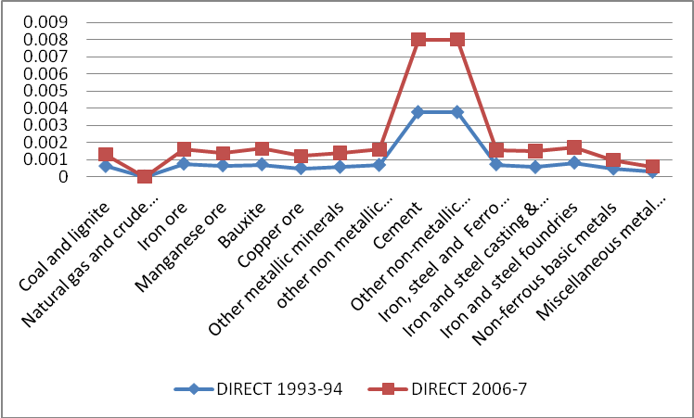

Table 6.1 Reduction in total CO₂ Intensity
Coal and lignite | -0.00057
other non metallic mineral | -0.00038
textile and textile products | -0.00041
Iron, steel and Ferro alloys | -0.0008

Figure 6.2. Total CO₂ intensity for minerals and mineral products in India during 1993-94 to 2006-7
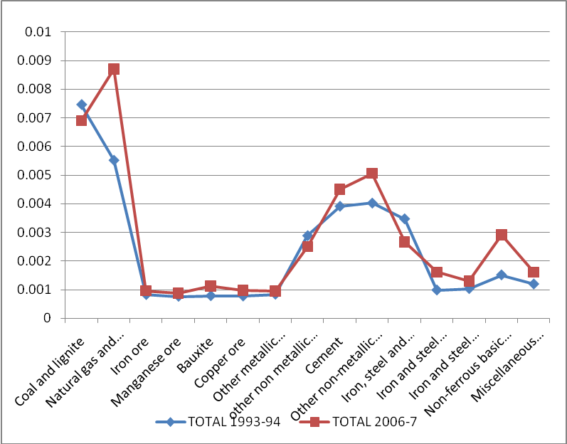
7. Conclusion
The current study deals with the intensity of non fuel mineral sectors of the Indian economy during the period 1993-94 to 2006-7. The study estimates the direct and total intensity of six non fuel mineral sectors of the economy. It also assessed the linkages between mineral and other few broad group of sectors of the economy. Finally it calculates the CO₂ emission intensity across these sectors.
Though very marginal, the direct intensity of minerals sectors has increased for most of the sectors of the economy. The total intensity has increased for iron ore, bauxite, copper ore and other metallic minerals. The effected sectors are mineral industries, machinery particularly electrical machinery, manufacturing, transport and construction sector. Among them the two important sectors identified over the period are -Bauxite as mineral and Iron and steel groups as mineral product in the Indian economy.
The impact of mineral sectors on the rest of the economy shows that highest linkages observed for the sectors itself with the sectors (except mineral product and services). Besides that the maximum linkages observed for mineral and mineral products sector with manufacturing sector, energy resources with mineral products, mineral with mineral products, information with manufacturing and energy resources. The CO₂ emission intensity both direct as well as total has increased over the course of the period especially for mineral and mineral product sector.
From this exercise it is apparent that non fuel mineral use is mostly confined to mineral and mineral product sector. Apart from that its contribution is observed in construction, machinery and transport sector. As we know that mineral is non renewable and finite, so efficiency in its use is always needed particularly for the countries like India where the demand for minerals is growing by leaps and bounds because of the infrastructure development. We have seen from the result that total requirement of minerals is still not efficient over the period. Moreover, the CO₂ emission generated from these sectors cannot be ignored.
Government of India announced series of mineral policy and amendments for technological development in mineral exploration and sustainable use of minerals. ‘The National Mineral Policy’ in 1993 and the amendment of the Mines and Minerals Regulation & Development Act, 1957, in 1994, are radical steps taken in the wake of economic and industrial reforms. Such policies/regulations were followed by (i) guidelines for Prospecting Licences (PL) for large areas in 1969; (ii) amendment of MMRD Act w.e.f. 20.12.99 (with prominence to ‘development’ over ‘regulation’) (iii) amendment of MCR, 1960 w.e.f. 05.05.2005, (iv) amendment of MCDR, 1988 w.e.f. 18.1.2000. In order to give further boost to private investment in the mineral sector, Planning Commission has set up a High Level Committee to review the National Mineral Policy and recommend possible amendments to Mines & Minerals Development & Regulation (MMDR) Act, 1957(GOI,2007). Amendments to the Mines and Minerals Development & Regulation (MMDR) Act and the Mineral Concession Rules (MCR) have been introduced to create congenial environment for attracting investment in the mineral sector. As a sequel to this, several Multinational Companies (MNC’s) have taken up exploration activity in the country.
It is a fact that the mineral production in India in the post independence period has grown in quantity as well as in value. The growth rate in the energy sector is eight to ten fold and there is steady growth even in metallic sector, except in gold where there is reverse trend.
Even though the act and policies are on board, not as such technical improvement has been observed in the use of mineral resources in the economy. In view of this, we can suggest some suggestions to improve the efficiency of the mineral resource for the Indian economy.
Rigorous exploration efforts are required for deficient minerals for which the country is dependent on import. Technologies for low-grade, large tonnage; high-grade, low tonnage; PGE deposits and high-tech minerals should be developed. Beneficiation technology has to be improved for the recovery of metals from the low grade ores, and also for the optimum recovery of high value minerals as the by-products from the mining of other minerals.
References
Chakraborty, D (1992) Mineral Sectors and the Indian Economy -- An Input-Output Approach, Asian Economic Review, XXXIV (2):221-248
CSO: Input-Output Transaction Tables 1993-94 and 2006-7, Central Statistical Organisation, Department of Statistics, Ministry of Planning, Government of India.
Dutta, M and S. Mukherjee (2010) An outlook into energy consumption in large scale industries in India: The cases of steel, aluminium and cement, Energy Policy 38: 7286–7298

GOI (2007) Report of the Working Group on Mineral Exploration and Development for the Eleventh Five Year Plan Over View Volume – I, Government of India, Planning Commission, New Delhi

Lee, H-L (2006) An Emissions Data Base for Integrated Assessment of Climate Change Policy Using GTAP, GTAP Resource #1143

Appendix 1
Total intensity of non fuel mineral sectors for 2006-7
 |  | Iron ore | Manganese ore | Bauxite | Copper ore | Other metallic minerals | Other non metallic minerals
1 | Agriculture &related activities | 0.0002 | 0.0000 | 0.0002 | 0.0001 | 0.0001 | 0.0036
2 | Coal and lignite | 0.0006 | 0.0001 | 0.0005 | 0.0006 | 0.0005 | 0.0023
3 | Natural gas and crude petroleum | 0.0007 | 0.0001 | 0.0007 | 0.0007 | 0.0005 | 0.0055
4 | Iron ore | 0.0005 | 0.0001 | 0.0005 | 0.0006 | 0.0004 | 0.0020
5 | Manganese ore | 0.0001 | 0.0000 | 0.0001 | 0.0001 | 0.0001 | 0.0005
6 | Bauxite | 0.0013 | 0.0010 | 0.0277 | 0.0338 | 0.0226 | 0.0234
7 | Copper ore | 0.0002 | 0.0000 | 0.0002 | 0.0002 | 0.0001 | 0.0012
8 | Other metallic minerals | 0.0012 | 0.0003 | 0.0045 | 0.0014 | 0.0011 | 0.0131
9 | other non metallic mineral | 0.0002 | 0.0000 | 0.0002 | 0.0002 | 0.0001 | 0.0018
10 | Miscellaneous food products | 0.0003 | 0.0001 | 0.0004 | 0.0004 | 0.0003 | 0.0041
11 | Beverages and Tobacco | 0.0003 | 0.0001 | 0.0004 | 0.0004 | 0.0003 | 0.0033
12 | textile and textile products | 0.0006 | 0.0001 | 0.0006 | 0.0006 | 0.0005 | 0.0049
13 | Wood and wooden products | 0.0010 | 0.0001 | 0.0007 | 0.0009 | 0.0007 | 0.0035
14 | Paper, paper prods. & newsprint and printing | 0.0007 | 0.0001 | 0.0006 | 0.0006 | 0.0005 | 0.0051
15 | Leather footwear and leather prod | 0.0004 | 0.0001 | 0.0004 | 0.0005 | 0.0004 | 0.0037
16 | Rubber products | 0.0014 | 0.0002 | 0.0011 | 0.0012 | 0.0010 | 0.0079
17 | Plastic products | 0.0009 | 0.0001 | 0.0012 | 0.0013 | 0.0011 | 0.0071
18 | Petroleum products | 0.0006 | 0.0001 | 0.0006 | 0.0006 | 0.0004 | 0.0047
19 | Coal tar products | 0.0007 | 0.0002 | 0.0008 | 0.0008 | 0.0006 | 0.0066
20 | Inorganic heavy chemicals | 0.0008 | 0.0002 | 0.0017 | 0.0009 | 0.0010 | 0.0222
21 | Organic heavy chemicals | 0.0005 | 0.0001 | 0.0009 | 0.0009 | 0.0009 | 0.0161
22 | Fertilizers | 0.0005 | 0.0005 | 0.0007 | 0.0005 | 0.0005 | 0.0435
23 | Other chemicals | 0.0006 | 0.0001 | 0.0009 | 0.0008 | 0.0010 | 0.0091
24 | Structural clay products | 0.0005 | 0.0004 | 0.0307 | 0.0015 | 0.0013 | 0.0912
25 | Cement | 0.0004 | 0.0001 | 0.0039 | 0.0006 | 0.0005 | 0.1246
26 | Other non-metallic mineral prods. | 0.0010 | 0.0051 | 0.0062 | 0.0010 | 0.0014 | 0.0768
27 | Iron, steel and Ferro alloys | 0.0295 | 0.0025 | 0.0045 | 0.0057 | 0.0051 | 0.0078
28 | Iron and steel casting & forging | 0.0120 | 0.0011 | 0.0048 | 0.0060 | 0.0047 | 0.0074
29 | Iron and steel foundries | 0.0124 | 0.0012 | 0.0091 | 0.0115 | 0.0083 | 0.0103
30 | Non-ferrous basic metals | 0.0026 | 0.0005 | 0.0307 | 0.0394 | 0.0263 | 0.0160
31 | Miscellaneous metal products | 0.0097 | 0.0010 | 0.0104 | 0.0130 | 0.0093 | 0.0135
32 | Tractors and agri. Implements and industrial machinery | 0.0063 | 0.0006 | 0.0050 | 0.0058 | 0.0042 | 0.0090
33 | Other non-electrical machinery | 0.0061 | 0.0006 | 0.0047 | 0.0059 | 0.0043 | 0.0089
34 | Electrical industrial Machinery | 0.0063 | 0.0007 | 0.0048 | 0.0060 | 0.0045 | 0.0102
35 | Other electrical Machinery | 0.0047 | 0.0007 | 0.0066 | 0.0082 | 0.0059 | 0.0136
36 | transport equipment | 0.0046 | 0.0005 | 0.0026 | 0.0031 | 0.0024 | 0.0073
37 | other miscellaneous manufacturing | 0.0018 | 0.0002 | 0.0022 | 0.0027 | 0.0021 | 0.0466
38 | Construction | 0.0031 | 0.0005 | 0.0026 | 0.0017 | 0.0013 | 0.0571
39 | Electricity | 0.0011 | 0.0001 | 0.0009 | 0.0011 | 0.0008 | 0.0059
40 | Information | 0.0010 | 0.0001 | 0.0013 | 0.0016 | 0.0013 | 0.0041
41 | other service | 0.0003 | 0.0001 | 0.0003 | 0.0003 | 0.0003 | 0.0030

Total intensity of non fuel mineral sectors for 1993-94
 | Iron ore | Manganese ore | Bauxite | Copper ore | Other metallic minerals | other non metalic mineral
Agriculture &related activities | 0.00007 | 0.00002 | 0.00001 | 0.00003 | 0.00014 | 0.00403
Coal and lignite | 0.00048 | 0.00010 | 0.00005 | 0.00014 | 0.00065 | 0.02332
Crude petroleum, natural gas | 0.00023 | 0.00005 | 0.00003 | 0.00006 | 0.00028 | 0.00291
Iron ore | 0.00038 | 0.00008 | 0.00004 | 0.00012 | 0.00055 | 0.00227
Manganese ore | 0.00009 | 0.00002 | 0.00001 | 0.00003 | 0.00015 | 0.00050
Bauxite | 0.00024 | 0.00005 | 0.00002 | 0.00007 | 0.00032 | 0.00124
Copper ore | 0.00026 | 0.00006 | 0.00003 | 0.00008 | 0.00038 | 0.00193
Other metallic minerals | 0.00023 | 0.00005 | 0.00002 | 0.00006 | 0.00031 | 0.00231
other non metallic mineral | 0.00011 | 0.00003 | 0.00001 | 0.00003 | 0.00018 | 0.00168
Miscellaneous food products | 0.00017 | 0.00004 | 0.00003 | 0.00008 | 0.00052 | 0.00421
Beverages and Tobacco | 0.00033 | 0.00007 | 0.00007 | 0.00018 | 0.00091 | 0.00527
textile and textile products | 0.00026 | 0.00006 | 0.00004 | 0.00012 | 0.00063 | 0.00348
Wood and wooden products | 0.00024 | 0.00005 | 0.00006 | 0.00016 | 0.00152 | 0.00338
Paper, paper prods. & newsprint and printing | 0.00031 | 0.00008 | 0.00009 | 0.00027 | 0.00119 | 0.00607
Leather footwear and leather prod | 0.00026 | 0.00006 | 0.00005 | 0.00016 | 0.00073 | 0.00343
Rubber products | 0.00038 | 0.00009 | 0.00007 | 0.00020 | 0.00101 | 0.00604
Plastic products | 0.00033 | 0.00008 | 0.00007 | 0.00021 | 0.00114 | 0.00508
Petroleum products | 0.00024 | 0.00005 | 0.00003 | 0.00007 | 0.00035 | 0.00277
Coal tar products | 0.00040 | 0.00009 | 0.00008 | 0.00024 | 0.00107 | 0.01111
Inorganic heavy chemicals | 0.00038 | 0.00037 | 0.00016 | 0.00047 | 0.00200 | 0.03096
Organic heavy chemicals | 0.00039 | 0.00013 | 0.00007 | 0.00020 | 0.00105 | 0.01604
Fertilizers | 0.00032 | 0.00011 | 0.00011 | 0.00020 | 0.00094 | 0.07787
Other chemicals | 0.00034 | 0.00010 | 0.00008 | 0.00023 | 0.00165 | 0.00829
Structural clay products | 0.00026 | 0.00006 | 0.00655 | 0.00012 | 0.00055 | 0.18991
Cement | 0.00048 | 0.00011 | 0.00006 | 0.00011 | 0.00051 | 0.13419
Other non-metallic mineral prods. | 0.00040 | 0.00010 | 0.00034 | 0.00023 | 0.00100 | 0.13163
Iron, steel and Ferro alloys | 0.02104 | 0.00457 | 0.00018 | 0.00053 | 0.00224 | 0.02228
Iron and steel casting & forging | 0.00950 | 0.00204 | 0.00022 | 0.00067 | 0.00337 | 0.02356
Iron and steel foundries | 0.01134 | 0.00236 | 0.00030 | 0.00092 | 0.00390 | 0.01472
Non-ferrous basic metals | 0.00228 | 0.00049 | 0.00479 | 0.01506 | 0.06016 | 0.02352
Miscellaneous metal products | 0.00670 | 0.00123 | 0.00065 | 0.00203 | 0.00865 | 0.02027
Tractors and agri. Implements and industrial machinery | 0.00337 | 0.00070 | 0.00022 | 0.00069 | 0.00363 | 0.00779
Other non-electrical machinery | 0.00414 | 0.00090 | 0.00027 | 0.00082 | 0.00356 | 0.00785
Electrical industrial Machinery | 0.00280 | 0.00062 | 0.00047 | 0.00146 | 0.00635 | 0.00730
Other electrical Machinery | 0.00202 | 0.00044 | 0.00048 | 0.00147 | 0.00721 | 0.00716
transport equipment | 0.00280 | 0.00060 | 0.00020 | 0.00061 | 0.00269 | 0.00669
other miscellaneous manufacturing | 0.00170 | 0.00037 | 0.00050 | 0.00154 | 0.00652 | 0.01986
Construction | 0.00129 | 0.00027 | 0.00025 | 0.00018 | 0.00083 | 0.06671
Electricity | 0.00075 | 0.00017 | 0.00005 | 0.00013 | 0.00060 | 0.00593
Information | 0.00042 | 0.00014 | 0.00013 | 0.00040 | 0.00184 | 0.00273
other service | 0.00032 | 0.00007 | 0.00005 | 0.00013 | 0.00057 | 0.00350

Appendix 2
Direct coefficients
1993-94 | Agriculture and agri food sector | Energy resources | mineral | mineral products | manufacturing sector | information sector | Service sector
Agri and agri food sector | 0.203 | 0.001 | 0.000 | 0.001 | 0.051 | 0.002 | 0.028
Energy resources | 0.018 | 0.391 | 0.060 | 0.106 | 0.050 | 0.020 | 0.054
mineral | 0.000 | 0.003 | 0.000 | 0.049 | 0.018 | 0.000 | 0.000
mineral products | 0.002 | 0.008 | 0.010 | 0.305 | 0.097 | 0.058 | 0.010
manufacturing sector | 0.052 | 0.048 | 0.056 | 0.061 | 0.225 | 0.058 | 0.091
information sector | 0.009 | 0.028 | 0.023 | 0.036 | 0.043 | 0.083 | 0.051
Service sector | 0.073 | 0.113 | 0.043 | 0.159 | 0.163 | 0.053 | 0.089
2006-7 | Agriculture and agri food sector | Energy resources | mineral | mineral products | manufacturing sector | information sector | Service sector
Agriculture and agri food sector | 0.235 | 0.015 | 0.000 | 0.001 | 0.026 | 0.000 | 0.038
Energy resources | 0.031 | 0.476 | 0.045 | 0.145 | 0.049 | 0.012 | 0.070
mineral | 0.000 | 0.000 | 0.008 | 0.042 | 0.021 | 0.000 | 0.000
mineral products | 0.000 | 0.005 | 0.027 | 0.267 | 0.140 | 0.048 | 0.004
manufacturing sector | 0.073 | 0.062 | 0.061 | 0.077 | 0.249 | 0.084 | 0.073
information sector | 0.014 | 0.032 | 0.018 | 0.037 | 0.066 | 0.175 | 0.045
Service sector | 0.098 | 0.068 | 0.044 | 0.136 | 0.124 | 0.052 | 0.083

Total coefficients
1993-94 | Agriculture and agri food sector | Energy resources | Mineral | Mineral products | Manufacturing sector | Information sector | Service sector
Agriculture and agri food sector | 1.267 | 0.021 | 0.010 | 0.027 | 0.100 | 0.014 | 0.052
Energy resources | 0.065 | 1.689 | 0.123 | 0.316 | 0.188 | 0.076 | 0.128
mineral | 0.004 | 0.011 | 1.004 | 0.078 | 0.036 | 0.008 | 0.006
mineral products | 0.024 | 0.049 | 0.034 | 1.483 | 0.207 | 0.111 | 0.046
manufacturing sector | 0.109 | 0.146 | 0.098 | 0.191 | 1.373 | 0.112 | 0.158
information sector | 0.028 | 0.076 | 0.040 | 0.098 | 0.098 | 1.109 | 0.078
Service sector | 0.135 | 0.251 | 0.090 | 0.344 | 0.321 | 0.115 | 1.159
2006-7 | Agriculture and agri food sector | Energy resources | Mineral | Mineral products | Manufacturing sector | Information sector | Service sector
Agri and agri food sector | 1.325 | 0.056 | 0.011 | 0.033 | 0.067 | 0.014 | 0.065
Energy resources | 0.130 | 1.975 | 0.129 | 0.463 | 0.261 | 0.093 | 0.183
mineral | 0.005 | 0.007 | 1.014 | 0.065 | 0.042 | 0.009 | 0.005
mineral products | 0.038 | 0.061 | 0.064 | 1.423 | 0.290 | 0.116 | 0.041
manufacturing sector | 0.168 | 0.207 | 0.115 | 0.233 | 1.436 | 0.172 | 0.147
information sector | 0.054 | 0.109 | 0.044 | 0.118 | 0.155 | 1.242 | 0.085
Service sector | 0.183 | 0.196 | 0.087 | 0.290 | 0.274 | 0.120 | 1.142

Appendix 3
Total CO2 coefficient for the year 1993-94 and 2006-7
 | Sectors |  | 1993-94 | 2006-7
1 | Agriculture & related activities |  | 0.00174 | 0.00202
2 | Coal and lignite |  | 0.00747 | 0.00690
3 | Crude petroleum, natural gas |  | 0.00552 | 0.00870
4 | Iron ore |  | 0.00082 | 0.00096
5 | Manganese ore |  | 0.00076 | 0.00088
6 | Bauxite |  | 0.00078 | 0.00113
7 | Copper ore |  | 0.00077 | 0.00098
8 | Other metallic minerals |  | 0.00083 | 0.00095
9 | other non metallic mineral |  | 0.00288 | 0.00250
10 | Miscellaneous food products |  | 0.00028 | 0.00054
11 | Beverages and Tobacco |  | 0.00006 | 0.00014
12 | textile and textile products |  | 0.00111 | 0.00070
13 | Wood and wooden products |  | 0.00043 | 0.00050
14 | Paper, paper prods. & newsprint and printing |  | 0.00218 | 0.00250
15 | Leather footwear and leather prod |  | 0.00026 | 0.00031
16 | Rubber products |  | 0.00117 | 0.00131
17 | Plastic products |  | 0.00137 | 0.00209
18 | Petroleum products |  | 0.00316 | 0.00988
19 | Coal tar products |  | 0.00228 | 0.00253
20 | Inorganic heavy chemicals |  | 0.00170 | 0.00257
21 | Organic heavy chemicals |  | 0.00174 | 0.00246
22 | Fertilizers |  | 0.00117 | 0.00127
23 | Other chemicals |  | 0.00436 | 0.00549
24 | Structural clay products |  | 0.00383 | 0.00497
25 | Cement |  | 0.00391 | 0.00450
26 | Other non-metallic mineral prods. |  | 0.00402 | 0.00506
27 | Iron, steel and ferro alloys |  | 0.00347 | 0.00267
28 | Iron and steel casting & forging |  | 0.00098 | 0.00161
29 | Iron and steel foundries |  | 0.00103 | 0.00130
30 | Non-ferrous basic metals |  | 0.00151 | 0.00291
31 | Miscellaneous metal products |  | 0.00119 | 0.00161
32 | industrial machinery |  | 0.00070 | 0.00079
33 | Other non-electrical machinery |  | 0.00104 | 0.00179
34 | Electrical industrial Machinery |  | 0.00077 | 0.00138
35 | Other electrical Machinery |  | 0.00016 | 0.00087
36 | transport equipment |  | 0.00046 | 0.00047
37 | other miscellaneous manufacturing |  | 0.00105 | 0.00237
38 | Construction |  | 0.00083 | 0.00332
39 | Electricity |  | 0.03918 | 0.04694
40 | Information |  | 0.00409 | 0.00857
41 | other service |  | 0.01668 | 0.01695
Direct CO2 coefficient for the year 1993-94 and 2006-7

 |  |  | 1993-94 | 2006-7
1 | Agriculture &related activities |  | 0.00000 | 0.00000
2 | Coal and lignite |  | 0.00061 | 0.00069
3 | Natural gas and crude petroleum |  | 0.00000 | 0.00000
4 | Iron ore |  | 0.00075 | 0.00085
5 | Manganese ore |  | 0.00065 | 0.00072
6 | Bauxite |  | 0.00071 | 0.00093
7 | Copper ore |  | 0.00049 | 0.00071
8 | Other metallic minerals |  | 0.00056 | 0.00084
9 | other non metallic mineral |  | 0.00067 | 0.00091
10 | Miscellaneous food products |  | 0.00016 | 0.00018
11 | Beverages and Tobacco |  | 0.00005 | 0.00006
12 | textile and textile products |  | 0.00028 | 0.00032
13 | Wood and wooden products |  | 0.00008 | 0.00009
14 | Paper, paper prods. & newsprint and printing |  | 0.00105 | 0.00119
15 | Leather footwear and leather prod |  | 0.00018 | 0.00020
16 | Rubber products |  | 0.00090 | 0.00102
17 | Plastic products |  | 0.00090 | 0.00102
18 | Petroleum products |  | 0.00170 | 0.00192
19 | Coal tar products |  | 0.00187 | 0.00212
20 | Inorganic heavy chemicals |  | 0.00090 | 0.00102
21 | Organic heavy chemicals |  | 0.00090 | 0.00102
22 | Fertilizers |  | 0.00090 | 0.00102
23 | Other chemicals |  | 0.00090 | 0.00102
24 | Structural clay products |  | 0.00375 | 0.00425
25 | Cement |  | 0.00375 | 0.00425
26 | Other non-metallic mineral prods. |  | 0.00375 | 0.00425
27 | Iron, steel and Ferro alloys |  | 0.00081 | 0.00091
28 | Iron and steel casting & forging |  | 0.00081 | 0.00091
29 | Iron and steel foundries |  | 0.00081 | 0.00091
30 | Non-ferrous basic metals |  | 0.00046 | 0.00052
31 | Miscellaneous metal products |  | 0.00028 | 0.00032
32 | industrial machinery |  | 0.00027 | 0.00030
33 | Other non-electrical machinery |  | 0.00010 | 0.00012
34 | Electrical industrial Machinery |  | 0.00002 | 0.00002
35 | Other electrical Machinery |  | 0.00002 | 0.00002
36 | transport equipment |  | 0.00002 | 0.00002
37 | other miscellaneous manufacturing |  | 0.00020 | 0.00022
38 | Construction |  | 0.00001 | 0.00001
39 | Electricity |  | 0.02712 | 0.03071
40 | Information |  | 0.00002 | 0.00002
41 | other service |  | 0.00047 | 0.00053

