Public revenue and carbon dioxide emissions:
an AGE analysis for Germany
Tobias Kronenberg

Abstract
Many governments are currently trying to reduce public expenditure and/or increase public revenue. Their focus on fiscal consolidation may come at the expense of environmental policy goals, for example in the case of environmentally motivated subsidies. However, there may be opportunities for policy measures that contribute to fiscal consolidation as well as furthering environmental policy goals, e.g. taxes on environmentally harmful products. The aim of this paper is to show how input-output analysis can contribute to finding such opportunities.
To this end, numerical simulations are performed on the basis of MMG (Macroeconomic Model for Germany). MMG is an applied general equilibrium (AGE) model which draws its theoretical foundations from the post-Keynesian macroeconomic framework. This framework allows the model to avoid the unrealistic assumption of full employment and the problematic aggregation of capital into an “aggregate capital stock”. Unlike the basic input-output model, it does not rely on constant relative prices. All commodity prices are fully flexible and free to adjust to changes in technology (i.e. the matrix of input-output coefficients), taxes or subsidies, and unit wage costs. In order to assess the effects of policy measures on the environment and fiscal consolidation, the model incorporates a variety of emissions and public revenue through taxes on labour income, capital income, commodities and production
The model results suggest that additional taxes on refined petroleum products and electricity are reduce carbon dioxide emissions while increasing public revenue, although they exhibit negative effects on GDP and value added. A similar tax on crude oil and natural gas would not increase public revenue because Germany is highly import-dependent with respect to these products.

Keywords
Public revenue, taxes, emissions, input-output model

JEL Codes
C67, C68, H6, H23, Q58

Contents
1 Introduction 1
2 The Model 2
2.1 The input-output core 3
2.2 Social accounting tables 4
2.3 The Price System 7
2.4 Implementation in GAMS 9
2.5 Solving the Model 13
3 Numerical Simulations 13
3.1 A new tax on refined petroleum products 13
3.2 A new tax on electricity 19
3.3 A new tax on crude oil and natural gas 24
3.4 Summary 29
4 Conclusion 29
Appendix 30
References 33

Figures
Figure 1: Distribution of primary income in MMG terms 6
Figure 2: Price change in simulation 1 14
Figure 3: Output change in simulation 1 16
Figure 4: Changes in household income and consumption in simulation 1 17
Figure 5: Change in public revenue in simulation 1 18
Figure 6: Carbon dioxide emission in baseline and scenario 1 18
Figure 7: Main results of scenario 1 19
Figure 8: Price effects in scenario 2 20
Figure 9: Output change in scenario 2 21
Figure 10: Changes in household income and consumption in scenario 2 22
Figure 11: Change in public revenue in scenario 2 22
Figure 12: Carbon dioxide emissions in baseline and scenario 2 23
Figure 13: Main results of scenario 2 23
Figure 14: Price changes in scenario 3 25
Figure 15: Output changes in scenario 3 26
Figure 16: Changes in household income and consumption in scenario 3 27
Figure 17: Change in public revenue in scenario 3 27
Figure 18: Carbon dioxide emissions in baseline and scenario 3 28
Figure 19: Main results of scenario 3 29

Tables
Table 1: MMG input-output table, Germany, 2005 4
Table 2: MMG social groups account 7
Table 3: Comparison of main results 29
Table 4: List of variables 30
Table 5: List of parameters 31
Table 6: Sector codes 31

Introduction
In the aftermath of the Great Financial Crisis, which was triggered by private agents defaulting on debt, many governments are now faced with rampant public debt. In some cases, public deficits as a percentage of GDP have reached double digit figures. While there are valid reasons for running temporary public deficits in times of crises, it is generally argued that public budgets should be more or less balanced over the long term, or should at least remain below some level as a percentage of GDP. The state, in its role as a lender of last resort in times of crises, has to make sure that private agents always remain confident in the state’s ability to meet its financial obligations. A number of governments in the Eurozone have already lost that confidence. In the light of these developments, many governments are currently trying to reduce the gap between spending and revenue, i.e. the public deficit. Naturally, this can be achieved by either reducing spending, or raising revenue, or both.
At the same time, global warming is still a grave danger to humans, especially those who happen to live in poor countries of low elevation with a high probability of being flooded as sea levels rise. In order to avoid or at least mitigate climate change, many governments are still spending a lot of money, for example on subsidising research on renewable energy technologies and improvements in energy efficiency. As governments search for opportunities to reduce spending, it seems natural that they will also look at these well-intended but perhaps costly programmes. Hence, fiscal consolidation might come at the expense of environmental policy.
The German case is no exception. Although Germany has come out of the Great Financial Crisis in surprisingly good shape (unemployment is actually lower than before), its public debt now stands at 83.2% of GDP, and its public deficit of 3.3% still exceeds the ‘Maastricht threshold’ of 3.0%. With the economy growing at a healthy pace and unemployment falling steadily, the case for additional deficit spending is no longer convincing. Chancellor Merkel has repeatedly stated that fiscal consolidation remains an important policy goal.
These considerations lead to the questions whether a policy oriented toward fiscal consolidation will get into conflict with the goal of combating climate change. The aim of this paper is to find policy measures that contribute to both goals simultaneously. A typical example would be some sort of eco-tax, which – if effective – reduces emissions while generating additional revenue for the government. The idea of taxing activities which pollute the environment is attractive to economists because it is firmly rooted in the theory of economic externalities set out by Arthur Pigou and serves to close the gap between marginal social cost and marginal private cost. Therefore, environmental taxes can be welfare-enhancing even in a strict neoclassical framework because they are seen as a remedy to the market failure caused by external effects. Thus, there are good reasons to support taxes to correct for environmental externalities.
The paper proceeds as follows: section 2 develops an applied general equilibrium (AGE) model for the German economy, drawing inspiration from the classical-Keynesian approach of Dejuán et al. . In section 3, some model-based scenarios are explored in order to identify the effects of various taxes on emissions and public revenue. Section 4 concludes.

The Model
MMG is an applied general equilibrium (AGE) model that takes account of the manifold relationships between the individual markets in the economy. AGE models evolved during the 1970’s as a natural offspring of the earlier input-output models developed by Nobel Laureate Wassily Leontief. The most common input-output model, the static open quantity model, can be a useful tool for answering certain types of economic questions, but due to its simple structure there are many problems which it cannot address. To start with, it does not account for the empirical relationship between current income and consumption expenditure by households as expressed in the Keynesian consumption function. Moreover, it does not incorporate the effects of price changes on demand, effectively excluding the possibility of substitution between final and intermediate goods.
Many AGE models are based on the neoclassical theory of general equilibrium. A well-known textbook on AGE modelling explicitly states that ‘the central idea of this work is to convert the Walrasian general equilibrium structure […] from an abstract representation of an economy into realistic models of actual economies’ . This idea was adopted in much of the empirical literature on AGE modelling. However, the neoclassical theory of equilibrium is not without flaws and critics. First of all, it should be noted that actual economies are generally not in a state of equilibrium, so models that assume a state of general equilibrium will always lack realism and should be interpreted with an appropriate measure of caution and modesty. Second, the neoclassical theory is based on highly unrealistic assumptions on the behaviour of firms and consumers. Third, the neoclassical theory of production lacks internal consistency, especially with respect to the role of capital.
Based on these considerations, the present paper adopts an alternative theoretical foundation: the classical-Keynesian approach developed by the ‘Cambridge school of Keynesian economics’ . This approach still relies on assuming general equilibrium on all commodity markets, so it is still subject to the first criticism mentioned above (against equilibrium models in general). However, it relies on a conception of equilibrium which is less far-fetched than the intertemporal equilibrium postulated by the neoclassical framework. The markets for commodities are modelled on the basis of input-output tables and other statistical data sources. The labour market, by contrast, is not explicitly modelled – it is assumed that labour is less than fully employed and that changes in the amount of labour input have no effect on the average wage rate, which is exogenously given. Similarly, the markets for financial capital (bonds, stocks and other financial assets) are not explicitly modelled. However, the structure of the model ensures that the basic condition for macroeconomic equilibrium – that investment is equal to saving – is fulfilled. Thus, MMG is based on an equilibrium concept which entails equilibrium in all product markets (demand equals supply) but allows for disequilibrium in the labour market (i.e. unemployment). This notion of equilibrium is consistent with the normal behaviour of a modern economy.
With respect to consumer and firm behaviour, MMG does not assume maximisation of utility or profits. The model of utility maximisation (“homo oeconomicus”) has been criticised on both theoretical and empirical grounds. Theoretically, the existence of fundamental uncertainty about the future implies that it is effective impossible to compute the expected value of (discounted) lifetime utility. Therefore, intertemporal utility maximisation is in practice not feasible. Empirically, a number of experiments have shown that people’s behaviour contradicts the implications of the model. That is, the model has been falsified by the evidence. MMG therefore adopts a classical-Keynesian view of the consumer, whose consumption decisions can be described by a consumption function relating consumption expenditure to current income. In a similar fashion, firms are not assumed to maximise profit for similar reasons. Furthermore, as Kalecki argued, firm managers may not be interested in maximising profit but rather in pursuing other goals. Following the classical-Keynesian tradition, firms are assumed to set prices according to a mark-up rule with a certain margin above unit production cost.
The third criticism mentioned above mainly refers to the notion of an ‘aggregate capital stock’. The aggregation of capital is problematic because there is no physical magnitude which could be used for aggregation. This is the fundamental difference between capital and other inputs. Human labour can be measured in hours (perhaps adjusted for productivity), land in square kilometres, energy in kWh, steel in tonnes, water in litres, and so on. The only way to measure capital is in terms of value (or price). Therefore, the aggregation of capital can only be performed after the price of a ‘unit of capital’ has been established. This problem invalidates the neoclassical theory of production and distribution, where the supply of aggregate capital – relative to other production factors – determines the price of capital, i.e. the interest rate. These problems were at the centre of the ‘Cambridge capital controversy’ . Further criticism was directed against the use of aggregate production functions . By the end of the 1970’s it was clear that the empirical support for the neoclassical aggregate production function was indeed very weak . In the light of these arguments, the present paper adopts the classical-Keynesian theory of production .
The technical details of the model are explained in the following sections.

The input-output core
The model structure follows the basic philosophy of the input-output approach, which highlights the importance of tracing all transactions between people and organisations in an economy. The core of MMG consists of a simple input-output model capturing the production of commodities by means of commodities. This ‘core’ reflects the interindustry transactions which take place whenever an industry purchases commodities produced by another industry in order to produce its own commodities. However, in order to achieve a complete coverage of all expenditure flows, MMG also captures all the transactions described in a SAM. In the input-output literature, there is no universally accepted terminology. In order to prevent misunderstandings, the semantic conventions of MMG are described in the following.
The IOT of MMG follows the commodity-by-industry concept. That is, each row of the Northwest quadrant refers to a commodity while each column refers to an industry. The classification of commodities is based on CPA 2002. Each industry is understood as a homogenous branch producing only one type of commodity (joint production is thereby ruled out). Thus, the resulting IOT is of the ‘symmetric’ variety, with column j referring to the production of the commodity to which row j refers. This concept is also used in the input-output tables published by the statistical offices of the EU member states and Eurostat.
Table 1: MMG input-output table, Germany, 2005
Input-output table | Homogenous branches |  |  |  | Final uses |  |  |  |  | Total use
Germany, 2005 | Production  of  goods | Production  of  services | Production  of  energy | Total | Final  consumption  expenditure  by  households | Final  consumption  expenditure  by  government | Gross  capital  formation | Exports | Final  use
Goods | 793,795 | 122,530 | 8,750 | 925,075 | 291,860 | 14,056 | 300,559 | 736,095 | 1,342,570 | 2,267,645
Services | 321,518 | 707,120 | 21,503 | 1,050,141 | 818,183 | 402,685 | 51,613 | 137,397 | 1,409,878 | 2,460,019
Energy | 42,721 | 29,669 | 70,670 | 143,060 | 56,196 | 279 | 4,428 | 23,558 | 84,461 | 227,521
Total intermediate use / final use at basic prices | 1,158,034 | 859,319 | 100,923 | 2,118,276 | 1,166,239 | 417,020 | 356,600 | 897,050 | 2,836,909 | 4,955,184
Net taxes on products | 13,188 | 42,792 | 1,399 | 57,379 | 130,001 | 4,490 | 26,760 | -430 | 2,836,909 | 4,955,184
Total intermediate use / final use at purchaser prices | 1,171,222 | 902,111 | 102,322 | 2,175,655 | 1,296,240 | 421,510 | 383,360 | 896,620 | 2,997,730 | 5,173,384
Compensation of employees | 353,246 | 760,785 | 16,969 | 1,131,000
Net taxes on production | 2,084 | 18,836 | -260 | 20,660
Consumption of fixed capital | 72,325 | 253,127 | 10,128 | 335,580
Net operating surplus | 94,698 | 432,829 | 11,633 | 539,160
Value added | 522,353 | 1,465,577 | 38,470 | 2,026,400
Output | 1,693,575 | 2,367,688 | 140,792 | 4,202,054
Imports of similar products | 574,070 | 92,331 | 86,729 | 753,130
Total supply of products | 2,267,645 | 2,460,019 | 227,521 | 4,955,184
Source: Destatis, author’s calculations
Table 1 shows the input-output table for the German economy of 2005 according to the MMG layout. There is a row for each of the three commodities and a column for each of the three industries. The Northwest quadrant describes the interindustry transactions, as discussed below.
The Northeast quadrant of Table 1 describes the final use of commodities. MMG distinguishes four final use categories: final consumption expenditure by households (including NPISH), final consumption expenditure by government, gross capital formation, and exports. In Table 1, the last two columns also report total final use and total use of commodities.
Normally, all monetary magnitudes are valued at basic prices (b.p.). Table 1 also shows the relationship between the valuation at basic prices and purchaser prices (p.p.). In the fourth row, total intermediate consumption and total final use are reported in terms of basic prices. The fifth row reports the amount of net taxes on the commodities concerned. Adding rows 4 and 5 yields the respective magnitudes valued at purchaser prices.
The Southwest quadrant describes the generation and distribution of primary income by dividing total value added among four value added components: compensation of employees (gross wages plus SSC paid by employers), net taxes on production, consumption of fixed capital, and net operating surplus. In the second-to-last row, imports of similar goods are reported. Note that in the standard ESA 95 tables, imported commodities are reported as ‘imports of similar goods’ in the column referring to the domestic industry producing the same (or similar) commodities. Furthermore, they are recorded as deliveries from that industry to the industry (or final use category) which was actually responsible for importing the commodities. Thus, imported commodities appear twice in the input-output table.

Social accounting tables
Although the input-output table (Table 1) contains a lot of useful information, it does not contain all the information necessary to provide a full account of the flows of income and expenditure in an economy. Therefore, MMG uses a number of additional accounts to capture those transactions. The information contained in these social accounting tables could, in principle, be used to fill out an entire SAM for the German economy. In the present paper this is not done because a SAM would quickly become too large to be displayed on paper. Furthermore, some of the ‘data’ used by MMG was obtained using a few ‘heroic’ assumptions which are certainly not very realistic. Putting such ‘data’ into a SAM together with the official input-output accounts, which were compiled by Destatis with great care and access to highly detailed survey data, would not do justice to the efforts of Destatis to provide reliable statistical information.
The first social accounting table continues basically where the input-output table leaves us – with primary income. It is therefore called the primary income distribution table. It shows how the three types of primary income (compensation of employees, net taxes on production, and net operating surplus) are distributed between sectors. MMG distinguishes four sectors: households, firms, government, and the rest of the world (ROW). Firms do not (yet) play a big role in MMG. By assumption, the entire net operating surplus is transferred to households in the form of capital income. The compensation of employees is assumed to be transferred directly to the household sector. In reality, a large chunk of this amount is redistributed through the social security system. At the end of the day, however, social security contributions are finally transferred back to households. Therefore, in order to keep the model structure simple, it is assumed at this stage that the entire compensation of employees is transferred to the household sector in the form of labour income.
The government generates revenue by raising taxes. Currently, MMG recognises four types of taxes: net taxes on commodities, net taxes on production, taxes on labour income, and taxes on capital income. Net taxes on commodities are reported in a special row of the input-output table (Table 1). Net taxes on production, according to MMG, form one component of value added. The remaining types of taxes are levied on labour income and primary income.
Figure 1 provides a graphical representation of the distribution of primary income. At the left side of the figure, the three components of net value added (compensation of employees, net operating surplus, net taxes on production) are shown. Net taxes on commodities are also shown (with a dashed line) because they form another part of the government’s tax revenue.
Figure 1 shows the distribution of income under the simplifying assumptions of MMG. Compensation of employees and net operating surplus are directly converted into primary factor (labour, capital) income. Both types of primary income are then subjected to taxation. After taxes have been paid, net labour income and net capital income are then transferred to households. Thus, the household sector’s income is equal to the sum of net labour income and net capital income.
In the current simple version of MMG, the only source of income for the government is taxation. The four types of taxes are shown in Figure 1. Net taxes on production and net taxes on commodities are also displayed in the input-output table. Taxes on labour income and capital income are not recorded in the input-output table; they are only recorded in the distribution of primary income account.
Figure 1: Distribution of primary income in MMG terms
Components of
net value added
Domestic sectors

Compensation of employees
1,131

Net operating surplus
539
Net taxes on production
21

Labour income
1,131

Capital income
539

Net labour income
977
Net capital income
491
Tax on labour inc.
154
Tax on capital inc.
154

Households’
net income
1468

Government’s
tax revenue
884
Net taxes on commodities
218
Source: author’s illustration
In order to capture distributional effects and socio-demographic changes, MMG breaks down the household sector into social groups. At its current stage of development, MMG makes a distinction between two groups called ‘workers’ and ‘rentiers’. By assumption, workers receive the entire net labour income while rentiers receive the entire net capital income. This identification of social groups by their main source of income is, of course, motivated by the post-Keynesian theoretical background discussed above. In the future, the household sector will be further disaggregated into smaller groups.
Table 2: MMG social groups account
 | Workers | Rentiers | Total
Net labour income | 977,184 | 0 | 977,184
Net capital income | 0 | 490,636 | 490,636
Total net income | 977,184 | 490,636 | 1,467,820
Consumption of goods | 220,022 | 71,838 | 291,860
Consumption of services | 616,796 | 201,387 | 818,183
Consumption of energy | 42,364 | 13,832 | 56,196
Total consumption expenditure at b.p. | 879,182 | 287,056 | 1,166,239
Net commodity taxes | 98,002 | 31,999 | 130,001
Total consumption expenditure at p.p. | 977,184 | 319,056 | 1,296,240
Saving | 0 | 171,580 | 171,580
Source: Destatis, author’s calculations
Table 2 shows MMG’s social groups account, representing the income and spending of the two social groups. It should be noted that most of the numbers in Table 2 have little to do with the official statistics; they are merely based on simple hypotheses that were adopted during the construction of MMG. The only numbers in Table 2 that come from official sources are the total figures for consumption.
The distribution of primary factor income in Table 2 is based on the aforementioned assumption that workers receive the entire net labour income while rentiers receive the entire net capital income. Under this assumption, total net income for each group can easily be computed. The numbers for consumption were derived under two simple assumptions: First, it was assumed that the saving rate of workers is equal to zero. With total net income of workers ‘known’, total consumption expenditure by workers (at p.p.) is then also ‘known’. And since total consumption expenditure by households is known from the official input-output table, the level of consumption expenditure by rentiers can be easily deduced. The amount of saving by rentiers was then calculated by subtracting consumption expenditure from net income.
A second assumption was made in order to derive the composition of each group’s consumption expenditure. It was assumed that the structure of consumption expenditure is the same for both groups, and hence equal to the overall structure of consumption expenditure which can be computed from the official input-output table. Thus, Table 2 was completely filled.
It should be noted that the two simplifying assumptions mentioned above were made because they facilitated the construction of a rough work functioning model. They are, however, not entirely realistic and will be replaced with estimations based on household survey data in the near future.

The Price System
MMG is based on the post-Keynesian theory of pricing. There is no room in this paper to survey the vast literature in this field, so the main ideas will be outlined very briefly. Post-Keynesian theory shows that the prices of most industrially produced commodities are determined by the cost of (re-)production; this is sometimes called the “production-cost approach”. The most common approach is based on the assumption of markup pricing. That is, firms are assumed to aim at a certain profit margin and set the selling price of their products such that this profit margin is always fulfilled. The size of the desired markup is assumed to be exogenous; it may be affected by market power, institutional characteristics of the economy and social norms. It is defined as follows:

- $m_{j}=\frac{R_{j}}{p_{j}q_{j}}$,

where m is the markup, R is the firm’s total profit, and the product of price p times quantity q is total revenue.
In order to derive the relationship between production cost and price, we start with the following identity, which states that total revenue is equal to the sum of intermediate consumption (INTCONS) and value added (VA):

- $p_{j}q_{j}={\text{INTCONS}}_{j}+{\text{VA}}_{j}$.

INTCONS and VA can be broken down into their components:

- $p_{j}q_{j}=\sum_{i=1}^{n}{p_{i}A_{i,j}q_{j}}+T_{j}^{1}+T_{j}^{2}+W_{j}+D_{j}+R_{j}$.

The first term on the right-hand side is intermediate consumption, written as the sum of p_{i}A_{i,j}q_{j} over all i, where p_{i} is the price of commodity i and A_{i,j} is the matrix of input-output coefficients. T¹ denotes net taxes on products, T² denotes net taxes on production, W denotes labour cost or compensation of employees (wages plus social security contributions), D denotes depreciation or consumption of fixed capital, and R denotes profit or net operating surplus.
Dividing (3) by qj yields:

- $$p_{j}=\sum_{i=1}^{n}{p_{i}A_{i,j}}+\frac{T_{j}^{1}}{q_{j}}+\frac{T_{j}^{2}}{q_{j}}+\frac{W_{j}}{q_{j}}+\frac{D_{j}}{q_{j}}+\frac{R_{j}}{q_{j}}$$

Note that q_{j} denotes real output measured in physical terms (i.e. tonnes of steel). Assuming that taxes are levied on a quantity basis, T¹ and T² will be proportional to q. Assuming further that unit wage costs are constant, W will also be proportional to q. Finally, it is assumed for simplicity that D is also proportional to q, since a higher level of output leads to more wear and tear of capital equipment and therefore faster depreciation thereof. Under these assumptions, (4) can be written as:

- $$p_{j}=\sum_{i=1}^{n}{p_{i}A_{i,j}}+α_{1}+α_{2}+α_{3}+α_{4}+\frac{R_{j}}{q_{j}}$$

Solving (1) for Rj and substituting it into (5) yields:

- $p_{j}=\frac{1}{1−m_{j}}\left(\sum_{i=1}^{n}{p_{i}A_{i,j}}+α_{1}+α_{2}+α_{3}+α_{4}\right)=\frac{c_{j}}{1−m_{j}}$,

where c_{j} is the unit cost of production, which is equal to the marginal cost of production if constant returns to scale prevail. In words, (6) states that the price of product j is equal to unit cost of production divided by the term (1-m_{j}), where m_{j} is the markup charged by firms in the corresponding industry.
In order to compute the values of A, the α’s and m_{j}, the well-established ‘normalisation trick’ was applied. Prices in the base year (2005) were normalised such that each price was equal to one. It was then an easy task to compute the A matrix and the values for each α and m_{j}.

Implementation in GAMS
The model was implemented using GAMS. In the following, the structure of the model is described by going through the GAMS code, using a slightly adapted notation which is more pleasant to read. For easy reference, the appendix contains a list of all variables and parameters used in MMG.
The first three lines describe the price system as set out above:
- p(y) = (SUM(x,p(x)*A(x,y)) + PI_coef("NETCOMTAX",y) + PI_coef("NETPRODTAX",y) + PI_coef("CONSFIXCAP",y) + PI_coef("COMPEMP",y)) / (1-MARKUP(y))
- OUTPUT_y(y) = ROUTPUT_y(y) * p(y)
- ROUTPUT = SUM(y,ROUTPUT_y(y))
Line 1 is simply equation (6) from section 3.3, written in a GAMS-friendly way. Since GAMS does not recognise Greek letters, the ‘α’ symbols have been replaces by PI_coef. Similary, the ‘∑’ symbol has been replaced by the ‘SUM’ expression, and m_{j} has been replaced by the parameter MARKUP. Line 2 describes the relationship between real output (measured in physical terms) and the value of output (measured in millions of Euros). If all elements of p are equal to one (as they are in the base year), the measure of physical output is equal to the value of output. Line 3 simply sums over all industries to get a measure of aggregate real output (which is, of course, a rather meaningless number).
The second block of equations refers to individual industries, indexed by y:
- Z_xy(x,y) = p(x) * A(x,y) * ROUTPUT_y(y)
- INTCONS_y(y) = SUM(x,Z_xy(x,y))
- NETCOMTAX_y(y) = PI_coef("NETCOMTAX",y) * ROUTPUT_y(y)
- INTCONS_PP_y(y) = INTCONS_y(y) + NETCOMTAX_y(y)
- COMPEMP_y(y) = PI_coef("COMPEMP",y) * ROUTPUT_y(y)
- NETPRODTAX_y(y) = PI_coef("NETPRODTAX",y) * ROUTPUT_y(y)
- CONSFIXCAP_y(y) = PI_coef("CONSFIXCAP",y) * ROUTPUT_y(y)
- NETOPSURP_y(y) = MARKUP(y) * OUTPUT_y(y)
- GVA_y(y) = COMPEMP_y(y) + NETPRODTAX_y(y) + CONSFIXCAP_y(y) + NETOPSURP_y(y)
- OUTPUT_y(y) = INTCONS_PP_y(y) + GVA_y(y)
- IMP_y(y) = IMP_coef(y) * TOTSUP_y(y)
- TOTSUP_y(y) ≥ TOTUSE_x(y)
Line 4 describes the use of input x by industry y as the product of the total supply of commodity y and the corresponding input-output coefficient A(x,y). Note that this equation is always true; it does not require the assumption of a constant A matrix (although this assumption will be made in the following). Since prices in MMG are fully flexible, a distinction is made between physical output, which is measured in tonnes of coal, kWh of electricity and so on, and the value of output, which measured in millions of Euros (MEUR). The A matrix is supposed to represent the physical aspects of production, e.g. the amount of coal used in electricity production. Multiplying A with real output (ROUTPUT_y) yields the amount of inputs used by industry y in physical terms. In order to get the value of those inputs, we have to multiply these amounts with the corresponding price vector p. Thus, Z_xy is the matrix of interindustry transactions, measured in monetary terms. Once Z_xy is known, the vector of intermediate consumption by industry (INTCONS_y) can be computed by summing all columns of Z_xy over x (Line 5).
Line 6 determines the value of net commodity taxes that have to be paid by industry y. The coefficient PI_coef(“NETCOMTAX”) represents the value of net commodity taxes per unit of real output (α₁ in the notation of section 3.3). By convention, all monetary magnitudes are usually valued at basic prices (b.p.). Thus, INTCONS_y is the value of intermediate consumption valued at b.p. Adding the amount of net commodity taxes to this yields the value of intermediate consumption valued at purchaser prices (p.p.) as expressed in Line 7.
Lines 8 to 10 determine the compensation of employees (gross wages plus social security contributions), the amount of net taxes on production and consumption of fixed capital. As explained in section 3.3, it is assumed that these magnitudes are proportional to real output. Line 11 determines the net operating surplus (i.e. profit) generated by firms in industry y as the product of MARKUP (m_{j} in the notation of section 3.3) and output (in monetary terms). Lines 12 and 13 are simply the definitions of gross value added (GVA) and output. Line 14 states that imports make up a fixed share (IMP_coef) in the total supply of each product. This assumption is admittedly restrictive, as it rules out the possibility of substituting domestically produced commodities for imported commodities and vice versa in case of relative price changes. Future versions of MMG are supposed to relax this assumption. Line 15 states that the supply of commodity j must not be smaller than the total use of commodity j. In equilibrium, of course, total supply will be equal to total use. Therefore, GAMS will be told to find a solution to the model which minimises total supply, subject to the constraint that total supply cannot be smaller than total use.
The third block of equations sums industry-specific magnitudes such as value added over all industries in order to compute aggregate magnitudes:
- INTUSE_i(i) = SUM(y,Z_xy(x,y))
- INTUSE = SUM(x,INTUSE_x(x))
- INTCONS = SUM(y,INTCONS_y(y))
- NETCOMTAXINTUSE = SUM(y,NETCOMTAX_y(y))
- INTUSE_PP = INTUSE + NETCOMTAXINTUSE
- COMPEMP = SUM(y,COMPEMP_y(y))
- NETPRODTAX = SUM(y,NETPRODTAX_y(y))
- CONSFIXCAP = SUM(y,CONSFIXCAP_y(y))
- NETOPSURP = SUM(y,NETOPSURP_y(y))
- GVA = SUM(y,GVA_y(y))
- OUTPUT = SUM(y,OUTPUT_y(y))
- IMP = SUM(y,IMP_y(y))
- TOTSUP = SUM(y,TOTSUP_y(y))
Equations (16) to (28) are of a purely definitional nature and therefore do not warrant more attention at this point.
The fourth block of equations refers to the distribution of primary income to households and government, and describes how the two social groups use that income for consumption purposes.
- PUBREV = t_compemp*COMPEMP + t_netopsurp*NETOPSURP + NETCOMTAX + NETPRODTAX
- NETLABINC = COMPEMP*(1-t_compemp)
- NETCAPINC = NETOPSURP*(1-t_netopsurp)
- NETINC_gr(gr) = NETLABINC*L_gr(gr)/L + NETCAPINC*K_gr(gr)/K
- NETINC = SUM(gr,NETINC_gr(gr))
- FINCONSHH_PP_GR(gr) = PTC_gr(gr)*NETINC_GR(gr)
- FINCONSHH_GR(gr) = FINCONSHH_PP_GR(gr)*(1-t_conshh)
- FINCONSHH_x(x) = SUM(gr,FINCONSHH_gr(gr)*C_coef(x,gr))
- FINCONSHH = SUM(x,FINCONSHH_x(x))
- NETCOMTAXCONSHH = t_conshh*FINCONSHH_PP
- FINCONSHH_PP = FINCONSHH + NETCOMTAXCONSHH
Line 29 states that public revenue is equal to the sum of income taxes, net commodity taxes and net production taxes. The taxation of primary factor income is modelled as a simple linear function with constant factor-specific tax rates. Lines 30 and 31 then describe the share of primary factor income which remains in the form of net factor income. Line 32 computes the net income of each social group. The share of net labour income accruing to group gr is assumed to be equal to group gr’s share in total labour provided. Currently, that share is equal to 1 for workers and equal to 0 for rentiers, but future extensions of MMG will incorporate more interesting features with respect to the distribution of factor income. Net capital income is distributed in the same fashion. Finally, aggregate net income of the household sector is computed in Line 33. The distribution of income is thus fully described.
The following equations then refer to the use of income for consumption purposes. Government expenditure is assumed to be an autonomous component of final demand and will be discussed below. The consumption expenditure of households, by contrast, is modelled endogenously by means of a simple linear consumption function. Line 34 describes the level of final consumption expenditure (valued at p.p.) of group gr as a function of that group’s propensity to consume (PTC) and the level of its net income. Currently, the PTC of workers is set equal to 1 by assumption. The PTC for rentiers is smaller than one and can be calculated from Table 2.
Line 35 computes final consumption at p.p. using the assumption of a constant commodity tax rate applying to all social groups. This assumption is somewhat unrealistic, since in reality different groups consume a different basket of goods and therefore the average commodity tax rate may differ, and will be relaxed in future versions of MMG. Line 36 then allocates the total consumption expenditure of each group over individual commodities by multiplying the level of expenditure with the corresponding consumption coefficient (which is currently exogenous). Lines 37 to 39, finally, compute the aggregate levels of final consumption expenditure by households valued at b.p. and p.p. as well as net taxes on commodities consumed by households.
The fifth block of equations refers to the components of autonomous demand.
- FINCONSGOV_x(x) = AUTDEM(x,"FINCONSGOV")
- FINCONSGOV = SUM(x,FINCONSGOV_x(x))
- NETCOMTAXCONSGOV = t_consgov*FINCONSGOV_PP
- FINCONSGOV_PP = FINCONSGOV + NETCOMTAXCONSGOV
- GCAPFORM_x(x) = AUTDEM(x,”GCAPFORM”)
- GCAPFORM = SUM(x,GCAPFORM_x(x))
- NETCOMTAXGCAPFORM = t_gcapform*GCAPFORM_PP
- GCAPFORM_PP = GCAPFORM + NETCOMTAXGCAPFORM
- EXP_x(x) = AUTDEM(x,"EXP")
- EXP = SUM(x,EXP_x(x))
- NETCOMTAXEXP = t_exp*EXP_PP
- EXP_PP = EXP + NETCOMTAXEXP
In line with the theoretical background discussed above, autonomous demand consists of three major components: final consumption expenditure by government, gross capital formation, and exports. Lines (40) to (51) therefore do not contain any behavioural elements. Taking the use of each commodity for any of the autonomous demand components as exogenous, they simply compute the amount of net commodity taxes (assuming, for simplicity, constant tax rates and abstracting from structural changes within a component of autonomous demand) and the level of aggregate consumption expenditure by government, gross capital formation, and exports at b.p. and p.p.
The sixth block of equations refers to the calculation of some totals and aggregate figures.
- FINUSE_x(x) = FINCONSHH_x(x) + FINCONSGOV_x(x) + GCAPFORM_x(x) + EXP_x(x)
- FINUSE = FINCONSHH + FINCONSGOV + GCAPFORM + EXP
- NETCOMTAXFINUSE = NETCOMTAXCONSHH + NETCOMTAXCONSGOV + NETCOMTAXGCAPFORM + NETCOMTAXEXP
- FINUSE_PP = FINUSE + NETCOMTAXFINUSE
- TOTUSE_x(x) = INTUSE_x(x) + FINUSE_x(x)
- TOTUSE = INTUSE + FINUSE
- NETCOMTAX = NETCOMTAXINTUSE + NETCOMTAXFINUSE
- TOTUSE_PP = TOTUSE + NETCOMTAX
- GDP = GVA + NETCOMTAX
Lines 52 to 60 are simply true by definition.
- EMCCONS_x(x) = FINCONSHH_x(x) * EFCCONS(x)
- EMCCONS = SUM(x,EMCCONS_x(x))
- EMCPROD_y(y) = OUTPUT_y(y) * EFCPROD(y)
- EMCPROD = SUM(y,EMCPROD_y(y))
- EMC = EMCCONS + EMCPROD
Finally, equations (61) to (65) are included to compute CO₂ emissions induced by production (63 and 64) and consumption (61 and 62) of products. Total CO₂ emissions are computed in equation (65). Future versions of MMG are supposed to quantify a larger variety of emissions; at the current stage only CO₂ is explicitly modelled.

Solving the Model
The current version of MMG is, basically, an extended input-output model with a disaggregated income multiplier and a price system based on the post-Keynesian ‘cost-of-production’ approach. In principle, such a model can be solved in the ‘usual’ way by computing a modified Leontief inverse, as De-Juán et al. have demonstrated. However, since MMG is supposed to be linked to the energy systems model IKARUS-LP, it was decided to use GAMS as a common platform for both models. Therefore, the current version MMG was implemented in GAMS. When using GAMS, it is not necessary (nor efficient) to solve the model for each endogenous variable in order to determine the closed-form solution. Instead, GAMS can be told to solve the model by finding values for all the variables which ensure that all equations and constraints are fulfilled. The objective function is to minimise total supply, subject to the constraint that all demands are satisfied. The model results are then written to an Excel file, where they can be comfortably viewed and interpreted.

Numerical Simulations
In the following, a number of numerical simulations are presented. All simulation results are compared to the base year (2005). The focus of the discussion lies on public revenue, carbon dioxide emissions, and other side effects of conceivable policy measures.

A new tax on refined petroleum products
The first simulation considers a massive increase in the tax on refined petroleum products (i.e. gasoline, diesel, heating oil). In the 2005 base year table, the share of NETCOMTAX in the total output of industry REFPET amounted to 0.001. This may seem absurdly small, but the reason for this low value is that the payment of the energy tax is largely recorded in the column of FINCONSHH. Therefore, it was easier to assume the introduction of a new tax which is levied on producers rather than consumers. It was assumed that the value of NETCOMTAX per unit of (real) output is changed from 0.001 to 0.1. The results are reported below.

Figure 2: Price change in simulation 1
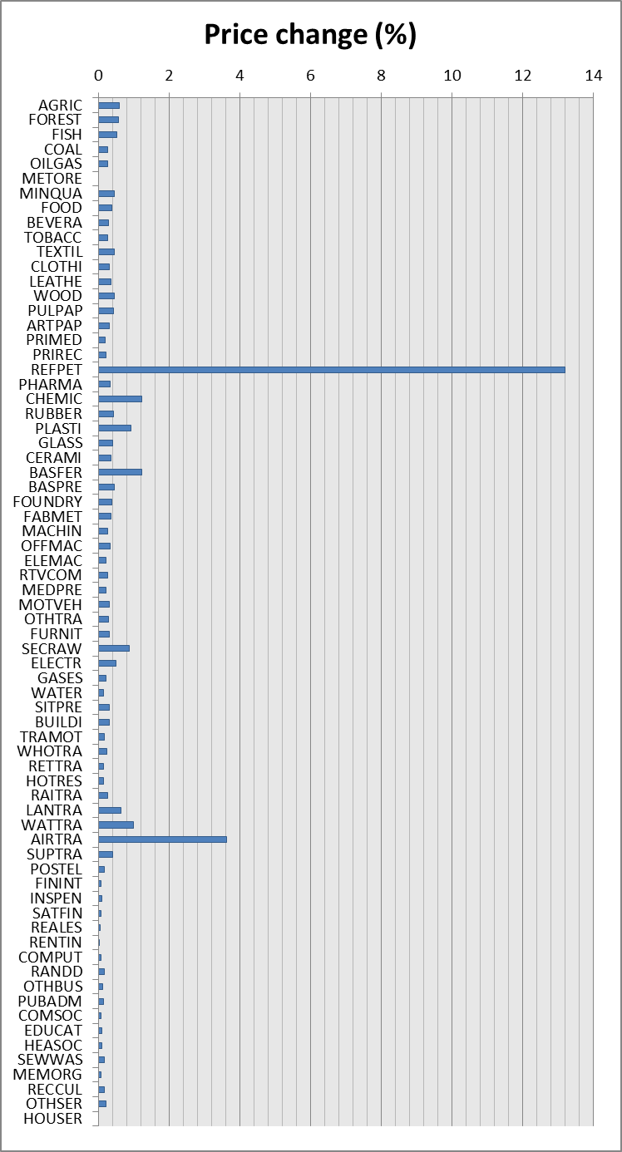
Source: author’s calculations
Figure 2 shows the effect of this policy measure on the prices of all commodities. Naturally, the largest effect is observed with respect to refined petroleum products themselves – the price of REFPET rises by more than 13% compared to the baseline. The second largest effect is observed for air transport (AIRTRA), a heavy consumer of REFPET, the price of which rises by 3.6% compared to the baseline. The prices of a few manufactured goods (chemical products, plastic products, basic ferrous metals, and secondary raw materials) rise by 0.5% to 1.0%. Interestingly, the price of electricity is barely affected. The effect on rail transport is almost zero, because rail transport now relies mostly on electricity (diesel locomotives being used almost exclusively as shunting engines). The effect on land transport other than rail is surprisingly small, amounting to less than 0.4%, while the price of water transport rises by roughly 1%. The prices of other services are barely affected by the increase in the price of REFPET.

Figure 3: Output change in simulation 1
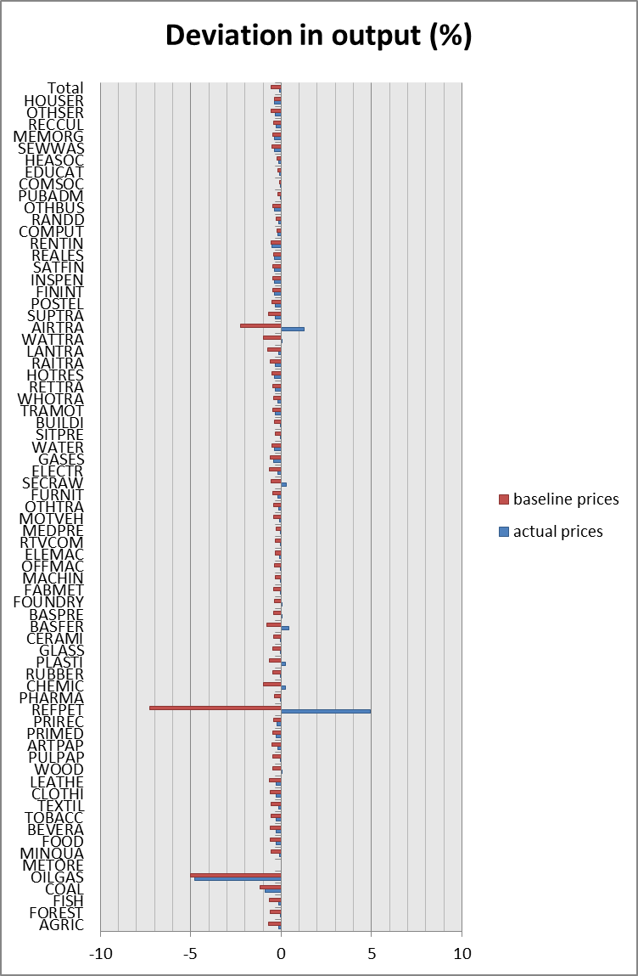
Source: author’s calculations
Figure 3 shows the effect of the new tax on the output of all industries, in baseline prices and current prices. Measured in baseline prices, the output of all industries declines. The most heavily affected industry is, of course, REFPET itself. Its output (in real terms) declines by 7.2%. The output of OILGAS and AIRTRA also decreases significantly, but for very different reasons. This can be seen by comparing the output of these industries in baseline versus actual prices. OILGAS is an upstream industry, whereas AIRTRA is downstream from REFPET. As the price of REFPET increases, the price of AIRTRA also increases (cf. Figure 2). Households react to this by demanding less AIRTRA, so the real output of AIRTRA falls. However, due to the increase in the price of AIRTRA, the value of output measured in current prices actually increases. For OILGAS, the situation is quite different. Its price has not risen substantially, but since the output of REFPET, a major customer, falls by more than 7%, the output of OILGAS is also affected, falling by roughly 5% in both real and nominal terms. The effect on the output of all other industries is modest by comparison, ranging between -1% and 0% in most cases. Some of the industries with the larger price effects, however, see their output grow in nominal terms (though not in real terms).
Figure 4: Changes in household income and consumption in simulation 1
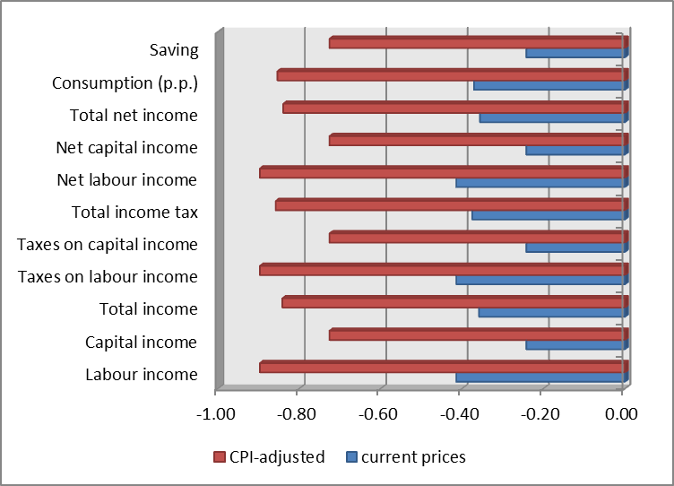
Source: author’s calculations
The reduction in output, naturally, is accompanied by a reduction in value added. Hence, the income of households decreases. Figure 4 shows how the loss in income is distributed across the two household groups. Workers are hit harder than capital owners: their income falls by 0.4% in nominal terms. Adjusting for the change in overall prices (the CPI is 0.5% higher compared to the baseline), this means a real income loss of 0.9% for workers. For capital owners, the income loss amounts to 0.2% in nominal terms and 0.7% in real terms. Net income and tax payments are reduced by the same percentages. Total net income of the household sector is reduced by 0.36% in nominal terms and 0.84% in real terms. Consumption is reduced by a marginally higher percentage (due to the relative income shift from workers to capital owners, as the latter exhibit a lower propensity to consume). With lower income, households also save less – net saving of the household sector falls by 0.24% in nominal terms and 0.73% in real terms.
Figure 5: Change in public revenue in simulation 1
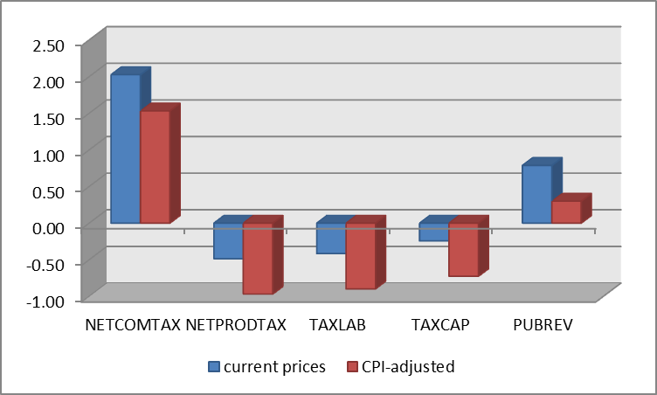
Source: author’s calculations
As households earn less income, public revenue from income taxes declines, and as the output of most industries falls, public revenue from net commodity taxes and net production taxes would also fall. However, the introduction of the new tax on REFPET provides an additional source of public revenue. Figure 5 shows the net effect on public revenue. Despite the decline in revenue from net production taxes and income taxes, the increase in NETCOMTAX is large enough to increase overall public revenue by 0.79% in nominal terms and 0.30% in real terms. Thus, the introduction of the new tax contributes to the goal of consolidating the public budget.
Figure 6: Carbon dioxide emission in baseline and scenario 1
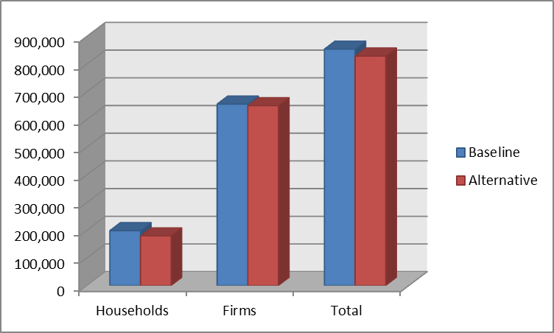
Source: author’s calculations
Figure 6 shows carbon dioxide emissions by households and firms in the baseline and scenario 1. A significant decrease can be observed in the household sector, where carbon dioxide emissions are reduced by 19,187 kt (i.e. 9.67% of the baseline value). The emissions by firms are reduced by 5,673 kt (0.87% of the baseline value). The reduction in total carbon dioxide emissions thus amounts to 24,860 kt (2.91% of the baseline value). From an ecological perspective, this is clearly good news. Combined with the increase in public revenue, scenario 1 could be a case of a ‘double dividend’, where two policy goals are (partially) achieved with one policy measure.
Figure 7: Main results of scenario 1
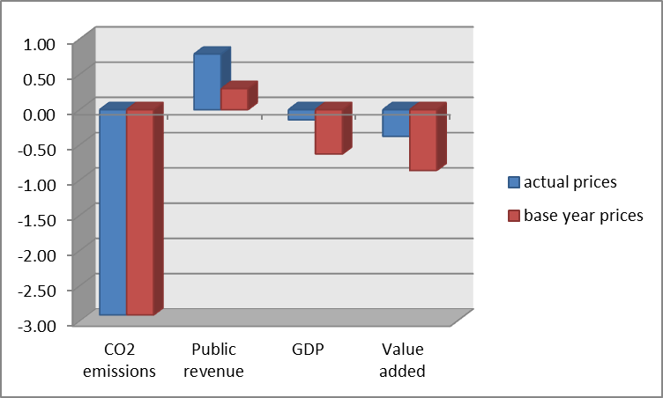
Source: author’s calculations
However, there is also some bad news. Figure 7 sums up the major effects of scenario 1. There is a (desired) reduction in carbon dioxide emissions and a (desired) increase in public revenue, but these effects have to be weighed against declines in GDP and value added. A further problem may be the effect on employment, which is not explicitly modelled in MMG. However, since the output of all goods declines, it seems natural to suppose that employment would also decline. This in turn might raise public expenditure if more people are entitled to receive unemployment benefit. As a result, the net effect on the public budget may not be as positive as Figure 7 suggests. Since the estimated effect on public revenue is not dramatically large, it may well turn into negative if the cost of additional unemployment is taken into account. Since the current version of MMG is not able to account for this effect, a new avenue for future work is born at precisely this moment.

A new tax on electricity
In this scenario it was assumed that a new tax (a commodity tax) is imposed on electricity. The coefficient on NETCOMTAX was raised to 0.1. Figure 8 shows the effect of this tax on prices. Naturally, the price of electricity is strongly affected, rising by more than 12% compared to the baseline. Interestingly, the massive increase in the price of electricity does not lead to substantial increases in other prices. The largest increases are observed for coal, products of pulp and paper (PULPAP), and water. However, even in these cases the increase is on the order of 1%. For most of the other industrial products, prices rise by roughly 0.5% compared to the baseline. The effects on the prices of services are mostly negligible.
Figure 8: Price effects in scenario 2
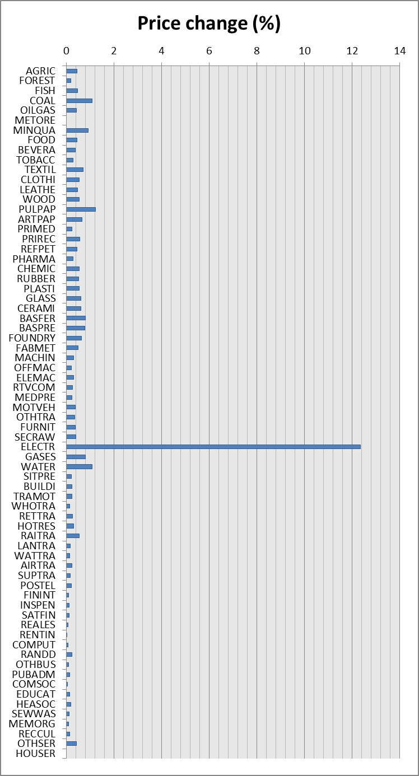
Source: author’s calculations
Figure 9: Output change in scenario 2
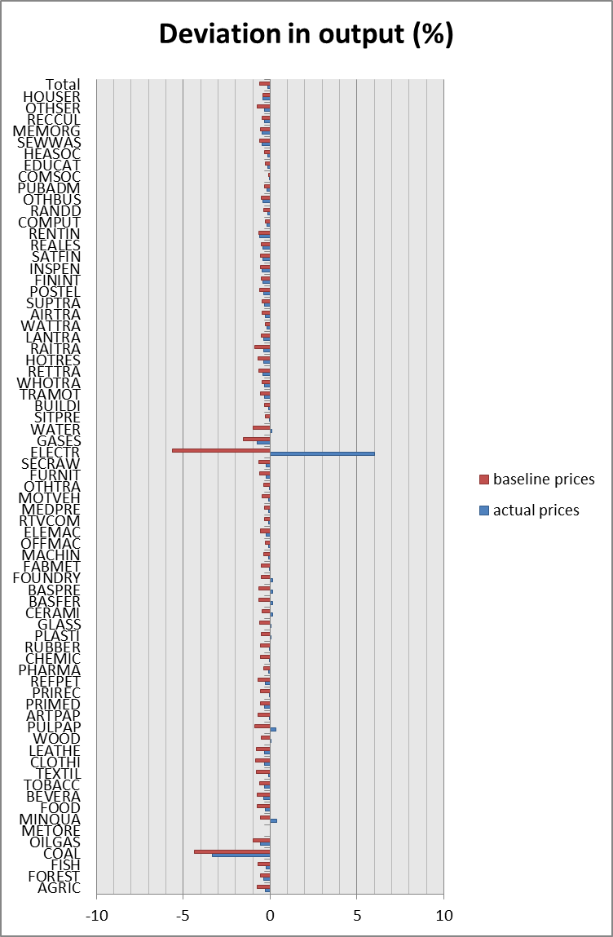
Source: author’s calculations
The effect on the output of industries, in actual and baseline prices, is shown in Figure 9. In baseline prices, the output of electricity is reduced by 5.6%. The output of coal, a major input of the electricity industry, is also reduced significantly (-4.4%). Valued at actual prices, the output of electricity rises by 6.0%, whereas the output of coal still falls by 3.3%. Other industries are barely affected.
Figure 10: Changes in household income and consumption in scenario 2
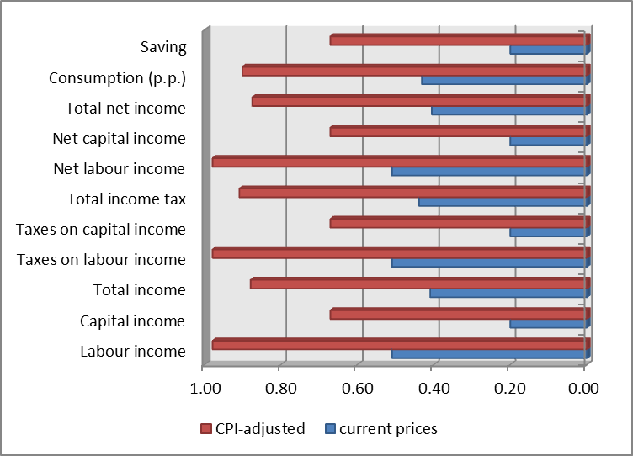
Source: author’s calculations
Figure 10 shows the effects of policy 2 on the income and consumption of households. The picture looks very similar to scenario 1 (Figure 4), only the numbers differ slightly. The main findings, however, are the same. Total income of households is reduced by 0.9% in real terms and 0.4% in nominal terms, and labour income is hit harder than capital income. In nominal terms, the former is reduced by 0.5% and the latter by only 0.2%. In real terms, the reduction amounts to 1.0% for labour income and 0.7% for capital income.
Figure 11: Change in public revenue in scenario 2
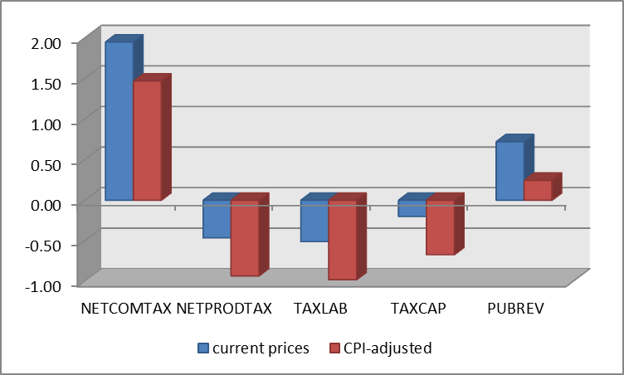
Source: author’s calculations
Figure 11, which reports the effect of policy 2 on public revenue by revenue source, exhibits a striking similarity to Figure 5. Thus, the effects of tax on electricity on public revenue are almost identical to those of a tax on refined petroleum products.
Figure 12: Carbon dioxide emissions in baseline and scenario 2
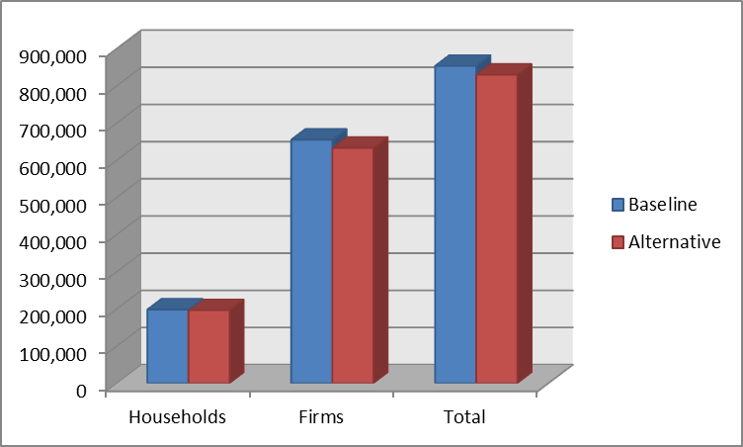
Source: author’s calculations
However, Figure 12 shows that the effects on carbon dioxide emissions are quite different when compared to scenario 1 (cf. Figure 6). While scenario 1 was characterised by a significant reduction in households’ emissions (by 19,187 kt), the same emissions are reduced by only 1,760 kt in scenario 2. With respect to firms’ emissions, the opposite is true. The reduction in carbon dioxide emissions by firms amounts to 21,831 kt in scenario 2 and 5,673 kt in scenario 1. In total, carbon dioxide emissions are reduced by 23,591 kt in scenario 2. This is slightly less than in scenario 1, where total emissions were reduced by 24,860 kt.
Figure 13: Main results of scenario 2
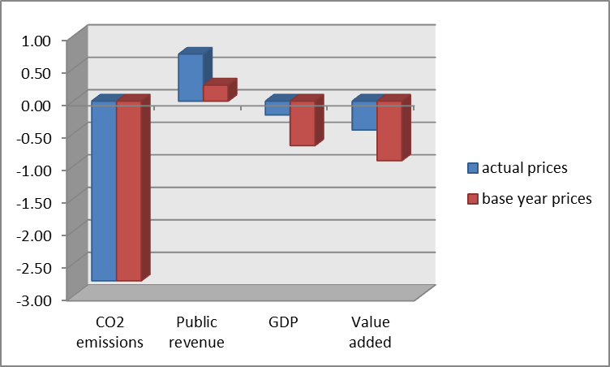
Source: author’s calculations
Figure 13 summarises the main results of scenario 2. Carbon dioxide emissions are reduced by 2.8% compared to the baseline, while public revenue is increased by 0.72% in nominal terms or 0.25% in CPI-adjusted terms. GDP is reduced by 0.21% in nominal terms (0.68% in real terms), and value added is reduced by 0.45% (0.92% in real terms). Thus, the two main objectives of reducing carbon dioxide emissions and raising public revenue are fulfilled, as in scenario 1. However, the negative effects on income and GPD are stronger in scenario 2.

A new tax on crude oil and natural gas
The third scenario entails a new tax (a commodity tax) on crude oil and natural gas. As with the previous scenarios, it was assumed that the coefficient of NETCOMTAX increases to 0.1. Figure 14 shows the effect of this tax on the prices of goods. The price of crude oil and natural gas (OILGAS) rises by more than 13% compared to the baseline. As a result, the prices of certain downstream products increase significantly as well. Most notably, the price of refined petroleum products rises by 11.0%. The price of air transport services (AITRA) rises by 3.1%. The price of various manufactured products increase as well, but in all other cases the increase amounts to less than 2%. Although electricity production relies to a large extent on natural gas, the price of electricity rises by only 1.3%.
Figure 14: Price changes in scenario 3
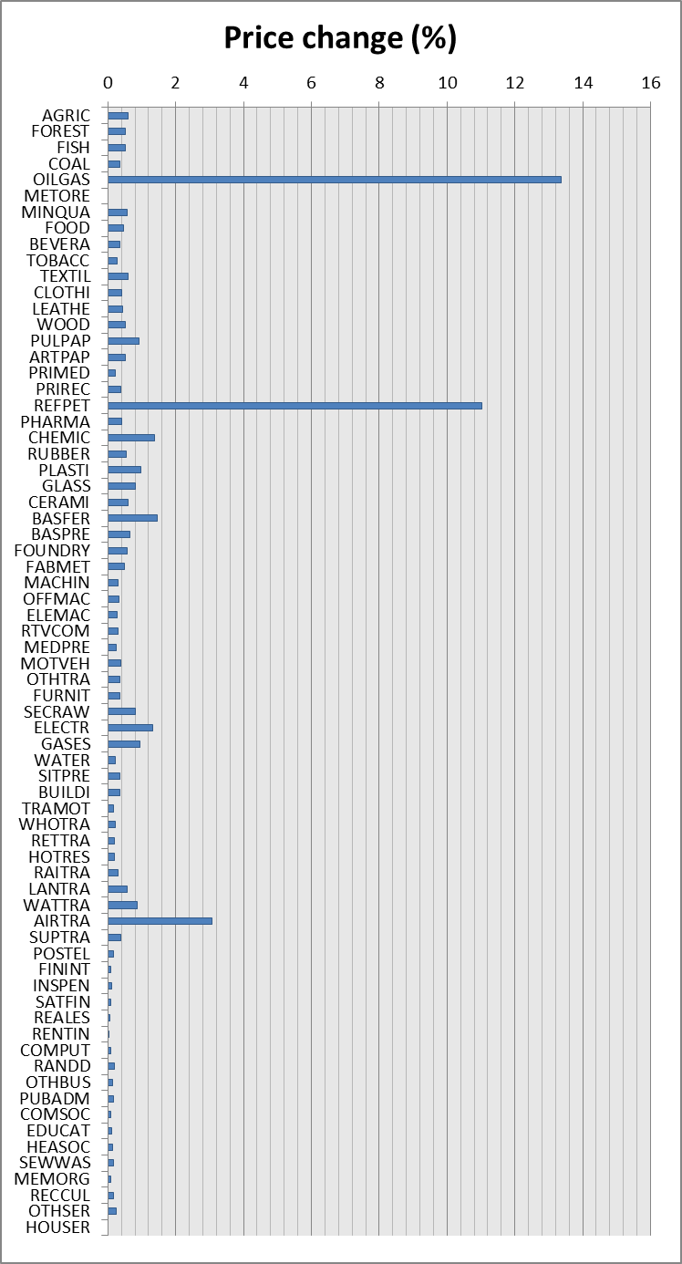
Source: author’s calculations
Figure 15: Output changes in scenario 3
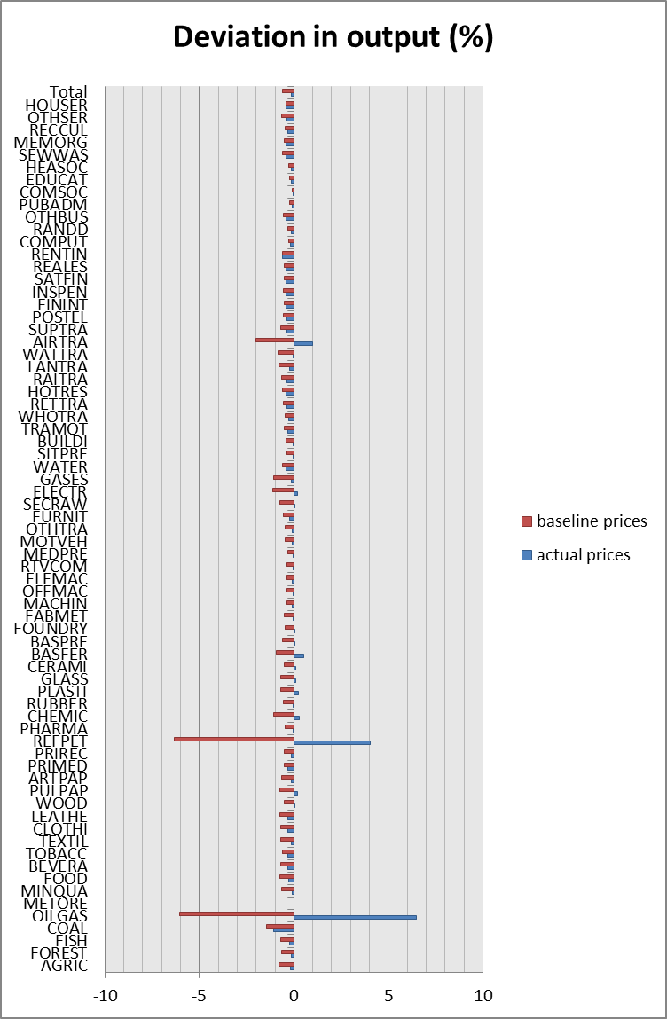
Source: author’s calculations
Figure 15 shows that the output of products whose prices increase significantly declines, at least when measured in baseline prices. Interestingly, the output decline of REFPET (6.3%) is stronger than that of OILGAS (6.0%), despite the fact that the tax is levied on the latter rather than the former. The output of AIRTRA declines by 2.0%. For all other products, the decline in output amounts to around 1% or less. In nominal terms, the output of OILGAS and REFPET rises considerably due to the increase in their prices.
Figure 16: Changes in household income and consumption in scenario 3
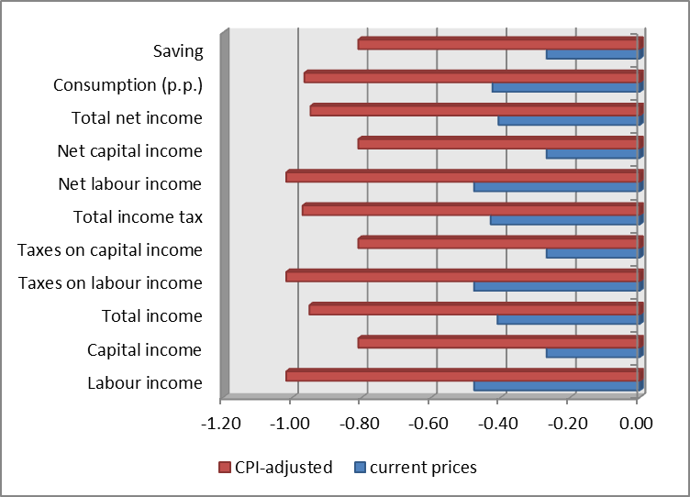
Source: author’s calculations
Figure 16 shows the effect of policy 3 on households. As in the previous scenarios, income and consumption are lower than in the baseline, and labour income is hit harder than capital income. However, the reduction in total income is somewhat larger (more than 1% in CPI-adjusted terms) than in the other scenarios.
Figure 17: Change in public revenue in scenario 3
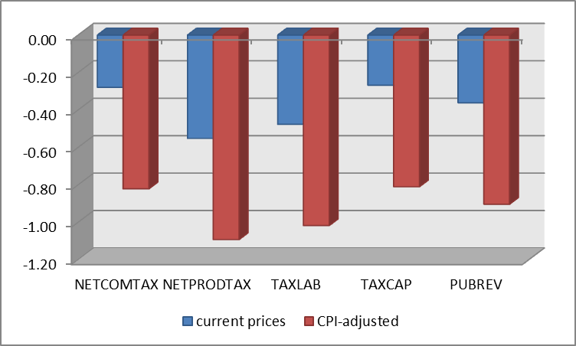
Source: author’s calculations
Figure 17 shows how policy 3 affects public revenue. In contrast to the previous scenarios, public revenue is actually lower than in the baseline. The loss in revenue from net production taxes and income taxes is larger, and there is no offsetting increase in net commodity taxes. Despite the introduciton of a new commodity tax on crude oil and natural gas, the revenue from net commodity taxes declines. The reason for this is that Germany imports most of the crude oil and natural gas it consumes. The few domestic producers will pay more tax, but foreign suppliers will not. According to the assumptions of MMG, prices are determined by domestic production costs. If domestic producers raise their prices due to an increase in production cost from their point of view, foreign suppliers react to this by raising their prices accordingly. If they did not do so, there would be an opportunity for arbitrage. MMG presupposes well-functioning international commodity markets. Under such conditions, there can be no significant differences between domestic and international commodity prices.
Figure 18: Carbon dioxide emissions in baseline and scenario 3
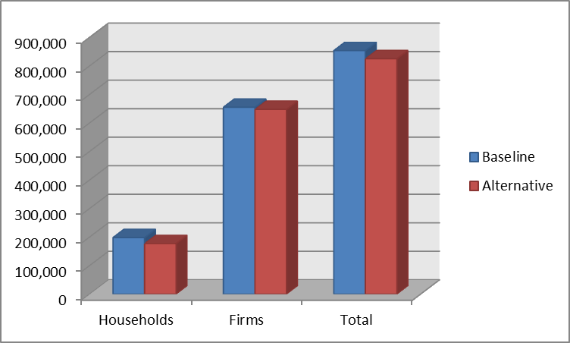
Source: author’s calculations
Figure 18 shows carbon dioxide emissions in the baseline and scenario 3. At least in this recpts, policy 3 is effective. It reduces housholds’ emissions by 21,010 kt, firms’ emissions by 7,351 kt, and total emissions by 28,361 kt. Thus, the reduction in emissions is larger than in scenario 1 and 2.
Figure 19: Main results of scenario 3
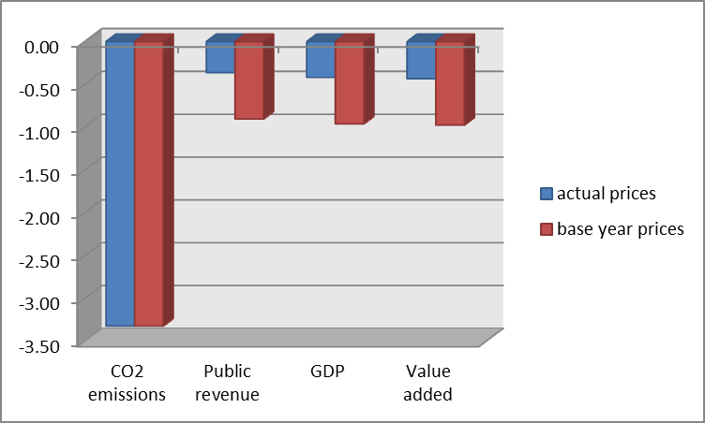
Source: author’s calculations
Finally, Figure 19 shows the main results of scenario 3. Carbon dioxide emissions are reduced by 3.32%, which is beneficial from an ecological point of view. However, policy 3 fails to improve public revenue, which falls by 0.36% compared to the baseline (0.90% when adjusting for the change in the CPI). GDP and value added are reduced by similar percentages.

Summary
Table 3 summarises the main results of the three policy scenarios, comparing them to the baseline values. All three policies reduce carbon dioxide emissions. The largest reduction (3.32%) is achieved in scenario 3. Thus, from a purely emission-focussed point of view, policy 3 is more beneficial than policies 1 and 2. However, policy 3 fails to bring about the desired improvement in public revenue. Policies 1 and 2, by contrast, do so. Thus, policy 3 cannot be recommended because it does not achieve both policy goals, whereas policies 1 and 2 do.
Table 3: Comparison of main results
 | Actual prices |  |  | Baseline prices
Scenario | 1 | 2 | 3 | 1 | 2 | 3
CO2 emissions | -2.91 | -2.76 | -3.32 | -2.91 | -2.76 | -3.32
Public revenue | 0.79 | 0.72 | -0.36 | 0.30 | 0.25 | -0.90
GDP | -0.15 | -0.21 | -0.42 | -0.63 | -0.68 | -0.96
Value added | -0.38 | -0.45 | -0.43 | -0.86 | -0.92 | -0.98
Source: author’s calculations
When comparing scenarios 1 and 2, the findings in Table 3 suggest that the former is more desirable than the latter, since it is characterised by a larger reduction in carbon dioxide emissions and a larger increase in public revenue. Moreover, the loss in GDP and value added is smaller in scenario 1 than in scenario 2.

Conclusion
The topic of this paper has been the possible conflict of interest between environmental policy (here: reducing greenhouse gas emissions) and fiscal consolidation. It was argued that a tax on emission-intensive products may generate additional revenue for the state and reduce carbon dioxide emissions simultaneously. On the basis of a classical-Keynesian applied general equilibrium model for the German economy, the effects of commodity taxes on three different product categories (crude oil and natural gas, refined petroleum products, and electricity) were quantitatively analysed. The model results suggest that all three taxes achieve a desired reduction in carbon dioxide emissions. However, the tax on crude oil and natural gas fails to increase public revenue and leads to a significant drop in GDP and aggregate value added. The other two taxes lead to higher public revenue and thereby contribute to both policy goals. The tax on refined petroleum products is more effective on both counts than the tax on electricity.
The results should of course be interpreted with caution due to the assumptions on which the model is based. Like all AGE models, MMG is subject to the critique that is can only represent states of equilibrium, whereas the real-world economy need not always be in such a state. The author also submits that the treatment of substitution effects resulting from price changes is not fully satisfactory in the current version of MMG. Future work will be aimed at modelling these effects more carefully on the basis of econometric techniques. Special attention will be paid to the consumption of energy by households. The substitution between domestically produced commodities and imported commodities will also receive more attention.

Appendix
Table 4: List of variables
Label | Long name
COMPEMP | Compensation of employees
COMPEMP_y(y) | Compensation of employees in industry y
CONSFIXCAP | Consumption of fixed capital
CONSFIXCAP_y(y) | Consumption of fixed capital by industry y
EMC | Emissions of CO2
EMCCONS | Emissions of CO2 caused by consumption
EMCCONS_x(x) | Emissions of CO2 caused by consumption of good x
EMCPROD | Emissions of CO2 caused by production
EMCPROD_y(y) | Emissions of CO2 caused by production of good y
EXP | Exports (valued at b.p.)
EXP_x(x) | Exports of commodity x
EXP_PP | Exports (valued at p.p.)
FINCONSGOV | Final consumption expenditure by government (valued at b.p.)
FINCONSGOV_x(x) | Final consumption expenditure by government on commodity x
FINCONSGOV_PP | Final consumption expenditure by government (valued at p.p.)
FINCONSGOV_PP | Final consumption expenditure by government (valued at p.p.)
FINCONSHH | Final consumption expenditure by households (valued at b.p.)
FINCONSHH_GR | Final consumption expenditure by group gr
FINCONSHH_gr(gr) | Final consumption expenditure of households belonging to group gr
FINCONSHH_x(x) | Final consumption expenditure by households on commodity x
FINCONSHH_PP | Final consumption expenditure by households (valued at p.p.)
FINUSE | Final use of commodities (valued at b.p
FINUSE_x(x) | Final use of commodity x
FINUSE_PP | Final use of commodities (valued at p.p.)
GCAPFORM | Gross capital formation (valued at b.p.)
GCAPFORM_x(x) | Gross capital formation
GCAPFORM_PP | Gross capital formation (valued at p.p.)
GVA | Gross value added
GVA_y(y) | Gross value added by industry y
IMP | Imports
IMP_y(y) | Imports of commodity y
INTCONS | Intermediate consumption of commodities
INTCONS_y(y) | Intermediate consumption by industry y (valued at basic prices)
INTCONS_PP_y(y) | Intermediate consumption by industry y (valued at purchasers’ prices)
INTUSE | Intermediate use of commodities
INTUSE_x(x) | Intermediate use of commodity x
INTUSE_PP | Intermediate use of commodities (valued at purchasers’ prices)
K | Capital stock
L | Labour services
NETCAPINC | Net capital income (after taxes)
NETCOMTAX | Net taxes on commodities
NETCOMTAX_y(y) | Net taxes on commodities used by industry y
NETCOMTAXCONSGOV | Net taxes on commodities consumed by government
NETCOMTAXCONSHH | Net taxes on commodities consumed by households
NETCOMTAXEXP | Net taxes on exported commodities
NETCOMTAXFINUSE | Net taxes on commodities for final use
NETCOMTAXGCAPFORM | Net taxes on commodities used for gross capital formation
NETCOMTAXINTUSE | Net taxes on commodities for intermediate use
NETINC | Net income of households
NETINC | Net income
NETINC_GR | Net income of group gr
NETINC_gr(gr) | Net income of group gr
NETLABINC | Net labour income (after taxes)
NETOPSURP | Net operating surplus
NETOPSURP_y(y) | Net operating surplus in industry y
NETPRODTAX | Net taxes on production
NETPRODTAX_y(y) | Net taxes on production paid by industry y
NETPROFIT | Net profits
NETWAGES | Net wages
OUTPUT | Output
OUTPUT_y(y) | Output by industry y
PUBREV | Public revenue
t_compemp | Virtual tax rate on COMPEMP
t_netopsurp | Virtual tax rate on NETOPSURP
TOTFINUSE | Total final use of commodities (valued
TOTSUP | Total supply of commodities
TOTSUP_y(y) | Total supply of commodity y
TOTUSE | Total use of commodities (valued at b.p.)
TOTUSE_x(x) | Total use of commodity x
TOTUSE_x(x) | Total use of commodity x
TOTUSE_PP | Total use of commodities (valued at p.p.)
Z_xy | Consumption of commodity x by industry y

Table 5: List of parameters
Label | Long name
A | Matrix of interindustry input-output coefficients
PI_coef | Matrix of primary input-output coefficients
IMP_coef | Vector of import coefficients
PTC_GR | Propensity to consume of group gr
C_coef | Matrix of consumption coefficients by commodity and social group
t_conshh | Net tax rate on commodities consumed by households
t_consgov | Net tax rate on commodities consumed by government
t_gcapform | Net tax rate on commodities for capital formation
t_exp | Net tax rate on exported commodities
AUTDEM | Autonomous demand
EFCPROD(y) | Emission factor: CO2 per unit of output in industry y
EFCCONS(x) | Emission factor: CO2 per unit of consumption of good x

Table 6: Sector codes
No. | CPA | MMG Code | Description
1 | 01 | AGRIC | agriculture
2 | 02 | FOREST | forestry
3 | 05 | FISH | fish
4 | 10 | COAL | coal
5 | 11 | OILGAS | crude oil and natural gas
6 | 12 | URAN | uranium
7 | 13 | METORE | metal ores
8 | 14 | MINQUA | other mining and quarrying products
9 | 15.1 - 15.8 | FOOD | food products
10 | 15.9 | BEVERA | beverages
11 | 16 | TOBACC | tobacco products
12 | 17 | TEXTIL | textiles
13 | 18 | CLOTHI | clothing
14 | 19 | LEATHE | leather and leather products
15 | 20 | WOOD | products of wood, cork and straw
16 | 21.1 | PULPAP | pulp, paper and paperboard
17 | 21.2 | ARTPAP | articles of paper and paperboard
18 | 22.1 | PRIMED | printed media
19 | 22.2 - 22.3 | PRIREC | printing services and recorded media
20 | 23 | REFPET | refined petroleum products and other fuels
21 | 24.4 | PHARMA | pharmaceutical products
22 | 24 excl. 24.4 | CHEMIC | chemical products
23 | 25.1 | RUBBER | rubber products
24 | 25.2 | PLASTI | plastic products
25 | 26.1 | GLASS | glass and glass products
26 | 26.2 - 26.8 | CERAMI | ceramics and other non-metallic mineral products
27 | 27.1. - 27.3 | BASFER | basic ferrous metals
28 | 27.4 | BASPRE | basic precious metals and other non-ferrous metals
29 | 27.5 | FOUNDRY | foundry work services
30 | 28 | FABMET | fabricated metal products
31 | 29 | MACHIN | machinery
32 | 30 | OFFMAC | office machinery and computers
33 | 31 | ELEMAC | electrical machinery
34 | 32 | RTVCOM | radio, television and communication equipment
35 | 33 | MEDPRE | medical, precision and optical instruments; watches and clocks
36 | 34 | MOTVEH | motor vehicles
37 | 35 | OTHTRA | other transport equipment
38 | 36 | FURNIT | furniture, other manufactured goods n.e.c.
39 | 37 | SECRAW | secondary raw materials
40 | 40.1, 40.3 | ELECTR | electricity, steam and hot water
41 | 40.2 | GASES | gases
42 | 41 | WATER | water
43 | 45.1 - 45.2 | SITPRE | site preparation, civil engineering
44 | 45.3 - 45.5 | BUILDI | building installation, completion and other construction services
45 | 50 | TRAMOT | trade, maintenance and repair of motor vehicles
46 | 51 | WHOTRA | wholesale trade
47 | 52 | RETTRA | retail trade and repairs
48 | 55 | HOTRES | hotel and restaurant services
49 | 60.1 | RAITRA | railway transportation services
50 | 60.2 - 60.3 | LANTRA | Other land transportation services
51 | 61 | WATTRA | water transport services
52 | 62 | AIRTRA | air transport services
53 | 63 | SUPTRA | Supporting and auxiliary transport services
54 | 64 | POSTEL | post and telecommuncation
55 | 65 | FININT | financial intermediation
56 | 66 | INSPEN | insurance and pension funding
57 | 67 | SATFIN | services auxiliary to financial intermediation
58 | 70 | REALES | real estate services
59 | 71 | RENTIN | renting services
60 | 72 | COMPUT | computer and related services
61 | 73 | RANDD | R&D services
62 | 74 | OTHBUS | other businsess services
63 | 75.1 - 75.2 | PUBADM | public administration and defence
64 | 75.3 | COMSOC | Compulsory social security services
65 | 80 | EDUCAT | education
66 | 85 | HEASOC | health and social work
67 | 90 | SEWWAS | sewage and waste disposal
68 | 91 | MEMORG | membership organisation services n.e.c.
69 | 92 | RECCUL | recreation, culture, sports
70 | 93 | OTHSER | Other services
71 | 95 | HOUSER | household services

References

Forschungszentrum Jülich, D-52425 Jülich, Germany. Tel.: 02461-61-1721. E-mail: t.kronenberg@fz-juelich.de
It should be noted that there is an important difference between Eurozone members and countries like the USA or the United Kingdom. The former do not possess a fully sovereign currency, the latter do. If a government has debts in its own sovereign currency, there can be no doubt about its ability to repay the debt, because it can always resort to the ‘printing press’. This may of course lead to inflation, but the costs of inflation may be lower than that of public default.
Figures refer to the end of 2010. Source: Eurostat press release 60/2011 .
That is, from a national point of view. The EU economy as a whole is still plagued by high unemployment and might considerably benefit from higher German demand. However, the EU-wide harmonisation of fiscal policy (or rather the lack thereof) is not the topic of this paper.
The labour market in Germany is fundamentally different from “normal” commodity markets due to legislation and bargaining institutions resulting in considerable wage rigidity. Therefore, it was decided to treat the average wage as an exogenous variable.
Recently the most forceful critiques against homo oeconomicus came from the fields of ecological economics and experimental economics .
Yes, the author is rather fond of Sraffa .
Although MMG works with the full-scale table which distinguishes 70 commodities and industries, Table 1 presents an aggregated three-sector version of the table.
De-Juán et al. treat depreciation in a different way, assuming that the markup refers to gross rather than net operating surplus. However, the treatment of depreciation does not crucially affect the model results.
This equation is also found in the neoclassical literature on monopolistic competition as a result of profit maximization when the price elasticity of demand is constant.
Additional relief may come from the fact that the rise in the overall price level reduces the real value of the existing public debt. This effect is not included in the model calculations.
Value added declines more than GDP because net commodity taxes are part of GDP but not of value added.
It should be noted that this assumption should does not mean that the prices of oil and gas are exclusively determined by domestic production conditions. Clearly, the oil and gas prices in Germany are mostly determined by global market conditions. It is assumed, however, that global oil and gas prices are exogenous and constant. Under these circumstances, a domestic tax on these products implies an increase in the prices of oil and gas being sold in Germany.

