Aggregation Effect in Carbon Footprint Accounting by the Multi-Region Input-Output Model

Xin Zhou
Institute for Global Environmental Strategies, 2108-11 Kamiyamaguchi, Hayama, Kanagawa, 240-0115 Japan.
E-mail: zhou@iges.or.jp

Hiroaki Shirakawa
Department of Urban Environmental Studies, Graduate School of Environmental Studies, Nagoya University,
Furo-cho, Chikusa-ku, Nagoya, 464-8601 Japan. E-mail: sirakawa@urban.env.nagoya-u.ac.jp
Manfred Lenzen
Integrated Sustainability Analysis, School of Physics, Faculty of Science, University of Sydney,
Rm 503, School of Physics A28, the University of Sydney, NSW 2006, Australia
E-mail: m.lenzen@physics.usyd.edu.au

Abstract
Sector aggregation can influence the robustness of the results of environmentally-extended analysis using MRIO models which limits its practical application. In this paper, we examined the size of the aggregation error in carbon footprint accounting using MRIO models and tried to explore factors which influence the effect of the aggregation error by Monte-Carlo simulations using the AIO2000 Table. We found that the range of error rates is pretty high (-479, 166), which indicates that sector aggregation has large effects on the results of ecological footprint accounting using the MRIO model. By ranking top error simulations, we found that there is a high concentration over specific regions and specific sectors, indicating that these regions and sectors are more influential on the size of the aggregation error. In addition, we found a relation between carbon intensity and final demand of sectors which may potentially contribute to large aggregation error.

Key words: aggregation error, multi-region input-output model, carbon footprint accounting

1. Introduction

In practice, environmental impact assessment and emissions accounting are generally conducted at firm's level, project level or product level, where the first-hand data is available. Since the early 1990s, input-output analysis has been widely used for environmental accounting, such as carbon footprint accounting and the calculations of embodied emissions and virtual water at sectoral levels for a nation, a region or multiple regions depending on the purpose of the research (Bicknell, 1998; Lenzen, 1998; Munksgaard and Pedersen, 2001; Wiedmann, et al. 2007; Peters and Hertwich, 2008; Zhou, et al., 2006; Zhou, et al., 2010). One of the advantages of using input-output analysis is that not only direct emissions but also indirect emissions from various upstream processes can be taken account. Every empirical input-output table rests on the definitions of industries and survey data of firms. An industry in the input-output table is usually an aggregation of similar products and the coefficients in the input-output matrix are averages of production functions of many different sampled firms. The usefulness of published input-output tables for practical environmental assessment is limited by the robustness of the results which may vary upon the approach of classifying and aggregating different firms, products or processes into sectors (Gibbons, et al., 1982; Wiedmann, 2009).

Aggregation error in input-output analysis is not new to the input-output society and has been discussed intensively since 1950s. Fisher (1958, 1962 and 1966) provided rich theoretical knowledge on the optimization of aggregation. Ara (1959) provided the theoretical proof of a necessary and sufficient condition for the aggregation of sectors acceptable for input-output analysis. Unlike conventional aggregation method to reduce the size of the input-output models, Leontief (1967) presented an alternative systematic procedure to eliminate certain goods and processes. Doeksen and Little (1968) tested with both hypothetical models and actual input-output models and concluded that the model size (level of aggregation) has little impacts on the multiplier size of non-aggregated sectors when the remaining sectors were highly aggregated. A useful implication is that with even a small regional model, it could be possible to determine the impacts of a new plant on local employment and income. By using the survey data and other information for the Philadelphia, Karaska (1968) tested the variations of Leontief coefficients of regional input-output table. He found that variation increased with the level of aggregation from the detailed four-digit level to the two-digit level defined in the Standard Industrial Classification (SIC) system and the variations of the local coefficients were greater than the variations of the technological coefficients. Hewings (1974) examined various methods for the identification of key sectors in a regional economy and tested with different aggregation levels of sectors. He concluded that various methods lack the consistency in identifying key sectors and are not insensitive to the level of aggregation. Gibbons and his colleagues (Gibbons, et al., 1982) developed an iterative process for disaggregating a sector, by which the magnitude of aggregation error can be reduced to a level which satisfies any desired tolerance. Blair and Miller (1983) examined the error through aggregation of regions in a multiregional input-output system and concluded that spatial aggregation does not necessarily lead to unacceptable error.

In environmentally extended input-output analysis, the aggregation problem will be more complicated. Not only the input-output structure of sectors to be aggregated will influence the aggregation error, but also the environmental nature of heterogeneous sectors (usually expressed by environmental impacts per unit output) will also make influences. There are still few studies explore the aggregation issue in the empirical environmental analysis using the input-output model. Lenzen (2007 and 2011) conducted some pioneer works on the effect of aggregation on shared responsibility and on theoretical analysis of aggregation and disaggregation in environmentally-extended Multi-region input-output analysis (MRIO).

In this paper, we examined the aggregation effect in carbon footprint accounting using the Asian Input-Output Table 2000 (AIO2000) published by the Institute of Developing Economies (2006). AIO2000 is a Chenery-Moses type of MRIO with 76 sectors for ten Asian-Pacific economies (Indonesia, Malaysia, the Philippines, Singapore, Thailand, China Mainland, Taiwan, the Republic of Korea, Japan and the USA). We analyse the range of aggregation error by randomly changing the level of aggregation and sectors to be aggregated with Monte Carlo simulations of 100,000 times. By ranking the errors, we tried to find out major factors influencing the size of error. Section 2 explains the methodology that we used for examining the aggregation error. Section 3 presents the results and Section 4 provides the conclusions.

2. Methodology

We first define matrices and vectors for the large-sized multi-region input-output model before aggregation and the small-sized model after aggregation as follows:

Table 1 Definitions
 | Before aggregation | After aggregation
Intermediate demand | $$X=\left[X^{\text{rs}}\right]=\left[x_{\text{ij}}^{\text{rs}}\right]$$ | $$Y=\left[Y^{\text{rs}}\right]=\left[y_{\text{ij}}^{\text{rs}}\right]$$
Final demand | $$g=\left\{g^{r}\right\}=\left\{g_{i}^{r}\right\}$$ | $$h=\left\{h^{r}\right\}=\left\{h_{i}^{r}\right\}$$
Total output | $$x=\left\{x^{r}\right\}=\left\{x_{i}^{r}\right\}$$ | $$y=\left\{y^{r}\right\}=\left\{y_{i}^{r}\right\}$$
Technical coefficients | $$A=\left[A^{\text{rs}}\right]=\left[a_{\text{ij}}^{\text{rs}}\right]$$ | $$B=\left[B^{\text{rs}}\right]=\left[b_{\text{ij}}^{\text{rs}}\right]$$
Leontief inverse | $$L=\left[L^{\text{rs}}\right]=\left[l_{\text{ij}}^{\text{rs}}\right]$$ | $$M=\left[M^{\text{rs}}\right]=\left[m_{\text{ij}}^{\text{rs}}\right]$$
Carbon intensity (emissions per unit output) | $$c=\left\{c^{r}\right\}=\left\{c_{i}^{r}\right\}$$ | $$d=\left\{d^{r}\right\}=\left\{d_{i}^{r}\right\}$$
Ecological footprint | $$e=\left\{e^{s}\right\}=\left\{e_{i}^{s}\right\}$$ | $$f=\left\{f^{s}\right\}=\left\{f_{i}^{s}\right\}$$

i and j represent sectors, and r and s represent regions. Technical coefficients are defined as:

$a_{\text{ij}}^{\text{rs}}={x_{\text{ij}}^{\text{rs}}}/{x_{j}^{s}}$ (1)

$b_{\text{ij}}^{\text{rs}}={y_{\text{ij}}^{\text{rs}}}/{y_{j}^{s}}$ (2)

There are same n sectors in each of t regions. The total size of the transaction matrix X before aggregation is therefore n²t and the size of each transaction block $X^{\text{rs}}$ is n². Sectors can be aggregated within each region but not across different regions. Aggregation is allowed to occur in more than one region simultaneously. Let us assume:

$\begin{aligned}\left\{n\text{ sectors in Region 1 are aggregated into }m(1)(≤n)\text{ sectors;} | \right.\left\{n\text{ sectors in Region 2 are aggregated into }m(2)(≤n)\text{ sectors;} | \right.\left\{⋯⋯⋯⋯⋯⋯⋯⋯⋯⋯⋯⋯⋯⋯⋯⋯⋯⋯⋯⋯⋯ | \right.\left\{n\text{ sectors in Region }r\text{ are aggregated into }m(r)(≤n)\text{ sectors;} | \right.\left\{⋯⋯⋯⋯⋯⋯⋯⋯⋯⋯⋯⋯⋯⋯⋯⋯⋯⋯⋯⋯⋯ | \right.\end{aligned}$

The whole transaction matrix after aggregation, Y, is a square matrix with the size of m²t, where $m=m(1)+m(2)+⋯m(t)≤n$. Each transaction block on the diagonal, $Y^{\text{rr}}$, is a square matrix with the size of m(1)², m(2)², …, and m(t)², respectively. Off-diagonal matrices are basically rectangular depending on the size of the supplying region and the size of receiving region after aggregation. For example, the size of $Y^{\text{12}}$ is m(1)m(2).

Based on the above-mentioned aggregation method, we define the summation matrix as follows:

$$S=\left[\begin{matrix}s(1) & 0 & 0 & 0 \\ 0 & s(2) & 0 & 0 \\ 0 & 0 & ⋱ & 0 \\ 0 & 0 & 0 & s(t)\end{matrix}\right]$$

s(1), s(2),…, and s(t) on the diagonal are block summation matrices for region 1, 2, …, and t, with the size of m(1)n, m(2)n, …, and m(t)n, respectively. Each column of the block summation matrix has one and only one number “1”. However each row can have more than one “1”, which determines which sectors to be aggregated.

Define $S'$ as the transpose of $S$. The relationships for transaction matrices, final demand, total output and carbon intensity before and after aggregation are presented as follows:

$\text{SXS}'=Y$ (3)

$S×x=y$ (4)

$S×g=h$ (5)

$S(c⊗x)y^{−1}=d$ (6)

Where $⊗$ represents multiplication of corresponding elements.

Based on conventional input-output analysis, we have the following relations for the non-aggregated model:

$x=(I−A)^{−1}g=L×g$ (7)

The calculation of carbon footprints using MRIO is as follows:

$c⊗x=c⊗L×g$ (8)

For a particular region s, the ecological footprints, $e^{s}$, is as follows:

$e^{s}=\sum{c^{r}⊗}L^{\text{rs}}g^{s}$ (9)

There are two ways of calculating the ecological footprints for the aggregated input-output model.

Method 1

$\bar{f}=S×e$ (10)

where $\bar{f}$ is the ecological footprints for aggregated sectors using Method 1. Since this method is only a summation of the ecological footprints for relevant sectors, there is no aggregation error. We call $\bar{f}$ the reference value in our simulations.

Method 2

Using Eqs. (3) – (6), we obtain the aggregated model. Based on the aggregated model, we have the following relations similar to Eqs. (7) – (9):

$y=(I−B)^{−1}h=M×h$ (11)

$d⊗y=d⊗M×h$ (12)

$f^{s}=(\sum{d^{r}⊗}M^{\text{rs}})h^{s}$ (13)

The difference between $f$ (see definition in Table 1) and the reference value $\bar{f}$, i.e. $(f−\bar{f})$ is defined as aggregation error in our simulations.

3. Simulations and Results

To examine the range of aggregation errors, we determine the summation matrix S randomly by Monte-Carlo simulations using the following procedure:
- Randomly determine the number of selected regions in which sectors are to be aggregated;
- Randomly determine which regions to be selected;
- Randomly determine for each of the selected regions the number of sectors to be aggregated;
- Randomly determine for each of the selected regions which sectors to be selected.

We repeat this procedure for 100,000 times and obtain the same amount of randomly determined summation matrices Ss. For each S, we calculate $\bar{f}$ and $f$, and $(f−\bar{f})$ for each element, i.e. $(f_{i}^{s}−{\bar{f}}_{i}^{s})$. We examine the range of aggregation error by the measure $(f_{i}^{s}−{\bar{f}}_{i}^{s})/{{\bar{f}}_{i}^{s}}$, which is called error rate in this paper.

The large-sized MRIO model that we used for simulations is AIO2000, which has ten economies and 76 sectors for each region. Since there are all “0”s for the inputs and outputs of Malaysian “Unclassified sector”, which constrain the calculation of the Leontief inverse, we combine the “Unclassified sector” with the sector of “Public Administration” and name it as “Unclassified” in the 75-sector system (see Appendix A). For the calculation of carbon intensity, we use GTAP-E Database Version 6, which provides the carbon intensity for 57 sectors (Dimaranan, 2006). We first match the 75 sectors in the AIO2000 and the 57 sectors in the GTAP Database (see also Appendix A), based on which we recalculate the carbon intensity for 75 sectors.

3.1 The size of the aggregation error

The range of error rates for all simulations at sectoral level is from -479 times (for aggregating three sectors, i.e. Crude petroleum and natural gas, Iron and steel, and Finance and insurance) to 166 times (for aggregating two sectors of Paddy and Synthetic resins and fiber) of their respective reference values, which indicates that sector aggregation has large effects on the results of ecological footprint accounting using the MRIO model. We separate sectors into two groups: sectors which are aggregated into new sectors after aggregation are grouped into one and sectors which keep the same in both before and after aggregation models are group into another. The simulation results for both groups in ten regions are summarised in Table 2 and 3. The distribution density of error rate in ten regions is shown in Figure 1.

Table 2 Summary of the error rate for aggregated sectors
Region | Minimum | Average | Maximum | Standard Deviation
Indonesia | -0.734 | 0.107 | 2.677 | 0.140
Malaysia | -12.176 | 0.037 | 11.471 | 0.162
Philippine | -8.139 | 0.057 | 29.343 | 0.271
Singapore | -0.438 | 0.066 | 1.885 | 0.162
Thailand | -2.941 | 0.044 | 165.589 | 0.713
China Mainland | -478.753 | 0.167 | 119.134 | 2.149
Taiwan | -1.384 | 0.072 | 8.798 | 0.119
Korea | -0.527 | 0.029 | 6.869 | 0.100
Japan | -7.846 | 0.065 | 4.558 | 0.100
USA | -0.355 | 0.092 | 1.574 | 0.088

Table 3 Summary of the error rate for non-aggregated sectors
Region | Minimum | Average | Maximum | Standard Deviation
Indonesia | -0.733 | -0.023 | 16.585 | 0.162
Malaysia | -0.758 | -0.040 | 5.779 | 0.118
Philippine | -0.669 | -0.042 | 5.309 | 0.100
Singapore | -0.876 | -0.049 | 3.349 | 0.127
Thailand | -0.772 | -0.030 | 6.237 | 0.107
China Mainland | -0.806 | -0.036 | 3.548 | 0.115
Taiwan | -0.595 | -0.031 | 5.072 | 0.094
Korea | -0.681 | -0.025 | 4.338 | 0.066
Japan | -0.694 | -0.038 | 2.906 | 0.074
USA | -0.826 | -0.043 | 3.596 | 0.106

Comparing the results for the two groups, except for a few cases, the range of error rate and the average level for aggregated sectors are bigger than those of non-aggregated sectors. This indicates aggregation exerts more impacts on aggregated sectors than non-aggregated sectors.

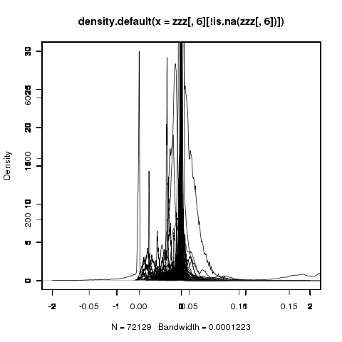
Indonesia
Thailand
Japan
Malaysia
China Mainland
USA
Philippines
Taiwan
Error rate
Error rate
Error rate
Error rate
Error rate
Error rate
Error rate
Error rate
Density (%)
Density (%)
Density (%)
Density (%)
Density (%)
Density (%)
Density (%)
Density (%)
-2 -1 0 1 2
0 5 10 15 20 25 30
Singapore
Korea
Density (%)
Density (%)
Error rate
Error rate

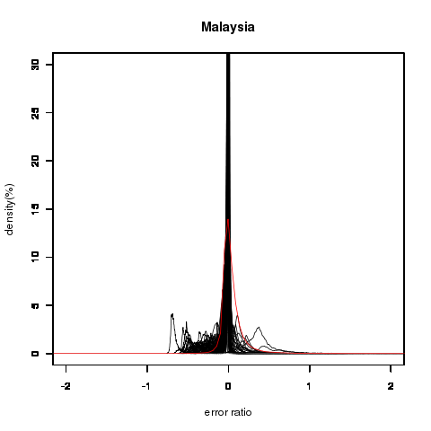

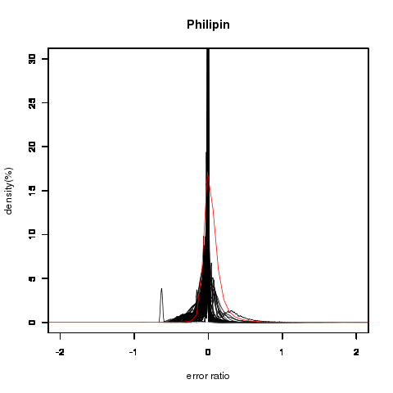

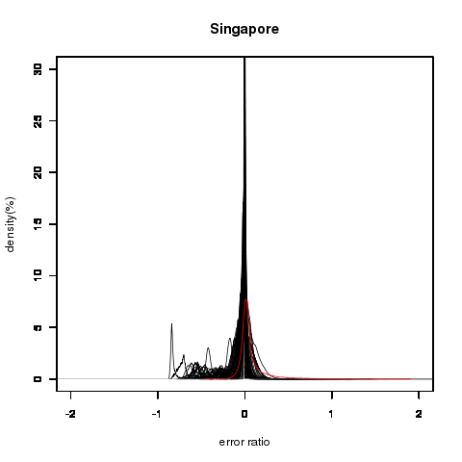
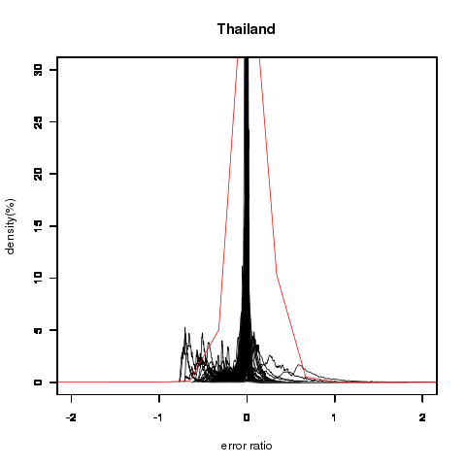

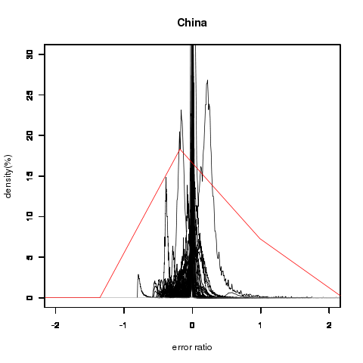

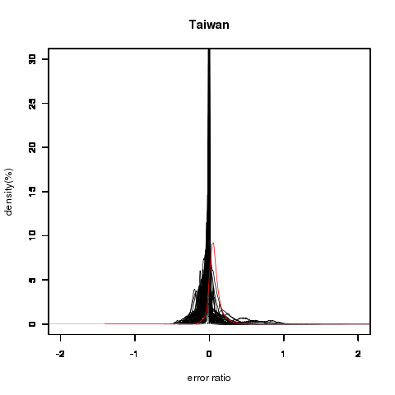

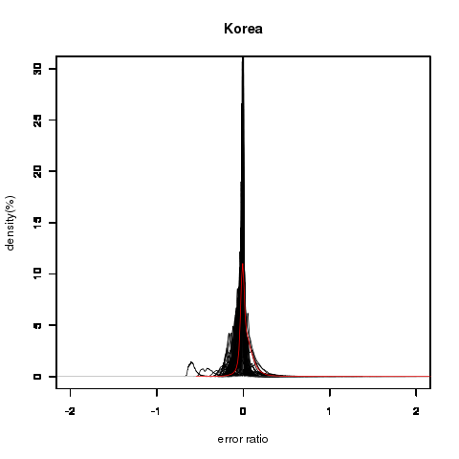
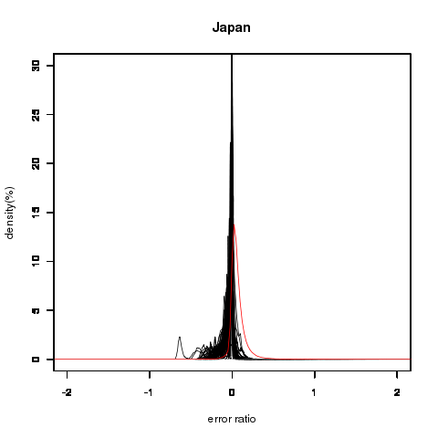

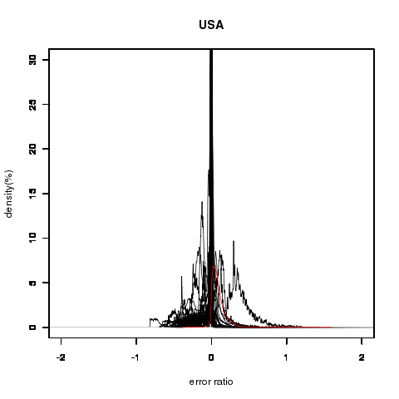

Fig.1 Distribution density of error rate in ten regions

3.2 Factors influencing the aggregation error

By ranking the absolute value of error rate, we identify those sectors whose aggregation will cause big errors (see an example in Table 4 for top 30 simulation results). Since carbon intensity, Leontief multiplier, emissions multiplier (derived based on carbon intensity and Leontief multiplier) and final demand will be the key variables which influence the aggregation error based on Eqs. (11) – (13), we examine these variables for before and after aggregation.

By preliminary analysis, we found that among top 300 simulation results (with absolute error rate ranging from 479 down to about 1.85), 140 occur in China’s Mainland, followed by the Philippines (105), Indonesia (22), Malaysia (14), Korea (13), and Japan and Singapore (3 respectively). Among 140 top results in China’s Mainland, sector “Iron and steel” occurs 87 times, followed by sector “Chemical fertilizers and pesticides” (25 times). For the Philippines, in 104 results out of 105, sector “Crude petroleum and natural gas” occurs. For Indonesia, sector “Iron and steel” occurs in 20 results out of 22 in total. For Malaysia, 13 results out of 14 include sector “Non-metallic ore and quarrying”. Korea does not have such high concentration over particular sectors. Among 13 results, sector “Timber” appears 5 times. For Japan, sector “Cement and cement products” appears twice times out of 3 in total. For Singapore, sector “Electricity and gas” and sector “Building construction” occur twice respectively.

To explore the reason why these sectors occur frequently in top ranking results, we examine the relations between carbon intensity and final demand for both before and after aggregation. By the time of writing this paper, complete results from statistical analysis has yet been obtained. By preliminary analysis, we found that these sectors usually have relatively higher carbon intensity in their specific regions (though in some cases not the highest in their regions), and at the same time they have a less contribution to the final demand of their relevant aggregated sectors. For example, for the top of the error rate, three sectors (i.e. Crude petroleum and natural gas, Iron and steel, and Finance and insurance) are aggregated into a new sector. The carbon intensity of the three sectors is 0.74, 1.51 and 0.03, respectively. Their contributions to the final demand of the aggregated sector are 32%, -22% and 90%, respectively. For sector “Iron and steel”, the big gap between its highest carbon intensity before aggregation and lowest contribution to the final demand of the aggregated sector makes it a distinguished sector in generating aggregation errors. For other 87 top cases for China which include sector “Iron and steel”, we found similar relations between its carbon intensity and contributions to the final demand of the aggregated sector.

Table 4 Ranking of top 30 aggregation errors
Rank | Country | No. of aggregation | Error rate | Aggregated sectors | Carbon intensity (after) | Carbon intensity (before) | Leontief multiplier (after) | Leontief multiplier (before) | Carbon multiplier (after) | Carbon multiplier (before) | Final demand (after) | Final demand (before)
1 | China | 3 | -478.753 | Crude petroleum and natural gas, Iron and steel, Finance and insurance | 0.907 | 0.735, 1.544, 0.030 | 2.116 | 1.739, 2.813,1.529 | 2.892 | 2.228, 5.191, 0.477 | 18614524 | 6068602, -4162585, 16708507
2 | Thailand | 2 | 165.589 | Paddy, Synthetic resins and fiber | 0.202 | 0.090, 0.499 | 1.626 | 1.437, 2.145 | 0.612 | 0.249, 1.563 | -113935 | -135191, 21256
3 | China | 3 | 119.134 | Iron and steel, Telephone and telecommunication, Finance and insurance | 0.759 | 1.544, 0.033, 0.030 | 2.221 | 2.813, 2.175, 1.529 | 2.738 | 5.191, 1.597, 0.477 | 21389644 | -4162585, 8843722, 16708507
4 | China | 5 | 65.765 | Paddy, Iron ore, Fish products, Chemical fertilizers and pesticides, Iron and steel | 0.911 | 0.062, 1.330, 0.060, 0.472, 1.544 | 2.496 | 1.921, 2.648, 2.419, 2.878, 2.813 | 3.499 | 1.240, 5.361, 1.342, 3.964, 5.191 | 19615881 | 19813723, 330883, 6907401, -3273541, -4162585
5 | China | 3 | -35.293 | Other rubber products, Iron and steel, Electronic computing equipment | 1.145 | 0.472, 1.544, 0.019 | 2.724 | 2.737, 2.813, 2.573 | 3.883 | 2.386, 5.191, 0.804 | 15144006 | 2761198, -4162585, 16545393
6 | Philippines | 2 | 29.343 | Crude petroleum and natural gas, Leather and leather products | 13.812 | 284.147, 0.304444107 | 2.103 | 1.486, 2.173 | 20.454 | 284.258, 0.695395 | 41118 | -3, 41121
7 | Philippines | 3 | 17.572 | Crude petroleum and natural gas, Other rubber products, Other transport equipment | 7.608 | 284.147, 0.172, 0.002 | 2.079 | 1.486, 2.142, 1.793 | 8.429 | 284.258, 0.5140, 0.222 | 117223 | -3, 95972, 21254
8 | Philippines | 2 | 17.112 | Crude petroleum and natural gas, Spinning | 8.125 | 284.147, 0.257 | 1.877 | 1.486, 1.845 | 8.523 | 284.258, 0.485 | 57846 | -3, 57849
9 | China | 3 | 14.761 | Spinning, Iron and steel, Electronic computing equipment | 0.915 | 0.173, 1.544, 0.019 | 2.714 | 2.702, 2.813, 2.573 | 3.286 | 1.48, 5.191, 0.804 | 20904509 | 8521701, -4162585, 16545393
10 | Philippines | 2 | 13.586 | Crude petroleum and natural gas, Other wooden products | 5.191 | 284.147, 0.036 | 1.900 | 1.486, 1.912 | 5.562 | 284.258, 0.388 | 123587 | -3, 123590
11 | China | 4 | -12.576 | Crude petroleum and natural gas, Refined petroleum and its products, Iron and steel, Non-ferrous metal | 0.887 | 0.735, 0.472, 1.544, 0.482 | 2.462 | 1.734, 2.154, 2.813, 2.804 | 3.631 | 2.228, 2.195, 5.191, 4.239 | 2819996 | 6068602, -1628065, -4162585, 2542044
12 | China | 2 | 12.186 | Weaving and dyeing, Iron and steel | 0.985 | 0.173, 1.544 | 2.808 | 2.801, 2.813 | 3.664 | 1.471, 5.191 | 12973490 | 17136075, -4162585
13 | Malaysia | 2 | -12.176 | Non-food crops, Non-metallic ore and quarrying | 0.459 | 0.015, 1.346 | 1.683 | 1.676, 1.695 | 0.845 | 0.286, 1.829 | 196598 | 242665, -46067
14 | Malaysia | 2 | -11.934 | Non-metallic ore and quarrying, Metal working machinery | 0.936 | 1.346, 0.124 | 1.746 | 1.695, 1.839 | 1.356 | 1.829, 0.449 | 110919 | -46067, 156986
15 | Malaysia | 2 | 11.471 | Non-metallic ore and quarrying, Shipbuilding | 0.861 | 1.346, 0.188 | 1.780 | 1.695, 1.891 | 1.261 | 1.829, 0.485 | 161021 | -46067, 207088
16 | China | 2 | 10.847 | Iron and steel, Real estate | 1.184 | 1.544, 0.175 | 2.498 | 2.813, 1.862 | 3.865 | 5.191, 1.148 | 20476625 | -4162585, 24639210
17 | China | 3 | 10.322 | Crude petroleum and natural gas, Iron and steel, Metal working machinery | 1.215 | 0.735, 1.544, 0.229 | 2.399 | 1.739, 2.813, 2.819 | 3.943 | 2.228, 5.191, 2.598 | 5795736 | 6068602, -4162585, 3889719
18 | Philippines | 2 | 9.983 | Crude petroleum and natural gas, Hotel | 3.648 | 284.147, 0.039 | 1.841 | 1.486, 1.849 | 3.946 | 284.258, 0.361 | 477794 | -3, 477797
19 | Philippines | 2 | 9.982 | Crude petroleum and natural gas, Hotel | 3.648 | 284.147, 0.039 | 1.842 | 1.486, 1.849 | 3.945 | 284.258, 0.361 | 477794 | -3, 477797
20 | Philippines | 3 | 9.973 | Crude petroleum and natural gas, Spinning, Heavy Electrical equipment | 4.817 | 284.1478, 0.257, 0.005 | 1.999 | 1.486, 1.845, 2.236 | 5.257 | 284.258, 0.485, 0.4826 | 200030 | -3, 57849, 142184
21 | Philippines | 3 | 9.565 | Crude petroleum and natural gas, Tobacco, Cement and cement products | 1.664 | 284.147, 0.077, 0.707 | 1.963 | 1.486, 1.826, 2.077 | 2.424 | 284.258, 0.197, 1.296 | 576358 | -3, 558643, 17718
22 | China | 3 | 9.119 | Non-metallic ore and quarrying, Chemical fertilizers and pesticides, Electronic computing equipment | 0.621 | 1.330, 0.472, 0.019 | 2.505 | 2.125, 2.878, 2.573 | 2.788 | 3.516, 3.964, 0.804 | 14299005 | 1027153, -3273541, 16545393
23 | Taiwan | 2 | 8.798 | Synthetic resins and fiber, Finance and insurance | 0.029 | 0.100, 0.002 | 1.479 | 2.428, 1.153 | 0.128 | 0.472, 0.010 | 14145348 | 85884, 14059464
24 | Philippines | 3 | 8.513 | Crude petroleum and natural gas, Chemical fertilizers and pesticides, Other manufacturing products | 3.783 | 284.147, 0.172, 0.003 | 2.055 | 1.486, 2.041, 2.106 | 4.240 | 284.258, 0.624, 0.390 | 155193 | -3, 40441, 114755
25 | Philippines | 3 | 8.198 | Forestry, Crude petroleum and natural gas, Electronic computing equipment | 1.603 | 0.426, 284.147, 0.002 | 2.280 | 1.319, 1.486, 2.580 | 1.853 | 0.584, 284.258, 0.195 | 655956 | 13838, -3, 642121
26 | Philippines | 3 | -8.139 | Crude petroleum and natural gas, Knitting, Non-ferrous metal | 3.084 | 284.147, 0.2571, 0.020 | 2.259 | 1.486, 2.275, 2.280 | 4.084 | 284.258, 0.6918, 0.527 | -2702 | -3, 23284, -25983
27 | Philippines | 2 | 8.049 | Crude petroleum and natural gas, Glass and glass products | 10.308 | 284.147, 0.707 | 2.186 | 1.486, 2.215 | 12.620 | 284.258, 1.422 | 30573 | -3, 30576
28 | Philippines | 2 | 8.039 | Crude petroleum and natural gas, Glass and glass products | 10.308 | 284.147, 0.707 | 2.184 | 1.486, 2.215 | 12.606 | 284.258, 1.422 | 30573 | -3, 30576
29 | Japan | 2 | -7.846 | Crude petroleum and natural gas, Non-metallic ore and quarrying | 0.096 | 0.001, 0.102 | 2.021 | 1.651, 2.048 | 0.174 | 0.060, 0.183 | -6197 | -10486, 4289
30 | China | 4 | 7.833 | Fish products, Slaughtering, Other rubber products, Iron and steel | 1.159 | 0.060, 0.060, 0.472, 1.544 | 2.751 | 2.419, 2.769, 2.737, 2.813 | 3.923 | 1.34, 1.119, 2.386, 5.191 | 17640078 | 6907401, 12134064, 2761198, -4162585

4. Conclusions

The construction of MRIO tables is both time-consuming and expensive. There are still very few of MRIO tables available for practical application. MRIO tables are made from national input-output tables and bilateral trade data. Different countries have different priority sectors and different details of their national input-output tables, which influence sector classification and the level of aggregation. In making MRIO tables, re-classification and aggregation are usually necessary to adjust the differences among national input-output tables. In the application of MRIO models for environmental analysis, sector re-classification and aggregation are also needed to match the environmental data and the economic data. Therefore sector aggregation is a practical and important task for environmentally-extended analysis using MRIO models.

Recognising the importance of sector aggregation, we examined the size of the aggregation error in carbon footprint accounting using MRIO models and tried to explore factors which influence the effect of the aggregation error in this paper by Monte-Carlo simulations using the AIO2000 Table. We have several conclusions.

First, the range of error rates is pretty high (-479, 166), which indicates that sector aggregation has large effects on the results of ecological footprint accounting using the MRIO model. Secondly, aggregation exerts more impacts on aggregated sectors than non-aggregated sectors in terms of their error rate. Thirdly, by ranking of top errors, we found that there is a high concentration over specific regions and specific sectors, which indicates these regions and sectors are more influential on the size of the aggregation error than others. An implication for practitioners who aggregate the MRIO model for environmental analysis is that exclusion of these sectors in the aggregation schemes will greatly decrease the size of errors. Fourthly, for those distinguished sectors whose aggregation with other sectors can cause large aggregation errors, we found a potential relationship between the carbon intensity of these sectors and their relative contributions to the final demand of the aggregated sectors. Relatively high carbon intensity of these sectors together with their low contributions to the final demand of relevant aggregated sectors makes these sectors a generator of large aggregation errors. An implication for aggregation practitioners is that a simple test of the relations of carbon intensity and the contributions to the final demand of aggregated sectors for sectors selected to be aggregated can help identify those sectors which may cause large aggregation errors. The last point is still a preliminary conclusion which needs further statistical demonstration.

Acknowledgements

This study is supported by the Japan Society for the Promotion of Science’s (JSPS) Grants-in-Aid for Scientific Research (B) (No. 21310033). We would like to express our gratitude to its financial aid.
Appendix A Sector Classification in AIO2000

Code | Description | Corresponding Sector Classification in the GTAP6 Database
001 | Paddy | pdr
002 | Other grain | wht, gro
003 | Food crops | v_f, osd, c_b
004 | Non-food crops | pfb, ocr
005 | Livestock and poultry | ctl, oap, rmk, wol
006 | Forestry | frs
007 | Fishery | fsh
008 | Crude petroleum and natural gas | oil, gas
009 | Iron ore | omn, col
010 | Other metallic ore | omn, col
011 | Non-metallic ore and quarrying | omn, col
012 | Milled grain and flour | pcr, vol, sgr, ofd
015 | Other food products | pcr, vol, sgr, ofd
013 | Fish products | cmt, omt, mil
014 | Slaughtering, meat products and dairy products | cmt, omt, mil
016 | Beverage | b_t
017 | Tobacco | b_t
018 | Spinning | tex
019 | Weaving and dyeing | tex
020 | Knitting | tex
022 | Other made-up textile products | tex
021 | Wearing apparel | wap
023 | Leather and leather products | lea
024 | Timber | lum
025 | Wooden furniture | lum
026 | Other wooden products | lum
027 | Pulp and paper | ppp
028 | Printing and publishing | ppp
034 | Refined petroleum and its products | p_c
029 | Synthetic resins and fiber | crp
030 | Basic industrial chemicals | crp
031 | Chemical fertilizers and pesticides | crp
032 | Drugs and medicine | crp
033 | Other chemical products | crp
035 | Plastic products | crp
036 | Tires and tubes | crp
037 | Other rubber products | crp
038 | Cement and cement products | nmm
039 | Glass and glass products | nmm
040 | Other non-metallic mineral products | nmm
041 | Iron and steel | i_s
042 | Non-ferrous metal | nfm
043 | Metal products | fmp
044 | Boilers, Engines and turbines | ome
045 | General machinery | ome
046 | Metal working machinery | ome
047 | Specialaized machinery | ome
048 | Heavy Electrical equipment | ome
059 | Precision machines | ome
049 | Television sets, radios,audios and communication equipment | ele
050 | Electronic computing equipment | ele
051 | Semiconductors and integrated circuits | ele
052 | Other electronics and electronic products | ele
053 | Household electrical equipment | omf
054 | Lighting fixtures, batteries, wiring and others | omf
060 | Other manufacturing products | omf
055 | Motor vehicles | mvh
056 | Motor cycles | otn
057 | Shipbuilding | otn
058 | Other transport equipment | otn
061 | Electricity and gas | ely, gdt
062 | Water supply | wtr
063 | Building construction | cns
064 | Other construction | cns
065 | Wholesale and retail trade | trd
066 | Transportation | wtp, atp, otp
067 | Telephone and telecommunication | cmn
068 | Finance and insurance | ofi, isr
069 | Real estate | obs
070 | Education and research | ros, osg
071 | Medical and health service | ros, osg
072 | Restraunts | ros, osg
073 | Hotel | ros, osg
074 | Other services | ros, osg
075 | Unclassified | ros, osg

References

- Ara, K., 1959. The aggregation problem in input-output analysis. Econometrica, Vol. 27, pp. 257-262.
- Blair, P., Miller, R.E., 1983. Spatial aggregation in multiregional input-output models. Environment and Planning A, Vol. 15, pp. 187-206.
- Bicknell, K.B., Ball, R.J., Cullen, R., Bigsby, H.R., 1998. New methodology for the ecological footprint with an application to the New Zealand economy. Ecological Economics 27(2), 149-160.
- Bullard, C. W., Sebald, A. V., 1988. Monte Carlo sensitivity analysis of input-output models. The Review of Economics and Statistics, pp. 708-712.
- Dimaranan, B. V., 2006. Global Trade, Assistance, and Production: GTAP 6 Data Base, 2-8, 2-9. Center for Global Trade Analysis, Purdue University, West Lafayette.
- Fisher, W. D., 1958. Criteria for aggregation in input-output analysis. The Review of Economics and Statistics, Vol. 40, pp. 250-260.
- Fisher, W. D., 1962. Optimal aggregation in multi-equation prediction models. Econometrica 30, pp. 744-769.
- Fisher, W. D., 1966. Simplification in economic models. Econometria 34, pp. 563-584.
- Gibbons, J. C., Wolsky, A. M., Tolley, G., 1982. Approximate aggregation and error in input-output models. Resources and Energy, Vol. 4, pp. 203-230.
- Hewings, G. J. D., 1974. The effect of aggregation on the empirical identification of key sectors in a regional economy: a partial evaluation of alternative techniques. Environment and Planning A, Vol. 6, pp. 439-453.
- Institute of Developing Economies, Japan External Trade Organization, 2006. Asian International Input-Output Table 2000, Volume 1, Explanatory Notes. Institute of Developing Economies, Tokyo.
- Karaska, G. J., 1968. Variation of input-output coefficients for different levels of aggregation. Journal of Regional Science, Vol. 8, pp. 215-227.
- Kondo, Y., Moriguchi, Y., Shimizu, H., 1998. CO2 emissions in Japan: influences of imports and exports. Applied Energy 59 (2-3), 163-174.
- Lenzen, M., 1998. Primary energy and greenhouse gases embodied in Australian final consumption: an input-output analysis, Energy Policy 26. 495-506.
- Lenzen, M., 2007. Aggregation (in-variance) of shared responsibility: A case study of Australia. Ecological Economics, Vol. 64, pp. 19-24.
- Lenzen, M. 2011. Aggregation and disaggregation in environmentally-extended multi-region input-output analysis. Economic Systems Research, in press.
- Leontief, W., 1967. An alternative to aggregation in input-output analysis and national accounts. The Review of Economics and Statistics, Vol. 49, pp. 412-419.
- Munksgaard, J., Pedersen, K.A., 2001. CO₂ accounts fro open economies: producer or consumer responsibility. Energy Policy 29, 327-334.
- Peters, G.P., Hertwich, E.G., 2008. CO2 embodied in international trade with implications for global climate policy. Environmental Science & Technology 42, 1401-1407.
- Wiedmann, T., Lenzen, M., Turner, K., Barrett, J., 2007. Examining the global environmental impact of regional consumption activities – Part 2: Review of input-output models for the assessment of environmental impact embodied in trade. Ecological Economics 61, 15-26.
- Wiedmann, T., 2009. A review of recent multi-region input–output models used for consumption-based emission and resource accounting. Ecological Economics, Vol. 69, pp. 211-222.
- Zhou, X., Imura, H., Shirakawa, H., 2006. Who is responsible for what: regional Ecological Footprint calculation for China with special emphasis on interregional dependency. Third World Congress of Environmental and Resource Economist, 3-7 July 2006, Kyoto, Japan.
- Zhou, X., Liu, X. B., Kojima, S. (Eds.), 2010. Carbon Emissions Embodied in International Trade: An Assessment from the Asian Perspective. Institute for Global Environmental Strategies (IGES), Hayama, Japan. Available at: http://enviroscope.iges.or.jp/modules/envirolib/upload/2719/attach/embodied_emissions_whole_sf_publication.pdf.pdf

