Study on the Relationship between Economic Growth and Structural Change of Agribusiness
--Evidences from National and Provincial Levels

Abstract: There is a great structural change in agribusiness around the world in the past two decades. Shed light on this process and its relationship with economic growth are good for understanding the role of agriculture in the economy. We find two main features of structural change in agribusiness are: (1) value added share of agribusiness system in national GDP is decreasing with the growth of economy; (2) value added shares of agri-processing and agri-distributing sectors in agribusiness are increasing with the growth of economy. These stylized facts could be explained in a demand driven economic model with different products in which consumers have hierarchic preference on agricultural product and non agricultural products. Our findings are useful for understanding the structural change in agribusiness both in empirical and theoretical sides.

Key words: agribusiness structural change economic growth Input Output table

1. Introduction

Agriculture is an important economic system since it provides the basic food and clothes for people’s life. There are a large number of countries that have witnessed neither agricultural growth nor economic development (Pingali, 2007). With the development of the economy, food and clothes are not merely produced and distributed by farmers, lots of economic institutes, like manufacturer, broker, etc., participate in the process from planting to the consumers. Davis and Goldberg(1957) proposed a new concept ‘agribusiness’ to comprehend the chain from farmers to consumers, and the meaning of agribusiness is that “the sum of all farming operations, plus the manufacture and distribution of all farm production supplies, plus the total of all operations performed in connection with the handling, storage, processing, and distribution of farm commodities”, and in brief, “agribusiness refers to the sum-total of all operations involved in the production and distribution of food and fiber”. Based on the concept, lots of researches were carried out (King et al., 2010). According to Davis and Goldberg (1957), agribusiness consists of four sectors: agricultural input sector, agricultural producing sector, agricultural processing sector, and agricultural distributing sector.

The value added structure inside agribusiness has meaningful economic implications in different perspectives. In production perspective, the value added structure of four sectors in agribusiness reflects the production in food and fiber system, more share of agricultural processing sector means deeper processing of food and fiber, the agribusiness system is a set “of value creating activities in the production-distribution process and the explicit structure of linkages among these activities or processes ”(Boehlje, 1999). In distribution perspective, the value added structure inside agribusiness means the revenue structure distributed into different sectors, more share of agricultural producing sector means farms benefit less compare with other institutions in agribusiness system (Amanor, 2009). In expenditure perspective, the value added structure inside agribusiness means the expenditure structure that consumers willing to pay for the products or service produced in different sectors in agribusiness system, more share of agricultural producing sector means that consumer would like to pay more on processed food and fiber. With the income growth, household will eating out, which include both food processing and distributing elements (Ma et al., 2006).

The development of agribusiness is related to the role of agriculture in the economy. The role of agriculture in the economy will be different with the economic development (Hayami and Godo, 2004). Agriculture is important for economic development (Tiffin and Irz, 2006), and agriculture itself is also an important content of economic development (De Janvry, 2010). In poor countries, the main task of agriculture is to provide sufficient food and fiber for the economies which focus on industrialization with low cost, high savings and investment. In rich countries, agriculture has multi-functions, not just for food and fiber supplier, but also for environmental and ecological objectives. In the countries between these poor and rich, agriculture is used for poverty reduction, and also treated as a tool for increasing the income of rural households or farmers. In poor countries, agricultural processing sector and agricultural distributing sector are weak since consumer’s demand for food and fiber is low-level, and the government also wants to allocate more resource on heavy industrial sector. The prices of food and fiber are cheap, and farmers are very poor. In rich countries, agricultural processing sector and agricultural distributing sector are strong since consumers’ pay more attention to the quality on food and fiber, and the government should give subsidy to support agriculture for the sake of farmers’ interests. In the countries between poor and rich, the tradeoff between famers’ income and prices of food and fiber should be kept balanced. The arise of prices of food and fiber is not good for industrialization in these countries since high prices of food and fiber will boost the cost of living and decrease return of capital which is the key engine of industrialization. However, low income of farmers due to low prices of food and fiber will lead to a severe income disparity society which is also not good for economic development. In a word, the structural change inside agribusiness depends on economic development, and the evolution of value added structure inside agribusiness with economic development is an important issue to better understand the role of agriculture and economic development itself.

The previous studies mainly focus on the qualitative analysis or case study based on quantitative analysis. In the global level, the globalization and transition happened in 1990s brought relatively rapid and intense agro-industrialization in many low- and middle-income economies (Reardon and Barrett, 2000; Swinnen and Maertens, 2007). The concept of agro-industrilization comprises three sets of changes: (1) the growth of agroprocessing, distribution, and farm-input provision activities off farm; (2) institutional and organizational change in the relation between agroindustrial firms and farms; (3) concomitant changes in the farm sector (Reardon and Barrett, 2000). In developed countries, like the USA, the food production and distribution industry is also in the midst of major structural change (Boehlje, 1999). The farm structures are more diverse in the transition process (Swinnen, 2009). Cost reduction leads to more vertically integrate between processers and farmers (Kvaloy and Tveteras, 2008). Related concepts, like food chain management, are proposed to provide support for coping with the structural changes of agribusiness (Fritz and Schiefer, 2008). However, the quantity analysis on the relationship between economic growth and structural changes in agribusiness is seldom, which is important for deep understanding the mechanism of evolution of agribusiness. Since structural change of agribusiness is enduring both in national and regional economies, we should observe agribusiness development in these two levels. For sake of data availability, we choose countries OECD IO Tables and provinces in People Republic of China represent for national and regional economies.

In this paper, we will study on the relationship between economic growth and structural changes in agribusiness both in empirical and theoretical aspects. We describe the data and accounting method in the second and third sections; in the fourth section, we characterize some stylized facts from the results at national level and provincial level; we then build a economic model focuses on the demand side of the economy to explain the stylized facts in section five; we conclude this paper in section six.

2. DATA

There are two reasons for utilizing the IO table to estimate the value added of agribusiness: (1) the definition of agribusiness requires that we should consider the interdependence of each sectors during the estimation. Only the IO table could reflect the agricultural supply chain, from the agri-input to agri-producing, to agri-processing, and to agri-distributing economy wide. (2) the data covering in IO table is broader than the data from industrial survey since the latter only survey enterprises that reach certain standards while the former cover all enterprises.

Data in national level
Although many countries compile IO tables individually, OECD IO tables the most popular IO tables in national level across the world used for the comparison study among countries. We adopt the OECD IO tables (2010 edition) for two reasons: (1) the industrial classification of OECD IO tables is consistent. (2) the OECD IO tables has 43 countries totally, which covers nearly all developed countries and the big developing countries.

Data in provincial level
There are two years of Chinese provincial IO tables: one is in 1997, which was compiled by Xu and Li (2008) includes 29 provinces; the other one is in 2002, which was compiled by the National Bureau of Statistic of China also includes 29 provinces. The industrial classifications of different provinces in the same year are consistent, though the industrial classifications of different years are different. Therefore, we have to adjust the industries into the same standard.

Data of GDP across countries
It is not an easy work to compare the GDP across countries. There are three main agencies which provide with comparable GDP data at national level according to different methods. We choose the GDP per capita from the United Nations, and use the GDP per capita from the Penn World Table and the World Bank for the robust test.

3. METHODOLOGY

The study on the estimation of agribusiness started 50 years ago since the concept of agribusiness created by Davis and Goldberg(1957). There are two methods innovated with the further study on this issue: the first method, which was proposed by Davis and Goldberg(1957) and Schluter et al.(1986), estimates the value added of agribusiness by computing the influence coefficient of food and fiber sectors (Davis and Goldberg, 1957; Schluter et al., 1986). This method is simple and not need detailed classifications of industries, but it assumes that the industrial linkage structures are fixed, which is unrealistic even when the structure of agribusiness is changing. The second method, proposed by Furtuoso et al.(1998), estimates the value added of agribusiness from IO table directly. This method, which will be illustrated later, relaxes the assumption in the first method. In order to estimate the agri-distributing sectors based on insufficient information about transportation and marketing sectors in IO table, it assumes that the share of distributing sectors used for agricultural products is the same as the share of output of agricultural products in the output of all products. Though Furtuoso et al.(1998) provided the method to estimate agribusiness, especially in the agri-input and agri-distributing sectors, they did not minus the part of distributing sector as agri-input. As a matter of fact, this part should be extracted from the agri-distributing sector since distributing sector is also important as an input material for agricultural production. Therefore, we estimate the value added of agribusiness based on the method modified on the method proposed by Furtuoso et al.(1998).

The estimation of agri-input
Agri-input is defined as the mixed parts that all sectors supply for the agri-producing sector. In the IO table, the production of each sector needs the inputs from all sectors because of the interdependence of all sectors. In the OECD IO tables and Chinese IO provincial tables, we find that all sectors have a part-role as agri-input. The value added of agri-input is computed as
(1)
where, GDP₁ is the value added of agri-input sector, AS is the set of all sectors in IO table, i is the element in AS, AB is the set of agri-producing sector in IO table, j is the element in AB, x_{i,j} means the value of sector i used for the production of sector j, CVA_{i} is the ratio of value added to output value of sector i.

The estimation of agri-producing
The value added of agri-producing is computed as
= (2)
where, j’ is the element of AB, VA_{j} is the value added of sector j in IO table.

The estimation of agri-processing
The value added of agri-processing is computed as
= (3)
where, AC is the set of agri-processing sector in IO table, l is the element of AC.

The estimation of agri-distributing
The value added of agri-processing is computed as
(4)
where, AD is the set of restaurant sector in agri-distributing, k is the element of AD, AE is the set of transportation and marketing sectors in agri-distributing, p is the element of AE, s is the share of agricultural-related service in transportation and marketing sectors in all transportation and marketing sectors that serve both for agricultural and non-agricultural products. As the assumption above, s equals to the share of output value of agricultural products in output value of all products.

4. Stylized facts

The structural change of agribusiness in economy wide

The share of value added of agribusiness in GDP deceases with the growth of the economy, both in national level and provincial level.

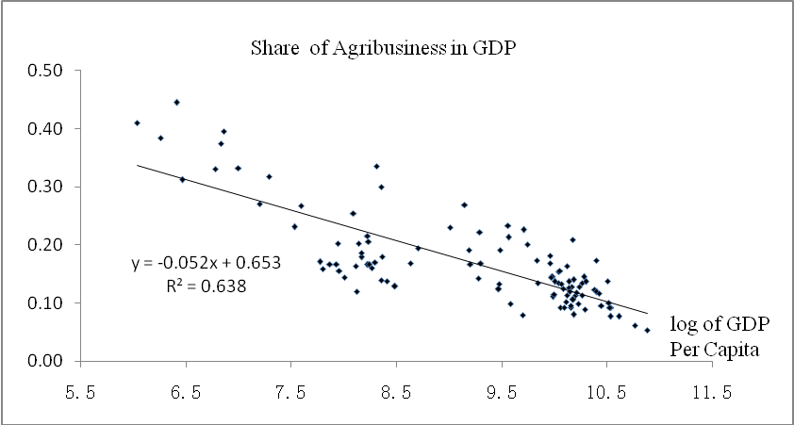
Note: US Dollar in year 1990.
Figure1 Share of Agribusiness in GDP Based on OECD IO Tables

The same as traditional agriculture sector, the share of value added of agribusiness in GDP also decreases with the growth of GDP per capita. Although the findings in Scoville(1973) demonstrates that the value added share of agribusiness in GDP is stable with economic growth, we do not find evidence in support of this opinion. Leones et al.(1994) proposed that the important of agriculture in national economy should be based on the role of agribusiness, not the agricultural producing sector. We find that it will be more important if we consider agribusiness instead of agricultural producing sector.

Figure 1 shows that the growth of 1 percent of GDP per capita, the value added share of agribusiness in GDP will decrease 0.052 in absolute value. Low income countries, like the People Republic of China, it’s GDP per capita in 1995 was 606.5 dollars, while the corresponding value added share of agribusiness in GDP was 44.5%; In India, it’s GDP per capita in 1995 was 417.4 dollars, while the corresponding value added share of agribusiness in GDP was 41.0%. Rich countries, like the USA, it’s GDP per capita in 1995 was 24039.2 dollars, while the correspond value added share of agribusiness in GDP was 12.5%; In Japan, it’s GDP per capita in 1995 was 25946.5 dollars, while the correspond value added share of agribusiness in GDP was 12.8%.

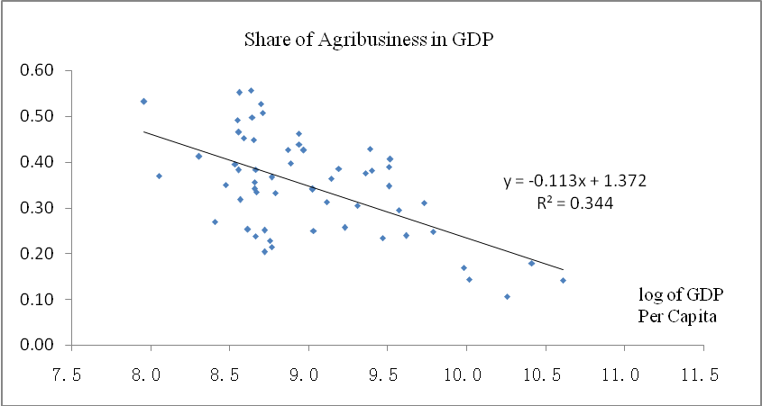
Note: CN RMB in year 2002.
Figure 2 Share of Agribusiness in GDP Based on Chinese Provincial IO Tables

In the provincial level of China, the value added share of agribusiness in GDP also decreases with economic growth, or provinces with higher GDP per capita have lower value added share of agribusiness in GDP.

Figure 2 shows that the growth of 1 percent of GDP per capita, the value added share of agribusiness in GDP will decrease 0.113 in absolute value. Low income provinces, like Guizhou in the southwest region of People Republic of China, it’s GDP per capita in 1997 was 2868.4 yuan, while the corresponding value added share of agribusiness in GDP was 53.2%; Shaanxi, a poor province in the northwest of China, it’s GDP per capita in 1997 was 4800.6 yuans, while the corresponding value added share of agribusiness in GDP was 34.9%. Rich provinces, like Shanghai in the east coast of China, it’s GDP per capita in 1997 was 33346.3 yuan, while the corresponding value added share of agribusiness in GDP was 17.9%; Beijing, the capital of China, it’s GDP per capita in 1997 was 21671.8 yuan, while the corresponding value added share of agribusiness in GDP was 16.9%.

The structural change of sectors in agribusiness
The share of agri-producing decreases with the growth of the economy, while the shares of agri-processing and agri-distributing increase with the growth of the economy both in national and provincial levels.

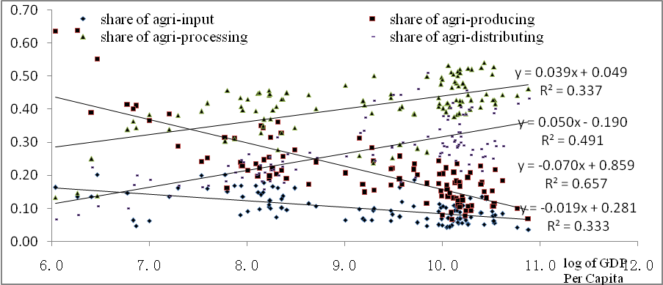
Note: US Dollar in year 1990.
Figure 3 Structural Change in Agribusiness Based on OECD IO Tables

Figure 3 shows that the value added shares of four sectors in agribusiness are more or less affected by the economic growth across the world. The growth of 1 percent of GDP per capita, the value added share of agri-input sector will decrease 0.019 in absolute value, the value added share of agri-producing sector will decrease 0.07 in absolute value, the value added share of agri-processing sector will increase 0.039 in absolute value, and the value added share of agri-distributing sector will increase 0.050 in absolute value. Low income countries, like the People Republic of China, it’s GDP per capita in 1995 was 606.5 dollars, while the value added shares of four sectors in agribusiness was 13.6%, 39.1%, 24.9% and 22.3%; In India, it’s GDP per capita in 1995 was 417.4 dollars, while the value added shares of four sectors in agribusiness was 16.3%, 63.7%, 13.4% and 19.9%. Rich countries, like the USA, it’s GDP per capita in 1995 was 24039.2 dollars, while the value added shares of four sectors in agribusiness was 8.1%, 8.9%, 51.3% and 31.7%; In Japan, it’s GDP per capita in 1995 was 25946.5 dollars, while the value added shares of four sectors in agribusiness was 5.5%, 12.1%, 47.1% and 35.4%.

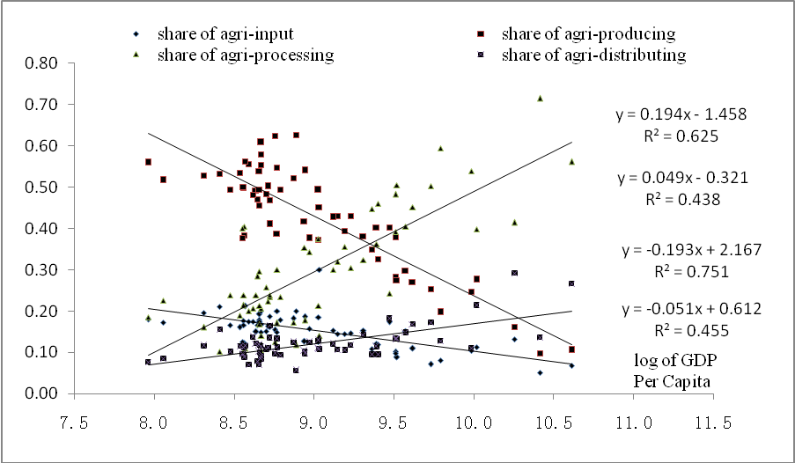
Note: CN RMB in year 2002.
Figure 4 Structural Change in Agribusiness Based on Chinese Provincial IO Tables

Figure 4 shows that the value added shares of four sectors in agribusiness are more or less affected by the economic growth in China. The growth of 1 percent of GDP per capita, the value added share of agri-input sector will decrease 0.051 in absolute value, the value added share of agri-producing sector will decrease 0.193 in absolute value, the value added share of agri-processing sector will increase 0.194 in absolute value, and the value added share of agri-distributing sector will increase 0.049 in absolute value. Low income countries, like Guizhou province, it’s GDP per capita in 1997 was 2868.4 yuan, while the value added shares of four sectors in agribusiness was 20.0%, 55.9%, 18.4% and 7.7%; In Shaanxi province, it’s GDP per capita in 1997 was 4800.6 yuan, while the value added shares of four sectors in agribusiness was 16.6%, 49.4%, 23.8% and 10.2%. Rich provinces, like Shanghai, it’s GDP per capita in 1997 was 33346.3 yuan, while the value added shares of four sectors in agribusiness was 5.1%, 9.8%, 71.5% and 13.6%; In Beijing, it’s GDP per capita in 1997 was 21671.8 yuan, while the value added shares of four sectors in agribusiness was 10.5%, 24.6%, 53.9% and 11.0%.

The trends of agribusiness and its four subsectors are unchangeable when we use the GDP per capita from the World Bank and Penn World Table.

5. Theoretical model

We assume that the structural change of agribusiness with the growth of economic is driven by the demand of the economy. Households decide to make the shares of agricultural product, industrial product and services in their expenditure, and choose the shares unprocessed agricultural product, processed agricultural product and service-included agricultural product in their expenditure on agricultural products. We will incorporate the above three kinds of agricultural products into households’ utility function based on the model, which has a strong explanation to the structural change of the whole economy from demand side proposed by Kongsamut, Rebelo and Xie(2001), to explain the structural change of agribusiness.

Consider an economy infinite time, n is the annual growth rate of population, the total supply of labor in period t is. Assume the households in this economy are homogeneity, and the supply of labor is inelastic. The household’s utility function is
(5)
where, is nonnegative，c(t) is the composited consumption of agricultural product, industrial product, and service according to Stone-Geary aggregation in period t, while agricultural product is the composited consumption of unprocessed agricultural product , processed agricultural product, and service-included agricultural product according to Stone-Geary aggregation in period t:
(6)
(7)
where, is the subsistent consumption of agricultural product, is the subsistent consumption of unprocessed agricultural product, ,,,,,,,,, are all positive parameters, with restrict that , and 。Households should first satisfy the subsistence of agricultural product compared with industrial product and services, and should first satisfy the subsistence of unprocessed agricultural product compared with processed agricultural product and service-included agricultural product. The existence of positive means that household will not consume service until their consumptions on agricultural product and industrial product reach a certain level. The existence of positive means that household will not consume service-included agricultural product until their consumptions on unprocessed agricultural product and processed agricultural product reach a certain level. These characteristics mean that consumers have hierarchic preference on the above products.

Consider the economy is closed, and the three kinds of agricultural products, industrial product and service should be provided domestically. According to the assumption of production function by Kongsamut, Rebelo and Xie(2001), we assume that:
(8)
where, is the output of product j produced in period t; and are the input of capital and labor of sector j in period t, respectively; is the Hicks-neural productivity of sector j; is the Harrod neural productivity, and is no different across sectors. The production function satisfies the neoclassical assumptions: (1) continuity, differentiability, positive and diminishing marginal product, and constant returns to scale; (2) Inada conditions. Assume that K(0) is the initial capital stock, L(0) is the initial population, and also assume that there is a constant rate of growth of the Harrod neural productivity, that is
(9)
for all t, with the initial condition X(0) greater than 0. The transversality condition of the representative household implies that .

The market-clearing conditions of labor and capital markets are:
(10)
(11)
where, K(t) and L(t) are the total supplies of capital and labor in period t respectively.

We assume that only industrial product could be used as investment product, therefore, the market-clearing condition of industrial product is:
(12)
where, is the depreciate rate of capital. This equation means that the industrial product could be consumed by households and invested by all sectors.

The market-clearing conditions of the three kinds of agricultural products are:
、、 and (13)

Assume that the output of this economy could satisfy the subsistence of households, that is
(14)

Assume that factors could mobile freely across sectors and their production functions are identical, that is
(15)

Assume that all markets are competitive. Let us choose the price of industrial product at each data as the numeraire, which leaves us with the prices of agricultural product ，the three kinds of agricultural products , and , and of service , and factor prices r(t) and w(t)。the consumption aggregator (2) and (3) imply that the prices of these products must satisfy
(16)
(17)

Competitive factor markets also imply that
(18)
(19)

And the prices of the three kinds of agricultural products and service are
，，和 (20)

Therefore, the resource constraint of this economy could be expressed as
(21)

The annual growth rate of industrial product in optimal path is
(22)

When ====0，there exists a balanced growth path. The annual growth rates of all products are all equal to g from the equilibrium condition. There is no balanced growth path when , , , or are positive parameters. The annual growth rate of each product is different from equation (16) and (17).

Proposition 1: suppose and are both positive parameters. Then there does not exist on equilibrium in which all sectors grow at the same rate, and in the Generalized Balanced Growth Path, the share of agricultural product in all products will be decreasing with the growth of the economy.
Proof: Based on the concept and deduction from Kongsamut, Rebelo and Xie(2001), when , the agricultural product, industrial product, and service will grow on the generalizaed balanced growth path, and the relationships among these products are
(23)

Proposition 2: suppose and are both positive parameters. Then there does not exist on equilibrium in which the three kinds of agricultural products grow at the same rate, and in the Generalized Balanced Growth Path, the share of unprocessed agricultural product in all agricultural products will be decreasing with the growth of the economy.
Proof: Assume that the agricultural product, industrial product and service are in the generalized balanced growth path, if , then, the three kinds of agricultural products are in the generalized balanced growth path, and the relationships among these products are
(24)

The above two propositions are consistent with the stylized facts of the relationship between economic growth and structural change of agribusiness. Therefore, the economic model built in this part has strong explanation to the development of agribusiness under economic growth perspective.

6. Conclusions

This paper analyzes the relationship between economic growth and structural change of agribusiness. Under the concept guided by Davis and Goldberg(1957), we build a comprehensive framework of agribusiness system. We then measure the value added of four sectors—agri-input sector, agri-producing sector, agri-processing sector, agri-distributing sector--in agribusiness system based on the method modified on Furtuoso and Guilhoto(2001) to characterize the fact of structural changes in agribusiness both in national level based on OECD IO Tables(2010 edition) and in province level based on Chinese provincial IO tables in 1997 and 2002.

The two main features of structural change in agribusiness are: (1) value added share of agribusiness system in national GDP is decreasing with the growth of economy; (2) value added shares of agri-processing and agri-distributing sectors in agribusiness are increasing with the growth of economy. These stylized facts could be explained in the theoretical model based on Kongsamut, Rebelo and Xie(2001) with different products in which consumers have hierarchic preference on agricultural product and non agricultural products.

However, the economic model we invented in this paper assumes that the productivity across different sectors are the same, which may be unrealistic since technology progress in industrial sector would be fast than that in agricultural sector. Therefore, to relax the assumption on supply side in the economic model should be carried on in the near future to make deeper understanding the relationship between economic growth and structural change of agribusiness. Meanwhile, besides value added, employment, scale and institutional facts are also important aspects of structural change of agribusiness, and we would incorporate these elements into both empirical and theoretical studies in the near future.

References
- Amanor, K., (2009). Global Food Chains, African Smallholders and World Bank Governance, Journal of Agrarian Change 9(2):247-262
- Boehlje, M., (1999). Structural changes in the agricultural industries: how do we measure, analyze and understand them? American Journal of Agricultural Economics 81(5): 1028-1041.
- Davis, J., Goldberg, R., (1957). A Concept of Agribusiness. Boston, Harvard University.
- De Janvry, A., (2010). Agriculture for Development: New Paradigm and Options for Success, Agricultural Economics 41(s1):17-36
- Fritz, M., Schiefer, G., (2008). Food Chain Management for Sustainable Food System Development: A European Research Agenda. Agribusiness 24(4):440-452
- Furtuoso, M., Barros, G., Guilhoto, J., (1998). The Gross National Production of the Brazilian Agroindustrial Complex. Brazilian Review of Agricultural Economics and Rural Sociology 36: 9-31
- Hayami, Y., Godo, Y., (2004). the three agricultural problems in the disequilibrium of world agriculture, Asian Journal of Agricultural and Development, 1(1): 3-14
- King, R., Boehlje, M., Cook, M., Sonka, S., (2010). Agribusiness Economics and Management, American Journal of Agricultural Economics 92(2):554-570
- Kongsamut, P., Rebelo, S., Xie, D., (2001). Beyond Balanced Growth. Review of Economic Studies 48: 869-882
- Kvaloy, O., Tveteras, R., (2008). Cost Structure and Vertical Integration between Farming and Processing. Journal of Agricultural Economics 59(2):296-311
- Leones, J., Schluter, G., Goldman, G., (1994). Redefining Agriculture in Interindustry Analysis. American Journal of Agricultural Economics 76(5): 1123-1129
- Ma, H., Huang, J., Fuller, F., Rozelle, S., (2006). Getting Rich and Eating Out: Consumption of Food Away from Home in Urban China, Canadian Journal of Agricultural Economics 54(1):101-119
- Pingali, P., (2007). Agricultural Growth and Economic Development: A View Through the Globalization Lens. Agricultural Economics 37(s1):1-12
- Reardon, T., Barrett, C., (2000). Agroindustrialization, Globalization, and International Development: an overview of issues, patterns, and determinants. Agricultural Economics 23: 195-205
- Schluter, G., Lee, C., Edmondson, W., (1986). Income and Employment Generation in the Food and Fiber System. Agribusiness 2(2): 143-158
- Scoville, O. (1973). The Agribusiness Sector: An Important Link in Economic Growth Models. American Journal of Agricultural Economics 55(3): 520-523
- Swinnen, J.,(2009). Reforms, Globalization, and Endogenous Agricultural Structures, Agricultural Economics, 40(s1):719-732
- Swinnen, J., Maertens, M., (2007). Globalization, Privatization, and Vertical Coordination in Food Value Chains in Developing and Transition Countries, Agricultural Economics, 37(s1):89-102
- Tiffin, R., Irz, X., (2006). Is Agriculture the Engine of Growth? Agricultural Economics 35(1):79-89
- Xu, X., Li, S., (2008). The Compilation and Analysis of Chinese Regional Input Output Tables(1997), Tsinghua University Press.

Hayami, Y., Godo, Y., 2004, the three agricultural problems in the disequilibrium of world agriculture, Asian Journal of Agricultural and Development, 1(1): 3-14.
The detailed information about the compilation and adjustment of OECD IO tables are in Yamano and Ahmad (2006).
The coverage of the OECD IO tables could be found at: http://www.oecd.org/dataoecd/10/25/44484093.pdf.
Xu, X., Li, S., 2008, The Compilation and Analysis of Chinese Regional Input Output Tables(1997), Tsinghua University Press.
Readers who are interested in this robust test could contact the author freely.

