Identifying critical supply chain paths that drive changes in CO₂ emissions

By

Yuko OSHITA¹⁾, Shigemi KAGAWA¹⁾, Keisuke NANSAI²⁾, and Sangwon SUH³⁾

1) Kyushu University, 6-19-1 Hakozaki, Higashi-ku, Fukuoka 812-8581, Japan
2) National Institute for Environmental Studies of Japan, 16-2, Onogawa, Tsukuba, Ibaraki 305-0053, Japan
3) Bren School of Environmental Science and Management, University of California, Address: Santa Barbara, CA 93106-5131, USA

*Corresponding author:
Yuko Oshita <oshita-yuko@live.jp>
Faculty of Economics, Kyushu University,
6-19-1 Hakozaki, Higashi-ku, Fukuoka, 812-8581, Japan,
Phone and Fax: +81-92-642-2450

Keywords: Climate change, critical supply-chain paths, CO₂ emission, structural decomposition analysis, structural path decomposition analysis, Japan

Abstract
In order to empirically examine the relationship between an economic system and the environment, identifying critical supply-chain paths that drive changes in CO₂ emissions is crucial. In this article, I extract and analyze the factors and key supply chains involved in changes in CO₂ emissions associated with Japan’s overall demand from 1990 to 2000 using the Wood and Lenzen (2009) SPD method on data from the 1990-1995-2000 linked Japanese environmental input-output tables at the four-digit commodity classification level. The results reveal that the volume of CO₂ emissions increased in large part due to changes in intermediate inputs from the electricity sector to the service sectors, such as “electricity$→$amusement and recreation facilities$→$household demand” and “electricity$→$school education (public)$→$local government demand”.

1. Introduction

To address the problem of global warming, reducing total emissions by managing life cycle CO₂ emissions associated with industrial production has garnered considerable attention (e.g., Murray and Wood, 2010). Examples of such initiatives include the discussions of Scope 3 emissions in the ISO14040 Series (see ISO 14040, 1997) and the Greenhouse Gas Protocol Initiative by the World Resources Institute (WRI) and World Business Council for Sustainable Development (see WBCSD, 1996). One reason for focusing on life cycle CO₂ emissions is because emission reduction can be achieved by requiring all industries (firms) from upstream to downstream to be accountable for both direct and indirect CO₂ emissions associated with the supply of raw materials and components (e.g., Wiedmann, 2009; Minx et al., 2009).

Importantly, such reductions require not only the conservation of energy during downstream industries’ production processes, but also the use of fewer energy-intensive materials and components (Suh, 2009). Allocating the responsibility for life cycle emissions in the supply chain among upstream and downstream industries can be done using shared responsibility analysis (Gallego and Lenzen, 2005; Lenzen et al., 2007; Lenzen, 2007). Similarly, identification of life cycle CO₂ emissions in the supply chain can be performed using input-output structural path analysis (IO-SPA) (Defourny and Thorbecke, 1984; Lenzen, 2003; Peters and Hertwich, 2006; Strømman et al., 2009). Using SPA methods, it is possible to identify key supply chains associated with particularly large volumes of life cycle CO₂ emissions, as well as to propose more efficient CO₂ emission reduction policies throughout the product life cycle.

In order to effectively reduce CO₂ emissions, identifying key factors that affect life cycle CO₂ emissions over time is very important. IO-SDA has been employed extensively in this task (Dietzenbacher and Los, 1997, 1998, 2000; Hoekstra and van den Bergh, 2003). It has been used to analyze changes in CO₂ emissions and material flows over time through assessing, for example, changes in the direct emission intensities of industrial sectors, production structures, and final demand (see e.g., Casler and Rose, 1998; Wier, 1998; Hoekstra and van den Bergh, 2006; Nansai et al., 2007, 2009; Baiocchi and Minx, 2010).

Casler and Rose (1998) decomposed source changes in CO₂ emissions in the U.S. from 1972 to 1982, showing that energy and material substitution both contributed to reducing CO₂ emissions, while technological changes (input efficiency changes) in energy and materials increased them. Wier (1998) examined the sources of changes in energy consumption and emissions of three air pollutants (CO₂, SO₂, and NO_{x}) in the Danish economy between 1966 and 1988. This long-term structural decomposition analysis revealed that changes in energy intensities brought about a marked reduction in the emissions of all the air pollutants, while changes in fuel mixes contributed to a reduction in SO₂ emissions and an increase in CO₂ and NO_{x} emissions (see Table 3-5 of Wier, 1998). The study concluded that final demand shifts were the main determinant of increased pollution emission; while technological developments such as changes to the fuel mix reduced SO₂-related environmental problems, they simultaneously increased CO₂ and NO_{x}-related ones. Hoekstra and van den Bergh (2006) examined the effects of structural changes on the physical material inputs to primary plastics, plastic products, primary iron and steel, and iron and steel products in the Netherlands from 1990 to 1997 and developed a forecasting method using the decomposition information. While previous environmental SDA studies have typically used an additive decomposition technique, Nansai et al. (2007) used a multiplicative input-output decomposition technique (see Dietzenbacher et al., 2000 for a description of the technique applied to labor productivity issues) together with a newly developed indicator called “eco-velocity” to assess the rates of consumption growth and technology advancement. An important application of this measure to Japan’s environmental IO table is that sectors related to information and communication technology (ICT) such as information services, personal computers, cellular phones, and telecommunications had the highest eco-velocities and the highest impact on the environment during the period between 1990 and 2000. This study provides additional evidence showing that the growth of the service sector has a significant impact on climate change policy (see Suh, 2006).

These findings show that IO-SDA has been used extensively in the area of environmental analysis and that it can provide very significant results to policy makers. However, previous IO-SDA methods lack the ability to estimate the effects of changes in the supply chain at high levels of resolution. In order to overcome this fundamental problem, Wood and Lenzen (2009) developed a new method, structural path decomposition (SPD), to estimate the effects of structural changes on pollution emissions associated with individual supply chains and to identify key supply chains having high pollutant emissions using structural path analysis (see Defourny and Thorbecke, 1984; Lenzen, 2003; Peters and Hertwich, 2006; Strømman et al., 2009). A case study undertaken in Australia between 1995 and 2005 showed that changes in the composition of exports in the livestock and meat and dairy categories led to a reduction in greenhouse gas emissions from the supply chains related to livestock such as “livestock$→$exports” and “livestock$→$meat and dairy$→$exports”. The authors were also able to extract supply chains that were key in increasing and decreasing greenhouse gas emissions.

With this background, the current study aims to extract and analyze the factors and key supply chains involved in changes in CO₂ emissions associated with Japan’s overall demand from 1990 to 2000 using the Wood and Lenzen (2009) SPD method on data from the 1990-1995-2000 linked Japanese environmental input-output tables at the four-digit commodity classification level.

2. Methodology

First, using the input-output model, the domestic output of each industry can be estimated with the following equation:

$x={\left(I−A\right)}^{−1}y$ (1)

where x is an (n × 1) vector representing the domestic output of each commodity, I is an (n × n) identity matrix, A is an (n × n) domestic input coefficient matrix containing the ratios of the amount of each input directly required to produce one unit of a commodity, and y is an (n × 1) vector representing the final domestic demand for each commodity. ${\left(I−A\right)}^{−1}$ is called the Leontief inverse matrix (L), where the elements of the matrix l_{ij} represent the demand for commodity i input directly and indirectly to produce one unit of commodity j. In other words, equation (1) represents the direct and indirect domestic production of each commodity induced by final demand. n is the number of commodity sectors.

Multiplying the direct CO₂ emission intensity vector c (1 × n) with equation (1) and decomposing the final demand vector y into the final demand commodity composition matrix Ψ (n × d), final demand category composition vector δ (d × 1), per capita final demand amount Y, and population P, the total amount of CO₂ emissions C can be expressed using the following equation:

$C=c{\left(I−A\right)}^{−1}y=\text{cL}\text{ψδ}\text{YP}$ (2)

where the direct CO₂ emission intensity is found by dividing the direct CO₂ emission from each sector $C_{j}$ by the monetary value of the domestic production of that same sector, which can be calculated using the expression $c_{j}=C_{j}/x_{j}$. Element $ψ_{\text{ij}}$ in the commodity composition matrix of the final demand can be obtained by dividing the monetary value of the final demand for commodities in that category by the total of each final demand category, such as household demand or central government demand. If $f_{\text{ij}}$ is the final demand matrix (n × d), where d is the number of final demand categories, this can be calculated using the expression $ψ_{\text{ij}}=f_{\text{ij}}/\sum_{i}^{n}{f_{\text{ij}}}$. Further, the elements in the category composition matrix of final demand can be obtained by dividing the demand from each final demand category by the total final demand, which can be expressed as .

Using the SDA methods of Dietzenbacher and Los (1997, 1998) to decompose the factors affecting changes in equation (2) over time revealed six factors, as indicated in the equation below:

(3)

The equation shows that the impact of changes in CO₂ emissions can be decomposed into six factors: (a) each sector’s direct CO₂ emission intensity , (b) changes in industrial structure , (c) commodity composition of final demand , (d) category composition of final demand , (e) per capita final demand , and (f) population . In order to estimate the impact of these structural changes from 1990 to 2000, I used equation (4) below, which represents the discrete structural decomposition of equation (3).

(4)

Here, (90) and (00) in equation (4) represent the values for the years 1990 and 2000, respectively, while $Δ$ represents the change from 1990 to 2000.

The Leontief inverse matrix L can now be converted into a series expansion as follows:

$L={\left(I−A\right)}^{−1}=I+A+A^{2}+A^{3}+⋯$ (5)

I is the direct effect, or direct unit production amount demanded by the final consumer for a specific commodity. A is an indirect secondary effect indicating the amount of production required to produce one unit of a specific commodity. Substituting equation (5) into equation (3) gives us the following equation:

(6)

The first line on the right side of equation (6) represents CO₂ emissions directly attributable to final demand, such as the change in CO₂ emissions from the electricity sector when households consume electricity. The second line represents CO₂ emissions indirectly attributed to the intermediate inputs in the sector in question, such as changes in CO₂ emissions from the electricity sector due to power consumption in the automobile sector when the households purchase automobiles. The impacts of the first line are referred to as first-order effects, while those in the second line are referred to as second-order effects. The effects of lines 3 and 4 in equation (6) are referred to as third-order effects. Effects of other orders can be estimated in the same manner.

Using equation (6), the six factors decomposed in equation (3) can be decomposed further for each supply chain. For example, if we look at $d\text{cψ}δ\text{YP}$, the first first-order term from equation (6), element by element, $\text{ d}c_{j}ψ_{\text{jk}}δ_{k}\text{YP}$ represents the impact of a change in the direct CO₂ emission intensity of sector j on CO₂ emissions discharged by the supply chain, sector j $→$ final demand k. Next, looking at $\text{cψ}δd\text{YP}$, the fourth first-order term, in the same way, $c_{j}ψ_{\text{jk}}δ_{k}d\text{YP}$ represents the impact of a change in the changes in per capita final demand on CO₂ emissions discharged by the supply chain, sector j $→$ final demand k.

The third-order impact, $c_{j}A_{\text{jk}}{dA}_{\text{kl}}ψ_{\text{lm}}δ_{m}\text{YP}$, represents the impact of changes in the input coefficients from sector k to sector l on CO₂ emissions discharged from the supply chain, final demand m $→$ sector l $→$ sector k $→$ sector j. Therefore, $c_{j}A_{\text{jk}}A_{\text{kl}}ψ_{\text{lm}}{dδ}_{m}\text{YP}$ represents the impact of the change in the ratio of final demand m to the total on CO₂ emissions from the same supply chain. For example, if m was exports, l was passenger cars, k was tires, and j was synthetic rubber, $c_{j}A_{\text{jk}}{dA}_{\text{kl}}ψ_{\text{lm}}δ_{m}\text{YP}$ would represent the impact associated with changes in the input coefficient of tires when one unit of passenger cars is produced, while $c_{j}A_{\text{jk}}A_{\text{kl}}ψ_{\text{lm}}{dδ}_{m}\text{YP}$ would represent the impact of the change in the ratio of exports in the total final demand. In the same manner, ${\text{dc}}_{j}A_{\text{jk}}A_{\text{kl}}ψ_{\text{lm}}δ_{m}\text{YP}$ represents the impact on CO₂ emissions discharged from the same supply chain due to changes in the direct CO₂ emission intensity of synthetic rubber, $c_{j}{\text{dA}}_{\text{jk}}A_{\text{kl}}ψ_{\text{lm}}δ_{m}\text{YP}$ shows the impact due to changes in the volume of synthetic rubber input per unit of tire production, $c_{j}A_{\text{jk}}A_{\text{kl}}{dψ}_{\text{lm}}δ_{m}\text{YP}$ shows the impact due to changes in the proportion of exports accounted for by passenger cars, $c_{j}A_{\text{jk}}A_{\text{kl}}ψ_{\text{lm}}δ_{m}d\text{YP}$ shows the impact due to a change in monetary per capita final demand, and $c_{j}A_{\text{jk}}A_{\text{kl}}ψ_{\text{lm}}δ_{m}YdP$ shows the impact resulting from a change in population. Using this SPD methodology, it is possible to extract the factors that have a major impact on changes in the total volume of CO₂ emissions associated with each supply chain. In order to extract the impact of each supply chain, I used equation (7) below as a discrete structural decomposition of equation (6).

$$\begin{aligned}\begin{aligned}\left.ΔC=\frac{1}{2}\sum_{t=\text{90},\text{00}}{Δ\text{cψ}\left(t\right)δ\left(t\right)Y\left(t\right)P\left(t\right)}+\frac{1}{2}\sum_{t=\text{90},\text{00}}{c\left(t\right)Δψδ\left(t\right)Y\left(t\right)P\left(t\right)}+\frac{1}{2}\sum_{t=\text{90},\text{00}}{c\left(t\right)ψ\left(t\right)ΔδY\left(t\right)P\left(t\right)} | \right\}\end{aligned}\end{aligned}\begin{aligned}\left. +\frac{1}{2}\sum_{t=\text{90},\text{00}}{Δ\text{cA}\left(t\right)ψ\left(t\right)δ\left(t\right)Y\left(t\right)P\left(t\right)}+\frac{1}{2}\sum_{t=\text{90},\text{00}}{c\left(t\right)Δ\text{Aψ}\left(t\right)δ\left(t\right)Y\left(t\right)P\left(t\right)} | \right\}\left. +\frac{1}{2}\sum_{t=\text{90},\text{00}}{c\left(t\right)A\left(t\right)Δψδ\left(t\right)Y\left(t\right)P\left(t\right)}+\frac{1}{2}\sum_{t=\text{90},\text{00}}{c\left(t\right)A\left(t\right)ψ\left(t\right)ΔδY\left(t\right)P\left(t\right)} | \right\}\end{aligned}\begin{aligned}\left. +\frac{1}{2}\sum_{t=\text{90},\text{00}}{Δ\text{cA}\left(t\right)A\left(t\right)ψ\left(t\right)δ\left(t\right)Y\left(t\right)P\left(t\right)}+\frac{1}{2}\sum_{t=\text{90},\text{00}}{c\left(t\right)Δ\text{AA}\left(t\right)ψ\left(t\right)δ\left(t\right)Y\left(t\right)P\left(t\right)} | \right\}\left. +\frac{1}{2}\sum_{t=\text{90},\text{00}}{c\left(t\right)A\left(t\right)Δ\text{Aψ}\left(t\right)δ\left(t\right)Y\left(t\right)P\left(t\right)}+\frac{1}{2}\sum_{t=\text{90},\text{00}}{c\left(t\right)A\left(t\right)A\left(t\right)Δψδ\left(t\right)Y\left(t\right)P\left(t\right)} | \right\}\left. +\frac{1}{2}\sum_{t=\text{90},\text{00}}{c\left(t\right)A\left(t\right)A\left(t\right)ψ\left(t\right)ΔδY\left(t\right)P\left(t\right)}+\frac{1}{2}\sum_{t=\text{90},\text{00}}{c\left(t\right)A\left(t\right)A\left(t\right)ψ\left(t\right)δ\left(t\right)Δ\text{YP}\left(t\right)} | \right\}\end{aligned} +…$$
1st order effects
2nd order effects
3rd order effects
(7)

The data used in this analysis was extracted from the 1990-1995-2000 Linked Environmental Input-Output Table at the four-digit commodity classification level (395 sectors), complied by Japan’s National Institute for Environmental Studies. Final demand is consolidated into eight sectors: outside household demand, household demand, central government demand, local government demand, public enterprise capital, private capital, inventory changes, and exports. The input coefficient matrix, total final demand, final demand commodity composition matrix, and final demand category composition vectors were obtained from the Linked Input-Output Table. I used sector-specific direct CO₂ emissions (tons C) and sector-specific direct CO₂ emission intensities (tons C/1 million yen) for the CO₂ emissions data for each sector, also derived from the Linked Input-Output Tables. Population data for 1990, 1995, and 2000 came from the Statistics Bureau of the Ministry of Internal Affairs and Communications.

3. Empirical findings from the Japan case study

3.1. Structural decomposition analysis of CO₂ emissions in Japan

The volume of CO₂ emissions for Japan, which was obtained by summing the direct CO₂ emissions of each industrial sector, was about 283 (Mt C) in 1990 and about 309 (Mt C) in 2000, showing an increase of 26 (Mt C), or 9.3% over the ten-year period. The CO₂ emissions associated with each final demand item in 1990 and 2000, calculated using equation (2) are given in Fig. 1, which shows that the induced emissions from household demand are relatively large. Compared to the annual increase in emissions from other final demand categories like household demand and exports, emissions associated with private capital have declined during the study period. Figure 2 shows the CO₂ emissions per 1 million yen in each final demand category, calculated by dividing the induced emissions by the total demand for each final demand category. While the CO₂ emissions induced per unit of final demand for exports and public enterprise capital were large, the emissions volume did not increase significantly from 1990 to 2000. In fact, emissions from some categories decreased.

I employed SDA to determine which factors were responsible for the marked changes observed in CO₂ emissions in the ten years from 1990 to 2000. Figure 3 shows the results of the SDA for changes in total CO₂ emissions in 1990 and 2000 calculated using equation (4). The results revealed that overall CO₂ emissions remarkably decreased due to changes in the direct CO₂ emissions intensity (${ΔC}_{c}$) as well as changes in the commodity composition of final demand (${ΔC}_{ψ}$). However, changes in the industrial structure (${ΔC}_{L}$) and final demand per capita (${ΔC}_{Y}$) both contributed to a marked increase in overall CO₂ emissions, with changes in the population (${ΔC}_{P}$) and the category composition of final demand (${ΔC}_{δ}$) also tending toward an increase. In other words, CO₂ emissions have declined through decreases in direct CO₂ emission intensity and because the commodity composition of final demand has changed due to an increase in the demand for commodities that have smaller environmental loads. On the other hand, total CO₂ emissions have increased due to increases in population and final demand per capita, and because the composition of the final demand categories has shifted toward items that have higher associated environmental loads.

Using this SPD analysis, SDA results can be broken down into detailed effects on supply chains.

[Insert Figure 1 here]

[Insert Figure 2 here]

[Insert Figure 3 here]

3.2. Empirical findings from SPD results

Table 1 shows the results of the SPD analysis. The “Order” column in Table 1 shows how many paths make up the supply chain, as expressed in equation (5). If the order is 1, the chain is “sector$→$final demand”. If the order is 2, the chain is “sector$→$sector$→$final demand”. If the order is 3, the chain is “sector$→$sector$→$sector$→$final demand” etc. “Factors” shown in Table 1 represent the factors expressed in equation (6). The second column from the left (Kt C) in the table shows the extent to which changes in factors in the supply chain alter the volume of CO₂ emissions.

First, of the top 60 results of the structural path decomposition analysis for 1990 to 2000 shown in Table 1, the factors responsible for major changes in impact can be seen to be the commodity composition of final demand ($Δψ$) and direct CO₂ emissions intensity ($Δc$), which accounted for 38% and 28%, respectively, of the total absolute value of the change in CO₂ emissions shown in Table 1. The change in the first-order input structure ($Δ\text{A1}$) was 11%, the change in the composition of final demand categories ($Δδ$) was 13%, and the change in final per capita demand ($ΔY$) was 8%. The reason for the small impact of changes in the commodity composition of final demand ($Δψ$) calculated by SDA is thought to be due to offsetting effects between factors that contribute both positively and negatively to CO₂ emissions through the supply chain (Fig. 4). Interestingly, changes in final demand per capita ($ΔY$), which had a large impact on the SDA results, did not have a marked impact on SPD results. In the SDA, this is thought to be due to the fact that the impact of changes in final demand per capita ($ΔY$) on each of the supply chains is positive so these impacts do not cancel each other out. In addition, of the final demand categories that had a large impact in the SPD, the largest impact (61%) was due to changes in the supply chain associated with household demand, with changes in the exports next at 16%. Most of the overall impact was accounted for by changes in supply chains associated with these two final demand categories.

Detailed examination of the SPD results revealed that the first-, second- and third-ranked changes in emissions were associated with supply chain, electricity$→$household demand (Table 1). All the factors (, $Δψ$, $Δδ$, $ΔY$, and ) associated with this supply chain not only appear in the top 60 sector rankings, but they account for approximately 36% of the overall impact. More specifically, an increase in use of electricity from household demand had the largest impact on CO₂ emission in the study period in Japan. The second-ranked factor was a reduction (improvement) in the direct CO₂ emission intensity of the electricity sector. The impact of these two changes nearly canceled each other out, but because of increased emissions from the third-ranked factor, change in final demand per capita, the 9th-ranked factor, change in the category composition of final demand, and the 24th-ranked factor, change in population, emissions associated with this supply chain increased.

The supply chain with the next largest impact was “ocean transport$→$exports”, which accounted for approximately 11% of the total change in emissions in Table 1. Changes in that supply chain increased CO₂ emissions because of an increase in the proportion of exports in final demand (ranked 4th), a rise in the direct CO₂ emissions intensity of ocean transport (ranked 7th), and a rise in final demand per capita (ranked 11th), though CO₂ emissions were lowered by a decline in the proportion of ocean transport demand in exports (ranked 8th). An increase in air-borne exports of products such as semiconductors and integrated circuits is thought to have offset a decrease in the demand for ocean transport of exports.

In many cases, the overall change in direct CO₂ emissions intensity ($Δc$) is negative, but for “ocean transport$→$exports” (ranked 7th), “non-residential construction (non-wooden)$→$private capital” (ranked 21st), “amusement and recreation facilities$→$household demand” (ranked 33rd), “public administration (local)$→$local government demand” (ranked 38th), and “vegetables$→$household demand” (ranked 41st), the change in direct CO₂ emissions intensity ($Δc$) tended towards increasing emissions. In addition, the impact of changes in electricity inputs in service sectors ($Δ\text{A1}$) such as “electricity$→$amusement and recreation facilities$→$household demand” (ranked 6th), “electricity$→$school education (public)$→$local government demand” (ranked 18th), “electricity$→$retail trade$→$household demand” (ranked 23rd), “electricity$→$public administration (local)$→$local government demand” (ranked 31st), “electricity$→$public administration (central)$→$central government demand” (ranked 53rd), and “electricity$→$railway transport (passengers)$→$household demand” (ranked 56th) tended toward increasing emissions. In other words, the energy inputs and power consumption of the service sector have increased, with energy dependence of services all contributing to an increase in CO₂ emissions (for an analysis of the relationship between the material and energy dependence of services and CO₂ emissions, see Suh (2006) and Nansai et al. (2009)).

In the following, the focus is on the change in the input structure, which significantly increased CO₂ emissions in the SDA results (see Fig. 3). Table 2 shows the supply chains in which CO₂ emissions were significantly increased because of changes in the input structure ($Δ\text{A1}$,$Δ\text{A2}$). According to the table, inputs to service sectors from electricity increased as described above (ranked 1st, 2nd, 4th, 7th, 9th, 13th, 17th, 19th, 20th, 21st, 23rd, and 27th in Table 2). With increased inputs from cement to cement products or ready mixed concrete, the CO₂ emissions from the “cement$→$ready mixed concrete (or cement products)$→$construction” supply chain increased (inputs ranked 10th, 11th, 12th, 15th, 16th, 18th, 24th, and 28th). It is noteworthy that the input from on-site power generation to retail trade or petroleum refinery products also increased (inputs ranked 14th, 16th, 29th, and 30th).

Supply chains in which CO₂ emission decreased due to changes in the input structure ($Δ\text{A1}$,$Δ\text{A2}$) are shown in Table 3. Compared with those in Table 2, these are small changes in CO₂ emissions. According to this table, there are numerous supply chains that are same with those in Table 2, such as “cement$→$ready mixed concrete (cement products)$→$constructions”. According to the column of factors, however, the cause of the decrease is not due to changes in cement input ($Δ\text{A1}$) in the “cement$→$ready mixed concrete (cement products)” chain but due to input changes ($Δ\text{A2}$) in the “ready mixed concrete (cement products)$→$constructions” chain (ranked 1st, 4th, 9th, 10th, 13th in Table 3). That is, CO₂ emissions decreased because of a decrease in an input from ready mixed concrete (cement products) to constructions, though there was an increase in CO₂ emissions caused by increased input from cement to ready mixed concrete (cement products).

Looking at the impact of the change in the commodity composition of final demand ($Δψ$) in Table 1, it is clear that CO₂ emissions from each of the supply chains have increased due to an increase in the demand for air transport, in household demand and exports (ranked 12th and 26th) and for refined road freight transport and petroleum products (including greases) in household demand (ranked 16th and 27th). The rise in demand for integrated circuits in exports has contributed to increasing CO₂ emissions generated from electricity required for productions of integrated circuits (ranked 29th). It also, however, appears that reductions in the demand for retail trade (ranked 28th) and hired car and taxi transport (ranked 36th) accounted for in household demand caused CO₂ emissions from the these supply chains to decrease. Conversely, the fall in demand for frozen fish and shellfish in household demand has contributed to decreasing CO₂ emissions from marine fisheries (22nd). Considering the situation such that household demand for road freight transport increased, while household demand for retail trade decreased, it can be thought that the households have purchased goods by internet services or mail-order selling without retail trade.

In addition, the decrease in CO₂ emission caused by decreased constructions demand from private capital is prominent. On the other hand, increased CO₂ emissions from escalating demand for information services from private capital is apparent (see Table 4). This indicates that investment in construction dropped and investment in IT-related business rose because of the collapse of the bubble economy in the 1990s. If we focus on the change in category composition of final demand ($Δδ$), most decreases are due to lowered CO₂ emissions from the supply chain “construction$→$private capital” through a decrease in private capital. On the other hand, the shares of government demand and household demand increased in the final demand.

[Insert Table 1 here]

[Insert Table 2 here]

[Insert Table 3 here]

[Insert Table 4 here]

4. Comparison with SPD results from Australia

We will now compare SPD results for the Australian economy between 1995 and 2005 as reported by Wood and Lenzen (2009) with the results obtained for the Japanese economy. It is important to note, however, that the Wood and Lenzen (2009) analysis considered 30 sectors in the period from 1995 to 2000, while the analysis presented in this study considers 395 sectors in the period from 1990 to 2000. First, as in Japan, the total volume of CO₂ emissions in Australia increased during the study period.

Table 5 shows the results of the SDA for Japan and Wood and Lenzen’s (2009) SDA for Australia. Compared with Japan, each factor’s overall contribution is very large for Australia. Specifically, compared with the Japanese values, the impacts of changes in per capita final demand ($ΔY$), the commodity composition of final demand ($Δψ$), direct CO₂ emissions intensity ($Δc$), and population ($ΔP$) are extremely large. Moreover, in contrast to trends in other factors’ impacts, which were the same as in Japan, changes in the industrial structure ($ΔL$) in Australia contributed to a reduction in CO₂ emissions, and the impact of the category composition of final demand ($Δδ$) was very small.

[Insert Table 5 here]

Table 6 shows the results of Wood and Lenzen’s (2009) SPD analysis (1995 to 2005). Like Japan, the change in the commodity composition of final demand ($Δψ$) and direct CO₂ emissions intensity ($Δc$) in Australia had a large impact on the change in CO₂ emissions, amounting to 39% and 22%, respectively, of the total in Table 6. However, the change in final per capital demand ($ΔY$), which at 9% of the total did not have a major impact in the Japanese results, accounted for 24% of the total in the Australian results, making it the second largest impact. As shown in the SDA data in Table 2, the reason for this difference is thought to be a significantly larger change in final demand per capita in Australia than in Japan. Also, when considering the final demand categories with large impacts, changes in supply chains associated with household demand, similar to Japan, accounted for 45% of the total, while changes in supply chains associated with exports accounted for 35%, meaning that nearly all of the final demand was accounted for by these two categories. However, the large impact caused by changes in the supply chain associated with exports in Australia is different from that in Japan. Additionally, in Australia, of those sectors that form supply chains with large impacts, the electricity sector (22% of the total) is important, just as in Japan, but a larger share is occupied by the supply chain associated with livestock or meat and dairy production in the Australian data (61% of the total). The characteristics of this sector are markedly different in the two countries. In another instance, in the “electricity$→$household demand” supply chain, increases in CO₂ emissions due to changes in final per capita final demand ($ΔY$) (ranked 2nd) and population ($ΔP$) (ranked 15th) are the same as for Japan. However, the drop in CO₂ emissions caused by a decrease in the demand for electricity (ranked 7th), accounted for in household demand, is opposite of the trend in Japan. We think this difference is due to household consumption demand going to commodities and services other than electricity. In contrast to the lower CO₂ emissions attributable to improved direct CO₂ emission intensity in the electricity sector in Japan, in Australia, CO₂ emissions increased (ranked 20th) because of increased direct CO₂ emissions intensity in the electricity sector.

The results above illustrate that performing SPD analyses and inter-country comparisons facilitates the elucidation of supply chain characteristics and the factors that drive CO₂ emissions in each country.

[Insert Table 6 here]
5. Conclusions

In this study, I elucidated six factors that affect supply chains causing changes in the volume of CO₂ emissions derived from final demand in the period from 1990 to 2000 in Japan: each sector’s direct CO₂ emission intensity, raw materials input structure, the commodities composition of final demand, the item composition of final demand, final demand per capita, and population. The factors that had the most marked impact on the total CO₂ emissions in Japan during this period were changes in the commodities composition of final demand (38%) and changes in direct CO₂ emissions intensity (28%). The final demand categories with the largest impacts were household demand (61%) and exports (16%).

The supply chain that had the largest impact was the path from electricity to household demand. The impact of this supply chain accounted for 36% of the total impact (in terms of absolute value) of the top 60 supply chains. However, changes in the commodity composition of final demand ($Δψ$) and final demand per capita ($ΔY$), which contributed to an increased CO₂ emissions, and the change in direct CO₂ emissions intensity ($Δc$), which decreased CO₂ emissions, on this supply chain offset each other. Similarly, the impact of the supply chain from ocean transport to exports was also large, but changes in the composition of final demand ($Δδ$), which increased emissions, and the change in direct CO₂ emissions intensity ($Δc$), which decreased emissions, offset each other. Moreover, because the volume of CO₂ emissions increased as a result of changes in the direct CO₂ emissions intensities ($Δc$) of the services sector and the agricultural sector, as well as changes in the input structure () of the electricity of the services sector, energy dependence of the service sector was more apparent. In addition, it became clear that increased demand for air transport, in household demand and exports, as well as the increase in demand for refined petroleum products (including greases) in household demand, had the effect of increasing CO₂ emissions from each of the associated supply chains (“air transport$→$exports” and “petroleum refinery products$→$household demand”). Conversely, falls in the demand for frozen fish and shellfish, as well as hired car and taxi transport, were accounted for in household demand and reduced the CO₂ emissions from these supply chains (“marine fisheries$→$frozen fish and shellfish$→$household demand” and “hired car and taxi transport$→$household demand”).

Comparisons with Wood and Lenzen’s (2009) case study in Australia revealed that the impacts of the changes in both final demand per capita ($ΔY$) and the supply chains associated with exports were larger than in Japan. Also, in Australia, more than 60% of the supply chains with large impacts were associated with the livestock sector, which also differed markedly from the economic structure in Japan.

Using SPD analysis, the results obtained from SDA can be broken down into detailed supply chains. Key economic factors with particularly large impacts can be extracted from the emission data associated with extensive supply chains. In doing so, it is possible to obtain insights into the specific factors affecting CO₂ emissions and to develop appropriate measures to moderate them.

Acknowledgements

An early version of this paper was prepared for the 2010 Conference of the Society for Environmental Economics and Policy Studies, Nagoya, in September 2010. I gratefully acknowledge helpful comments received from Yuichi Moriguchi. I also thank Shigemi Kagawa, Keisuke Nansai, Sangwon Suh, and Manfred Lenzen for their constructive comments and helpful suggestions. This research has been supported by Grants-in-aid for research fellowship (No. 226908) of the Japan Society for the Promotion of Science.

References

- Baiocchi, G. and Minx, J.C., (2010) Understanding changes in the UK’s CO₂ emissions: a global perspective, Environmental Science & Technology, vol.44, no.4, pp 1177-1184.
- Casler, S.D. and Rose, A., (1998) Carbon dioxide emissions in the U.S. economy: a structural decomposition analysis, Environmental and Resource Economics, vol.11, no.3, pp. 349-363.
- Defourny, J. and Thorbecke, E., (1984) Structural path analysis and multiplier decomposition within a social accounting matrix framework, Economic Journal, vol.94, pp. 111-136.
- Dietzenbacher, E. and Los, B., (1997) Analyzing decomposition analysis, in: A. Simonovits and A.E. Steenge (eds.) Prices, Growth and Cycles (London, Macmillan), pp.108-131.
- Dietzenbacher, E. and Los, B., (1998) Structural decomposition techniques: sense and sensitivity, Economic Systems Research, vol.10, no.4, pp.307-323.
- Dietzenbacher, E., Los, B., (2000) Structural decomposition analyses with dependent variables, Economic Systems Research, vol.12, no.4, pp.497-514.
- Dietzenbacher, E., Hoen, A.R. and Los, B., (2000) Labor productivity in Western Europe 1975–1985: an intercountry analysis, Journal of Regional Science, vol.40, no.3, pp. 425-452.
- Fritz, O.M., Sonis, M., Hewings, G.J.D., (1998) A Miyazawa analysis of interactions between polluting and non-polluting sectors, Structural Change and Economic Dynamics, vol.9, no.3, pp.289-305.
- Gallego, B. and Lenzen, M., (2005) A consistent formulation of producer and consumer responsibility, Economic Systems Research, vol. 17, no.4, pp.365-391.
- Hertwich, E. and Peters, G., (2009) Carbon footprint of nations: a global, trade-linked analysis, Environmental Science & Technology, vol.43, no.16, pp. 6414-6420.
- Hendrickson, C.T., Lave, L.B., and Matthews, H.S., (2006) Environmental life cycle assessment of goods and services: an input-output approach, RFF Press.
- Hoekstra, R. and van den Bergh, J.C.J.M., (2003) Comparing structural and index decomposition analysis, Energy Economics, vol.25, no.1 pp.39-64.
- Hoekstra, R. and van den Bergh, J.C.J.M., (2006) The impact of structural change on physical flows in the economy: forecasting and backcasting using structural decomposition analysis, Land Economics, vol.82, no.4, pp. 582-601.
- ISO 14040, (1997) International standard, environmental management – life cycle assessment –, principles and framework, International Organization for Standardization (ISO), Geneva, 1997.
- Lenzen, M., (2003) Environmentally important paths, linkages and key sectors in the Australian economy, Structural Change and Economic Dynamics, vol.14, no.1, pp.1–34.
- Lenzen, M., Murray, J., Sack, F. and Wiedmann, T., (2007) Shared producer and consumer responsibility – theory and practice, Ecological Economics, vol.61, no.1, pp. 27-42.
- Lenzen, M., (2007) Aggregation (in-)variance of shared responsibility: a case study of Australia, Ecological Economics, vol.64, no.1, pp. 19-24.
- Minx, J.C., Wiedmann, T., Wood, R., Peters, G.P., Lenzen, M., Owen, A., Scott, K., Barrett, J., Hubacek, K., Baiocchi, G., Paul, A., Dawkins, E., Briggs, J., Guan, D., Suh, S., Ackerman, F. (2009) Input-Output Analysis and Carbon Footprinting: An Overview of Applications, Economic Systems Research, vol. 21, no.3, pp.187-216.
- Murray, J. and Wood, R. (Eds.) (2010) The Sustainability Practitioner’s Guide to Input-Output Analysis, Common Ground Publishing, Illinois, USA.
- Nansai, K., Kagawa, S., Suh, S., Inaba, R., and Moriguchi, Y. (2007) Simple Indicator to Identify the Environmental Soundness of Growth of Consumption and Technology: “Eco-velocity of Consumption”, Environmental Science & Technology, vol.41, no.4, pp. 1465-1472.
- Nansai, K., Kagawa, S., Suh, S., Fujii, M., Inaba, R. and Hashimoto, S., (2009) Material and energy dependence of services and its implications for climate change, Environmental Science & Technology, vol.43, no.12, pp.4241-4246.
- Sonis, M., Oosterhaven, J., Hewings, G.J.D., (1993) Spatial economic structure and structural changes in the EC: feedback loop input–output analysis, Economic Systems Research, vol.5, no.2, pp.173-184.
- Sonis, M., Hewings, G.J.D., Guo, J. Edison, H., (1997) Interpreting spatial economic structure: feedback loops in the Indonesian inter-regional economy, Regional Science and Urban Economics, vol.27, no.3, pp. 325-342.
- Peters, G.P. and Hertwich, E.G., (2006) The Importance of imports for household environmental impacts, Journal of Industrial Ecology, vol.10, no.3, pp. 89-109.
- Peters, G. and Hertwich, E., (2008) CO₂ embodied in international trade with implications for global climate change policy, Environmental Science & Technology, vol.42, no.5, pp. 1401-1407.
- Strømman, A.H., Peters, G.P. and Hertwich, E.G., (2009) Approaches to correct for double counting in tiered hybrid life cycle inventories, Journal of Cleaner Production, vol.17, no.2, pp. 248-254.
- Suh, S., (2006) Are services better for climate change? Environmental Science and Technology, vol.40, no.21, pp. 6555-6560.
- Suh, S. (Ed.), (2009) Handbook of Input-Output Economics in Industrial Ecology, Springer, New York, NY, USA.
- WBCSD, (1996) Environmental assessment: a business perspective, World Business Council for Sustainable Development.
- Wier, M. (1998) Sources of changes in emissions from energy: a structural decomposition analysis, Economic Systems Research, vol.10, no.2, pp.99-112.
- Wiedmann, T., (2009) Carbon footprint and input–output analysis – an introduction, Economic Systems Research, vol.21, no.3, pp. 175-186.
- Wood, R. and Lenzen, M., (2006) Zero-value problems of the logarithmic mean divisia index decomposition method, Energy Policy, vol.34, no. 12, pp.1326-1331.
- Wood, R. and Lenzen, M., (2009) Structural path decomposition, Energy Economics, vol.31, pp.335-341.

Figures and Tables

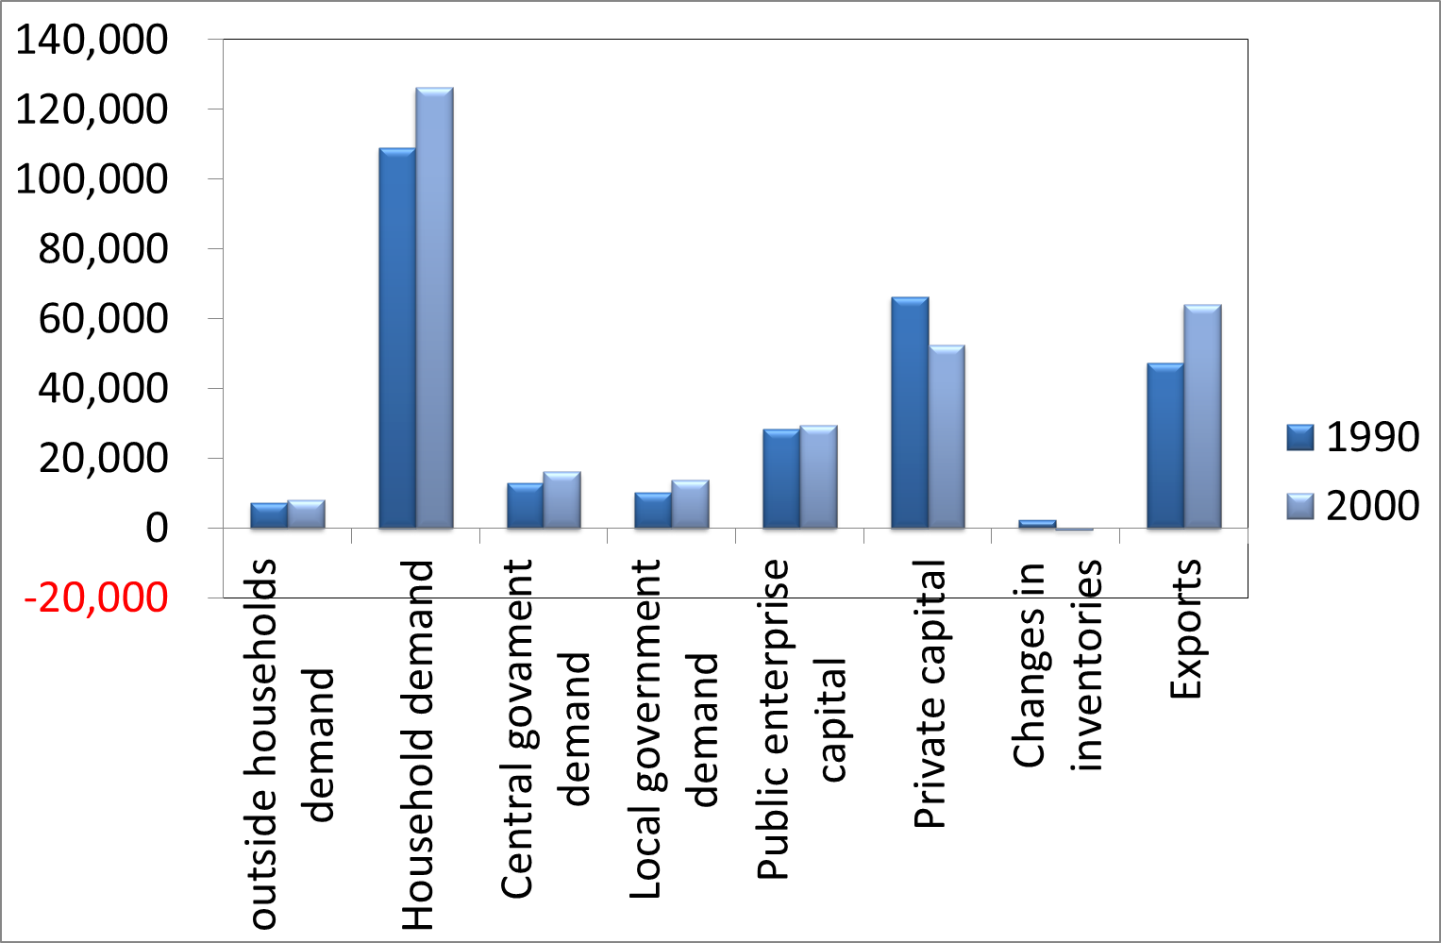
Final demand category
Figure 1. CO₂ emissions induced by each final demand category,
1990 and 2000

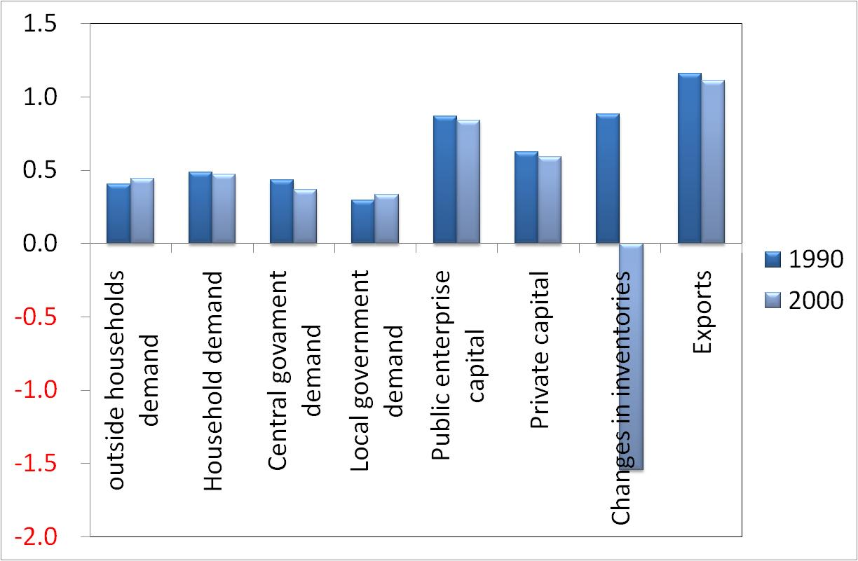
Final demand category

Figure 2. CO₂ emissions induced per 1 million yen in each final demand category, 1990 and 2000

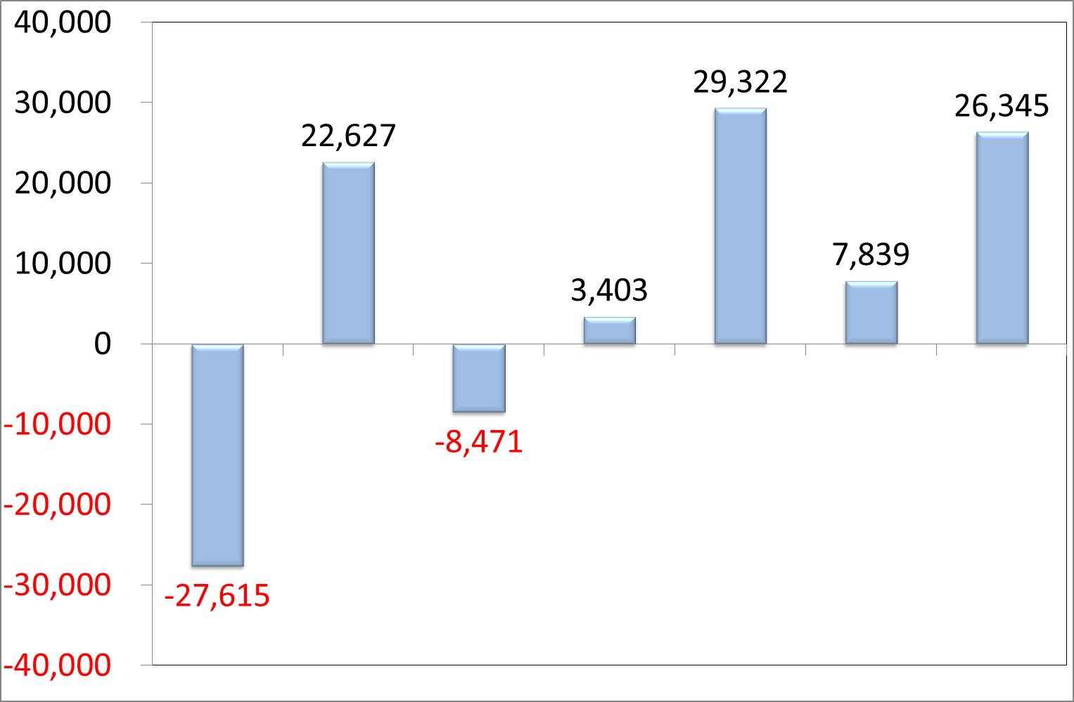
ΔC_{L} ΔC_{δ} ΔC_{Y} ΔC_{P} ΔC
ΔC_{c}
ΔC_{Ψ}
Decomposition factors
Figure 3. Decomposition effects in changes in CO₂ emissions in 1990 and 2000

Table 1. Results of structural path decomposition (SPD) analysis, 1990 to 2000
Rank | Kt-C | Order | Factor | Final demand | Sector (1st order) | Sector (2nd order) | Sector (3rd order)
1 | 7954 | 1 | $Δ$Ψ | Household demand | Electricity
2 | -6359 | 1 | $Δ$c | Household demand | Electricity
3 | 2382 | 1 | $Δ$Y | Household demand | Electricity
4 | 1990 | 1 | $Δ$δ | Exports | Ocean transport
5 | -1469 | 1 | $Δ$c | Central government demand | Public administration (central)
6 | 1444 | 2 | $Δ$A1 | Household demand | Amusement and recreation facilities | Electricity
7 | 1417 | 1 | $Δ$c | Exports | Ocean transport
8 | -1284 | 1 | $Δ$Ψ | Exports | Ocean transport
9 | 1231 | 1 | $Δ$δ | Household demand | Electricity
10 | -1209 | 2 | $Δ$Ψ | Household demand | Amusement and recreation facilities | Electricity
11 | 917 | 1 | $Δ$Y | Exports | Ocean transport
12 | 915 | 1 | $Δ$Ψ | Exports | Air transport
13 | -843 | 1 | $Δ$Ψ | Household demand | Amusement and recreation facilities
14 | -839 | 3 | $Δ$Ψ | Private capital | Non-residential construction (non-wooden) | Ready mixed concrete | Cement
15 | -777 | 1 | $Δ$Ψ | Private capital | Non-residential construction (non-wooden)
16 | 764 | 1 | $Δ$Ψ | Household demand | Road freight transport
17 | -739 | 2 | $Δ$c | Household demand | Retail trade | Electricity
18 | 704 | 2 | $Δ$A1 | Local government demand | School education (public) | Electricity
19 | 692 | 3 | $Δ$δ | Exports | Hot rolled steel | Crude steel (converters) | Pig iron
20 | 687 | 2 | $Δ$A1 | Household demand | Electricity | Electricity
21 | 654 | 1 | $Δ$c | Private capital | Non-residential construction (non-wooden)
22 | -654 | 2 | $Δ$Ψ | Household demand | Frozen fish and shellfish | Marine fisheries
23 | 651 | 2 | $Δ$A1 | Household demand | Retail trade | Electricity
24 | 639 | 1 | $Δ$P | Household demand | Electricity
25 | -627 | 1 | $Δ$c | Household demand | Road freight transport
26 | 623 | 1 | $Δ$Ψ | Household demand | Air transport
27 | 570 | 1 | $Δ$Ψ | Household demand | Petroleum refinery products (inc. greases)
28 | -544 | 1 | $Δ$Ψ | Household demand | Retail trade
29 | 515 | 2 | $Δ$Ψ | Exports | Integrated circuits | Electricity
30 | 507 | 3 | $Δ$Ψ | Exports | Hot rolled steel | Crude steel (converters) | Pig iron
31 | 478 | 2 | $Δ$A1 | Local government demand | Public administration (local) | Electricity
32 | 470 | 1 | $Δ$δ | Central government demand | Public administration (central)
33 | 451 | 1 | $Δ$c | Household demand | Amusement and recreation facilities
34 | 440 | 1 | $Δ$Ψ | Household demand | Sewage disposal
35 | -436 | 1 | $Δ$Ψ | Local government demand | Waste management services (public)
36 | -430 | 1 | $Δ$Ψ | Household demand | Hired car and taxi transport
37 | -425 | 3 | $Δ$δ | Private capital | Non-residential construction (non-wooden) | Ready mixed concrete | Cement
38 | 419 | 1 | $Δ$c | Local government demand | Public administration (local)
39 | -415 | 2 | $Δ$Ψ | Household demand | Retail trade | Electricity
40 | -411 | 1 | $Δ$c | Central government demand | Medical services (medical corporations, etc.)
41 | 409 | 1 | $Δ$c | Household demand | Vegetables
42 | -390 | 2 | $Δ$c | Local government demand | Public administration (local) | Electricity
43 | 385 | 1 | $Δ$δ | Central government demand | Medical services (medical corporations, etc.)
44 | -383 | 1 | $Δ$δ | Private capital | Non-residential construction (non-wooden)
45 | 377 | 1 | $Δ$c | Private capital | Residential construction (non-wooden)
46 | -377 | 1 | $Δ$c | Household demand | Retail trade
47 | 372 | 1 | $Δ$Y | Household demand | Retail trade
48 | -367 | 3 | $Δ$A2 | Public enterprise capital | Public construction of rivers, drainages and others | Ready mixed concrete | Cement
49 | -358 | 3 | $Δ$δ | Private capital | Residential construction (non-wooden) | Ready mixed concrete | Cement
50 | 357 | 2 | $Δ$δ | Central government demand | Medical services (medical corporations, etc.) | Electricity
51 | 350 | 2 | $Δ$A1 | Private capital | Other civil engineering and construction | Cement
52 | -349 | 2 | $Δ$c | Household demand | Amusement and recreation facilities | Electricity
53 | 349 | 2 | $Δ$A1 | Central government demand | Public administration (central) | Electricity
54 | -348 | 1 | $Δ$c | Household demand | Sewage disposal
55 | 339 | 3 | $Δ$A1 | Exports | Hot rolled steel | Crude steel (converters) | Pig iron
56 | 328 | 2 | $Δ$A1 | Household demand | Railway transport (passengers) | Electricity
57 | -324 | 2 | $Δ$c | Central government demand | Medical services (medical corporations, etc.) | Electricity
58 | 323 | 1 | $Δ$Y | Local government demand | Waste management services (public)
59 | -317 | 2 | $Δ$A1 | Public enterprise capital | Public construction of roads | Cement
60 | 311 | 3 | $Δ$A1 | Public enterprise capital | Public construction of rivers, drainages and others | Ready mixed concrete | Cement

Table 2. Top 30 supply chains with increased CO₂ emissions due to input structure changes
Rank | Kt-C | Order | Factor | Final demand | Sector (1st order) | Sector (2nd order) | Sector (3rd order)
1 | 1444 | 2 | ΔA1 | Household demand | Amusement and recreation facilities | Electricity
2 | 704 | 2 | ΔA1 | Local government demand | School education (public) | Electricity
3 | 687 | 2 | ΔA1 | Household demand | Electricity | Electricity
4 | 651 | 2 | ΔA1 | Household demand | Retail trade | Electricity
5 | 478 | 2 | ΔA1 | Local government demand | Public administration (local) | Electricity
6 | 350 | 2 | ΔA1 | Private capital | Other civil engineering and construction | Cement
7 | 349 | 2 | ΔA1 | Central government demand | Public administration (central) | Electricity
8 | 339 | 3 | ΔA1 | Exports | Hot rolled steel | Crude steel (converters) | Pig iron
9 | 328 | 2 | ΔA1 | Household demand | Railway transport (passengers) | Electricity
10 | 311 | 3 | ΔA1 | Public enterprise capital | Public construction of rivers, drainages and others | Ready mixed concrete | Cement
11 | 294 | 3 | ΔA1 | Public enterprise capital | Public construction of rivers, drainages and others | Cement products | Cement
12 | 269 | 3 | ΔA1 | Public enterprise capital | Public construction of roads | Ready mixed concrete | Cement
13 | 248 | 2 | ΔA1 | Household demand | General eating and drinking places (except coffee shops) | Electricity
14 | 229 | 2 | ΔA1 | Household demand | Retail trade | On-site power generation
15 | 228 | 3 | ΔA1 | Public enterprise capital | Public construction of roads | Cement products | Cement
16 | 220 | 3 | ΔA1 | Private capital | Non-residential construction (non-wooden) | Ready mixed concrete | Cement
17 | 206 | 2 | ΔA1 | Household demand | Hotels and other lodging places | Electricity
18 | 179 | 3 | ΔA1 | Private capital | Residential construction (non-wooden) | Ready mixed concrete | Cement
19 | 161 | 2 | ΔA1 | outside households demand | Eating and drinking places for pleasure | Electricity
20 | 158 | 2 | ΔA1 | Central government demand | Medical services (public) | Electricity
21 | 157 | 2 | ΔA1 | Private capital | Residential construction (non-wooden) | Electricity
22 | 157 | 2 | ΔA1 | Public enterprise capital | Other civil engineering and construction | Cement
23 | 155 | 2 | ΔA1 | Household demand | Ceremonial occasions | Electricity
24 | 135 | 3 | ΔA1 | Private capital | Non-residential construction (non-wooden) | Cement products | Cement
25 | 132 | 3 | ΔA2 | Exports | Hot rolled steel | Crude steel (converters) | Pig iron
26 | 128 | 2 | ΔA1 | Household demand | Petroleum refinery products (inc. greases) | On-site power generation
27 | 116 | 2 | ΔA1 | Household demand | Sewage disposal | Electricity
28 | 112 | 3 | ΔA1 | Private capital | Residential construction (non-wooden) | Cement products | Cement
29 | 111 | 2 | ΔA1 | Household demand | Cosmetics, toilet preparations and dentifrices | On-site power generation
30 | 111 | 3 | ΔA1 | Exports | Hot rolled steel | Crude steel (electric furnaces) | On-site power generation

Table 3. Top 15 supply chains with decreased CO₂ emissions due to input structure changes
Rank | Kt-C | Order | Factor | Final demand | Sector (1st order) | Sector (2nd order) | Sector (3rd order)
1 | -367 | 3 | ΔA2 | Public enterprise capital | Public construction of rivers, drainages and others | Ready mixed concrete | Cement
2 | -317 | 2 | ΔA1 | Public enterprise capital | Public construction of roads | Cement
3 | -293 | 2 | ΔA1 | Exports | Integrated circuits | Electricity
4 | -292 | 3 | ΔA2 | Public enterprise capital | Public construction of roads | Ready mixed concrete | Cement
5 | -254 | 3 | ΔA1 | Exports | Hot rolled steel | Crude steel (electric furnaces) | Pig iron
6 | -214 | 2 | ΔA1 | Central government demand | Medical services (non-profit foundations, etc.) | Electricity
7 | -188 | 2 | ΔA1 | Household demand | Frozen fish and shellfish | Marine fisheries
8 | -166 | 2 | ΔA1 | Public enterprise capital | Public construction of rivers, drainages and others | Cement
9 | -156 | 3 | ΔA2 | Public enterprise capital | Agricultural public construction | Ready mixed concrete | Cement
10 | -115 | 3 | ΔA2 | Public enterprise capital | Public construction of rivers, drainages and others | Cement products | Cement
11 | -112 | 3 | ΔA2 | outside households demand | Cellular phones | Research and development (intra-enterprise) | Electricity
12 | -110 | 2 | ΔA1 | Household demand | Other processed seafood | Marine fisheries
13 | -108 | 3 | ΔA2 | Public enterprise capital | Public construction of roads | Cement products | Cement
14 | -105 | 2 | ΔA1 | Central government demand | Medical services (medical corporations, etc.) | Electricity
15 | -912 | 2 | ΔA1 | Household demand | House rent | Activities not elsewhere classified

Table 4. Supply chains that affect CO₂ emissions through changes in private capital commodity composition
Kt C | Order | Factor | Final demand | Sector (1st order) | Sector (2nd order) | Sector (3rd order)
-839 | 3 | ΔΨ | Private capital | Non-residential construction (non-wooden) | Ready mixed concrete | Cement
126 | 2 | ΔΨ | Private capital | Information services | Electric power for commercial use
154 | 1 | ΔΨ | Private capital | Information services

Table 5. Japanese (1990 to 2000) and Australian (1995 to 2000) structural decomposition analyses
 | Δc | ΔL | ΔΨ | Δδ | ΔY | ΔP | ΔC
Japan | -83% | 82% | -23% | 15% | 91% | 22% | 100%
Australia | -133% | -17% | -155% | 2% | 259% | 105% | 100%

Table 6. Results of Wood and Lenzen (2009): Australian structural path decomposition analysis (1995 to 2005)

Rank | Kt-C | Order | Effect | Final demand | Sector  (1st order) | Sector  (2nd order) | Sector (3rd order)
1 | -375 | 1 | ΔΨ | Exports | Livestock
2 | 374 | 1 | ΔY | Household demand | Electricity
3 | -315 | 2 | ΔΨ | Exports | Meat and dairy | Livestock
4 | 311 | 1 | ΔΨ | Household demand | Transport
5 | -294 | 2 | Δc | Household demand | Meat and dairy | Livestock
6 | 248 | 2 | ΔY | Household demand | Meat and dairy | Livestock
7 | -244 | 1 | ΔΨ | Household demand | Electricity
8 | -242 | 2 | Δc | Exports | Meat and dairy | Livestock
9 | -235 | 2 | ΔΨ | Household demand | Meat and dairy | Livestock
10 | 220 | 1 | ΔΨ | Changes in inventories | Livestock
11 | 205 | 2 | ΔY | Exports | Meat and dairy | Livestock
12 | -192 | 1 | Δc | Exports | Livestock
13 | -175 | 1 | ΔΨ | Private capital | Transport
14 | 163 | 1 | ΔY | Exports | Livestock
15 | 151 | 1 | ΔP | Household demand | Electricity
16 | -139 | 1 | Δc | Exports | Grains
17 | -136 | 1 | ΔΨ | Public enterprise capital | Electricity
18 | -135 | 1 | Δδ | Public enterprise capital | Electricity
19 | 130 | 2 | ΔA1 | Household demand | Trade | Livestock
20 | 128 | 1 | Δc | Household demand | Electricity
21 | 113 | 3 | ΔA2 | Household demand | Trade | Meat and dairy | Livestock
22 | -110 | 1 | Δc | Private capital | Livestock
23 | 106 | 2 | ΔA1 | Household demand | Meat and dairy | Livestock
24 | 103 | 1 | ΔY | Exports | Metals
25 | 102 | 1 | ΔΨ | Private capital | Livestock
26 | 101 | 2 | ΔP | Household demand | Meat and dairy | Livestock
27 | -100 | 1 | Δc | Government demand | Govt, public services
28 | 100 | 1 | ΔY | Exports | Coal and minerals
29 | 93 | 1 | ΔY | Private capital | Livestock
30 | 87 | 2 | ΔA1 | Exports | Meat and dairy | Livestock
Source: Wood and Lenzen (2009), Table 2.
Note: changes in CO₂ volume were converted from Kt CO₂ to Kt C.

