China’s Industry Potential for Carbon Emission Reduction based on Optimal Input-Output model*

FU, Xue, Dr.
Hubacek, Klaus, Prof.
Meng, Bo, Dr.
Feng, Kuishuang, Dr.

Abstract

With the high speed development of economy over 30 years, China has experience energy development and use grow, thus discharged carbon dioxide as the world’s largest emitter and established a binding target that, in 2020 China’s carbon dioxide emissions per GDP will decrease to 40% -45% . This research works out the actual potential of industry structure adjustment from the perspective of China’s industry carbon emission reduction. It means the change in the ratio of the output of a specific industry to that of the whole economy, under the three kinds of scenarios on constraints of carbon emission reduction. First, Energy-Carbon-Emission-Economy Input-Output (ECEIO) table is designed and compile. Second, an optimal input-output model is established which combine the environment system with economy system considering international trade. Third, this model is applied to 2005 China’s ECEIO table with 44 industries, and to 2007 China’s ECEIO table with 15 industries and to 2007 Shanghai’s ECEIO table. It finds that it is necessary to increase the output of high-tech industries and services with a low coefficient of small amount of carbon emission, for examples, mechanism, electricity manufacture, and real estate, finance and other service. Moreover, industry adjustment is sensitive to the energy structure, the speed of economy growth and carbon emission constraints. If the ratio of renewable energy for the change of structure of energy is considered to be increased; the increase range of industry adjustment will rise with the increase in reduction of carbon emission and decline in the speed of economy growth. In detail, small amount of heavy industry with high carbon emission coefficients should be decrease its ratio of output to the whole economy. The degree of decline in ratio of its output to the whole economy should be increase with the increase in reduction of carbon emission and decline in the speed of economy growth. Last, suggestions are given for industry structure adjustment base on the calculated specific indicators to achieve emission reduction targets with less damage of optimal economic growth.

1. Introduction

1.1 Background
With the high speed development of economy and the increase in population after China’s reform and opening-up, energy development and use has been substantially grow with carbon emissions which have increased accordingly. According to the U.S. Energy Information administration (EIA) statistics, in 2007, China has 6.256 billion metric tons of carbon dioxide emissions (equivalent to 2.642 billion tons of carbon), accounting for 21% of the world’s total emissions and surpassing the U.S. as the world's largest emitter^{[1]}. Under the pressure of international opinion based on the emission reduction requirements and its own development needs, China established a binding target that, in 2020 China’s carbon dioxide emissions per GDP will decrease to 40% -45% compared with 2005’s, and in 2020 the proportion of China’s non-fossil fuels consumption to the total primary energy consumption will decline to 15%. For the next few years, the coal consumption-based energy consumption structure will not change, therefore, the adjustment of the industrial structure, the improvement of energy efficiency and other methods will become the main ways to reduce carbon emissions.
The importance, necessary, difficulty and plausibility of China’s reduction of carbon emission can be analyzed from the change situation in international carbon emission. From US EIA statistic, we calculate the ratio of carbon dioxide emission of six countries with the largest emitter in the world, shown as figure 1. China emitted 2.861 billion metric tons carbon dioxide from the consumption of energy, 12.9% of the world carbon dioxide emission in 1995, as the second largest emitter in the world, and then its emission rose to 7,706.826 billion metric ton in 2009, 25.4% of world carbon dioxide emission, as the largest emitter in the world. Most of the other large emitter’s carbon dioxide emission decreased. USA, the world’s largest emitter in 1995, discharged 5.319 billion metric ton, accounting for 24% of the world carbon dioxide emission, and then slowly increased its emission as 5.424 billion metric ton, 17.9% of the world carbon dioxide emission. The ratio of carbon emission in Russia, Japan and Germany to that of the world decreased respectively from 7%, 5% and 4% to 5%, 4% and 3%. India as a developing country similar to China, discharge carbon dioxide slowly glowed from 4% of the world in 1995 to 5% of the world in 2009.
Figure 1.1. Ratio of carbon emission by country
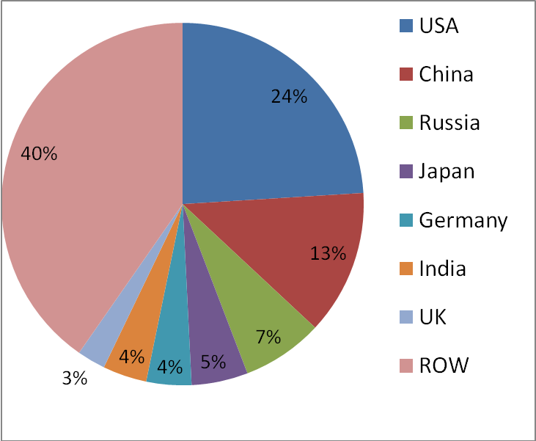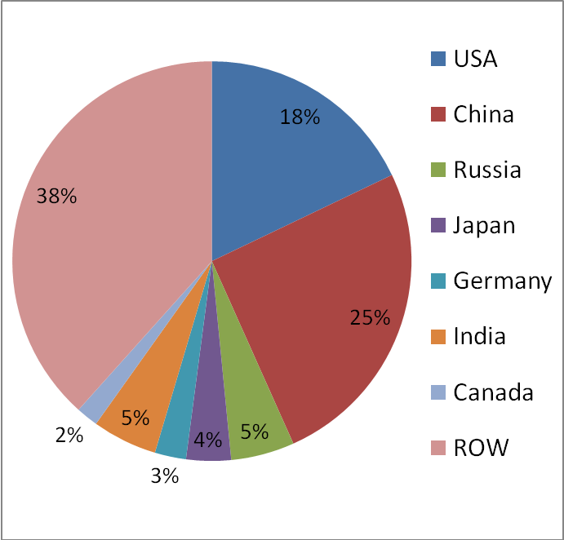
Carbon emission in 1995 Carbon emission in 2009
Figure 2 gives the trend of carbon intensity using market exchange rates from 1995 to 2009 for six countries with largest emitter in the world. China’s carbon intensity is the second largest in the world before 2004, next to Russia, and became the largest in the world after 2004. It is 3.053 metric tons of CO₂ per 1000 year 2005 US dollar in 1995, declined to1.935 metric tons per 1000 US$ in 2001 and increased to 2.219 metric tons per 1000 US$ in 2005, at last declined to 2.219 metric tons per 1000 US$ in 2009. The decrease range from 1995 to 2009 ( 27.3%) was the second large decline in carbon intensity of the world, next to Russia’s 41.2%. India’s carbon intensity declined from 1.925 metric tons per 1000 US$ in 1995, to 1.406 metric tons per 1000 US$ in 2009, less 27% than the former. The other developed countries had the low carbon intensity, which slowly declined from 0.585 metric tons per 1000 US$ to 0.421 metric tons per 1000 US$ in USA, from 0.364 metric tons per 1000 US$ to 0.269 metric tons per 1000 US$ in Germany, and from 0.274 metric tons per 1000 US$ to 0.249 metric tons per 1000 US$ in Japan at the same time. The difficulty in the China’s reduction of carbon emission can be known when comparing the target of carbon intensity declining by 40%-45% within 15 years from 2005 to 2020, to the previous decrease by 27.3%, within 14 years from 1995 to 2009.
Figure 1.2 Carbon Intensity using Market Exchange Rates
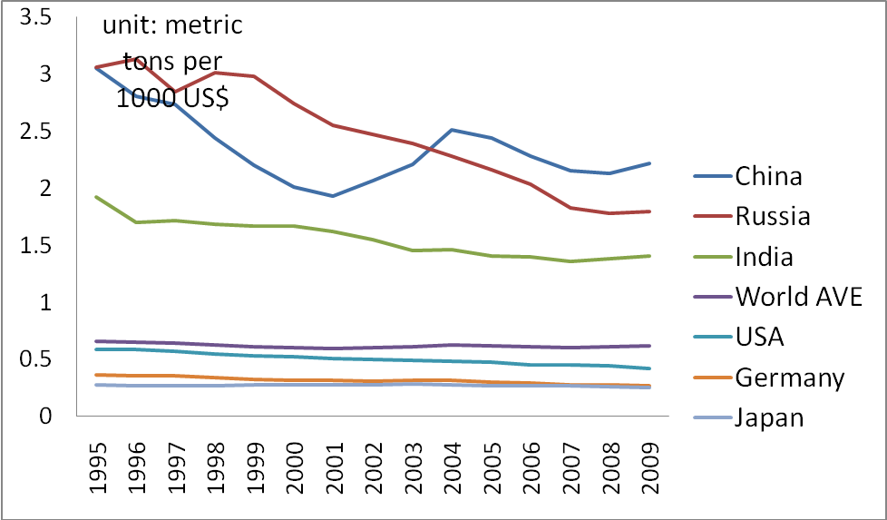
Figure 3 shows the carbon emission by industry in different countries. Electricity and heat production is a kind of industry with the largest ratio of carbon emission in the whole carbon dioxide sourcing from the energy consumption. From International Energy Agency (IEA), this ratio was 48.3% in China and 42.2% in USA in 2006. Manufacturing industries and construction are the industry with the second largest ratio in China, namely 33.2% in 2006. While transport was the industry with the second largest ratio in USA, name 31.1% in 2006. Moreover, other sectors, including servers and residential consumption differed in the ratio from China to USA, respectively 7.7% and 11.3%. The carbon intensity was different among the sectors.
Figure 1.3. Carbon emission by industry
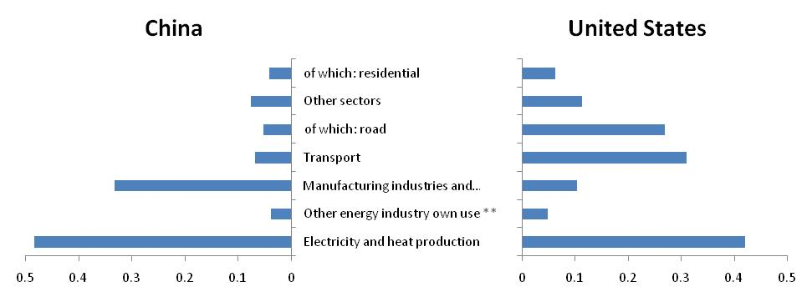
China is able to make the strategy of adjustment of industry structure to reduce the carbon dioxide emission. In general, there are three main ways to deduce carbon emission, including restructure industry structure, reduce household energy consumption, and change the energy structure. In China, coal consumption account for 70% of the whole fuel energy, and it won’t change dramatically at long terms. Chinese urbanization rate reach over 50%, the trend of urbanization will cause the increase in energy consumption of urban household. These two characters determine the necessity of adjustment industry structure. Moreover, this strategy should be implemented without damage the economic growth.
For the aim of reduction of carbon emission, how China adjust the industry structure? From figure 4, we find the unbalance between the ratio of carbon emission and ratio of output. Heavy manufactures, transportation had the largest ratio of carbon emissions; agriculture, food manufactures, textile, construction and commercial have the less ratio of carbon emission. On contrast, construction, commercial, agriculture, energy industry and high technology had comparative large ratio of output; food manufacture, wood processing, textile and mining have less ratio of output. In detail, heavy industries had the largest percentage of carbon emission. Taking industry 9(Metal processing and manufacture) industry 7(Chemical and Pharmaceutical and Medicine Manufacturing), and industry 8 (Building materials and non-Metallic Materials Industry) for example, their carbon emission takes respectively 28.9%, 13.5% and 9.5% of the total carbon emission, from the first large to the third large ratio of carbon emission. The next largest carbon emission exited in industry 13 (Transportation, storage, and information service), which took 8.6% of the total carbon emission. Among those industries with lest carbon emission, industry 12 (Construction) takes 1.5% of the total carbon emission; the light manufactures, e.g. industry 3 (Food manufacture and tobacco processing), industry 5 (Wood processing and Manufacture of Articles for Culture, Education and Sport Activities), and industry 4(Textile, Wearing Apparel) respectively took 2.1%, 2. 2%, 3.2% of the total carbon emission; for services, industry 14(wholesale and retail trades) took 2.6% of carbon emission; industry 1 (Agriculture) took 3.7% of carbon emission; the carbon emission of industry 6 (Petroleum Processing, Coking and Nuclear Fuel Processing) takes 4.1%. We can find the distribution of ratio of carbon emission is opposite to the distribution of ratio of output. See the ratio of carbon emission. The output of industry 12 (Construction) takes 16.6% of the total output, as the largest ratio to total output; and the output of industry 14 (wholesale and retail trades) takes 16.3% (the second largest); the output of industry 1 (Agriculture) takes 13.1% (the third largest), output of industry 6 (Petroleum Processing, Coking and Nuclear Fuel Processing) takes 11.2% (the fourth largest). Among the industries with comparative small ratio of output, industry 9 (Metal processing and manufacture) raked the fifth, and took 2.9% of total output, which is contrast to its comparative large ratio of carbon emission. Light manufactures, such as industry 5 4 3, had the smallest ratio of carbon emission as 1.0%, 1.6% and 2.5% respectively. The next smallest is mining, industry 2, had took 2.6% of carbon emission. The industries with smallest output ratio consisted to those with smallest carbon emission ratio. Therefore, we can infer the plausible industry adjustment strategy as that it is necessary to decrease the output of those industries with high carbon emission ratio but low output ratio, such as industry 9; on the other hand, it may increase the output of those industries with low carbon emission ratio but high output ratio, such industry 14, 12 and 7. However, how much extend the industry output will change should be determined based on more effective methods. Thus we need to construct an Energy-Carbon Emission-Economy Input-Output table. This table is the data base of establishing the association between production and consumption among different industries, and energy consumption and emitted dioxide carbon during production and consumption.
Figure 1.4 Comparison of carbon emission and output by industry
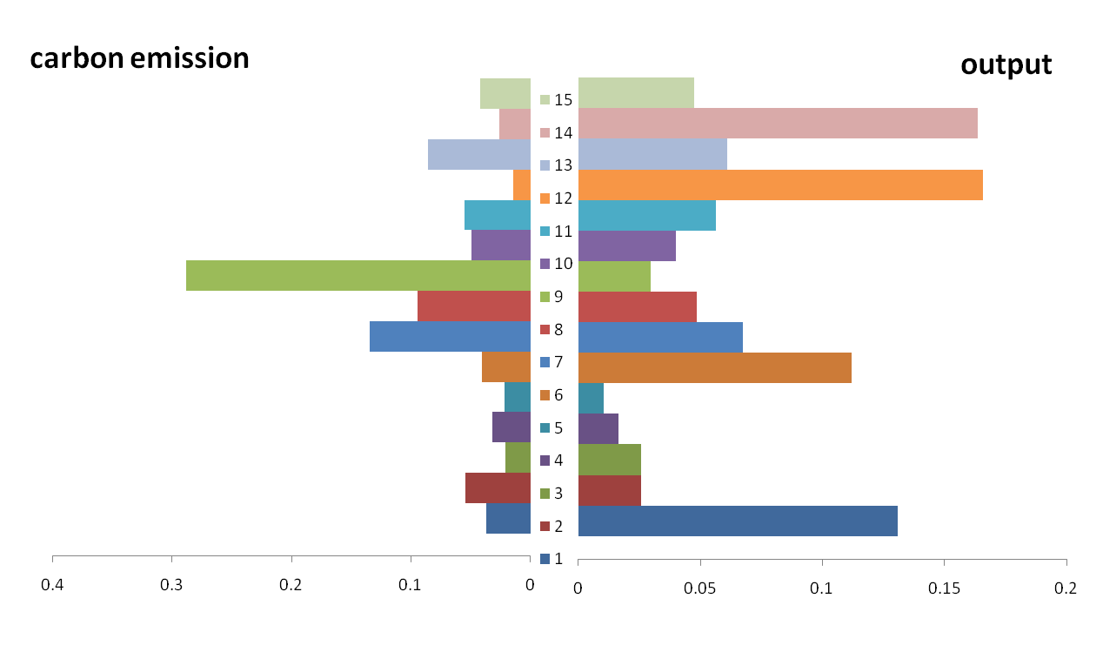
Data source: 2008 China’s energy year book, 2007 China’s Input-Output table (the index of industry refers to appendix 1)
Since adjustment of industry structure should not damage the economy, our objective is to maximize the GDP at planning year. Moreover, the association of industry and household, and their linkage to fuel energy consumption and carbon emission, should be considered in our analysis. Therefore, we build an optimal model which includes the objective of GDP and constraints of production and carbon emission.
The following section gives the literature review of the current research on the low carbon economy. Section 3 is establishment of Energy-Carbon Emission-Energy Input-Output table. It links the production of each industry and consumption to the fuel energy consumption, as well as to the embodied carbon emission. Base on this table, in section 4, we can present an optimal input-output model, with maximize objective of GDP and constraints of carbon emission, to investigate how to realize the target of reduction of carbon emission by industry adjustment, and simulate the optimal industrial structure. Here are some scenarios with assumption economy growth, energy structure change, and carbon emission target. The final section gives some simulation results and suggestion on the policy of industry structure adjustment.
1.2 Literature Review
IPCC Fourth Assessment Report (IPCC-TAR, 2001) ^{[2]} has summarized the international carbon emissions forecasting model into the top-down (top-down) and bottom (bottom-up) two types. The former can be used to describe the interactions between macro-economic, and also could be divided into macro-economic model ^{[3]} and the CGE model ^{[4]}. The latter focused on the analysis of micro data and technical data. In order to restructure industries and develop the low-carbon economy from the point of view of macro-adjustment, we take the former model.
CGE model is most popular in Climate-Energy-economy model. The model was developed by combination of the energy model and economic model in 1980 and 1990^{[5-10]}. The model is divided into AGE model with econometrics method ^{[12-13]} and the model with calibration by literature, the former can obtain the precise parameter, however, because it is lack of data in carbon emission and they are inaccurate, the present model are the latter. The issue analysis on by the model includes the feedback effect of pollute on economy^{[14]} and research on the effect of technique advantage on cost of reduction of carbon emission^{[15-16]}, the influence of environmental tax and carbon tax on social welfare^{[17-18]}, analysis on the cost of “Kyoto protocol” and lose in GDP. Development research center of the state council of China develops the model of GAINS^{[19]} and analysizes the law of pollution controlling in China, technology of controlling in emission, cost effective strategy, reduction of energy consumption and controlling the quality of air and reduction of emission of green house gas ; it, based on CGE model, also analysis on the policy of energy saving and environment conservation, respectively give scenarios on energy tax and environment tax at national level, and simulation on the policy effect by multi-regional CGE model, and find that different distribution of discharge right will not bright out the efficiency variance in total, but difference in equality of policy, the principle of per capita entitlement superior to the principle of history^{[20]}.
We take input-output analysis because it is the most effective system analysis method, and it can reflect the industrial structure, and relate the production to carbon dioxide originated by fuel energy consumption. Therefore, we can apply it to restructuring output by industry on the purpose of reduce carbon emission. Moreover, it has many advantages in application comparing to CGE model: 1) variables are endogenous, so output, value added and final demand are determined by economy system itself; 2) models can be verified, linear and easy to computation. Hence, if we assume the suitable parameter and technology, it is easy to realize the refiguration of output by industry consistent with carbon emission.
Leontief first used the input-output model for the analysis of environmental issues. Comparing to CGE model, it is more concentrating on the connection between industries ^{[21]}. Since then, many economists improved the research of the theory and application in the field resource and environment. Recently it is used in analysizing the energy and carbon emission, Miller and Blair apply it to analysis on the energy consumption of economic system caused by final demand^{[22]}. Lenzen estimates greenhouse gases of the initial energy embedded in goods and services^{[23]}; Hawdonand Pearson (1995) shows the complex relation between energy, environment and economic welfare^{[24]}, Proops et al. (1993) demonstrate the changes in concentration of atmospheric carbon dioxide as well the changes of industry structure will affect carbon emission in the future 20 years. Recent studies use the methods such as structural decomposition techniques and sensitivity analysis in the input-output analysis, to build the relationship between carbon emissions and the industrial structure and economic development^{[25-27]}. China's current research based on static analysis focuses on the use of national input-output table of carbon emissions ^{[28-31].}
Chen Xikang, researcher of Chinese Academy of Sciences has presented IO technology, and has applied it to energy, water, environment, education, international trade and many other fields; In recent years, the nonlinear and dynamic implication of IO technique enables the technique to be used for long-term forecasting and planning, which is the outstanding feature of this research, and get an outstanding contributions to the prediction food output in the country ^{[32]}. Xia Yan, combining the input-output analysis and linear programming technologies, has studied China’s industrial restructuring potential in order to achieve the 2020 carbon intensity targets ^{[33]}. Spatial input-output model provides a theory framework of research on the inter-regional and industrial complexity relation ^{[34]}, but there are only a few application because of difficulty in data collection^{[35-36]} Combination of the input-output model with linear programming, optimal control technologies etc. Peters Clen et al(2009) and Wiedmann at el (2008) makes use of MRIO model analysis the effect of Chinese carbon emission and British carbon emission^{[37-38]}.
Literature about optimization of industrial structure for the study of low-carbon path of economic development has rarely been found with ways combining the input-output model and linear programming. China, with a vast size and all places varies widely for economic development and energy use, is surely to be different to facilitate the different development of characteristics of the industrial restructuring plan to achieve the carbon demission goals. This paper will build up an optimal input-output model to simulate the optimal industrial structure and presents some suggestion on how to develop carbon economy.

2. The Energy-Carbon-Economy Input-Output table

2.1The Energy-Carbon-Economy Input-Output table
We compile an Energy-Carbon-Economy Input-Output table (ECEIO). It gives quantitative and valuable association between the supply of various industries (including industry of energy by type) with demand of these industries and households, and embodied carbon dioxide during production and consumption. The fossil energy burning activity can emits carbon emission and 90% of carbon emission mainly origin from fossil energy consumption. Since fossil energy of different type discharge carbon dioxide at different ratio, it need to compile an Energy-Carbon Emission -Economy table, which shows energy by type is produced and supplied by different energy industry, and is consumed or used by different industry or consumer. The energy’s consumption and usage are respectively shown in this table because the former is composed of final consumption of fossil energy and the loss of energy, but the latter also include transformation loss of energy. This table shows completely the usage and consumption of energy by type in each industry, its embodied carbon emission, so as compute intensity of carbon emission in each industry (carbon emission per GDP/output). The direct and indirect carbon emission embodied in the production and consumption can be reflected through input-output model embodied carbon emission, in further, an optimization input-output model can be developed to measure the potential capability of different industry.
The calculation of the carbon emission in the ECEIO table has two important issues. First, carbon emission in an industry is accounted by summarizing the consumption or usage of energy by type in this industry multiplied the corresponding coefficient of energy of this type. Most researches not distinguish the consumption of energy and usage of energy, which is crucial to precisely account the carbon emission. The consumption of energy by type accounted in ECEIO table is different with the total consumption of energy by type, an index in the “China’s Energy statics year book”. The total consumption of energy by industry refers to the total amount of energy which is used to produce the products of this industry. It includes the part of energy purchased from other industry for final usage of production, and the part of indirect consumption of energy, which is the secondary energy produced in and used by this industry itself, and then input to this industry for the final usage of production. In the “China’s Energy statics year book”, the total consumption of energy in chemical includes the purchased fuel oil and coking coal for production of chemical materials, and the electricity, which is produced by the thermal power established by the chemical industry and used or purchased by this industry itself. So the total consumption of energy is reflected as the usage of energy in ECEIO table. The total consumption of energy is divided into final consumption of energy, processing and transaction of energy, and the loss of energy. The final consumption of energy refers to energy of all types purchased from other industry, which is consumed directly in this industry and for the production of products of this industry. The input and output transformation is the embodied energy in the secondary energy during input transformation. For example, the energy embodied in thermal power, is transformed from the input of primary energy. The loss of energy is the actual loss of transformation during the secondary energy production. The consumption of energy in ECEIO table is composed of the final consumption of energy and the loss of energy, but not the transformation of energy. The carbon emission of each industry is originated from final consumption of energy, and energy processing and transformation, and loss. The final consumption of energy includes the part of usage of energy as raw material, not as burning fossil energy, which should be deduced from the used energy for carbon emission in this industry. In the ECEIO table, we account the consumption or usage of energy by type as the basis of calculation the carbon emission. Moreover, the carbon emission origin from consumption of energy and that from usage of energy are both computed and compared. The former is mainly accounted based on the final consumption of energy by type; the latter based on the total consumption of energy by type.
Table 2.1 Energy-carbon emission-economy input-output table
output  input |  |  |  |  | Intermediate usage |  | Final usage |  |  |  | Total output
 |  |  |  |  | energy | Non-energy | Rural consumption | Urban consumption | Government consumption | … | Total output
input | Intermediate input | Energy industry | Coal producing and selection | billion Yuan | $$\begin{aligned}X^{\text{EE}} \\ X_{u}^{\text{EE}} \\ X_{c}^{\text{EE}} \\ X_{c}^{\text{CE}} \\ \\ E_{u}^{E} \\ E_{c}^{E} \\ C^{E}\end{aligned}$$ | $$\begin{aligned}X^{\text{EN}} \\ X_{u}^{\text{EN}} \\ X_{c}^{\text{EN}} \\ X_{c}^{\text{CN}} \\ \\ E_{u}^{N} \\ E_{c}^{N} \\ C^{N}\end{aligned}$$ | $\begin{aligned}F^{E} \\ F_{u}^{E} \\ F_{c}^{E} \\ F_{c} \\ \\ E_{{}_{u}}^{F} \\ E_{c}^{F} \\ C^{F}\end{aligned}$ |  |  |  | $$\begin{aligned}X^{E} \\ X_{u}^{E} \\ X_{c}^{E} \\ X_{c} \\ \\ E_{u} \\ E_{c} \\ C\end{aligned}$$
input | Intermediate input | Energy industry | Coal  Carbon | ton(/ton standard coal)  standard ton
input | Intermediate input | Energy industry | … | …
input | Intermediate input | Energy industry | … | …
input | Intermediate input | Energy industry | Gas production and supplying | billion Yuan
input | Intermediate input | Energy industry | Gas  Carbon | M³(/ton standard coal)  standard ton
input | Intermediate input | Energy industry | Total Usage of energy  Total Consumption of energy  CO2 emission | ton standard coal  ton standard coal  standard ton
input | Intermediate input | Non energy industry | agriculture | billion Yuan | $$X^{\text{NE}}$$ | $$X^{\text{NN}}$$ | $$F^{N}$$ |  |  |  | $$X^{N}$$
input | Intermediate input | Non energy industry | … | …
input | Intermediate input | Non energy industry | … | billion Yuan
input | Intermediate input | Non energy industry | The third industry
input | Intermediate input | Intermediate input in total |  | billion Yuan
input | Value added | Fix capital depreciation |  | 10⁴ Yuan | $$V^{E}$$ | $$V^{N}$$
input | Value added | Remuneration of labor |  | 10⁴ Yuan | $$V^{E}$$ | $$V^{N}$$
input | Value added | Tax and profit |  | 10⁴ Yuan | $$V^{E}$$ | $$V^{N}$$
input | Value added | Value added in total |  | 10⁴ Yuan | $$V^{E}$$ | $$V^{N}$$
input | Total input |  |  | 10⁴ Yuan | $$X^{E}$$ | $$X^{N}$$
Note: The unit of value is 10⁴ Yuan. The unit of volume is measured both as physic quantity and transferred standard unit. Physic quantity unit is denoted for raw coal, crude oil, Petroleum products, Coking products as ton, for natural gas, oven gas, LPG as cube meter, for hydro power and nuclear, and thermal power respectively as kW•h, heat kJ. Consistent unit, energy of various types can be measured as standard coal.
Secondary, carbon emission coefficient of energy of type is different. For primary energy, carbon emission coefficient refers to standards of US Oak Ridge National Laboratory，or 《2006 IPCC Guidelines on National Greenhouse Gas Inventories》, here we index the standard to 国务院发展研究中心报告. For the second energy source, such as electricity and thermal heat, makes processing and transformation of the primary energy source, so its coefficient is decided by composition coefficient of primary energy source. This composed coefficient can be calculated by the transformation term of electricity or thermal heat in energy balance table. It gives more accurate method than the fixed coefficient in the other research or computed coefficient according to the assumed input source. From the energy balance table, input to electricity (or heat) of primary energy of type is multiplied its carbon emission coefficient and then divided by the output of electricity (or heat). The result value gives more precisely the carbon emission coefficient of electricity (or heat).
In the ECEIO table, energy of type is distinguished between primary energy and secondary energy. The type of energy as raw material is other coking products, and other petroleum products, and so on. They should be deduced from the usage or consumption of energy when calculating the carbon emission. Energy of type is accounted in value and in the standard quantity (ton standard coal); the latter unit is corresponded to unit of the carbon emission. This table connects the value of economic system to the volume of consumed energy of type and embodied carbon emission. We can calculate the direct and indirect consumption and usage of energy by type in different industry, and the direct and indirect emitted carbon dioxide in products, and export and import.
The ECEIO table is shown as table 2.1. The industries are classified into energy industry and non-energy industry. Energy industry consists of primary energy industry and secondary energy industry. The former includes (1) Coal Producing and Selection, (2) Oil Producing and Selection, and (3) Natural Gas Producing and Selection (4) Hydro Power and Nuclear; the later includes (5) Thermal Power, (6) Petroleum Processing, (7) Coking, (8) Steam and Heat Water Supply, (9) Gas Supply. The energy industry can be classified into fossil energy industry and non-fossil energy industry, renewable and non-renewable energy industry. The industry (4) is non-fossil energy and renewable energy; other industries are the fossil energy, and non-renewable energy. All of the industries and energy type is listed as table 2.2.
The row of ECEIO table reflects the usage and consumption of product of energy industry and non energy industry. Output of energy of all types ($X^{E}$), in value, meet the intermediate demand of by energy industry ($X^{\text{EE}}$) and that by non-energy industry ($X^{\text{EN}}$) and final demand ($F^{E}$). Different from the classic IO table, product of energy of all types ($X_{u}^{E}$), in volume, is for the usage of energy industry ($X_{u}^{\text{EE}}$) and that of non-energy industry ($X_{u}^{\text{EN}}$) and the usage of household ($F_{u}^{E}$); the consumption of energy of all types with standard unit (ton standard coal) or quantitative unit ($X_{c}^{E}$) is consumed by energy industry ($X_{c}^{\text{EE}}$) and by non-energy industry ($X_{c}^{\text{EN}}$); and the embodied carbon emission caused by consumption of energy of all types $X_{c}^{}$ is for energy industry ($X_{c}^{}$) and for non-energy industry ($X_{c}^{}$) and for household ($F_{c}^{E}$). In addition, the total usage of energy of all types ($E_{u}^{E}$) is for usage by energy industry ($E_{u}^{\text{EE}}$) and usage by non-energy industry ($E_{u}^{\text{EN}}$) and usage by household ($F_{u}^{E}$), the total consumption of energy of all types ($E_{c}^{\text{EE}}$) is for consumption by energy industry ($E_{c}^{\text{EE}}$) and consumption by non-energy industry ($E_{c}^{\text{EN}}$) and consumption ($F_{c}^{E}$), the total carbon emission caused by consumption of energy of all types ($C$) is from the carbon emission caused by energy industry ($C^{E}$) and by non-energy industry ($C^{N}$) and by household ($C^{F}$). In addition, the output of products of non-energy industry ($X^{N}$), in value, meet the demand of energy industry ($X^{\text{NE}}$) and by non-energy ($X^{\text{NN}}$) and the final demand ($F^{N}$).
The column of ECEIO table reflects the input of energy industry and non-energy industry. The total input of energy industry ($X^{E}$) origins from primary input ($V^{E}$) and intermediate input of energy industry ($X^{\text{EE}}$) and intermediate input of non-energy industry ($X^{\text{NE}}$).The total input of energy industry ($X^{N}$) origins from primary input ($V^{N}$) and intermediate input of energy industry ($X^{\text{NE}}$) and intermediate input of non-energy industry ($X^{\text{NN}}$).
In the ECEIO table, $X$ is the column of output,$\bar{X}=\left[\begin{matrix}X^{\text{EE}} & X^{\text{EN}} \\ X^{\text{NE}} & X^{\text{NN}}\end{matrix}\right]$，the element ${\bar{x}}_{\text{kj}}$ refers to the product used in industry $k$ for production in industry $j$. $A$ is the direct coefficient matrix in input-output table in value, $A=\left[\begin{matrix}A^{\text{EE}} & A^{\text{EN}} \\ A^{\text{NE}} & A^{\text{NN}}\end{matrix}\right]$. The element$\left\{a_{\text{kj}}\right\}=\left\{\frac{{\bar{x}}_{\text{kj}}}{x_{j}}\right\}$ is the product used in industry $k$ for production of industry$j$, namely$A^{\text{EE}}=\left\{a_{\text{kj}}^{\text{ee}}\right\}=\left\{\frac{{\bar{x}}_{\text{kj}}^{\text{ee}}}{x_{j}^{e}}\right\}$，$A^{\text{EN}}=\left\{a_{\text{kj}}^{\text{en}}\right\}=\left\{\frac{{\bar{x}}_{\text{kj}}^{\text{en}}}{x_{j}^{n}}\right\}$，$A^{\text{NE}}=\left\{a_{\text{kj}}^{\text{ne}}\right\}=\left\{\frac{{\bar{x}}_{\text{kj}}^{\text{ne}}}{x_{j}^{e}}\right\}$，$A^{\text{NN}}=\left\{a_{\text{kj}}^{\text{nn}}\right\}=\left\{\frac{{\bar{x}}_{\text{kj}}^{\text{nn}}}{x_{j}^{n}}\right\}$.$Y$ is the column of final demand, $F=[F^{E}F^{N}]^{'}$ is the column of final demand of kind, the element of which $f_{k}$is the final usage of industry $k$, the initial input, is $V=\left[\begin{matrix}V^{E} & V^{N}\end{matrix}\right]$，the element of which$v_{j}$ is the value added in industry $j$; $X=\left[\begin{matrix}X^{E} & X^{N}\end{matrix}\right]$, the element of which $x_{j}$ is the total input of industry $j$; the matrix of energy usage$X_{u}=\left[\begin{matrix}X_{u}^{\text{EE}} & X_{u}^{\text{EN}}\end{matrix}\right]$, the element of which$x_{u_{\text{kj}}}$ is the usage of energy of type $k$ for production of industry$j$; the matrix of energy consumption $X_{c}^{E}=\left[\begin{matrix}X_{c}^{\text{EE}} & X_{c}^{\text{EN}}\end{matrix}\right]$, the element $x_{c}^{e_{\text{kj}}}$is the consumption of energy of type $k$ for production of industry $j$; the matrix of energy consumption $X_{c}=\left[\begin{matrix}X_{c}^{\text{CE}} & X_{c}^{\text{CN}}\end{matrix}\right]$, the element $x_{c_{\text{kj}}}$is the carbon emission caused by consumption of energy of type $k$ for production of industry $j$; $F_{u}^{E}$ is the final usage of energy; $F_{c}^{E}$ is the final consumption of energy; $F_{c}$ is carbon emission for the final consumption of energy; $X_{u}^{E}$ is the total usage of energy; $X_{c}^{E}$ is the total consumption of energy; $X_{c}$ is the total carbon emission caused by consumption of energy; the row vector of usage of energy is $E_{u}=\left[E\begin{matrix}u^{E} & E_{u}^{N}\end{matrix}\right]$, the element of which $e_{u_{\text{ij}}}$ is the usage of energy of type $i$ (standard coal) for production of industry $j$; The row vector of consumption of energy is $E_{c}=\left[E\begin{matrix}c^{E} & E_{c}^{N}\end{matrix}\right]$, the element of which $e_{c_{\text{ij}}}$ is the consumption of energy of type $i$ (standard coal) for production of industry $j$; The row vector of carbon emission is $C=\left[\begin{matrix}C^{E} & C^{N}\end{matrix}\right]$, the element of which $c_{\text{ij}}$ is the carbon emission discharged by energy of type $i$ (standard coal) for production of industry $j$. $E_{u}^{F}$ is the final usage of energy, the sum of usage of energy is $E_{u}$. $E_{c}^{F}$ is the final consumption of energy, the sum of the energy consumption is $E_{c}$.$C^{F}$ is the final usage of energy, the sum of the carbon emission is $C$.
The usage of energy $X_{u}^{E}$ consists of the consumption of energy $X_{c}^{E}$ and the energy processing and transformation$X_{t}^{E}$ and the energy loss $X_{l}^{E}$.
$X_{u}^{E}=X_{c}^{E}+X_{t}^{E}+X_{l}^{E}$ (2.1)
The unit of usage of energy $X_{u}^{E}$, and consumption of energy $X_{c}^{E}$ can be transferred to the standard unit (ton standard coal). So we can measure the total energy usage and total energy consumption,
$e_{u_{j}}=\sum_{k=1}^{m}{x_{u_{\text{kj}}}}$ (2.2)
$e_{c_{j}}=\sum_{k=1}^{m}{x_{c}^{e_{\text{kj}}}}$ (2.3)
Here, $m$ is the total number of energy industry.
The consumption of energy discharge carbon dioxide. The energy of different type emits the carbon dioxide at different emission rate. The carbon dioxide emitted by consumption of energy of type $k$ in industry $j$ denoted as $x_{c_{\text{kj}}}$,
$$x_{c_{\text{kj}}}=d_{k}×x_{c}^{E_{\text{kj}}}$$
Here $d_{k}$ is the CO2 emission coefficient of type$k$. It is consistently link to the energy consumed unit of ton standard coal. Carbon emission coefficient is measured according to the equation and data in 《2006 IPCC Guidelines on National Greenhouse Gas Inventories》,
CO2 emission coefficient ($d$)=carbon embodied ×net thermal value×oxidation rate (2.4)
The carbon emission coefficients of energy by type are shown in table 2.3. The thermal power or heat is computed by carbon emission of all input of energy by all types for one unit of the output of product of thermal power or heat according to the energy balance table of each year.
The sum of carbon dioxide emitted by consumption of energy of type $k$ in industry $j$ is the carbon emitted by consumption of energy in industry$j$,
$c_{j}=\sum_{k=1}^{m}{x_{c}^{e_{\text{kj}}}}$ (2.5)
The matrix of intensity of used energy is $I_{u}^{E}$, the element $\left\{i_{\text{kj}}\right\}=\left\{\frac{x_{u}^{e_{\text{kj}}}}{x_{j}}\right\}$ is the usage of energy of type $k$ for one unit of production of industry$j$; the matrix of intensity of consumed energy is $I_{c}^{E}$, the element $\left\{i_{c}^{e_{\text{kj}}}\right\}=\left\{\frac{x_{c}^{e_{\text{kj}}}}{x_{j}}\right\}$, is the consumption of energy of type $k$ for one unit of production of industry$j$; the matrix of intensity of carbon emission $I_{c}$, the element $\left\{i_{c_{\text{kj}}}\right\}=\left\{\frac{x_{c_{\text{kj}}}}{x_{j}}\right\}$ is the carbon emitted by usage of energy of type $k$ for one unit of production of industry$j$. The vector of intensity of total usage of energy is $I_{u}^{E}$, the element $\left\{i_{\text{kj}}^{'}\right\}=\left\{\frac{e_{u}^{e_{j}}}{x_{j}}\right\}$ is the total usage of energy for one unit of production of industry$j$; the vector of intensity of final consumption of energy is $i_{c}^{}$, the element $\left\{i_{c}^{}\right\}=\left\{\frac{e_{c}^{e_{j}}}{x_{j}}\right\}$, is the final consumption of energy for one unit of production of industry$j$; the vector of intensity of carbon emission $i_{c}^{'}$, the element $\left\{i_{c_{\text{kj}}}^{'}\right\}=\left\{\frac{c_{j}}{x_{j}}\right\}$ is the carbon emitted by usage of energy for one unit of production of industry$j$.
From ECEIO table, we obtain the equations as follows:
$X=\text{AX}+F$ (2.6)
$X_{u}^{E}=I_{u}^{E}X+F_{u}^{E}$ (2.7)
$X_{c}^{E}=I_{c}^{E}X+F_{c}^{E}$ (2.8)
$X_{c}=I_{c}X+F_{c}$ (2.9)
$E_{u}=i_{u}^{'}X+E_{u}$ (2.10)
$E_{c}^{'}=i_{c}^{}X+E_{c}$ (2.11)
$E_{c}=I_{c}X+E_{c}$ (2.12)
2.2 Table of usage and consumption of energy in ECEIO
The table of usage and consumption of energy is the base of compiling ECEIO table. The usage of energy is the sum of the final consumption, the energy of processing and transformation, and the loss from the point of view of input. Because the energy of the intermediate transformation is classified into thermal power, heating supply, coal washing, coking, petroleum refineries, gas works, and briquettes according to the secondary energy production technical, total energy consumption by industry is computed as the sum of the final consumption of energy by industry, and the intermediate transformation according to the different production technical. The term “2.Input(-) & Output (+) of Transformation” in “China’s energy balance table” gives the consumption of energy by type during the process of “thermal power, heating supply, coal washing, coking, petroleum refineries, gas works(Coke input (-)), and briquettes”. Taking thermal power for example, many types of energy are input into the production of thermal power, the sum of input energy of types is the total input of energy in the thermal production. The final consumption plus loss, and the energy of the transformation of corresponding energy in the term “thermal power, heating supply, coal washing, coking, petroleum refineries, gas works, and briquettes”，form the table of “final consumption + loss + loss of transformation”, namely the table of energy consumption. The term “3.loss” in “China’s energy balance table” gives the loss of energy by type. This part of energy can be assigned by the ratio of final energy consumption into various industries, including the consumption of rural and urban household. Let loss $E^{d}=[E_{1}^{d},E_{2}^{d},⋯,E_{\text{10}}^{d}]$, ratio of final consumption of energy by type $δ_{\text{10}×m}=[δ_{1},δ_{2},⋯,δ_{m}]$, here$δ_{i}=[\frac{m_{i}}{\sum{m_{i}}}]$，$m_{i}$ is the amount of energy of final consumption by industry. The energy consumption by industry is
$M^{'}=M+E^{d}×δ$ (2.13)
The energy consumption by input method is
$E_{c}=S+M^{'}=M+S+E^{d}δ$ (2.14)
Combining “China’s energy balance table” with “final energy consumption by industrial sector”, we can account matrix of energy usage and consumption in ECEIO table. This is the core to calculate the carbon emission. The part of matrix of energy’s usage and consumption among the energy industries in 2005 is shown as table 2.2. This table gives the quantitative amount of usage of energy and consumption of energy. The consumption of energy of each type in each energy industry is obtained from “final energy consumption by industrial sector” in 2005. In secondary energy industry, the transformation from energy of each type and loss from “China’s energy balance table” in 2005 is added into the consumption of energy of each type. The summarized figure is the usage of energy of this type. The figure in blank is the consumption of energy when it is different with the usage of energy. Similarly, from the “final energy consumption by industrial sector” in 2005, the matrix of energy consumption among the non-energy industries and households can be obtained, which are the same with energy usage among these industries. These tables can be compiled as standard unit (10⁴ ton standard coal).
2.2 The energy usage and consumption among energy industries in 2005
 | 1 | 2 | 3 | 4 | 5 | 6 | 7 | 8 | 9
1 Coal(10⁴ ton) | 9165.28  （4583.17） | 125.02 | 9.50 | 0.00 | 105673.95  （2410.461） | 51.48 | 32744.86  （1077.8） | 13788.25  （246.25） | 1354  (77.04)
2 Oil (10⁴ ton) | 0.00 | 522.36 | 8.18 | 0.00 | 21.45  (0.17) | 29195.18  (154.67) | 0.00 | 0.33  (0.002) | 0.26
3 Nature Gas(10⁸ Cu. M3) | 1.71 | 0.30 | 56.15 | 0.00 | 31.97(0.45) | 3.49 | 11.27 | 23.17(0) | 8.84  (4.59)
4 Hydro & Nuclear Power (10⁸ kW•h) | 106.54 | 65.78 | 3.86 | 565.43 | 0.00 | 56.49 | 0.16 | 103.66 | 5.40
5 Thermal Power(10⁸ kW•h) | 481.58 | 297.33 | 17.46 | 0.00 | 2555.89 | 255.37 | 0.72 | 468.56 | 24.39
6 Petroleum Product(10⁴ ton) | 89.44 | 224.60 | 28.59 | 0.00 | 1579.71  (106.21) | 293.68 | 39.26 | 174.91  (3.08) | 27.71  (13.32)
7 Coking(10⁴ ton) | 34.55 | 0.27 | 0.01 | 0.00 | 4.87 | 0.00 | 61.71 | 0.88 | 229.51  (1.6)
8 Heat(10⁴ million KJ) | 297.91 | 5242.08 | 0.00 | 0.00 | 10572.66 | 25843.93 | 2922.81 | 3.54 | 220.01
9 Gas(10⁸ Cu. M3) | 3.64 | 0.00 | 0.01 | 0.00 | 167.92  (1.24) | 0.00 | 48.92 | 95.09  (0.04) | 10.98
Total usage | 5587.99 | 1762.37 | 797.12 | 694.91 | 76982.01 | 43483.16 | 29352.42 | 11231.86 | 1677.39
Total consumption | 4285.23 | 1760.32 | 797.12 | 694.91 | 5541.45 | 1984.62 | 1839.60 | 900.16 | 381.22
2.3 Table of carbon emission in ECEIO table
We compile the part of carbon emission in ECEIO table. It is obtained from the usage and consumption of energy. Carbon Emission Caused by the consumption of energy excludes the consumption of energy for materials because the part of energy is not burnt and not bring into carbon emission. The carbon emission of industry$j$ by energy type $k$, $x_{c_{\text{kj}}}$, can be calculate as
$x_{c_{\text{kj}}}=d_{k}×(x_{c}^{e_{\text{kj}}}+x_{t}^{e_{\text{kj}}}+x_{t}^{e_{\text{kj}}}−x_{m}^{e_{\text{kj}}})$
The carbon emission can be accounted completely according to the usage of energy excluding the part of energy as material. To avoid repeated computation, the carbon emission of industry $j$ by energy type $k$ is accounted base on the final energy consumption
$x_{c_{\text{kj}}}=d_{k}×(x_{c}^{e_{\text{kj}}}−x_{m}^{e_{\text{kj}}})$ (2.15)
The carbon emission of industry $j$is $c_{j}=\sum_{k=1}^{n}{x_{c_{\text{kj}}}}$. The carbon emission coefficient $i_{c_{\text{kj}}}$ is carbon emission emitted by energy type $k$for output of industry$j$ $i_{c_{\text{kj}}}={x_{c_{\text{kj}}}}/{x_{j}}$. The carbon emission intensity has two kinds, (1) the CO2 per output of industry $j$,$i_{c_{j}}$, is the carbon emission directly emitted for the one unit of output in industry$j$, $i_{c_{j}}={c_{j}}/{x_{j}}$ ; and (2) CO2 per value added ,$i_{j}$, is the carbon emission directly emitted for the one unit of value added in industry$j$,$i_{j}={c_{j}}/{v_{j}}$.
From the compiled ECEIO table, carbon emission in 2005 is 2.4 billion metric tons from usage of energy and 1.3 billion metric ton from final consumption of energy. Figure 2.6 respectively gives the share of 44 industries to the total carbon emission, and the share of rural/urban households. The industry with the largest share of carbon emission is the energy industry if carbon emission including transformation of energy; otherwise, it is the heavy industries. Among the carbon emission from usage of fossil energy including transformation of energy, the largest share of emission exits in these industries: 5 Production and Distribution of Thermal Power (25.6%), 6 Processing Petroleum (10.9%), 7 Coking (9.1%), 30 Smelting and Pressing of Ferrous Metals (10.8%), 42 Transportation, storage, Storage and Post (4.1%), 8 Production and Distribution of Heat Power (3.7%); Among the that from final consumption of energy, the largest share are from these industries: 30 Smelting and Pressing of Ferrous Metals (19.4%), 29 Manufacture of Non-metallic Mineral Products (9.8%), 24 Manufacture of Raw Chemical Materials and Chemical Products (9.6%), 42 Transportation, storage, Storage and Post (7.3%), 5 Production and Distribution of Thermal Power (6.3%).
Figure 2.1 Share of carbon emission by industry
As for carbon emission intensity in 2005, production of 10000 Yuan output bring out 0.77 metric tons carbon dioxide from usage of energy and 0.43 metric tons from consumption of energy, 10000 Yuan value added cause 1.29 metric tons carbon dioxide from usage of energy and 0.72 metric tons from consumption of energy. We can get two characteristics of the carbon intensity of each industry shown in figure 2.2. (1) The energy industry has the largest carbon intensity, and the intensity of carbon from the usage of energy is much larger than that from the consumption of energy. 8 Production and Distribution of Heat Power bring out 53.98 metric tons carbon dioxide from usage of energy and 8.22 tons from consumption for 10000 Yuan output, and 100.45 tons from usage of energy and 15.29 tons from consumption of energy for 10000 Yuan value added, 7 Coking as per 10⁴ Yuan output 35.67 metric tons carbon dioxide from usage of energy and 2.12 tons from consumption, and per 10⁴ Yuan value added 61.91 tons from usage of energy and 3.67 tons from consumption of energy, 5 Production and Distribution of Thermal Power as per 10⁴ Yuan output 9.46 metric tons carbon from usage of energy and 1.31 tons from consumption, and per 10⁴ Yuan value added 12.31 tons from usage of energy and 1.7 tons from consumption of energy, 6 Processing Petroleum as per 10⁴ Yuan output 4.78 metric tons from usage of energy and 0.36 tons from consumption, and per 10⁴ Yuan value added 12.72 tons from usage of energy and 0.95 tons from consumption of energy. (2)The heavy industry has the comparative large carbon intensity. 30 Smelting and Pressing of Ferrous Metals bring into 2.29 metric tons carbon dioxide from usage/consumption of energy for 10000 Yuan output, and 5.41 tons from usage/consumption of energy for 10000 Yuan value added. 29 Manufacture of Non-metallic Mineral Products bring into 1.22 metric tons carbon dioxide from usage/consumption of energy for 10000 Yuan output, and 5.85 tons carbon dioxide from usage/consumption of energy for 10000 Yuan value added. 24 Manufacture of Raw Chemical Materials and Chemical Products bring into 2.25 metric tons carbon dioxide from usage/consumption of energy for 10000 Yuan output, and 3.04 tons carbon dioxide from usage/consumption of energy for 10000 Yuan value added.
Figure 2.2 Carbon intensity in 2005 (unit: ton/10⁴ Yuan)
2.4 Ways of reduction of carbon emission
From ECEIO table, first, reducing the carbon emission requires changing the industry structure. We compare the CO2 share of each industry to all industries with the output share of each industry to the total output. Figure 2.3 shows the share of CO₂ from final consumption of energy, and the output share of each industry to the total. On one hand, the heavy industry and energy industry take the large share of carbon emission from final consumption to that of all industries, but less share of value added to GDP. For example, 30 Smelting and Pressing of Ferrous Metals takes 21.8% of carbon emission in all industries and 3.6% of output to the total output, 29 Manufacture of Non-metallic Mineral Products as 11% of carbon emission and 1.9% of output, 5 Production and Distribution of Thermal Power as 7.2% of carbon emission 2.1% of value added in all industries. On the other hand, services and high technology industry take the large output share but less carbon emission share. For example, 44 Real estate finance and other service takes 17.7% of output to the total output and 4.5% of carbon emission in all industries, 43 wholesale and retail trades takes 7.8% of output and 2.6% of carbon emission in all industries. 33 Manufacture of General Purpose Machinery as 1.1% of carbon emission, and 2.6% of output; 34 Manufacture of Special Purpose Machinery has 0.7% of carbon emission and 1.6% of value added; 35 Manufacture of Transport Equipment has 1.1% of carbon emission and 3.1% of value added; 36 Manufacture of Electrical Machinery and Equipment has 0.6% carbon emission and 2.3% of value added; 37 Manufacture of Communication Equipment Computers and Other Electronic Equipment has 0.8 of carbon emission and 4.1% of value added. Reduction of carbon emission can be realized through increase the output of high technology industry with less carbon emission, and decrease the output of heavy industry and energy industry with high carbon emission.
Figure 2.3 The CO₂ share and value added share of each industry

Secondary, reducing the carbon emission requires changing structure of energy input by industry. Among the all types energies, the hydro power and new clear power do not emit carbon emission, fossil energy emit carbon dioxide with different rate. The output requires different amount input of energy by type, emitting different amount of carbon dioxide. According to figure 2.4, the carbon emission from the usage of energy has 47.3% from coal, 10.2 from oil, 1.1% from nature gas, 21.6% from thermal power; the emission from the consumption of energy has 38.5% from thermal power, 25.7% from coal, 12% from petroleum product and 11.9% from coking. Reduction of carbon emission requires deducing the input of energy of type with high carbon emission coefficient and increasing input of energy of type with low carbon emission coefficient. Figure 2.4 shows the carbon emission coefficient of each industry by energy type. Comparing to other energy, coal and thermal power emit at largest extent of carbon emission for 10000 Yuan output of secondary energy industry. coal emit 43.4 tons carbon for 10000 Yuan output of 8 Production and Distribution of Heat Power, 34.6 tons carbon for 7 Coking, 8.1 tons carbon for 10000 Yuan output of 5 Production and Distribution of Thermal Power, 2.2 tons carbon for 10000 Yuan output of Gas from usage of energy. Thermal power emit 7.3 ton carbon for 10000 Yuan output of 8 Production and Distribution of Heat Power, 1 ton carbon for 10000 Yuan output of 5 Production and Distribution of Thermal Power from both usage and consumption of energy. Among the non-energy industry, the carbon emission coefficient in heavy industry is comparative large. Coal emit 1.5 ton for 10000 Yuan output of 29 Manufacture of Non-metallic Mineral Products, coking 1.2 tons carbon for 30 Smelting and Pressing of Ferrous Metals, thermal Power emit 0.8 ton carbon for 10000 Yuan output of 31 Smelting and Pressing of Non-ferrous Metals, 0.5 ton in 29 Manufacture of Non-metallic Mineral Products, 0.5 ton in 30 Smelting and Pressing of Ferrous Metals. On contrary, the hydro power and new clear power has no carbon emission. Oil and nature gas has the low carbon emission. The carbon emission coefficient of oil and nature gas in high technology industry and service is the lowest. It is below 0.1 ton carbon for thousand Yuan of output in 44 Real estate finance and other service, 43 wholesale and retail trades 33 Manufacture of General Purpose Machinery 34 Manufacture of Special Purpose Machinery 35 Manufacture of Transport Equipment 36 Manufacture of Electrical Machinery and Equipment 37 Manufacture of Communication Equipment Computers and Other Electronic Equipment. The reduction of carbon emission can be realized through deduce the input of coal and thermal power in energy industry and heavy industry, and increase the input of oil and nature gas in high technology industry and service.
Figure 2.4 Carbon dioxide shares by type and carbon intensity of industry by type
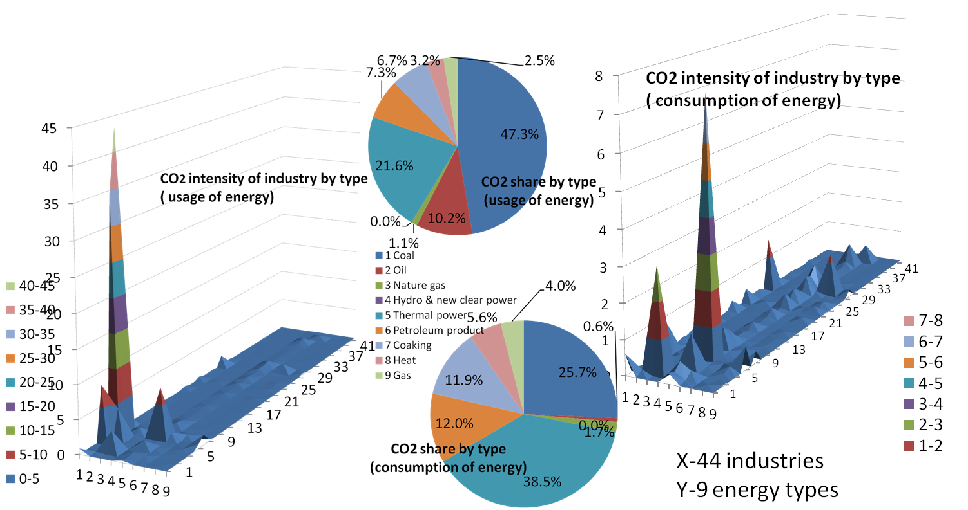

3 Adjustment potential of industry structure to reduce carbon emission

3.1 Mechanism of adjusting industry structure to reduce carbon emission

Industry structure is adjusted to reduce the carbon emission in total. The mechanism is preformed as shown in figure 3.1. The energy system with 9 types of energy is associated with economy system with all kinds of industries and households. The carbon dioxide is emitted during the production of industry when using or consuming the energy of all types by different rate. If the industry structure is adjusted well, the carbon emission can be reduced without decrease of the total output or GDP. One the one hand, China reduces the output of industry with high carbon emission coefficient (heavy industry) and increases the output of industry with low carbon emission coefficient (high technology industry). The input of energy to heavy industry decrease, which further induce the energy input of other industries decreasing, so carbon emission decrease; while the input of energy to high technology industry increase, which further induce the energy input of other industries increasing, so carbon emission increase. The directly and indirectly carbon emission caused by the decrease in the output of heavy industry is more than the directly and indirectly carbon emission caused by the increase in the output of high technology. On the other hand, China reduces the output of industry with low total demand coefficient or low value added rate, and increases the output of industry with high total demand coefficient or high value added rate. It made the total output or GDP increase. The strategy of adjustment of industry structure has two effects. One is changing the energy input and reducing emitted carbon emission; another is changing the relationship of input and output among industries and increase the GDP or total output.

Figure 3.1 adjustment of industry structure to reduce CO2
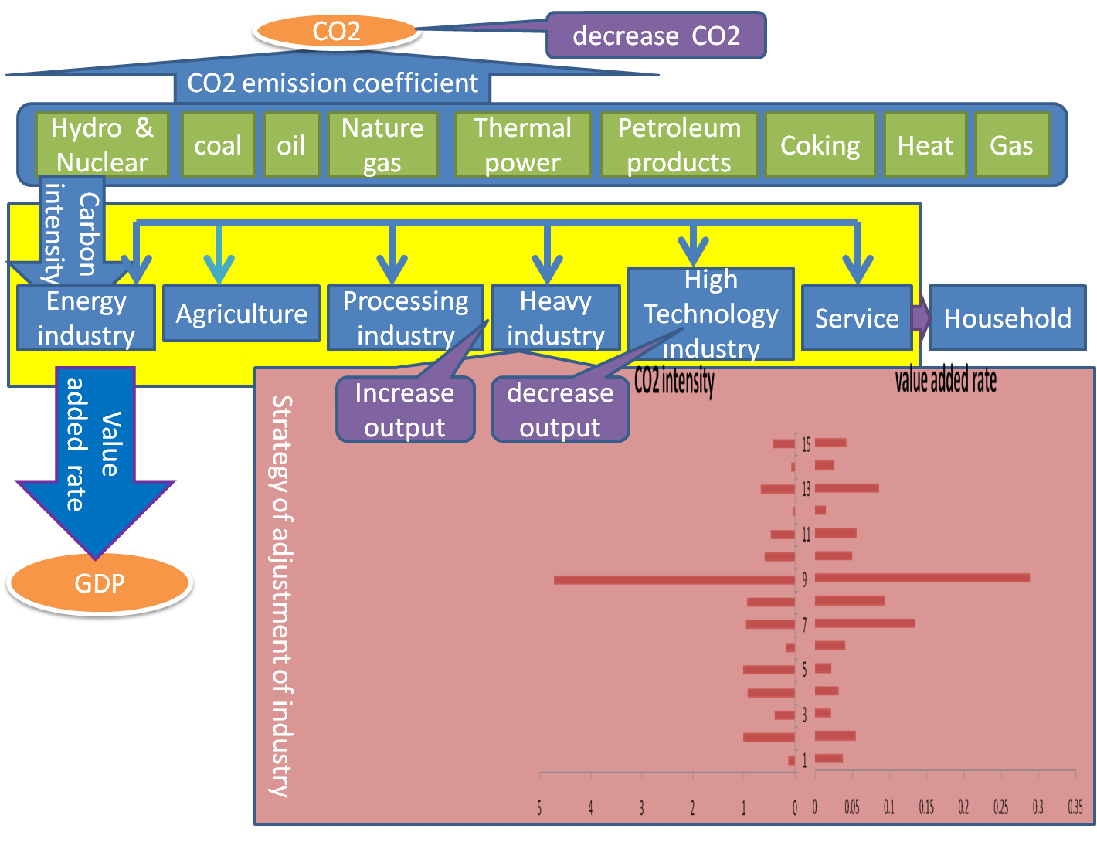
Note: the CO2 intensity and value added rate are obtained according the ECEIO table in 2007 with 15 industries.
The strategy can be known through comparing CO2 intensity and value added share by the industries. Through compiled ECEIO table in 2007 (the index of industry refers to appendix 1), we can find that services and agriculture have less CO2 intensity (1.37 ton per 1000 Yuan) and larger share of value added in output (3.7%). Heavy manufactures have the largest CO2 intensity as well as largest value added share (rate). For example, CO2 intensity of industry 9 Metal processing and manufacture was 47.21 ton per 1000 Yuan, that of industry 7 Chemical and Pharmaceutical and Medicine Manufacturing was 9.65 ton per 1000 Yuan, and that of industry 8 Building materials and non-Metallic Materials Industry was 9.41 ton per 1000 Yuan, the share of value added to output in these three industry were 28.9%, 13.5% and 9.4%. High technical manufacture, for example, industry 10 Mechanic, electronic equipment and other manufacturer, have less CO2 intensity, namely, 6.00 ton per 1000 Yuan, but comparative large value added share (rate), i.e. 5.0%; Light manufactures have comparative large CO2 intensity but less value added share (rate). CO2 intensity of industry 5 Wood processing and Manufacture of Articles for Culture, Education and Sport Activities, industry 4 Textile, Wearing Apparel, and industry 3 Food manufacture and tobacco processing were respectively 10.16 9.34 and 4.04 ton per 1000 Yuan, and the share of these industries were 2.2%, 3.2% and 2.1%. Energy industries, for instance, industry 6 Petroleum Processing, Coking and Nuclear Fuel Processing and industry 11 Electricity, heat power and water production and supply have comparative less CO2 intensity, i.e. 1.75 ton per 1000 Yuan and 4.75 ton per 1000 Yuan, as well as comparative less share of value added, i.e. 4.1% and 5.6%. However, industry 2, Mining, had comparative large CO2 intensity, i.e. 10.17 ton per 1000 Yuan and small share of value added, i.e. 5.5%.

3.2 Potential of adjusting industry structure to reduce carbon emission
We research on the potential of structure adjustment on the reduction of carbon emission. China can improve the percentage of industry with low carbon emission among the whole national economy to achieve the total amount of carbon emission of the whole country. Industry structure adjustment reflects the change in the ratio of different industry output to the national economy results in the change in the amount of dioxide carbon amount of the whole economy. A good research way is to connect input of various kinds, including energy, to the output of national economy of various industries. The output of each industry corresponding to the carbon dioxide resulted from consumption of fossil energy. We use the carbon coefficient to reflect the relation between output of various industries and carbon dioxide emission. In the future, the industry structure change in developing country is very large. The ratio of Chinese gross domestic production of three industries is 10.3：46.3：43.4 in 2009, meanwhile, the sum of GDP of the first industry and the second industry 19.3 trillion Yuan，next to American and superior to Japan. The productivity of the first industry is low, the second industry has high pollution and high emission, the third industry has low carbon emission coefficient and high profit. Assume the GDP of China in 2020 will reach to or near to that of America, the production of various industries will be adjusted to make the output of industry with high emission reduced and the output of industry with low emission increase so as to the emission of whole country reduction.
We assume economy growth rate reach to the foresee target and total amount of carbon emission below the foresee target, thus we get the potential capability of adjustment of industry structure, hence the reduction of carbon emission. The potential capability of adjustment of industry structure refers to the difference of output of various industries at present structure and that of optimal structure. Through setting the various scenarios of industry structure adjustment, we give the scenarios of reduction of carbon emission permitted, the potential capability vary from the various industries. It is defined as the difference between outputs of each industry at present with that of optimal structure given carbon emission constraint. The minus refer to the potential capability for output to decrease, and positive means the potential capability for output to increase. The potential capability has more amounts, then this industry has more space to be improved or optimized so that the contribution of this sector is large; the potential capability has fewer amounts, the industry has less space to be improved or optimized so that the contribution of this industry is small. The potential capability of adjustment of industry structure is shown as,
${ΔS}_{j}=S_{j}^{t}−S_{j}^{0}$ (3.1)
$[S_{j}]=[{x_{j}}/X]$refer to the ratio of output $x_{j}$of industry $j$ to the total output $X$, $S_{i}^{t}$ and $S_{j}^{0}$ respectively reflect the industry structure of industry $j$ after optimization and initial industry structure of industry $i$ before optimization.

3.3 Optimal input-output model
Target of carbon emission is classified into two types: target of intensity of carbon emission and that of absolute amount of carbon emission. Assuming the carbon emission is produced by fossil energy consumption, other non-fossil energy consumption and ecology activity don’t produces dioxide carbon, we calculate three scenarios with three cases, they are constraints under three growth rates with two types of target of carbon emission.
The first target is that of intensity of carbon emission. China presents the target of decreasing the intensity of carbon emission that, in 2020 China’s carbon dioxide emissions per GDP decreased to 40% -45% compared with 2005’s, and in 2020 our nation’s non-fossil fuels declined to 15% around proportion in primary energy consumption. From this, we can calculate the index of the constraints of carbon intensity. Let intensity of carbon emission ($I$) equal to the total amount of dioxide carbon produced by energy consumption ($C$) divided by national production amount ($\text{GDP}$), then the equation is expressed as:
$I=C/{\text{GDP}}$ (3.2)
${ΔI}_{\text{15}}=−\frac{{C_{1}}/{{\text{GDP}}_{1}}−{C_{0}}/{{\text{GDP}}_{0}}}{{C_{0}}/{\text{GDP}}}×\text{100}\text{\%}∈(\text{40}\text{\%,}\text{45}\text{\%})$ (3.3)
Thus the index of reduction of carbon emission in average of 15 year from 2005 to 2020 should reach to
$\begin{aligned}\sqrt[\text{15}]{(1−\text{40}\text{\%})}−1=−6\text{.}\text{76}\text{\%} \\ \sqrt[\text{15}]{(1−\text{45}\text{\%})}−1=−5\text{.}\text{93}\text{\%}\end{aligned}$ (3.4)
Table 3.1 The index of intensity of carbon emission and the carbon emission per year (%)
Scenario 1 |  |  | Scenario 2 |  |  | Scenario 3 |  |  | Scenario 4
Intensity of carbon emission | Growth rate of GDP（m） | Total amount of carbon emission（r） | Intensity of carbon emission | Growth rate of GDP（m） | Total amount of carbon emission（r） | Intensity of carbon emission | Growth rate of GDP（m） | Total amount of carbon emission（r） | Intensity of carbon emission | Growth rate of GDP（m） | Total amount of carbon emission（r）
-5.93 | 9 | 2.53 | -6.35 | 9 | 2.08 | -6.76 | 9 | 1.63 | -9.14 | 9 | -0.4
-5.93 | 8 | 1.60 | -6.35 | 8 | 1.14 | -6.76 | 8 | 0.70 | -8.30 | 8 | -0.4
-5.93 | 7.5 | 1.12 | -6.35 | 7.5 | 0.67 | -6.76 | 7.5 | 0.23 | -7.44 | 7.5 | -0.4

We assumes the province target of reducing the intensity of carbon emission is consist to that of whole country, then total carbon emission by production in various industries in total is reduced arrange from 5.93% to 6.76%. In order to analysis in more detail, we take the mean value of target of carbon emission，then the index of target of carbon emission intensity has high value（5.93%）, middle value（6.35%）, and low value（6.76%）. To research on the industry structure adjustment potential, we assume growth rate per year of GDP has three cases, that is the growth rate of GDP is quick growth rate（9%）, normal growth rate（8%） and slow growth rate（7.5%）three cases。From above assumption, we obtain the three scenarios with different change in the amount of carbon emission and the intensity of carbon emission (shown as table 3.1）.
It researches on the effect of energy structure and effectively changes on carbon emission. Assuming the carbon dioxide produced by fossil energy, the amount of carbon emission is calculated as energy standard coal, then carbon emission produced by coal is largest, oil is less, and gas is lest. While the renewable energy, including the bio fuel, solar energy, wind energy and geothermal energy, and so on, don’t discharge carbon emission. To calculate the carbon emission from energy activity requires energy consumption and carbon emission transaction. Carbon emission coefficient is measure according to the equation and data in 《2006 IPCC Guidelines on National Greenhouse Gas Inventories》 and the National Statistic Bureau 《energy statistic yearbook》.
In future, the development of energy of world is to reduce the consumption of fossil energy and increase the ratio of renewable energy to the whole energy, and improve the efficiency of energy. Foresee this ratio in 2020 will reach to 15%. In 2009, China has energy structure of which has coal consumption as main consumption with high carbon emission. Coal consumption takes 70% of energy consumption, oil takes 17.8%, gas takes 2.9%, water and nuclear power takes 8.3%. Thus the renewable energy will rise from 8.3% in 2009 to 15% in 2020. We can assume that the increase rat of renewable energy each year as 5.4% of that of last year. Assuming the percentage of substituting fossil energy by renewable energy is consistent for every industry. We can measure the coefficient of carbon emission in future. In the case of economy growth, to guarantee the safe of energy and environment, it is necessary to change the energy structure and efficiency for the potential capability of reduction of the carbon emission.
This paper builds the optimization input-output model. The goal is to model the largest GDP in input-output relations, carbon emission constraints and different economic growth scenarios; the establishment of industrial restructuring goal programming model is as follows:
$\text{max}E(I−A)X$(3.5) $s\text{.}t\text{.}\begin{aligned}\left\{\text{AX}+Y+U−M≤X | \right.\left\{C_{Z}X+C_{Y}≤r×{\text{TC}}_{0} | \right.\left\{\text{VX}≥m×{\text{GDP}}_{0} | \right.\left\{X^{l}≤X≤X^{u} | \right.\left\{U^{l}≤U≤U^{u} | \right.\end{aligned}$ (3.6)
Stands for direct consumption coefficient matrix in the input-output tables, is that the total output column vector of each industry, is that the column vector of final demand, $E$ is unit raw vector, and respectively, are exports and imports, Input-output tables that direct consumption coefficient matrix. $C_{Z}$ is the carbon emission coefficient during production, $C_{Y}$ is carbon emission coefficient during household living, ${\text{TC}}_{0}$ is the carbon emission at the initial time, $r$ is the current rate of carbon emission compared with the rate at initial time. It is set according to the three target of reduction of carbon emission high, middle and low and three case of growth rate of GDP. is value added rate row vector, GDP is the gross domestic production at initial time，$m$for current GDP growth rate compared with that at initial time, corresponding to the growth rate of three case. The subscript $l$ and superscript $u$ are lower and upper bounds respectively. There are no low bound for production and export, and no up bound for import. The up bound of output is 125% output of various industry of past year（ten Raa，2009）.
Specific constraints are explained as follows:
$s\text{.}t\text{.}\begin{aligned}\left\{\text{Input-output balance constraints} | \right.\left\{\text{Emission reduction targets constraints} | \right.\left\{\text{Economy growth constraint} | \right.\left\{\text{the upper and lower bounds of output} | \right.\left\{\text{the upper and lower bounds of export} | \right.\end{aligned}$（3.6）

Various constraints on the model explained as follows: input-output balance equation states that the output of various industries to meet demand, final demand, import and export. Emission reduction targets constraints is set as three constraint circumstances and economic growth constraints is set as three constraint circumstances in Table 3.1. Solving the four emissions scenarios are as below, to achieve the industrial structure optimization potential. According to three scenarios about the carbon emission reduction rate constraints and economic growth rate constraints, we know that, in model (1), coefficient $m$ is the ratio of GDP at current period to that of initial period, and coefficient $r$ is growth rate of carbon emission of current period compared with that of initial period. The second constraint shows the carbon emission is less than that in scenarios, so it grow as the rate of $m$ comparing to emission at initial time. The third constraint show that the economy growth rate is more than that in scenarios, so it grow as the rate r。Hence, the three circumstance can guarantee that carbon emission intensity low than the target at Copenhagen Conference. We can calculate the optimization output in the optimization model, and then the potential capacity of industry structure adjustment. We resolve the solution of the model.
The effect of the industry structure adjustment and energy structure adjustment show as
$ΔC=C^{t}−C^{0}=\sum{x_{j}^{t}c_{j}}−\sum{x_{j}^{0}c_{j}}$ (3.7)
$C_{j}^{t}$ and $C_{j}^{0}$ is the difference of carbon emission after and before optimization.
3.4 Potential of structure adjustment in China and that in Shanghai
We use the optimal model to calculate the optimal industry structure of China and Shanghai. So we compile the ECEIO table of China in 2005 with 44 industries, and the ECEIO table in 2007 with 15 industries, the ECEIO table of Shanghai in 2007. The value part comes from input-output table of China in 2005 and 2007 and the input-output table of Shanghai in 2007. The volume data of energy and carbon emission can be computed according to “energy balance table” and “final used energy by industry” of China in 2005 and 2007 and that of Shanghai in 2007. All of the carbon emission is accounted according to the final consumption of energy by type. The ECEIO table of China in 2005 has 44 industries the classification of industry in these tables is shown as appendix 1. The ECEIO table of China in 2007 has 15 industries; the classification of industry in these tables is shown as appendix 2. The ECEIO table of Shanghai in 2007 has 26 industries; the classification of industry is shown as appendix 3. According to the ECEIO table with combination of value and volume data, we obtain the carbon emission coefficient before and after adjustment, and then from this table, we obtain the optimal structure of industries by application of the optimization model. Comparing the optimal structure and previous structure, we know how to adjust the industry structure to guarantee the target of reducing dioxide carbon emission at target year.
According to the ECEIO table, we calculate the carbon dioxide coefficient of various industries before and after change of energy structure, and compare it to the ratio of original output of various industries to total output. This is the basis of industry structure adjustment by applying the optimization model. The result of optimization model is the output which can guarantee the maximization of gross domestic production, and the carbon emission after industry structure adjustment less than the carbon emission constraints. From the ratio of output of each industry to total output of the whole country, we know the difference of it with original ratio of output of each industry to the total output of the whole country and obtain the way of adjustment of industry structure. We set three scenarios of target of carbon emission intensity by high target, middle target and low target, and three cases of economy growth rate as 9%, 8% and 7.5%, hence 9 cases of constraints of carbon emission, and then apply the optimization model to design the way of industry structure adjustment.
3.4 .1 Potential of structure adjustment based on China’s ECEIO table in 2005
First, we give the industry adjustment based on China’s ECEIO table in 2005. Based on China’s ECEIO table in 2005 with 44 industries, we set the constraint of carbon emission intensity—decrease by 6.35% per year. If GDP increase by 8%, the amount of carbon emission increases by 1.14% per year as the second case of Scenarios 2. We calculate the optimal adjustment of industry structure and potential of carbon emission change, as shown table 3.2.
Among 44 industries, the output and carbon emission decrease in energy industry and heavy industry with high carbon emission coefficient. These industries include 1 Mining and Washing of Coal 5 Production and Distribution of Thermal Power, 7Coking, 8 Production and Distribution of Heat, 9 Production and Distribution of Gas, 21 Manufacture of Paper and Paper Products, 24 Manufacture of Raw Chemical Materials and Chemical Products, 25 Manufacture of Medicines, 26 Manufacture of Chemical Fibers, 29 Manufacture of Non-metallic Mineral Products, 30 Smelting and Pressing of Ferrous Metals, 31 Smelting and Pressing of Non-ferrous Metals. Meanwhile, the output of 29 Manufacture of Non-metallic Mineral Products, 30 Smelting and Pressing of Ferrous Metals, and 5 decrease at the largest extend, about 1% of the original output. The carbon emission of 1 Mining and Washing of Coal decrease 8.7%; the carbon emission of other industries decreases by 19.75%. On contrary, the output and carbon emission increase in the rest of industries, including energy industry with low carbon emission coefficient. The carbon emission all increase by 33.75% for all of these industries. The output increase at largest extent in the service, (i.e. 44 Real estate finance and other service, 43 wholesale and retail trades, 42 Transportation, storage, Storage and Post), high technology industry (i.e. 37, Manufacture of Communication Equipment, Computers and Other Electronic Equipment 35 Manufacture of Transport Equipment, 36 Manufacture of Electrical Machinery and Equipment, 33anufacture of General Purpose Machinery), and processing industry (i.e. 14 Manufacture of Foods, 28 Manufacture of Plastics), and 41 Construction, 10 Agriculture.

Table 3.2 Potential adjustment of industry structure and reduction of carbon emission
Industry j | $${ΔS}_{j}$$ | $${{ΔC}_{j}}/{C_{j}^{0}}$$ | Industry j | $${ΔS}_{j}$$ | $${{ΔC}_{j}}/{C_{j}^{0}}$$
1 | -0.39% | -8.70% | 23 | 0.03% | 33.75%
2 | 0.07% | 33.75% | 24 | -0.53% | -19.75%
3 | 0.01% | 33.75% | 25 | -0.19% | -19.75%
4 | 0.04% | 33.75% | 26 | -0.18% | -18.76%
5 | -0.98% | -19.75% | 27 | 0.11% | 33.75%
6 | 0.14% | 33.75% | 28 | 0.23% | 33.75%
7 | -0.09% | -19.75% | 29 | -1.01% | -19.75%
8 | -0.02% | -19.75% | 30 | -1.45% | -19.75%
9 | -0.05% | -19.75% | 31 | -0.61% | -19.75%
10 | 0.51% | 33.75% | 32 | 0.14% | 33.75%
11 | 0.02% | 33.75% | 33 | 0.21% | 33.75%
12 | 0.02% | 33.75% | 34 | 0.11% | 33.75%
13 | 0.03% | 33.75% | 35 | 0.23% | 33.75%
14 | 0.24% | 33.75% | 36 | 0.21% | 33.75%
15 | 0.05% | 33.75% | 37 | 0.36% | 33.75%
16 | 0.04% | 33.75% | 38 | 0.05% | 33.75%
17 | 0.20% | 33.75% | 39 | 0.06% | 33.75%
18 | 0.09% | 33.75% | 40 | 0.01% | 33.75%
19 | 0.06% | 33.75% | 41 | 0.55% | 33.75%
20 | 0.08% | 33.75% | 42 | 0.32% | 33.75%
21 | -0.38% | -19.75% | 43 | 0.44% | 33.75%
22 | 0.04% | 33.75% | 44 | 1.15% | 33.75%
Note: The carbon emission increases by $ΔC$=1.4 million ton carbon dioxide (carbon emission intensity decrease 6.35% per year).${ΔS}_{j}$ is the ratio of industry to total output. ${{ΔC}_{j}}/{C_{j}^{0}}$ means the change in the amount of carbon emission. Positive (+) means increase, and minus (-) means decrease.
3.4 .2 Structure adjustment of 3 scenarios on China’s ECEIO table in 2007
Second, we give the industry adjustment based on China’s ECEIO table in 2007. We set carbon emission intensity with low constraint (scenario 1), middle constraint (scenario 2) and high constraint (scenario 3). Each scenario has three levels of GDP growth rate, 9%, 8% and 7.5%. We list the 9 case of potential adjustment of industry structure in the table 3.3. As for industry structure adjustment, the most industries increased in their output. The ratio of output of high technology industry and service to the total output should increase. High technique industry, such as mechanical, electronic equipment manufacturer, has the largest increase range, as 1.72%-1.85%, real estate, finance and other service has the second large increase range, as 1.17%-1.26%. Among the industries which increase output, the increase range became large as the constraints of carbon emission tighter, or as the economy growth rate slower. For example, for mechanical, electronic equipment manufacturer, its industry structure increase as 1.72%，1.74%，1.77% with the carbon emission constraints as 2.53, 2.08, and 1.63 ton carbon dioxide, which is corresponding to scenario one, i.e. carbon emission intensity decrease as 5.93%, to scenario 3, i.e. carbon emission intensity decrease as 6.76%, all in the case of economy growth rate as 9%. For the industries with high carbon emission coefficient, such as heavy industries, their output should decrease most. For example, metal processing and manufacturer should decrease 8.13%-8.74%. Its industry structure decrease by the rate as 8.13%，8.25%，8.37% with the carbon emission constraints as 2.53, 2.08 and 1.63 ton carbon dioxide, which is corresponding to scenario 1, i.e. carbon emission intensity decrease as 5.93%, to scenario three, i.e. carbon emission intensity decrease as 6.76%, all in the case of economy growth rate as 9%. As for the economy growth rate as 9%, 8% and 7.5%, the carbon emission constraint decrease as 5.93%, this industry structure decrease respectively as 8.13%，8.38% and 8.50%.
Table 3.3 China’s Potential adjustment of industry structure (no energy structure change)
$${ΔS}_{j}$$ | Scenario 1(low) |  |  | Scenario 2(middle) |  |  | Scenario 3(high)
GDP  $$ΔC$$ | 9%  2.53 | 8%  1.60 | 7.5%  1.12 | 9%  2.08 | 8%  1.14 | 7.5%  0.67 | 9%  1.63 | 8%  0.70 | 7.5%  0.23
1 | 0.54% | 0.55% | 0.56% | 0.55% | 0.56% | 0.57% | 0.55% | 0.57% | 0.58%
2 | 0.32% | 0.33% | 0.34% | 0.33% | 0.34% | 0.34% | 0.33% | 0.34% | 0.34%
3 | 0.46% | 0.47% | 0.48% | 0.47% | 0.48% | 0.49% | 0.47% | 0.49% | 0.49%
4 | 0.48% | 0.49% | 0.50% | 0.48% | 0.50% | 0.50% | 0.49% | 0.50% | 0.51%
5 | 0.28% | 0.29% | 0.30% | 0.29% | 0.30% | 0.30% | 0.29% | 0.30% | 0.31%
6 | 0.23% | 0.24% | 0.24% | 0.23% | 0.24% | 0.25% | 0.24% | 0.25% | 0.25%
7 | 0.68% | 0.70% | 0.71% | 0.69% | 0.71% | 0.72% | 0.70% | 0.72% | 0.73%
8 | 0.25% | 0.26% | 0.26% | 0.25% | 0.26% | 0.27% | 0.26% | 0.27% | 0.27%
9 | -8.13% | -8.38% | -8.50% | -8.25% | -8.50% | -8.62% | -8.37% | -8.61% | -8.74%
10 | 1.72% | 1.77% | 1.80% | 1.74% | 1.79% | 1.82% | 1.77% | 1.82% | 1.85%
11 | 0.37% | 0.38% | 0.39% | 0.38% | 0.39% | 0.39% | 0.38% | 0.39% | 0.40%
12 | 0.69% | 0.71% | 0.72% | 0.70% | 0.72% | 0.73% | 0.71% | 0.73% | 0.74%
13 | 0.47% | 0.48% | 0.49% | 0.47% | 0.49% | 0.49% | 0.48% | 0.49% | 0.50%
14 | 0.48% | 0.49% | 0.50% | 0.49% | 0.50% | 0.51% | 0.49% | 0.51% | 0.52%
15 | 1.17% | 1.20% | 1.22% | 1.18% | 1.22% | 1.24% | 1.20% | 1.24% | 1.26%
Note: The industry is classified as China’s ECEIO table in 2007( Appendix).
We compute the potential adjustment of industry structure with the energy structure change, shown in table 3.4. Consider the energy structure change, namely the change in the ratio of non-fossil energy to the consumption of first primer energy by 15% from 2005 to 2020. It means the non-fossil energy consumption increase by 5.4%. In this case, potential adjustment of industry structure has the same direction of change like previous case in table 3.3, but small range of increase and decrease. First, we focus on the industry with increase in structure, the high technique industry with low carbon emission, such as mechanism and electronic equipment, increase at largest range as 1.4%-1.53%, real estate, finance and other service, its range of increase at the second large range as 0.95%-1.04%. Among the industries with increase in output, their increase range became larger with the carbon emission tighter. For example, mechanism, electronic equipment manufacture, its industry structure increase as the rate of 1.4%，1.42%，1.45% for carbon emission constraints as 2.53, 2.08 and 1.63 ton carbon dioxide, from scenario one, carbon emission intensity decrease 5.93% to scenario three, carbon emission intensity decrease 6.76%, all with economy growth rate 9%. For economy growth rate respectively as 9%, 8% and 7.5%, carbon emission constraints decrease 5.93% per year, the industry structure increase as 1.4%, 1.45% and 1.48%. For the industry with high carbon emission coefficient, the output should decrease. The largest adjustment occurs in the industries with high carbon coefficient, such as metal processing and manufacturer, it decrease by 6.62%-7.24%. the industry structure decrease at the rate as6.62%，6.74%，6.86%, with the carbon constraint as 2.53, 2.08, 1.63 ton carbon dioxide, which is corresponding to scenario one, i.e. carbon emission intensity decrease as 5.93%, to scenario three, i.e. carbon emission intensity decrease as 6.76%, all in the case of economy growth rate as 9%. It industry structure respectively decrease as 6.62%，6.87% and 7%, with constraints of carbon emission decrease by 5.93% for the economy growth rate as 9%, 8% and 7.5%.
Table 3.4 China’s potential capability of industry structure (energy structure change)
$${ΔS}_{j}$$ | Scenario one* |  |  | Scenario two* |  |  | Scenario three*
$$ΔC$$ | 2.53 | 1.60 | 1.12 | 2.08 | 1.14 | 0.67 | 1.63 | 0.70 | 0.23
GDP | 9% | 8% | 7.5% | 9% | 8% | 7.5% | 9% | 8% | 7.5%
1 | 0.44% | 0.45% | 0.46% | 0.45% | 0.46% | 0.47% | 0.45% | 0.47% | 0.48%
2 | 0.26% | 0.27% | 0.28% | 0.27% | 0.28% | 0.28% | 0.27% | 0.28% | 0.29%
3 | 0.37% | 0.39% | 0.40% | 0.38% | 0.39% | 0.40% | 0.39% | 0.40% | 0.41%
4 | 0.39% | 0.40% | 0.41% | 0.39% | 0.41% | 0.42% | 0.40% | 0.42% | 0.42%
5 | 0.23% | 0.24% | 0.25% | 0.24% | 0.24% | 0.25% | 0.24% | 0.25% | 0.25%
6 | 0.19% | 0.20% | 0.20% | 0.19% | 0.20% | 0.20% | 0.20% | 0.20% | 0.21%
7 | 0.55% | 0.58% | 0.59% | 0.56% | 0.59% | 0.60% | 0.57% | 0.60% | 0.61%
8 | 0.20% | 0.21% | 0.22% | 0.21% | 0.22% | 0.22% | 0.21% | 0.22% | 0.22%
9 | -6.62% | -6.87% | -7.00% | -6.74% | -6.99% | -7.12% | -6.86% | -7.11% | -7.24%
10 | 1.40% | 1.45% | 1.48% | 1.42% | 1.48% | 1.50% | 1.45% | 1.50% | 1.53%
11 | 0.30% | 0.31% | 0.32% | 0.31% | 0.32% | 0.32% | 0.31% | 0.32% | 0.33%
12 | 0.56% | 0.58% | 0.59% | 0.57% | 0.59% | 0.60% | 0.58% | 0.60% | 0.61%
13 | 0.38% | 0.39% | 0.40% | 0.39% | 0.40% | 0.41% | 0.39% | 0.41% | 0.42%
14 | 0.39% | 0.41% | 0.41% | 0.40% | 0.41% | 0.42% | 0.40% | 0.42% | 0.43%
15 | 0.95% | 0.99% | 1.00% | 0.97% | 1.00% | 1.02% | 0.99% | 1.02% | 0.104
Note: The industry is classified as China’s ECEIO table in 2007( Appendix).
3.4.3 Structure adjustment of 3 scenarios on Shanghai’s ECEIO table in 2007
Third, we give the industry adjustment based on Shanghai’s ECEIO table in 2007. We make use of Shanghai ECEIO in 2007 to address the optimal industry structure. The industry is shown in appendix. The constraints in first three scenarios are decreased carbon emission intensity, but the increased amount of carbon emission. The constraint in scenario 4 is decreased absolute amount of carbon emission which is made according the standard of European reduction standard.
Shanghai’s optimal adjustment of industry structure is shown in table 3.6. The services and the high technology increase their output at the largest degree, for example, 26 Real estate finance and other service as 1.8%-2.2%, 16 Manufacture of Communication Equipment, Computers and Other Electronic Equipment as 1.1%-1.3%, 13 Manufacture of General Purpose and Special Purpose Machinery as 0.5%-0.7%, 14 Manufacture of Transport Equipment as 0.5%-0.6%, 25 wholesale and retail trades as 0.4%-0.5%, 15 Manufacture of Electrical Machinery and Equipment as 0.3%-0.4. On contrary, the heavy industry and processing industry decrease their output at largest degree. In detail, 24 Transportation, storage, Storage and Post decrease by 2.1%-2.2%, 11 Smelting and Pressing of Ferrous Metals decrease by 1.8%-1.9%, 9 Chemical and Pharmaceutical and Medicine Manufacturing and 8 Petroleum Processing, Coking and Nuclear Fuel Processing, decrease by 0.8%-2.3%, 4 Manufacture of Textile decrease by 0.3%, and 10 Building materials and non-Metallic Materials Industry decreased by 0.3%.
Table 3.5 Shanghai’s potential adjustment of industry structure
$${ΔS}_{j}$$ | Scenario 1 |  |  | Scenario 2 |  |  | Scenario 3 |  |  | Scenario 4
GDP | 9% | 8% | 7.5% | 9% | 8% | 7.5% | 9% | 8% | 7.5%
$$ΔC$$ | 0.025 | 0.016 | 0.011 | 0.021 | 0.011 | 0.007 | 0.016 | 0.007 | 0.002 | -0.004
1 | 0.0% | 0.1% | 0.1% | 0.1% | 0.1% | 0.1% | 0.1% | 0.1% | 0.1% | 0.1%
2 | 0.0% | 0.0% | 0.0% | 0.0% | 0.0% | 0.0% | 0.0% | 0.0% | 0.0% | 0.0%
3 | 0.2% | 0.2% | 0.2% | 0.2% | 0.2% | 0.2% | 0.2% | 0.2% | 0.2% | 0.2%
4 | -0.3% | -0.3% | -0.3% | -0.3% | -0.3% | -0.3% | -0.3% | -0.3% | -0.3% | -0.3%
5 | 0.1% | 0.1% | 0.1% | 0.1% | 0.1% | 0.1% | 0.1% | 0.1% | 0.1% | 0.1%
6 | 0.1% | 0.1% | 0.1% | 0.1% | 0.1% | 0.1% | 0.1% | 0.1% | 0.1% | 0.1%
7 | 0.1% | 0.1% | 0.1% | 0.1% | 0.1% | 0.1% | 0.1% | 0.1% | 0.1% | 0.1%
8 | -0.8% | -0.8% | -0.8% | -0.8% | -0.8% | -0.8% | -0.8% | -0.8% | -0.8% | -0.7%
9 | -0.8% | -1.2% | -1.5% | -1.0% | -1.5% | -1.7% | -1.2% | -1.7% | -2.0% | -2.3%
10 | -0.3% | -0.3% | -0.3% | -0.3% | -0.3% | -0.3% | -0.3% | -0.3% | -0.3% | -0.3%
11 | -1.9% | -1.9% | -1.9% | -1.9% | -1.9% | -1.8% | -1.9% | -1.8% | -1.8% | -1.8%
12 | 0.2% | 0.2% | 0.2% | 0.2% | 0.2% | 0.2% | 0.2% | 0.2% | 0.2% | 0.2%
13 | 0.5% | 0.6% | 0.6% | 0.6% | 0.6% | 0.6% | 0.6% | 0.6% | 0.6% | 0.7%
14 | 0.5% | 0.6% | 0.6% | 0.5% | 0.6% | 0.6% | 0.6% | 0.6% | 0.6% | 0.6%
15 | 0.3% | 0.4% | 0.4% | 0.4% | 0.4% | 0.4% | 0.4% | 0.4% | 0.4% | 0.4%
16 | 1.1% | 1.2% | 1.2% | 1.1% | 1.2% | 1.3% | 1.2% | 1.3% | 1.3% | 1.3%
17 | 0.1% | 0.1% | 0.1% | 0.1% | 0.1% | 0.1% | 0.1% | 0.1% | 0.1% | 0.1%
18 | 0.0% | 0.0% | 0.0% | 0.0% | 0.0% | 0.0% | 0.0% | 0.0% | 0.0% | 0.0%
19 | 0.0% | 0.0% | 0.0% | 0.0% | 0.0% | 0.0% | 0.0% | 0.0% | 0.0% | 0.0%
20 | 0.2% | 0.2% | 0.2% | 0.2% | 0.2% | 0.2% | 0.2% | 0.2% | 0.2% | 0.2%
21 | 0.0% | 0.0% | 0.0% | 0.0% | 0.0% | 0.0% | 0.0% | 0.0% | 0.0% | 0.0%
22 | 0.0% | 0.0% | 0.0% | 0.0% | 0.0% | 0.0% | 0.0% | 0.0% | 0.0% | 0.0%
23 | 0.5% | 0.5% | 0.5% | 0.5% | 0.5% | 0.5% | 0.5% | 0.5% | 0.5% | 0.6%
24 | -2.2% | -2.2% | -2.2% | -2.2% | -2.2% | -2.1% | -2.2% | -2.1% | -2.1% | -2.1%
25 | 0.4% | 0.5% | 0.5% | 0.5% | 0.5% | 0.5% | 0.5% | 0.5% | 0.5% | 0.5%
26 | 1.8% | 2.0% | 2.0% | 1.9% | 2.0% | 2.1% | 2.0% | 2.1% | 2.2% | 2.2%
Note: The industry is classified as Shanghai’s ECEIO table in 2007( Appendix).
3.5 Summary and policy suggestion
China takes the permission about the obligation of carbon emission, it is necessary to make the policy to reduce the carbon emission of various industries. It should make out according to develop economy, the situation of the industries structure and their coefficient of carbon emission of industries. To realize the target of reduction of carbon emission, China simply stop the supply of electricity of industries with high carbon emission, such as cement industry, it will weaken the productivity and make the cost rising, so we should realize the potential capability of industry adjustment for carbon emission.
This paper compiles the ECEIO table of China in 2005 and in 2007, and the ECEIO table in Shanghai, and build up an optimization input-output model to address the optimal adjustment of industry structure and potential reduction of carbon emission.
Based on ECEIO table of China in 2005, we set the intensity of carbon emission decreased by 6.35%, namely carbon emission increased by 1.14 % if GDP growth rate as 8%, and find that the output and carbon emission decrease in energy industry and heavy industry with high carbon emission coefficient (1 Mining and Washing of Coal 5 Production and Distribution of Thermal Power, 7Coking, 8 Production and Distribution of Heat, 9 Production and Distribution of Gas, 21 Manufacture of Paper and Paper Products, 24 Manufacture of Raw Chemical Materials and Chemical Products, 25 Manufacture of Medicines, 26 Manufacture of Chemical Fibers, 29 Manufacture of Non-metallic Mineral Products, 30 Smelting and Pressing of Ferrous Metals, 31 Smelting and Pressing of Non-ferrous Metals). On contrary, the output and carbon emission increase in the rest of industries, including energy industry with low carbon emission coefficient.
Based on ECEIO table of China in 2007, the adjustment of industry structure at the three scenarios of carbon emission is make to increase the output of high technique industry, such as mechanic and electronic equipment manufacture increase by 1.72%-1.85%, service, such as real estate, finance and other service increase by 1.17%-1.26%. If considering the energy structure change, mechanic and electronic manufacturer increase by 1.4%-1.53%, real estate, finance and other service increase by 0.95%-1.04%. While increase range of these industries will rise with the decline of carbon emission and economy growth slow in larger degree. The industry with high coefficient of carbon emission, such as mechanic processing and manufacturer, should decrease by the rate of 8.13%-8.74%. The range of adjustment in these industries will increase with the degree of decline of carbon emission and growth rate slower.
Based on ECEIO table of Shanghai in 2007, the adjustment of industry structure is made on four scenarios of carbon emission. Scenario 4 is the decreased absolute amount of carbon emission which is made according the standard of European reduction standard. The services and the high technology increase their output at the largest degree, for example, 26 Real estate finance and other service as 1.8%-2.2%, 16 Manufacture of Communication Equipment, Computers and Other Electronic Equipment as 1.1%-1.3%, 13 Manufacture of General Purpose and Special Purpose Machinery as 0.5%-0.7%, 14 Manufacture of Transport Equipment as 0.5%-0.6%, 25 wholesale and retail trades as 0.4%-0.5%, 15 Manufacture of Electrical Machinery and Equipment as 0.3%-0.4. On contrary, the heavy industry and processing industry decrease their output at largest degree. In detail, 24 Transportation, storage, Storage and Post decrease by 2.1%-2.2%, 11 Smelting and Pressing of Ferrous Metals decrease by 1.8%-1.9%, 9 Chemical and Pharmaceutical and Medicine Manufacturing and 8 Petroleum Processing, Coking and Nuclear Fuel Processing, decrease by 0.8%-2.3%, 4 Manufacture of Textile decrease by 0.3%, and 10 Building materials and non-Metallic Materials Industry decreased by 0.3%.
Those research results will give a reference for the government to make plan of industry adjustment to realize the target of carbon emission with being harm to economy.

Reference
- Annual Energy Outlook 2010, www.eia.doe.gov
- IPCC, 2005 IPCC (2005), Special Report on Carbon Dioxide Capture and Storage, Intergovernmental Panel on Climate Change, Working Group III, Cambridge University Press, Cambridge UK.
- Pan Jiahua, Zhen Yan, Carbon Emissions and Development Right, World Environment, 2008 (4).
- Wang chan, Chen Jiling, Zhou Ji, Impact assessment of CO2 mitigation on China economy based on a CGE model, Journal of Tsinghua University, Science and Technology, 2005(12).
- J. Whalley and R. Wigle, Cutting CO2 emissions: the effects of alternative policty approaches. The Energy Journal 1991(12): 109–124.
- Manne, Richels, The Kyoto Protocol: A Cost Effective Strategy for Meeting Environmental Objectives? Energy Journal Special Issue on the Costs of the Kyoto Protocol: A MultiModel Evaluation, 1999.
- Peck, S.C., T.J. Teisberg.. "CETA: A Model for Carbon Emissions Trajectory Assessment." The Energy Journal 1992, 13(1): 55-77.
- Alcamo, J., G.J. van den Born, A.F. Bouwman, B.J. de Haan, K. Klein Goldewijk, O. Klepper, J. Krabec, R. Leemans, J.G.J. Olivier, A.M.C. Toet, H.J.M. de Vries and H.J. van der Woerd: 1994, Modeling the global society-biosphere- climate system, Part 2: Computed scenarios, Wat. Air Soil Pollut., 75 (this volume).
- Nordhaus, W.D., and Z. Yang. RICE: A Regional Dynamic General Equilibrium Model of Optimal Climate-Change Policy. New Haven, Conn.: Yale University and Massachusetts Institute of Technology. 1995.
- Pantelis Capros and Leonidas Mantzos, The European energy outlook to 2010 and 2030, Int. J. Global Energy Issues, 2000, 14, Nos. 1-4,
- Jorgenson, Dale W. and Peter J. Wilcoxen, “Reducing US Carbon Emissions: An Econometric General Equilibrium Assessment,” Resource and Energy Economics, 1993a,15(1):7-26, March.
- Jorgenson, Dale W. and Peter J. Wilcoxen, “Reducing US Carbon Dioxide Emissions: An Assessment of Alternative Instruments,” Journal of Policy Modeling, 1993b, 15(5-6): 491-520, Oct-Dec.
- Hazilla, Michael & Kopp, Raymond J, Social Cost of Environmental Quality Regulations: A General Equilibrium Analysis, Journal of Political Economy, 1990.
- Vennemo, H., A dynamic applied general equilibrium model with environmental feedbacks. Econ. Modelling, 1997 (14):99–154.
- Gerlagh and van der Zwaan, Gross World Product and Consumption in a Global Warming Model with Endogenous Technological Change, Resource and Energy Economics 2003 (25): 35–57.
- van der Zwaan and Gerlagh, Economics of Geological CO2 Storage and Leakage, under review. 2008.
- Erickson, D. & Jensen, J.R. CO2 sequestration in an unminable coalbed – San Juan Basin, Colorado, USA, in: Williams, D., Durie, B., McMullan, P., Paulson, C., Smith, A. (Eds.), Proc. of the 5th Int. Conf. on Greenhouse Control Technologies, Cairns, 2000: 589-592
- Babiker, M. H., Metcalf, G.E. & Reilly, J. Tax distortions and global climate policy. Journal of Environmental Economics and Management, 2003(46): 269-287.
- Amann M, Jiang Kejun et al. GAINS Asia: Scenarios for cost-effective control of air pollution and greenhouse gases in China. 2008. http://gains.iiasa.ac.at/gains/download/GAINS-Asia-China.pdf
- 李善同，何建武，《可计算一般均衡模型及其应用》，经济科学出版社，2010。
- Xiannuan Lin, Karen R. Polenske. Input-Output Anatomy of China’s Energy Use Changer in the 1980s[J]. Economic Systems Research, 1995,(7-1):67-83.
- Miller, R. E., and P. Blair, 1985, Input-Output Analysis: Foundations and Extensions, Prentice Hall, Inc.
- M. Lenzen, Primary energy and greenhouse gases embodied in Australian final consumption: an input–output analysis, Energy Policy, 1998, 26.
- Hawdon, D. and Pearson, P. 1995. Input-output simula tions of energy, environment, economy inter action in the UK. Energy Economics, 17, 1: 73-86.
- Proops, J.L., M. Faber, G. Wagenhals (1993). Reducing CO2 Emissions: A comparative Input-Output Study for Germany and the UK, Springer-Verlag, Berlin.
- Tarancon Moran, Miguel Angel & del Rio Gonzalez, Pablo, "A combined input-output and sensitivity analysis approach to analyse sector linkages and CO2 emissions," Energy Economics, 2007, 29(3):578-597,
- Tarancón, Miguel Angel & del Río, Pablo & Callejas Albiñana, Fernando, "Assessing the influence of manufacturing sectors on electricity demand. A cross-country input-output approach," Energy Policy, 2010, 38(4):1900-1908,
- 齐晔，李惠民，徐明，中国进出口贸易中的隐含碳估算，中国人口资源与环境，2008，18 (3)。
- 云凤，杨来科，中美贸易与气候变化——基于投入产出法的分析，世界经济研究，2009 (07)。
- 王玉潜. 能源消耗强度变动的因素分析方法及其应用[J]. 数量经济技术经济研究, 2003,(08) .
- 史丹,张金隆. 产业结构变动对能源消费的影响[J]. 经济理论与经济管理, 2003,(08) .
- Chen Xi-kang, Guo Ju-e. and Yang Cui-hong. Extending the input-output model with Assets [J], Economic Systems Research, 2005(17): 211-226.
- Xia Yan, Research on the issue of Chinese energy and carbon emission by input-holding-output model[M], Chinese Academy of Science, 2010.
- Isard W. 1956, Location and Space-economy, (The MIT Press, Cambridge), MA.
- ZhangYaxiong and Zhao Kun, Impact of Beijing Olympic-Related Investments on Regional Economic Growth of China: Interregional Input-output Approach，Economy Research, 2008，3。
- Pan Wenqing and Li Zinai, Feedback and Spillover Effects between Coastal and Non-coastal Regions of China[J]，Economy Research，2007(5): 68-77.
- Han Zhiyong, Wei Yimin, Fan Ying, Research on change features of Chinese energy intensity and economic structure，Application of Statistics and Management, 2004（23 ）1.
- Peters, Glen, C.L. Weber, D. Guan and K. Hubacek, 2007. China's growing CO2 emissions - a race between increasing consumption and efficiency gains. Environmental Science and Technology, 41 (17): 5939-5944.
- Wiedmann, T., R. Wood, M. Lenzen, J. Minx, D. Guan, and J. Barrett. (2008) “Development of an Embedded Carbon Emissions Indicator – Producing a Time Series of Input-Output Tables and Embedded Carbon Dioxide Emissions for the UK by Using a MRIO Data Optimisation System”. Report to the UK Department for Environment, Food and Rural Affairs by Stockholm Environment Institute at the University of York and Centre for Integrated Sustainability Analysis at the University of Sydney, June 2008. DEFRA, London, UK. This report is reported by Guardians, BBC News and in many press releases.

Table A.1: The classification of energy type
Energy | Industry in ECEIO table | Industry in input-output table
Raw Coal, Cleaned Coal, Other Washed Coal | Mining and Washing of Coal | Mining and Washing of Coal
Crude Oil | Extraction of Petroleum | Extraction of Petroleum and Natural Gas
Nature Gas | Extraction of Natural Gas | Extraction of Petroleum and Natural Gas
Hydro Power and Nuclear Power | Production and Distribution of Hydro Power and Nuclear Power | Production and Distribution of Electric Power and Heat Power
Thermal Power | Production and Distribution of Thermal Power | Production and Distribution of Electric Power and Heat Power
Gasline, Kerosene, Diesel Oil, Fuel Oil, other Petroleum Product | Processing of Petroleum, Processing of Nuclear Fuel | Processing of Petroleum, Processing of Nuclear Fuel
Coke, Other Coking Products | Coking | Coking
Heat | Production and Distribution of Heat Power | Production and Distribution of Electric Power and Heat Power
Coke Oven Gas, LPG, Refinery Gas, Other Gas | Production and Distribution of Gas | Processing of Petroleum, Processing of Nuclear Fuel, Coking, Production and Distribution of Gas
Table A.2: The classification of energy type
 | Energy | carbon emission coefficient(10⁴ t)
 |  | 国务院发展研究中心报告(徐国泉)国家科委气候变化项目 | IPCC
1.Mining and Washing of Coal | Raw Coal | 0.7476 | 0.7559
1.Mining and Washing of Coal | Cleaned Coal | 0.7476 | 0.7559
1.Mining and Washing of Coal | Other Washed Coal | 0.7476 | 0.7559
2.Extraction of Petroleum | Crude Oil | 0.5825 | 0.5857
3.Extraction of Natural Gas | Nature Gas | 0.4435 | 0.4483
4.Production and Distribution of Thermal Power* | Thermal Power | 2.1114
5.Processing of Petroleum, Processing of Nuclear Fuel | Gasline | 0.5825 | 0.5538
5.Processing of Petroleum, Processing of Nuclear Fuel | Kerosene | 0.5825 | 0.5714
5.Processing of Petroleum, Processing of Nuclear Fuel | Diesel Oil | 0.5825 | 0.5921
5.Processing of Petroleum, Processing of Nuclear Fuel | Fuel Oil | 0.5825 | 0.6185
5.Processing of Petroleum, Processing of Nuclear Fuel | other Petroleum Product | 0.5825 | 0.5857
6.Coking | Coke | 0.7476 | 0.855
6.Coking | Other Coking Products | 0.7476 | 0.6449
7.Production and Distribution of Heat Power* | Heat | 0.9966
8.Production and Distribution of Gas | Coke Oven Gas | 0.7476 | 0.3548
8.Production and Distribution of Gas | Other Gas | 0.7476 | 0.3548
8.Production and Distribution of Gas | LPG | 0.5825 | 0.5042
8.Production and Distribution of Gas | Refinery Gas | 0.5825 | 0.4602
Note: *the coefficient of thermal power and heat is accounted according to the energy balance table of 2005.
Table A.3:ECEIO table industry classification
 | Industry |  | Industry
1 | Mining and Washing of Coal | 19 | Manufacture of Leather, Fur, Feather and Related Products
 | Raw Coal (10⁴ ton/10⁴ ton standard coal) | 20 | Processing of Timber, Manufacture of Wood, Bamboo, Rattan, Palm, and Straw Products and Manufacture of Furniture
2 | Extraction of Petroleum | 21 | Manufacture of Paper and Paper Products
 | Crude Oil (10⁴ ton/10⁴ ton standard coal) | 22 | Printing, Reproduction of Recording Media
3 | Extraction of Natural Gas | 23 | Manufacture of Articles For Culture, Education and Sport Activity
 | Nature Gas (10⁸ Cu. M³/10⁴ ton standard coal) | 24 | Manufacture of Raw Chemical Materials and Chemical Products
4 | Production and Distribution of Hydro Power and Nuclear Power | 25 | Manufacture of Medicines
 | Hydro Power and Nuclear Power (10⁸ kW•h/ 10⁴ ton stand coal) | 26 | Manufacture of Chemical Fibers
5 | Production and Distribution of Thermal Power | 27 | Manufacture of Rubber
 | Thermal Power (10⁸ kW•h/ 10⁴ ton stand coal) | 28 | Manufacture of Plastics
6 | Processing of Petroleum | 29 | Manufacture of Non-metallic Mineral Products
 | Petroleum Product(10⁴ ton/10⁴ ton standard coal) | 30 | Smelting and Pressing of Ferrous Metals
7 | Coking | 31 | Smelting and Pressing of Non-ferrous Metals
 | Coking Products(10⁴ ton/10⁴ ton standard coal) | 32 | Manufacture of Metal Products
8 | Production and Distribution of Heat Power | 33 | Manufacture of General Purpose Machinery
 | Heat (10⁴ million KJ/10⁴ ton standard coal) | 34 | Manufacture of Special Purpose Machinery
9 | Production and Distribution of Gas | 35 | Manufacture of Transport Equipment
 | Gas (10⁸ Cu. M³/10⁴ ton standard coal) | 36 | Manufacture of Electrical Machinery and Equipment
10 | Agriculture | 37 | Manufacture of Communication Equipment, Computers and Other Electronic Equipment
11 | Mining and Processing of Ferrous Metal Ores | 38 | Manufacture of Measuring Instruments and Machinery for Cultural Activity and Office Work
12 | Mining and Processing of Non-Ferrous Metal Ores | 39 | Other Manufacturing
13 | Mining and Processing of Nonmetal Ores and Mining of Other Ores | 40 | Production and Distribution of Water
14 | Manufacture of Foods | 41 | Construction
15 | Manufacture of Beverages | 42 | Transportation, storage, Storage and Post
16 | Manufacture of Tobacco | 43 | wholesale and retail trades
17 | Manufacture of Textile | 44 | Real estate finance and other service
18 | Manufacture of Textile Wearing Apparel, Footware, and Caps | 45  46 | Rural households  Urban households
Table A.4: Classification of industry in China’s optimal industry structure
Classifi-  cation 1 | Classifi-cation 2 |  | Classifi-cation 1 | Classifi-cation 2
1 | 1 | Agriculture | 9 | 7 | Metal processing and manufacture
2 | 2 | Mining | 10 | 8 | Mechanic, electronic equipment and other manufacturer
3 | 3 | Food manufacture and tobacco processing | 11 | 9 | Electricity, heat power and water production and supply
4 | 3 | Textile, Wearing Apparel | 12 | 10 | Construction
5 | 3 | Wood processing and Manufacture of Articles for Culture, Education and Sport Activities | 13 | 11 | Transportation, storage, and information service
6 | 4 | Petroleum Processing, Coking and Nuclear Fuel Processing | 14 | 12 | wholesale and retail trades
7 | 5 | Chemical and Pharmaceutical and Medicine Manufacturing | 15 | 13 | Real estate finance and other service
8 | 6 | Building materials and non-Metallic Materials Industry | 16 | 14* | Household’s final demand/ Total industry
Note: 1. Carbon emission (Figure 6) consists to classification 1, meanwhile 16 corresponding to Household’s final demand.
2. Carbon emission intensity (Figure 7) consists to classification 2, meanwhile 14 corresponding to Total industry.
3. Forecast IO table in 2007 consists to classification 2.
Table A.4: Classification of industry in Shanghai’s optimal industry structure
No. | Industry | No. | Industry
1 | Agriculture | 14 | Manufacture of Transport Equipment
2 | Mining | 15 | Manufacture of Electrical Machinery and Equipment
3 | Food manufacture and tobacco processing | 16 | Manufacture of Communication Equipment, Computers and Other Electronic Equipment
4 | Manufacture of Textile | 17 | Manufacture of Measuring Instruments and Machinery for Cultural Activity and Office Work
5 | Manufacture of Textile Wearing Apparel, Footware, Leather, Fur, Feather and Related Products | 18 | Manufacture of Artwork and Other Manufacturing
6 | Wood processing and Manufacture | 19 | Recycling and Disposal of Waste
7 | of Articles for Culture, Education and Sport Activities | 20 | Production and Supply of Electric Power and Heat Power
8 | Petroleum Processing, Coking and Nuclear Fuel Processing | 21 | Production and Supply of Gas
9 | Chemical and Pharmaceutical and Medicine Manufacturing | 22 | Production and Supply of Water
10 | Building materials and non-Metallic Materials Industry | 23 | Construction
11 | Smelting and Pressing of Ferrous Metals | 24 | Transportation, storage, Storage and Post
12 | Metal processing and manufacture | 25 | wholesale and retail trades
13 | Manufacture of General Purpose and Special Purpose Machinery | 26 | Real estate finance and other service
Energy industry: (2), (6), (11), non-energy industry (1), (3), (4), (5), (7), (8), (9), (10), (12), (13)
Appendix 2 the energy structure change——optimization model
We make the energy structure change each year. Here ${\text{ES}}_{{}^{i}}^{T}$is the energy structure at T year ,${\text{ES}}_{{}^{i}}^{T}$ ${\text{ES}}_{{}^{i}}$
令${\text{EC}}_{{}^{i}}=\sqrt[(\text{2015}−\text{2009})]{({\text{ES}}_{i}^{\text{2015}}{\text{ES}}^{\text{2009}})}−1$

*
The calculation process is $\sqrt[(\text{2020}−\text{2009})]{\frac{\text{15}\text{\%}}{8\text{.}3\text{\%}}}−1=5\text{.}4\text{\%}$

