Shared responsibility of CO₂ emissions from trade and international freight transport

Arce González, Guadalupe; Cadarso Vecina, María-Ángeles; Gómez Sanz, Nuria; Zafrilla Rodríguez, Jorge; Tobarra Gómez, María-Ángeles*

Universidad de Castilla-La Mancha Facultad de Ciencias Económicas y Empresariales
Plaza de la Universidad n. 2, 02071, Albacete (Spain)
Phone +34 967 599 200 Ext. 2382
E-mail: MariaAngeles.Tobarra@uclm.es

ABSTRACT
The objective of our paper is to analyse the impact of international trade of CO₂ emissions with input-output data for which a country like Spain can be regarded as responsible, using a criterion of shared responsibility among trade partners. This implies first, calculating emissions embodied in imported and exported final and intermediate products and then allocating these emissions either to Spain or the rest of the world (following the methodology in Cadarso et al., 2011, in revision), that is a point between the producer and consumer responsibility criteria. In this way, a country (and sector) is responsible for all the emissions associated with the production of goods consumed domestically, plus part of those incorporated into exports, plus part of those incorporated into imports (intermediate and final). Secondly, we also need to calculate and allocate emissions from international transport of those products. As countries become more interlinked in international global supply chains, final products and more importantly intermediate inputs travel more, due to an increasing number of stages of production in different locations, and longer distances. To do so we extend a methodology already presented in Cadarso et al. (2010) that combines data from input-output tables, trade data (imports and exports by country of origin/destination and means of transport) and CO₂ emissions data. We take into account the requirements of imported inputs, the distance they travel and the means of transport used. We apply this methodology to Spanish data, comparing results for 1995, 2000 and 2005, and offer a detailed analysis by (importing / exporting / net) industry, using the DTA assumption.

Keywords: CO₂ emissions, international transportation, offshoring, consumer responsibility.
JEL: F14, Q56, L91
1. Introduction.

As awareness for the effects of economic activities on the environment increases and governments try to reach agreements on how to deal with CO₂ emissions, more literature tries to establish who is responsible for how much pollution. In this topic, most papers apply either producer (PR) or consumer responsibility (CR) criteria. The first one implies one country should be hold responsible for emissions generated in production within its borders. The second criterion means a country should answer for the pollution incorporated in the goods and services it demands, regardless of where they were produced. It seems fair countries can be made partly responsible both for emissions needed to produce those goods they enjoy and for pollution caused when generating value added and income. The concept of shared responsibility (SR) attempts to bridge those two elements and we will present the methodology to do so and apply it to Spanish data.
From a global climate change perspective some argue that it is more desirable that production takes place where it has a smaller environmentally cost and then trade the products internationally, what would reduce emissions associated to production. In this way, countries may contribute differently to global emissions depending on their environmental comparative advantage (see Peters and Hertwich, 2008a). However this argument neglects pollution embodied in international freight transport (see Cadarso et al., 2010 and Cristea et al., 2011). In order to develop a complete environmental advantage comparative measure, emissions from international transport should be included. When transport emissions are not considered there is an underestimation of total emissions, and this underestimation is higher the longer the distance covered by the commodity from the producer to the user, either final consumer or intermediate consumption importer, to avoid such a problem transport emissions shall be considered.
The structure of the paper is as follows. Section 2 reviews previous literature related to international transport emissions and emissions responsibility criteria. Sections 3 and 4 deal with methodology. In the first one, a measure of an economy international transport of imports emissions and an emission multiplier for international freight transport are described, while the second one discusses responsibility criteria and widens the shared criterion by considering transport. Section 5 and 6 present the main results for the application to the Spanish economy for the period 1995-2006, section 5 deals with transport emissions calculations while responsibility criteria are discussed in section 6. Finally, section 7 presents our conclusions.
We calculate emissions from international transport due to imports and exports for Spain and a transport trade emissions balance. Our paper also contributes to the literature above as one of the first attempts to calculate responsibility for emissions for a country and its sectors with real data following the shared responsibility criteria defined in section 4. Furthermore, we introduce a new concept: broad shared responsibility. This is a measure of shared responsibility augmented to include emissions from international transportation. In this fashion we aim to present a fairer and more comprehensive allocation of responsibility for emissions among countries.

2. International transport emissions computation and allocation literature.
In relation to the environmental impacts of international trade, the literature has mainly focused on measurement and allocation of responsibility of environmental consequences of imported goods and exports, but it neglects the environmental effects of the transport required by international trade (van Veen-Groot and Nijkamp, 1999).
On the other hand, the literature about environmental impacts of international transport is fragmented. There is a wide-ranging literature that focuses on the environmental impacts of international trade by specific transport methods (by sea, by air, by road), seeking to improve and increase the number of variables and the accuracy of the estimations (Corbett and Koehler, 2003, Endresen et al., 2003, Eyring et al., 2005, Corbett and Winebrake, 2008, on sea transport, including freight and passengers transport; Steenhof et al., 2006, Tarancón and del Río, 2007, on land transport, are some examples). Our goal is not so much to improve those measures through a new procedure as to propose a methodology that links emissions to the means of transport used, and mainly to the distance travelled, by each sector of imported goods. Also, the literature on “food-miles” widely tackles the problem of international transport focusing on the distance a commodity travel between its production and the final consumer for the food case (Jones, 2002, Weber and Matthews, 2008), but not for all the products in an economy, as we seek. Another example is Van Veen-Groot et al. (2001), who, from a qualitative point of view, analyse the impact of imports and exports in the Dutch paper industry on international transport and the environment under four different scenarios. We try to measure and to allocate the responsibility of environmental impacts of international transport of imports for each sector in the economy.
Another focus of the literature on emissions from economic activity relates to allocating responsibility. There are two main criteria: producer (PR) and consumer (CR) responsibility. PR has the advantage of being relatively easy to calculate: most countries provide data on emissions from production by industry. It is no surprise this is also the main criterion in international conferences and agreements on environmental policy (Kyoto Protocol). On the other hand, CR allows emissions linked to international trade and, therefore carbon leakage, to be accounted for (Ferng, 2003), and could be considered as fairer when imposing the burden of emissions reduction on countries or industries. The drawback of using CR rather than PR is that countries with high emissions from production compared to consumption (mainly developing countries) could be discouraged to introduce changes to reduce emissions (Bastianoni et al., 2004).
Shared responsibility (SR) as a middle way between both criteria has been suggested as a possible solution. Its main advantage lies in its ability to engage industries, countries and end consumers in the reduction of emissions arising during both production and consumption. This is particularly interesting when we consider the effect that increasing product fragmentation and offshoring processes (Grossman and Rossi-Hansberg, 2006, for USA, and Cadarso et al., 2008, for Spain) cause on emissions. If countries become partly responsible for emissions generated abroad to produce inputs, intermediate products and components they use, there will be a stronger commitment to reduce emissions in the whole of the global value chain (Hall, 2000; Green et al., 1996; Seuring and Müller, 2008). It could also facilitate agreements between developed and developing countries, as it reduces the distance when moving away from PR and closer to CR (Lenzen et al., 2007).
Calculation of consumer responsibility (CR) using single-region input-output methodology can be found in Munksgaard and Pedersen (2001) for Denmark, Ahmad and Wyckoff (2003) for OECD countries and Peters and Hertwich (2006) for Norway. Sánchez-Chóliz and Duarte (2004) calculate the CO₂ emission balance for Spain finding a small increase at national level up to 1995. We follow a close approach to those papers as we also apply the domestic technology assumption (DTA). Multi-regional papers do not make that assumption, for example, Lenzen et al. (2004) for production and consumption in Denmark, Peters and Hertwich (2008b), which calculates emissions associated with production and consumption of three different gasses in Norway (CO₂, NO_{x} and SO₂), and Peters and Herwitch (2008a), focused on CO₂ emissions for Annex B and non Annex B countries for 2001 using GTAP databases.
Shared responsibility (SR) is a more recent development in the literature so papers are few and mainly theoretical. This line of research tries to allocate responsibility for emissions as a bridge between PR and CR. Some papers applied this concept to sharing among industries (Bastioni et al., 2004) or agents (Gallego and Lenzen, 2005; Lenzen et al., 2007; and Rodrigues and Domingos 2008) within a country, while others share emissions among countries taking trade flows into account (Ferng, 2003, and Peters, 2008).
We calculate emissions from international transport due to imports and exports for Spain and a transport trade emissions balance. Our paper also contributes to the literature above as one of the first attempts to calculate responsibility for emissions for a country and its sectors with real data following the shared responsibility criteria and, furthermore, we introduce a new concept: broad shared responsibility. This is a measure of shared responsibility augmented to include emissions from international transportation. In this fashion we aim to present a fairer and more comprehensive allocation of responsibility for emissions among countries.

3. Methodology for measuring emissions linked to international freight transport
3.1. Transport emissions linked to distance, means of transport and tonnage
In this section, we review the methodology used to calculate CO₂ emissions linked to the international transport of imports following Cadarso et al. 2010. A general measure of CO₂ emissions linked to a ton of imports coming from country c, using means of transport r can be calculated as a number product of the following vectors:
$E_{c}^{t}={\text{Km}}_{c}⊗E^{t}$ (1)
where ${\text{Km}}_{c}$ is a rx1 vector that measures the distance in kilometres between c, the commodity country of origin, and the importing country by the means of transport chosen, and $E^{t}$ is a rx1 vector that includes CO₂ emissions resulting from one ton of commodity covering one kilometre by a given means of transport r (this vector does not depend on the country). We obtain as many vectors as geographical areas, 23 in our case, and they show the importance of distance and also the transport mean chosen on the amount of emissions.
We distinguish the EU-15 countries one by one, and place the rest of the EU countries together, Turkey and the other EU candidates (Croatia and Former Yugoslav Republic of Macedonia), the remaining European countries, a group of rapidly growing Asian countries (China, India, Thailand and South Korea), the rest of Asia, America, Africa and Oceania. We account for four means of transport: sea, rail, road and air, and other (including post, self-propelled, fixed transport systems and unknown), so t = 1 …5. The distances included in${\text{Km}}_{c}$ for rail, road and air transport are approximated by kilometre distances between Madrid and the capital city of each corresponding country.The distance for maritime transport is the kilometre equivalent of the nautical miles between Valencia and the main national sea port for each of the countries considered (or the closest major sea port in the case of landlocked countries).
Finally, information on CO₂ emissions per ton-Km for each type of transport in$E^{t}$ are obtained from the European Community Shipowners’ Associations (ECSA) in the Network for Transport and the Environment. Using these data, we assume CO₂ emissions per ton-Km of 18 grams for maritime transport, 17 for rail, 50 for road, 540 for air and 25 for other modes. These data are conservative, since other sources consider higher emissions per ton-Km, except for maritime transport, for example, 11 for maritime transport (Corbett and Koehler, 2003), 18 for rail, 180 for road (truck), 680 for air and 100 for other modes (pipelines) (Weber and Matthews, 2008). So, our results can be under-estimated, mainly the emissions from air and road transport, especially because Tarancón and del Río (2007) point out that out of five EU countries analysed, Spain has the most inefficient structure of road transport.
To calculate CO₂ emissions linked to country c imports of good i it is necessary to consider the structure of imports coming from such country, ${\text{Etrans}}_{c}^{\text{mt}}$. We combine the information previously estimated and sectoral information of imports per country and mean of transport, provided by the Spanish National Customs Agency (Dirección General de Aduanas, henceforth DGA), which offers data on imports in tons for each product (classified originally accoding to Taric code and reclassified following NACE at 38, n = 1…38, to in order to combine with input-output tables classification ). By adding by mean of transport we obtain a pollution vector linked to imports from a specific country, ${\text{Etrans}}_{c}^{m}$, and by adding for all countries we obtain the equivalent expression for the whole economy, ${\text{Etrans}}^{m}$.

3.2. Distinction between imported inputs and imported final goods
We shall differentiate the ${\text{Etrans}}_{c}^{m}$ measure on the pollution linked to international transportation into emissions linked to intermediate inputs and emissions linked to final goods. This decomposition can be performed by considering the input-output tables distinction between imported inputs and imported final products, resulting in two matrixes emissions associated to international transport, either of intermediate inputs, $\bar{E}{\text{trans}}_{c}^{m}$, or final goods, $\bar{E}{\text{trans}}_{c}^{\text{my}}$. Used input-output data come from the Spanish Input-Output Framework elaborated by INE (2005), the Spanish Statistical Institute. We take the symmetric input-output tables of the years 1995, 2000 and 2005, aggregated into 37 sectors and deflated taking 2000 as base year. Total emissions of air pollutants (E) come from Spanish Satellite Accounts on Atmospheric Emissions (Cuentas Satélite sobre Emisisones Atmosféricas, INE).
By multiplying $\bar{E}{\text{trans}}_{c}^{m}$by the coefficient matrix it is possible to measure pollution linked to international transport of imports of each input by industry per country, $\bar{e}{\text{trans}}_{c}^{m}$. Adding all countries it is possible to find a general measure of direct pollution from offshoring transportation. This is a general measure, defined as “broad outsourcing” by Feenstra and Hanson (1999). By considering only the elements of the main diagonal we move to the “narrow outsourcing” measure, closer to the concept of production fragmentation.

3.3. Multiplier for international freight transport emissions
The next step in transport emissions analysis is to find a multiplier for total (direct and indirect) emissions linked to the international transport of inputs. The multiplier allocates the responsibility for pollution included in the international transport of products to their final consumers (domestic or foreign through exports) and not to the importing/producing industries. The expression is as follows:
$\bar{ε}{\text{trans}}^{m}=\bar{e}{\text{trans}}^{m}{\left({\text{I-A}}^{d}\right)}^{\text{-1}}$ (2)
Where $A^{d}$ is the input-output matrix of domestic production coefficients. The measure of pollution linked to the transport of inputs provided by (2) only allows us to calculate the pollution generated in the last round of inputs that conform a global value chain. A more complete measure requires the use of a multi-regional form or to impose very restricting assumptions.
By making use or our transport emissions multiplier it is possible to account for the total amount of pollution related to the international transport of imported products required to meet the total final demand. The total transport emissions can be calculated as:
$\begin{aligned}\bar{E}{\text{transtotal}}^{m}=\bar{e}{\text{trans}}^{m}{\left({\text{I-A}}^{t}\right)}^{\text{-1}}y^{d}+\bar{E}{\text{trans}}^{\text{my}}= \\ \bar{ε}{\text{trans}}^{m}y^{r}+\bar{ε}{\text{trans}}^{m}y^{x}+\bar{E}{\text{trans}}^{\text{my}}\end{aligned}$ (3)
(3.a) (3.b) (3.c)
In this expression, $y^{d}$corresponds to final demand covered by domestic production that is compound by $y^{x}$, exports, and $y^{r}$, the sum of private consumption, public consumption and investment (as the rest of total demand). As a result, (3.a) shows total emissions linked to international transport embodied in imports required to meet final demand for domestic consumption (y^{r} is final demand except for exports, i.e. public and private consumption and investment); (3.b) shows total emissions linked to international transport embodied in imports needed for exports (the part of final demand which is to be consumed outside the country) and (3.c) shows the emissions linked to international transport of imports directly addressed to meeting final demand.
Finally, to understand the impact globalisation on emissions we could also consider a weighted measure of total transport emissions on production emissions, defined as:
$\text{Eglob}=\frac{{\text{Etrans}}^{x}+{\text{Etrans}}^{m}}{{εy}^{d}}⋅\text{100}$ (4)
where ${\text{Etrans}}^{x}$ and ${\text{Etrans}}^{m}$ account for total transport emissions for exports and imports, where the former are calculated similarly to the latter, and ${εy}^{d}$accounts for emissions generated in the domestic production process.

4. Methodology for measuring different responsibility criteria and broadened variables to include international transportation
In this section we present the methodology to compute the different responsibility criteria, with special attention to the SR measure, and their augmented versions to include emissions from international freight transport of imports and exports.
The total emissions associated with domestic production by firms within a country, or, in other words, the producer responsibility (PR), is calculated in the input-output approach according to the following expression:
$\text{PR}=\hat{e}(I−A^{d})^{−1}{\hat{y}}^{d}=ε^{d} ({\hat{y}}^{r}+{\hat{y}}^{x})$ (5)
where $\hat{e}$ is a diagonal matrix of emissions by unit produced by each sector of activity, I is the identity matrix, $A^{d}$ is the technical coefficients matrix, and ${\hat{y}}^{d}$ is the diagonal matrix that captures the final demand met by domestic production. Elements in matrix $\hat{e}$ are obtained by dividing CO₂ emissions per activity sector (E), by its effective production. We can then calculate the emission multiplier that quantifies direct and indirect emissions by domestic final demand $ε^{d}=\hat{e}(I−A^{d})^{−1}$. The matrix of final domestic production can be decomposed in two elements: production of exports (diagonal matrix ${\hat{y}}^{x}$) and production for domestic demand (final demand and consumption, diagonal matrix ${\hat{y}}^{r}$). In this fashion, we can distinguish emissions responsibility for production of those two components.
We can also analyse the matrix resulting from expression (5) both by rows and by columns. PR by rows (PR row) can be defined as the sum of the elements in each row, and it represents direct emissions for that industry when producing goods and services (either intermediate inputs required by other industries or final products). PR by columns (PR col), or sum of the elements for each column, is the total of direct and indirect emissions incorporated into the inputs from any industry that are used for production in that sector (VIS in Pasinetti’s terms). The two concepts are very different for each industry, but when aggregating all rows or columns for the economy they necessarily coincide.
Consumer responsibility (CR), as used by Munskgaard and Pedersen (2001), Ahmad and Wyckoff (2003), Sánchez-Chóliz and Duarte (2004) and Peters and Herwitch (2006, 2008a), will be the sum of two elements: 1) emissions from domestic production to meet domestic demand (consumption and investment), and 2) emissions from imported goods and services (either intermediate or final products).
Direct and indirect emissions incorporated into imports coming from country c would be calculated by ($E_{c}^{m}$):
$\begin{aligned}E_{c}^{m}={\hat{e}}_{c}(I−A_{c}^{t})^{−1}[A_{c}^{m}{\left({\text{I-A}}^{d}\right)}^{\text{-1}}{\hat{y}}^{d}+{\hat{y}}_{c}^{m}]= \\ ε_{c}^{t}[A_{c}^{m}(I−A^{d})^{−1}{\hat{y}}^{r}]+ε_{c}^{t}[A_{c}^{m}(I−A^{d})^{−1}{\hat{y}}^{x}]+ε_{c}^{t}{\hat{y}}_{c}^{m}\end{aligned}$ (6)
In order to calculate the above expression we need the amount of emissions per monetary unit of production of the country from which imported goods come ($e_{c}$), the total coefficient matrix for country c ($A_{c}^{t}$), the technical coefficient matrix for goods imported by country c ($A_{c}^{m}$) and the diagonalised matrix of final demand directly bought from country c (${\hat{y}}_{c}^{m}$). $ε_{c}^{t}={\hat{e}}_{c}(I−A_{c}^{t})^{−1}$ is the total emissions multiplier for country c, which quantifies direct and indirect emissions per unit of total final demand (domestic plus imported). In the single-region model, expression (6) can be simplified by assuming that the production technology and pollution in all the countries involved are the same, is the Domestic Technology Assumption (DTA). This assumption allows $A_{c}^{t}$ to be replaced by$A^{t}$, $e_{c}$by $e$ and $ε_{c}^{t}$ by $ε^{t}$, and gives as a result a model of full domestic technology assumption where all the production rounds are considered. By adding emissions of imports from all countries or considering all countries to be a single region, rest of the world, we can measure total direct and indirect emissions from imports by a country ($E^{m}$):
$E^{m}=\hat{e}(I−A^{t})^{−1}[A^{m}{\left({\text{I-A}}^{d}\right)}^{\text{-1}}{\hat{y}}^{d}+{\hat{y}}^{m}]$ (7)
Finally, the expression for the consumer responsibility (CR) for the whole of the economy is:
$\begin{aligned}\text{CR}=\left[\hat{e}(I−A^{d})^{−1}{\hat{y}}^{r}\right]+\left[\hat{e}(I−A^{t})^{−1}[A^{m}{\left({\text{I-A}}^{d}\right)}^{\text{-1}}{\hat{y}}^{r}+{\hat{y}}^{m}]\right]= \\ ε^{d}{\hat{y}}^{r}+ε^{t}[A^{m}(I−A^{d})^{−1}{\hat{y}}^{r}]+ε^{t}{\hat{y}}^{m}\end{aligned}$ (8)
In a similar fashion to what we explained above for PR, we can calculate CR row as the sum of the elements in each row, that will include direct emissions from a sector when producing goods and services to attend domestic demand, plus emissions embodied in the imported intermediate goods and services used for production in that industry and final imports. CR columns, or sum of all elements in the column for each industry, will comprise direct and indirect emissions from intermediate goods and services (either produced domestically or imported) plus emissions from imported final goods in that industry.
By contrast to Gallego and Lenzen (2005) and Lenzen et al. (2007), that analyse inter-industry emissions using PR and CR, we make two contributions in this paper: 1) we include international trade, and 2) we allocate responsibility for emissions to industries as purchasers instead of focusing exclusively on end consumers (consumption, public expenditure, investment and exports). This seems more appropriate if our objective is to persuade firms to control emissions and reduce the environmental impact of their strategies, while there is little end consumer can do.
As commented in the introduction, we think it seems appropriate that countries are hold partly responsible both for emissions embodied in goods consumed domestically (independently of where they were produced) and for emissions caused when producing and generating income domestically. This is the basis for SR, a criterion that lies within the other two. The expression for this SR for a country in a single-region model is:
$\begin{aligned}\text{SR}=φ\text{PR}+(1−φ)\text{CR}= \\ ={\text{φε}}^{d} ({\hat{y}}^{r}+{\hat{y}}^{x})+(1−φ)\left[ε^{d}{\hat{y}}^{r}+ε^{t}[A^{m}(I−A^{d})^{−1}{\hat{y}}^{r}]+ε^{t}{\hat{y}}^{m}\right]= \\ ε^{d}{\hat{y}}^{r}+{\text{φε}}^{d}{\hat{y}}^{x}+(1−φ)\left[ε^{t}[A^{m}(I−A^{d})^{−1}{\hat{y}}^{r}]+ε^{t}{\hat{y}}^{m}\right]\end{aligned}$ (9)
9.1
9.2
9.3

A country is responsible for all the emissions associated with the domestic production of goods consumed within the borders (9.1), plus part of those incorporated into exports (9.2), plus part of those embodied into imports (intermediate and final for the first and the second terms in 9.3 respectively). The share percentage $φ$ among sectors for a close economy was calculated by Lenzen et al. (2007) as added valued divided by net production (total production less intra-industrial consumption). As we must share responsibility not only among industries but also among countries that trade, we can calculate the shared responsibility expression for country A that trades only with B (which could be the rest of the world) would be:
${\text{SR}}_{A}=ε^{d} {\hat{y}}^{r}+φ_{A}ε^{d}{\hat{y}}^{x}+(1−φ_{B})\left[ε^{t}[A^{m}(I−A^{d})^{−1}{\hat{y}}^{r}]+ε^{t}{\hat{y}}^{m}\right]$ (10)
10.1
10.2
10.3

The parameters included in diagonalised matrices $φ_{A}$ and $φ_{B}$, are the quotient of value added to the net product of sectors of activity in countries A and B respectively. In expression (10.2) we see that country A is hold responsible for a share $φ_{A}$ of emissions generated when producing goods that are exported (the rest should be assigned to the countries importing those goods). Expression (10.3) shows the share $(1−φ_{B})$ of emissions embodied in imports by country A from B. B is responsible for part of the emissions generated by industries that produce goods exported to A, depending on B’s value added on net production ($φ_{B}$). The method explained makes a country accountable for that part of emissions that are due to its consumption, either at aggregate level or by sectors. On the other hand, the proposed allocation of shared responsibility does not lead to double accounting, since some countries’ exports are other countries’ imports.
$\begin{aligned}\text{SR}=φ\text{RP}+(1−φ)\text{RC}=\text{φε} (y^{r}+y^{x})+(1−φ)\left[{εy}^{r}+ε^{t}[A^{m}(I−A^{d})^{−1}y^{r}]+ε^{t}y^{m}\right]= \\ ε y^{r}+\text{φε}y^{x}+(1−φ)\left[ε^{t}[A^{m}(I−A^{d})^{−1}y^{r}]+ε^{t}y^{m}\right]\end{aligned}$Final expression for SR would then be as follows:
(11)
$\text{BRP}=ε y^{r}+{εy}^{x}+φ\text{Etrans} y^{x}$Our paper also makes an original contribution as it combines the responsibility criteria with the calculation of emissions from international transport of imports and exports. Once calculated as we did in the section above, we can allocate them following the same PR, CR and SR. In that sense, we can define some broadened or augmented versions BPR, BCR and BSR as follows:
(12)
$\begin{aligned}\text{BRC}=ε y^{r}+(1−φ)\left[ε^{t}[A^{m}(I−A^{d})^{−1}y^{r}]+ε^{t}y^{m}\right]+ \\ +(1−φ)\bar{ε}{\text{trans}}^{m}y^{r}+(1−φ)\bar{E}{\text{trans}}^{\text{my}}\end{aligned}$ (13)
$\begin{aligned}\text{BSR}=φ\text{BRP}+(1−φ)\text{BRC}=ε y^{r}+\text{φε}y^{x}+(1−φ)\left[ε^{t}[A^{m}(I−A^{d})^{−1}y^{r}]+ε^{t}y^{m}\right]+ \\ (1−φ)\bar{ε}{\text{trans}}^{m}y^{r}+(1−φ)\bar{E}{\text{trans}}^{\text{my}}+φ\text{Etrans} y^{x}\end{aligned}$
(14)
This final and most complete expression (14) is composed of the following elements:
- εy^{r}: emissions generated when producing domestically goods and services that are demanded within the borders (consumption and investment).
- φεy^{x}: a share φ of the emissions generated when producing domestically goods and services that are exported.
- φEtrans y^{x}: a share φ of the emissions generated when transporting goods produced domestically that are then exported.
- (1-φ)εA^{m} (I-A^{d})⁻¹ y^{r}: a share (1-φ) of the emissions generated abroad when producing goods that are imported to be used as intermediate inputs in our country.
- (1-φ)ε y^{m}: a share (1-φ) of the emissions generated abroad when producing goods that are imported as final goods.
- (1-φ)εtrans^{m} y^{r}: a share (1-φ) of the emissions generated when transporting goods that are imported to be used as intermediate inputs in our country.
- (1-φ)Etrans^{my}: a share (1-φ) of the emissions generated when transporting goods that are imported as final goods.

5. CO₂ emissions from international transport of Spanish imports
In order to provide a global view of the importance of offshoring on the environmental scenery we start by showing the result for our more general measure. The weight of transport emissions is growing fed by the generalisation in the use of fragmentation production processes and global value chains. As a result of that we observe an increase in our globalisation emissions measure, Eglob in expression 4, as shown in Figure 1. The calculation combines same year IOT and emissions data for 1995 and 2000, while for 2004 and 2006 data for 2005 IOT have been combined with 2004 and 2006 emissions data.
Figure 1. Normalised emissions measures, 100 for 1995, and weighted globalisation measure, in percentage.
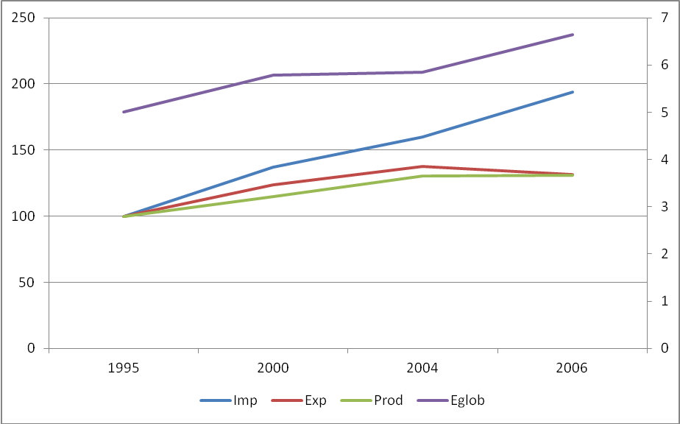
Source: Own elaboration as explained in section 3.
There is a clear growing pattern for the globalisation measure that shows how global emissions are increasingly due to goods transport. For the Spanish case, the measure has increased by over a point and a half, from 5 to 6.65%, in the analysed period.
We review now all the elements behind our global measure. Focusing now on imports transport emissions by mean of transport the main polluter is sea transport, even though its polluting coefficient is the lower one. This result is repeated for all years, as shown in graph 2, where rail and others are not included because of their very low values (over 11.000 CO₂ Gg for sea compared to 41 for rail and 105 for other in 2000). The explanation is in the high amount of volume carried by container shipping especially when it comes from countries across the globe, around 90% of the total, with road in the second position with over 8%, and air, rail and other with less than 1% each. Also there is a strong increase in the amount of CO₂ emissions from maritime transport between 1995 and 2006, it reflects a continuous pattern that combines a rise in trade and a change in sourcing from America to Asia in particular.
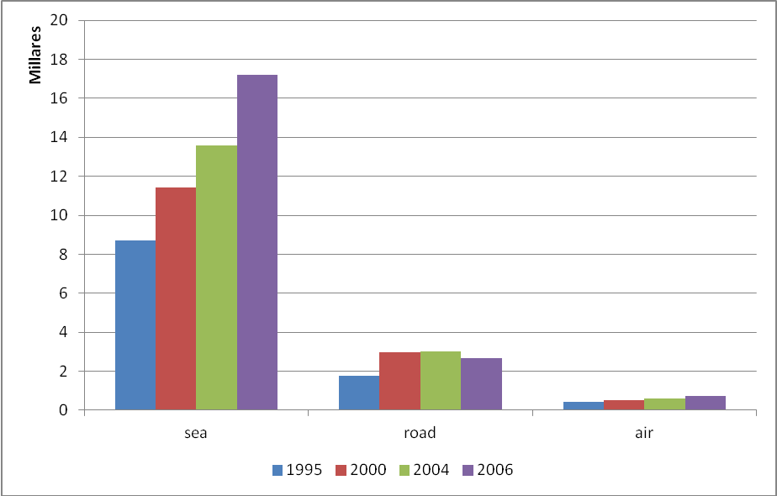
Figure 2. CO₂ emissions due to imports transport by mode of transport (Gigagrams).
Source: Own elaboration as explained in section 4.
In relation to the origin of the purchased inputs we observe important changes in this period as shown in figure 3. In 1995, Spanish main trade partner in terms of both volume and transport generated emissions was America, with around 43% of the imports volume and 39.5% of the linked emissions (not shown in the graph). The importance of language facilities in Central and South American purchases and the Spanish dependence of natural resources explain the important position of American imports. However, at the end of the period America was in a second position, with Asia overcoming it because of its accelerated growth, from 18 to 37% of imports volume and from 18 to 34% of linked emissions between 1995 and 2006. The main contributor is the China, India, Thailand and Korea group with over 19% of the volume and over 18% of linked emissions. In the general picture EU-15 is our third trade partner for the whole period, however it has reduced moderately its weight in both volume and emissions.
Figure 3. Imports volume by region in percentages.
Source: Own elaboration as explained in section 4.
We move now to the estimated results when combining inputs volume, polluting rates per mean of transport and input-output tables. We are interested in the sectors that purchase intermediate inputs (direct measures) and those that finally use those imported intermediate inputs to transform them to the final demand (total measures). The direct analysis is much more simpler and shows a smaller number of trade emissions responsible agents, however it does not reflect the Spanish production structure as the total measures do, allowing to identify the real responsible agents for transport emissions.
Direct transport emissions linked to imported intermediate inputs, $\bar{E}{\text{trans}}_{c}^{m}$, refers to the sectors that purchase the intermediate inputs, that is not necessarily the sectors that produce them. Since we only focus on those inputs that generate emissions when being moved, we only consider industrial sectors. We observe in figure 4 the importance of energy and raw materials or low value added sectors in Spanish CO₂ transport related emissions, those are also large tonnages sectors, Those sectors also have very high growing rates (around 700% for Oil industries and 300% for Mining and Metallurgy), although CO₂ transport related emissions grow in all sector with the only exception of Food and beverage. There is also a noticeable growth in sectors with much smaller share of direct emissions, such as Electronic components (475.8%), Furniture (460%) and Office machinery and computers (300%). The figures are very similar when direct transport emissions linked to imported intermediate inputs to satisfy exported demand are analysed. Transport of inputs use to produce domestically consumed or exported goods account for around about 82 to 84% of the total CO₂ produced by international goods transport for the whole period, with emissions of goods for final consumption transport playing a much smaller role.
Figure 4. Direct transport emissions linked to imported intermediate inputs to satisfy domestic demand (Gigagrams).
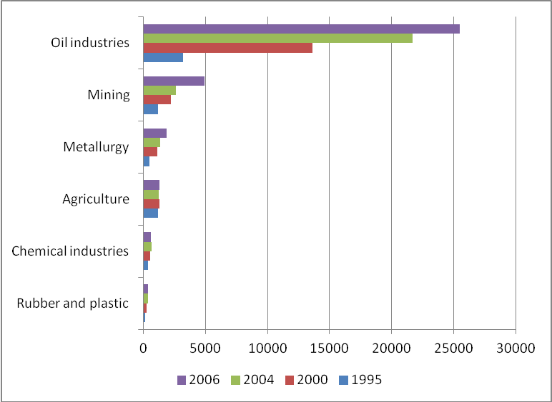

.
Source: Own elaboration as explained in section 4.
When focusing on total measures the picture changes drastically. For total pollution linked to intermediate imports in industrial sectors, expressions 3.a and 3.b, the inter-sector relationships among sectors become patent, changing the distribution of emissions. Those sectors that are main transport emissions importers do not produce final goods, so they spread emissions along different production sectors that acquire the importer intermediate inputs. Two different figures, 5 and 6, show these results, allowing us to distinguish whether final demand goes to domestic consumers or to exports. The sectors distribution changes for these two cases because exported goods could be imported intermediate inputs in the receiving country, so sectors devoted to final consumers are secondary, while sectors orientated to intermediate consumption appear as principal. This characteristic makes the figure for total emissions related to exports, 5, closer to the direct transport emissions, 4, with high tonnage sectors in main positions. The main difference with the direct emissions graph is the significant reduction in Oil industries related emissions. Although the sector is still present, since it is the principal energy provider also for final consumers, its transport associated emissions are much lower, from over 25,000 Gg. according to the direct emissions in 2006 to less than 5,000 Gg. in total ones.
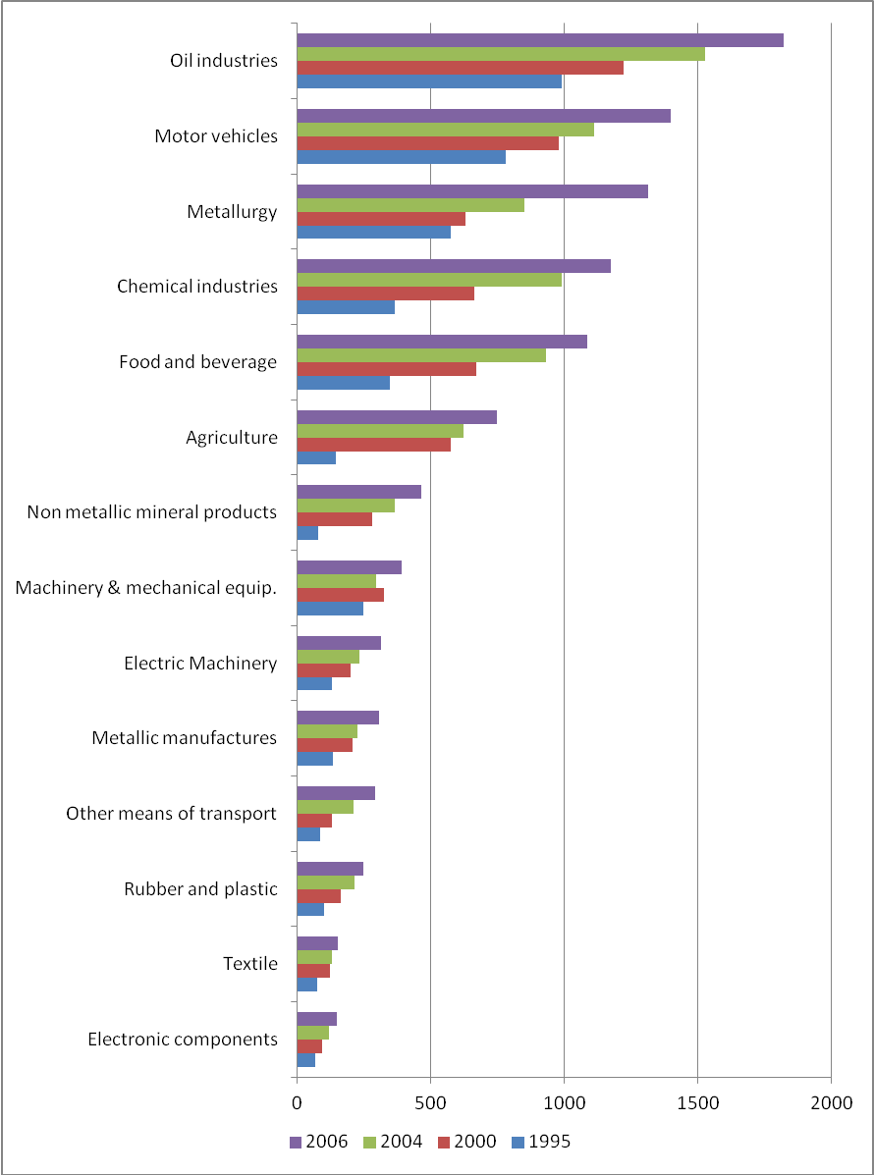
Figure 5. Total transport emissions linked to imported intermediate inputs to satisfy exports, industrial sectors (Gigagrams).
Source: Own elaboration as explained in section 4.
Figure 5, the exports one, shows how transport emissions are distributed among a large number of sectors, and there is a tendency to rise in all of them. The strength of the Motor vehicles sector in Spain explains its second position in the graph, accompanied by Metallurgy, Chemical industries and Food and beverage in the leading positions, all above 1000 Gg for 2006.
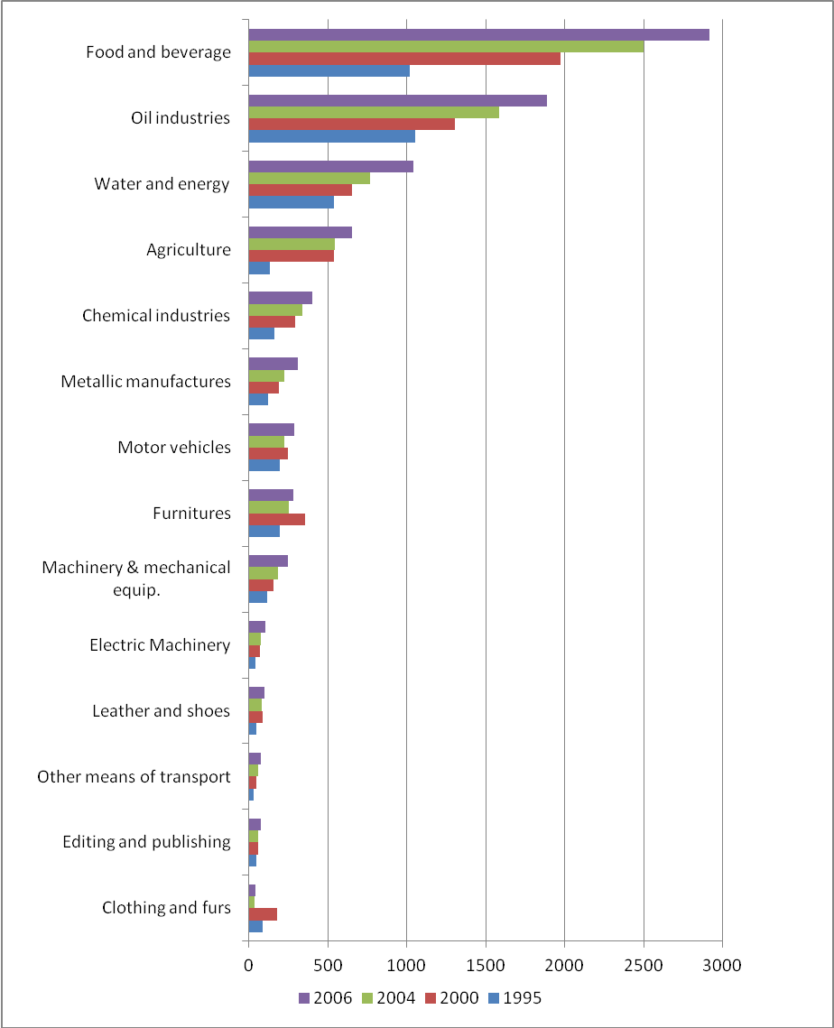
Figure 6. Total transport emissions linked to imported intermediate inputs to satisfy domestic demand, industrial sectors (Gigagrams).
Source: Own elaboration as explained in section 4.
Figure 6, the domestic consumption one, shows how transport emissions are distributed among a smaller number of sectors, only three above 1000 Gg in 2006. The main polluter industry is strongly final goods orientated.
In general, we observe in both graphs that those sectors that are leading the global offshoring processes are not in the main positions in these values, mainly because they are nor high tonnage sectors neither highly dependent on energy.
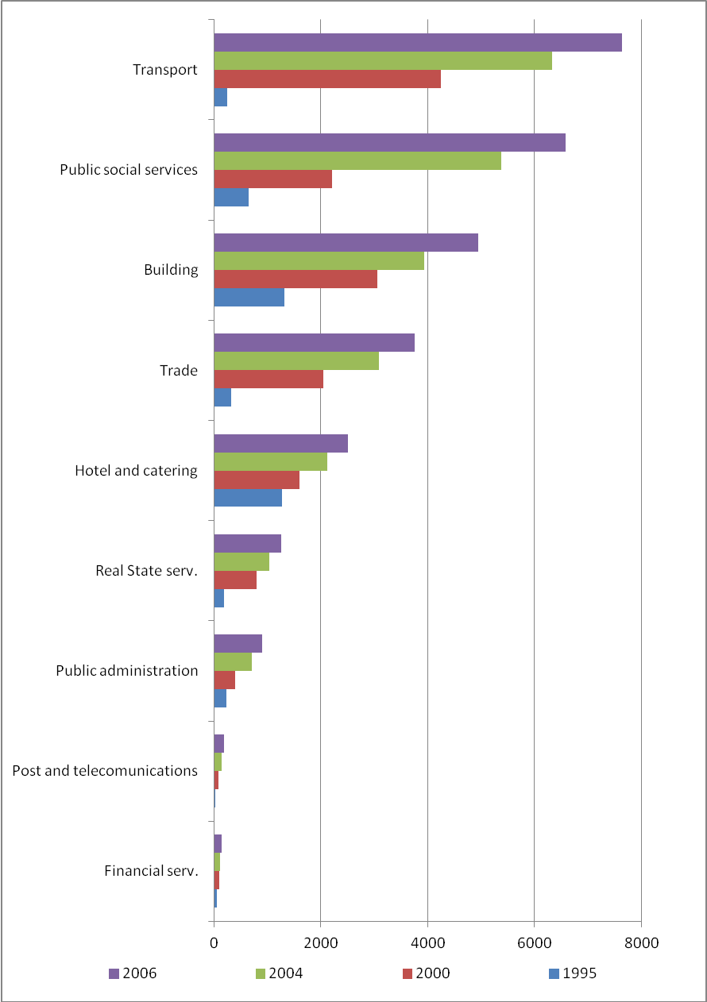
Figure 7. Total transport emissions linked to imported intermediate inputs to satisfy domestic demand, service sectors (Gigagrams).
Source: Own elaboration as explained in section 4.
We can now show emissions associated to services sectors, since these sectors buy intermediate goods from domestic industrial transport emissions importers. They were not present as direct polluters but appear as main total polluters, with values well above the industry sectors ones. Sectors orientated to business play a minor role, while Transport and Public social services, that include education, health, cultural and other services, have the higher values and the higher growing rates. The equivalent graph for exports is not included, since main polluters according to graph 7 are not exportable, with the exception of Transports, with intermediate inputs transport emissions linked to exports close to 6000 Gg., and Trade, with values around 500 Gg., both in 2006. Any other value is below 50 Gg. Transport becomes then the major direct polluter adding up to 13.500 Gg.

6. CO₂ global emissions from production, trade and international transport: responsibility criteria for Spanish industries.
In this section we combine results on emissions from international transport calculated in the above section with the calculation of different measures of responsibility criteria. In doing so, we will distribute emissions from production activities, trade and international transport among industries and countries. We will study their evolution over time and compare different industries.
Figure 8 shows all emissions associated to production of final goods, exports (either final or intermediate goods), international transport of imported inputs and international transport of imported final goods, it is necessary to highlight that all measures are considered in terms of total emissions, a measure more appropriate than direct emissions. Results in the graph show only those sectors where the proportion of emissions associated to domestic production is smaller than the foreign ones, adding together goods and transport related emissions. However Oil industries, Transport and Food and beverage have not been included in the graph, even though domestic emission are only 37, 48 and 49% of total, since their high absolute values, over 33.000, 182.000 and 68.000 gigagrams respectively) would have forced the graph to be rescale, so that we had lost track of the reaming sectors. The most competitive Spanish industrial sectors are among the sectors with less than 50% domestic CO₂ emissions. Figure 8, Chemical and pharmaceutical industries, Motor vehicles, Machinery and mechanical equipment, Electric machinery and also Food and beverage not shown for the reason explained above. All those sectors are very integrated in global value chains, and have become internationally competitive by specializing only in those stages of production were Spain could compete, leading to a global distribution of production emissions. Also other sectors leading international offshoring processes at international level, among them sectors related to knowledge and information technologies, such as, Instruments, optics and watches, Electronic components, and some traditional industries such as Furniture (including toys), Wood and cork, Leather and shoes and Textiles (see Feenstra and Hanson, 1996, Campa and Goldberg, 1997, and Falk and Wolfmayr, 2008, or Gómez et al., 2006 and Cadarso et al., 2008 to the Spanish economy) are present in Figure 8. In general, only 11 out of the 37 analysed sectors have domestic emissions higher to imported ones, and the range is wide, from 51% for Agriculture to 80% for Energy and water. As an average, domestic emissions are slightly below the mean but very close, with values around 40% for the whole period.
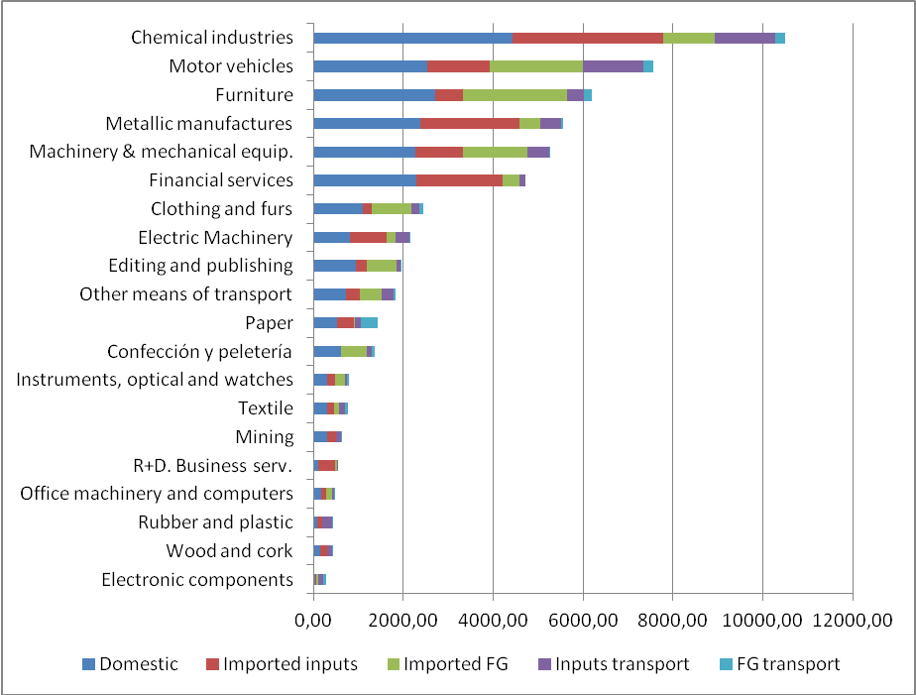
Figure 8. Combined CO2 emissions related to production, imported intermediate goods and final goods, and transport, selected sectors 2004 (Gigagrams).
Source: Own elaboration with elements explained in section 3.

Figure 9: Shared responsibility, PR and CR by components, 2005
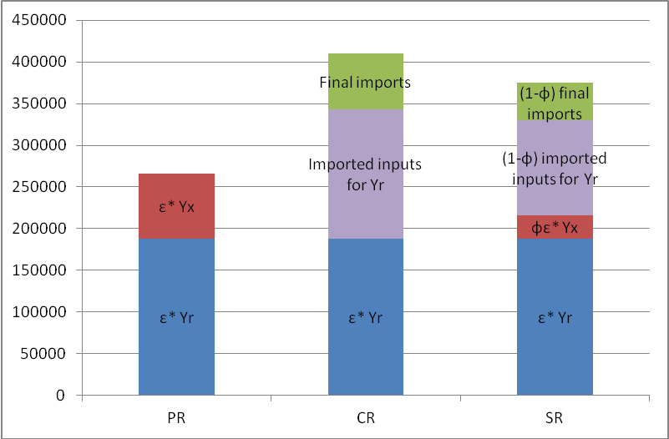
Source: Own elaboration as explained in section 4.
Figure 10: Broad shared responsibility, BPR and BCR, by components, 2005.
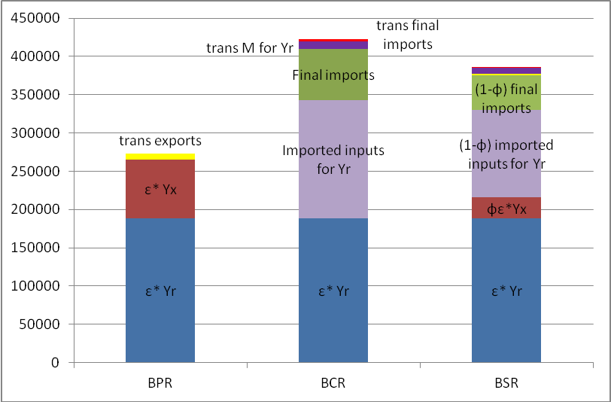
Source: Own elaboration as explained in section 4.

In Figure 9 we can compare emissions according to the different criteria for Spain in 2005. As expected, emissions using CR are higher than PR while SR is mid-way between the previous two, but closer to CR. In blue we present emissions from producing domestically those goods and services that are consumed also within our borders. As such, they are included in all three criteria. In red we have emissions from producing domestically our exports. All of those emissions are included in the PR, only a share (φ) is included in SR and none of it in the CR. In violet, emissions generated abroad to produce inputs imported by Spain to produce goods and services that are consumed domestically. All of them are included in the CR criterion, none of them in the PR and a share (1-φ) in the SR. Finally, emissions generated abroad to produce final goods imported by Spain are in green colour. As with the previous category, the total amount of emissions is included in the CR, none in the PR and a share (1-φ) in the SR.
Total emissions according to the CR criterion are more than 55% higher than using the PR responsibility. Imported inputs for domestic demand account for most of the difference, while emissions from imported final goods are also high (154,921 the first term and 66,832 CO₂ Gg for the second). SR lies within those two extremes (386,626 vs. 272,663 for PR and 422,960 for CR).
Figures 9 and 10 are presented together so they can be compared. The broad definitions of responsibility in figure 10 are the same as in figure 9 but including international freight transportation. In yellow we have the emissions from the transport of exports (included in PR but not in CR), in purple we present emissions from transporting the imported inputs required to produce goods and services for domestic consumption and in light red, emissions from transport of imported final goods (both are included in CR but not in PR). As in the case of SR, in broad SR we include a share φ of the first term and a share 1- φ of the second and third. A first comment on the information presented in figure 10 is that, in global terms, emissions from transportation are relatively low compared to emissions from production (either domestic or imported). But it is still important to include it, not only for comprehensiveness, but also because this transportation component of emissions is far more accentuated for some industries, as we will comment later on this section. A second point to note is that emissions from transporting imported inputs and final goods are higher than emissions from the transportation of exports (13,132 vs. 7,026 CO₂ Gg). The emissions from transporting exports are 2.6% of total BPR, while emissions from transporting imported inputs for producing goods and services for domestic consumption represent 2.4% of BCR and emissions from transportation of imported final goods are 0.7% of BCR. The sum of the shares of emissions from transportation in BSR reaches 3%.
The evolution of the different responsibility we have calculated can be observed in figure 11. We discover the increase from 1995 to 2000 and 2005 in all six variables, but it is particularly noticeable for CR and BCR. Emissions according to CR and BCR increased by 68% from 1995 to 2005 (18% for PR and BPR), while the same figure for SR and BSR is 57%. The differences in the rises of emissions from transportation are clear: 34% for emissions from transporting exports, 55% for emissions from transporting importing inputs required for domestic consumption and 81% for transporting imported final goods. This reflects not only the higher increase in imports compared to exports but also the longer distances travelled by imported inputs and final goods.
Figure 11: Comparison of responsibility criteria and evolution for 1995, 2000 and 2005.
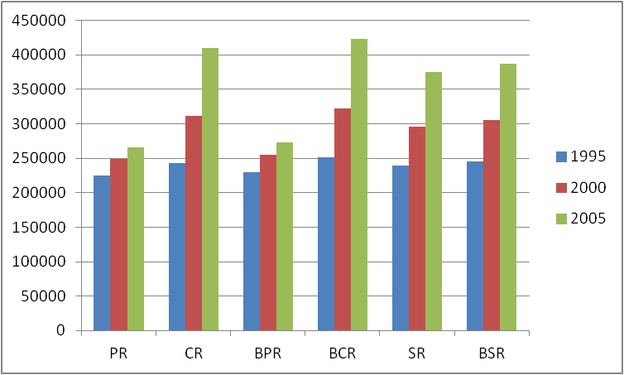
Source: Own elaboration as explained in section 4.

By looking at results for selected industries we can observe the differences in the share of emissions from the components we mentioned above. In figure 12 we present results for BSR for Agriculture, Food and beverages, Extractive industries and Machinery. For both Agriculture and Food and Beverages, the main cause of emissions is domestic production (40% and 46%), but there are important differences in relation to emissions from exports and imported inputs (and their transportation). As an important share of agricultural products are exported, the share of those emissions is 20% (plus an additional 7% due to its transportation), for only 7% for Food and beverages. On the other hand, Food and beverages require more inputs (for example, agriculture products) than agriculture, and this is why the share of emissions from imported inputs is 25% (plus 2% of its transportation) versus 11% for agriculture. For these products the role of transportation in generating CO₂ emissions is very important: they are highly traded goods, heavy, sizeable and travelling long distances.
If we look at a sector where most of its production is exported, like the extractive industries, we can see that 25% of emissions are due to exports, plus 54% of emissions due to the transportation of those exports. This is the result of the characteristics of these products: heavy and long distance travel. On the contrary, machinery products are basically imported into the Spanish economy. That explains the 56% share of emissions from imported final goods in total BSR. Production at home requires a variety of inputs and components that are not produced domestically but imported, so 18% of emissions are due to this category, compared to 15% from production for domestic consumption and 9% for exports.
Figure 12: Broad shared responsibility, selected sectors, 2005

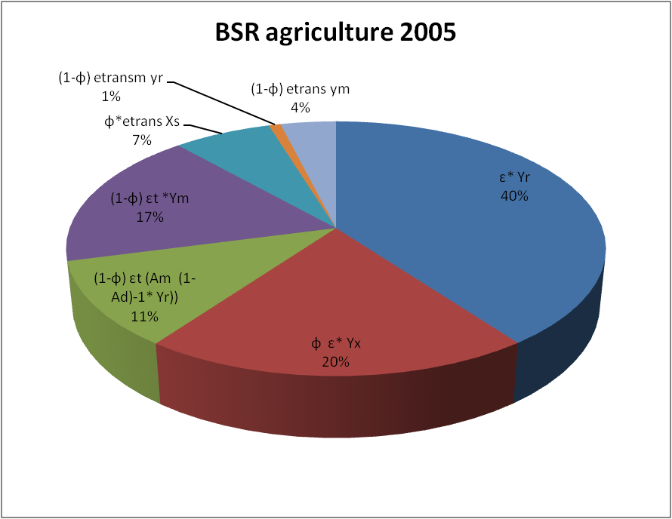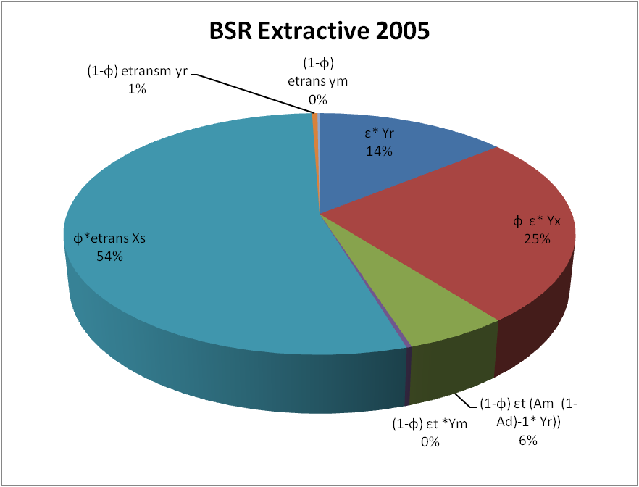

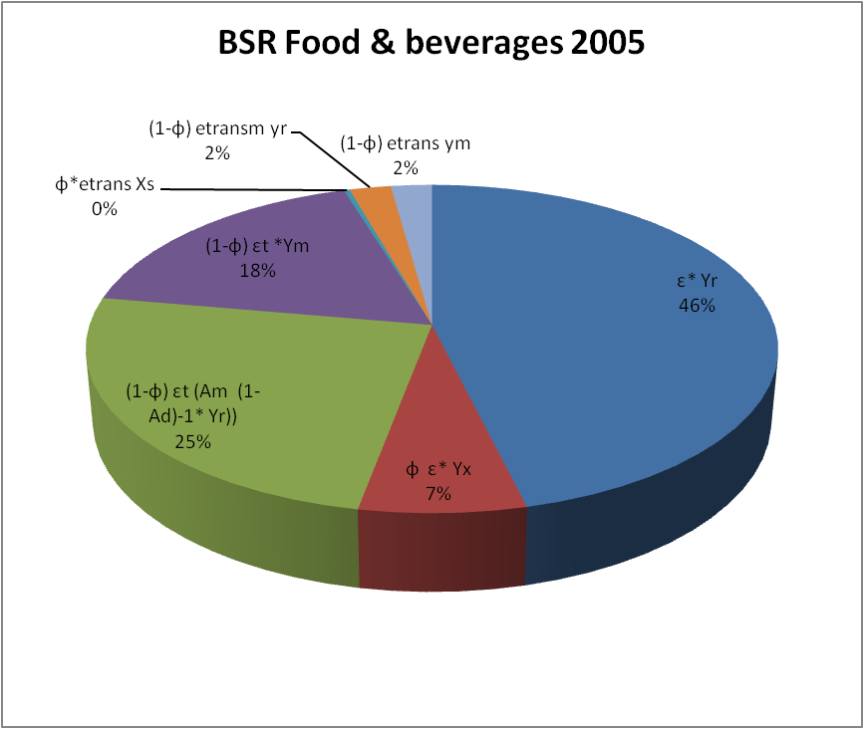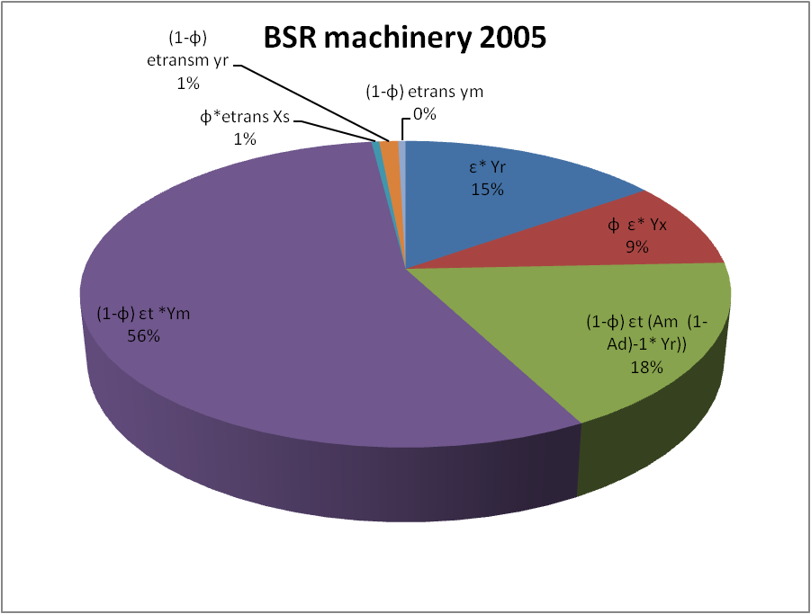

Source: Own elaboration as explained in section 4.

These results can also be considered from a different perspective. By studying emissions of the different components by columns and by rows we can analyze how much pollution an industry transmit to the rest of the economy (in terms of the inputs it produces and supplies to other industries, rows) or the emissions involved in all the inputs from other industries it employs when producing (columns). We can illustrate this point by considering figures 13 and 14. Industries depicted in figure 13 are those everybody will think of as the most polluting: all modes of transport, minerals, oil, and above all, energy and water. For these industries, PR row (light blue) is much higher than PR column (dark blue). This means these industries generate a lot of pollution in producing inputs that are later used by the rest of the economy.

Figure 13: Industries with PR row > PR col, 2005.
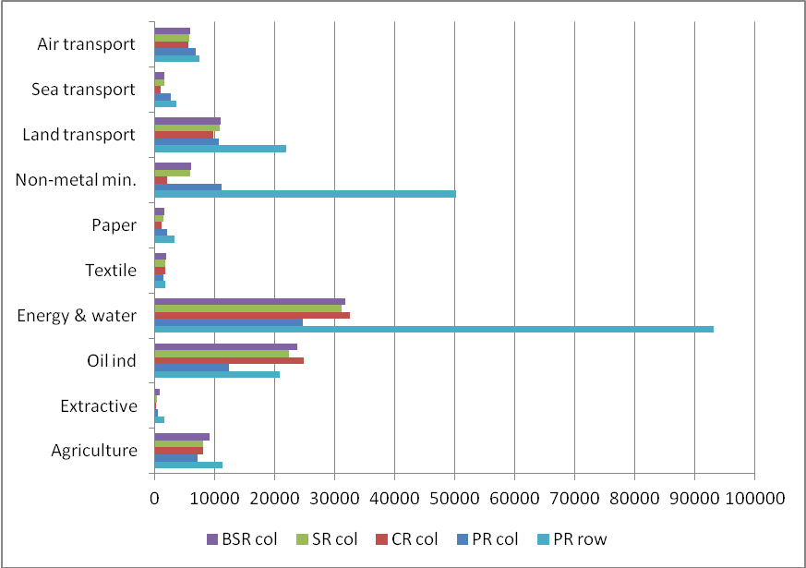
Source: Own elaboration as explained in section 4.

By contrast, many industries in figure 14 would probably be neglected as sources of pollution. They present higher PR column than PR row, meaning they do not transmit too much emissions to the rest of the economy but they use highly polluting inputs in their production. These sectors are mainly services, vehicles, machinery, food and beverages and, above all, the building sector. Not only that, but most of those sectors have a much higher CR, SR and BSR column total. The reason for this is that we also import their highly polluting inputs from abroad, as well as some final products. And this is why the differences between emissions according to PR and CR (column) criteria are more pronounced. The effect of including emissions from transportation is also noticeable for the building sector: imported inputs are heavy and large, so emissions due to this element are high. This 2005 year is also close to the pike of the building bubble in Spain (more than 600,000 flats or houses were concluded in that year and almost one million were sold).
Figure 14: Industries with PR col > PR row, 2005
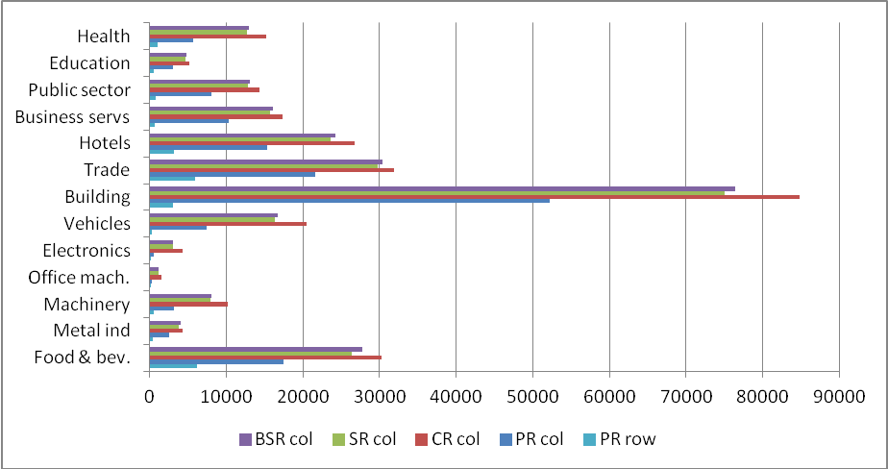
Source: Own elaboration as explained in section 4.

Finally, there are two components of emissions that are not included in the figures above. This is because they are not computed in either the PR or the CR (and, consequently, in the SR) criteria. These are emissions generated in the production abroad of the inputs we import in order to produce goods than are later exported. They are not included in PR as they are generated abroad. Nor are they computed in CR, because the products are exported. The emissions from transporting those imported inputs are equally not included in PR, CR or SR for the same reasons. These emissions are the result of global value chains, that is, the fragmentation of production into several stages that are located around the world depending on costs. This pollution would be neglected in normal calculations of responsibility and we would expect it to be growing quite fast, in line with previous results about the increase in the offshoring process in Spain (see Cadarso et al., 2008).
Note that the first stage of the chain would be included in PR for the first country of origin and the last stage of the chain would be included in CR (and/or PR) for the country of final destination. In fact, the last country will bear most of the burden when computing emissions responsibility. But countries involved in the intermediate stages would not be hold responsible even though they profit from the fact that those polluting inputs are produced somewhere before they are transformed and then shipped again. Those countries will only be responsible for emissions generated in that domestic transformation (or a share φ of them).
This is even more blatant when we consider the associated transportation. Although we have broadened the PR, CR and SR criteria to include emissions from transportation, our measures still fail to capture the emissions generated in transporting those inputs required to generate products that are exported. If a product is transformed in many different and consecutive stages, located far apart, the emissions will rise very fast, but nobody will become responsible for them. Only transportation of the first stage, from the country starting the chain to the second country, (or a share of it 1 – φ) would be considered in BPR for country one; and transportation for the last stage, from the penultimate to the ultimate country in the chain, (or a share φ of it), would be included in BCR (or BPR if it needs some domestic final transformation) for the last country. Emissions from the remaining rounds of transportation would be missing.
Figure 15: Global value chains: the “missing emissions”, 2005
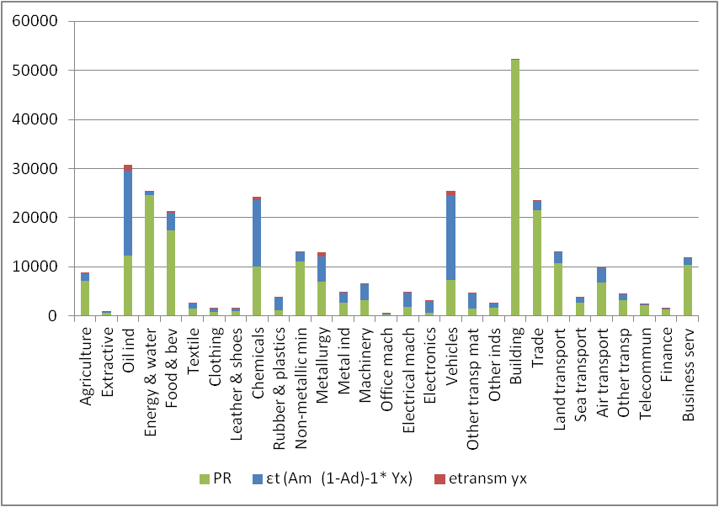
Source: Own elaboration as explained in section 4.

We present in Figure 15 results for those neglected emissions, blue for emissions generated abroad when producing inputs imported by the corresponding Spanish industry to generate exports, red for the associated emissions from transporting those inputs into Spain. PR (in green) is also included so we can compare magnitudes. These two elements are particularly important in sectors where Spain has a role in the offshoring process, like chemicals and, very distinctively, vehicles. The automobile industry in Spain is not only very relevant in terms of valued added and employment, but it also presents very important forward and backward linkages. Firms in this industry are mainly multinationals that locate different stages of production where it becomes more profitable and trade inputs and components among those locations. This implies Spain imports a large quantity of components that are then included and/or transformed to some extent to produce cars, a high proportion of which are exported to other European countries.

6. Conclusions.

There is an increasing awareness of the problems generated by uncontrolled emissions what justify international organizations actions. Most occidental countries share this preoccupation and are applying changes to environmental laws aimed to reduce production generated pollution. However these measures are being applied within countries frontiers and cannot control for a high, and growing, percentage of emissions related to a country producers or consumers but generated outside that country.
The generalisation of global value chains has evolved motivated by firms’ competitiveness strategies, aimed to reduce costs or increase presence in international markets. The creation of global value chains has led to a relative increase of transport emissions compared to production emissions, so firms have won competitiveness while society is assuming the cost, an increase in global pollution. Global value chains are becoming more common and are being build on production relationships with even more distant countries, as confirmed for the Spanish case by the relative increase in sea shipping generated emissions and the absolute increase in emissions generated in freight transport with China and other Asian countries.
Imports transport emissions have almost doubled from 1995 to 2006, but patterns are different among sectors. The analysis of direct transport measures, that allocates emissions in the importer sector for either intermediate inputs of final goods, shows how most emissions are linked to purchases of high tonnage sectors of raw materials or low value added products. Examples are Oil industries, Mining or Metallurgy. However these are not final product sectors, but mainly intermediate inputs producers, so they distribute the imported transport emissions among the rest of the economy. When focusing on total transport emissions measures, that consider inter-sectoral redistribution, main actors change. Oil industries are still present, and other major polluters appear on scene, such as Motor vehicles and Chemical industries, as exports producers, or Public social services, Building, Food and beverage or Water and energy, as domestic producers. Transport is the major polluter in both cases, with very impressive emissions growth rates, as the main Oil industries user. In general, while direct emissions are very concentrated, for 2006 95% of direct emissions are concentrated in only 6 sectors, total emissions are more equally spread, with 95% emissions distributed in 18 sectors.
When considering the weight of domestic emissions on total emissions required by domestic production and consumption, we observe that it is below half of total emissions for most sectors (23 out of 37). Global value chains have led to the incorporation of foreign emissions in growing percentages in all sectors, and this trend is even steeper for the most competitive Spanish industrial sectors. This implemented and growing pattern makes necessary to search for adequate identification and allocation emissions criteria. We have computed and analysed the evolution of CO2 emissions for the Spanish industries using different responsibility criteria. In this fashion we have illustrated the differences that arise when allocating responsibility for emissions to industries and countries depending on how much they produce, consume or some type of commitment between the two. According to all criteria emissions are consistently increasing, and even more rapidly if we attend to consumer responsibility. The difference between PR and CR criteria is intensifying, and therefore our country is avoiding even heavier payments in the emissions trading mechanism. We have also analysed PR by rows and columns, so we have identified to which extent industries that are not usually regarded as top pollutants are in fact responsible. Construction is the clearest case but services like trade, hotels and business services are also indirectly generating high emissions by means of the inputs they require to produce.
Shared responsibility can be considered as a fairer criterion for allocating responsibility. Using value added over net production (as in Lenzen et al., 2007) as the sharing percentage, the shared responsibility for the aggregated Spanish economy is much closer to the CR than to PR. This is consistent with an economy that imports more intermediate and final products than it exports.
By introducing the concept of broad responsibility criteria we have augmented the responsibility calculations per industry with the corresponding emissions from international transportation. This is important for two reasons: 1) the responsibility in terms of emissions of international freight transportation is largely neglected, especially in international agreements like Kyoto’s Protocol; 2) in a global economy where production fragmentation and offshoring have an increasingly role in organising the economic activity, intermediate inputs, components and parts travel much more and longer distances. Even though a 2-3% of total emissions (using the BSR criterion) does not seem a big impact, we have identified sectors where introducing transport emissions is very relevant, for example agriculture, 12%, and Food and beverages, 4%. Even more interesting, there is a part of emissions from production and transport that are computed in any of those criteria: the emissions from imported inputs required to generate goods that are subsequently exported. The amount of emissions, both embedded in producing those imported inputs and in transporting them, is very impressive (even higher than PR) for industries like Vehicles, Chemicals, Machinery, Electrical machinery, Metallurgy and Oil industries. More research on the line is required to evaluate the impact from global value chains on gas emissions.

References
Ahmad, N. and Wyckoff, A., 2003. Carbon dioxide emissions embodied in international trade of goods. OECD Science, Technology and Industry Working Paper, 15.
Bastianoni, S., Pulselli, F. M. and Tiezzi, E., 2004. The problem of assigning responsibility for greenhouse gas emissions. Ecological Economics, 49, 253– 257
Cadarso, M.A., López, L.A. and Tobarra, M.A., 2007. El papel de las multinacionales en la deslocalización y la especialización vertical de la industria española. Revista de Economía Mundial, 16, 27-55.
Cadarso, M.A., Gómez, N., López, L.A. and Tobarra, M.A., 2008. The EU enlargement and the impact of outsourcing on industrial employment in Spain, 1993-2003, Structural Change and Economic Dynamics, 19 (1), 95-108.
Cadarso, M.A., Gómez, N., López, L.A. and Tobarra, M.A., 2010. CO2 emissions of international freight transport and offshoring: measurement and allocation, Ecological Economics, 69 (8), 1682-1694.
Cadarso, M.A., Gómez, N., López, L.A. and Tobarra, M.A., 2011. International Trade and Shared Environmental Responsibility by Sector. An Application to the Spanish Economy, mimeo.
Campa, J. and Goldberg, L.S., 1997. The evolving external orientation of manufacturing industries: evidence from four countries. NBER Working Paper, 5919, February.
Corbett, J.J. and Koehler, H.W, 2003. Updated emissions form ocean shipping, Journal of Geophysical Research – Atmospheres, 108, 4650-4666.
Corbett, J.J. and Winebrake, J.J., 2008. International trade and global shipping, in K.P. Gallagher (Ed.), Handbook on trade and the environment. Chentelham, UK. E. Elgar, 33-48.
Cristea, A., Hummels, D. and Puzzelo, L., 2011. Trade and the Greenhouse Gas Emissions from International Freight Transport, paper presented at the ETSG Conference Copenhagen, Denmark.
DGA, several years. Estadísticas de Comercio Exterior Españolas (Datacomex). Secretaría de Estado de Comercio, Ministerio de Industria, Comercio y Turismo.
Endresen, O., Sorgard, E., Sundet, J.K., Dalsoren, S.B., Isaksen, I.S.A., Berglen, T.F. and Gravir, G. (2003). Emission from international sea transportation and environmental impact. Journal of Geophysical Research, 108(D17), 4560, doi:10.1029/2002JD002898.
European Commission, 2007. EU Energy and transport in figures 2007. Directorate – General for energy and Transport. EC, Brussels.
European Community Shipowners’ Associations (ECSA), 2008a. Climate Change and shipping. Network for transport and environment, http://www.ntm.a.se
European Community Shipowners’ Associations (ECSA), 2008b. Climate Change and shipping. ECSA position paper. Network for transport and environment, http://www.ntm.a.se
Eyring, V., Aardenne, J.van, Lauer, A. 2005. Emissions from international shipping: 1.The last 50 years. Journal of Geophysical Research, 110, D17305, doi:10.1029/2004JD005619.
Falk, M. and Wolfmayr, Y., 2008. Services and materials outsourcing to low-wage countries and employment: Empirical evidence from EU countries. Structural Change and Economic Dynamics, 19, 38-52.
Feenstra, R.C. and Hanson, G.H., 1996. Globalization, Outsourcing, and Wage Inequality. American Economic Review, 86, 240-245.
Feenstra, R.C. and Hanson, G.H., 1999. The impact of outsourcing and high-technology capital on wages: Estimates for the United States, 1979-1990, Quarterly Journal of Economics 114, 907-940.
Ferng, J. J., 2003. Allocating the responsibility of CO₂ over-emissions from the perspectives of benefit principle and ecological deficit. Ecological Economics, 46, 121-141.
Gallego, B. and Lenzen, M., 2005. A Consistent Input–Output formulation of shared Producer and Consumer Responsibility. Economic Systems Research, v. 17, n. 4, 365–391.
Green, K., Morton, B. and New, S., 1996. Purchasing and environmental management: interaction, polices and opportunities. Business Strategy and the Environment, 5, 188-197.
Gómez, N.; López, L.A. and Tobarra, M.A., 2006. Pautas de deslocalización de la industria española en el entorno europeo (1995-2000): la competencia de los países de bajos salarios. Boletín Económico de Información Comercial Española, 2884, 25-42.
Grossman, G.M. and Rossi-Hansberg, E., 2006. The rise of offshoring: it’s not more wine for cloth anymore. Symposium The New Economic Geography: Effects and Policy Implications, Jackson Hole, Wyoming.
Hall, J., 2000. Environmental supply chain dynamics. Journal of Cleaner production, 8, 455-471.
INE, 2005. Contabilidad nacional de España. Marco input-output. Serie 1995-2000. Madrid, Instituto Nacional de Estadística.
INE, 2006. Cuentas Satélite sobre emisiones Atmosféricas. Serie 1995-2000. Madrid, Instituto Nacional de Estadística.
Jones, A., 2002. An environmental assessment of food supply chains, a case study on dessert apples. Environmental Management, 30, 4, 560-576.
Lenzen, M., Murray, J., Sack, F. and Wiedman, T., 2007. Shared producer and consumer responsibility – Theory and practice. Ecological Economics, 61, 27-42.
Lenzen, M.; Pade, L.L. and Munksgaard, J., 2004. CO₂ multipliers in multi-region input-output models. Economic System Research, 16, 4, 391-412.
Munksgaard, J. and Pedersen, K., 2001. CO₂ accounts for open economies: producer or consumer responsibility? Energy Policy, 29, 327-334.
Pasinetti, P. L., 1973. The notion of vertical integration in economic analysis, Metroeconomica, 25,1-29.
Peters, G. P., 2008. From production-based to consumption-based national emission inventories. Ecological Economics, 65, 13-23.
Peters, G. P. and Hertwich, E. G., 2006a. Pollution embodied in trade: the Norwegian case. Global Environmental Change, 16, 379-389.
Peters, G. P. and Hertwich, E. G., 2006b. The importance of imports for household environmental impacts. Journal of Industrial Ecology, 10 (3), 89-109.
Peters, G. P. and Hertwich, E. G., 2008a. CO₂ embodied in international trade with implications for global climate policy. Environmental Science and Technology, 42 (5), 1401-1407.
Peters, G. P. and Hertwich, E. G., 2008b. Post-Kyoto gas inventories: production versus consumption. Climatic Change, 86, 51-66.
Rodrigues, J. and Domingos, T., 2008. Consumer and producer environmental responsibility: comparing two approaches. Ecological Economics, 66, 533-546.
Roca, J. and Serrano, M., 2007a. Income growth and atmospheric pollution in Spain: an input-output approach. Ecological Economics, 63 (1), 230-242.
Sánchez-Chóliz, J. and Duarte, R., 2004. CO₂ emissions embodied in international trade: evidence for Spain. Energy Policy, 32, 1999-2005.
Seuring, S. and Müller, M. (2008). From a literature review to a conceptual framework for sustainable supply chain management. Journal of Cleaner production, 16, 1699-1710.
Steenhof, P., Woudsma, C. and Sparling, E., 2006. Greenhouse gas emissions and the surface transport of freight in Canada. Transportation Research Part D, 11, 369-376.
Tarancón, M. A. and del Río, P., 2007. Structural Factors affecting land-transport CO₂ emissions: a European comparison. Transportation Research Part D: Transport and Environment, 12 (4).
UNFCCC, 2005a. Information on greenhouse gas emissions from international aviation and maritime transport. FCCC/SBSTA/2005/INF.2. United Nations Framework Convention on Climate Change.
UNFCC, 2005b. Methodological issues relating to emissions form fuel used for international aviation and maritime transport. FCCC/SBSTA/2005/MISC.6. United Nations Framework Convention on Climate Change.
UNFCCC, 2008. Report of its Subsidiary Body for Scientific and Technological Advice on its twenty.eight session held in Bonn from 4 to 13 June 2008. FCCC/SBSTA/2008/6. United Nations Framework Convention on Climate Change.
Van Veen-Groot, D. and Nijkamp, P., 1999. Globalisation, transport and the environment: new perspectives for ecological economics. Ecological Economics, 31, 331-346.
Van Veen-Groot, D. B.; Njkamp, P. and van den Bergh, C.J.M., 2001. A scenario study of globalization impacts on international transport and the environment: an application to the Dutch paper industry. Journal of Environmental Planning and Management, 44 (1), 21-40.
Weber, C.L. and Matthews, H.S. (2008). Food-miles and the relative climate impacts of food choices in the United States. Environmental Science and Technology, 42, 3508-3513.
Wiedman T., Lenzen, M., Turner, K, and Barret, J., 2007. Examining the global environmental impact of regional consumption activities – Part 2: Review of input-output models for the assessment of environmental impacts embodied in trade. Ecological Economics, 61, 15-26.

In order to guarantee comparison with more recent data, we include the 12 new EU countries in this category for 1995 and 2000.
The only exception is Turkey, where Istanbul is preferred, since the capital is not the main axis for production and is more centred.
Data availability forces us to assume that these emissions are constant over the period. However, the International Energy Agency (2000) points out three factors that could reduce them: using less fuel per kilometre, improving utilisation (carrying more passengers or tonnes of freight per vehicle-kilometre) and improving traffic conditions, so that vehicles perform better.
However, this source does not discriminate between intermediate and final goods and to make this distinction we will use input-output tables (see sub-section 3.2).
We assume that a good i gives rise to similar pollution due to transport independently of whether it is going to be used as a final or intermediate good We also consider that the distribution of imports per country of origin into intermediate and final goods according to input-output tables presents a problem since we apply the same share of imports to all countries. This assumption is not necessarily correct, and it is more difficult to meet at a low disaggregation level, such as ours, which has only 25 industrial sectors. However, we use a different distribution according to products.
Difference offshoring, also defined by Feenstra and Hanson is not considered in this paper.
That is, not including direct emissions by households and public sector when consuming energy goods (gas, coal and oil derivatives).
In the notation, capital letters are indicative of matrices and lower case letters are used for column vectors. The exception is emissions multiplier matrices that start with a Greek letter. As a diagonal matrix (diagonalisation) will be represented by (^).
This assumption, although common in literature (Munksgaard and Pedersen, 2001, Sánchez-Chóliz and Duarte, 2004, Peters and Hertwich, 2006), requires many restrictions in calculations, since production technology, and therefore pollution, is expected to differ from country to country. On the other hand, see Wiedman et al. (2007) for a theoretical review of single-region and multi-region input-output models for the assessment of environmental impacts of trade and Andrew et al. (2009) for a quantification of the errors introduced by various approximations of the full Multi-regional input-output, for national carbon footprint accounting. These last authors conclude that the difference when measuring the ecological footprint using a DTA model or an MRIO for the Spanish economy in 2001 is only 1%, but they do not consider the possible differences by industries.
In any event, emissions generated by investment goods should be treated differently from other final demand elements, since the former are within the production system. We consider that responsibility for emissions produced by investment goods must be accounted for by the businesses buying them, spread over a number of years according to fixed capital consumption.
Peters (2008) also shows an expression for calculating shared responsibility for a multi-regional model, but there is no empirical application.
The advantages of using value added divided by net product as a distribution measure, following Lenzen et al. (2007) are: invariance with respect to disaggregation of the supply chain, aggregation of the supply chain and gross or net accounting.
For our case, because of the application of a single-region model and the use of a similar technology assumption (DTA), $φ_{A}$ = $φ_{B}$.
However, different sectors of activity share only the emissions that each uses when producing goods and not those associated with the consumption of intermediate goods by each sector. To add these in, it would be necessary to work with vertically integrated sectors.

