Russian’s foreign trade relations researches
as an integrated part of an IO analysis
Svetlana Slobodyanik, Liudmila Tishina
Institute of Macroeconomic Researches (Russia, Moscow)
E-mail: slobodianik1986@mail.ru, shre@mail.ru

Abstract
The paper concerns researches in the field of Russia’s foreign trade relations, which accompany compilation of expert IO tables for pre-forecast year. The necessity of these researches for creation of the information database of the IO tool is described. Also the analytical potential is assessed for analysis of shifts in competitive ability of domestic goods and services, as well as factor analysis of processes in import consumption and import substitution. Authors bring up some methodological problems which arise while constructing import resources use table (so called “import matrices”) and impede systems and complex approach to analysis of foreign trade, production, final consumption and gross capital formation.
The paper provides the results of the quantitative analysis in the export/import structural changes which took place in the Russian’s economy during the last decade. These shifts are due to price and physical volume changes. Authors make conclusions about positive and negative trends which had place in Russian foreign trade. Authors also discuss perspectives of Russia’s entry to the WTO as well as extension of the Customs Union (The Republic of Belarus, the Republic of Kazakhstan, the Republic of Kirghizia and the Russian Federation).

1. Introduction
For the last two decades there were only one benchmark IO tables in Russia based on a survey for 1995 (disaggregated at the level of 227 product groups). Till 2003 Russian Statistical Office (Rosstat) published annual IO tables which were less detailed and covered only 23 sectors. After that there were no more any IO tables for the Russian economy. Only in 2009 there was a decree of the government which legislated compilation of the detailed IO tables on a regular basis (once-every-5-years) and enforced the work on the benchmark IO tables for 2011. However the need of public authorities in the integrated tool of analysis and forecasting of economy is very high. That is why our Institute compiles expert-based IO tables for the Ministry of Economic Development of the Russian Federation on annual basis. To construct these tables a large array of statistical information is involved, in particular, data on Russia’s foreign trade which allow to form the columns of export and import. In its turn the column of import comes from the Import Resources Use table (so called “import matrix”).
It is necessary to underline that embedding of indicators of foreign trade in the system of IO tables is accompanied by a number of serious methodological problems: adjustment for shadow import, estimation of export/import real dynamics, distribution of total exports/imports by economic activities, passing from purchasers’ prices to basic prices and so on. Approaches to resolve the above-mentioned methodological problems are developed by our Institute. This allows to compile pre-forecast IO tables and make scenario forecasts on their base.
While compiling expert-based IO tables preliminary work on gathering of data in foreign trade and further analysis is done. This preliminary work allows to understand tendencies in Russia's foreign trade. The particular features of Russia’s foreign trade relations should be considered at the stage of compiling IO tables for the pre-forecast year and at the stage of scenario forecasting as well. These particular features include high import-dependency (with a significant share of shadow import) and export-orientation on raw materials. As a result, deep insight in Russian interindustry relations is formed.
The paper consists of two parts. In the first part a comprehensive analysis of export/import flows in Russia is provided, in particular, an approach to assess import-dependency and export-orientation of different sectors is proposed. In the second part a modelling tool which allows to make forecasts of foreign trade by elements is described. An approach to embed the block of foreign trade in the IO modelling scheme is discussed as well.

2. Dynamics and structure of Russia's foreign trade
Since the early 2000s there is an export surplus of goods in the Russian Balance of Payments (see Table 1). In 2010 export of goods in Russia equaled 400,4 billion USD, an increase by 3,8 times to the level of 2000; import of goods equaled 248,7 billion USD, an increase by 5,5 times. As a result the share of the country in world export rose from 1,6% to 2,7%, in world import – from 0,5% to 1,5%.
Table 1. Russia’s external trade (on methodology of the Balance of payments), billion USD
 | 2000 | 2007 | 2008 | 2009 | 2010 | 2010/00
External turnover | 149,9 | 578,2 | 763,5 | 495,2 | 649,2 | 4,3
Export of goods | 105,0 | 355,2 | 471,6 | 303,4 | 400,4 | 3,8
Import of goods | 44,9 | 223,1 | 291,9 | 191,8 | 248,7 | 5,5
Export surplus of goods | 60,1 | 132,1 | 179,7 | 111,6 | 151,7

It should be noted that the positive dynamics of foreign trade turnover was provided mainly by high world prices for primary energy (crude oil, natural gas, coal). Thus, favorable world market conditions led to the increase of export volumes, which in turn entailed the inflow of money into the country and increased the demand for imports (see Figure 1).
Figure 1. Dynamics of Russia’s external turnover and dynamics of average oil export price for Urals
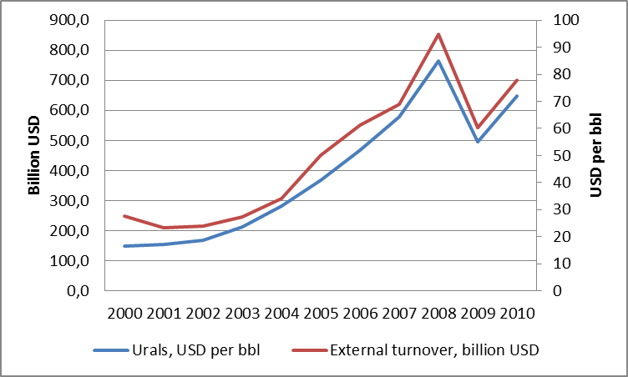
However, high world prices for primary energy provoked serious distortions in the structure of export and import – today Russia exports raw materials and imports products with high value added and consumer goods. This can be clearly viewed in the reported data of customs statistics (see Figures 2a, 2b).
The main groups of goods imported in Russia are machinery and transport equipment (48,6% of total imports in 2010), chemical products (16,2%), textile products (10,2%), foodstuffs and agricultural raw materials (except for textile) (8,5%). So, the share of the group machinery and transport equipment, which is characterized by high value added, was about half of all imported goods, moreover, it increased from 31,4% in 2000 to 48,6% in 2010. The share of chemical products was relatively stable through the decade (it was around 15-17%). The share of officially registered textile products increased nearly twice (from 5,9% in 2000 г. to 10,2%). At the same time there was a considerable decline in the share of foodstuffs and agricultural raw materials (a decline of 13,3% over the period). This can be explained by the fact that transnational corporations have established their production facilities in the country.

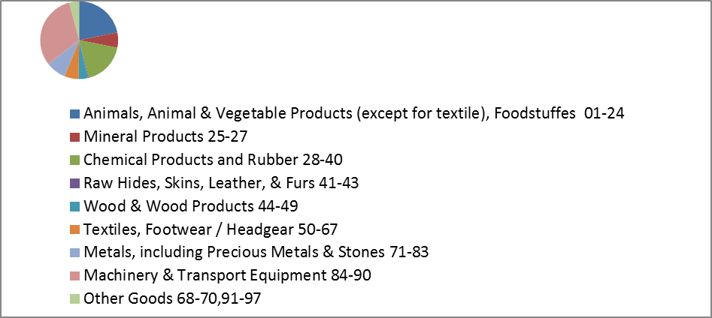
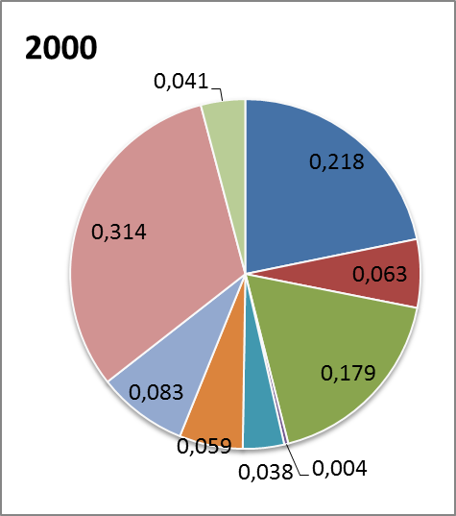
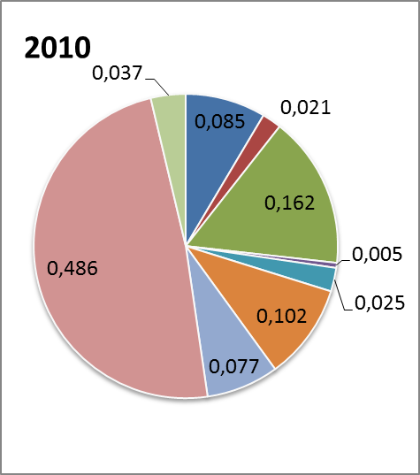
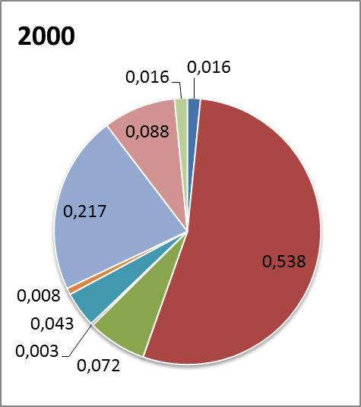
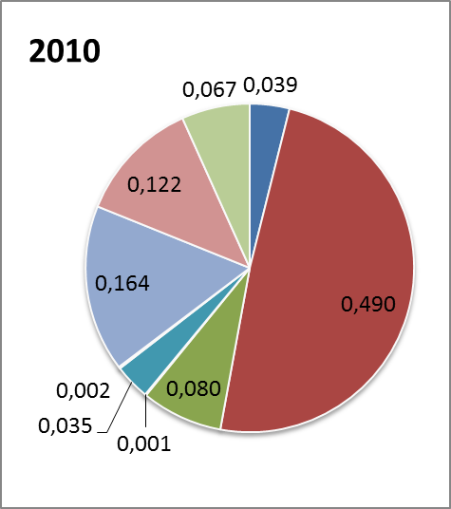
Figure 1. Structure of Russia’s import and export in 2000 and 2010 (total imports/exports at constant 2000 prices, billon USD)
2b) export
Total imports =33,9
Total imports =188,0
Total exports=103,0
Total exports=177,8
2a) import

The main groups of goods exported by Russia are mineral products (49% in 2010), metals (16,4%), machinery and transport equipment (12,2%). The last one is generally characterized by export of defense products, in which production Russia traditionally holds strong positions. However, there is a small positive shift in the structure of export for the period 2000-2010, connected with reduction of mineral products and metals in the share of exports (by 4,8% and 5,3% respectively) and relative increase of machinery and transport equipment, foodstuffs and agricultural raw materials, and other goods.
For purposes of compiling IO tables it is necessary to match codes of customs statistics with codes of economic activities. At the same time it will help to solve the problem of estimating import-dependency and export-orientation for economic sectors. In our institute so called “transition keys” are developed to adopt HS codes to OKVED codes and this helps us to compute price indices and real dynamics indices for export and import by economic activities.
To estimate import-dependency by sectors different approaches may be proposed. For purposes of our analysis the share of import in total resources in the economy (total imports + total output) was calculated. The largest ratios on import-dependency are in machinery branches (DK, DL, DM), manufacturing of textiles, wearing apparel, leather and related products (DB, DC) and some other sectors (see Table 2). At the same time, situation becomes even worse after adjustments for shadow import. Thus, in the textile and wearing apparel industry the share of import in total resources rises from 46% to 65%, in leather and related products industry – from 66% to 82%. It is necessary to underline that Russia strongly depends on import in some strategic areas, for example, food products, pharmaceutical products, investment machinery equipment. Moreover, our country imports, mostly, finished goods. Such a dependency threatens the economic security of Russia.
Table 2. Expert-based estimates of import-dependency of the Russian economy (for 2008 year)
NACE code (Rev.1.1) | Share of import in resources |  | Share in total imports of goods |  | Share of shadow in official import | Share of import of finished goods
NACE code (Rev.1.1) | official registered | corrected to shadow | official registered | corrected to shadow | Share of shadow in official import | Share of import of finished goods
A | 0,08 | 0,08 | 0,04 | 0,04 | 0,00 | 0,81
DA | 0,16 | 0,17 | 0,09 | 0,09 | 0,05 | 0,90
DB | 0,46 | 0,65 | 0,03 | 0,06 | 0,54 | 0,96
DC | 0,66 | 0,82 | 0,01 | 0,03 | 0,58 | 0,94
DG | 0,31 | 0,33 | 0,06 | 0,09 | 0,05 | 0,71
24.4 | 0,69 | 0,69 | 0,04 | 0,03 | 0,00
DH | 0,27 | 0,27 | 0,03 | 0,03 | 0,00 | 0,96
DJ | 0,12 | 0,12 | 0,08 | 0,07 | 0,00 | 0,67
DK | 0,48 | 0,48 | 0,16 | 0,15 | 0,00 | 0,82
DL | 0,51 | 0,53 | 0,15 | 0,15 | 0,07 | 0,75
30 | 0,76 |  | 0,03
31 | 0,36 |  | 0,04
32 | 0,65 |  | 0,06
33 | 0,47 |  | 0,03
DM | 0,46 | 0,47 | 0,22 | 0,20 | 0,04 | 0,82
34 | 0,57 |  | 0,19
35 | 0,19 |  | 0,03

It should be noted that the adjustment for shadow import is also necessary for purposes of the IO tables compiling. The share of shadow from official registered import is substantial in our country, though there is a steady positive trend to decrease (32,4% in 2000 and 8,3% in 2010). The structure of the shadow is expert-based estimated in our institute.
For the analysis of industries’ export-orientation data on export at FOB prices (the FOB price is viewed as purchaser’s price in relation to the export flows) and data on the volume of domestic production use at purchasers' prices were taken. Export-orientation index was calculated as the ratio of export to the volume of domestic production use for each sector.
The most export-oriented activity is mining and quarrying, in particular, of energy producing materials (see Table 3). The ratio equals 27,3% for coal, 65,6% - for crude oil and 67,1% for natural gas. Also, Russia exports iron ore and precious stones. The share of this sector in total exports of goods is more than half (52% in 2008). Thus, export-orientation on raw materials in the structure of export is apparent. For export-oriented manufacturing industries the share of primary products and semi-finished goods in the structure of export is high. So, Russia exports timber and wood, basic chemical products and synthetic rubber, rolled ferrous metal products and non-ferrous metals.
Table 3. Estimate of export-orientation of the Russian economy (for 2008 year)
 | Share of export in the volume of domestic production use | Share in total export of goods | Share of raw materials and semi-finished goods in total exports
C | 0,597 | 0,520 | 1,000
CA | 0,631 | 0,507 | 1,000
coal | 0,273 | 0,017 | 1,000
oil | 0,656 | 0,339 | 1,000
gas | 0,671 | 0,151 | 1,000
CB | 0,188 | 0,013 | 1,000
DD | 0,213 | 0,009 | 0,689
DF | 0,306 | 0,178 | 0,003
DG | 0,305 | 0,054 | 0,516
DJ | 0,305 | 0,122 | 0,655

As a result, the analysis of structure and dynamics of foreign trade turnover in Russia allows to make following conclusions:
1. There was export surplus of goods in the Russian Balance of Payments during the whole period 2000-2010. Despite the fact that the surplus is mainly due to the huge price disparities, it provides the inflow of money to our country and, consequently, allows to modernize in the economy.
2. Export-orientation on raw materials and primary goods is evident with a dominant share of mineral products in total exports of goods. Besides this, in manufacturing sector Russia also exports products with law value added. However, over the past decade, there were small positive shifts to the increase of machinery and transport equipment in the share of total exports.
3. Russia imports, mostly, finished goods with high value added. Also, import-dependency in a number of sectors (including some strategically important areas) is very high. This can threaten the economic security of the country.
4. While constructing the IO tables a large shadow import must be taken into account. This is one of particular features of the Russian economy. A positive tendency on the decrease of the “shadow” over the last decade can be revealed.

3. Regression model of import demand for final consumption and it's use in IO analysis (example)
Approaches to involve scenario conditions on export and import in macroeconomic forecasting with the IO tool are developed in our institute. One of the approaches is to integrate regression models in the IO tool. Thus, we propose to make import demand functions in key areas of import products’ use (for final consumption, intermediate consumption and investments). Scenario conditions on export are given on the basis of the expected world market conjuncture, expected needs of major trade partners and exchange rates. As an example, a regression model of import demand for final consumption is described.
Quantity index of imported goods for final consumption (in real rates to the base level of 1996) was taken as a dependent variable. The factors were: 1) the dynamics of real disposable income and 2) competitiveness index (both to the base level of 1996). The latter combines a number of factors influencing price availability of imports. It was calculated as:
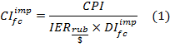
where:
- Competitiveness index of imported goods for final consumption at domestic markets;
– Consumer Price Index;
- Index of exchange rate (RUR/USD);
– Deflator index of imported goods for final consumption.
So, the higher the exchange rate of the ruble against the dollar is, the more expensive imported goods for final consumption become, and competitiveness index decreases. The higher the deflator index of imported goods for final consumption is, the more expensive imported products relative to domestic ones become, and the less we buy import. The higher the CPI is, the more expensive domestic goods become and, consequently, the more we buy import.
While estimating the function of import demand for final consumption it is expected that an increase of real disposable income should lead to increased purchasing power and demand for import. Similarly, positive impact of the competitiveness index is expected.
A two-factor demand function of imported goods for final consumption was estimated:
where:
- Quantity index of imported goods for final consumption;
– Index of Real Disposable Income.
As a result, the function with following parameters was built:
s.e. (0,279) (0,139) (0,337) (0,110)
All the coefficients are significant at the 5%-level in the model, the coefficient of determination (R²) is very high. Hence, it becomes possible to make forecasts of import demand for final consumption on the base of scenario conditions of the Ministry of Economic Development on the rates of real disposable income, exchange rates, CPI, the index-deflator of imports.
We made a forecast of import demand for final consumption for 2011. An expected growth of import demand equals 5,7%. Similarly, demand functions for import of intermediate and investment goods can be built. As a result, we obtain forecasts of import demand, which forms the column totals of intermediate consumption, final consumption and gross capital formation in the import matrix (excluding changes in inventories). Import matrix can be constructed at 2010 constant prices for the analysis of structural changes in the economy or at current prices to compile the forecast IO tables for 2011.

Conclusion
The foreign trade block plays a significant role in compiling of the IO tables. It provides information for the construction of the import matrix, which, in its turn, is latter embedded into the system of IO tables. Deep insight in processes which take place in the Russian foreign trade is necessary, especially with the increasing openness of domestic economy, Russia's accession to the WTO and extending of the Customs Union. The IO concept provides integrated and consistent tool for evaluating changes in customs duties, trade flows, prices’ ratio of domestic and global markets and their influence on the Russia’s economy.

In the analysis of structural shifts in export and import for the period 2000-2010 the structure was assessed at constant 2000 prices (billion USD) to remove the distorting effect of the price factor. It is interesting to note that in 2010 export at constant 2000 prices (177.8 billion USD) appeared to be lower than officially recorded import (188.0 billion USD). Hence, we may suggest that export surplus of goods in the current balance of payments was achieved by huge price disparities.
In accordance with Harmonized Commodity Description and Coding System
OKVED codes are harmonized with Statistical classification of economic activities in the European Community (NACE Rev. 1.1)

