Challenges faced when energy meets water: water implications of power generation in the northern regions of China
Xin Li¹, Kuishuang Feng², Yim Ling Siu¹, Klaus Hubacek²

¹ Sustainability Research Institute, School of Earth and Environment, University of Leeds, Leeds, LS2 9JT, UK.
² Department of Geographical Sciences, University of Maryland, College Park, MD 20742, USA.

Introduction
Human activities, especially those associated with energy consumption, are the major causes to climate change, which can have significant impacts on water, including changes of precipitation, increases of sea level, flooding, and so on and so forth .Also, energy system requires substantial amount of water for the processes ranging from mining and processing of fuels to cooling of power generators. In this study, we focus on water requirements of energy system.

A number of studies have been carried out to examine and compare the water intensity of energy production by sources. To a large extent, most studies are focused onthe U.S.. Water requirements for the conventional energy production can be substantial. For instance,thermo-electric water withdrawalfor cooling purposes accounts for approximately 50% of total water withdrawal in the U.S. . The considerable water requirements in energy production have caused water shortages in many countries. For example, pointed out that in 2008, the amount of freshwater withdrawal and consumption for power generation were 60 – 170 billion gallons and 2.8 – 5.9 billion gallons, respectively. Ithasled towater supply stresses in approximately 80 watersheds across the US.

On the one hand, some renewable energy sources consume less water than the conventional energy sources in energy/electricity production. For instance, in the US, water consumption of photovoltaic power generation is one eighth of water use in fossil fuel-based power generation. On the other hand, other renewable energy technologies such as the applications of concentrated solar power system can have significant water implications. For instance, a concentrated solar power system with wet-cooling system installed can consume up to 4.7 litres of water to generate one kilowatt hour of electricity (kWh).

There has been limited research investigating water requirements in energy production in China., one of the first of its kind,studied the life cycle CO₂ emissions and water consumption of wind power in China. The authors concluded that wind power could be seen as carbon and water saving solutions. With vast geographical coverage of China, this study is not able to pinpoint and highlight the regional water situation. In addition, owing to the significant differences in the regional power mix, the extent to which the applications of renewable energy sources could contribute to CO₂emission reduction in Chinais not known.Furthermore, the focus of the existing literature islargely on the amount of water needed during the life-cycle phases of power generation (in terms of withdrawal or consumption, or both). Very few studies have addressed the problem of water quantity-quality impacts of electricity production.

Based on the integrated hybrid life cycle approach, this study aims to examineand compare the impacts of three electricity generation systems, namely coal power, wind power and solar power, on CO₂ emissions, water consumption and water quality in Inner Mongolia, China.

Inner Mongolia - a future energy hub in China

The CO₂ emission mitigation from power generation in China
With 9.3% of global CO₂ emissions come from power generation, a number of studies have discussed the possibilities of CO₂ emission mitigation at national level in China.pointed out that the existing coal-dominated power generation system would have significant potential in reducing China’s total CO₂ emissions. Focusing on greenhouse gas (GHG) emissions, quantified the mitigation potentials based on the applications of carbon-neutral technologies in the coming decade. This study calculatedthat GHG emissions of China’s power generation are 297.688g/MJ, which is equivalent to 1071.677 g/kWh. The diversification of electricity mix through replacing fossil fuels by renewable energy and nuclear power can reduce the GHG emissions to 220.470g/MJ (or 793.692g/kWh) in 2020. A further reduction of CO₂ emissions to reach 169.014g/MJ (or 608.450g/kWh) can be achieved by introducing carbon capture and storage (CCS) technology.

Despite the potentials to reduce CO₂ emissions at national level, a number of studies highlighted regional differences in China and showed the importance of considering these differences in fair and effective national carbon emission abatement policies .

The potentials in reducing China’s CO₂ emissions from power generation can be more substantial to some regions than the others. Figure 1 shows a diverse mix of energy sources in China’s electricity production. While a significant proportion of electricity is generated by hydropower in central and southern China, coal accounts for more than 95% of total electricity generation in regions such as Beijing, Tianjin, Hebei, Shanxi, Shandong, Inner Mongolia and Heilongjiang,

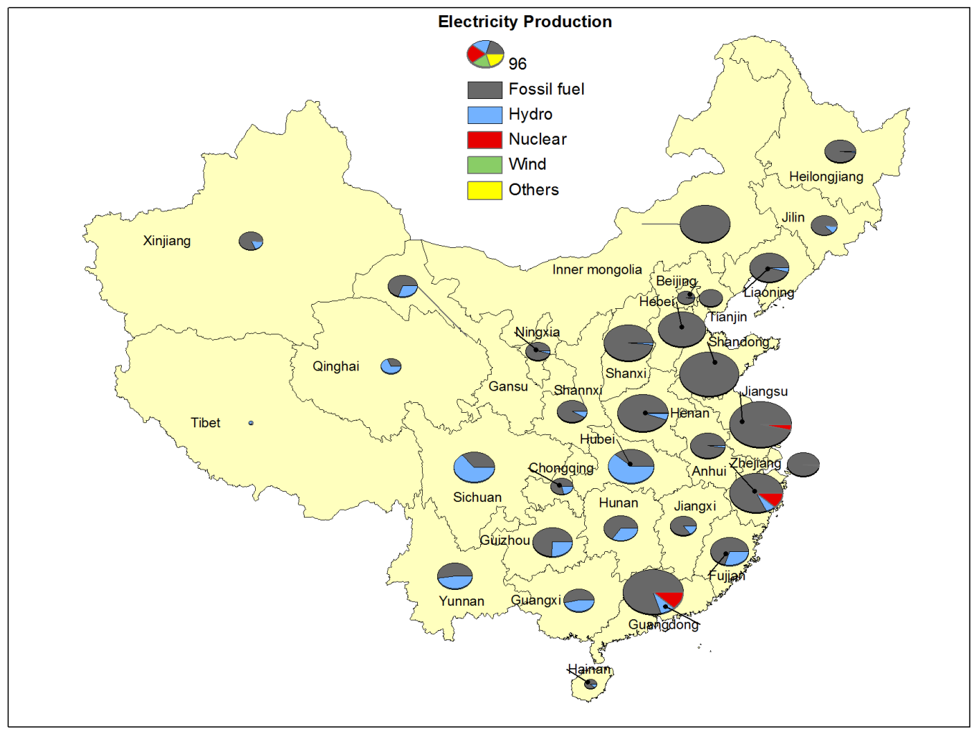
Figure 1 A diverse energy mix in China’s power generation

Located in the north of China (See Figure 2), Inner Mongolia has a total area of 1.18 million square kilometres, which covers 12.3% of the territory of China. Inner Mongolia is endowed with various natural resources, including rare earth elements (76% of the total reserves in the world), wind power (one fifth of total wind power potentials in China) and coal (top of China with 701.6 billion tonnes of reserves), according to the Inner Mongolia Government . In the past years, the GDP growth of Inner Mongolia, which is renowned for her leading position in China, has an average annual growth rate over 20% between 2003 and 2007 and over 15% between 2008 and 2010 .

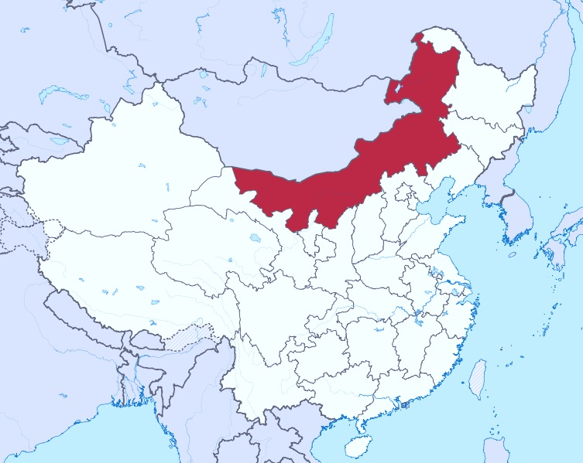
Figure 2Location of Inner Mongolia in China
Energy Production in Inner Mongolia
In 2009, Inner Mongolia’s total power generation capacity has reached 55.6 GW . Coalhas accounted for 97.6% of total power generation, which amounted to 225 billion kWh. 57.2% of the electricitygenerated were consumed within Inner Mongolia with the remaining electricity exported to other regions in China. At present, Inner Mongolia has outpaced all the other regions in China in terms of growths in newly installed power generation capacity, power generation per capita and domestic power exports.

Inner Mongolia is one of the first regions to use wind power in China, which can be traced back to the 1970s. Decentralized wind power was used to provide electricity supply for herdsmen in remote areas during its early development. Centralized wind power was not used until 1989, in which a wind farm with total generation capacity of 1MW was deployed with financial support from the United States. At present, Inner Mongolia has the largest installed capacity of wind power among regions in China. Total generation capacity increased from 8.2MW in 1995 to 13,858 MW in 2010. Figure 3 shows the capacity growth of wind power in Inner Mongolia during the past 15 years.

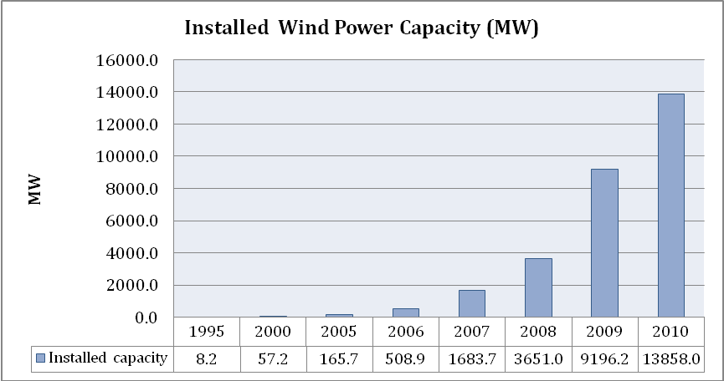
Figure 3Growth of wind power generation capacity in Inner Mongolia, China.
Source: Ling and Cai (2012)

The future deployment of wind power can be substantial. As one of the seven wind farm locations, Inner Mongolia would deploy 31.2GW and 58.1GW by 2015 and 2020, respectively. Besides, Inner Mongolia has one of the largest solar power potentials in China .Since the Chinese government has committed to promoting renewable energy sources, the percentage share of renewable energy to total energy supply will be considerable in the future. Despite the significant potentials in renewable energy sources, Inner Mongolia isthe largest coal producers in China. In 2011, total coal production in Inner Mongolia amounted to 979 million tonnes, which accounted for 27.8% of the total coal production in China.

Water resources in Inner Mongolia
Unlike other northern regions in China, Inner Mongolia has abundant water resources. Total water availability amounts to 38.9 billion cubic metres, of which 52.7 % are surface water and 47.3 % are ground water .
In 2010,agriculture accounted for 75.3% of total water consumption in Inner Mongolia. Industry, contributed to 11.6% of total water consumption with the remaining of water consumed by urban and public (1.6%), services (3.8%) and ecological protection(7.7%).

However, water resources are unevenly distributed in Inner Mongolia. East Inner Mongolia, which covers 27% of the territory and accounts for 18% of the total population and 20% of the farmland land, endowswith 65% of water resources; whilstwest Inner Mongolia, which covers26% of the territory and has 66% of the total population and 30% of farm land, accounts for 25% of the water resources . With vast territory and uneven distribution of water resources, it has led tosevere water shortages in some areas inInner Mongolia. For example, according to China Environment Statistical Yearbook (2009), 18% of people in Inner Mongolia do not have access to freshwater, which is higher than any other region in China. Total water shortage is expected to increase from 1,000 million cubic meters in 2011 to 3,000 million cubic meters in 2020. Furthermore, water pollution compounds the pressing issues of freshwater availability& distribution. By the end of 2010, 54.6% of the watersheds were severely polluted (failed to achieve Grade IV water quality standard) .The concentrations of chemical oxygen demand (COD) are higher than the Grade IV water quality standard in Songhua River, Liao River and Yellow River that flows through Inner Mongolia .Water quality level higher than grade IV is considered not suitable for direct human contact .

Methods and Data
Integrated hybrid life cycle analysis: theory, formulation and applications
Integrated hybrid life cycle analysis is a combination of conventional process-based life cycle analysis (LCA) and input-output analysis. Conventional process-based LCAoften underestimates the environmental impacts of a product due to the arbitrary selection of system boundary. Upstream impacts beyond the selected system boundary are neglected.The underestimation is referred to as truncation error. Figure 4illustratesan example of upstream cut-offs of a paperboard containers and boxes industry.
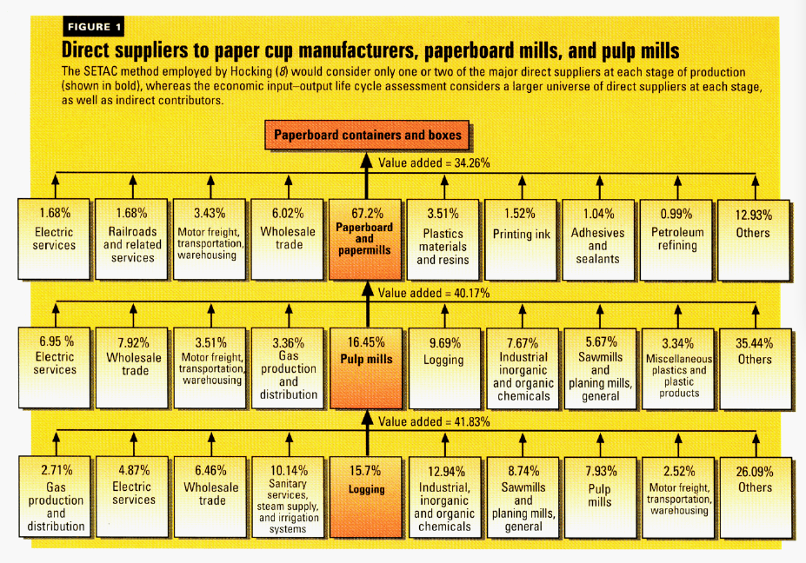
Figure 4 An example of upstream cut-offs in conventional process-based life cycle analysis.
Source:
Integrating LCA with input-output analysis (IOA) has provided a viable means to complementingthe system boundaryofconventional LCA approach. The early application of IOA in LCA can be traced back to the early 1990s from the estimation of life cycle CO₂ emissions of an automobile in Japan by . Later on, presented an economic input-output based life cycle analysis (EIO-LCA) to assess the environmental repercussions of five products in the U.S, including automobiles, refrigerators, computer purchases, paper cups and plastic cups.The IOA and LCA systemshave been treated individually, until postulateda linkage between LCA and IOA, which is now often known asthe integrated hybrid life cycle analysis.

Integrated hybrid life cycle analysis has been used in a number of energy studies in recent years. For example, demonstrated the application of the integrated hybrid life cycle analysis in the estimation of GHG emissions of rape methyl ester (RME) biodiesel, which is considered as a promising alternative to fossil fuels in the UK. compared three LCA techniques, including process-based LCA, input-output based hybrid LCA and integrated hybrid LCA, in assessing GHG emissions of wind energy in the UK.

Research Method
A general framework of the integrated hybrid life cycle analysis is given in Table 1. Two matrices are introduced to link input-output analysis (represented by A) and conventional life cycle analysis (represented by ) in the integrated hybrid life cycle analysis. One matrix (represented by U) presents the upstream cut-off flows from the economic sectors in the input-output system to the process system. The downstream cut-off flows from the process system to the IO system is represented by another matrix (represented by D in Table 1).

 | Processes | Industries | Functional unit
Products | Physical flow matrix () | Downstream cut-off (D)
Industries | Upstream cut-off (U) | Input-output matrix (A) | f
Environmental intervention | Environmental intervention of LCA ( | Environmental intervention of I-O (B)
Table 1A general framework of integrated hybrid life cycle analysis

The mathematical formulation of the integrated hybrid life cycle analysis approach is depicted in Equation 1.

Equation 1


WhereG_{IH}is the total environmental intervention matrix; and B are the environmental intervention matrix for conventional LCA system and the I-O system, respectively; represents inflows and outflows of products to processes in the conventional LCA system; Ais the flows among economic sectors in the input-output system; U is the upstream cut-off matrix; D is the downstream cut-off matrix; f represents the functional unit of the LCA system, which is one kilowatt hour in this study.

Research Data
This research needs several types of data, including the process-based life cycle data of selected power generation technology, input-output table of case study, and sectoral CO2 emissions, water consumption and COD discharge data. Data source and compilation methods are introduced in the following subsections.

Process-based life cycle data
The process-based life cycle datasets are originated from Ecoinvent Database, which we obtained data on 300MW pulverized coal power, 800kW wind power and 3kW solar PV systems.

300 MW pulverizedcoal power system – this dataset includes pulverized coal power generation in China. Data on coal power plants (with total generation capacity over 1 GW) are extracted from China Electric Power Yearbook (2008). For Inner Mongolia, 62 power generation units are listed. Each coal power plant has a combination of different power generation units, ranging from 600MW, 500MW, 330MW, 300MWand 200MW. Since process-based 600MW power generator (most widely used with 25 units in total) is not available in China, we have chosen the 300MW power generator (second only to 600 MW, with 13 units in total)in this study instead.

800 kW wind power system – this dataset includes wind power generation system in the Switzerland. The decision of using 800 kWwind turbine in this study isbased on two reasons: 1) By the end of 2007, Inner Mongolia has 1,736 wind turbines deployed with a total generation capacity of 1.56 GWand 898.6 kW on average. 2) Wind turbines produced in China are withlicences from European partnersandthus, we assume the material used and the manufacturing processes of wind turbines in China are identical to the European countries.

3kW Solar PV – this dataset includeselectricity production with grid-connected photovoltaic power plants mounted on buildings slanted roof in Switzerland.

IO Data
Following the standard compilation scheme established by the National Bureau of Statistics, regional IO tables have been complied to represent 30 regions in China from 1987. In this study, the most recent Inner Mongolia input-output table for the year 2007 is used. The economy of Inner Mongolia is categorised into 135 economic sectors.

Upstream and downstream cut-off matrix
We adopted the methods used by and to compile of upstream cut-off matrix (matrix U).The price data are extracted from China Price Yearbook.According to , the downstream cut-off Dwould be negligible if a functional unit is used instead of an arbitrary demand. In this study, we assume that all the power outputs are consumed by the electricity sector in the input-output table and thus, matrix D is set to zero.

CO₂ emission data
CO₂ emission data are compiled using the method introduced by .

Water consumption data
The water consumption data of Inner Mongolia is extracted from China Statistical Yearbook . However, the datahas been processed and aggregated into seven sectors which are agriculture, forest and finishing, industry, services, households, and eco-environment. As suggestedby , the incorporation of environmental impact indicators from other sources could help to improve the results. Hence, in this study, we incorporate the sectoral wastewater discharge data, which is extracted from Inner Mongolia Bureau of Statistics, and water reuse rate data, which is originated from Industries Water Requirement Quota and Standards of Inner Mongolia, to compile the sectoral water consumption data.The compilation of sectoral water consumption has two steps. First, sectoral water use data is estimated using the sectoral wastewater discharge data and water reuse data. Second, the results are multiplied by water consumption rate for industries, which are obtained from Inner Mongolia Water Bulletin (2008), to generate the sectoral water consumption data. Detailed compilation procedures are given as following.

The water recycling ratehas stipulated the percentage of water used need to be recycled in different industries. For example, 90% of the water used in coal mining and processing industry needs to be recycled.In other industries such as manufacturing of food, there is a very large variation of water recycle rate, rangingfrom 35% to 100% due to different products in food industry. Equation 2 depicts the calculation of the recycling rate.

Equation 2
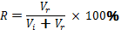

Whereas R represents recycle rate in percentage; V_{r} represents total amount of reuse water at a given time period; V_{i} represents new water intake at a given time period.

The denominator of equation 2 represents total water use of the industry, thus

Equation 3

In this study, we assume that water lossesin production and from evaporationare negligible. Consequently, new water intake V_{i} is equivalent to wastewater discharge, which is obtained from Inner Mongolia Statistical Yearbook (2008). Then we list sectoral water recycle rate. The water use for each sector is calculated using Equation 4, which is derived from Equation 3 above:

Equation 4
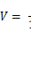

The calculated total water use with lower recycle rate is 17.2 billion m³, which is not far from the total water use - 17.5 billion m³ - from Inner Mongolia Water Bulletin . Then, the sectoral water use data are multiplied by the water consumption rate, which is generated from Inner Mongolia Water Bulletin. Based on the bulletin, water consumption rate are 61.4% for industries.Due to a lack of data, water consumption coefficients of services are adopted from . The sectoral water consumption data can be found in Appendix I.

Chemical oxygen demand (COD) discharge data
The COD discharge data is given in Inner Mongolia Statistical Yearbook, in which 37 secondary industries are included. Then, we calculate the average COD level in wastewater discharge (namely COD discharge coefficients), which can be found in Appendix II.For agriculture sectors, we adopt the COD discharge coefficients of agriculture sectors from .

presented a hydrological model to investigate the impact of COD discharge on water availability in North China. The authors calculated the water requirements to dilute COD discharges so that the mixed water (wastewater contains COD plus dilution water) can be used for other purposes. The model is not feasible in this study, as wastewater discharge is not separated into surface water and ground water in the Inner Mongolia Statistical Yearbook. Instead, we incorporate the general principle of mass balancing in that model. The quantity of COD in wastewater () equals to the quantity of COD after dilution (). As can be seen from Appendix II, the concentration of COD in wastewater is higher than Grade I standard; the reasons for using Grade I standard will be given below. In order to achieve Grade I standard, additional water is needed to dilute the COD concentration.

Equation 5

where v₁ is total volume of wastewater discharge; ₁ is the concentration of COD in the wastewater; v₂ is the total volume of water needed to dilute the COD content in wastewater; ₂ is the standard concentration of COD.

The General Administration of Quality Supervision, Inspection and Quarantine of the People’s Republic of China (AQSIP) has promulgated the industrial wastewater discharge standards (is known as the standard thereafter), which classify the contents of COD into three grades (See Appendix III).Grade I is adopted due to

1) The standard is stipulated in 1996, higher standard should be implemented with the improvement of wastewater treatment technology in the past decade.
2) As long as fulfilling the requirements in Grade II, industries are allowed to discharge wastewater to the watersheds, which are only available for agricultural purposes. The water quality of the watershed is considered as poor quality of water resources (Grade IV in water quality standard).
3) In Inner Mongolia Statistical Yearbook, COD discharge data is separated into two catalogues: COD removal and COD discharge. We assume that the COD discharge data are derived after the removal of COD content in secondary wastewater treatment plants. There are two evidences to validate our assumption: First, the COD removal figures are an order of magnitude higher than COD discharged figures; second, primary wastewater treatment plants use physical methods to remove tangible wastes in water body, which cannot remove COD content. Hence, Grade III in the wastewater standard is not considered in this study.

Research Limitations
First, since the detailed sectoral water use data is not available in most regions, the use of wastewater discharge data in the compilation of sectoral water use data has been adopted from a couple of studies . The inherent assumption of using wastewater discharge in this study is that water loss in production and from evaporation is negligible. Since a minor fraction of water is consumed in industries at present, such an assumption isvalid. However, the study can further be improved by incorporating detailed water data when they are made available in the near future. Second, the choice of representative power generation technologies might overestimate their environmental impacts.

4. Results and discussions
In Inner Mongolia, coal power represented more than 95% of the total power generation. Wind power is the second largest power generation source and has been experiencing a significant growth since 2005. In addition, Inner Mongolia has one of the most significant potentials of solar power in China. Thus, we focus on these three power generation technologies.

CO2 emissions
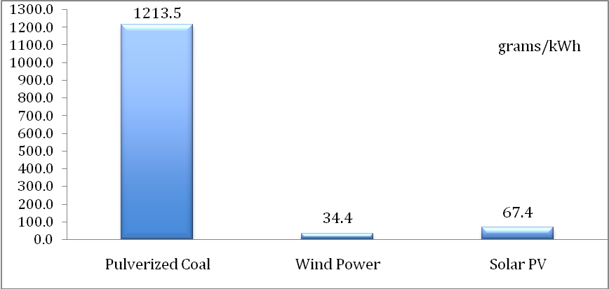
Figure 5:Life cycle CO₂emissions of pulverized coal, wind power and solar PV systems per kWh in Inner Mongolia, China.

Figure 5compares the life cycle CO₂ emissions of pulverized coal, wind power and solar PV systems. Pulverized coal emits 1,213.5 grams of CO₂per kilowatt-hour of electricity output, compared with 34.4 g/kWh and 67.4 g/kWh for wind power and solar PV systems, respectively. The significant differences in CO₂ emissions between different energy production systems indicate that substantial reduction inCO₂ emissionscan be attained if the existing coal-dominated power generation technology were substituted by renewable energy technologies.

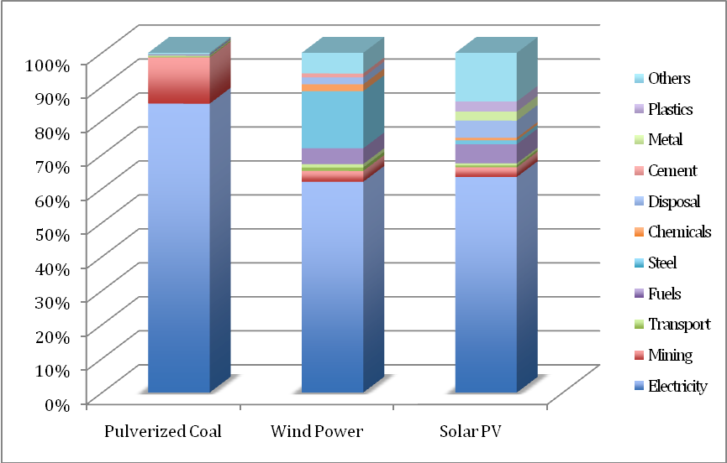
Figure 6:A breakdown of sectoral CO₂ emissions generated from pulverized coal, wind power and solar PV systems in Inner Mongolia, China.
Note: Steel is not included in Metal

In Figure 6, a breakdown of the CO₂ emissions by sectorsshows that the electricity sector contributes most to the life cycle emissions of all power generation technologiesin Inner Mongolia. For pulverized coal power generation, coal combustion at plant accounts for most of the emissions (1031.8 g/kWh), followed by the coal mining (165.2 g/kWh) and transportation. Activities related to power plant construction, such as steel production (2.1 g/kWh), account for a minor proportion of the total emissions. For wind power and solar PV, electricity generation accounts for more than 50% of the total CO₂ emissions. Similar results can be found in , which provides a national level analysis on CO₂ emissions of wind power in China. The emissions might come from the indirect linkages between the renewable energy sources and electricity generation through the manufacturing of metals, plastics and cement. The high carbon intensity of the existing power generation system in Inner Mongolia also contributes to the significant CO₂ emissions from electricity generation.

Water consumption
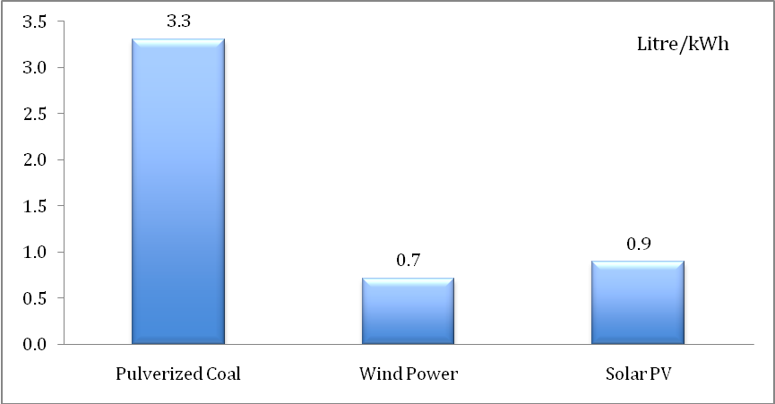
Figure 7A comparison of life-cycle water consumption of pulverized coal, wind power and solar PVsystems in electricity generationin Inner Mongolia, China.

Figure 7 presents the life cycle water consumption required by pulverized coal, wind power and solar PV systems to generate electricity in Inner Mongolia. Pulverized coal consumes 3.3 litres of water per kilowatt-hour of electricity output whencompared to0.7 litres/kWh and 0.9 litres/kWh for wind power and solar PV systems, respectively. It is concluded that a switch from a pulverized coal system to wind power and solar PV can reduce water consumption per kilowatt-hour of power output significantly, a similar finding asin CO₂ emissions.

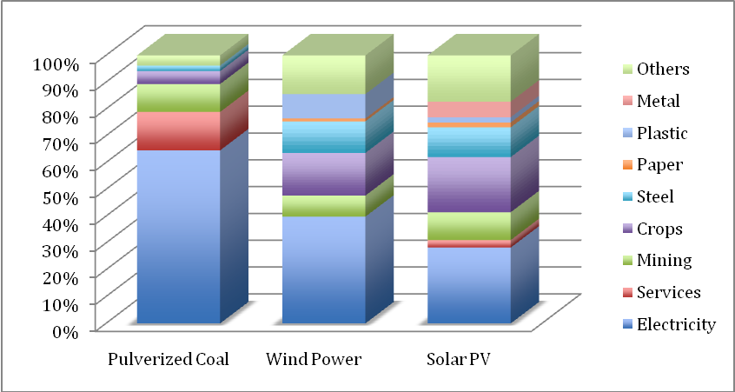
Figure 8 A breakdown of sectoral water consumption of pulverized coal, wind power and solar PV systems in electricity generation in Inner Mongolia, China.
As shown in Figure 8, the electricity sector accounts for approximately 60% (or 2.13 l/kWh) of the water consumption for pulverized coal. Most water sources are consumed for cooling purposes.Electricity accounts for most significant share in water consumption for the wind power system (0.28 l/kWh out of 0.71 l/kWh in total) and the solar PV system (0.27l/kWh out of 0.90 l/Kwh). In addition, mining, crops and steel are important water consumers.

COD discharge

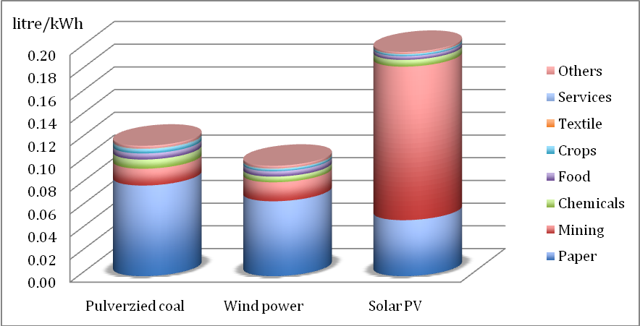
Figure 9Dilution water required for electricity generation in pulverized coal, wind power and solar PV systems in Inner Mongolia, China (why do we have different shapes here?)
COD discharge is estimated as required dilution water since the discharge of wastewater needs to be diluted to achieve the water quality standard. From Figure 9, dilution water to purify the discharged wastewater from pulverized coal, wind power and solar PV amounted to 0.11, 0.09 and 0.19 litres per kWh, respectively. Upon the water consumption in Figure 8, the addition of dilution water increases water consumption of pulverized coal, wind power and solar PV by 3.3%, 12.7% and 21.1%, respectively. COD discharge from paper production uses most of the dilution water for pulverized coal and wind power due to the high concentration of COD in paper industry’s wastewater. By contrast, mining of metals accounts (Mainly silicon) for the highest proportion of dilution water for solar PV (0.13l/kWh), and it is followed by paper, chemicals and food production.

Discussion
Renewable energy technologies can be regarded as carbon and water saving solutions to the existing coal-dominated power generation system in Inner Mongolia. Presently, Inner Mongolia is the second largest coal producer in China. The uneven distribution of energy sources in China has called for the construction of long-distance power transmission system, which has been initiated by the State Grid Corporation of China (SGCC). One of the primary targets with the transmission system reinforcement is to increase the ratio of power transmission to coal transportation - from 1:20 in 2005 to 1:4 in 2020. The changes in ratio could have significant implications on the water availability and the water quality in Inner Mongolia.

This study also reveals that, other than carbon emissions, the selection choice ofdifferent power generation technologies need to consider water impacts, especially if the choice has to be made among different renewable energy technologies. It is shown that solar PV leads to higher COD levels than wind power due to the mining of metals. Presumably, the environmental repercussions of solar PV can be more considerable if emissions of other pollutants such as cadmium are taken into account.

There are many factors need to be considered in optimizing the power system from technical issues such as system operation to the environmental issues such as the mitigation of CO₂emissions. A coherent energy policy should consider as many sustainability indicators as possible. Further investigation of other sustainability indicators needs to be implemented to ensure the current choice of power generation technologies will not compromise the sustainability in the future, taking into account the substantial life-span of power generation systems.

Future research
Besides the carbon emissions and water impacts examined in this study, coal-fired power plants are the most significant contributors to mercury emissions in China, which amounted to 304 t in 2010, according to . Whether the switch from coal to RE can deal with mercury emissions needs to the examined in the future.

Also, 3% of the total electricity supply is used for wastewater treatment in the U.S. and so as to other developed countries. Future research could focus thetwo-way energy-water relations.

5. References

Appendix

Appendix I sectoral water consumption and water coefficients

 | Water consumption (10,000 m³) | Economic output (10,000 yuan) | Water consumption coefficient (m³/10,000 yuan)
Economic sectors | Water consumption (10,000 m³) | Economic output (10,000 yuan) | Water consumption coefficient (m³/10,000 yuan)
Agriculture | 779200.0 | 6421574.0 | 1213.4
Forest, finishing, livestock | 127500.0 | 6342863.0 | 201.0
Coal mining & processing | 20558.3 | 7629806.4 | 26.9
Petroleum & Natural Gas Pumped | 12.4 | 630965.8 | 0.2
Mining & Dressing of Ferrous Metals | 349.4 | 2341200.7 | 1.5
Mining & Dressing of Nonferrous Metals | 2338.7 | 2021735.9 | 11.6
Mining & Dressing of Non-metal Minerals | 212.5 | 1628769.9 | 1.3
Processing of Agricultural Side-Line Food | 4666.1 | 912753.5 | 51.1
Manufacturing of Food | 2161.3 | 8914647.1 | 2.4
Manufacturing of Beverage | 3006.5 | 1254994.5 | 24.0
Tobacco Products | 28.5 | 386674.8 | 0.7
Textile Industry | 440.9 | 1425883.0 | 3.1
Textile, Clothes, Shoes & Hats | 49.7 | 1639205.6 | 0.3
Leather, Furs, Down & Related Products | 34.6 | 108823.2 | 3.2
Timber Processing, Bamboo, Cane | 2398.7 | 859677.6 | 27.9
Palm Fibre& Straw Products | 548.5 | 196560.3 | 27.9
Paper-making & Paper Products | 5469.6 | 374270.4 | 146.1
Printing & Record Pressing | 93.7 | 390490.8 | 2.4
Petroleum Processing, Coke Products & Processing of Nuclear Fuel | 206.0 | 1587319.4 | 1.3
Chemical Materials & Products | 2660.0 | 3867593.5 | 6.9
Manufacturing of Medicine | 1817.0 | 575195.6 | 31.6
Plastic Products | 45.2 | 453652.5 | 1.0
Non-metal Mineral Products | 376.1 | 3773112.8 | 1.0
Smelting & Pressing of Ferrous Metals | 41496.8 | 7032359.4 | 59.0
Smelting & Pressing of Nonferrous Metals | 2202.8 | 10513854.2 | 2.1
Metal Products | 2.2 | 38571.3 | 0.6
General-Purpose Equipment | 19.8 | 760220.0 | 0.3
Special Equipment | 174.3 | 840643.9 | 2.1
Transported Equipment | 25.2 | 2065849.2 | 0.1
Electric Equipment & Machinery | 15.4 | 421611.8 | 0.4
Manufacturing of Telecoms, Computer & Other Electronic Equipment | 8.2 | 845809.3 | 0.1
Instruments, Meters, Cultural & Office Machinery | 5.9 | 162573.1 | 0.4
Production & Supply of Electric Power | 31938.7 | 7780758.0 | 41.0
Production & Supply of Gas | 26.5 | 751728.3 | 0.4
Production & Supply of Water | 2131.8 | 146129.5 | 145.9
Construction | 5852.9 | 11705703.3 | 5.0
Transport and warehousing | 3123.5 | 10075826.0 | 3.1
Post and telecommunication | 309.7 | 1290483.6 | 2.4
Wholesale and retail trade | 1538.4 | 6992825.7 | 2.2
Eating and drinking places | 566.2 | 2573768.2 | 2.2
Passenger transport | 136.8 | 427536.0 | 3.2
Finance and insurance | 709.7 | 3226008.0 | 2.2
Real estate | 321.6 | 1461761.7 | 2.2
Social services | 263.2 | 1461970.6 | 1.8
Health Services, social welfare | 1186.7 | 3596116.6 | 3.3
Education and culture | 617.5 | 1992087.5 | 3.1
Scientific research | 45.8 | 190703.1 | 2.4
General technical services | 100.9 | 252170.8 | 4.0
Public and other services | 3141.9 | 6283872.6 | 5.0
Total | 1050136.1 | 136628711.7 | 76.9

Appendix II Wastewater discharge and water discharge standard by sectors
Economic Sectors | Wastewater discharge | COD discharge | Average COD  level | Water discharge standard (Grade I)
Unit | 10,000 m3 | tonne | g/m3 | g/m3
Agriculture | 8807.46 | 25541.64 | 290.000 | 100
Coal Mining & Processing | 2829.56 | 4038.91 | 142.740 | 100
Petroleum & Natural Gas Pumped | 1.70 | 0.09 | 5.318 | 60
Mining & Dressing of Ferrous Metals | 240.42 | 107.04 | 44.520 | 100
Mining & Dressing of Nonferrous Metals | 2092.28 | 18988.36 | 907.545 | 100
Mining & Dressing of Non-metal Minerals | 14.62 | 65.49 | 447.910 | 100
Mining of Other Mineral | 0.00 | 0.00 | 0.000 | 100
Processing of Agricultural Side-Line Food | 1605.55 | 12635.80 | 787.006 | 100
Manufacturing of Food | 1933.61 | 10653.12 | 550.946 | 100
Manufacturing of Beverage | 1241.40 | 13488.52 | 1086.561 | 100
Tobacco Products | 5.88 | 18.04 | 306.718 | 100
Textile Industry | 303.44 | 2254.47 | 742.962 | 100
Textile, Clothes, Shoes & Hats | 34.20 | 84.67 | 247.533 | 100
Leather, Furs, Down & Related Products | 23.82 | 82.68 | 347.143 | 100
Timber Processing, Bamboo, Cane, | 330.15 | 428.49 | 129.789 | 100
Palm Fibre & Straw Products | 0.00 | 0.00 | 0.000 | 100
Paper-making & Paper Products | 3011.23 | 49981.95 | 1659.851 | 100
Printing & Record Pressing | 0.00 | 0.00 | 0.000 | 100
Petroleum Processing, Coke Products & Processing of Nuclear Fuel | 141.77 | 98.12 | 69.211 | 100
Chemical Materials & Products | 1464.47 | 2903.29 | 198.249 | 100
Manufacturing of Medicine | 500.17 | 1766.53 | 353.188 | 100
Plastic Products | 0.00 | 0.00 | 0.000 | 100
Non-metal Mineral Products | 207.08 | 120.07 | 57.982 | 100
Smelting & Pressing of Ferrous Metals | 2855.72 | 1777.99 | 62.261 | 100
Smelting & Pressing of Nonferrous Metals | 303.18 | 213.38 | 70.382 | 100
Metal Products | 0.60 | 1.12 | 186.291 | 100
General-Purpose Equipment | 8.19 | 23.35 | 285.076 | 100
Special Equipment | 155.96 | 116.87 | 74.938 | 100
Transported Equipment | 13.88 | 10.81 | 77.871 | 100
Electric Equipment & Machinery | 8.48 | 5.24 | 61.765 | 100
Manufacturing of Telecoms, Computer | 7.86 | 10.11 | 128.633 | 100
Instruments, Meters, Cultural | 0.00 | 0.00 | 0.000 | 100
Production & Supply of Electric Power | 3516.72 | 2029.68 | 57.715 | 100
Production & Supply of Gas | 2.92 | 43.42 | 1486.986 | 100
Production & Supply of Water | 234.73 | 280.88 | 119.659 | 100
Housing & Civil Construction | 0.00 | 0.00 | 0.000 | 100
Railway Transport | 0.00 | 0.00 | 0.000 | 100
Other Sectors | 120.03 | 515.52 | 429.503 | 100
Total | 32017.07 | 148285.66 | 463.15

Appendix III Grade Classification of wastewater discharge
Grade Classification | Description
Grade I | Water discharge into Class III watershed in GB 3838 (exclude specified water protection zones and swimming zones) and Class II seas in GB 3097, implement Grade I
Grade II | Water discharge into Class IV, V watershed in GB 3838 and Class III seas in GB 3097, implement Grade II
Grade III | Water discharge into secondary wastewater treatment plant of sewage system, implement Grade III
Table xx industrial wastewater discharge standards
Source: AQSIP

Appendix IV industrial wastewater discharge standard
Industry | Grade I | Grade II | Grade III
Beet sugar manufacturing, fatty acid synthesis, wet fibreboard processing, dye manufacturing, organophosphorus pesticides industry | 100 | 200 | 1000
Monosodium glutamate, ethanol, medicines, medicines, biochemistry, fur industry, pulp purification industry | 100 | 300 | 1000
Petroleum refinery | 60 | 120 | 150
Secondary wastewater treatment plant | 60 | 120 | -
Other wastewater discharge | 100 | 150 | 500

Appendix V Environmental Quality Standards for Surface Water
The environmental quality standards for surface water stipulate the indicators and standard values of surface water, which is categorised into 5 grades. 23 indicators for surface water standards are includedsuch as temperature, PH value, COD, copper, mercury, lead and so on and so forth. The standards for COD is listed below
Category | Grade I | Grade II | Grade III | Grade IV | Grade V
COD (mg/L) | 15 | 15 | 20 | 30 | 40
Source: Environmental quality standard for surface water (2002)

Own calculation. Figures are derived from Li et al. (2010), which separate Inner Mongolia into Eastern Inner Mongolia and Western Inner Mongolia.
Classification of water quality standard in China see Appendix V
2010 Ecoinvent database v2.2
There is a disparity in the statistical figures given by Shi (2008) and Ling and Cai (2012) on the 2007 total generation capacity. The disparitymay be due to the differences in the statistical method used. The China Electricity Council only takes the wind farms in operation into account in calculating wind power generation capacity. The manufacturers of wind turbine use the sales figuresinstead to derivewind power generation capacity. It is beyond the scope of this study to investigate the statistical method used in these two studies. Since Shi’s study (2008) contains data on the number of wind turbines and the total generation capacity, we have opted for these figures for use in this study.
It includes 22 provinces, 4 municipalities and 4 autonomous regions. Hong Kong, Macao, Taiwan and Tibet are not included.
Some industries have more than one water recycle rate. As in the input-output table, it is assumed that industries have homogeneous product. The classification of industries is in much detail. For example, manufacturing of food has a wide range of water recycle rate - from 35% for manufacturing of canned meat to 70% for manufacturing of milk. Thus, we list the lower recycle rate and higher recycle rate and estimate the lowest and highest water requirements for each industry.
To clarify, the Grade IV water quality standard is for the quality of watershed such as river and like, which is different from the industrial wastewater discharge standard.

