Sectors reconstruction simulation of Wenchuan Earthquake in China
Ning LI^{,2*}, Jidong WU², Peng ZHANG², Bihang FAN²
1. State Key Laboratory of Earth Surface Processes and Resource Ecology, Beijing Normal University, Beijing, China
2. Key Laboratory of Environmental Change and Natural Disaster, MOE, Beijing Normal University, Beijing, China

Abstract: In catastrophe mitigation strategies, a decision of sector recovery capacity of disaster impact needs to be determined. Such a decision usually based on economic losses simulation by contingency of catastrophe on overproduction and reconstruction period. This paper measured productive capacity, ripple effects and key adaptive behaviors under different sectors for 2008 Wenchuan Earthquake of China using ARIO model. They are household sector, manufacture sector and utilities and public services sector. The results show that the sectors easiest to be suffered loss were Household sector and Manufacture sector, residential buildings provide important housing service to people. These sectors service were significantly compromised by earthquake damages, and should be taken into account firstly in the disaster mitigation system. Under the same overproduction level, the most obvious recovery variation occurred in public services sector. It is a nice elicitation that by increasing the production capacity in these sectors of intermediate consumption would beneficial to reduce loss obviously. The utilities also have priority to be support in productive structural for decreasing reconstruction period. Therefore, ARIO model is useful tool for decision making through indirect economic loss simulation and reconstruction benefit assessment.
Keywords: indirect economic loss; Wenchuan Earthquake; ARIO model; reconstruction

1 Introduction
The Wenchuan Earthquake (WEQ) occurred on May 12, 2008, in China’s Sichuan Province (Ms=8.0). It is the most disastrous earthquake in China since the great Tangshan Earthquake (Ms=7.8) occurred on July 28, 1976 (Yuan, 2008). It resulted in direct damages amounting to CNY 749 billion, approximately 90% of the GDP of Sichuan province in 2007. More than 87,000 people died and nearly 375,000 others were injured (NCDR, 2008).
After the deadly WEQ, Chinese government starts to make reconstruction plan and to speed up the productive capacity in different sector to decrease the economic losses. Although the plan has been questioned by expert committee of General Office of the State Council of the People’s Republic of China, it is still an active debated question in the China catastrophe mitigation system (NCDR, 2008) about how percent overproduction+ capability should be add to suitable key sector.
As we know, a plan’s design of natural disaster mitigation system based on loss analyses. In this research approach, total losses consist of two parts, direct economic loss (DEL) and indirect economic loss (IDEL). Generally, the DEL of an event is repairing or replacement cost (at the prevent price level) of the assets that have been damaged or destroyed. The IDEL is the reduction in production goods and service, it includes business interruption in the disaster event aftermath, production loss during the reconstruction period, and service loss. For example, if a plant with $1 million is destroyed and immediately rebuilt, total loss is $1 million; if reconstruction is delayed by one year, total losses is the sum of the replacement cost (DEL) and the value of one year of production (IDEL). The IDEL value can be very high in some sectors, especially when basic needs are at stake (Hallegatte and Dumas, 2007) in a long period. IDEL is a key factor to balance reconstruction period.
In the plan by NCDR, Sichuan would only recover production within 36 months to cope with DEL, comparing to a plan able to finish reconstruction by longer period to cope with IDEL, if the additional cost of the upgraded support was enough and used on suitable industry sector. However, this is not certain to be the case, because of without simulation done before making the decision.
In order to know the reconstruction period by adding cost, we need understand IDEL simulation in sectors by model based on economic chain impact by model. It includes how IDEL decrease and recover continually to per-disaster level, integrated losses grade influent by both DEL and IDEL in sectors, and benefit analysis for extra reconstruction capability in different integrated losses grade to know what sectors have priority to add the capability.
The economic impact of disasters on a regional economy is very complex, modeling these impact has difficulty, especially the economic dynamics on IEDL of the changes over space and time. Most of the case, policy-makers focus mainly on the human suffering and physical damages (DEL) that occur immediately after a disaster. They tend to overlook the subsequent IDEL caused by complex economic processes and ripple effects. Actually, direct damages are only a partial and limited view of natural disaster consequences, as ripple effects can be turn up at larger scales and during longer periods. Even more than physical damages, however, IDEL and ripple effects are extremely difficult to assess, and all published estimates remain highly uncertain, some researchers still unremitting develop IDEL model. Rose (2004), Cochrane (2004), Greenberg (2007) and Wu, et al. (2009) have compared different methods for disaster IEDL assessment, including Input-Output (IO) models, Computable General Equilibrium (CGE) models, and econometric models. Among them, IO models are powerful tools to assess the disaster ripple effects among economic sectors, through the interplay of intermediate consumptions and demands. It is probably the most widely used modeling framework in disaster impact analysis (Brookshire et al., 1997; Okuyama, 2007, Rose et al., 1997). These study result show that IDEL really is a good indicator to figure reconstruction issues. In this line, Hallegatte (2008) used a modified IO structure, the Adaptive Regional Input-Output (ARIO) model, to point out IDEL in different sector for disaster management.
IDEL has being recognized as very significance in wake of serious natural disasters in China, researchers did highlight the role of ripple effects for establishing effective disaster-risk reduction measures, however usually used model are proportional coefficient method and static IO coefficients to estimate IDEL (Xu, 1998; Lu et al., 2002; Liu and Zhao, 2008; Hu, et al., 2008). These methods need more consider the dynamic mechanism of these ripple effects during the reconstruction period. Improving risk management and assessing potential benefits tools require assess DEL from disaster and simulate IDEL from adding productivity in reconstruction period. In disaster aftermaths, these estimates and simulation are significance to support resource allocation for restoration.
This paper focus on a necessity of making the post-disaster reconstruction plan of WEQ of Sichuan Province in China, assessed DEL and IDEL based on the ARIO model. It represents scenario on losses reduction and reconstruction period shortage through sectors, cope with high magnitude category earthquake, and design of its future earthquake mitigation system.

2 ARIO model and impact areas
2.1 ARIO Model
The ARIO model based on traditional IO tables and has been improved for regional disaster-impact modeling. It is a useful tool to assess the “ripple effects” caused by an overall disaster shock to an economic system at a regional scale. For a classical IO model in an equilibrium economic system, the input-output coefficient matrix that describes the quantity provided by each sector to other sectors, the production vector and the final demand vector are linked by the following relationship:
(1)
The equation (1) can be turned to:
(2)
The term is known as the Leontief Inverse. It indicates that how much the output of each sector must change due to the final demand variation. It might seem that a $1 worth of cement (i.e., for building reconstruction in the construction sector) increase in demand will directly and indirectly stimulate the cement production to change by more than $1 equivalent, thus result is a ripple effect. Given the assumed regularity of the production in each industry, the Leontief Inverse can be used for policy simulations reflected in changes in final demand as follows:
(3)
The equation (3) provides a starting point for measuring IDEL that are backward propagation, i.e., reduced consumption needs due to the lower production of the tourism sector after the disaster.
Thus, even limited physical damages may cause ripple effects, spreading to the regional economy.
In contrast to the conventional IO model structure, the ARIO model focuses on changes in production capacity due to productive capital losses, which reflect the forward propagation IDEL and changes in adaptive behaviors of economic actors in disaster aftermath. The ARIO model takes into consideration a regional economy that consists of a large number of households and N different industries. For each industry, the production, the local input-output table (LIO), and the demand are linked by the following relationship (Hallegatte et al, 2008):
$Y(i)=\sum_{j}{A(i,j)}Y(j)+\text{LFD}(i)+E(i)+\text{HD}(i)+\sum_{j}{D(j,i)}$
(4)

Where j = 1, ...N , N is total sectors. A is the LIO table, which differents from the traditional IO table, because it distinguishes intermediate consumption produced locally and those produced outside the disaster impacted region (see Hallegatte, 2008, in detail), Y is the production vector. LFD is the Local Final Demand vector, E is the Exportation vector, and HD and D are the disaster damages to households and industries. The sum of vector LFD, E, HD, and D is the total final demand. Each industry i also needs to import an amount I(i) of goods and services to produce an amount Y(i). The disaster affects the economy in two ways. First, it creates a large reconstruction demand from households (HD) and businesses (D); second, it reduces productive capacity because of business productive capital destructions (measured by D).
Assumes here: no the reconstruction fund limitation for reconstruction (in fact, china support a very plenteous finance in the case); no technological progress; no large change on economic structure in Sichuan, LIO coefficient is fixed; the economy return to pre-disaster levels after local reconstruction be finished. The impact outside Sichuan province not estimated.

Also, The model considers following disaster-impact dynamics: (1) forward propagation (underproduction and supply shortage due to reduced production capacity) and backward propagation (reduced intermediate consumption needs due to lower production) among sectors; (2) adaptation behaviors of producers and consumers (they import from outside when local production is inadequate in affected region, and they return to their original local suppliers when production back to normal); (3) production limits that depend on available labors and existing productive capital; (4) a priority-rationing scheme (priority is given to intermediate consumption first, then reconstruction needs and local demands, and lastly exports).

Based on these issues above, this paper took 1 month as a step to calculate capacity and consumption in each sector of post-disaster. This model in more detail has comprehensively described in Hallegatte et al., 2008, which had already be applied on Louisiana and New Orleans disaster.
2.2 Impact area
The WEQ resulted in huge direct loss to physical property, and in large numbers of causalities in the affected areas because of their relatively low seismic resistance level. Sichuan Province (Fig.1) least 4.8 million people had been made homeless. It made DEL at about CNY 749 billion (US$123 billion), this loss amounted to about 90% of the province’s gross domestic product (GDP) in 2007(NCDR and MOST, 2008). The indirect effect on the economic system is likely to be large.
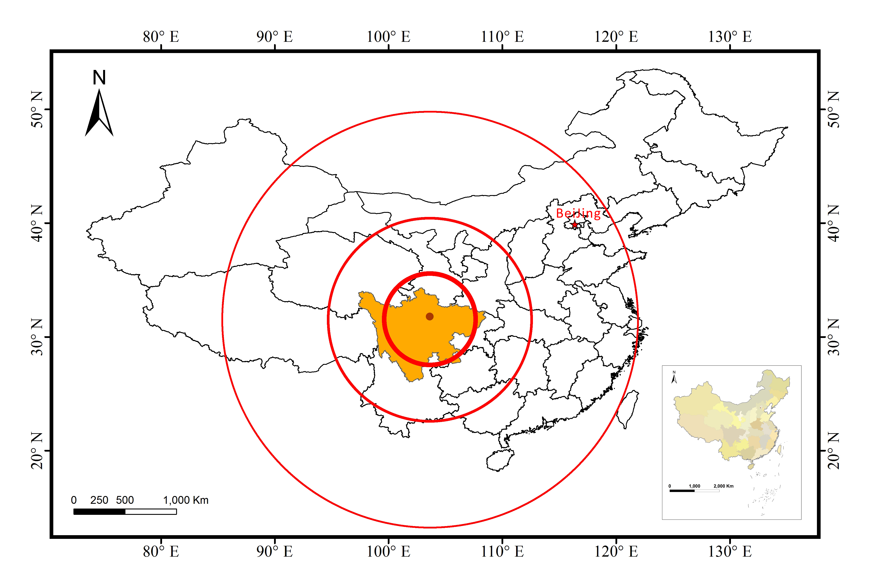
Sichuan
Fig 1: Position diagram of WEQ in Sichuan Province, China.

3 DEL analysis and its sectors order
3.1 DEL analysis
The 2005 IO table of Sichuan Province is used for building ARIO sectors. The LIO table was merged from 42 sectors of IO to 15 sectors; composed of 14 productive sectors and 1 household sector. The distributed DEL column of sector-by-sector was from NCDR and MOST, 2008. This data had been revised to take into account the fact that some losses cannot be repaired, replaced or rebuilt (e.g., ecological loss). The total DEL was CNY 749 billion (Table 1) for 15 sectors.

Table 1 Distributed DEL and simulated IDEL of WEQ by ARIO sectors in Sichuan Province
(billion CNY in 2008)
No. | ARIO Sectors
1 | Agriculture (farming, forestry, animal husbandry and fishery etc)
2 | Mining (coal, petroleum and natural gas, etc.)
3 | Manufacture (food, equipment, machinery, etc.)
4 | Utilities (electric power and heat, gas, water etc)
5 | Construction
6 | Transportation, warehousing and postal services etc
7 | Information (computer service and software industry)
8 | Wholesale and retail trade
9 | Finance, real state, renting, tourism et al
10 | Professional and business services (scientific research etc)
11 | Other service
12 | Educational services, health care, social security and social welfare
13 | Culture, sports, recreations, accommodation and catering services
14 | Government (public administration and social organizations)
15 | Household (housing and property, includes cars, furniture et al.)

3.2 Sectors order of DEL
In particular, production suffered a serious setback because of serious damages to productive capital, especially in key sectors of the local economy. The damage blocked rivers and roads, destroyed bridges, electricity, and interrupted water supply as well as telecommunication and production. Table 1 shows household, manufacture, mining and education have larger DEL due to these sectors have the highest quantity of productive capital. Household damages represent 40% of total DEL, becoming a key sector. The Utilities, Manufacture, and Finance sector take the second level that directly relate to the normal operation of the economy account for 34% of total DEL, while transportation, Manufacture, real state, renting, and tourism have the lower DEL than other sectors.
In the model, we assume that production from Sector 4 (utilities), sector 5 (construction), sector 8 (wholesale and retail trade) and sector 6 (transportation, warehousing and postal services) cannot be delocalized, while the production of other sectors can be imported rather than locally produced. The resulting damage was tremendous (Munich Re, 2008). It restricted the production process at least in the short term, even changing the local production structure. Moreover, production bottlenecks in intermediate consumption may have amplified the insufficient production capacity through forward propagations.

4 IDEL analysis and its sectors order
4.1 IDEL analysis

IDEL represent as adding value (VA value) of sector production. Based on sector’s DEL distribution in Table 1, the ARIO model provided the IDEL simulation results for each sector (final column in table 1). In this version, production could increase by 20% in 6 months in case of large increase demand become an assumption, which processed 96 months reconstruction, VA value reached pre-disaster level.
Under this assumption, the simulation shows IDEL (the VA various is negative value) and gains (the VA various is plus value) in different sectors in the reconstruction periods. the VA various for the total sectors reached pre-disaster level (VA=0) processed in 40 months, the aggregated VA value (without the construction sector and without discounting) reached CNY 175 billions in pre-disaster prices. The housing service “production loss” was estimated at CNY 126 billion, and the sum of IDEL was CNY 301 billion, amounting to approximately 40% of the DEL (CNY 749 billion).
4.2 Sectors order of IDEL
In Table 1, the household sector 15 and educational services sector 12 presented larger VA value in the 15 sectors. The Manufacture sector 3, the finance sector 9 and government sector 14 increased a lot order position due to the intermediate consumption of the construction sector. The construction sector 5 with value of construction at CNY -49 billion, shown overproduction in this sector made recovery early and gain profit when other sectors reached pre-disaster level from large reconstruction demands and overproduction. Overproduction of rebuild roads, bridges and buildings by increasing additional equipment and workers from outside the affected region or by round-the-clock production can help the construction production shortage and speedup its recovery (Hallegatte and Dumas, 2008). The counterpart assistance from other relatively developed provinces outside of Sichuan is a good path to process overproduction and finish reconstruction period. Because of data limits in China, we have no empirical information on the economic impact.

5. Integrated assessment of losses grade with DEL and IDEL distribution of sectors
In order to see integrated loss grade, we figured grade A, B, C by on both DEL and IDEL order (Fig.2). The loss level decrease gradually from up-left in the grade A (black), grade B (grey) to down-right in the grade C.
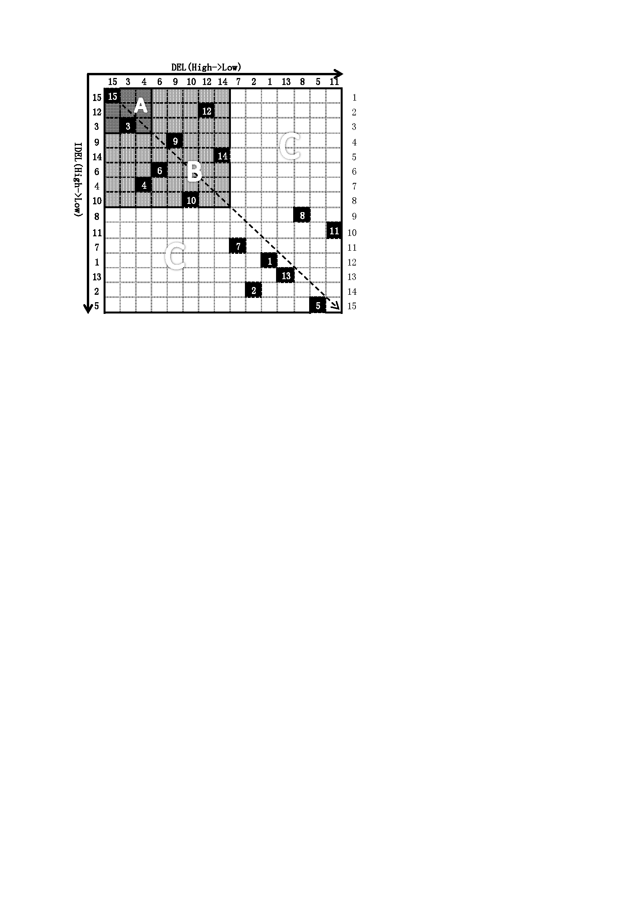
Fig. 2 Integrated losses grade with DEL and IDEL distribution

The sectors on the up-right of diagonal line belong to the larger sensitivity sectors with DEL, while sectors on the down-left of diagonal line have larger sensitivity with IDEL. Grade A includes sector 15 and sector 3, which concerned in sector of household and Manufacture, they have both higher DEL and IDEL. Houses and residential buildings provide important housing services to the population, compromised this service was most intensity and key aspect of disaster losses and should be taken into account firstly. Utilities sector 4, transportation sector 6, finance, real state and tourism sector 9, professional and business services 10, educational services and health care social security sector 12, and government sector 14 belong to grade B. These sectors express middle intensity of disaster influence. The Grade C included remained sectors 1, 2, 7, 8, 11, 13 with smaller action than other sectors. The household sectors 5 also belong to this grade due to it benefit from reconstruction demand faster.
Fig.2 also shown that sectors with larger DEL not always have larger IDEL, contrarily, more important was that sectors with smaller DEL have the possibility to be impacted by a larger IDEL due to ripple effects among sectors. For example, the IDEL of sector 12, include educational services, health care, social security and social welfare had the order No. 7th of DEL and the order No. 2th of its IDEI, and its IDEL value (44.4) reaches 117% of DEL value(Table 1). This is an easy to be ignored issue in loss assessment for decision-making.

6. Reconstruction scenarios to IDEL

6.1 Reconstruction scenarios
Based on Chinese catastrophe mitigation system, four scenarios of overproduction parameters in post-disaster were made in Table 2. The parameters are：[100%, 0 months] (no overproduction)；[120%, 6 months]（best-guess value in this paper）；[120%, 3 months] and [150%, 6 months]. ([120%, 6 months] means that the sector can increase its production capacity by 20% compared to pre-disaster in 6 months in response to production shortages when the pre-disaster production capacity is 100%). Assuming an overproduction in the construction sector could be repaired or replaced quickly damaged infrastructure and buildings, the productivity could be restored to its pre-disaster VA level fast, and IDEL can be significant reduced. The ARIO model simulated the economy restoration progress with the four scenarios to identify the IDEL, as well as the benefit of overproduction and reconstruction demand in each sector.

Table 2 Simulated IDEL and reconstructed periods of WEQ under four scenarios
by ARIO model simulation.
Overproduction parameters | Reconstruction periods (months) | IDEL (billion CNY ) (% of DEL)
No overproduction | 102 | 480 (64.1%)
{120%; 6 months} | 96 | 301 (40.2%)
{120%; 3 months} | 86 | 249 (33.2%)
{150%; 6 months} | 84 | 118 (15.7%)

6.2 Evolution of Overproduction and total IDEL value variations

6.2.1 IDEL value variations

Under the same overproduction capacity to be accelerated followed the quake, when change the overproduction period from 6 months to 3 months, IDEL should account from 301 to 249 billion CNY, shows percent of DEL value decreased 7% (Table 2). The mean reason consist speed up supply production, mitigated ripple affect of production shortage. It is why government rapid dive fund into post-disaster reconstruction to speed up overproduction resiliency after huge disaster occurrence. Overproduction can mitigate production shortages by increasing additional equipment and workers arriving from outside the affected region or by round-the-clock production. The counterpart assistance from other relatively provinces outside of Sichuan is a good path to finish overproduction, and the migrants return of also compensate worker shortage during reconstruction period.
6.2.2 Reconstruction period variations

Fig. 3 shows the total VA value variation in a full reconstruction period. Averagely, through overproduction, the total VA decreased by nearly 15% in a few months following the disaster. Then it increased to exceed the pre-disaster levels about 40 months after the shock (VA variation reach 0), because of reconstruction demand and overproduction. Face to extreme scenario [120%, 3 months], the larger production capacity result reconstruction period shorten to 24 months. For the case of no overproduction scenario, smaller VA increasing variation needed longer reconstruction period of 96 months. The stronger overproduction capacity accelerated in a short period, the smaller IDEL suffered. Overproduction can cope with the production shortage by increasing additional equipment and workers from outside the affected region, or round-the-clock production. The counterpart assistance from other relatively developed province outside the Sichuan is a good measure for overproduction.
Figure 3: VA variation (in percent of pre-earthquake VA level) under four scenarios of overproduction parameters.

6.3 Evolution of IDEL variations for integrated grade
Fig. 4 shows the integrated loss grade’s VA value variation in a full reconstruction period. Under the same overproduction capacity to be accelerated, in the scenario of no overproduction, the VA variation tend was approximate in grade A, grade B and Grade C. In the other three scenarios, the VA variation in grade B was the most sensitive in the three grades. They had a shorter reconstruction period and larger VA value. It should suggest that to take favorable and advanced policies to protect the production capacity supply in these sectors of grade B. These preferential policies could eased the burden on the local reconstruction and reduce IDEL fast.
Fig. 4 VA various (in percent of pre-earthquakeVA level) of integrated loss grade under four scenarios of overproduction parameters. (a), (b), and (c) figure mean value of VA variation in sectors belong to Grade A, Grade B and Grade C, respectively.

7 Conclusions
7.1 Summary
This preliminary assessment studied the lengthy reconstruction period that followed the WEQ event by ARIO modeling the significant IDEL. IDEL equal to CNY 301 billion, 40% of the DEL of CNY 749 billion, at pre-disaster prices, and a reconstruction period was about 96 months. DEL was mainly concerned in household and physical infrastructures.
The IDEL and reconstruction period have close relationship. Comparing with no overproduction scenario (IDEL= CNY 480 billion), namely, only depend on the capability of surplus capital after disaster, if the maximum production capability reach to 120% of pre-disaster within 6 months, the IDEL would decrease 7%, the reconstruction period may shorten 10 months at least. If it reach to 150 with 6 month, the decrease should be more obviously. Thought this is a ideal assume, this simulated results shown the action for decreasing disaster total losses by speed up reconstruction through support of labor power and material resources.
The orders of three integrated grades by this model were cognized realistically. The sectors easiest to be suffered loss were Household sector and Manufacture sector, residential buildings provide important housing service to people, and this service were significantly compromised by earthquake damages. Therefore, these sectors should be taken into account firstly in the disaster mitigation system. Under the same overproduction level, the most obvious recovery variation occurred in Grade B. It is a nice elicitation that by increasing the production capacity in these sectors of intermediate consumption would beneficial to reduce loss obviously. This way should be a chiefly consider after an earthquake disaster in Sichuan province of China.
ARIO model provides a decision making tool through IDEL simulation and reconstruction benefit assessment. The analysis scene is available to understand the mitigating policy of disaster risk management for decision maker. More generally, this paper suggests that DEL is not a good cost measure for disaster mitigation strategies, and a alternative indicators should be used to carry out risk analysis and management.
7.2 Discussion
This work shows that the ability to adapt is important in reducing IDEL in a local economy. Active fiscal policies and reconstruction planning by the government may also contribute to the increase of production capacity and the mitigation of the negative effects of the disaster.
There are several major limitations in this IDEL estimate. First, this estimate does not consider the limits in available reconstruction funds pay by public support. Because Chinese central finance established reconstruction funds for post-quake reconstruction (about CNY 300 billion, i.e. 30% of total DEL), and these funds released over three years. The Sichuan government also established comparable funds collected through local government allocation, counterpart assistance, social donations, domestic bank loans, foreign emergency loans on favorable terms, urban and rural self-possessed and self-collected capital, etc. (NDRC, 2008). In reality, households and businesses had to pay their share of loss, thus IDEL may be larger than CNY 301 billions.
Second, GDP grew at an average annual rate of 8% over the last 30 years in China, and economic structure is rapidly changing in Sichuan with secondary industry now playing a dominant role, with 44.2% of GDP in 2007. Furthermore, with rapid economic expansion and urbanization, the urban population rate increased from 26.7% in Sichuan in 2000 to 35.6% at the end of 2007. The level of urbanization is expected to reach more than 50% by 2020, when there will be 50 million people living in Sichuan cities (City Structure Planning of Sichuan Province 2001-2020, by the Sichuan municipal government authority). Over the estimated 8-year (96 months) reconstruction period, these large-scale economic changes will interfere with reconstruction. As ARIO assumes a stable population and economy in absence of disaster, these interactions were not taken into account in the analysis, in spite of their potential importance.
Reconstruction fund shortages are thus major stresses for reconstruction, especially for households or small businesses at the county level. In particular, when households and business have to finance reconstruction on their own resources, they tend to save money to repay the resulting debts, thereby reducing consumption and final demand. This macroeconomic backward-propagation economic loss is far from negligible. These limitations were disregarded in our modeling exercise, but further research will investigate in more details this issue. This back-propagation economic loss is far from negligible. Significant losses can and do arise from this change.
It is noteworthy that such a model is not able to reproduce well the weeks followed the disaster. During the weeks, production was perturbed mainly by business and lifeline interruptions, and by the impossibility labors or clients to reach company locations (Cho et al., 2001). Modeling these mechanisms requires a much finer disaggregation, which would yield larger difficulties in data collection. This is one promising way to progress in our understanding, modeling, assessing, and predicting of disaster consequences. The WEQ also demonstrated the high seismic risk in Sichuan Province and the surrounding areas. Further research and scenario simulations will be useful to design public policy in both the short and the long terms. We also analyzed possible changes in labor supply, but results not presented for now because of a lack of validation data.
Although china has not IDEL assess system face to each catastrophe, government had realized the significance of IDEL reduced. After the earthquake, they made a plan called "The Overall Planning for Post-Wenchuan Earthquake Restoration and Reconstruction” . to provide various preferential policies for local enterprises and investors on speed up the pace of reconstruction and implemented active fiscal policies for mitigating the effects, including tax reduction and exemption, price intervention, deducting partial administrative charges, giving support to key enterprises and medium-small-sized enterprises, adjusting industry entrance permission (NDRC, 2008). On the other hand, the 18 assistance provinces (cities) in China offered assistance with no less than 1% of their last ordinary budget revenues to their 18 counterpart counties (cities, districts) in Sichuan province. Furthermore, the government mobilized 130,000 army and policeman to take part in reconstruction in the early days of the disaster. They restore road and bridge, install stricken person, made significant contribution for increasing production capacity.
By these implemented polices, Sichuan spent near 24 months finished basic post-disaster restoration, and spent about 36 months finished entirely restoration (The Central People’s Government of the People’s Republic of China, ‘The Introduction of for Post-Wenchuan Earthquake and Reconstruction’) in May, 2011. Construction is the fastest restoration sector, these practice results close to our simulated period. For the IDEL value, there is no official number be published in China yet.
However, it is note that speed up reconstruction needs input large numbers of labor and instrument, which caused increase in building material prices and salary. This increasing may heighten cost of building and reduce reconstruction supply, even cause debt of stricken person and business. Therefore, in order to reduce the negative affect of reconstruction, government should encourage reconstruction by stricken person themselves, should support company to use native workers to help them obtain employment. By this consideration, developing disaster insurance becomes a long-term plan for catastrophe mitigation system of China.
Great direct damages and increasing reconstruction costs with financial burdens may contribute to the significant IDEL. Overproduction is an important adaptation measure to mitigate the negative effects of the WEQ for the long term. Although lots of uncertainty exists, this preliminary study represents scenario for the future. It proves to be a useful tool for disaster impact assessments and can lead to risk reduction measures, especially where insurance companies are concerned.

Acknowledgments
I want to thank editor and anonymous referees for their useful comments on an earlier version of this paper, and Prof. Peijun Shi from the State Key Laboratory of Earth Surface Processes and Resource Ecology, Beijing Normal University, for their precise and rapid answers to my questions concerning losses data. This work was supported by State Key Laboratory of Earth Surface Processes and Resource Ecology (Grant No. 2010-ZY-05), by Specialized Research Fund for the Doctoral Program of Higher Education", (Grant No.20100003110019) and by Fund of Integrated Risk Governance – Models and Modeling (Grant No. 2010DFB20880).

References
Cho, S. Gordon, P., Moore, J., Richardson, H., Shinozuka, M., & Chang, S. (2001). Integrating transportation network and regional economic models to estimate the costs of a large urban earthquake. Journal of Regional Science, 41, 39-65
Cochrane, H., 2004. Economic loss: Myth and measurement. Disaster Prevention and Management 13, 290-296.
Greenberg, M.R., Lahr, M., Mantell, N., 2007. Understanding the economic costs and benefits of catastrophes and their aftermath: A review and suggestions for the U.S. federal government. Risk Analysis 27, 83-96.
Hallegatte, S., 2008. An adaptive regional input-output model and its application to the assessment of the economic cost of Katrina. Risk Analysis 28(3), 779-799.
Hallegatte, S., Dumas, P., 2008. Can natural disasters have positive consequences? Investigating the role of embodied technical change. Ecological Economics 68(3), 777-786.
Hu, A.J., Li, N., Shi, P.J., Guo, H.F., Zhao, H.P., Yin, X.H., 2008. Indirect effects of infrastructure disruptions caused by extreme weather events with application of the inoperability input-output model. Economic Geography 29(4), 529-534. (in Chinese).
Liu, X.L., Zhao, Y., 2008. Estimation on Indirect Economic Losses of Geomorphic Hazards-Taking debris flow as an example. Progress in Geography 27(3), 7-12. (in Chinese).
Lu, C., Wei, Y.M., Fan, Y., Xu, W.X., 2002. Quantitatively analytic model for the impact of natural disaster on national economy. Journal of Natural Disasters 11(3), 15-20. (in Chinese).
Munich, Re., 2008. Severe winter and earthquake Two significant events in China. Munich Reinsurance Group, Geoscience Research Group, Munich, Germany. (http://www.munichre. com/publications/302-05851_en.pdf).
NCDR (National Commission for Disaster Reduction), MOST (Ministry of Science and Technology of China), 2008. Wenchuan earthquake disaster - a comprehensive analysis and evaluation. Science Press, Beijing, 136-155.
NDRC(National Development and Reform Committee of China), 2008. The State Overall planning for the Post-Wenchuan Earthquake Restoration and Reconstruction. National Development and Reform Committee of China. (http://en.ndrc.gov.cn/policyrelease/ P02008101062200674 9250.pdf)
Okuyama, Y., 2007. Economic Modeling for Disaster Impact Analysis. Economic Systems Research 19, 115-124.
Rose, A., 2004. Economic principles, issues, and research priorities in hazard loss estimation. In: Okuyama, Y., Chang, S.E. (Eds.), Modeling Spatial and Economic Impacts of Disasters. Springer, New York, 13-36.
Rose, A., Lim, D., 2002. Business interruption losses from natural hazards: conceptual and methodological issues in the case of the Northridge earthquake. Environmental Hazards 4, 1-14.
Rose, A., Benavides, J., Chang, S.E., Szczesniak, P., Lim, D., 1997. The regional economic impact of an earthquake: direct and indirect effects of electricity lifeline disruptions. Journal of Regional Science 37, 437-458.

Wu, J.D., Li, N., Hu, A.J., Cui, W.J., Zhang, P., 2009. Economic impact of natural disaster and indirect economic loss estimation methods. Progress in Geography, 28(6), 1-8, 2009 (in Chinese).
Xu, S.L., 1998. The concept of economic loss by disasters and measuring the sector-related-type indirect economic loss. Journal of Natural Disasters 7(4), 7-15. (in Chinese).
Yuan, Y.F., 2008. Impact of intensity and loss assessment following the great Wenchuan Earthquake. Earthquake Engineering and Engineering Vibration 7(3), 247-254.

Corresponding author: State Key Laboratory of Earth Surface Processes and Resource Ecology, Beijing Normal University, Beijing, China, No.19 Xinjiekouwai Street, Haidian District, Beijing 100875, China. E-mail: ningli@bnu.edu.cn
Sichuan Provincial Bureau of Statistics, Sichuan Statistical Yearbook 2008.
http://www.gov.cn/zwgk/2008-09/23/content_1103686.htm. 2008-09-23

