The 20th International Input-Output Conference
and the 2nd Edition of the International School of Input-Output Analysis, Bratislava, Slovakia, June 24-29, 2012

MATERIAL FLOW MANAGEMENT. EVOLUTION OF THE 'ANALYSIS OF INPUT/OUTPUT IN PHYSICAL UNITS.

Pasqua L’Abbate
LUM Jean Monnet University
S.S. 100 km 18, 70010 Casamassima(Ba)
Italy

ABSTACT The lifestyle of the industrialized modern civilization, every day requires the transformation of a huge amount of material. Natural resources are transformed in industrial goods and services, but at the end of the cycle returns to the environment after use in an altered form, as waste and emissions. The society degradation and the physical resource scarcity, have made the society aware of the complexity of natural resources and of social systems, and the circular interdependencies that exist between the systems. The economic system seen as a subset of the environmental system, is studied by applying the balance of matter, by calculating the physical flows of matter and energy. For the calculation of these flows were born a number of tools. This study considered the innovative instrument : the Physical Input - Output Tables (PIOTs). The following work will expose the concepts PIOTs basis of, their history, the differences between MIOTs (monetary Input - Output table) and PIOTs, and make examples of application. Finally we report the strengths and limitations, and perspectives needed to make the PIOT interesting and convenient tool for evaluating environmental and economic policies.
Keywords: input-output, PIOTs, material flow, environmental accounting.

1.Introduction
In recent years it has been demonstrated that our planet has its limits and is not able to provide materials and energy to infinity(Commoner 1986)(Georgescu-Roegen 2003). This is why in many countries are developing environmental accounting, which takes into account the nature of consumption, in order to make an efficient management of natural capital. The idea decrease the quantity of material and energy used to produce and consume begins to grow , and also the fact to unbind the economic growth from the physical growth [3]. International organizations begin to speak about "dematerializing" the economy, such as the European Commission (2003) and OECD (2004). The market does not incorporate the "hidden costs" of commodity production: negative externalities, and the GDP (gross domestic product) is not a welfare indicator does not consider natural capital as a factor of production (Hawken, Lovins & Lovinzs 1999). The management of natural capital is needed, so it's inevitable move from a traditional accounting in part, based on an analysis of financial indicators alone, and balances to a complete set of accounts that takes into account the flows of matter, in order to obtain an information tool ensuring control of the environmental variable and also leading the development of environmental indicators and indices (Giljum et al. 2009) (Suh, Kagaua 2009). A 'government agency need new indicators to apply an environmental policy, and a' business needs of environmental indicators to calculate its efficiency in the management of natural capital. We have recently developed a set of tools for the monitoring of physical flows. In this paper we analyze the tool called PIOTs, tables input / output in physical units, we will see the differences between these tables in physical units and traditional tables in monetary units, and will present a special application of this tool.

2.Materials and methods
2.1 Basis and History

Over the years there have been a number of approaches to accounting which takes into account the flows of matter, starting from the middle of the eighteenth century (1694-1774) Francois Quesnay, in his Tableau économique described the movement of goods, with a model based on 'analogy with the blood system in humans (Quesnay 1756-1758). In 1906 W. Leontief, based on patterns of accumulation of enlarged Marx, drawn from the theories of Quesnay and the Physiocrats, developed the analytical forms of accounts, which later became the elements of modern input-output analysis in monetary units. (Leontief 1970, Leontief et al. 1977). Ayres in 1969 introduced the principle of matter-energy balance, quantifying the amount of waste and seeks to develop a "matrix of waste" (Ayres and Knesse 1969). In 1971 the statesman Nicholas Georgescu - Roegen published his essays on the bio-economic theory. The theory was incompatible with neoclassical economics by proposing new methods of study of production processes and consumer choices, systems derived from observation of nature and its laws, the study of natural cycles and the times in which they do . (Georgescu - Roegen 2003) Considering the laws of thermodynamics came to a very simplified model of the global circulation of flows between the environment and the economic process (Fig.1). The model shows that no economic system can continue to exist unless it receives energy and matter from the outside, even if we could recycle all the waste, an amount of matter has now been lost, and this prevents the stock of natural capital to remain constant . The methodology for the analysis of material flows (MFA), was born from the concept, the subject matter is transformed continuously from low entropy to high entropy matter and the process is irreversible (Ayres and Ayres 1999, Lagioia 2006).

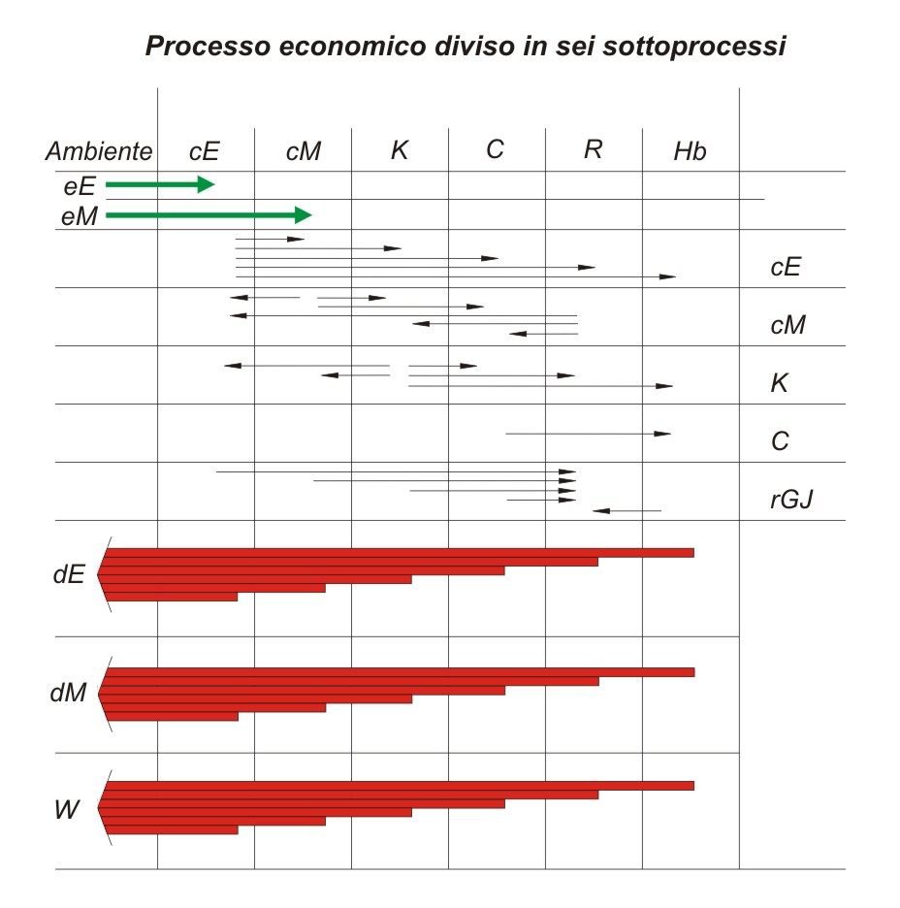
Fig 1 Diagram of the global circulation of the flows Between the environment, and it is Divided into six sub-economic process, into the primary flows, output flows end of the process. (Source: Georgescu-Roegen 1971).

Legend fig. 1
inflow | outflow
eE = energy  eM = material | dE = energy dissipated  dM = material dissipated  W = waste  rGJ = material for reuse

2.2 The PIOTS
PIOTs are matrices describing the total material flow into and out of a process anthropic, thermodynamic principles are applied, and the flows of matter calculated by means of mass balances, in this way the economic system is incorporated in a broader environmental system . Manufacturing sectors are separated by the final demand, and changes in physical inventories are recorded for each field (Giljum Hubacek 2009). Capital and labor are conceived as the funds that turn the flow of natural resources in a flow of products, and the addition of input and output components represent a flow that starts and ends with the resources with waste (Daly 1968). The PIOTs are constructed from the known MIOTs (Monetary Input-Output table) differently. A PIOT is not a conversion unit of MIOT, a PIOT not be obtained by multiplying the MIOT with a vector prices / tons of feed material for each cell. The financial statements used for the construction of the tables I / O in monetary units and in physical units are different, the balance used for the construction of a MIOT is as follows:
TOTAL OUTPUT = TOTAL INPUT OF GOODS AND SERVICES + ADDED VALUE
The identity that applies to the PIOT is:
TOTAL OUTPUT = INPUT OF RAW MATERIAL + TOTAL INPUT OF GOODS AND SERVICES - WASTE AND EMISSIONS
In MIOT logic only environmental products that have cost can be represented and monetary value. The extension of the PIOT respect to MIOT is the inclusion of the 'environment as a source of raw material on the input side and residues on the output side (for residues is meant: solid waste, liquid waste and emissions into the air)(Stamher 1997).

2.2 Development application of PIOTs
Since the nineties the first studies on the flows of matter have been made in Europe by the Institute of Interdisciplinary Studies of Austrian University for Austria and the Wuppertal Institute in Germany(ISTAT 2009)(Suh 2004). Since 1990, we can see four parallel lines of research:
I. The first leads to the conceptualization of the system (Duchin 1992, 2009);
II. The second studies the development of the methodology (Konijn et al.1997; Nakamura and Kondo 2002, Hoekstra 2003, Suh 2004; Giljum and Hubacek 2004; Dietzenbacher 2005; Dietzenbacher et al 2009, Weisz and Duchin 2005);
III. The third considers various applications of PIOTs, developing a water accounting (Gascòet to 2004), waste and development of energy bills (Duchin 1990; Duchin and Lange 1994; Duchin and Lange 1998;
Hubacek and Giljum 2003, Kagawa et al , 2004).
IV. The fourth series of studies has focused on the compilation of tables of national accounts in physical units.
From 1990 to today have been developed a series of tables for the various nations. The first table PIOTs for the national accounts has been calculated for Austria for the year 1983 (and Kratterl Kratena 1990; Kratena et al 1992) for Austria there is currently a highly aggregated PIOTs (Weisz 2000). For Germany, for the year 1990, a full PIOT was published by the General Office of Statistics, with the matrix which contains 58 activities of the conventional accounts, plus an additional area for external environmental protection services (Stahmer at 1997, 1978) and for 1995 (Statistisches Bundesamt 2001) and then were further elaborated in Tables I / O (Bringezu et al 2003; Stahmer et al 2003). For Denmark was published PIOT for the year 1990 (Gravcard) and for 1999 (Pedersen). For Italy a PIOT aggregate was made by Nebbia for 1995 and for 2000 (Nebbia 2003). For Finland a PIOT has been submitted for the year 1995 (Mäenpää 2002). For the Netherlands a table I / O was published in 2003 (Hoekstra). For Japan in 2003 (Ariyoshi and Moriguchi) a PIOT has been built and currently there are others under construction at regional level. For the United Kingdom a PIOT of 76 sectors is undergoing preparation(Wiedmann).

4. DISCUSSION AND CONCLUSIONS

One of the advantages of PIOTs is to have the ability to integrate into one framework the various sources of data obtained from: accounts for energy, waste accounts, production statistics, statistics for recycling and emissions, and international trade statistics(Hoekstra et al. 2006). information given in Tables I / O allows the connection between raw materials, energy inputs, production of goods and waste and emissions in each sector of the economy.An analysis of these data helps identify priority areas to carry out strategies for natural resource management, and compatibility between PIOT and MIOT( I/O tables in monetary units) leads to obtain a direct relation ship between indicators derived from physical flows and indicators economy. The resulting indicators are useful for monitoring the processes of splitting the use of natural resources from economic growth and moving towards their more sustainable use (WRI 2000). It is necessary that economy invests in dematerialization, protection of natural capital, creating systems of production and distribution of democracy, considering all types of capital: financial, product, natural, cultural and ethical, and note that therefore, the human needs and not by the market. The “dematerialization” of the economy and the decoupling of economic growth from environmental degradation are messages sent by various international organizations. The objective of reducing the use of natural resources is a necessary but not sufficient to ensure sustainability(WRI 2000), the question remains as to understand what exactly to reduce. It is therefore important to develop a complete set of accounts to realize a sustainable development strategy. The PIOT allows the connection between micro and macro-level descriptions of material flows, the representation of the cycles, the identification of mechanisms and indicators of materialization. Its conceptual simplicity and includes the operational relationships of quantities and prices, factors and the technology of production, income distribution, capital investments and international trade work . The problem is to compare the existing tables, because the sectors are aggregated in different ways, and dissimilar materials are included and excluded. In order to ensure comparability of tables I / O of distinct economies, it is of fundamental importance that international harmonization . This is aimed at creating a system for integrating environmental and economic accounts focused on a standardization of the methodological procedure to set the physical accounts nationally and supra. Resolving the issue will be a precondition for further development and more widespread applications of the future PIOT

REFERENCES
Ayres R.U., Kneese A.V.,1969, "Production, consumption and externalities", American Economic Review, 59, (3), 282-297.
Ayres, R., Ayres, L., 1997, Use of material balances to estimate aggregate waste generation in the United States.In P.C, Schulze (Ed.), Measures of environmental performance and ecosystem condition (pp.96-156). Washington, DC: National Academy Press.
Alier J. M. 2010, Seminario tenuto presso la Facoltà di Economia di Pisa, Dipartimento di Scienze Economiche.
Daly, H., 1968, On economics of Political Economy, Journal of Political Economy, 76 (3) 392-406.
De Marco O., Lagioia G., Amicarelli V., Sgaramella A., 2009, Constructing Physical Input-Output Tables with Material Flow Analysis (MFA) Data: Bottom-Up Case Studies” Handbook of Input-Output Economics in IndustriaI EcoIogy Edited by Sangwon Suh University of Minnesota, Departmento f Bioproductsa nd BiosysternsE ngineering, Saint Paul, U.S.A. Springer.
Gravgaard Pedersen, O. (1999) Physical Input-Output Tables for Denmark. Products and materials 1990. Air emissions 1990-92 Statistics Denmark, Kopenhagen.
Georgescu-Roegen, N.,1972, The Entropy Law and the Economic Problem, in The Ecologist”, 2, 7, pp.13-8.
Georgescu -Roegen, N. (2003), Bioeconomia, verso un’atra economia ecologicamente e socialmente sostenibile, Bollari Boringhieri, Milano.
Hawken P. A. Lovins e L.H. Lovins (1999), Capitalismo naturale .La prossima rivoluzione industriale, Edizioni Ambiente, Milano.

Hoekstra, R., Van Den Bergh, C.J.M., 2007, Constructing physical input-output tables for environmental modelling and accounting: framework and illustrations, Ecological Economics 59, 375-393.
Hoekstra, R. 2003, Structural change of the physical economy.Decomposition analysis of phy.ical and hybrid-unit input-output tables. Amsterdam: Tinbergen Institute.
Hoekstra, R., Van Den Bergh, C.J.M., 2007, Constructing physical input-output tables for environmental modelling and accounting: framework and illustrations, Ecological Economics 59, 375-393.
Hubacek, K., Giljum, S., 2003, Applying physical input–output analysis to estimate land appropriation (ecological footprints) of international trade activities. Ecological Economics 44, 137–151
Giljum, S., Hubacek, K., 2004, Approaches of physical input–output analysis to estimate primary material inputs of production and consumption. Economic Systems Research 16 (3), 301–310.
Giljum, S., Hubacek, K., Sun, L., 2004, Beyond the simple material balance: a reply to Sangwon Suh's note on physical input– output analysis. Ecological Economics 48, 19–22.
Giljum, S., Hubacek, K., 2009, Conceptual Foundations and Applicationsof Physical Input-output Tables, Handbook of Input-Output Economics in IndustriaI EcoIogy Edited by Sangwon Suh University of Minnesota, Departmento f Bioproductsa nd BiosysternsE ngineering, Saint Paul, U.S.A. , Springer.
Gravgård-Pedersen O., 1999, Physical Input–Output Tables for Denmark. Products and Materials 1990, Air Emissions 1990–92. Statistics Denmark, Kopenhagen, ISBN 87-501-1076-4.
ISTAT, 2009, Costantino C., Femia A.,Tudini A., ,” Contabilità ambientale e pressioni sull’ambiente naturale: dagli schemi alle realizzazioni”, Annali di statistica, Anno 138 Serie XI - vol. 2
Kytzia, S., Faist, M., & Baccini, P.,2004, Economically extended-MFA: A material flow approach far a better understanding of food production chain. Journal of cleaner Production, J 2 (8-10), 877-889.
Kneese, A. V. Ayres, R.U. & d’Arge, R. C. , 1970, Economics and the environment: A material balance approach. Baltimore, MD/London: John Hopkins.
Konijn, P.J.A., de Boer, S., van Dalen, J., 1995. Material Flows and Input–Output Analysis: Methodological Description and Empirical Results. Notanr: 006-95-EIN.PNR/int BPA-nr: 698-95-EIN. PNR/int. Sector National Accounts, Statistics Netherlands, The Netherlands.
Konijn, P.J.A., de Boer, S., van Dalen, J., 1997. Input–output analysis of material flows with application to iron, steel and zinc. Structural Change and Economic Dynamics 8, 129–153.
Kratena, K., Chovanec, A., Konechy, R., 1992, Eine okologische volkswirtschaftliche gesamtrechnung fur osterreich. Die umwelt input output tabelle 1983. Wien: Institut fur sozial wirtschafts und umweltpolitische forschung.
Kratterl, A., Kratena, K., 1990. Reale Input–Output Tabelle und ökologischer Kreislauf. Physica- Verlag, Heidelberg.
Lagioia, G., Amicarelli, V., De Marco O. (2006), On the utility of combining two analytical methodologies: Material Flow Analysis(MFA) and Input Output Accounting (IOA), Lecture Series on Computer and Computational Sciences, Volume 7, pp.690-694.
Leontief, W. (1970), Environmental repercussions and the economic structure, The review of Economics and Statistics, 52, (3), 262 -171.
Leontieff , W., Carter, A., Pedri, P. (1977), The Future of Word Economy, New York.
Mäenpää, I., 2002. Physical input–output tables of Finland 1995 — solutions to some basic methodological problems. 14th International conference on input–output techniques, Montreal, Canada
Moll, S., & Acosta, J., 2003, Physical input-output analyses: some experiences from angoing research.Paper presented at the Con Account Workshop, Wuppertal.
Nebbia, G., 1990, "Sul valore energetico delle merci", Politica ed Economia, (III), 21, (7/8), 49-50.
Quesnay, F.( 1756-1758) “Tableu economique”, in K. Mark “ Capitale” vol.1, p.215-230; cap.XVIII, II libro
Strassert, G. (2000), Physical input-output accounting and analysis: new perspectives, 13th International Conference on Input-Output Techniques, Macerata, Italy.
Stahmer, C., Kuhn, M., Braun, N., 1997. Physical Input–Output Tables for Germany, 1990. Working Paper No. 2/1998/B/ 1German Federal Statistical office.
Statistische Bundesambt, 2001. Endbericht zum Projekt A Physical ]Input–Output Table for Germany, 1995. Vertragsnummer 98/ 559/3040/B4/MM, Wiesbaden.
Suh, S., 2004a. A note on the calculus for physical input–output analysis and its application to lan d appropriation of international trade activities. Ecological Economics 48 (1), 9–17.
Suh, S., and Kagawa S., 2009, Industrial Ecology and Input-Output Economics: A Brief History, Handbook of Input-Output Economics in IndustriaI EcoIogy Edited by Sangwon Suh University of Minnesota, Departmento f Bioproductsa nd BiosysternsE ngineering, Saint Paul, U.S.A. , Springer.
Strassert, G., (2000), physical input-output accounting and analysis: new perspectives, 13th International Conference on Input-Output Techniques, Macerata, Italy
Weisz, H., Duchin, F., 2005, Physical and monetary input– output analysis: What makes the difference? Ecological Economics 57 (3), 534-541.
WRI (World Resources Institute), 2000. Weight of Nations: Material Outflows from Industrial Economies. World Resources Institute, Washington DC.

