Fuzzy Linear Programming Approach to Updating Input-Output Technical Coefficients
K. B. Avisoª, M. A. B. Promentillaª , K. D. S. Yu^{b}, J. R. Santos^{c} and R. R. Tanª
ª Chemical Engineering Department, De La Salle University, 2401 Taft Avenue, Malate, Manila, 1004, Philippines
^{b}School of Economics, De La Salle University, 2401 Taft Avenue, Malate, Manila, 1004, Philippines
^{c} Department of Systems Engineering, The George Washington University

Abstract

The technical coefficient matrices in input-output (IO) models are empirical and thus inherently historical in nature. Numerous methods have been proposed to update these matrices to enable IO models to be more accurate for forecasting applications. In this work, we propose a fuzzy linear programming (FLP) approach to updating the technical coefficients of IO tables. This method determines the updated set of coefficients by finding the smallest deviation from the previous set of technical coefficients necessary to satisfy updated final demand and total output data. Triangular fuzzy numbers (TFNs) are assumed to define the allowable bounds for updating the coefficients, and max-min aggregation is utilized to identify the optimal set of updated technical coefficients. We demonstrate this methodology on a case study using the Philippine IO data.

Keywords: input-output tables; technical coefficient updating; fuzzy linear programming,

- Introduction

The structure of an economy is reflected in economic transactions which can be summarized in an input-output (IO) model (Leontief, 1936). However, completing the IO table of an economy requires significant data collection effort and resources, and thus IO tables are often not updated on a yearly basis. This problem is especially pronounced in developing countries, where relatively limited resources are available to government agencies that are tasked with updating IO accounts. For instance, in the case of the Republic of the Philippines, official 2006 IO tables were only published towards the end of 2013 (PNSCB, 2013). Furthermore, for countries that publish annual IO data, the year of release is typically delayed by about two years (see, for example, BEA 2014). However, updated coefficients are essential for more accurate economic forecasting, which has led to efforts to develop various updating techniques.

Several quantitative procedures for approximating and updating IO tables have been proposed. The most popular method is the RAS method (Stone, 1961; Stone and Brown, 1962), which identifies absorption (r) and fabrication (s) factors to adjust the current technical coefficients matrix and thus make it consistent with known interindustry data for the year being approximated. Snower (1990) on the other hand proposed the TAU method as an alternative way of updating the IO table, which utilizes equations derived from the static open Leontief models of outputs and prices to find better estimates of the technical coefficients. More recent developments have tried to address the existence of negative entries in the IO table, such as the GRAS model proposed by Junius and Oosterhaven (2003) as well as the sign preserving absolute differences (SPAD) developed by Jackson and Murray (2004). Strømman (2009) provides an assessment of the tradeoffs between the RAS and the SPAD model. Alternatively, linear programming (LP) approaches have been (Matuszewski et al, 1964; Davis et al., 1977) based on the principle of minimizing total cumulative adjustment of all technical coefficients, relative to the old values, while satisfying the system-wide balance of economic flows.

Other techniques have also been proposed for the subjective estimation of input-output coefficients in the absence of prior data. Saaty and Vargas (1979) demonstrated the use of the analytic hierarchy process (AHP) to estimate the low-resolution input-output data of Sudan. Banai-Kashani (1987) subsequently developed an improved, network-based approach to account for feedback loops. More recently, Landeta et al. (2008) developed a Delphi technique for coefficient estimation.

The estimation of IO technical coefficients is subject to uncertainties and a methodology which can handle uncertainties in data can be addressed by fuzzy set theory (Zadeh, 1965). In this paper, a fuzzy linear programming model, which is the fuzzification of the linear model proposed by Davis et al. (1977) and Matuszewski et al. (1964), is developed for updating the IO coefficients taking into consideration expert knowledge on the volatility or consistency of the technical coefficients of economic sectors.

The rest of the paper is organized as follows. The next section provides a formal definition of the problem which is followed by the development of the proposed methodology. It is then followed by a case study to demonstrate the capabilities of the model. Finally, conclusions and recommendations for future work are provided.

- Problem Statement
Given an economy consisting of n number of sectors, the technical coefficients matrix (A) in year m is an n x n matrix where each element is defined by the parameter a_{ij} indicating the contribution of Sector i per unit output of Sector j. The formal problem statement then is to find the updated technical coefficients (a’_{ij}) based on fuzzy numbers. It is common practice for stylized fuzzy distributions (e.g. triangular or trapezoidal) to facilitate both calibration and subsequent calculations. In this work, triangular fuzzy numbers, which are defined exogenously through an expert’s judgment of an economic sector’s volatility or tendency to change, are utilized to define the membership functions.

- Methodology
Nomenclature
Sets
I set of economic sectors {i|i = 1, 2,… , N}
Variables
$$λ$$ | Over-all fuzzy consistency
$$λ_{ij}$$ | Individual consistency indices
$${a'}_{ij}$$ | updated technical coefficient for the input of Sector i into Sector j
A’ | Updated coefficient’s n x n matrix with elements a’_{ij}

Parameters
$$a_{ij}^{}$$ | Known technical coefficient which indicates the relative contribution of Sector i per unit output of Sector j
$$a_{ij}^{U}$$ | the upper limit of the triangular fuzzy number associated with the technical coefficient $a_{ij}$
$$a_{ij}^{L}$$ | the lower limit of the triangular fuzzy number associated with the technical coefficient $a_{ij}$
A | Technical coefficient matrix with elements $a_{ij}$
$$x_{i}$$ | Total output of Sector i in target year
X | Total output vector in target year with elements x_{i}
$$y_{i}$$ | Final demand for Sector i in target year
Y | Final demand vector in target year with elements y_{i}
The methodology proposed here utilizes triangular fuzzy numbers (TFN) to update the technical coefficients matrix (A). Fuzzy set theory was initially proposed by Zadeh (1965) and has since provided mathematical foundations for modeling subjective and imprecise information. Fuzzy optimization principles were then initially proposed by Bellman and Zadeh (1970); this seminal work defined fuzzy optima as the “confluence” of fuzzy objectives and fuzzy constraints. Fuzzy mathematical programming was later proposed by Zimmerman (1978) to account for multiple objectives, and for systems with soft constraints. Different aggregation methods were considered in his work, but max-min aggregation has become well-used due to its inherent conservatism as well as computational efficiency. A two-step fuzzy optimization model is developed here to obtain the updated technical coefficients. This two-step procedure for fuzzy optimization as proposed by Guu and Wu (1997) ensures Pareto optimality of the solution. The first phase of the optimization maximizes the fuzzy consistency, λ, and the second step identifies the Pareto optimal solution.

Step 1 involves solving for Equation 1 wherein the numerical value of the consistency index ranges from 0 to 1 as given in Equation 2.
$$\max{λ}$$ | (1)
$$0≤λ≤1$$ | (2)

This consistency index minimizes the deviation between the current technical coefficient and the predicted one subject to the fuzzy bounds. These bounds are represented by TFNs defined by (a_{ij}^{L}, a_{ij}, a_{ij}^{U}) wherein a_{ij}^{L} represents the lower limit of the new coefficient while a_{ij}^{U} is the upper limit. The triangular fuzzy numbers (TFN) for the technical coefficients are based on exogenously defined volatilities of the economic sectors such that the TFN for high volatility sectors have the widest spread, with TFN of (0, a_{ij}, 1) as shown in Figure 1a. For medium volatility (Figure 1b), the lower limits of the TFNs are 2/3 of the distance from a_{ij} to 0 while the upper limits are 2/3 of the distance from a_{ij} to 1.00. For the low volatility sectors the lower limits are 1/3 of the distance from a_{ij} to 0 and the upper limits are 1/3 of the distance from a_{ij} to 1.00 as illustrated in Figure 1c.

As can be seen in Figures 1a to 1c, the updated technical coefficients (a’_{ij}) should fall between the fuzzy limits a_{ij}^{L} and a_{ij}^{U}, such that the level of satisfaction (λ) is equal to 1 if a’_{ij} is equal to a_{ij}, indicating that there was no change in the value of the technical coefficient. Alternatively, λ, increases linearly from 0 to 1 between a_{ij}^{L} to a_{ij} and decreases linearly from 1 to 0 between a_{ij} to a_{ij}^{U}. Note that the updated technical coefficient can be less than the initial technical coefficient a_{ij} as shown in Figures 1a and 1c or it may be greater than a_{ij} as depicted in Figure 1b.

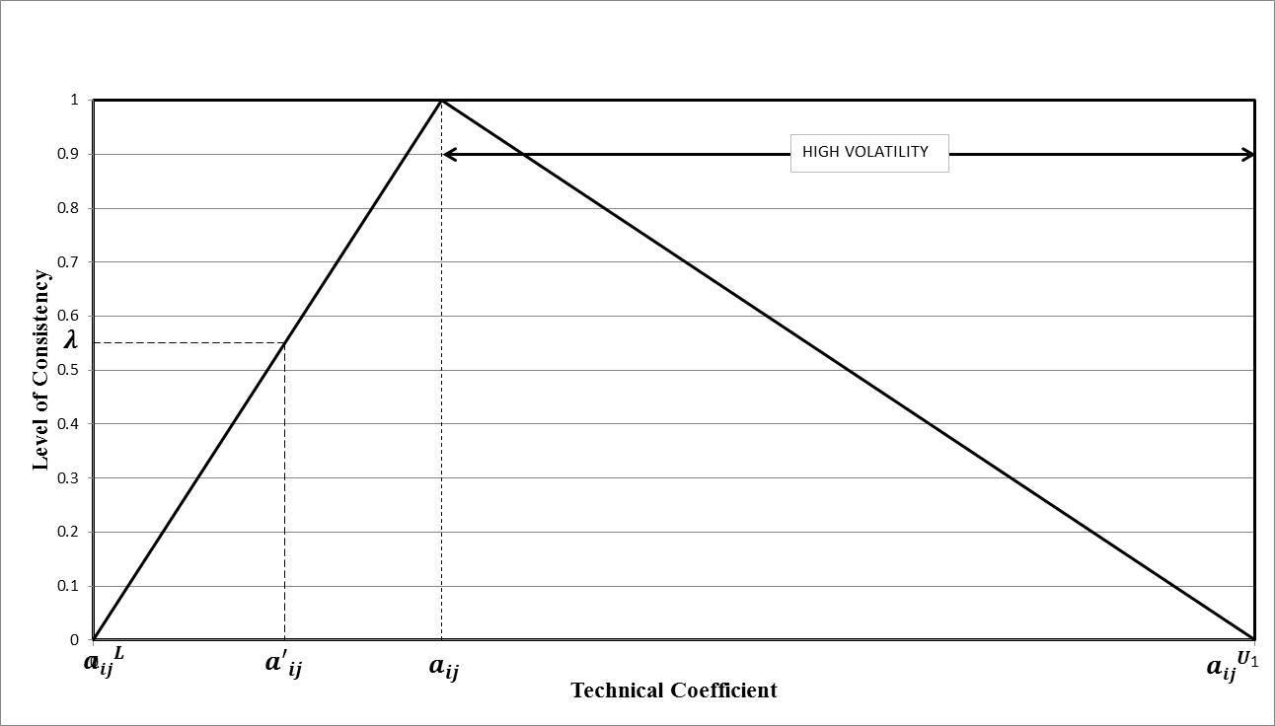
Figure 1a. Triangular fuzzy membership function for high volatility sectors

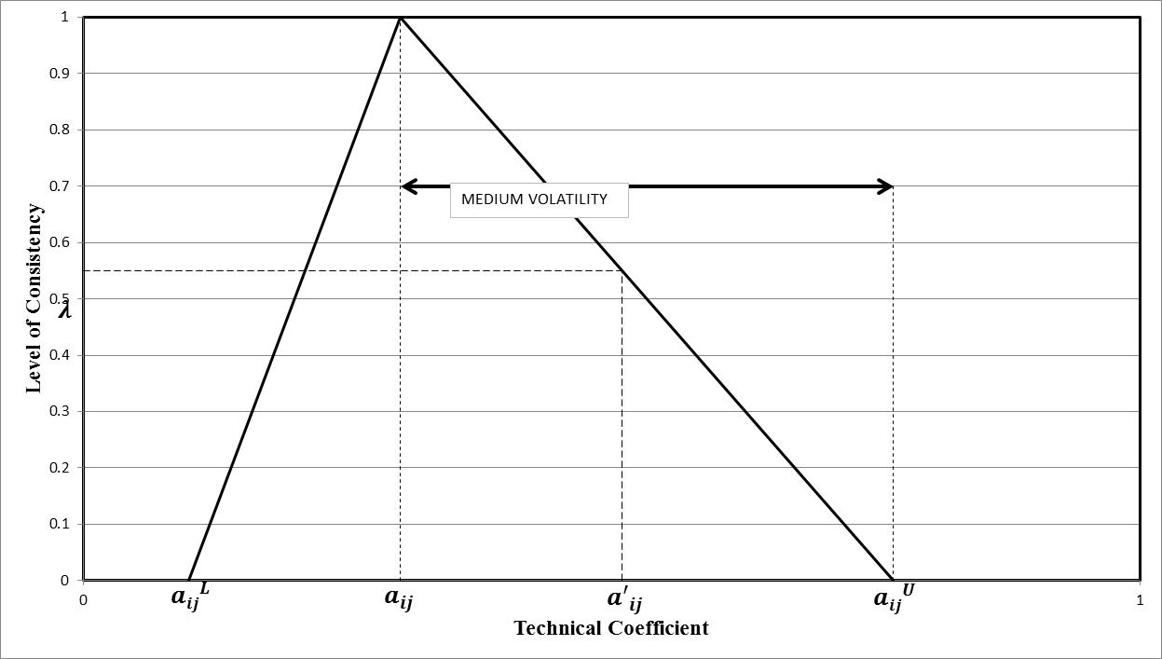
Figure 1b. Triangular fuzzy membership function for medium volatility sectors

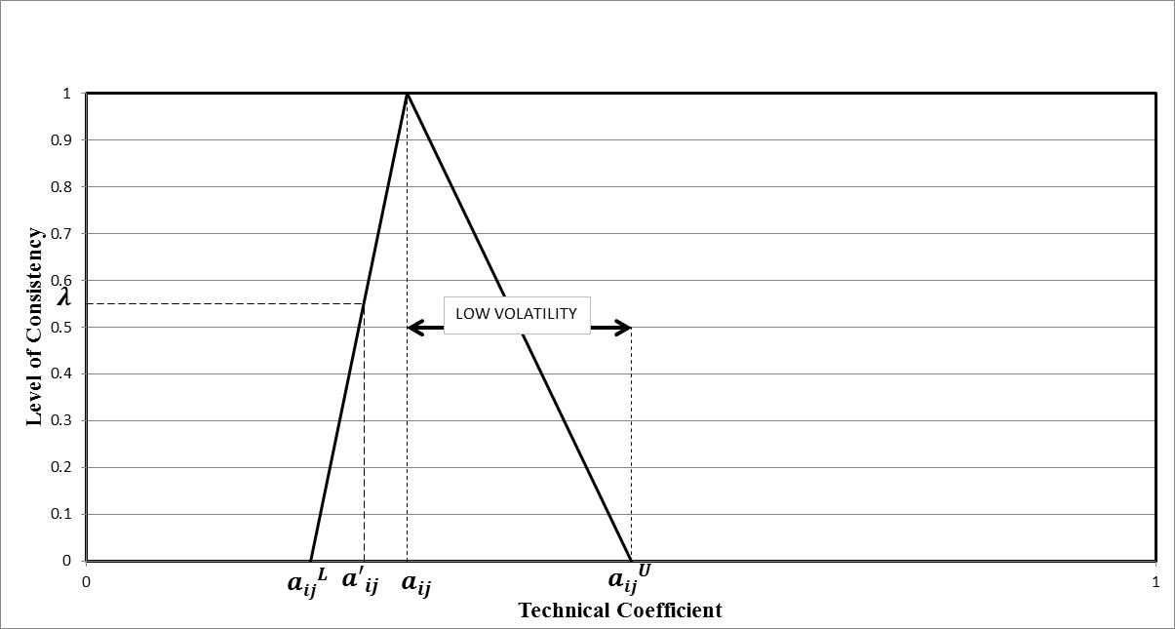
Figure 1c. Triangular fuzzy membership function for low volatility sectors

The optimization model will then maximize the consistency index in consideration of the TFNs of all technical coefficients as given by Equations 3 and 4. Furthermore, the column sums of the updated matrix A should be less than or equal to 1 as given by Equation 5.
$$\frac{\left({a'}_{ij}-a_{ij}^{L}\right)}{\left(a_{ij}^{}-a_{ij}^{L}\right)}≥λ$$ | $$∀i,j$$ | (3)
$$\frac{\left(a_{ij}^{U}-{a'}_{ij}\right)}{\left(a_{ij}^{U}-a_{ij}^{}\right)}≥λ$$ | $$∀i,j$$ | (4)
$$\sum_{i=1}^{n}{{a'}_{ij}}≤1$$ | $$∀j$$ | (5)

The constraint given by Equation 5 is a property of the technical coefficient matrix since the total input requirements from the contributing row sectors cannot exceed the total production output of a column sector. Furthermore, the updated technical coefficients matrix (A’) should maintain the Input-Output relationship given by Equation 6.

$$A'x+y=x$$ | (6)

Once the over-all consistency index (λ) is identified, it is then utilized as a constraint in the second step of the procedure. The second step is to identify the Pareto optimal solution. This is done by defining that the objective function is to maximize the individual consistency indices (λ_{ij}) of the technical coefficients as given by Equation 7 and that each index should not be less than the identified over-all consistency index (λ) as indicated in Equation 8.
Max | $$\sum_{i=1}^{N}{\sum_{j=1}^{N}{λ_{ij}}}$$ | (7)
$$λ≤λ_{ij}≤1$$ | $$∀i,j$$ | (8)

Equations 3 and 4 are transformed into equations 9 and 10 simply by using the individual consistency indices at the right - hand side of the inequality instead of the over-all consistency index. Equations 5 and 6 are maintained as constraints.
$$\frac{\left({a'}_{ij}-a_{ij}^{L}\right)}{\left(a_{ij}^{}-a_{ij}^{L}\right)}≥λ_{ij}$$ | $$∀i,j$$ | (9)
$$\frac{\left(a_{ij}^{U}-{a'}_{ij}\right)}{\left(a_{ij}^{U}-a_{ij}^{}\right)}≥λ_{ij}$$ | $$∀i,j$$ | (10)

- Case Study
The case study considered here utilizes the low-resolution 3-sector IO Table of the Republic of the Philippines for the year 1994. The three economic sectors considered are Agriculture, Industries and Services. The technical coefficients matrix (A) together with the final demand and total output for the year 1994 are shown in Table 1. The objective is to update these technical coefficients and provide an estimate of the technical coefficients matrix (A’) for another year, which is taken to be the year 2000. The final demands and total outputs of the three sectors in the year 2000 are provided in Table 2. Furthermore, exogenously defined volatility judgments on the economic sectors are given. These are assumed to apply uniformly throughout a column.

Table 1. Technical Coefficients Matrix (A) of the Philippines in the Year 1994 (PNSCB, 2014)
 | Agriculture | Industry | Services | In Thousand PhP
 |  |  |  | 1994 Final Demand  (y) | 1994 Total Output  (x)
Agriculture | 0.0963 | 0.1399 | 0.0121 | 194,205,892 | 472,248,085
Industry | 0.1314 | 0.3987 | 0.1607 | 657,771,110 | 1,548,466,889
Services | 0.0519 | 0.0993 | 0.1813 | 898,311,319 | 1,314,912,978

Table 2. Final Demands and Total Outputs of the Philippine Economy in the year 2000 (PNSCB, 2006)
Economic Sector | In Thousand PhP
 | 2000 Final Demand  (y) | 2000 Total Output  (x)
Agriculture | 235,794,203 | 686,481,940
Industry | 1,616,492,107 | 4,201,807,404
Services | 2,138,038,261 | 3,010,876,609

Volatility may be judged subjectively by an expert or established based on statistical analysis of previous values of the technical coefficients. In the case of this work the agriculture sector is considered to be relatively low in volatility due to established and relatively stable technologies and practices. The industry sector is considered to exhibit medium volatility because of the potential for technology improvements. The services sector is considered to be high in volatility due to the diverse nature of activities that make up this sector. The volatility will define the membership function of each technical coefficient as discussed in the previous section on methodology. Using the coefficient a₁₂ which has an initial value of 0.1399 as an example, the TFN is constructed using a medium volatility spread for the industry sector where the upper limit is identified to be 2/3 (0.667) of the distance between a₁₂ and 1.00 resulting in a value of a₁₂^{U} = 0.7136 and the lower limit to be 2/3 (0.667) of the distance between a₁₂ and 0.00 resulting in a value of a₁₂^{L} = 0.0466. The limits for the other coefficients are obtained in a similar manner and the resulting TFNs are shown in Table 3. Since the services sector is considered a high volatility sector, the lower limit is set to be 0 while the upper limit is set at 1.00.

Table 3. Triangular Fuzzy Numbers for Updating the Technical Coefficients
 | Agriculture | Industry | Services
Agriculture | (0.0642, 0.0963, 0.3972) | (0.0466, 0.1399, 0.7136) | (0.0000, 0.0121, 1.0000)
Industry | (0.0876, 0.1314, 0.4206) | (0.1328, 0.3987, 0.7998) | (0.0000, 0.1607, 1.0000)
Services | (0.0346, 0.0519, 0.3676) | (0.0331, 0.0993, 0.7000) | (0.0000, 0.1813, 1.0000)

Solving Equation 1 subject to the constraints given in Equations 2 – 6, the resulting over-all consistency index is 0.4679. This consistency index is then utilized for identifying the Pareto optimal solution shown in Table 4. The lowest consistency index of 0.4679 was obtained for elements a’₁₂ and a’₁₃. However, a’₂₁, a’₂₂, a’₃₁ and a’₃₂ obtained a consistency index of 1.00 indicating that the updated coefficient is unchanged in comparison to the technical coefficient of the base year.

Table 4. Updated Technical Coefficients Matrix (A’) Resulting from Fuzzy Updating
 | Agriculture | Industry | Services
Agriculture | 0.0792 | 0.0903 | 0.0057
Industry | 0.1314 | 0.3987 | 0.2724
Services | 0.0519 | 0.0993 | 0.1395

Table 5. Technical Coefficients Matrix of the Philippines in the Year 2000 (PNSCB, 2006)
 | Agriculture | Industry | Services
Agriculture | 0.0800 | 0.0896 | 0.0064
Industry | 0.1457 | 0.4469 | 0.2017
Services | 0.0388 | 0.0899 | 0.1556

Comparing the results of the optimization model with the actual values of the year 2000 technical coefficients shows that the greatest deviation between the predicted and actual values is 35% which is observable for the coefficient a’₂₃. On the other hand, the coefficient a’₁₂ had the lowest deviation of only 0.98%.

- Conclusion
A fuzzy linear programming approach for updating the technical coefficients of the IO table has been developed. The capabilities of the model were demonstrated using a low-resolution case study based on IO Tables of the Republic of the Philippines. Results show that the proposed methodology was able to provide an estimate of the updated technical coefficients given an indication of the volatility of the economic sectors. Future work will focus on developing methodologies for eliciting expert judgment and for calibrating the appropriate fuzzy limits for each technical coefficient. Integrating the information derived from time series data can also be explored to improve the methodology.

References
Banai-Kashani, A. R. (1987). Dominance and Dependence in Input-Output Analysis: The Nonlinear (Network) Approach. Mathematical Modelling 9: 377 – 380.

Bellman, R. E., & Zadeh, L. A. (1970). Decision-making in a fuzzy environment. Management science, 17(4), B-141.

Bureau of Economic Analysis (2014). Industry economic accounts. Retrieved from http://bea.gov/industry/index.htm#annual.

Davis, H.C., Lofting, E. M., Sathaye, J. A. (1977). A Comparison of Alternative Methods of Updating Input-Output Coefficients. Technological Forecasting and Social Change 10: 79 – 87.

Guu, S. M., & Wu, Y. K. (1997). Weighted coefficients in two-phase approach for solving the multiple objective programming problems. Fuzzy Sets and Systems, 85(1), 45-48.

Jackson, R., & Murray, A. (2004). Alternative input-output matrix updating formulations. Economic Systems Research, 16(2), 135-148.

Junius, T., & Oosterhaven, J. (2003). The solution of updating or regionalizing a matrix with both positive and negative entries. Economic Systems Research, 15(1), 87-96.

Landeta, J., Matey, J., Ruiz, V., Galter, J. (2008). Results of a Delphi survey in drawing up the input–output tables for Catalonia. Technological Forecasting and Social Change 75: 32 – 56.

Leontief, W. W. (1936). Quantitative input and output relations in the economic system of the United States, Review of Economic and Statistics, 18(3): 105-125.

Matuszewski, T.I., Pitts, P. R., Sawyer, J. A. (1964). Linear Programming Estimates of Changes in Input Coefficients. Canadian Journal of Econ. Polit. Sci. 30: 203 – 210.

Philippine National Statistics Coordination Board (2006). The 2000 Input – Output Table. Retrieved from http://www.nscb.gov.ph/announce/2013/20Dec12_IO70x70_release.asp

Philippine National Statistics Coordination Board (2013). The 2006 Input – Output Accounts of the Philippines. Makati: NSCB.

Philippine National Statistics Coordination Board (2014). The 1994 Input – Output Table. Retrieved from http://www.nscb.gov.ph/io/PreviousReleases.asp.

Saaty, T. L., Vargas, L. G. (1979). Estimating technological coefficients by the analytic hierarchy process. Socio-Economic Planning Sciences 13: 333 – 336.

Snower, D. J. (1990). New methods of updating input–output matrices. Economic Systems Research, 2(1), 27-37.
Stone, R. (1961). Input-output and national accounts. Paris: Organisation for European economic co-operation.
Stone, R., & Brown, A. (1962). A computable model of economic growth (Vol. 1). London: Chapman and Hall.
Strømman, A. H. (2009). A multi-objective assessment of input-output matrix updating methods. Economic Systems Research, 21 (1), 81 – 88.
Zadeh, L. A. (1965). Fuzzy sets. Information and control, 8(3), 338-353.
Zimmermann, H. J. (1978). Fuzzy programming and linear programming with several objective functions. Fuzzy sets and systems, 1(1), 45-55.

