MACROECONOMIC EFFECTS OF THE TRANSITION TO INFLATION TARGETING IN THE RUSSIAN ECONOMY

Alexander Baranov^{1, 2}, Vadim Gilmundinov^{1, 2, 3}
¹ Novosibirsk National Research State University
² Institute of Economics and Industrial Engineering SB of RAS
³ Novosibirsk State Technical University
Novosibirsk, Russia
baranov@ieie.nsc.ru, gilmundinov@mail.ru

Key words: inflation targeting, money supply, exchange rate, monetary policy, anti-inflationary policy, general equilibrium, macroeconometrics, input-output model, economic forecast

0. Introduction
In the last years, Russian economy has clearly delineated its Achilles' heel – raw-export model of economic growth almost completely exhausted its potential. But an effective alternative model supposed to come instead has not developed yet. As a result, despite on high oil prices on world markets and accelerating economic growth in developed countries, the Russian economy has recently experienced a significant slowdown of growth rates in 2012-2013. A consideration of the changes in the Russian economy is given in the beginning of the paper to identify reasons of the slowdown. One of the explanations of this slowdown is the strengthening of monetary policy of Russian Central Bank and its re-orientation on inflation suppression instead currency regulation and economic growth support. Despite on low liquidity of the Russian bank system and high interest rates, the key target of the Russian Central Bank is to suppress annual inflation rates from 8.4% in 2011 to 5.0% and 4.0% in 2013 and 2015, relatively. On our mind, it is one of the key reasons of the slowing the Russian economy. It raises a question about appropriate assessment of the macroeconomic effects of this policy on the Russian economy and prospects for its further development, taking into account prevailing macroeconomic constraints and structural problems.
For this purpose the study concerns with some methodological issues of modeling and assessment of macroeconomic effects of change in monetary policy’s targets in general equilibrium framework and Clopper Almon and Leaf Johansen macroeconometric approaches. Combining this approaches the applied general equilibrium input-output macroeconometric model of the Russian economy with aggregated monetary and currency markets has developed and briefly described in the paper. We use neo-keynesian macroeconomic theory and theory of inter-branch competition as theoretical foundations of our approach. Modern neo-keynsian macroeconomic theory helps us to raise adequacy of simulating aggregated markets and macroeconomic interrelations with assumptions of price rigidity of markets. The theory of inter-branch competition allow us to simulate intersectoral interrelations on aggregated markets.
According to the results of calculations the transition to inflation targeting in Russia would considerably and amplifying slow down annual growth rates of the Russian GDP approximately for 1.1% in 2013-2015. It would cause the Russian GDP losses from this policy to grow from 0.9% in 2013 to 4.0% in 2015. Machinery and construction as well as capital investments have the most negative impact from the tightening of credit conditions. In addition to the above-mentioned results of simulation we present in the paper a renewed quarterly forecast for the Russian economy in 2014 based on upper-level macroeconometric model.

1. Slowing economic growth in Russia in 2013-2014
In 2013 there was a significant slowdown in economic growth in Russia. GDP growth and gross industrial output decreased significantly in comparison not only with the period of economic recovery of 1999-2008, but with an average annual growth rate in the post-crisis period 2010-2012. (Table 1). GDP growth in 2013 (1.3%) by 2.7 percentage points below the average annual growth rate in 2010-2012. (4%) and by 5.3 pp - in 1999-2008. (6.6%).
Especially significantly reduced growth rates in the industry. In 2013, in fact there was a stop industrial growth despite the fact that during the boom years (1999-2008) average annual growth rate of industrial production was 6.1%.
The most dangerous negative trend has been the decline in 2013 investments in fixed assets, the growth rate which was - 0.3%. This occurs under conditions where the depreciation of fixed assets on the Russian economy as a whole is about 50%, and in some key sectors (mining, manufacturing and distribution of electricity, gas and water, transport and communications, education, health) exceeds this figure. At this investment growth rate is difficult to expect radical structural changes in the economy, which would bring it in the coming years for greater diversification and reduced dependence on the world energy market.
In the budgetary sphere we note that the consolidated budget of the Russian Federation in 2013 was a deficit of 1.3% of GDP. But Public debt/GDP ratio was 11 % and is one of the best among world economies.
Table 1
Growth rates of some key macroeconomic indicators of Russia's economy in 2013 and the average annual rate in 2010-2012 and in 1999-2008, %
 | 2010 | 2011 | 2012 | 2013 | Average growth rate in 2010-2012 | Average growth rate in 1999-2008 | Difference between growth rate in 2010-2012 and in 2013 | Difference between growth rate in 1999-2008 and in 2013
GDP | 104,5 | 104,3 | 103,4 | 101,3 | 104,0 | 106,6 | -2,7 | -5,3
GDO per capita | 104,4 | 104,2 | 103,2 | 101,1 | 103,9 | 107,1 | -2,8 | -6,0
Population | 100,1 | 100,1 | 100,2 | 100,1 | 100,1 | 99,5 | 0,0 | 0,6
Number of employees | 100,2 | 100,2 | 100,4 | 99,9 | 100,2 | 100,7 | -0,3 | -0,8
Capital investment | 106,3 | 110,8 | 106,6 | 99,7 | 107,8 | 111,9 | -8,1 | -12,2
Labor productivity | 104,3 | 104,1 | 103,0 | 101,4 | 103,8 | 105,9 | -2,4 | -4,5
Sources: Rosstat data, authors calculations.

2. Quarterly changes in the basic macroeconomic indicators in the 2009-2014 and reasons for the slowdown in economic growth in Russia in 2013-2014
Slowing economic growth in Russia, noted in 2013 continued in the first quarter of 2014. In the first quarter of 2014 GDP growth compared to the first quarter of 2013 was 0.8%. GDP growth in the quarter was two times lower than in the first quarter of 2013 (1.6%) and 6 (!) times lower than in the first quarter of 2012 (4.8%) (see Table 2). Growth rate of production for basic economic activities (industry, construction, agriculture, transport and communications, trade) to the corresponding quarter of 2013 was 0.3%, that is growth was practically absent.
Table 2
Quarterly growth rates of some of the major macroeconomic indicators of Russia's economy in the years 2012-2014
 | 2012 |  |  |  | 2013 |  |  |  | 2014
 | 1st quarter | 2nd quarter | 3d quarter | 4th quarter | 1st quarter | 2nd quarter | 3d quarter | 4th quarter | 1st quarter
GDP growth rate for the corresponding quarter of the previous year, % | 104,8 | 104,3 | 103 | 102,1 | 101,6 | 101,2 | 101,2 | 101,2 | 100,8
The growth rate of the basic types of economic activity for the corresponding quarter of the previous year, % | 105 | 103,2 | 101,6 | 101,1 | 100,6 | 100,2 | 99,9 | 101,8 | 100,3
The growth rate of nominal M2 money supply for the previous period , % | 7,3 | 1,4 | 1,3 | 3,5 | 6,8 | 2,9 | 2,5 | 2,7 | 4,2
The growth rate of real M2 money supply for the previous period , % | 2,2 | -0,1 | 7,3 | -3,2 | 2,4 | 2,2 | 6,1 | 3,7 | -0,1
Net export, $US bln | 50,7 | 39,2 | 23,1 | 32,8 | 37,7 | 28,9 | 23,7 | 32,8 | 40,3
Quarterly average prices for crude oil Urals, U.S. dollars per barrel | 117,4 | 106,9 | 109,4 | 109,5 | 111,4 | 102,4 | 110,0 | 108,4 | 104,8
Quarterly average nominal exchange rate, rub/$US | 30,03 | 31,06 | 30,92 | 30,37 | 30,42 | 31,66 | 32,80 | 32,54 | 35,14
Quarterly average real exchange rate, rub/$US (adopted as the base average quarterly exchange rate in Q4. 2001) | 7,34 | 7,49 | 7,89 | 7,25 | 6,96 | 7,20 | 7,72 | 7,73 | 8,01
Sources: Rosstat data, Central Bank of Russia data, authors calculations.

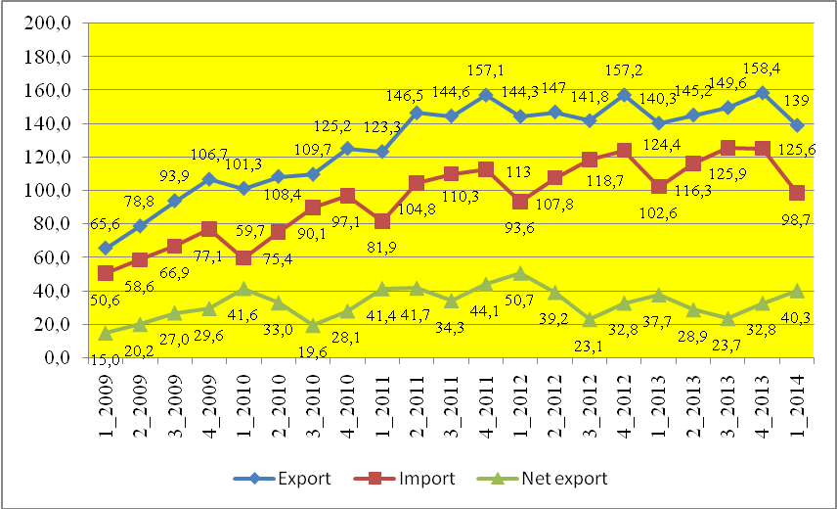
Figure 1. Quarterly dynamics of exports, imports and net exports of the Russian Federation in 2009-2014, $US bln.
Sources: Bulletin of Banking Statistics, № 5, 2011, P. 12-13; Bulletin of Banking Statistics, № 3(226), 2012 , P. 37; Bulletin of Banking Statistics, № 3(226), 2012; Bulletin of Banking Statistics, № 9(244), 2013, P. 42.

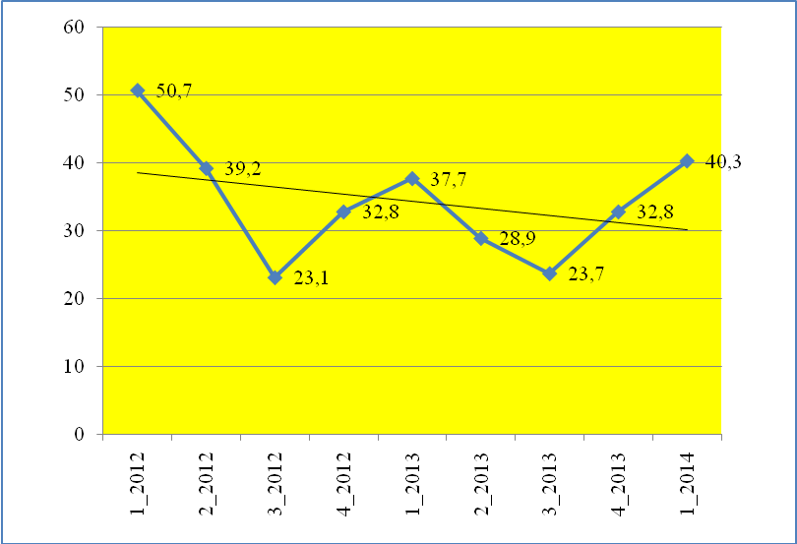
Figure 2. Quarterly changes in net exports of goods and services in the Russian Federation during from 1st quarter 2012 1 to 1st quarter 2014 with the trend line, $US bln.
Sources: Bulletin of Banking Statistics, № 3(226), 2012; Bulletin of Banking Statistics, № 9(244), 2013, P. 42; Bulletin of Banking Statistics, № 9(244), 2013, P. 42; URL: http://www.cbr.ru/statistics/print.aspx?file=credit_ statistics/bal_of_payments_est_new.htm&pid=svs&sid=itm_45297 (29.04.2014).

The main reasons for the decline of economic growth in the Russian economy in 2013 - early 2014.

1. Reducing the rate of growth of exports due to a decrease in global economic growth. The decline in production in a number of EU countries (Spain, Italy, France, Portugal and some others) and low rates of economic growth in the EU as a whole had a negative impact on exports, since the EU is the main trading partner of Russia. Export growth in 2009 - 2011 years change it trend to stagnation and even decline in the last two years (see Fig. 1 and Fig. 2). Net exports in the first quarter of 2014 (40.3 billion U.S. dollars) was approximately 20% lower than that of the first quarter of 2012 (50.7 billion U.S. dollars - see Fig. 2).

2. Lack of money growth rate and, consequently, an increase in interest rates in the economy. If the average quarterly nominal M2 money supply grew at a significant pace, an increase over the period 2010 - 2013. about 2.2 times, the pace of the real money supply was much more modest (146%). In 2013 compared to 2012's average real M2 money supply increased only by about 6% (see Fig. 3). Low growth rate of the money supply has led to a gradual increase in real interest rates. Fig. 4 clearly seen that the MIBOR rate in 2011 - 2014 tended to grow. Until February 2013 increased nominal lending rates for individuals and legal entities. They then declined slightly and increased again in the early months of 2014 (see Fig. 5). Growth rates in the interbank market in the first quarter of 2014 is fraught with increasing lending rates for businesses and individuals that may have a negative impact on economic growth in the second half of 2014.

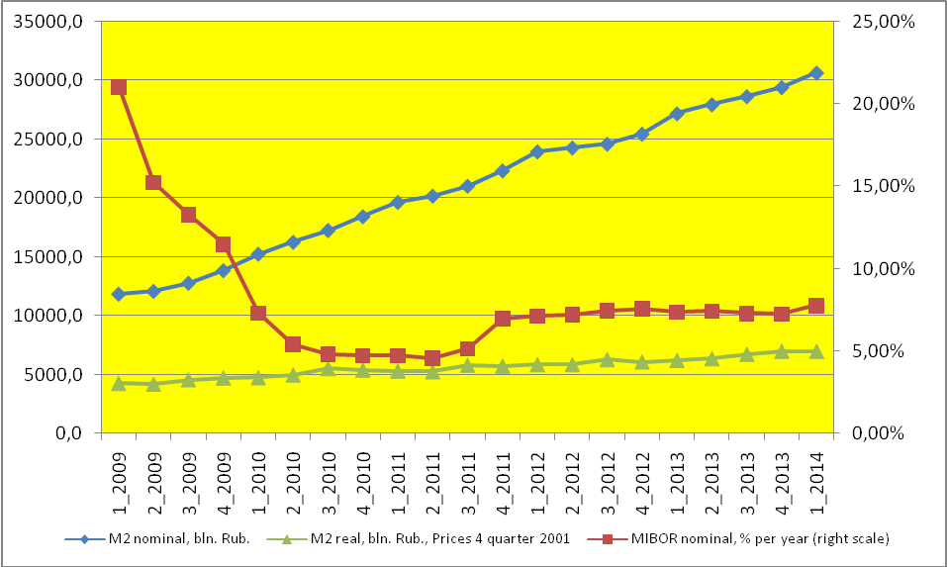
Figure 3. Dynamics of average quarterly value of M2 (nominal and real) and the MIBOR interest rate in 2009 - 2013

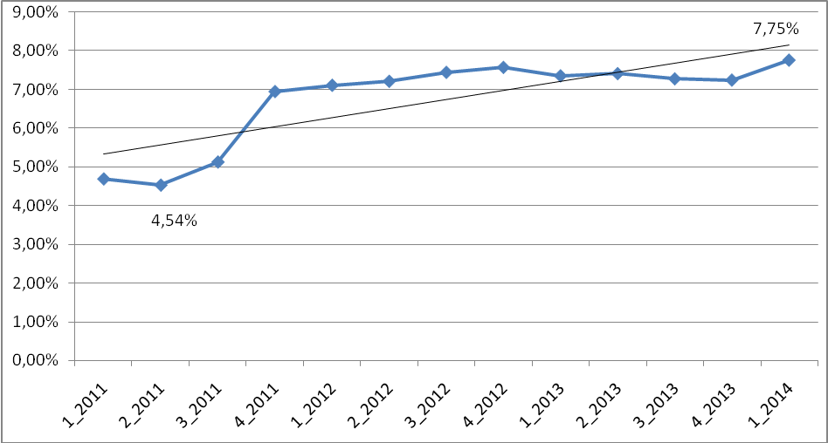
Figure 4. Dynamics of the average MIBOR rates in 2011 - 2014 years with the trend line, per annum (for loans with maturity from 31 to 90 days)

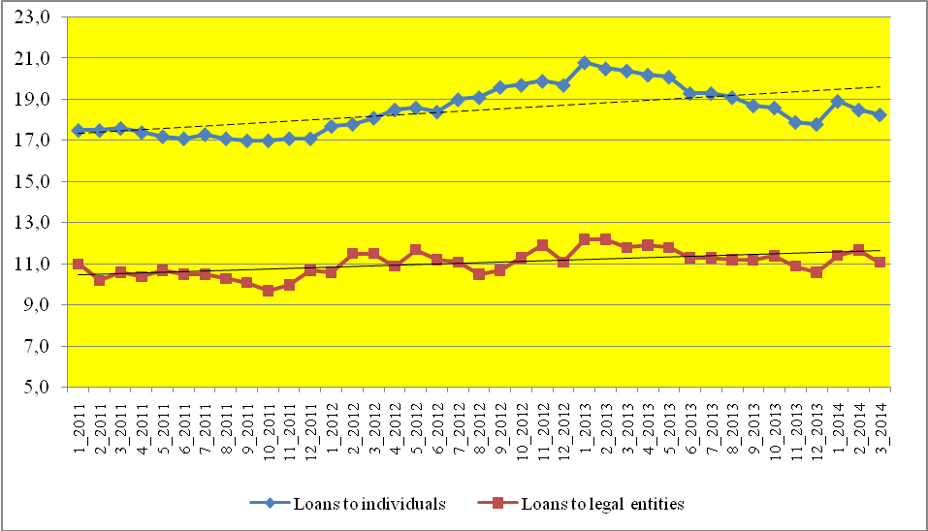
Figure 5. Weighted average interest rate on loans provided to legal entities and individuals for more than 1 year in 2011 - 2014., Monthly, annual %.
Sources: Bulletin of Banking Statistics, № 5, 2011, P. 126; Bulletin of Banking Statistics № 3(226), 2012, P. 135; Bulletin of Banking Statistics № 4(251), 2014, P. 133, 136.

3. Restrictions related to the lack of production capacity in several key sectors of the economy. One possible reason for the economic slowdown is its restriction associated with a high level of capacity utilization. Analysis of capacity utilization by economic activity shows that in some of them the capacity utilization rate in recent years was really quite high. This applies to basic economic activities as the production of iron, steel, rolled products, hydraulic turbines, freight cars, the production of ammonia, fertilizer and some other positions where the capacity utilization rate reached values close to the limit - from 80% to 93%. This level of capacity utilization combined with high depreciation of fixed assets, conserved in most sectors of the Russian economy at the level of 50% and above . Low investment observed in the Russian economy in the period after 2009, will gradually aggravate the problem of limited capacity for economic growth in some industries. Although the majority of economic activities for which statistics are kept capacity utilization, such restrictions no, because the level of this indicator does not exceed 60-70%.

4. Rising production costs associated with a permanent increase in tariffs of natural monopolies and real wages. Economically unfounded and regular increase in tariffs of natural monopolies, is undoubtedly one of the factors contributing to increase production costs. Growth tariffs of natural monopolies with a certain time lag returns them same as the increase in the prices of suppliers of raw materials and equipment. This factor leads to a decrease in revenues of enterprises and in this sense, acts in the direction of slowing economic growth. However, in our opinion, this factor is not one of the most important in explaining the reasons for the slowdown of economic growth in Russia.
Real wage growth has dual consequences: 1) increases the cost of production, which adversely affects the financial performance of companies; 2) a positive effect on the increase in demand for consumer goods and housing investments, promotes the growth of retail trade that stimulates economic growth. Real wage growth contributed to keeping consumer demand at a high level and was one of the drivers of economic growth in Russia in the year 2013, providing growth in retail turnover by 3.9% and production of paid services by 2.1%. Relative to the first quarter of 2014 it should be noted further growth of real wages by 4.2%, which stimulated the growth of retail trade turnover by 3.5%.

3. A GE-IO model with aggregated markets
Two models were constructed to estimate macroeconomic and structural effects of the transition to inflation targeting in Russia. The first one is a quarterly based macroeconometric model suggested by Alexander Baranov to analyze influence of key macroeconomic variables on a dynamic of the Russian real GDP. The second one is a general equilibrium input-output (GE-IO) model of the Russian economy with aggregated money and currency markets suggested by Vadim Gilmundinov. Let’s focus on description of the key equations of the last one.
A paradigm of the GE-IO model is shown on Scheme 1. The model includes IO equations for product markets with input-output coefficients to assume inter-branch links, as well as econometrically estimated equations for aggregated monetary and currency markets and sectors’ output elasticities with real interest rate, real wage and real exchange rate of national currency to assume an inter-branch competition and links between aggregated markets.

Product markets
(econometric I-O model)
Currency market
(macroeconometric model)
Money market
(macroeconometric model)

Labor market
(multi-sectoral econometric model)

Finance market
(multi-sectoral econometric model)

Scheme 1. A paradigm of GE- IO Model with aggregated markets
The core of the GE-IO model is a quarterly based IO model. The model has inward and backward links with macroeconometric models, which describes aggregated markets (money and currency markets in the current version). Links between IO model and macroeconometric models of aggregated markets are based on the endogenization of some key variables of aggregated markets which have influence on sectoral outputs (interest rate, exchange rate, inflation rate). Key equations of the model are described below.
Let
n – number of sectors (n = 28 in the current version);
K – number of variables of aggregated markets (in this paper K = 3);
dx_{i,t} – change rate in total output of sector i in quarter t to the same quarter in the previous year (quarter t-4), i = 1,..,n;
e_{i,k} – elasticity of total output of sector i to variable of aggregated markets k;
φ_{k,t} – change in variable of aggregated markets k in quarter t (with assuming a time lag);
a_{i,j} – technological IO coefficient, i, j = 1,…, n.
${\text{dx}}_{i,t}=\sum_{k=1}^{K}{e_{i,k}⋅ϕ_{k,t}},\begin{matrix} & \end{matrix}i=1,\text{.}\text{.},n$In this case we can estimate influence of changes in aggregated markets on change rates in total output of sector i as:

In this case total output of sector i in quarter t (x_{i,t}) can be defined as
$x_{i,t}=(1+{\text{dx}}_{i,t})∗x_{i,t−4},\begin{matrix} & i=1,\text{.}\text{.}\text{.},n & \end{matrix}$

Final product of sector i in quarter t (y_{i,t}) can be obtained from traditional IO equations:
$x_{i,t}=\sum_{j=1}^{n}{a_{i,j}⋅x_{j,t}}+y_{i,t},\begin{matrix} & i=1,\text{.}\text{.}\text{.},n & \end{matrix}$
To get estimations of this model we’ve estimated for the Russian economy a technological matrix {a_{i,j}}_{i,j = 1,…, n} for year 2010 and elasticity matrix {e_{i,k}} _{i = 1,…, n;k = 1,…, K} based on multiple regressions built on quarterly statistics of Russia in 2003-2011 (see Table 3).
Estimations given in Table 3 could be interpreted as estimations of competitiveness of branches to deterioration of conditions on corresponding aggregated market. It allows us to use the theory of inter-branch competition to interpret the results of calculations in the model and to explain changes in the Russian economy’s structure.

Table 3
Elasticity of Total Output to macroeconomic variables of main sectors of the Russian Economy (In parentheses lags of independent variables, in quarters, are specified)
 | Real exchange rate (Rub in USD) | Real wage | Real interest rate | R²
Agriculture | -0,06 (1) |  | -0,19 (3) | 0,20
Coal | 0,95 (0) | -0,58 (0) | 1,16 (0) | 0,63
Oil |  | 0,26 (0) | 0,30 (0) | 0,17
Natural Gas | -0,44 (4) | 0,53 (0) | -0,28 (0) | 0,78
Other minerals | -0,25 (4) |  | -0,54 (0) | 0,30
Food, beverages, etc. | -0,10 (4) | 0,41 (0) |  | 0,63
Clothes | -0,30 (4) | 0,51 (0) | -0,26 (0) | 0,65
Pulp industry | -0,31 (4) | -0,07 (0) | -0,58 (0) | 0,83
Oil refinery |  |  | -0,20 (0) | 0,25
Chemistry industry | -0,39 (4) | -0,06 (2) | -0,60 (0) | 0,61
Construction materials | -0,30 (4) | 1,20 (0) | -0,67 (0) | 0,79
Ferrous metallurgy | -1,10 (3) | 0,36 (0) | -0,96 (3) | 0,81
Non-ferrous metallurgy | -0,27 (4) | 0,46 (0) | -0,47 (0) | 0,68
Metal products | -0,45 (4) | 0,46 (0) | -0,50 (0) | 0,65
Machinery | -0,57 (4) | 0,79 (0) | -1,43 (0) | 0,62
Other industrial products | -0,11 (4) |  | -0,56 (0) | 0,71
Energy | -0,13 (4) |  | -0,34 (0) | 0,49
Water supply | -0,13 (4) |  | -0,34 (0) | 0,49
Construction | 0,15 (4) | 0,75 (0) | -0,75 (0) | 0,61
Trade | 0,06 (3) | 0,67 (0) | -0,43 (0) | 0,92
Transport |  | 0,41 (0) | -0,40 (1) | 0,53
Communication |  | 0,41 (0) | -0,40 (1) | 0,53
Finance and Insurance | -0,27 (2) | 1,28 (0) | -1,08 (2) | 0,86
Real Estate and Consulting | -0,30 (1) | 1,02 (0) | -0,79 (1) | 0,62
R&D | 0,08 (4) | 0,47 (0) | -0,20 (0) | 0,76
Education |  | 0,14 (0) |  | 0,59
Health, Culture, etc. |  | 0,08 (0) |  | 0,41
Utilities | 0,06 (4) | 0,30 (0) | -0,33 (0) | 0,78
Empty fields imply absence of statistically significant estimations (level of significance more than 10%)
Sources: Authors’ estimations based on official statistics in 2003-2010

A model of money market is based on the well-known Baumol-Tobin model. Based on quarterly statistics for 2003-2011 we’ve estimated following econometric model:

Ln((1+IRN_{t})/(1+IRN_{t-4}) = – 0,02+0,16*Ln(P_{t-4}/P_{t-8}) – 0,08*Ln(M_{t}/M_{t-4}) + 0,16*Ln(X_{t-5}/X_{t-9}), R² = 80,2%
where
IRN_{t} – average nominal Interest Rate in period t;
P_{t} – total output’s deflator in period t;
M_{t} – money supply in period t;
X_{t} – total output in constant prices in period t.

A model of currency market describes nominal exchange rate of the Russian ruble to USD (ExRN_{t}) and based on estimations of currency inflows and outflows in a balance of payment of Russia.
Import of goods and services (Im_{t}) is defined by its share in total output in current prices:

Ln(1+Im_{t}/P_{t}*X_{t}) = 0,125 + 0,025*Ln(ExRR_{t}/ExRR_{t-4}), PV = 99,7%,

where ExRR_{t} – real exchange rate of Russian ruble to USD.

Export of goods and services (Ex_{t}) is defined by a normative equation:

Ex_{t} = ExNonO&G_{t} + OilPrice_{t}*ExpOilVol_{t}/0,54,

where
ExNonO&G_{t} – non oil&gas export in period t;
OilPrice_{t} – export price of Urals in period t, USD per barrel;
ExpOilVol_{t} – export of Urals in period t (in barrels);
0,54 – average share of oil export in oil&gas export of Russia.

A model of nominal exchange rate of the Russian ruble to USD:

Ln(ExRN_{t}/ExRN_{t-4}) = – 0,04 + 1,20*Ln(1+dPrivateReserves_{t}/CurrenceInflows_{t}) –
– 0,49*Ln(1+dCurrenceInflows_{t}/CurrenceInflows_{t}), R² = 79,5%,

where
dPrivateReserves_{t}/CurrenceInflows_{t} – relation of net currency changes in private sector to total currency inflows in period t.
dCurrenceInflows_{t}/CurrenceInflows_{t} – relation of net currency inflows to total currency inflows in period t.

4. Results of calculations

4.1. Simulation of the influence of changes in monetary policy on dynamics and structure of the Russian economy
Three scenarios of the Russian Economy’s development in 2013-2015 are considered in general equilibrium input-output model of the Russian economy with aggregated money and currency markets to estimate an impact of the squeezing of money supply. In the first scenario “Inflation targeting” it is suggested that annual inflation rates will be suppressed to 4.0% in 2015. The second scenario “Neutral policy” assumes that Central bank of Russia would not intrude in money market to decrease inflation. The third scenario “Monetary easing” implies high growth rates of money supply to stimulate the Russian economy. All three scenarios are suggested similar dynamics of oil prices and real wages to carry “ceteris paribus” comparative analysis.
The results of calculation are shown in the Table 4.

Table 4
Dynamics of some key macroeconomic indicators of the Russian economy in 2010-2015
 | Actual data |  |  | Forecast
 |  |  |  | 1st scenario  “Inflation targeting” |  |  | 2nd scenario  “Neutral policy” |  |  | 3rd scenario  “Monetary easing”
 | 2010 | 2011 | 2012 | 2013 | 2014 | 2015 | 2013 | 2014 | 2015 | 2013 | 2014 | 2015
Average export price of the Russian oil, USD per barrel | 74,1 | 101,7 | 103,1 | 99,6 | 101,6 | 103,7 | 99,6 | 101,6 | 103,7 | 99,6 | 101,6 | 103,7
Money supply change rate, % | 31,1 | 22,3 | 11,9 | 3,9 | 1,9 | 0,9 | 10,7 | 10,1 | 10,0 | 20,0 | 20,0 | 20,0
GDP change rate, % | 4,5 | 4,3 | 3,4 | 1,4 | 0,9 | 1,0 | 2,4 | 2,3 | 2,5 | 3,2 | 3,8 | 4,4
Capital investments change rate, % | 6,3 | 10,8 | 6,6 | -2,2 | -3,7 | -3,6 | 0,4 | -0,2 | 0,5 | 2,6 | 3,8 | 5,1
Average nominal exchange rate, Russian rubles per USD | 30,4 | 29,4 | 31,1 | 31,8 | 32,5 | 33,3 | 32,0 | 33,2 | 34,8 | 32,4 | 34,4 | 37,4
Change rate of real exchange rate of Russian ruble per USD, % | 13,2 | 16,2 | 0,7 | 2,9 | 1,2 | -0,1 | 3,7 | 2,2 | 0,8 | 3,9 | 3,1 | 1,7
GDP deflator change rate, % | 14,2 | 15,5 | 8,5 | 6,6 | 5,1 | 4,0 | 8,0 | 7,6 | 7,2 | 9,7 | 11,2 | 12,1
Average annual nominal interest rate, % | 13,4 | 10,4 | 11,2 | 11,6 | 10,8 | 9,8 | 10,5 | 9,8 | 9,0 | 9,8 | 9,2 | 9,0
Average annual real interest rate, % | -0,4 | -4,4 | 2,5 | 4,7 | 5,4 | 5,6 | 2,2 | 2,0 | 1,7 | 0,1 | -1,8 | -2,8
Sources: 2010-2012 – Rosstat, Central bank of Russia; 2013-2015 – results of calculation in GE-IO model of the Russian economy with aggregated money and currency markets
Data given in the Table 4 show that gradual transition to inflation targeting in Russia in 2011-2012 had led to significant growth in real interest rates from -4.4% in 2011 to 2.5% in 2012 and 4.7% in 2013.
To achieve 4.0% inflation rate in 2015 Central bank of Russia should decrease change rate of money supply from 11.9% in 2012 to only 0.9% in 2015. As a result there would be a sharp decrease in real GDP growth rates from 3.4% in 2012 to 1.0% in 2015. Fixed capital producers and capital investments get the most negative impact from the inflation targeting. Average annual change rate of capital investments would be -3.1% in this scenario. The main reason of this is significant growth in real interest rates from 2.5% in 2012 to 5.6% in 2015. According to the results of calculations the inflation targeting policy leads to significant fall in growth rates of the Russian GDP in 2013-2015 approximately 1.3% in comparison to “Neutral policy” scenario. It causes raising real GDP losses from 0.9% in 2013 to 4.0% in 2015 in relation to “Neutral policy” scenario (see Fig. 6). Total real GDP losses in 2013-2015 are equal to 7.2% of GDP in 2012.

Figure 6. Estimation of GDP losses from the inflation targeting in Russia in 2013-2015
Sources: results of calculation

The results of calculations allow us to conclude that the inflation targeting policy would be suitable for the Russian economy only in condition of high investing activity. But in the current conditions in the Russian economy characterized by an extremely low investment activity and technological backwardness it would be cause too large GDP losses and decline in capital investments.
Thus, obtained results substantiate the inconsistency of the existing model of macroeconomic policy in Russia with monetary-oriented suppression of inflation and structural policy aimed at modernizing and stimulating innovation.

4.2. Renewed quarterly forecast for the Russian economy in 2014

Recent statistics for the Russian economy shows that slowdown of the Russian economy in this year seems to be more significant than it is estimated by the previous calculations in the GE-IO model. To estimate a possible dynamic of the Russian economy in this year we use macroeconometric model.
Russia's economic development in 2014 will be held in conditions associated with the two most important factors.
1. The one hand, economic growth is projected to accelerate in the U.S. and the EU. This will contribute to an increase in demand for major exports and a positive impact on the growth rate of the Russian economy.
2. On the other hand, it is likely that will be substantial economic sanctions against Russia by the U.S. and the EU in connection with the events in Ukraine. It can negatively affect economic growth in Russia and even lead to a decline in production.

Basic (inertial) version of GDP growth forecast in 2014 based on the following assumptions.
- The global economy is gradually recovering, there is a growth in the U.S. and the EU. Average annual price of Urals blend crude oil will remain at 2013 that is 108 U.S. dollars per barrel. This price will increase gradually from the price of 1 quarter 2014 (U.S. $ 104.75 per barrel) to 111.2 U.S. dollars per barrel in the fourth quarter.
- Not change significantly in the monetary policy of the Central Bank of Russia. The average annual nominal and real M2 money supply will grow at the same rate as in 2013, that are 115.2% and 109.2%, respectively.
- Measures of fiscal policy, consisting in the early implementation of a number of major infrastructure projects (reconstruction of the Transsib, the Baikal - Amur railway and some others), which may be taken by the Russian government in 2014, will not have a significant impact on the economic dynamics of this year.
- Not be taken significant economic sanctions against Russia from Western countries.
According to this variant, the GDP growth in Russia in 2014 in comparable prices will be 99.9%. In other words, there will be no economic growth (see Table 4). In this regard, the forecast growth rate of final consumption of the population, according to our estimates, will not exceed 1-2%.

Pessimistic version of GDP growth forecast in 2014 based on the following assumptions.
1. The world economy is slowing down due to the introduction of sanctions against Russia. Happens the stock market crash, the subsequent financial crisis begins turning into the economic slowdown in the U.S. and the economic downturn in the EU, which is linked to Russia close economic ties. Average annual price of Urals blend crude oil is reduced by 10% compared to the average level in 2013 (108 U.S. dollars per barrel) and will fall gradually from the price of 1 square. 2014 (104.75 U.S. dollars per barrel) to U.S. $ 90 per barrel in the fourth quarter.
2. As a result of sanctions against Russia's financial sector commercial banks lose their ability to attract financial resources from abroad, as a result of the decline in production volumes are reducing lending to legal entities and individuals. All this leads to the fact that the real and nominal M2 money supply in the economy of Russia in 2014, does not increase in the 2-4 quarters in 2014 and remains at the level of the first quarter.
3. Measures of fiscal policy, consisting in the early implementation of a number of major infrastructure projects, which may be taken by the Russian government in 2014, not implemented due to the need to use the National Welfare Fund for the implementation of social obligations of the Government of the Russian Federation.
According to this variant, the GDP growth in Russia in 2014 in comparable prices will be 98.6% (see Table 4). In connection with this predictive value of final consumption of the population in 2014 will not increase.

Optimistic version of GDP growth forecast in 2014 based on the following assumptions.
1. The global economy is gradually recovering greater rate than was predicted in late 2013 - early 2014. Average annual price of Urals blend crude oil increased by 10% compared to the average level in 2013 (108 U.S. dollars per barrel) and will gradually increase the price of 1 square 2014 (U.S. $ 104.75 per barrel) to 111.2 U.S. dollars per barrel in the fourth quarter.
2. The Central Bank of Russia will hold a softer monetary policy. Average annual real M2 money supply will increase the rate of 118%, which is twice higher rate than in 2013. The growth rate of nominal money supply will be 125.1% (assuming that the GDP deflator will be at 2013, that is 105,9%).
- Measures of fiscal policy, consisting in the early implementation of a number of major infrastructure projects, which may be taken by the Russian government in 2014, will have a positive impact on economic dynamics in the fourth quarter of 2014.
According to this variant, the GDP growth in Russia in 2014 in comparable prices will be about 102 % (see Table 4). In this regard, the forecast growth rate of final consumption of the population, according to our estimates, will be about 5 %.

Table 4. GDP growth rate in Russia in 2014 in accordance with three development scenarious, percentage of the corresponding period of previous year.
 | 1st quarter | 2nd quarter | 3d quarter | 4th quarter | 2014 totally
Basic version | 100,8 | 100,0 | 99,4 | 99,5 | 99,9
Pessimistic version | 100,8 | 99,6 | 97,8 | 96,6 | 98,6
Optimistic version | 100,8 | 101,1 | 101,9 | 103,6 | 101,9
Source: authors’ calculations.

In line with our forecast, GDP growth in the Russian economy in 2014 will be in the range 98.6% - 101.9%. In other words in 2014 with high probability in Russia will take place low rate of economic growth or decline in production.

Results of the calculations help us to identify following economic policy measures to accelerate economic growth in Russia:
1. According to our opinion, confirmed by long-term analytical and forecasting calculations using the methods of mathematical statistics, softer credit - monetary policy of the Central Bank of Russia can revive economic growth in Russia. According to our estimates, ceteris paribus, the increase in the average annual nominal money supply in 2014 compared to 2013 by approximately 30% in the base case forecast (in the realized variant of basic forecast it is about 15%) will increase the growth rate of GDP from 99.9% to 102.3%. This may occur some increase in inflation. However, the negative effects of zero economic growth represents a far more significant than the acceleration of inflation by 1 - 2 percentage points.
2. In the field of fiscal policy is extremely important to start the implementation of major infrastructure investment projects. Their financing is planned to partially exercise by the National Welfare Fund, whose funds are currently invested in U.S. government securities and bonds of some other Western countries with extremely low interest.
3. Supports export, primarily non-oil and gas exports. In this area, the Government of the Russian Federation is developing three groups of activities - financial support, non-financial support measures and the better investment environment.
4. Great importance is the establishment of the Eurasian Economic Union, which will replace the Customs Union. Within the framework of the Eurasian Economic Union planned to maximize the realization of four principles - freedom of movement of goods, services, capital and labor - the principles laid down in the Eurasian integration.

Bibliography

1. Central Bank of the Russian Federation. The main directions of state monetary policy in 2013 and in 2014-2015. – http://cbr.ru/today/publications_reports/on_2013(2014-2015).pdf.
2. Clopper Almon, The Craft of Economic modeling, 2nd edition, Needham Heights, MA, Ginn Press, 1989.
3. Leif Johansen, A Multi-Sectoral Study of Economic Growth, 2nd enlarged edition, Amsterdam, North Holland Publishing Company, 1974.
4. Gilmundinov V.M. Estimation of influence money and currency markets parameters on productivity of the Russian economy // Vestnik of Novosibirsk state university. Social and economic sciences series. - 2012. - T. 12, № 1. - p. 5-17.
5. Baranov A.O. A slowdown of economic growth in Russia and prospects of overcoming it // EKO. - 2013. - № 12. - p. 22-37.

The study is supported by Russian Fund of Humanities in framework of scientific project ("Influence of Macroeconomic Policy with Monetary and Currency Restrictions on Dynamics and Structure of a Raw-Export Oriented National Economy with Imperfect Markets"), a project №14-02-00359.
Central Bank of the Russian Federation. The main directions of state monetary policy in 2013 and in 2014-2015. – http://cbr.ru/today/publications_reports/on_2013(2014-2015).pdf. – p. 24.
Clopper Almon, The Craft of Economic modeling, 2nd edition, Needham Heights, MA, Ginn Press, 1989.
Leif Johansen, A Multi-Sectoral Study of Economic Growth, 2nd enlarged edition, Amsterdam, North Holland Publishing Company, 1974.
Russia in Figures. Statistical handbook. 2013. Rosstat - M., 2013. - P. 78.
Russia in Figures. Statistical handbook. 2013. Rosstat - M., 2013. - P. 245 - 248.
Socio - economic situation in Russia. 2013. Rosstat - M., 2013, - P.7.
Socio - economic situation in Russia. January – March 2014. – М: Rosstat, 2014. - P.7.
A basic version of the model is described in Gilmundinov V.M. Estimation of influence money and currency markets parameters on productivity of the Russian economy // Vestnik of Novosibirsk state university. Social and economic sciences series. - 2012. - T. 12, № 1. - p. 5-17.

