Technology-based criterion to share environmental responsibility
Jorge Enrique Zafrilla, Luis Antonio López and David Soto
Jorge.Zafrilla@uclm.es; Luis.LSantiago@uclm.es; David.Soto2@alu.uclm.es
Faculty of Economics and Business, University of Castilla-La Mancha
Plaza de la Universidad, 1, 02071, Albacete, Spain
Abstract
Global greenhouse-gas emissions (GHG) are rising faster than ever. The number of Kyoto Protocol signatory countries is shrinking. Europe´s Carbon Emissions Market is crashing. Positions of high pollutant and exporters emerging countries according to the acceptance of supranational agreements are far from making real. Why is the Kyoto Protocol failing and which are the post-Kyoto perspectives? From our point of view one of the main problems is the establishment of the Producer Responsibility Criterion for emissions allocation by region. Big pollutant and exporter countries, like China or India, are not willing to sign this kind of international agreements. They are claiming for more consumer responsibilities in the share of responsibilities.
In this paper we asses a new perspective for sharing internationally traded emissions allocation by region based on a technological criterion. Virtual carbon embodied in trade will be shared depending on the technology benchmarking between multiple countries involved in the global supply chains. Developed countries with negative emissions balances, would be responsible of a part of emissions embodied in imports, the non-domestically produced emissions which are avoided by trade. Exporter country would be responsible of the rest of real emissions. Differences between technological structures will be the allocation key. Incentives to not outsource pollutant phases of production to environmental lawless countries will arise, as those emissions have to be accounted as domestically. Big exporter countries will transfer a part of the producer responsibility. This could be an incentive to sign international GHG agreements.
For the sake of policy implications and for the pursuit of easier agreements, we will develop thirty bi-regional models, for six worldwide regions and five models per region, to capture the reallocation of each new region emissions inventories.

- INTRODUCTION
The planet has lost the first round of the Climate Change Mitigation battle. According to the IPCC Working Group III contribution to the 5th Assessment Report, anthropogenic Greenhouse Gases Emissions (GHG) have increased by 1GtCO₂-equivalent per year in the period 2000 to 2010 (IPCC, 2014). Current GHG atmosphere concentrations will generate a disturbing increase of global temperatures associated to climate inertia. However, new efforts and perspectives of analysis are required in order to revert the figures presented by IPCC.
Following Arto and Dietzenbacher (2014), GHG emissions increased are related, mainly, to changes in the levels of world consumption per capita. Smaller effects are related to population growth and changes in consumption composition. The huge technology improvements that have taken place in the last years, have not been enough to balance this increase of global emissions. The economic growth pressure of emerging countries has contributed to this GHG emissions increases. The 15% of all GHG emissions increase in the last years has been produced in emerging countries but it has been caused by changes in consumptions patterns and compositions in other developed countries (Arto and Dietzenbacher, 2014).
The proliferation of Global Production Chains represents one of the main drivers of these GHG increases. In 2008, the 26% of CO₂ emissions were internationally traded (Peters et al., 2011). Trade which, in 2007, reach 21 of World´s GDP. International trade jeopardizes global environmental sustainability because of the importance of linkages effects in emerging countries. The most of the emissions generated are produced along the stages of the production chain (indirect emissions), not in the production of the good traded (direct emissions) as López et al. (2013) show for the Spain-China case. Moreover, there is another threaten, increasing vertical specialization processes, explained by Hummels et al. (2001), show that only 1/3 of total trade is due to final goods trade, the rest, 2/3, is due to inputs trade (Johnson and Noguera, 2011), which have worse environmental effects because of the importance of linkages effects in emerging economies (López et al., 2014).
Developed and developing international trade relationships are mainly motivated because of the seeking of comparative advantages related to low salaries, on the one hand, and to low energy costs, on the other hand, which could shows the existence of carbon leakage. Nevertheless, environmental legislation in regions like Europe, has not been as hard to incentive firms and industries to move the whole or a part of their production chains to other countries. Besides some social negative consequences related to the increase of global production chains with emerging countries, like labor conditions, there are local and global environmental consequences that should be taken into account. Air pollution is a real problem in emerging countries, which could be considered as a local problem. The massive use fossil fuels in industrial processes and in residential uses generate air particulates concentrations which are affecting to citizens health (Chen et al., 2013). This is not only a local pollution problem, Lin et al. (2014) shows, through an atmospheric chemical transport model how a part of this local emissions are moved to the rest of the world causing dramatically increases of sulphurs concentrations in regions located far away from the emission is initially generated. And, of course, GHG emissions derived from this massive use of fossil fuels generated the Greenhouse effect, which is a global affair.
Nowadays, a fragmented environmental policy regime drives the global action against climate change (Jakob et al., 2013). Kyoto Protocol signature countries have established limits to GHG emissions, in the last years, some countries, like Canada, are leaving Kyoto commitments and non-signatory countries are free to choose their own emissions targets. These asymmetries produce negative incentives to firms and industries in, both, developed and developing countries. Developed countries offshore their production in order to reduce countries´ emissions. Developing countries are far to sign international agreements with current responsibilities assignments criteria. Under our opinion, the Producer Responsibility (PR) criterion considered in the Kyoto Protocol as the emissions allocation key is one of the reasons of the global GHG emissions increase. Searching of alternative emissions allocation criteria is a necessity.
In this paper we propose a new assignment criterion based on the “best technology” concept, the Technology-based criterion. Recent literature has provided other alternatives to the Producer Responsibility criterion, which is not accepted by emerging countries alluding to historical responsibility reasons and to consumption perspectives. The Consumer-based responsibility criterion (explained in Munksgaard and Pedersen (2001), Peters and Hertwich (2006) and Cadarso et al. (2012)) does not fulfil developed countries expectations, as they assume the responsibility of high pollution intensities in developing countries which could affect their competitiveness. Other alternatives, like Shared Responsibility criteria tries to shared responsibilities between agents involved in the trade relationships (Ferng, 2003), using, in some cases, the international trade flows as reference (Peters (2008) and Cadarso et al. (2012)). Last one is the Income Responsibility criterion (Marques et al., 2012) which takes into account emissions required to generate a country´s income (wages, profits and rents). This method is a useful method to control the effects of the carbon leakage as is assigning responsibilities to the country which generated more income. Developing countries and their “low salaries” pull effect are negative incentive to offshore with this method.
As another alternative to the vast literature developed in terms of emissions responsibilities assignments, the Technology-based criterion proposed in this paper tries to look for an intermediate solution to the problem and is based in the concept of the “best technology” to share responsibilities, as the only alternative to ensure a sustainable future for the planet, ensuring, at the same time, a sustained growth in emerging countries (Liu et al., 2013). This criterion, which comes from the Producer Responsibility criterion, share responsibilities if the trade relationship between two regions increase global emissions. Using the idea behind the Pollution Haven Hypothesis and the Balance of Avoided Emissions explained in López et al. (2013) we will make counterfactual analysis for all trade relationships between regions to evaluate the increase or not of global emissions because of the existence of international trade. If the trade relationship does not increase emissions, the Producer Responsibility criterion will be the best allocation method, following the Kyoto Protocol guidelines. However, if trade relationship increase global emissions, because importing country had produced its imports with a lower pressure over the climate change, the importing country will account its producer responsibility emissions (emissions generated if the country had produced its imports) and the exporting country will account the difference between real emissions and the emissions accounted by importing country. This allocation criterion generates goods incentives for climate change mitigation: a) There is an incentive in developed countries to trade with “cleaner” partners as they will assume a big part of the emissions traded; b) Developing countries has the incentive to produce with the least environmental impact, they pay the excess of emissions; c) There is an incentive to transfer the best technologies to emerging countries to continue exploiting comparative advantages; d) The countries still keep the key to reconvert economies and control offshoring policies, but with this criterion there is a transfer of responsibility to a sectorial level and a firm level in the offshoring decisions, being the environmental impact an obstacle to avoid.
The paper is divided into three sections. Section 2 develops the methodology proposed for the Technology-based criterion. Section 3 presents the main results. Section 4 presents the discussion and main conclusions of the paper.
- METHODOLOGY
The Technology-based Criterion (Tb) is based in a comparative analysis between emissions embodied in exports of each region and a counterfactual exercise of regions producing its imports. This analysis will be done once all emissions, under a Producer Responsibility (PR) criterion, are estimated. This first steps of the analysis can be expressed in a MRIO (Multi-Regional Input-Output Model) form:
$$E^{inputs}=\left(\begin{matrix}{\hat{e}}_{1} & 0 & 0 & ⋯ & 0 \\ 0 & {\hat{e}}_{2} & 0 & ⋯ & 0 \\ 0 & 0 & {\hat{e}}_{3} & ⋯ & 0 \\ ⋮ & ⋮ & ⋮ & ⋱ & ⋮ \\ 0 & ⋯ & ⋯ & ⋯ & {\hat{e}}_{r}\end{matrix}\right)·\left(\begin{matrix}L_{11} & 0 & 0 & ⋯ & 0 \\ 0 & L_{22} & 0 & ⋯ & 0 \\ 0 & 0 & L_{33} & ⋯ & 0 \\ ⋮ & ⋮ & ⋮ & ⋱ & ⋮ \\ 0 & ⋯ & ⋯ & ⋯ & L_{rr}\end{matrix}\right)·\left(\begin{matrix}0 & Z_{12}^{m} & Z_{13}^{m} & ⋯ & Z_{1s}^{m} \\ Z_{21}^{m} & 0 & Z_{23}^{m} & ⋯ & Z_{2s}^{m} \\ Z_{31}^{m} & Z_{32}^{m} & 0 & ⋯ & Z_{3s}^{m} \\ ⋮ & ⋮ & ⋮ & ⋱ & ⋮ \\ Z_{r1}^{m} & ⋯ & ⋯ & ⋯ & 0\end{matrix}\right)$$ | (1)
$E^{final}=\left(\begin{matrix}{\hat{e}}_{1} & 0 & 0 & ⋯ & 0 \\ 0 & {\hat{e}}_{2} & 0 & ⋯ & 0 \\ 0 & 0 & {\hat{e}}_{3} & ⋯ & 0 \\ ⋮ & ⋮ & ⋮ & ⋱ & ⋮ \\ 0 & ⋯ & ⋯ & ⋯ & {\hat{e}}_{r}\end{matrix}\right)·\left(\begin{matrix}L_{11} & 0 & 0 & ⋯ & 0 \\ 0 & L_{22} & 0 & ⋯ & 0 \\ 0 & 0 & L_{33} & ⋯ & 0 \\ ⋮ & ⋮ & ⋮ & ⋱ & ⋮ \\ 0 & ⋯ & ⋯ & ⋯ & L_{rr}\end{matrix}\right)·\left(\begin{matrix}0 & y_{12}^{x} & y_{13}^{x} & ⋯ & y_{1s}^{x} \\ y_{21}^{x} & 0 & y_{23}^{x} & ⋯ & y_{2s}^{x} \\ y_{31}^{x} & y_{32}^{x} & 0 & ⋯ & y_{3s}^{x} \\ ⋮ & ⋮ & ⋮ & ⋱ & ⋮ \\ y_{r1}^{x} & ⋯ & ⋯ & ⋯ & 0\end{matrix}\right)$ | (2)
Where E^{inputs} are the emissions embodied (under the PR criterion) in the production to export of inputs in each region. E^{final} are the emissions embodied (PR) in the production to export of final goods in each region. ${\hat{e}}_{r}$ are the emissions coefficients, supplied by the WIOD, per each region. $L_{rr}$ are the inverse matrix of Leontief for each region defined, using WIOD tables, as: ${\left(I-A_{rr}^{d}\right)}^{-1}$; $Z_{rs}^{m}$are the intermediate inputs imports of region s from region r (notice that those imports are equal to exports from region r to region s); $y_{rs}^{m}$are the final goods exports from region r to region s.
All the estimations are going to be calculated and defined in a bi-regional context. One of the main objectives of this new emissions responsibility criterion is to force sectors and firms to internalize environmental negative externalities. To do so, it is very important to identify properly the agents involved in the trade transaction and the sectors which, direct and indirectly, pollutes more. In this sense we consider that the use of bi-regional models is more appropriate to the use of MRIO models as they disseminate the responsibility among agents of different countries and sectors (Atkinson et al., 2011) so bi-regional model will identify more properly agents. Previous equations can be expressed, considering regions 1 and 2, in a bi-regional context as:
$${PR}_{1}≡{CR}_{2}=\left[e_{1}·{\left(I-A_{1}^{d}\right)}^{-1}·Z_{12}^{m}\right]+\left[e_{1}·{\left(I-A_{1}^{d}\right)}^{-1}·y_{12}^{x}\right]=e_{1}·{\left(I-A_{1}^{d}\right)}^{-1}·X_{12}$$ | (3)
$${PR}_{2}≡{CR}_{1}=\left[e_{2}·{\left(I-A_{2}^{d}\right)}^{-1}·Z_{21}^{m}\right]+\left[e_{2}·{\left(I-A_{2}^{d}\right)}^{-1}·y_{21}^{x}\right]=e_{2}·{\left(I-A_{2}^{d}\right)}^{-1}·X_{21}$$ | (4)
Where ${CR}_{s}$, the Consumer Responsibility of country s, is equal to ${PR}_{r}$; $X_{rs}$ is the addition of inputs and final goods exports from region r to region s, as we are not going to differentiate between both types of good trade.
Once the emissions embodied in exports are estimated under the PR criterion, the next step is estimate the counterfactual analysis for each region ($c_{12}$). Considering the trade between two regions (exports from region 1 to region 2), we estimate potential emissions if region 2 produces its imports from region 2:
$$c_{12}=e_{2}·{\left(I-A_{2}^{d}\right)}^{-1}·X_{12}$$ | (5)
At the same time we estimate the second counterfactual for exports from region 2 to region 1:
$$c_{21}=e_{1}·{\left(I-A_{1}^{d}\right)}^{-1}·X_{21}$$ | (6)
Once the $PR$ emissions embodied in trade between regions and the counterfactual analysis are estimated, we can estimate the Technology-based emissions for each country. The definition of the new criterion will depend on the best environmental friendly technology of the countries involved in the trade relationships. In this case, and focus in the case of region 1 the ${Tb}_{1}$will be:
$${Tb}_{1}≡\left\{\begin{matrix}if {PR}_{1}<c_{12} then {Tb}_{1}={PR}_{1} \\ if {PR}_{1}>c_{12} then \left\{\begin{matrix}{Tb}_{1}={PR}_{1}-c_{12}+c_{21} \\ ∆{Tb}_{2}=c_{12}\end{matrix}\right.\end{matrix}\right.$$ | (7)
$${Tb}_{2}≡\left\{\begin{matrix}if {PR}_{2}<c_{21} then {Tb}_{2}={PR}_{2} \\ if {PR}_{2}>c_{21} then \left\{\begin{matrix}∆{Tb}_{1}=c_{21} \\ {Tb}_{2}={PR}_{2}-c_{21}+c_{12}\end{matrix}\right.\end{matrix}\right.$$ | (8)
The $Tb$ criterion assigns responsibilities depending on the best country technology. Following the equation 7, in the first case, if the ${PR}_{1}<c_{12}$ there will not be any reallocation of emissions because this comparison shows that the region 1 and region 2 trade relationships improves the environment. Region 1 will be responsible of its emissions as producer country. However, if ${PR}_{1}>c_{12}$the trade relationship is not the best solution for the environment. If the region which is importing had produced its imports, global emissions had been lower. In this case, the selection of trade partners did not follow a sustainable pattern in terms of environmental impacts, so the country (either sector or firm) which taking the offshoring decision have to account a part of emissions generated. In this case, and using the estimation of the counterfactual analysis, region 2 $Tb$ emissions (the importing region) will account $c_{12}$ amount of emissions. Region 1 $Tb$ emissions (the exporter region) will account for${PR}_{1}-c_{12}+c_{21}$, only if $c_{21}$exists.
In this paper we are going to estimate the new $Tb$ for a 6 regions world, but using bi-regional models, so the former equations are going to be replicated thirty times considering all possible trade relationships between regions.
The database that we are going to use is the World Input-Output Tables from the WIOD aggregated to 6 regions. Emissions coefficients comes from the WIOD environmental accounts and we choose only the Carbon Dioxide (CO₂) emissions per sector.
- MAIN RESULTS
The application of the Technology-based (Tb) criterion defines a new map of emissions responsibilities. In the Graph 1, an aggregation of the Tb results is presented in comparison with the Producer Responsibility (PR) criterion, used in the Kyoto Protocol as the assignment criterion, and with the Consumer Responsibility (CR) criterion presented as an alternative by the literature and some countries, like the case of Norway or UK. Under the PR, and considering the regions classification chosen. If we analyze emissions embodied in international trade, China emerges as the most pollutant country with more than 2,021,650 ktCO₂ in 2009. This figure is more than three times higher than Europe and NAFTA emissions, the developed economies which trade, intensively, with China. As we can conclude, on the one hand China is the factory of the world and on the other hand presents high pollution intensities. In terms of PR China is only followed by ROW but with a difference of almost 1 GtCO₂ (1,299,699 ktCO₂). In terms of CR the map of responsibilities changes. Chinese responsibility falls to the lowest levels, confirming the concept of factory of the world. In this case developed regions, like Europe and NAFTA, increases their responsibility drastically (Europe doubles its responsibility). The ROW CR presents the highest figure. The opening degree of ROW (which include the poorest countries, like African countries, together with developing economies with high purchasing power, like East Asian Arab countries) is bigger than in Europe or NAFTA, which main trade influence areas are themselves. Moreover, many ROW countries are also part of the global production chains, so this amount of imports (derived in a high CR) will be re-exported to other countries. In conclusion, PR and CR presents two antagonistic responsibility assignments criteria in terms of make countries responsible. PR criterion is positive to developed countries but bad for the environmental, as developing countries does not sign it. And CR is good for emerging economies, but developed countries, with the figure of Kyoto Protocol, obstruct the proliferation of this kind of criteria.
Since PR is not mitigating global emissions increases, and alternatives like CR are not preferred by developed countries, which have the key in the establishment of emissions responsibility criteria, the proposal of new alternatives is required in order to re-configure a new map of emissions responsibilities. The Tb criterion proposed shows an interesting alternatives in the exercise of sharing emissions. As we can see in the Graph 1, European Tb responsibility reach one of the highest positions in the list of most pollutants regions (1,093,117 ktCO₂), only exceeded by China (1,357,080 ktCO₂) and ROW (1,394,837 ktCO₂). In the three cases the Tb criterion is an intermediate solution between PR and CR, which could help countries to find incentives of signing international or bi-regional agreements with these new emissions figures. This Tb criterion assigns a big amount of emissions to Europe. This result shows how Europe is not establishing trade relationships with the most adequate partners in terms of the best environmental trade performance. In this sense, developed regions could have the incentive to force exporter countries to produces in a more efficient way or even to transfer know-how to those emerging countries, generating positive externalities. The case of NAFTA and, to a lesser extent, East Asia is similar to Europe as they are the developed regions considered in our paper. The case for emerging countries is also interesting. China and countries like India, Russia and Turkey, among others, reduces considerably their PR as transfers a big amount of emissions to “cleaner” countries. This reduction favor the willing to sign emissions reduction international agreements, as developing countries assume a big part of the responsibility as consumers and, moreover, generates the incentive in developing countries of introduce new cleaner technologies and cleaner production chains if they want to still being the factory of the world. If developed countries have to assume those emissions as consumer, in future contracts they will choose cleaner trading partners or will produce domestically to avoid the accounting of those emissions.

Graph 1: Technology-based criterion compared to other emissions responsibility criteria for 2009 (ktCO₂).
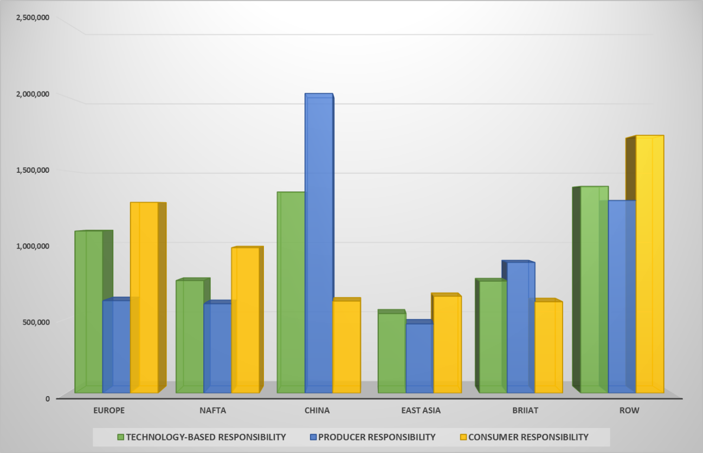Source: Own calculations

Graphs 2 and 3 present similar information to Graph 1, but the focus is put in bi-regional trade relationships, not in global results. The use of bi-regional models allow us to analyze bi-lateral trade relationships, it is easier to establish agreements between two parts (either countries, sectors or firms) than between multiple trading regions, which generate a scattering of responsibilities. Graph 2 presents the case of developed countries (Europe, NAFTA and East Asia) trade relationship with the rest of regions. For the case of Europe, CR (yellow bar) shows the intensity of imports between regions and PR (blue bar) the intensity of exports. It is interesting to highlight two cases, the trade between Europa and ROW, in which the European Tb would be higher than the PR and the CR criteria. This results shows that there is an intense trade relationship between both regions and in the most of the cases Europe technologies are cleaner than ROW techs. The case is also interesting, imports from China generates (see CR) a big amount of emissions which should be accounted in the Chinese environmental accounts. The Tb assigns to Europe a big amount of emissions to Europe. The Europe and China trade relationships increase global emissions. For NAFTA and East Asia, with some differences related to the amount of emissions, presents similar results to Europe. In both cases the trade relationships with China and ROW increase global emissions dramatically. The Tb for both developed regions increase their emissions, relaxing the willingness to sign agreements of China and ROW. It is also interesting to highlight how results to BRIIAT does not replicate the patterns found for China and ROW in the case of NAFTA and East Asia, however BRIIAT and Europe´s trade relationship present similar results to the China and ROW case. As we can see BRIIAT is a noted trade partner of Europe and uses more emissions intensive technologies. The EU- BRIIAT Tb increase European emissions responsibilities in a remarkably amount.
Graph 2: Developed countries Technology-based criterion compared to the Producer and Consumer Responsibility, 2009 (ktCO₂).
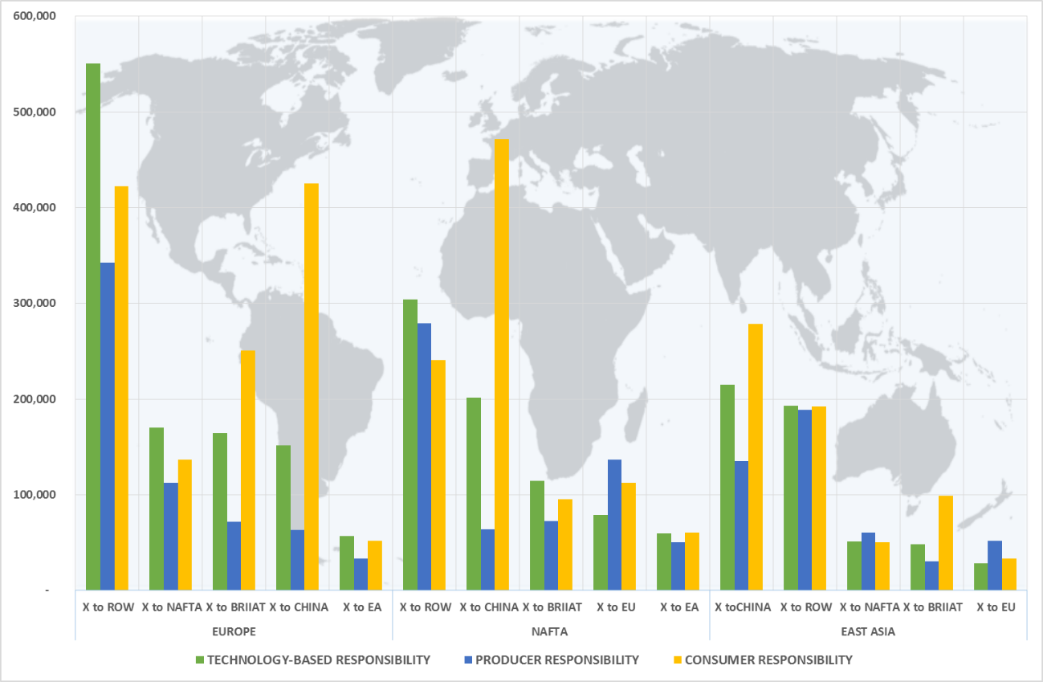Source: Own calculations
Graph 3 present the other side of the new world´s emissions responsibility map. While China and BRIIAT present the highest figures under the PR criterion in the trade relationship with the rest of the regions, the Tb for those two developing countries reallocate responsibilities to the consumer countries (Europe, NAFTA and East Asia, as we commented before). Nevertheless is interesting to highlight how China, for example, reduces it PR emissions, but the re-assignation of the Tb still giving China a big amount of emissions. The use of a high pollutant technology penalizes the country. This result shows one of the main attractive of the Tb, the incentive for developing countries is improve their production processes, not only ignore the emissions generated. The results for bi-lateral China-BRIIAT trade relationships are also interesting. The reduction of Chinese Tb and the increase of BRIIAT Tb, show that Chinese production chains are more pollutant than BRIIAT, even considering that BRIIAT includes regions like India, Indonesia or Russia, not especially famous because of their clean industrial processes.

Graph 3: Developing countries Technology-based criterion compared to the Producer and Consumer Responsibility, 2009 (ktCO₂).
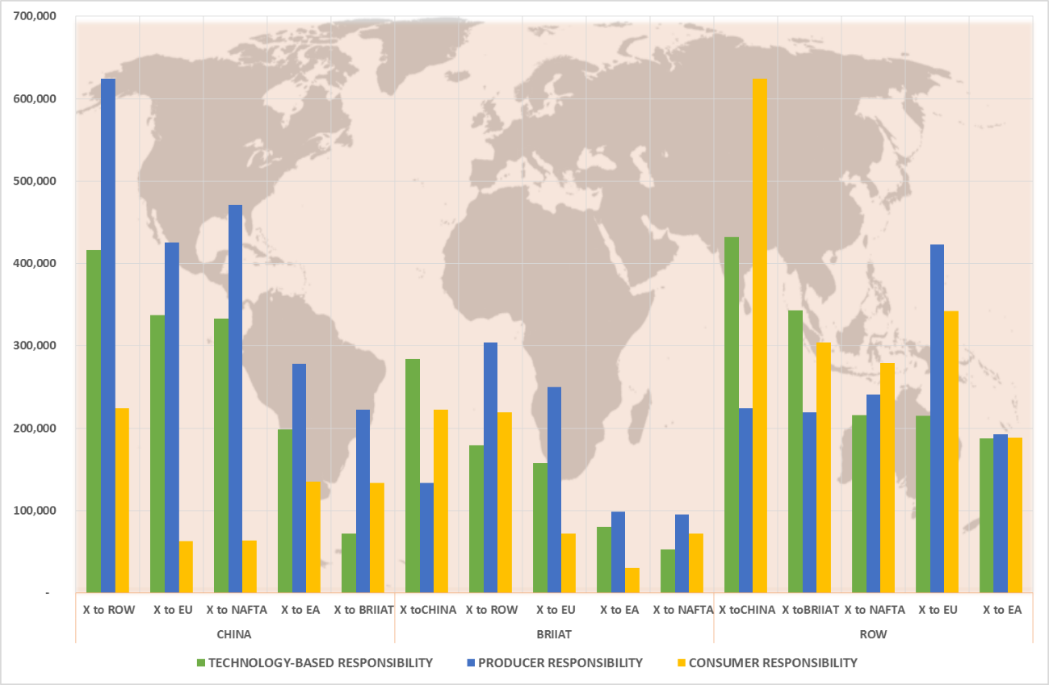
Source: Own calculations

- CONCLUSIONS
A part of the strong economic growth of the developing countries in the last years has been supported by the increasing developed countries imports. These countries have offshored their production processes seeking to exploit economic comparative advantages. One of the main consequences has been the pressure over the environment derived from the high energy and emissions intensity of developing countries. In fact, in the last years global GHG emissions have increased in more than 1 GtCO₂-equivalent per year, and objective far from the worries about the climate change mitigation strategies.
Nowadays, an asymmetric environmental policy is established in the world. On the one hand environmental friendly countries, like Kyoto Protocol signature countries and others with some environmental legislation, are establishing GHG emissions reductions plans and are introducing new technologies which tries to reduce fossil fuels dependency. On the other hand, developing countries, even considering some weak environmental legislations, are not signing this global agreements. As a result, a big amount of developed countries industries are moving a part of their production chains to those emerging countries fulfilling the domestic emissions commitments, with a subsequent increase of global emissions. The Kyoto Protocol establish the Producer Responsibility as the valid allocation criterion. A big amount of developed countries are willing to sign emissions reduction commitments, subsequent offshore production processes does not account on their balances, nevertheless developing countries does not sign those agreements as they do not want to be responsible of those exported emissions. The establishment of the PR criterion strengthen this situations.
In this paper we have proposed a new emissions responsibility criterion which tries to share emissions between countries involved in trade relationships, but based in the “best technology” concept. Through the use of the concept of the Pollution Haven Hypothesis and the Balances of Avoided Emissions, the Technology-based responsibility criterion is going to identify those trade relationships which are good for the environment analyzing the production technologies on each country. The results show a new map of emissions responsibilities where the polarization of the PR and the Consumer Responsibilities (CR) are relaxed. In the case of developed regions, mainly in the case of Europe, the amount of emissions accounted in domestic balances embodied in the imports is huge. Europe is trading with high pollutant regions like China or ROW, so a big part of those emissions generated (the virtual emissions embodied in the domestic production of imports) should be accounted in Europe. The rest of emissions will be accounted in the exporter countries. This exercise has been replicated to rest of the bi-lateral trade relationships between regions.
This new responsibility criterion have several advantages like the incentive of developed regions to trade with more environmental friendly regions, developing countries are forced to produce with the least environmental impact (to reduce the amount of emissions which should be account and to keep trade relationships with developed countries), the transfer of cleaner technologies is a possibility as regions, sectors or firms which take the offshore decision will have to internalize environmental negative externalities.

- BIBLIOGRAPHY
Arto, I., Dietzenbacher, E., 2014. Drivers of the Growth in Global Greenhouse Gas Emissions. Environmental Science & Technology.
Atkinson, G., Hamilton, K., Ruta, G., Van Der Mensbrugghe, D., 2011. Trade in ‘virtual carbon’: Empirical results and implications for policy. Global Environmental Change 21, 563-574.
Cadarso, M.-Á., López, L.-A., Gómez, N., Tobarra, M.-Á., 2012. International trade and shared environmental responsibility by sector. An application to the Spanish economy. Ecological Economics 83, 221-235.
Chen, Y., Ebenstein, A., Greenstone, M., Li, H., 2013. Evidence on the impact of sustained exposure to air pollution on life expectancy from China’s Huai River policy. Proceedings of the National Academy of Sciences 110, 12936-12941.
Ferng, J.-J., 2003. Allocating the responsibility of CO2 over-emissions from the perspectives of benefit principle and ecological deficit. Ecological Economics 46, 121-141.
Hummels, D., Ishii, J., Yi, K.-M., 2001. The nature and growth of vertical specialization in world trade. Journal of International Economics 54, 75-96.
IPCC, 2014. Climate Change 2014. Mitigation of Climate Change, in: Change, W.G.I.I.P.o.C. (Ed.).
Jakob, M., Marschinski, R., Hübler, M., 2013. Between a Rock and a Hard Place: A Trade-Theory Analysis of Leakage Under Production- and Consumption-Based Policies. Environmental and Resource Economics 56, 47-72.
Johnson, R.C., Noguera, G., 2011. Accounting for intermediates: Production sharing and trade in value added. Journal of International Economics in press.
Lin, J., Pan, D., Davis, S.J., Zhang, Q., He, K., Wang, C., Streets, D.G., Wuebbles, D.J., Guan, D., 2014. China’s international trade and air pollution in the United States. Proc Natl Acad Sci.
Liu, Z., Guan, D., Crawford-Brown, D., Zhang, Q., He, K., Liu, J., 2013. A low-carbon road map for China. Nature 500, 143-145.
López, L.-A., Arce, G., Zafrilla, J., 2014. Financial Crisis, Virtual Carbon in Global Value Chains, and the Importance of Linkage Effects. The Spain–China Case. Environmental Science & Technology 48, 36-44.
López, L.A., Arce, G., Zafrilla, J.E., 2013. Parcelling virtual carbon in the pollution haven hypothesis. Energy Economics 39, 177-186.
Marques, A., Rodrigues, J., Lenzen, M., Domingos, T., 2012. Income-based environmental responsibility. Ecological Economics 84, 57-65.
Munksgaard, J., Pedersen, K.A., 2001. CO₂ accounts for open economies: producer or consumer responsibility? Energy Policy 29, 327 - 334.
Peters, G.P., 2008. From production-based to consumption-based national emission inventories. Ecological Economics 65, 13-23.
Peters, G.P., Hertwich, E.G., 2006. Pollution embodied in trade: The Norwegian case. Global Environmental Change 16, 379-387.
Peters, G.P., Minx, J.C., Weber, C.L., Edenhofer, O., 2011. Growth in emission transfers via international trade from 1990 to 2008. Proceedings of the National Academy of Sciences.

EUROPE, NAFTA (North America, Canada and Mexico), CHINA, EAST ASIA (Japan, Taiwan and South Korea), BRIIAT (Brazil, Russia, India, Indonesia, Australia and Turkey) and RoW (Rest of the World).

