Effects of household consumption patterns on employment:
Evidence from Spain during the economic crisis
Febrero, Eladio; Bermejo, Fernando*

University of Castilla-La Mancha
Faculty of Social Science
Department of Economics and Finances
Avda. de los Alfares, 44
16071 Cuenca - Spain
Phone: +34 969179100. Fax:+34 969179176
E-mail: Eladio.Febrero@uclm.es; Fernando.Bermejo@uclm.es

*Corresponding author

Abstract
The aim of this paper is to evaluate the impact of household spending on the Spanish labour market during the Great Recession. After a decade of prosperity, we are caught in a downward spiral, in which lower household consumption raises unemployment rates and the risk of becoming unemployed hinders consumption.
The present paper proposes an analysis based on the Input-Output framework to evaluate the effects on employment of changes in the consumption pattern imposed by the recession. On this basis, using expenditure data on goods and services provided by the Household Budget Survey of the National Statistics Institute of Spain and Input-Output methodology, we first measure the labour directly and indirectly linked to the consumption demands of the most representative types of households. In this regard, we make use of a standard classification by household earnings as well as a distribution based on the professional activity of the household reference person. Next, we develop a structural decomposition analysis (SDA) to identify the driving forces of changes in employment which cause the variation of the expenditure pattern of the households previously defined. This paper is intended as an empirical exercise to shed some light on the ongoing debate that nowadays is taking place in Spain about unemployment and the recent labour market reforms.

Keywords: Great Recession, Households, Consumption, Employment, Input-Output analysis.

Topic: Structural Change.

Introduction
The Spanish economy has been no exception to the negative effects of the Great Recession. After a decade of prosperity, a series of financial and fiscal imbalances have led to a significant problem of effective demand. As a consequence of this collapse, we are caught in a downward spiral, in which lower household consumption raises unemployment rates and the risk of becoming unemployed hinders consumption.
In this recession context, household consumption analysis becomes a relevant issue, not only to assess how the welfare of different types of households has been affected by the crisis, but because the demand for goods and services is crucial for defining both the production structure and the labour market, which are directly influenced by the age and income composition of a country’s population.
On this basis, the present paper proposes an analysis based on Input-Output methodology to evaluate the effects on employment of changes in households' consumption during the period of recession. We first measure the labour directly and indirectly linked to the consumption demands of the most representative types of households, making use of expenditure data on goods and services for a basic classification of households by the age of the reference person. Subsequently, a structural decomposition analysis is carried out in order to identify and evaluate the determining factors that have contributed to total changes in employment associated to households’ consumption. The results of this analysis confirm that the average incomes of younger and old-age households is the main key to explain the decline in the amount of jobs generated by the consumption of the younger and the increase in the case of the old-age households, which highlights the positive contribution of the expenditure in pensions on the labour market during the recession.
The structure of this paper is as follows. In the second section, we introduce the main consequences of the Great Recession on the Spanish economy and how the income and consumption of Spanish households have been affected. In the third section, we explain the methodology used in this investigation, considering, first, the model to measure total labour requirements generated by households’ consumption, then the definition of the structural decomposition analysis to be performed. In section four we give a summary of the main empirical results and section five concludes.

Understanding the effects of the Great Recession in Spain
After having enjoyed an outstanding period of prosperity from 1997 to mid 2007, Spain officially fell into recession in the last quarter of 2008, when GDP showed a second negative quarterly rate of growth. Employment and investment declined substantially, resulting in a significant loss in wealth for many households. Although the recession was first interpreted as the consequence of a phenomenon caused by the real estate market in the United States, later analyses have shown that it was a much more complex effect (Alvarez, Luengo, & Uxó, 2013). Imbalances initially manifested in the financial market, later became a crisis of growth and employment, to evolve subsequently to a sovereign debt crisis in the euro zone. These three aspects are closely related and mutually reinforcing in a downward spiral that can be kept in time unless appropriate measures are taken (Shambaugh, 2012).
An excessive level of debt derived from an unsustainable pattern of economic growth before the crisis led to the so-called debt trap (Dejuán, 2013), in which agents demand capacity is very low as a result of the high percentage of revenues that should be spent on the payment of debt service. Although borrowing is initially a boost to aggregate demand, it can become a problem if the ratio debt to disposable income rises too much and the loss of lenders confidence limits borrowers refinancing.
This situation had two major consequences, on the one hand, it caused the stagnation of productive activity and thus the rise in unemployment -which constitutes one of the fundamental keys in this analysis- but on the other hand, non-performing loans of private agents moved the debts of the private sector to the public sector through the emergency measures adopted by the euro zone governments, which brought on the previously mentioned sovereign-debt crisis.
Spain has been no exception to this negative trend and has suffered especially hard the problems described above. Officially the Spanish economy entered a period of recession at the end of 2008, though prosperity ended in mid 2007, due mainly to the end of the boom in the construction industry.More specifically, the following factors were relevant (Febrero & Bermejo, 2013):
- The ECB begins to raise interest rates at the end of 2005, because of fears of inflation caused by hikes in raw material prices, shifting from 2% in November 2005 to 4.25% in July, 2008, for main refinancing operations.
- The real estate market began to show signs of a significant saturation level. In 2007, more than 400.000 dwellings remain unsold, and in 2008, 200.000 more dwellings are added to this stock.
- Households had become highly indebted in 2007, reaching a debt of 84.54% GDP in that year, whilst it was 35.37% ten years before. Moreover, house prices were really high in 2007. At the end of this year the price of a new dwelling was 23.7% more expensive than at the beginning of 2005, and 200% higher than at the beginning of 1997.
Accordingly, the decrease in real estate demand led to one lower level of activity in the construction which, due to its weight in the whole of the Spanish economy, had an especially significant impact on the labour market.
In short, the accumulation of these imbalances during the pre-crisis economic prosperity became the trigger of a process that was weakening the aggregate demand and, as a direct consequence, deteriorating the level of production, employment and household income. This fact reduced drastically private consumption, output and employment, closing the circle of the debt trap above mentioned.
In general, the solutions proposed to emerge from the crisis have continued the orthodox guidelines aimed at achieving budget balance and increase savings through the containment of public expenditure. In this recession context, household consumption analysis becomes a relevant issue in order to assess how the welfare of different types of households has been affected by the crisis.
According to the Households Budget Survey (henceforth, HBS) of the Spanish Statistical Office, the average income of households decreased by 11.4% between 2008 and 2012. This loss has been distributed unequally between different types of households. Thus, households where the reference person is a self-employed person (-15.36%), unemployed (-18.4%) and, above all, receiver of other (-26.93%) social benefits, were the most affected. By the contrary, households where the reference person is a pensioner were the only group showing a positive growth (4.72%).
Figure 1. Percentage changes in average income of households (real terms 2008=100). 2008-2012
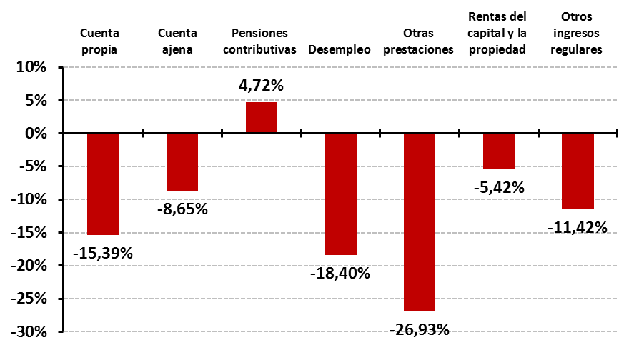
Earnings related
pensions
Capital and property income
Employed
Unemployment
Other social benefits
Other
regular earnings
Self-employed
Source: Own elaboration from Households Budget Survey data (Spanish Statistics Office).

Data in Figure 1 points out that, over a period of time in which the average income of households has been significantly reduced, the increase in contributory pensions has meant a guaranteed income for their beneficiaries. According to the HBS, between 2006 and 2012, old-age pensions were the main source of income for 85% of the households where the reference person was aged 65 or older. This issue has not only contributed to achieve the basic objectives of economic insurance and smoothing consumption that traditionally are attributed to pension systems, but also, as it is described later, has had a positive impact on economic growth and the labour market.
The economic insurance of retirees’ households becomes a relevant issue during the period of recession, when comparing their consumption expenditure with the rest of the households. Figure 2 shows the annual change experienced by spending on household consumption between 2006 and 2012 (compared to 2006 base year), where the turning point in 2007 identifies clearly the end of the period of economic boom and the beginning of the recession.
Figure 2. Households’ consumption (real terms 2006=100). 2006-2012
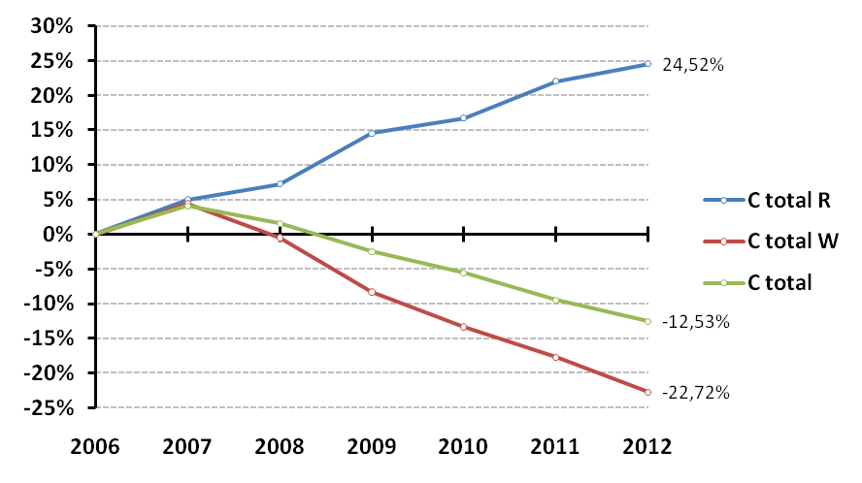
Old-age households (65+)
Employed households
Total of households
Source: Own elaboration from Households Budget Survey data (INE).

As could be expected, lower households’ income imply less households’ consumption, which declined by 12.53% between 2006 and 2012, despite a slight increase on the eve of the recession. However, not all of households followed a similar trend, since those ones whose reference person was a pensioner aged 65 or older increased their consumption by 24.52%, while in the households where the reference person was employed decreased by 22.72%.
It is easy to understand that the reduction of household consumption expenditure has been mainly intensified by the direct loss of income from wages. Figure 3 makes clear this relationship, showing that employment rates decrease (-10.72%), declining wages (-10.43%) and the drop of households’ consumption (-12.53%) follow a similar trend during 2006-2012. On the contrary, the average pension follows a positive trend (16.26%) between 2006 and 2012, which is strongly correlated to the expenditure on consumption of the old-age households that has been previously shown.
Figure 3. Employment, consumption, salaries and pensions (real terms 2006=100). 2006-2012
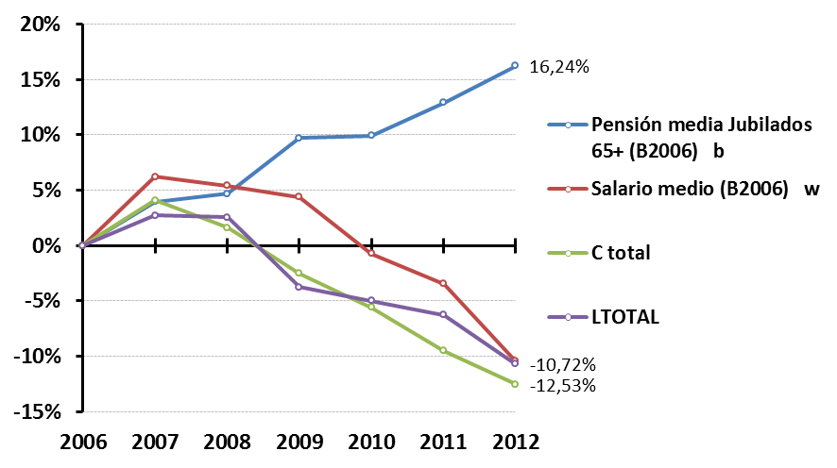
Average old-age pension
Average salary
Total consumption of households
Total employment
Source: Own elaboration from Households Budget Survey data (INE).

These circumstances should be taken into account when assessing the criteria of austerity that prevail in current economic reforms. The policy prescription encourages a systematic reduction of the costs associated with social protection, considering that a balanced government budget and less public debt will promote economic growth. Nevertheless, while spending is an important constraint, having low spending should not be contemplated as the main objective. If governments cut social insurance programmes, the flow of income to beneficiaries decreases and with it go the stabilizing effects of their spending (Ghilarducci, Saad-Lessler, & Fisher, 2012).
In this line, regarding measures adopted to pension systems, policymakers should bear in mind that a pension system is not successful just because it involves little government spending, a successful pension system is the one that achieves its goals of smoothing consumption and income replacement with the least cost (Barr & Diamond, 2008). Furthermore, if pension systems have been part of our economic model for so many years, it has not only been for the unquestionable social benefits that they have produced, but because they have also contributed to the economic growth (Ferreiro & Serrano, 2011). Pensions allow the elderly to meet their spending needs during the retirement, which can be considered as a source of additional demand able to bring into production resources which, otherwise, would have remained idle (Cesaratto, 2002).
According to this view, public pension spending is supposed to maintain a positive relation to employment, since the former funds a growing demand for consumer goods and, in turn, more employment makes a pension system more sustainable. This question is the main reason behind our analysis, which is developed in the next empirical section.

Employment and households’ consumption
Our objective is to examine the relationship between households’ consumption and employment for the Spanish economy during the Great Recession. For this purpose, considering the age of the household reference person, we split the total number of households into two main groups. The first one is composed by the old-age households (65+) and the second one includes households which reference person is aged between 20 and 64. In a first part of our study we will estimate the employment associated to the consumption of both groups of households during the period 2006-2011, and in a second part, we will perform a structural decomposition analysis to identify the main factors behind the evolution of the employment linked to these levels of consumption.
To accomplish this, we develop a model based on the methodology described in (Hawdon & Pearson, 1995) and (Miyazawa, 1968, 1976). In these models, the consumption of households is disaggregated from the rest of the final demand to be integrated in an enlarged Leontief inverse matrix as intermediate consumption. Following this criterion, we make use of an extended Input-Output model where the final demand includes exclusively the consumption of the two groups of households described above. This consumption is treated in the model as an exogenous final demand which, under the Keynesian principle of effective demand, will lead to a higher level of production through the multiplier. This increase in the level of production requires higher employment that generates, on one hand, income for workers to purchase goods and services that are considered the endogenous consumption in the model and, on the other hand, a source of income for the government in the form of taxes and social contributions that shall be used to pay off transfers to households.
Figure 4 depicts the key features of the model, making clear the interdependence flows defined between income, expenditure and output.
Figure 4. Modeling households’ consumption.
FD
c₆₅₊
N₆₅₊
Y₆₅₊
C₆₅₊
C₂₀₋₆₄
L
c₂₀₋₆₄
N₂₀₋₆₄
Y₂₀₋₆₄
c_{L}
Y_{L}
X
C_{L}
A
T
T_{L}
v
X_{C}
t & cs

Source: Own elaboration

Analytically, two set of simultaneous equations, one for the output $X_{C}$ and another one for the income${ Y}_{L}$, drive the model:
$X_{C}=A·X_{C}+c_{L}·Y_{L}+c_{H}·Y_{H}·N_{H}$ [1]
$Y_{L}=v·X_{C}-T_{L}$ [2]
The detailed meaning of the terms in the model is as follows:
- $X_{C}$is the total domestic production associated to households’ consumption and $A$ accounts for the technical coefficients of production.
- $c_{L}$and$c_{H }$are column vectors accounting for the distribution of the consumption baskets of the endogenous and exogenous demand respectively.
- According to the first simultaneous equation [1], $Y_{L}$ is the income that finances the endogenous workers’ consumption. In equation [2], $Y_{L}$ is the row vector of income corresponding to the workers’ compensation for the production of consumer goods that households can buy (reduced by taxes and social contributions$T_{L }$). This compensation is included in vector$v$, which contains the remuneration of one unit of product for each industrial sector arising from the value added associated to the labour input required to produce the goods and services purchased by households.
- $c_{H}·Y_{H}·N_{H}$is the exogenous final demand and accounts for the monetary value of the consumption baskets that are purchased by the $N_{H}$ number of households and financed with the average income $Y_{H}$.
The equilibrium output solution of the model will be conditioned by three key features: (i) the pattern of consumption of the considered households (via consumption coefficients $c_{L}$and$c_{H }$), (ii) the interindustrial production structure (defined by the matrix of technical coefficients$A$), and (iii) the distribution of income by the different income groups, that is, the exogenous value $Y_{H}$ for the group of households concerned and the endogenous compensation of workers${ Y}_{L}$, (via value added $v$ in production$X_{C} )$. The system thus defined can be solved by substituting equation [2] in [1]:
$X_{C} = {(I-A-c_{L}·v)}^{-1}·<c_{H}·Y_{H}·N_{H}>$ [3]
Where ${(I-A-c_{L}·v)}^{-1}$ is the extended inverse matrix that allows us calculate the total effects of changes in exogenous final demand $<c_{H}·Y_{H}·N_{H}>$ on output $X_{C}$, based on the interindustrial structure given by technical coefficients $A$ and the induced consumption of workers employed in $X_{C}$.
In a further step, using the employment coefficients $l_{d}$ (the number of jobs created per unit of output), we compute the total amount of labour required to obtain output $X_{C}$ as follows:
$L_{H}=l_{d}·<X_{C}> = l_{d}·{(I-A-c_{L}·v)}^{-1}·<c_{H}·Y_{H}·N_{H}>$ [4]
The outcomes from this equation allow us to quantify any change in total production and employment as a result of a particular variation in the exogenous component. This has been extensively used in the economic analysis as a forecasting tool and also in impact assessments from a given change in final demand (Wu & Chen, 1990). Regarding the latter, the second part of our analysis develops a temporal analysis of the employment in the Spanish economy during the recession based on structural decomposition analysis (SDA) techniques.
The starting point is equation [4]: if ${ l}_{d}·{(I-A-c_{L}·v)}^{-1}$ is called $l_{v}$ as the vector of vertically integrated labour coefficients, using the terminology in (Pasinetti, 1973), and the households’ consumption$<c_{H}·Y_{H}·N_{H}>$ is $Y$, the total change in employment from base year 0 until year 1 is as follows:
$∆L=L_{1}- L_{0}= l_{v1}·Y_{1}-l_{v0}·Y_{0}$ [5]
Equation [5] can be represented as:
$∆L=l_{v1}·Y_{1}+l_{v0}·Y_{1}-l_{v0}·Y_{1}-l_{v0}·Y_{0}$ [6.a]
$∆L=\left(l_{v1}-l_{v0}\right)·Y_{1}+l_{v0}·\left(Y_{1}-Y_{0}\right)$ [6.b]
where differences in the total employment between two years are explained by changes in inputs coefficients and changes in final demand (Skolka, 1989). In this decomposition, the difference in vectors of vertically integrated labour coefficients has been weighted with the current year’s final demand, and the difference in final demand has been weighted with the base year’s vector of vertically integrated labour coefficients.
It would have been equally valid to apply$l_{v1}·Y_{0}$in the previous transformation, which means considering the base year’s final demand to weight the difference in the vectors of vertically integrated labour coefficients and the current year’s vector of vertically integrated labour coefficients to weight the difference in final demand:
$∆L=\left(l_{v1}-l_{v0}\right)·Y_{0}+l_{v1}·\left(Y_{1}-Y_{0}\right)$ [7]
Nevertheless, the results are different depending on which reference has been taken, therefore the most usual solution consists of applying the average of the two equations:
$∆L=\left(l_{v1}-l_{v0}\right)·Y_{1/2}+l_{v1/2}·\left(Y_{1}-Y_{0}\right)$ [8]
where: $Y_{1/2}=\frac{1}{2}Y_{0}+\frac{1}{2}Y_{1}$ and $l_{v1/2}=\frac{1}{2}l_{v0}+\frac{1}{2}l_{v1}$
Equation [8], as it is shown in Figure 5, can be further decomposed to more accurately identify changes in employment that has been originated by different effects related to the technology and the final demand.
Figure 5. Structural Decomposition Analysis of employment
$$L_{H}=\left\{l_{d}·{(I-A-c_{L}·v)}^{-1}\right\}·\left\{c_{H}·Y_{H}·N_{H}\right\}$$
$${\left\{l_{d}·{(I-A-c_{L}·v)}^{-1}\right\}}_{1/2}·∆\left\{c_{H}·Y_{H}·N_{H}\right\}$$
$${\left\{l_{d}·{(I-A-c_{L}·v)}^{-1}\right\}}_{1/2}·∆c_{H}·{\left\{Y_{H}·N_{H}\right\}}_{1/2}$$

$${\left\{l_{d}·{(I-A-c_{L}·v)}^{-1}\right\}}_{1/2}·{c_{H}}_{1/2}·∆\left\{Y_{H}·N_{H}\right\}$$
$${\left\{l_{d}·{(I-A-c_{L}·v)}^{-1}\right\}}_{1/2}·{c_{H}}_{1/2}·∆Y_{H}·{N_{H}}_{1/2}$$
$${\left\{l_{d}·{(I-A-c_{L}·v)}^{-1}\right\}}_{1/2}·{c_{H}}_{1/2}·{Y_{H}}_{1/2}·∆N_{H}$$

$$∆\left\{l_{d}·{(I-A-c_{L}·v)}^{-1}\right\}· {\left\{c_{H}·Y_{H}·N_{H}\right\}}_{1/2}$$
$$∆l_{d}·{{(I-A-c_{L}·v)}^{-1}}_{1/2}· {\left\{c_{H}·Y_{H}·N_{H}\right\}}_{1/2}$$
$${l_{d}}_{1/2}·∆{(I-A)}^{-1}·{{(c_{L}·v·{(I-A)}^{-1})}^{-1}}_{1/2}· {\left\{c_{H}·Y_{H}·N_{H}\right\}}_{1/2}$$
$${l_{d}}_{1/2}·∆{(I-A-c_{L}·v)}^{-1}· {\left\{c_{H}·Y_{H}·N_{H}\right\}}_{1/2}$$

$${l_{d}}_{1/2}·{{(I-A)}^{-1}}_{1/2}·{∆(c_{L}·v·{(I-A)}^{-1})}^{-1}· {\left\{c_{H}·Y_{H}·N_{H}\right\}}_{1/2}$$

Source: Own elaboration

Following (Han, 1995), changes in technology can be decomposed into a direct effect related to the variation of sectoral employment coefficients and an indirect effect caused by changes in the extended technical matrix. In addition, this indirect effect can be split into changes related to the technical coefficients (via matrix$A$) and changes related to the induced workers consumption.
As regards final demand effects, according to the decomposition described in (Hoekstra & van den Bergh, 2002; Lin & Polenske, 1995) changes in employment can be explained by two types of determinant effects: the product mix effect, which is caused, for the particular case of our investigation, by shifts in the composition of the pensioners’ consumption basket, and a final demand level effect, i.e. effects of the growth of the overall level of final demand, which are related in our analysis to changes in the number of pensioners and the average pension.

Main results
This section provides information about the main results of this research. Data appendix contains more details about the sources of the information used to obtain these results.
We first describe how vectors of consumption for the different types of households have been calculated. Final consumption appears in SIOT classified only in three levels, namely, Households, NPISH and Government. Consequently, we need a procedure to extract the consumption related to the different groups of households under analysis from the total number of households. To accomplish this, we used the statistics of the households’ consumption over the sample of roughly 24.000 households contained in the HBS. By defining specific data filters related to age, we are able to estimate the exogenous consumption basket of those households where the reference person is aged 65 or above$c_{65+}$, or is aged between 20 and 64$c_{20-64}$. The monetary values of these exogenous consumption baskets are obtained by applying the previous percentages to the average income of old-age households$Y_{65+}$and younger households$Y_{20-64}$. Furthermore, multiplying these values by the total number of households $N_{65+}$and$N_{20-64}$, we would have the exogenous final demand of the model.
The information related to the endogenous workers’ consumption is obtained from HBS data following a similar procedure to the previous one described for the exogenous consumption. In this particular case, we identify those households where the reference person is in employment and calculate the consumption basket$c_{L}$. Later, according to the model description in Figure 4, applying $c_{L}$ to the sectoral value added$v$, we obtain the endogenous workers’ consumption.
Table 1 shows the estimates for the consumption baskets above described. At this point, it is important to mention that previous results have been obtained taking into account three important requirements: (i) the deduction of VAT, since we are interested in the expenditure of workers and pensioners in basic prices to make it compatible with the TSIO data, (ii) the discounting of the imputed rents included in the values of housing and real estate, since the nature of this expenditure do not put in motion any amount of labour linked to this activity, and (iii) the monetary values in SIOT and HBS are expressed in real terms (base year 2006) and have been deflated by using the HBS constant prices tables extracted from the Spanish Statistics Office.
Table 1. Households’ and workers’ consumption baskets. (2006-2011)

Sectors | $$c_{65+}$$ |  |  | $$c_{20-64}$$ |  |  | $$c_{L}$$
 | 2006 | 2011 | Δ₂₀₀₆₋₁₁ | 2006 | 2011 | Δ₂₀₀₆₋₁₁ | 2006 | 2011 | Δ₂₀₀₆₋₁₁
Agriculture and fishing | 5.37% | 5.22% | -0.15% | 3.02% | 3.11% | 0.09% | 2,92% | 2,97% | 0,06%
Mining and quarrying | 0.11% | 0.08% | -0.03% | 0.03% | 0.03% | 0.00% | 0,02% | 0,02% | 0,00%
Food, beverages and tobacco | 22.18% | 21.78% | -0.40% | 16.32% | 16.97% | 0.65% | 15,90% | 16,20% | 0,29%
Clothing, textiles and footwear | 7.52% | 6.08% | -1.43% | 8.28% | 7.69% | -0.59% | 8,29% | 7,84% | -0,45%
Chemicals and intermediate products | 3.11% | 3.62% | 0.51% | 2.28% | 2.45% | 0.17% | 2,23% | 2,32% | 0,09%
Machinery and electrical equipment | 2.14% | 3.04% | 0.89% | 2.92% | 3.56% | 0.64% | 2,96% | 3,64% | 0,68%
Furnishing, accesories and recycling | 5.28% | 4.64% | -0.64% | 6.33% | 5.30% | -1.03% | 6,41% | 5,36% | -1,05%
Electricity, gas and water supply | 8.99% | 9.42% | 0.43% | 8.69% | 9.69% | 1.00% | 8,65% | 9,55% | 0,90%
Construction | 2.09% | 2.06% | -0.03% | 1.11% | 0.95% | -0.15% | 1,09% | 0,92% | -0,17%
Sale and repair of motor vehicles and fuels | 5.41% | 4.24% | -1.17% | 10.57% | 7.31% | -3.26% | 10,69% | 7,47% | -3,22%
Maintenance services | 0.72% | 0.76% | 0.04% | 0.52% | 0.54% | 0.02% | 0,52% | 0,60% | 0,08%
Restaurants and Hotels | 8.51% | 7.80% | -0.71% | 13.01% | 11.99% | -1.02% | 13,27% | 12,48% | -0,79%
Transport | 1.10% | 0.94% | -0.16% | 1.50% | 1.45% | -0.05% | 1,52% | 1,46% | -0,06%
Post and telecommunications | 3.05% | 3.81% | 0.75% | 3.23% | 4.15% | 0.92% | 3,20% | 4,12% | 0,93%
Insurance and Financial services | 4.09% | 4.55% | 0.45% | 3.50% | 3.74% | 0.24% | 3,49% | 3,71% | 0,22%
Housing and real estate | 3.54% | 4.47% | 0.93% | 4.07% | 6.16% | 2.09% | 4,18% | 6,01% | 1,83%
Business services | 1.65% | 0.85% | -0.80% | 1.54% | 0.87% | -0.67% | 1,40% | 0,82% | -0,58%
Education | 0.25% | 0.25% | 0.00% | 1.24% | 1.50% | 0.27% | 1,30% | 1,64% | 0,34%
Health and social work | 4.29% | 4.72% | 0.43% | 2.80% | 3.35% | 0.56% | 2,78% | 3,38% | 0,60%
Community, recreation and personal services | 10.59% | 11.68% | 1.09% | 9.04% | 9.18% | 0.13% | 9,18% | 9,50% | 0,32%
Average income ⁽¹⁾(euros) | 14,430 | 16,381 | 13.5% | 24,305 | 22,650 | -6.8%
Thousands of persons | 4,196 | 4,727 | 12.6% | 11,659 | 12,615 | 8.2%
Total consumption ⁽²⁾ (10⁶ euros) | 60,551 | 77,439 | 27.9% | 283,382 | 285,723 | 0.8%

Notes: c₆₅₊ Consumption of households where the reference person is aged 65 or above
c₂₀₋₆₄ Consumption of households where the reference person is aged between 20 and 64
c_{L} Consumption of households where the reference person is an employed
(1) (2). Monetary values in real terms. Base 2006.
Source: Own elaboration from HBS data (Spanish Statistics Office)

Broadly speaking, the consumption basket$c_{65+}$reflects a pattern of consumption mainly focused on essential goods and services to cover basic necessities –food, beverages and tobacco together with health and social work make up approximately a quarter of the total expenditure for the elderly-, whilst younger households show a higher level of consumption in the vehicles sector and hotels. Although the households’ consumption baskets have not experienced large variations between 2006 and 2011, the impact of the crisis has substantially changed their participation in consumption respect to the total number of households. The loss of income in younger households (-6.8%), which has been mainly caused by unemployment, has lead to a decrease in the share of consumption over the total households from 70.67% in 2006 to 63.92% in 2011. During the same period, the weight of the old-age households’ consumption has increased from 11.11% to 14.99% over the value of the total number of households (Figure 6).
Figure 6. Old-age and younger households’ consumption over total households’ consumption.
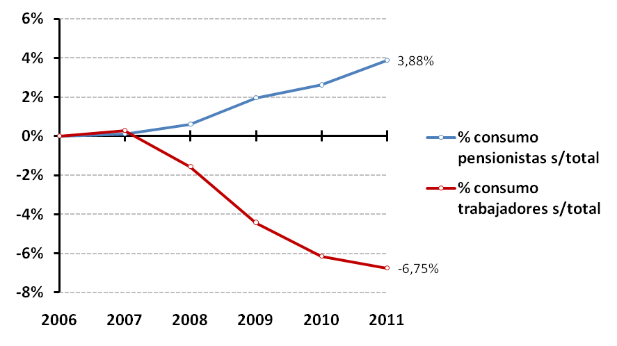
11.11%
70.67%
Younger households’ consumption over total households’ consumption
Old-age households’ consumption over total households’ consumption
Source: Own elaboration from HBS data (Spanish Statistics Office).

Considering, as indicated previously, that contributory pensions are the main source of income for 85% of old-age households, data above highlight the important stabilizing effect of the Spanish pension system during the crisis. Pensions have guaranteed the purchasing power for most of the elderly households and have financed the aggregate demand associated to their level of consumption. As it is shown in Table 2, this fact has contributed to alleviate the negative trend in production and employment associated with the rest of the households.
Table 2. Employment associated to households’ consumption.
Sectors | $$L_{65+}$$ |  |  | $$L_{20-64}$$
 | 2006 | 2011 | Δ₂₀₀₆₋₁₁ | 2006 | 2011 | Δ₂₀₀₆₋₁₁
Agriculture and fishing | 182.271 | 201.691 | 10,65% | 663.910 | 595.832 | -10,25%
Mining and quarrying | 3.763 | 3.361 | -10,68% | 15.329 | 10.694 | -30,24%
Food, beverages and tobacco | 128.491 | 144.462 | 12,43% | 509.895 | 465.829 | -8,64%
Clothing, textiles and footwear | 99.633 | 85.979 | -13,70% | 492.606 | 360.954 | -26,73%
Chemicals and intermediate products | 74.864 | 67.861 | -9,35% | 334.364 | 233.001 | -30,32%
Machinery and electrical equipment | 23.351 | 20.324 | -12,96% | 123.072 | 79.145 | -35,69%
Furnishing, accesories and recycling | 108.892 | 136.219 | 25,10% | 558.012 | 535.525 | -4,03%
Electricity, gas and water supply | 24.368 | 38.019 | 56,02% | 111.474 | 140.637 | 26,16%
Construction | 53.566 | 48.494 | -9,47% | 216.921 | 150.467 | -30,64%
Sale and repair of motor vehicles and fuels | 89.949 | 83.083 | -7,63% | 562.350 | 382.902 | -31,91%
Maintenance services | 187.429 | 215.996 | 15,24% | 836.220 | 769.227 | -8,01%
Restaurants and Hotels | 122.369 | 147.169 | 20,27% | 712.259 | 672.944 | -5,52%
Transport | 58.743 | 68.761 | 17,05% | 281.496 | 262.807 | -6,64%
Post and telecommunications | 22.220 | 30.937 | 39,24% | 105.573 | 117.071 | 10,89%
Insurance and Financial services | 47.022 | 60.513 | 28,69% | 207.729 | 206.302 | -0,69%
Housing and real estate | 48.885 | 69.190 | 41,54% | 246.856 | 301.544 | 22,15%
Business services | 147.027 | 197.561 | 34,37% | 677.509 | 718.509 | 6,05%
Education | 18.504 | 27.421 | 48,19% | 141.827 | 171.435 | 20,88%
Health and social work | 66.968 | 87.329 | 30,40% | 241.831 | 262.781 | 8,66%
Community, recreation and personal services | 216.831 | 286.865 | 32,30% | 933.262 | 928.873 | -0,47%
Total ⁽¹⁾ | 1.725.145 | 2.021.234 | 17,16% | 7.972.497 | 7.366.479 | -7,60%
Sectors | $${\%L}_{65+} over L_{TOTAL}$$ |  |  | $${\%L}_{20-64} over L_{TOTAL}$$
 | 2006 | 2011 | Δ₂₀₀₆₋₁₁ | 2006 | 2011 | Δ₂₀₀₆₋₁₁
Agriculture and fishing | 9,61% | 11,89% | 23,75% | 34,99% | 35,12% | 0,37%
Mining and quarrying | 5,26% | 6,62% | 25,87% | 21,42% | 21,06% | -1,69%
Food, beverages and tobacco | 10,25% | 12,46% | 21,55% | 40,69% | 40,19% | -1,23%
Clothing, textiles and footwear | 9,51% | 11,13% | 16,96% | 47,03% | 46,71% | -0,69%
Chemicals and intermediate products | 4,17% | 5,10% | 22,16% | 18,65% | 17,51% | -6,09%
Machinery and electrical equipment | 3,21% | 3,67% | 14,23% | 16,94% | 14,30% | -15,60%
Furnishing, accesories and recycling | 8,36% | 11,14% | 33,26% | 42,86% | 43,81% | 2,23%
Electricity, gas and water supply | 9,08% | 11,21% | 23,48% | 41,52% | 41,46% | -0,15%
Construction | 1,84% | 3,00% | 62,60% | 7,46% | 9,29% | 24,58%
Sale and repair of motor vehicles and fuels | 7,13% | 8,49% | 19,09% | 44,59% | 39,15% | -12,21%
Maintenance services | 4,80% | 5,71% | 19,12% | 21,40% | 20,35% | -4,91%
Restaurants and Hotels | 5,08% | 6,18% | 21,62% | 29,57% | 28,25% | -4,46%
Transport | 4,45% | 5,38% | 20,91% | 21,33% | 20,57% | -3,56%
Post and telecommunications | 6,84% | 8,86% | 29,54% | 32,49% | 33,52% | 3,17%
Insurance and Financial services | 6,49% | 8,42% | 29,68% | 28,68% | 28,70% | 0,08%
Housing and real estate | 8,21% | 10,23% | 24,63% | 41,47% | 44,61% | 7,56%
Business services | 4,67% | 5,82% | 24,75% | 21,50% | 21,17% | -1,54%
Education | 1,56% | 2,12% | 35,85% | 11,98% | 13,28% | 10,81%
Health and social work | 4,21% | 5,01% | 19,05% | 15,20% | 15,08% | -0,80%
Community, recreation and personal services | 5,28% | 6,77% | 28,20% | 22,72% | 21,91% | -3,56%
Total ⁽¹⁾ | 5,42% | 6,83% | 26,15% | 25,04% | 24,91% | -0,51%

Source: Own elaboration from HBS data (Spanish Statistics Office).
The upper part of Table 2 presents the results of employment calculated from equation [4] for old-age households${ L}_{65+}$and younger households${ L}_{20-64}$. The rationale behind the variation in production and employment related to households’ consumption are the imbalances that triggered the recent economic crisis. But: what structural components have been the driving forces behind changes in employment and what has been the weight of these changes during the period of analysis?. The SDA techniques described in the previous methodological section give an answer to these issues, and allow us to quantify the contribution of the main factors that have caused the difference in the total employment (Table 3).
Table 3. SDA results. (2006-2011)

$$L_{H}=l_{d}·{(I-A-c_{L}·v)}^{-1}·<c_{H}·Y_{H}·N_{H}>$$
 | $$Households 65+$$ |  |  | $$Households 20-64$$
$$L_{H 2006}$$ | 1.725.145 |  |  | 7.972.497
TOTAL $∆L_{H}$ | 17.16% |  |  | -7.60%
Technological change  $∆\left\{l_{d}·{(I-A-c_{L}·v)}^{-1}\right\}$ | -8.03% |  |  | -6.57%
Requirements of sectoral employment  $∆l_{d}$ | -9.39% |  |  | -7.80%
Changes in intermediate consumption  $∆{(I-A-c_{L}·v)}^{-1}$ | 1.37% |  |  | 1.23%
Changes in technical coefficients  $∆{(I-A)}^{-1}$ | 2.03% |  |  | 1.75%
Endogenous consumption changes  $∆{(c_{L}·v·{(I-A)}^{-1})}^{-1}$ | -0.66% |  |  | -0.52%
Changes in households’ consumption  $∆\left\{c_{H}·Y_{H}·N_{H}\right\}$ | 25.19% |  |  | -1.03%
Product mix effect  $∆c_{H}$ | -1.55% |  |  | -1.83%
Level effect  $∆\left\{Y_{H}·N_{H}\right\}$ | 26.74% |  |  | 0.79%
Changes in number of households  $∆N_{H}$ | 12.96% |  |  | 7.60%
Changes in the average income  $∆Y_{H}$ | 13.79% |  |  | -6.80%
$$L_{H 2011}$$ | 2.021.234 |  |  | 7.366.479

Source: Own elaboration.

Data above present the variation of the total employment associated to households’ consumption from 2006 to 2011. The results related to old-age households show that the increase of 17.16% in the number of jobs can be explained by two opposing effects: an increase by 25.19% in the exogenous final demand and a decrease by 8.03% due to changes observed in the technology.
More specifically, changes related to the exogenous consumption were produced by the increase in the number and the average income of this group of households. The maintenance and improvement of the purchasing power of the elderly (mostly by pensions) is responsible for 13.79% of changes in employment, whilst the increase in the number of old-age households has contributed in 12.96%. Both factors are combined in the so-called level effect, which refers to the variation (positive and especially relevant for this particular case) of the final demand in absolute terms. However, changes in consumption due to the product mix effect cause a negative impact on the total number of jobs (although of minor importance, -1.78%). This reduction occurs as a consequence of a change in the consumption behaviour of old-age consumers from 2006 to 2011.
The difference in employment due to technological effects (-8.03%) can be further decomposed into changes produced by labour productivity growths (-9.39%) and changes in the intermediate consumption (1.37%), which are also explained by the variation in the technical coefficients included in matrix A (2.03%) and the induced consumption of workers employed in the output to match the final demand (-0.66%).
Regarding households where the reference person age is between 20 and 64, changes due to the exogenous final demand result in a negative value (-1.03%), which reinforces the decrease by 6.57% due to changes in technology and lead to a total negative employment variation of -7.60%. Despite the positive effect (7.60%) of the growth in the number of households, the level effect stays quite balanced (0.79%) due to the loss of income suffered by this group of households (-6.80%), which explains the negative impact of the exogenous consumption on the total employment.
In the light of these results, the reduction of the average income suffered by younger households appears as the main determining factor explaining the difference in the employment trend related to the consumption of the two groups of households concerned.

Conclusions
The Spanish economy has been no exception regarding the negative impact of the Great Recession and is suffering especially hard the problems related to unemployment. Imbalances responsible for the collapse in aggregate demand have triggered a downward spiral in which lower household consumption raises unemployment rates and the risk of becoming unemployed hinders consumption. Thus, the employment rate and the average salary decreased by roughly 16% and 10% respectively between 2007 and 2012. As a main consequence, the average income of the Spanish households decreased by 11.4% and the total consumption fell by 12.5%.
However, not all households have followed such a negative trend. Our analysis has shown that households where the reference person is aged 65 or above, experienced a significant increase in consumption (24.5%) that finally has generated 296,089 jobs from 2006 to 2011. This positive outcome has contributed to alleviate the negative trend in the employment associated to the consumption of the younger households (-606,018).
The structural decomposition analysis performed in the last part of our study confirms that the average income has been the main driving force explaining the evolution of employment for the households concerned. The increase in the average income of old-age households, mostly from pensions, is responsible for 13.79% of changes in employment associated to their consumption, which result in 40,830 jobs. At the same time, the loss of income in younger households, mainly due to the outstanding rise in unemployment, is responsible for 6.80% of decrease in employment associated to their consumption, roughly 41,200 jobs.
As a conclusion, outcomes above can be understood as a prove of the stabilizing effect of the Spanish pension system during the crisis, which not only has contributed to the economic insurance of the elderly, but also has been a source of employment through the production associated to the old-age households’ consumption.

Data appendix
This section provides a brief description of the main data sources used in this research.
  - The domestic Symmetric Input-Output Tables (henceforth, SIOT) for Spain has been obtained from the WIOD Database. This database is a project funded by the Research Directorate General of the European Commission, covering 27 EU countries and 13 other major countries in the world for the period from 1995 to 2011. The Input-Output Tables are defined at basic prices and the information is disaggregated in 35 industries based on the NACE classification worldwide (Timmer et al., 2012).
  - Consumption data for the different types of households considered in this exercise have been collected from the Household Budget Survey (HBS) carried out by the Spanish Statistics Institute. This database provides information on the amount and structure of households’ expenditure according to the COICOP (Classification of Individual Consumption by Purpose), which is one of the classifications of the National accounts system. It is used to classify transactions made between producers and the institutional sector of households. The HBS also includes socio-economic characteristics related mainly to the standard of living, income, professional activity of the household reference person.
  - It is important to note that there is not an official correspondence between HBS and SIOT. In order to provide comparable results between consumption purposes and products, HBS and SIOT have been aggregated in a basic classification of 20 sectors of activity according to the purpose of this particular investigation.
  - Compensation and number of workers by productive sectors have been collected from the National Accounting of the Spanish Statistics Institute.

References

Alvarez, I., Luengo, F., & Uxó, J. (2013). Fracturas y crisis en Europa: Madrid: Clave Intelectual.
Barr, N., & Diamond, P. (2008). Reforming pensions: Principles and policy choices: Oxford University Press.
Cesaratto, S. (2002). The economics of pensions: a non-conventional approach. Review of Political Economy, 14(2), 149-177.
Dejuán, Ó. (2013). The debt trap. In Ó. Dejuán, E. F. Paños & J. U. Gonzalez (Eds.), Post-Keynesian Views of the Crisis and Its Remedies (pp. 87-107): Routledge.
Febrero, E., & Bermejo, F. (2013). Spain during the Great Recession. In O. Dejuán, E. Febrero & J. Uxó (Eds.), Post-Keynesian Views of the Crisis and Its Remedies (pp. 266-293).
Ferreiro, J., & Serrano, F. (2011). Uncertainty and Pension Systems Reforms. Journal of Economic Issues, 45(2), 317-322.
Ghilarducci, T., Saad-Lessler, J., & Fisher, E. (2012). The macroeconomic stabilisation effects of Social Security and 401 (k) plans. Cambridge journal of economics, 36(1), 237-251.
Han, X. (1995). Structural change and labor requirement of the Japanese economy. Economic Systems Research, 7(1), 47-66.
Hawdon, D., & Pearson, P. (1995). Input-output simulations of energy, environment, economy interactions in the UK. Energy Economics, 17(1), 73-86. doi: http://dx.doi.org/10.1016/0140-9883(95)98908-M
Hoekstra, R., & van den Bergh, J. J. M. (2002). Structural Decomposition Analysis of Physical Flows in the Economy. Environmental and Resource Economics, 23(3), 357-378. doi: 10.1023/A:1021234216845
Leontief, W., & Ford, D. (1972). Air pollution and the economic structure: empirical results of input-output computations. Input-output techniques, 9-30.
Lin, X., & Polenske, K. R. (1995). Input–output anatomy of China's energy use changes in the 1980s. Economic Systems Research, 7(1), 67-84.
Miyazawa, K. (1968). Input-output analysis and interrelational income multiplier as a matrix. Hitotsubashi Journal of Economics, 8(2), 39-58.
Miyazawa, K. (1976). Interindustry Analysis and the Structure of Income Distribution Input-Output Analysis and the Structure of Income Distribution (Vol. 116, pp. 1-21): Springer Berlin Heidelberg.
Pasinetti, L. L. (1973). The notion of vertical integration in economic analysis. Metroeconomica, 25(1), 1-29. doi: 10.1111/j.1467-999X.1973.tb00539.x
Shambaugh, J. C. (2012). The Euro's Three Crises. Brookings Papers on Economic Activity, 157-231.
Skolka, J. (1989). Input-output structural decomposition analysis for Austria. Journal of Policy Modeling, 11(1), 45-66. doi: http://dx.doi.org/10.1016/0161-8938(89)90024-0
Timmer, M., Erumban, A., Francois, J., Genty, A., Gouma, R., Los, B., . . . Rueda-Cantuche, J. (2012). The World Input-Output Database (WIOD): Contents, Sources and Methods. WIOD Background document available at www. wiod. org.
Wu, R.-H., & Chen, C.-Y. (1990). On the application of input-output analysis to energy issues. Energy Economics, 12(1), 71-76. doi: http://dx.doi.org/10.1016/0140-9883(90)90010-D

