Rents in the Era of Resource Scarcity:
Tracking Payment Flows through the Global Economy

Faye Duchin
Department of Economics
Rensselaer Polytechnic Institute
Troy, NY USA

Stephen H. Levine
Department of Civil and Environmental Engineering
Tufts University
Medford, MA USA

Abstract. Resource prices rise when more costly sources need to be exploited. When the world price increases, owners of low-cost sources receive scarcity rents. These rents are bound to increase in the future along with the size of the human population and raised consumption expectations. The magnitude of the rents depends on the range of resource qualities being simultaneously exploited and can represent a substantial transfer of wealth to those with property rights to large stocks of high quality, easily accessible resources.

This paper presents a framework for mapping the network of global money flows originating with payments for consumer goods in one or more economies, through payments for intermediate goods along the supply chain, to ultimate receipts by owners of embodied factors of production. For a world economy of m regions, n sectors, and k factors of production, the full network is described by a Payment Flow Matrix of dimensions 2mn x m(n + k). A related matrix of dimension mk x mn, the Consumer to Factor Matrix, calculated from it, transforms the vector of selected consumer payments directly to the corresponding vector of receipts by resource owners in different regions. We formulate a set of scenarios for a three-region, four-sector, three-resource world economy, where progressively increased consumer demand requires a second and then a third region to extract raw ore. This numerical example illustrates how the amount of rents transferred to the low-cost producers depends on the differential costs of extraction relative to the highest-cost producer and on the size of the lower-cost endowments relative to world demand. The network flows are calculated through an ex post operation applied to a multi-regional input-output (MRIO) database. We first compute the results for the alternative scenarios about the future using the World Trade Model with Bilateral Trade and then generate the MRIO database, corresponding to each scenario, from which the payment network is derived.

Keywords: resource scarcity, scarcity rents, global payment network, global supply chain,
scenario analysis, World Trade Model with Bilateral Trade,
multi-regional input-output (MRIO) database
Rents in the Era of Resource Scarcity:
Tracking Payment Flows through the Global Economy

Growing populations, growing affluence, and the materials diversity of modern technologies are straining the resource capacities on which we draw. The situation need not inspire panic, but should instead stimulate more diligent and more comprehensive approaches to the balance between supply and demand across the entire periodic table.

Tom Graedel et al., On the Materials Basis of Modern Society

- Introduction

Motivation

At a time when global demand for oil is low and supply continues to increase, Saudi Arabia announced at the November 2014 meeting of OPEC that it would not cut its production volume. This is a momentous decision on the part of the country that has been the world’s largest producer and exporter of petroleum and also, as the lowest-cost producer, the major recipient of resource rents, a country that, at other times, has cut back production to bolster prices. The ability of Saudi Arabia, and indeed of OPEC, to govern oil prices is weakened as new sources of oil and new substitutes become available, and temporarily low prices undermine this competition. Oil monopolizes our attention now, but other resources also have the potential to dramatically influence the future international distribution of income and wealth.

The key variables in determining the distribution of future resource rents include the demand for resource-intensive goods and services associated with increases in population and affluence and with changes in consumption preferences. Also important is the potential for substitutions in production among individual materials, waste management practices and secondary sources of materials, and new technologies more generally. Resource availability depends on the distribution of natural endowments, resource depletion or contamination as in the case of water, and new discoveries. Limits on production may be imposed as business strategy or due to inadequate production capacity or to legislation like environmentally motivated constraints on water withdrawals. Candidates for supply shortages include phosphate ore for fertilizer and geographically concentrated metals such as strontium (China), the platinum group (South Africa and Russia), niobium (Brazil), tellurium (United States and Australia), and manganese (Ukraine and South Africa) (Graedel et al. 2013).

Material flows in an economy start from resources, which are extracted, processed, incorporated in intermediate goods, and eventually embodied in consumer products. The supply chain for a particular consumer product includes the resources and intermediate goods required for its production. Money payments flow in the reverse direction to the material flows; they originate in the payments made by consumers for final products, continue downstream through payments for intermediate products, and terminate in payments to the owners of the embodied resources and of other factors of production, namely labor and built capital. Quantification of a payment network permits tracing the money paid for food by consumers in the United States, for example, to its ultimate recipients: the owners of built capital (in the form of profits) and workers in food processing and transport and other industries in the U.S. and other countries, and the farmers and those with ownership rights to land and water in the places where the crops were grown and livestock raised. In an era of resource constraints, global transfer of rents on scarce resources can be expected to grow as a share of the prices of food, or an iPhone, and many other products, and for this reason they will become increasingly critical to identify and quantify.

Review of the Literature

Porter (1985) identified the central importance for a firm of managing what he called its supply chain as a basis for creating competitive advantages. Gereffi broadened the focus from business strategy and emphasized the payments to factors of production at each node along a product’s increasingly fragmented global supply chain (Gereffi and Korzeniewicz 1994). Gereffi and Lee (2012) point out the value of the concept not only for business planning, but also for evaluating national competitiveness and formulating development strategies. Kaplinsky stresses the importance for developing countries of studying global value chains to identify opportunities to participate in the global economy on more favorable terms than just exporting raw materials (Kaplinsky and Morris, 2001). The global value-chain literature is comprised largely of case studies, both for high-technology sectors such as Dedrick et al. (2010) on the iPod and for processing of primary products of interest to developing countries, for example Humphrey and Memedovic (2006) on agriculture and food or Palpacuer et al. (2005) on clothing.

There is a large body of case study literature on supply chains and value chains and networks: we use the terms interchangeably but point out that network is the more accurate choice as the paths among nodes can involve loops rather than product or money flowing between two nodes in one direction only. Quantifying the networks requires not only data but also analysis as the chain or network structure is not directly measurable. With the recent availability of detailed input-output tables covering a large part if not the totality of the world economy, it is now possible to quantify global value chains. Timmer et al. (2014), as members of the team that compiled one of these databases (Dietzenbacher et al. 2013), use it to calculate for selected final bills of goods the corresponding payments made for 14 manufactured products in 40 countries for each year between 1995 and 2008 to three categories of workers and to owners of capital in different regions. They report, for example, that for cars sold in Germany, the portion of the value of sales that remains in Germany as payments to labor and capital has fallen from 78% to 66%: while the share earned by German capital has remained unchanged at around 20%, the share paid to German workers fell from 57% to 46%. Labor income as a share of total value-added decreased in both high-income and low-income economies, falling globally from 59% to 53%. Their concerns are distinguishing payments that stayed in the home region or “leaked” abroad over the time period studied.

The long-established fact that a well-defined input-output computation can quantify the factors of production embodied in a given bill of final goods makes it the method of choice for computing value networks. With the growing availability of detailed and documented global MRIO databases, a more focused research program on global value networks becomes possible.

This Study

Our study is situated within a research framework that distinguishes earnings on resources from profits on built capital and extends the analysis to alternative scenarios about the future. This step requires both a model capable of capturing the impacts of scenario assumptions and a database for representing the scenarios. We make use of the World Trade Model with Bilateral Trade (WTMBT) (Strømman and Duchin 2006) and compile the outcomes of each scenario in the form of an MRIO table: see Duchin, Levine, and Strømman (2015) and Duchin and Levine (2015) for a description of the integration of the WTMBT and MRIO analysis. The WTMBT is based on the logic of comparative advantage: it allows for a choice among technologies in each region and assigns production of each output according to regional comparative advantages subject to factor constraints, where the endowments may increase or be depleted according to the scenario. Scarcity rents are earned on fully utilized, high-quality factors of production, or on technologies that are low-cost relative to others. Analysis of the resulting MRIO matrix quantifies what we call the Payment Flows Network and the associated Payment Flows Matrix (PFN and PFM) as well as the Consumer-to-Factor Network and Matrix (CFN and CFM). The PFN follows the detailed pathways from consumer payments through payments for intermediate goods to factor receipts while the PFN maps consumer payments directly to receipts by owners of factors of production.

The present study departs from other studies in that we focus the analysis not on data for the past but on scenarios about the future. Existing MRIO databases describe payments to factors of production as value-added, comprised of payments to one or more categories of labor with the remainder of value-added treated as profits attributed to owners of capital. Thus defined, profits include both payments to built capital as well as royalties and rents on resources and residual forms of income. Given our focus on resources, we disaggregate capital income to distinguish payments for use of built capital from those for specific natural resources specified by the scenario. The WTMBT distinguishes the ex ante resource price, which is earned whether or not the endowment is fully utilized, from the scarcity rent, which is non-zero only if the constraint is binding: the sum of the two is the unit price of the resource. A numerical example illustrates the nature of the investigation and the kinds of conclusions that can be drawn from the analysis.

In Section II we describe the quantification of payment flows in a single region with no imports or exports (or ones that are exogenous and included with domestic final demand). This starting point utilizes the familiar notation of the basic input-output model. The primal and dual models provide the quantities and prices, respectively, that we require. From them we derive the Consumer-to-Factor Matrix, providing the basis for the desired equation transforming consumer payments directly to payments to factor owners, and the more general Payment Flows Matrix. In Section III we move to the global, multi-region economic system, where each region is able to meet its final demand through an endogenously determined combination of imported and domestically produced goods. We describe the WTMBT and the matrices of interest, the CFM and the PFM.

Section IV develops a set of four scenarios designed to reveal the economic logic behind the determination of these matrices and provides an interpretation of the results. The illustrative example is for a three-region economy with four sectors and three factors of production. Section V relates these results to the further development of the proposed research program for addressing strategic questions about resources from the distinct points of view of a variety of stakeholders.

The paper includes four appendices. Appendix A shows the algebra for the WTMBT, and Appendix B defines the matrices and vectors constructed from a WTMBT solution to form the corresponding MRIO matrices and vectors from which the new matrices of interest are calculated. Appendix C supplements Section IV of the paper by providing, for readers wishing to analyze their own scenarios, the data for our baseline scenario. Appendix D shows a full Payment Flow Network, including payments for intermediate goods, for the two extreme scenarios. This appendix is included for completeness, as the result discussed in the text focus only on the direct mapping from consumer payments to factor receipts.

II. Payment Flows in a Single-Region Economy

Consumer-to-Factor Network

The objective is to develop the equation that transforms the vector of consumer payments directly to the associated vector of factor payments. We begin with the familiar primary input-output equation describing quantity relationships and its associated dual price equation. Given consumer demand, the n x 1 vector y, and A, the n x n matrix whose columns describe the intermediate input requirements per unit of output, the quantity equation,

x = Ax + y or x = (I – A)⁻¹y, (1)

solves for the outputs of goods and services, the n x 1 vector x, where both y and x are measured in physical units. Given F, the k x n matrix whose columns quantify requirements for each of k resources per unit of sectoral output, the resource requirements are given by the k x 1 vector φ,

φ = Fx. (2)

The dual model determines prices, p, for the n sectoral outputs, based on exogenously specified resource prices, π,

p = A^{T}p + F^{T}π or p = (I – A^{T})⁻¹F^{T}π. (3)

Alternative scenarios may specify values for changes in demand, y; in technologies, represented by columns of A and F; or in factor prices, π.

We then define the vector of consumer payments $y_{p}=\hat{p}y$ and the vector of factor payments $φ_{π}=\hat{π}φ$. These two are related by $φ_{π}={\text{Φy}}_{p}$where Φ is the k x n consumer-to-factor matrix; its ij^{th} element $φ_{\text{ij}}$is the fraction of the payments made by consumers of product i that ultimately go to the owners of resource j. For the case of a single-region economy consisting of three sectors and two factors the consumer-to-factor matrix Φ is represented by the network in Figure 1.

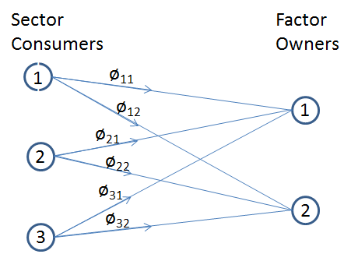

Figure 1: The Consumer-to-Factor Network

Using Eq. (1) and (2), and making use of the properties of the inverse matrix B = (I – A)⁻¹, we obtain the relationship

${\begin{aligned}φ_{π} =\hat{π}φ \\ =\hat{π}\text{Fx} \\ =\hat{π}\text{FBy} \\ =\hat{π}\text{FB \{}\hat{p}\end{aligned}}^{−1}y_{p}$ . (4)

Thus the Consumer-to-Factor Matrix for a single region is

${Φ=\hat{π}\text{FB \{}\hat{p}}^{−1}$. (5)

For the network shown in Figure 1 this matrix is

$$Φ=\left[\begin{matrix}φ_{\text{11}} & φ_{\text{12}} \\ φ_{\text{21}} & φ_{\text{22}} \\ φ_{\text{31}} & φ_{\text{32}}\end{matrix}\right]$$

with elements
$φ_{\text{ij}}=\frac{π_{i}}{p_{j}}(\sum_{k}{f_{\text{ik}}b_{\text{kj}}})$. (6)

The elements in the i^{th} column of Φ describe how each money unit, say each dollar, of consumer payments for the product of sector i is ultimately distributed among the owners of the k factors. The matrix Φ is scenario-specific as it is dependent both on technological assumptions in A and F and on factor prices, π. In the case of the multiregional economy, as we will see, the payment networks are in addition responsive to changes in final demand.

Payment Flows Network

While the consumer-to-factor matrix allows us to determine payment flows to factor owners given payments made by consumers, it does not reflect the paths taken by the payments from consumers (C) through various sectors (S) and finally to factor owners (F). The full Payment Flows Network for this 3-sector 2-factor economy is shown in Figure 2, and the algebraic expressions are derived subsequently. Payments start from consumption outlays (the nodes labeled C) for the three goods, flow to the three sectors (S) as receipts and subsequent payments, and end with payments to the owners of the two factors (F).
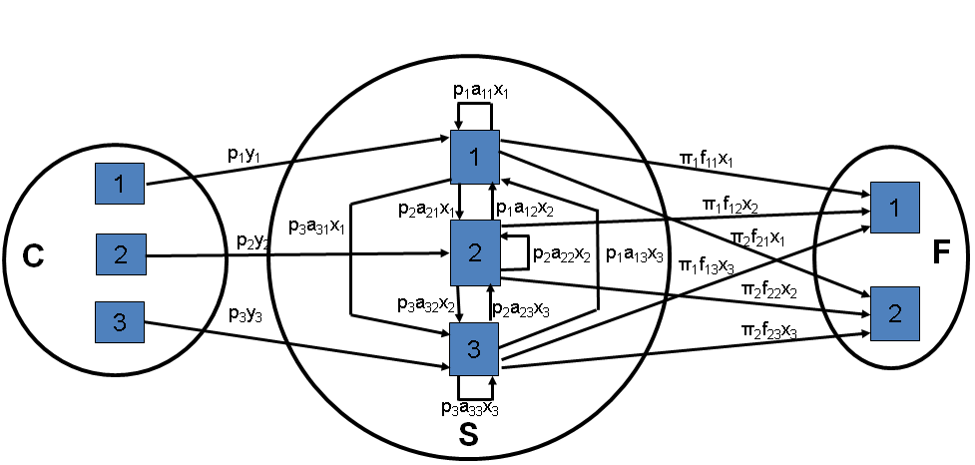

Figure 2. Payment Flows Network for a Single Region with
Three Sectors and Two Factors

Corresponding to a Payment Flows Network is a Payment Flows Matrix, D, composed of three submatrices: (1) the diagonal n x n Consumer Payment Matrix, D_{CS} = $\hat{p}\hat{y}$, (2) the n x n Intermediate Payment Matrix, D_{SS} = $(\hat{p}A\hat{x})^{T}$, and (3) the n x k Factor Payment Matrix, D_{SF} = $(\hat{π}F\hat{x})^{T}$. D_{CS}, as a diagonal matrix, contains the same information as the vector y_{p}, while the matrix D_{SF} provides details on the immediate source of the payments to factor owners not distinguished in the vector φ_{π}. D_{SS} describes the payment flows among the economic sectors, information not readily available in the consumer-to-factor matrix. The transposes appearing in D_{SS} and D_{SF} reflect the fact that payments flow in the reverse direction from goods. The D matrix is then

$D=\left[\begin{matrix}D_{\text{CS}} & 0 \\ D_{\text{SS}} & D_{\text{SF}}\end{matrix}\right]=\left[\begin{matrix}\hat{p}\hat{y} & 0 \\ (\hat{p}A\hat{x})^{T} & (\hat{π}F\hat{x})^{T}\end{matrix}\right]$. (7)

The fact that D_{CF} is equal to 0 reflects the absence of direct payments from consumers to factor owners.

Once x and p are calculated from A, F, y and π, the D matrix for the 3-sector 2-factor example of Figure 2 is:

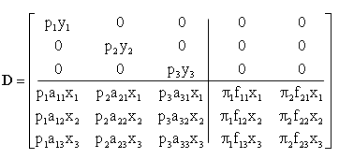

The network and the matrix contain the same information; however, the matrix contains zeroes where the network simply omits arcs with no flows. For alternative scenarios that specify changes in technologies (columns of A and F), demand (y), or factor prices (π), new values for x and p are obtained using Eq. (1) and (3).

III. Payment Flows in a Multiregional Economy

Money flows in the global economy include the payments for traded goods and services. The data structure for accommodating the information describing these transactions is the Multiregional Input-Output (MRIO) table. Duchin and Levine (2015) define the MRIO table corresponding to a solution of the WTMBT and show how to construct it. Appendix A of this paper shows the equations for the WTMBT, and Appendix B defines the matrices and vectors derived from a model solution for constructing the MRIO table.

World Trade Model with Bilateral Trade (WTMBT)

The WTMBT (Strømman and Duchin 2006) is a linear program that minimizes global factor use while satisfying consumption requirements and respecting regional factor constraints. Model results are outputs, x_{i}, and e_{ij}, the bilateral trade vectors, as well as world prices, p, and the region-specific scarcity rents, r_{i}, earned on fully utilized factors. The starting database and the scenario results are then combined to derive the A_{B} and Y_{B} matrices, which form the basis of the network analysis and from with an MRIO is constructed. See Appendix B for the definition and derivation of A_{B} and Y_{B}.

The WTMBT is based on the logic of comparative advantage. It is able to distinguish bilateral trade relationships by the explicit inclusion of the costs associated with international transportation of traded goods between any two regions along with the cost of production in the exporting regions. Along with the more familiar input-output objects, A_{i}, F_{i}, y_{i}, and π_{i} for each region i, the WTMBT database requires information on distances between pairs of regions and the mass of each product to be transported. This is accommodated in an n x n matrix, T_{ji}, for transport between each pair of regions, i and j. We will assume that the n^{th} sector, and therefore the n^{th} row of T_{ji} quantifies the demand for international transport in ton-kilometers per unit of each good imported to region i from j. An empirical application may include several transport rows distinguished by mode of transport.

Also required for each region is f_{i}, the k x 1 vector of resource endowments that constrains the region’s production capacities. When a relatively low-cost producer runs into an endowment constraint, a higher-cost producer needs to enter the market thus raising the world price of the good in question and allowing the lower-cost producers to earn rents on their scarce factors. The model is shown in Appendix A; for more detail, see Strømman and Duchin (2006).

In a previous paper the authors (Duchin and Levine, 2015) construct an MRIO table for each WTMBT scenario outcome. The production portion of this table is the multiregional equivalent of the matrix A; we called it the “Big A” matrix, denoted as the mn x mn matrix A_{B}. In contrast to the one-region case, an element of A_{B} quantifies the quantity of the relevant input imported for a given sector from a particular region (with the associated transport services also accounted for if it is not domestically produced). Since trade flows are endogenous to the WTMBT, A_{B} (unlike A) is scenario-specific even if there are no changes in technologies.

A_{B} accounts for imports of intermediate goods only. Imported consumer goods are represented in the mn x mn matrix we call Y_{B} and the vector of its row sums, the mn x 1 vector y_{B.} A row of Y_{B} contains the deliveries of a good produced in a specific economy to consumers in all regions; thus a component of y_{B} quantifies the amount of a consumer good produced in that region independent of where it is purchased and consumed. (By contrast y contains the quantity of a consumer good purchased by domestic consumers regardless of where it was produced). With A_{B} and y_{B} so defined, it follows that

x = (I – A_{B})⁻¹y_{B}, (8)

where x is the mn x 1 vector of output.

To proceed, we define three more matrices. The first is Y_{OD} (OD for off-diagonal), equal to Y_{B} but with zeroes down the diagonal, which consequently contains only the exported consumer goods. The other matrices, S_{B} and T_{S}, where the former contains import shares and the latter is used to incorporate international transport services into the A_{B} matrix. The matrices A_{B}, Y_{B}, S_{B}, T_{S}, and Y_{OD}, and the vector y_{B,} are all described in Appendix B and, in more detail, in Duchin and Levine (2015).

We are now able to derive the Consumer-to-Factor Matrix for the multiregional case, used to transform consumer payments, y_{p}, to the receipts of factor owners, now including the endogenous scarcity rents, φ_{π+r}. Similar to the one-region case,

$\begin{aligned}φ_{π+r}=(\hat{π}+\hat{r})\text{Fx} \\ =(\hat{π}+\hat{r})F(I−A_{B})^{−1}y_{B} \\ =(\hat{π}+\hat{r})F(I−A_{B})^{−1}S_{B}(I+T_{S})y \\ =(\hat{π}+\hat{r})F(I−A_{B})^{−1}S_{B}(I+T_{S}){\hat{p}}^{−1}y_{p}\end{aligned}$ (9)
$={\text{Φy}}_{p}$,

where the kn x mn matrix Φ is defined as follows:

$Φ=(\hat{π}+\hat{r})F(I−A_{B})^{−1}S_{B}(I+T_{S}){\hat{p}}^{−1}$. (10)

The column of Φ corresponding to a specific sector in a given region indicates the distribution $1.00 of consumer purchases of that sector’s output among the owners of factors in all regions. Eq. (10) is the multiregional Consumer-to-Factor Matrix, the multiregional counterpart of Eq. (5).

Since we are especially interested in the impact of scarcity rents on payment flows we can also derive

$\begin{aligned}φ_{r}=Φ_{r}y_{p} \\ =\hat{r}F(I−A_{B})^{−1}S_{B}(I+T_{S}){\hat{p}}^{−1}y_{p}\end{aligned}$

to determine the components of consumer payments that are earned by factor owners as scarcity rents alone, payment for the high quality, easy access, or desirable geographic location of the resource.

From the data objects that have been defined, we can also form the multiregional Payment Flows Matrix, which is a generalization of that for the one-region case shown in Eq. (7):
$D=\left[\begin{matrix}D_{\text{CS}} & 0 \\ D_{\text{SS}} & D_{\text{SF}}\end{matrix}\right]=\left[\begin{matrix}\hat{p}\hat{y} & 0 \\ [\hat{p}(A_{B}\hat{x}+Y_{\text{OD}})]^{T} & [(\hat{π}+\hat{r})F\hat{x}]^{T}\end{matrix}\right]$. (11)

D_{SS} has been extended to account for payments made by sectors for imported consumer goods while D_{SF} now includes payments made to factor owners as endogenous scarcity rents.

IV. Scenario Analysis

In this section we demonstrate the kind of investigation that can be carried out through a scernario analysis in this framework, taking the example of a global economy with three regions, four sectors, and three factors of production. The regions are stylized versions of (1) industrialized, (2) agricultural, and (3) mineral-rich economies. The sectors are (1) agriculture, (2) manufacturing, (3) mining, and (4) inter-regional transportation. The factors are (1) labor, (2) ore, and (3) land. The scenarios include a baseline, S0, and three alternative scenarios, S1, S2, and S3, that assume a progressive increase of 10%, 20% and 30%, respectively, in consumer demand for all products in the resource-rich region. (Numerical values for the A, F, and T matrices and the y, π, and f vectors, for the baseline scenario are given in Appendix C.)

Scenario S0

The database for the baseline scernario, S0, is constructed to allow for complete specialization, with the industrialized region producing all the manufactiured goods, the agricultural region growing all the food, and the resource-rich region extracting all the ore for the global economy. This outcome is assured by specifying adequate regional endowments to allow the lowest-cost producer of each good to cover total global demand. The regional baseline results for output x, prices p, and factor use φ are as follows:

The output vectors show the pattern of specialization. Product prices differ little across regions. The product itself has a world price with the differences explained by the cost of transporting imports: thus the prices are lowest in the regions that produce for domestic consumption. Since no factors are fully utilized, rents, r, are all zero. The payments to the owners of the factors of production are as follows:

Scenario S1

Scenario S1specifies 10% increase in final demand in the resource-rich region. Since the resource-rich region can no longer satisfy total global demand for ore, the next lower-cost region, in this case region 1, must also mine some. Now region 1 extracts almost three tons; region 3 uses its full endowment of 150 tons and now receives a scarcity rent of $0.80 per ton in addition to the $2.00 per ton it received in the baseline case. The price of ore rises somewhat, but the other prices are hardly affected.

Note that the significant increase in payments to the owners of ore in Region 3 is almost all due to the payment of a scarcity rent.

Scenario S2

Under scenario S2 final demand in region 3 is further increased to exceed baseline consumption by 20%. Naturally, outputs of all sectors increase relative to S1. Prices, however, remain unchanged since the endowments in all regions are adequate to support the same pattern of production and trade as under scenario S1:

As a result the scarcity rents are unchanged from the previous scenario, and payments to factor owners increase slightly to account for the larger quantities required.

Scenario S3

With an increase in final demand in region 3 to 30% over the baseline, sectoral output increases further. This time there is an enormous increase in prices relative to the other scenarios. The reason for this steep increase is two-fold. First, region 1 has now also exhausted its endowment of ore so an even higher-cost region, region 2, must begin to mine ore. Second, the cost structure of region 2 is substantially higher than that of region 1, and it is the cost of the highest-cost region that actually produces that sets the world price. The rent per ton of ore in region 3 is only slightly higher than that in region 1 since the latter is only a slightly higher-cost producer. However both rents (at $7.32 and $9.29, respectively), are much higher than the price of raw ore under the baseline of $2 per ton in region 3.

The share of global income earned by the resource-rich region increases from 22% under the baseline scenario, to 27% under scenarios S1 and S2, to 57% under scenario S3. The share of global income earned by those with property rights to ore increases from 21% to 60%, most of it in the resource-rich, low-cost region. With this enormous gtransfer of wealth, the earnings of resource owners have increased more steeply than prices, growing more than five-fold between S0 and S3.

V. Discussion

Our objective in this paper is to bring attention to some of the challenges surrounding resource scarcities that are bound to become increasingly critical in the future. We present techniques for anticipating them through scenario analysis, and for evaluating approaches to addressing them. An illustrative example for a three-region, four-sector, three-factor economy demonstrates that increases in resouce demand may have either moderate or else very substantial impacts on resource scarcity rents and prices of resource-intensive goods, depending on the global abundance and geographic distribution of the resource relative to the volume of demand and on the differences in quality of the resource, ease of access, and the technology utilized for exploiting the resource.

Methodologically, we develop an algorithm situated within a multi-regional input-output framework for mapping a vector of consumer payments for one good or an entire bill of goods in one or more regions of the world to the associated payments received by owners of the embodied factors of production. Like other MRIO technbiques, this algorithm can be applied ex post to MRIO matrices for the past. However, we have shown in a recent set of papers the reasons why an input-output model of the world economy is needed for MRIO scenario analysis and demonstrated how to compile those scenario outcomes into the format of an MRIO table (Duchin et al. 2014; Duchin and Levine, 2014). In this paper we put those ideas to use to clarify some of the issues surrounding future scarcity rents when confronted with increases in demand. The approach is readily applied to scenario assumptions involving other kinds of assumptions such as voluntary reductions in output to raise prices by inducing high-cost producers to enter the market, voluntary increases in production if capacities allow in order to force out fledgling substitutes by requiring very high subsidies to keep them in business, and indeed the choice among alternative technologies under scenarios affecting their relative cost structures.

While it is convenient to be able to map consumer payments directly to factor receipts, the money follows well-defined steps along those paths, being paid out for many rounds of intermediate goods along the way. In this paper we also define the full Consumer Payment Network, which tracks the paths of the specified consumer payments through all rounds of intermediate goods along the supply chain for the final good.

References

Dedrick, J., K. L. Kraemer, and G. Linden, 2010. “Who Profits From Innovation in
Global Value Chains? A Study of the iPod and Notebook PCs,” Industrial and Corporate Change, 19(1): 81–116.
Dietzenbacher, E., B. Los, R. Stehrer, M. P. Timmer, and G. de Vries. 2013. “The Construction of World Input–Output Tables in the WIOD Project,” Economic Systems Research, 25(1): 71– 98.
Duchin, F. and Levine, S. H, 2015. Sustainable Use of Global Resources: Combining Multiregional Input-Output Analysis with a World Trade Model for Analyzing Scenarios. Part 2: Implementation, Journal of Industrial Ecology.
Duchin, F., Levine, S. H, and Strømman, A., 2015. Sustainable Use of Global Resources: Combining Multiregional Input-Output Analysis with a World Trade Model for Analyzing Scenarios. Part 1: Conceptual Framework, Journal of Industrial Ecology.
Gereffi, G. and M. Korzeniewicz, Eds., 1994. Commodity Chains and Global Capitalism, Westport, CT: Praeger.
Gereffi, G. and J. Lee, 2012. “Why The World Suddenly Cares About Global Supply Chains,” Journal of Supply Chain Management, 8(3): 24-32.
Graedel, T. E., E. M. Harper, N. T. Nassar, and B. K. Reck. 2013. “On the materials basis of modern society,” Proceedings of the National Academy of Sciences of the United States of America doi: 10.1073/pnas.131275211.
Humphrey, J., and O. Memedovic, 2006. “Global Value Chains in the Agrifood Sector,” United Nations Industrial Development Organization Working Paper, Vienna, 2006(http://www.unido.org/fileadmin/user_media/Publications/Pub_free/Global_value_chains_in_the_agrifood_sector.pdf).
Kaplinsky, R. and M. Morris, 2001. A Handbook for Value Chain Research, Prepared for the International Development Research Council (IDRC), University of Notre Dame, Notre Dame, Indiana.
Palpacuer, F., P. Gibbon, and L. Thomsen, 2005. “New Challenges for Developing Country Suppliers in Global Clothing Chains: A Comparative European Perspective,” World Development, 33(3): 409-430.
Porter, M.E., 1985. Competitive Advantage, New York: The Free Press.
Strømman, A. H. and Duchin, F., 2006. “A world trade model with bilateral trade based on comparative advantage,” Economic Systems Research, 18(3), 281-297.
Timmer, M.P., A. A. Erumban, B. Los, R. Stehrer, and G. J. de Vries, “Slicing up global value chains,” Journal of Economic Perspectives, 28(2): 99-118.
Zhang, Y., D. Li, C. Yang, and Q. Du, 2011. “On the Value Chain and International Specialization of China’s Pharmaceutical Industry,” Journal of International Commerce and Economics, United States International Trade Commission, pp. 81-107.

Appendices.

Appendix A: The World Trade Model with Bilateral Trade (WTMBT)

WTMBT Primal

Minimize $C=\sum_{i}{π_{i}^{T}F_{i}}x_{i}$, (A1)
$x_{i}+\sum_{j¹i}{e_{\text{ji}}}=A_{i}x_{i}+y_{i}+\sum_{j¹i}{e_{\text{ij}}}+\sum_{j¹i}{T_{\text{ji}}}e_{\text{ji}}$,$∀i$ (A2)
$F_{i}x_{i}≤f_{i}$ ,$\text{i }.\text{ \} \{}$ (A2)

x_{i} ≥ 0 , $\text{i }.\text{ \} \{}$ (A3)

WTMBT Dual

The price dual can be written explicitly as follows:

$\text{Maximize} Z=\sum_{i}{y_{i}^{T}p_{i}}−\sum_{i}{f_{i}^{T}r_{i}}$ (A4)
such that $(I−A_{i}^{T})p_{i}≤F_{i}^{T}(π_{i}+r_{i})$, $∀i$, (A5)

$(p_{i}−p_{j})≤T_{\text{ji}}^{T}p_{i}$, $∀i$j. (A6)

p_{i} , r_{i} ≥ 0 , $\text{i }.\text{ \} \{}$ (A7)

The price of each good in the producing region is determined by Eq. (A5), with the highest-cost among regions that actually produce and export a good setting the price and receiving no rent, while all lower-cost producers charge the same price and thus receive scarcity rents. The second price constraint, Eq. (A6), describes price formation in importing regions, for which a strict equality holds. (See Strømman and Duchin, 2006 for proofs.) The WTMBT accounts for the role of inter-regional transport sectors in providing the transport service (Eq. A2) and in determining regional prices (Eq. A6). The T_{ji} matrix contains zeroes in all rows except the row (or rows) for transport sectors. (The roles of these variables are illustrated by the numerical example of Section IV.) The n^{th} element in each n x 1 price vector, p_{i}, corresponding to the transport sector, is the price per ton-kilometer, and the price for an imported good sold in region i includes the cost of purchasing the good and of transporting it. See StrØmman and Duchin (2006) for more details.

Appendix B: The A_{B}, S_{B}, T_{S} and Y_{B} Matrices

Section III shows the derivation of the Payment Flow Matrix and the Consumer Factor Matrix in terms of the matrices A_{B}, S_{B}, T_{S} and Y_{B}. This appendix defines each of them in standard input-output notation.

A_{B} is the MRIO equivalent of the A matrix for a single region. It differs in that the former included imported intermediate products via S_{B} and the transportation of imports to the purchasing region via T_{S.} These objects are defined as follows.

A_{B} = S_{B} (I + T_{S})A (B1)

where (for a three-region example)

$$A=\left[\begin{matrix}A_{1} & 0 & 0 \\ 0 & A_{2} & 0 \\ 0 & 0 & A_{3}\end{matrix}\right]$$

The S_{B} matrix describes the proportions of domestic and imported goods that are used to meet intermediate or final demand; its elements

={ (B2)

where e_{ij} is the vector of exports from region i to region j, are also used to derive

(B3)

and thus T_{S}. The matrix S_{B}T_{S}A describes the contribution of transport to A_{B}. The S_{B} and T_{S} matrices are also used to derive

(B4)

and

$y_{B}=S_{B}(I+T_{S})y$. (B5)

Finally we define Y_{OD}, the matrix containing the off-diagonal elements of Y_{B} and zeroes down the diagonal. Its non-zero elements represent only final goods that are imported. The mn x 1 vector y_{B} is the vector comprised of the row-sums of Y_{B}. Its entries for a particular region quantify the final goods that are produced in that region regardless of where they are ultimately consumed.

Appendix C. Scenario Analysis

This appendix contains the Baseline (S0) scenario data analyzed in the text for the
three-region economy with four sectors and three factors of production. The model is shown in Appendix A.

Regions: (1) industrialized, (2) agricultural, (3) mineraral-rich.
Sectors: (1) agriculture, (2) manufacturing, (3) mining, (4) inter-regional transportation.
Factors: (1) labor, (2) ore, (3) land).

The A, F, and T matrices and the y, π, and f vectors are as follows:

The Φ matrix is:

Appendix D: The Payment Flows Network

The Payment Flows Network tracks the pathways followed by payments made by consumers for one or more goods in one or any number of regions, through the network of intermediate production, to the owners of the embodied factors of production. The matrix corresponding to this network is defined in Eq. (11). Below we show the networks using numbers that correspond to the numerical example in the text for three regions, four sectors, and three factors of production (see text and Appendix C). We illustrate the networks for the payment flows generated by consumers in region 1 of the 20 units of manufacturing output (sector 2) for the two extreme scenarios, the baseline (S0) and S3.

Scenario S0

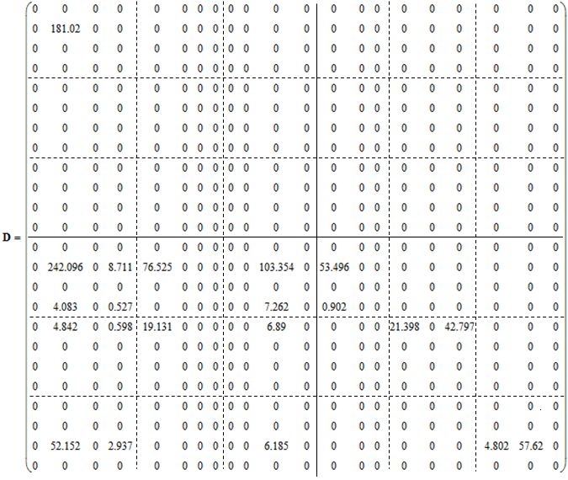

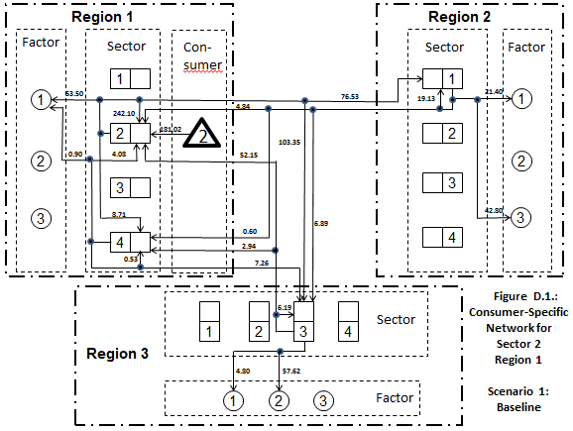

Scenario S3

