Analysis of BEC data for estimating the import tables in Europe

Defense-Palojarv, Pille (a); Antonio F. Amores (b);

*(a) European Commission, Eurostat*

*(b) European Commission, Joint Research Centre – IPTS*

*E-mail:* [*Pille.palojarv@ec.europa.eu*](mailto:Pille.palojarv@ec.europa.eu)

[*AntonioF.AMORES@ec.europa.eu*](mailto:AntonioF.AMORES@ec.europa.eu)

In the consolidation process for European Supply-Use and Input-Output tables Eurostat, the Statistical Office of European Union, has to estimate imports matrices for all EU countries when not available from the Member States. Eurostat has investigated the use of additional trade data such as BEC (Broad Economic Classification) data for this estimation and has compared it with the current estimation based on a proportionality assumption for each product line between the uses of imports and the total uses.

The paper will describe: 1.use of BEC data to estimate imports matrices, 2. the comparison of this method with the proportionality assumption and the real data using a measure of deviation such as WAPE (Weighted Average Percentage Error), 3. Possible refinement of the methodology by going at more detailed level of the trade classification (HS or CN detailed levels).

*Disclaimer: The views expressed in this paper are those of the authors and should not be attributed to the European Commission or its services.*

## Background

Use of BEC data in consolidation process of European Supply and Use Tables or in the compilation of multi-regional Input-Output tables has been discussed during several meetings between Eurostat and Member States. The idea is to use for those countries that do not provide import matrix at basic prices in frame of ESA 2010[1] data transmission programme[2] with data from BEC (Broad Economic Categories) available in Eurostat from foreign trade database (Comext). As a follow-up from earlier discussions, Eurostat agreed to analyse BEC data available in house and compare them with import matrices at basic prices received from Member States for years 2010 and 2011 (data transmitted in line with the new ESA 2010).

## Analyses of BEC data against transmitted data

Under the data transmission programme for ESA 95[3] the provision of import matrix at basic prices to Eurostat was not obligatory. However, 14 Member States had sent it on voluntary basis. In the new transmission programme for ESA2010 transmission of this table is mandatory on a 5-yearly basis. By March 2015 16 Member States[4] had provided import matrix at basic prices for the year 2010 and 10[5] for the year 2011 (on a voluntary basis). Comparison presented in this paper is based on data received from Member States under ESA 2010 and BEC data from the foreign trade database.

Though transmission of import matrix is now obligatory for certain years, not all countries are fulfilling this requirement. Therefore, for the consolidation process of European tables or in the framework of FIGARO (Full International and Global Accounts for Research in Input-Output Analysis)[6] project, Eurostat has to estimate this missing part. One possible solution would be to use BEC data to estimate import matrix.

First analyses of two data set was done by comparing the structure of import matrix (Intermediate consumption (IC), Final private consumption (FPC) and Gross fixed capital formation (GFCF)) to the structure from BEC data, i.e. allocation of import to consumption goods, intermediate goods and to capital goods. BEC structure was compared with the following import tables:

1. table 1612: import matrix at basic prices (both with and excluding changes in inventories),

2. table 1610: use table at basic prices (both with and excluding changes in inventories)

3. table 1600: use table at purchaser's prices (excluding changes in inventories).

Comparison was done for 40 products available from BEC (Annex 1). For each country a summary table was prepared to compare allocation of products between IC, PHC and GFCF in different tables. As an example, find below the extraction from Austrian analysis:

**Table 1: Comparison of structure between BEC data and tables 1600, 1610 and 1612**

|  |  |  |  |  |
| --- | --- | --- | --- | --- |
| **Comparison of BEC data to use tables** |  |  |  |  |
|  |  |  |  |  |
|  | **IC** | **PHC** | **GFCF** | **TOTAL** |
| **01 Products of agriculture, hunting and related services** |  |  |  |  |
| BEC | 0.431 | 0.568 | 0.001 | 1.000 |
| T 1612 with inventories – import matrix at basic prices | 0.686 | 0.302 | 0.013 | 1.000 |
| T 1612 without inventories | 0.679 | 0.299 | 0.022 | 1.000 |
| T 1610 with inventories – use table at basic prices | 0.686 | 0.302 | 0.013 | 1.000 |
| T 1610 without inventories | 0.679 | 0.299 | 0.022 | 1.000 |
| T 1600 – use table at purchases prices | 0.645 | 0.335 | 0.020 | 1.000 |

## Problems with the use of BEC data

Though allocation of foreign trade data to end-use categories based on BEC classification seems to be a good alternative where no import matrix for a country is available, there are also a number of limitations and difficulties to use it in practice.

OECD has described in several papers the difficulties to use BEC data for Supply and Use tables. Main problems have been summarised in presentation "International trade by end-use and the BEC classification" given by C. Webb and N. Yamano[7]:

* **Mainly** for industry / **Mainly** for household consumption
* Split between Intermediate and Consumption goods (e.g. fuels, pharmaceutical products etc.)
* Split between Capital and Consumption goods (e.g. personal computers, private cars etc.)
* Goods NEC – mixed end-uses
* Services not covered by BEC data
* Re-exports not visible in BEC data
* Confidential and missing data

To deal with some of the issues listed above, the OECD has developed an alternative correspondence table to link HS codes with end-use categories[8]. It introduces five additional "mixed end-use categories":

1. personal computers
2. passenger cars
3. personal phones
4. packed medicines
5. and precious goods.

This distinction allows to treat better goods, which can be consumed both for private and intermediate consumption. OECD is using the HS-BEC correspondence for example for the BTDIxE (Bilateral Trade Data by Industry and End-use).

## Use of BEC data based on Estonian example

As mentioned above, Eurostat compared data for 16 countries. Example below is based on Estonian data as Eurostat had contacted Estonian Statistical Office for additional information and clarifications.

Estonia is using BEC data to compile their import matrix. However, they have developed also an internal classification BECUSL to respond better for the need of Supply and Use Tables.[9]

**Table 2: BECUSL – internal classification used by Statistics Estonia for supply and use tables**

|  |  |  |
| --- | --- | --- |
| **BEC** | **END - USE** | **BECUSL** |
| **111** | intermediate goods | intermediate goods or capital goods |
| **121** | intermediate goods | intermediate goods |
| **21** | intermediate goods | intermediate goods |
| **22** | intermediate goods | intermediate goods or capital goods |
| **31** | intermediate goods | intermediate goods |
| **322** | intermediate goods | intermediate goods |
| **42** | intermediate goods | intermediate goods |
| **53** | intermediate goods | intermediate goods |
| **321** | motor spirit | motor spirit |
| **51** | passenger cars | passenger cars |
| **112** | consumption goods | consumption goods |
| **122** | consumption goods | consumption goods |
| **61** | consumption goods | consumption goods or intermediate goods |
| **62** | consumption goods | consumption goods or intermediate goods |
| **63** | consumption goods | consumption goods or intermediate goods |
| **522** | consumption goods | consumption goods |
| **41** | capital goods | capital goods or intermediate goods or consumption goods |
| **521** | capital goods | capital goods or intermediate goods |
| **7** | goods | goods |
| **63G** | consumption goods | consumption goods |

In Consolidated EU27 and Euro Area Supply-Use and Input-Output Tables Technical Group Meeting, held on March 23-24 2015 at ONS, London, Statistics Estonia presented results of allocation based on both classifications. Classifying goods according to BECUSL instead of BEC increases share of goods going to Intermediate consumption, from 54% in BEC to 59% in BECUSL. Consumption goods remain at the same level (22%) in both classifications. The second biggest group for changes is related to capital goods. According to BECUSL there are 3% less of goods allocated to this group. Also the importance of passenger cars in the total goods decreases by 2 % when comparing BECUSL to BEC.

**Graph 1: Comparison of allocation of goods in Estonia using BEC and BECUSL**

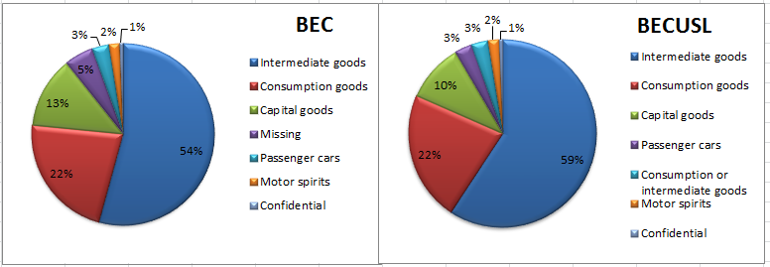

When comparing BEC data at product level with data from imported matrix Statistics Estonia has transmitted to Eurostat, structures for some of them can be quite different. In some other cases allocation between different end-uses can be rather similar at aggregated product level, but differ at more detailed level. To illustrate this, we have selected three product groups:

* CPA 21 Basic pharmaceutical products and pharmaceutical preparations
* CPA 26 Computer, electronic and optical products
* CPA 27 Electrical equipment

1. **CPA 21 Basic pharmaceutical products and pharmaceutical preparations**

**Table 3: CPA 21 comparison of structure between BEC and tables 1600, 1610 and 1612**



Pharmaceutical products are one of the groups where the allocation according to BEC to different end-use categories is complicated and can be misleading. In case of Estonia almost 80% of pharmaceuticals should be for final use. However, in the import matrix compiled by Statistics Estonia the share of pharmaceutics for final use is much less and allocation to IC is more than twice as initially shown by foreign trade data. In fact, as pharmaceuticals can be used also for example in production of food products or also in agriculture, the real share used in intermediate consumption is higher than shown in BEC. Estonia receives information on hospital's expenditure on medicaments from the Government accounting system. It is the main source to define the share for IC.

1. **CPA 26 Computer, electronic and optical products**

**Table 4: CPA 26 comparison between BEC to tables 1600, 1610 and 1612**



Allocation of computer, electronic and optical products between difference end-uses looks surprisingly similar based on BEC and import matrix, but also here is needed some caution as distribution can differ at more detailed level of products. The main problem is to identify what goes to IC and what is used as capital goods.

Estonia has 3 sub-groups to compile the CPA26:

* + communication equipment: according to BEC these products should go to capital good. As this group contains also mobile phones, Estonia re-allocates them on the basis of private household consumption to final consumption;
  + computers: are recorded in capital goods and the spare parts of computers are in intermediate consumption;
  + TV, photo, video etc.: about 2/3 of these products are going to consumer goods.

1. **CPA 27 Electrical equipment**

**Table 5: CPA 27 comparison between BEC to tables 1600, 1610 and 1612**



When comparing the allocation from BEC to real data from Estonia, the share of intermediate goods is significantly higher than original data from BEC. Estonia uses for 4 sub-groups to compile the CPA27:

* electric motors: based on BEC about 4/5 of goods go to intermediate consumption and the rest to capital goods;
* batteries, accumulators: small part of those goods are recorded in IC and in GFCF, rest goes to household final consumption;
* electric lighting equipment: according to BEC these products belong to intermediate consumption;
* domestic appliances: majority is for the final consumption, but also enterprises purchases these goods. Therefore, small part is recorded also to IC.

## Comparison of BEC structure and table 1612

When comparing allocation of data between three end-uses based on BEC and real data from import matrices Member States have transmitted to Eurostat we can see that for all countries, except for Greece and Romania, represented in the table below BEC underestimates the share of intermediate goods and overestimates of that for two other end-uses. BEC values higher than actual values are highlighted in the table.

**Table 6: Comparison of end-use structures based on BEC and table 1612, 2010**

|  |  |  |  |  |  |  |
| --- | --- | --- | --- | --- | --- | --- |
|  | **IC** | | **PHC** | | **GFCF** | |
|  | **BEC** | **Import matrix** | **BEC** | **Import matrix** | **BEC** | **Import matrix** |
| **CZ** | 0.650 | 0.772 | 0.179 | 0.122 | 0.171 | 0.107 |
| **DE** | 0.625 | 0.721 | 0.216 | 0.177 | 0.159 | 0.102 |
| **DK** | 0.500 | 0.768 | 0.331 | 0.143 | 0.169 | 0.089 |
| **EE** | 0.611 | 0.721 | 0.264 | 0.168 | 0.125 | 0.111 |
| **FR** | 0.578 | 0.673 | 0.274 | 0.245 | 0.149 | 0.082 |
| **EL** | 0.534 | 0.494 | 0.309 | 0.352 | 0.157 | 0.153 |
| **HU** | 0.689 | 0.813 | 0.161 | 0.119 | 0.150 | 0.069 |
| **IE** | 0.503 | 0.783 | 0.310 | 0.143 | 0.187 | 0.074 |
| **IT** | 0.653 | 0.720 | 0.239 | 0.214 | 0.107 | 0.066 |
| **LT** | 0.529 | 0.674 | 0.327 | 0.254 | 0.144 | 0.073 |
| **NL** | 0.590 | 0.762 | 0.232 | 0.136 | 0.178 | 0.101 |
| **RO** | 0.655 | 0.570 | 0.195 | 0.268 | 0.151 | 0.162 |
| **SK** | 0.678 | 0.708 | 0.195 | 0.201 | 0.127 | 0.091 |
| **SI** | 0.652 | 0.670 | 0.232 | 0.232 | 0.116 | 0.098 |
| **SE** | 0.596 | 0.680 | 0.252 | 0.167 | 0.152 | 0.153 |
| **UK** | 0.554 | 0.642 | 0.275 | 0.274 | 0.171 | 0.085 |
|  |  |  |  |  |  |  |
| **MIN** | **0.500** | **0.494** | **0.161** | **0.119** | **0.107** | **0.066** |
| **MAX** | **0.689** | **0.813** | **0.331** | **0.352** | **0.187** | **0.162** |

Analysing structures at product level, we can see a number of goods where allocation to end-use based on BEC gives very different results from what we can see from transmitted data. For example, for majority of countries BEC shows that more than 90% of import should go to final use for CPA 03 Fish and other fishing products; aquaculture products; support services to fishing. However, in transmitted tables we can see that all countries have re-allocated a significant part also to IC. Their shares vary from 18% in Greece up to 100% in the United Kingdom. In CPA 02 Products of forestry, logging and related services BEC allocates 100% to IC, but almost all countries have modified it and allocated part also to PHC (between 2% in Slovakia up to 59% in Greece). Also for CPA 10-12 Food products, beverages and tobacco products and CPA 13-15 Textiles, wearing apparel and leather products in many countries allocation based on BEC data would differ quite significantly from the structure of actually transmitted data. Not surprisingly we also see differences in product groups with multiple end-use possibilities where a product can be used either for IC or PHC or GFCF. For example, CPA 21 Basic pharmaceutical products and pharmaceutical preparations, CPA 26 Computer, electronic and optical products and CPA 29 Motor vehicles, trailers and semi-trailers. For those products countries are using additional data sources (government accounts, household budget surveys etc.) to verify and modify information received from BEC.

When looking at intermediate consumption (IC), we can observe countries like Greece, Slovakia and Slovenia, where the allocation based on BEC data provides the same results as reported by country in their import matrices. However, there is also number of countries where BEC provides very different results. For example Denmark and Ireland are two countries with lowest shares for intermediate consumption when based on BEC data, but in their import matrices this share is much higher and above average of all countries. In Romania and in less extent also in Greece BEC seems to overestimate the share of goods going to intermediate consumption and underestimate two other end-uses.

**Graph 2: Comparison of IC based on BEC and table 1612**

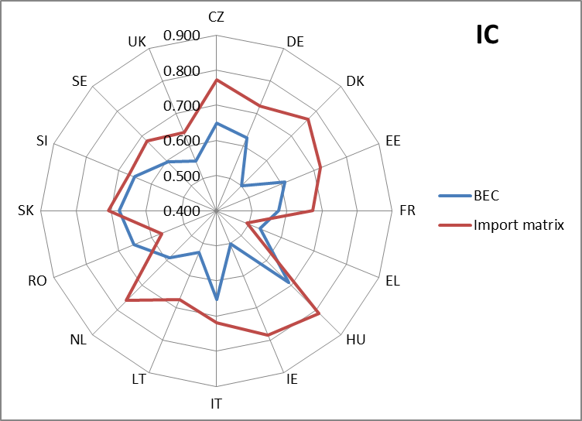

**Graph 3: Comparison of PHC based on BEC and table 1612**

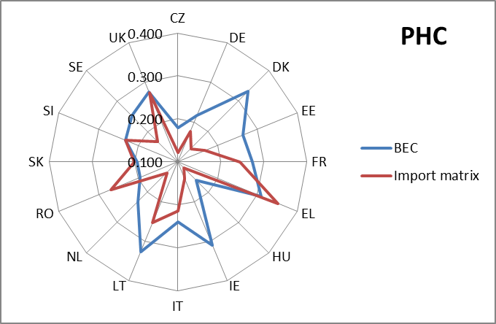

For final consumption Slovakia, Slovenia and the United Kingdom show the same results based on two sources. However, for majority of countries BEC data show higher rate for final use than actually reported in import matrices. Again, Denmark and Ireland show significant discrepancies between the real data and BEC. As for intermediate consumption, Romania and Greece remain exceptions where according to BEC data the share of goods attributed to final consumption should be lower than is actually used in their import matrices.

**Graph 4: Comparison of GFCF based on BEC and table 1612**

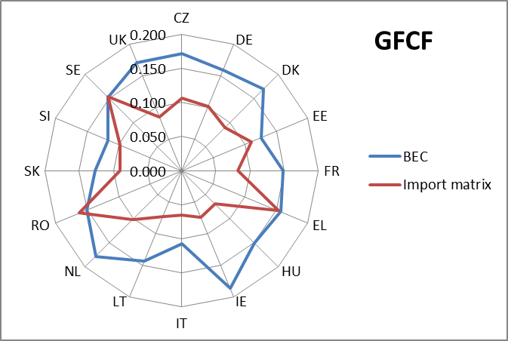

In case of GFCF, the BEC would allocate higher share to capital goods than actually used by countries. There are only two exceptions: Sweden, where the share in BEC is as in the import matrix, and Romania, the only country where BEC is underestimating capital goods. For all countries we can assume that they correct data and allocate part of capital goods to intermediate goods.

## Comparison of results based on BEC to the proportionality assumption and the real data using WAPE

In the current consolidation process Eurostat applies the proportionality assumption to obtain import matrices for countries that have not transmitted it to Eurostat. It means that the import vector is allocated using proportions from the use table at producers' prices to obtain an import matrix. Within this exercise we wanted to test who far are these results from the real data, but also compare it to results obtained when using BEC data. For this purposes WAPE (Weighted Average Percentage Error) was used. This indicator weights each percentage deviation of the elements of a matrix from the true value by the relative size of the latter in the overall sum of the elements of the true matrix. This indicator considers errors in absolute value in order to avoid potential compensations of deviations due to different signs.

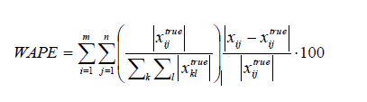

The two tables below show results for WAPE. In the first one structure from the import matrix is compared with the one from use table. As BEC data cover mainly goods, WAPE calculations exclude services part. Results are presented for each member states, except for Ireland where due to confidentiality reasons full calculations were not possible. In case of Slovakia, both tables have quite similar structures and the error rate is very small for all components. The highest error rates are for Romania, around 14% of error for intermediate consumption and private consumption. When looking error rates at product level, the highest errors are for CPA 02 Products of forestry, logging and related services (2.7%), CPA 03 Fish and other fishing products; aquaculture products; support services to fishing (2.5%) and for CPA 31_32 Furniture; other manufactured goods (1.5%). Also Italy and Denmark show errors rates above 10% for intermediate consumption and private consumption. In Italy the products with higher error rates are CPA 02 Products of forestry, logging and related services (2.0%), CPA 19 Coke and refined petroleum products (1.2%) and CPA 10_12 Food products, beverages and tobacco products (1.1%) and in Denmark CPA 18 Printing and recording services (2.3%) and CPA 28 Machinery and equipment n.e.c. (1.6%).

**Table 7: WAPE assessment: Import matrix vs use table at purchases prices, 2010**

|  |  |  |  |  |
| --- | --- | --- | --- | --- |
|  | **IC** | **PHC** | **GFCF** | **TOTAL** |
| **CZ** | 4.1% | 4.3% | 0.3% | 8.7% |
| **DE** | 9.3% | 9.2% | 2.6% | 21.2% |
| **DK** | 11.4% | 10.2% | 2.8% | 24.4% |
| **EE** | 8.6% | 8.2% | 2.2% | 19.0% |
| **FR** | 7.7% | 7.4% | 1.0% | 16.1% |
| **EL** | 4.7% | 4.3% | 0.5% | 9.5% |
| **HU** | 7.3% | 6.7% | 1.1% | 15.1% |
| **IT** | 13.1% | 12.1% | 2.3% | 27.5% |
| **LT** | 9.7% | 10.9% | 2.5% | 23.2% |
| **NL** | 8.0% | 9.8% | 2.4% | 20.2% |
| **RO** | 14.3% | 13.9% | 3.3% | 31.5% |
| **SK** | 1.9% | 2.0% | 0.5% | 4.5% |
| **SI** | 6.1% | 6.0% | 1.8% | 13.9% |
| **SE** | 6.9% | 7.0% | 1.8% | 15.7% |
| **UK** | 9.3% | 8.8% | 2.9% | 20.9% |
|  |  |  |  |  |
| **MIN** | 1.9% | 2.0% | 0.3% | 4.5% |
| **MAX** | 14.3% | 13.9% | 3.3% | 31.5% |

Table below shows results for analysis were BEC data structure was compared to the one from import matrices transmitted to Eurostat. In this assessment Germany has the lowest error rates, but they are still relatively high and close to maximum errors presented in comparison above. Product groups with higher errors are forCPA 02Products of forestry, logging and related services (1.1%), CPA 03Fish and other fishing products; aquaculture products; support services to fishing(1.9%) and CPA 19Coke and refined petroleum products (1%). Country with highest error rates is Denmark, about 21% for intermediate consumption and private final consumption. Here the main products contributing to errors are CPA 03Fish and other fishing products; aquaculture products; support services to fishing(4.3%), CPA 18 Printing and recording services (2.7%), CPA 21 Basic pharmaceutical products and pharmaceutical preparations (1.8%), CPA 02 Products of forestry, logging and related services (1.8%) and CPA 10_12Food products, beverages and tobacco products(1.6%).

**Table 8: WAPE assessment: BEC data vs Import matrix, 2010**

|  |  |  |  |  |
| --- | --- | --- | --- | --- |
|  | **IC** | **PHC** | **GFCF** | **TOTAL** |
| **CZ** | 14.4% | 12.5% | 4.2% | 31.1% |
| **DE** | 10.4% | 8.6% | 2.7% | 21.6% |
| **DK** | 21.2% | 20.6% | 5.0% | 46.7% |
| **EE** | 15.1% | 14.1% | 2.8% | 32.0% |
| **FR** | 15.0% | 13.7% | 5.7% | 34.3% |
| **EL** | 12.9% | 14.3% | 3.6% | 30.8% |
| **HU** | 13.6% | 8.9% | 6.8% | 29.3% |
| **IT** | 11.9% | 12.3% | 4.4% | 28.6% |
| **LT** | 16.0% | 16.8% | 2.4% | 35.2% |
| **NL** | 14.9% | 11.6% | 7.9% | 34.4% |
| **RO** | 17.3% | 11.6% | 8.9% | 37.7% |
| **SK** | 11.8% | 10.0% | 3.9% | 25.7% |
| **SI** | 11.4% | 11.7% | 2.1% | 25.3% |
| **SE** | 12.3% | 11.9% | 4.2% | 28.3% |
| **UK** | 14.5% | 14.2% | 5.1% | 33.8% |
|  |  |  |  |  |
| **MIN** | 10.4% | 8.6% | 2.1% | 21.6% |
| **MAX** | 21.2% | 20.6% | 8.9% | 46.7% |

## Possible refinement of the methodology by going at more detailed level of the trade classification (HS or CN detailed levels)

Results from WAPE show that the current proportionality assumption to estimate missing import data provides better results than applying information from BEC data. It might be due to the fact that in BEC some end-use groups are still multi-purpose and cannot be correctly allocated at this level of detail (40 product groups). For some countries also confidential data or adjustments make up a significant part, but these data groups cannot be treated correctly without further investigation or additional information.

Eurostat discussed these issues with member states during the meeting of Consolidated EU27 and Euro Area Supply-Use and Input-Output Tables Technical Group Meeting, in March in London. In their feedback National Statistical Institutes stress that BEC data are a good source to estimate import matrices, but the data should be available at more detailed level. For example in Estonia foreign trade data are converted to BEC at 8-digit level of Common Nomenclature. Missing and confidential data (about 6% of the import value) are available at 2-digits level of CN. At this level of detail it is possible to carry out better analysis for product where the end-use cannot be defined unambiguously, e.g. pharmaceutical products, mobile phones, passenger cars etc.

Following up the comments from the Technical Group, Eurostat will continue the work on BEC data and invest the possible use of CN data to estimate missing import matrices.

## Conclusions and future plans

Though many countries declare that they use BEC data to compile their import matrix, the comparisons presented above demonstrate that BEC structures from foreign trade cannot be applied automatically. Member States who use BEC data in their regular production are using it at much more detailed level and with an advantage to have an expertise about their national economy and knowledge about local market. When Eurostat would estimate import matrices for those Member States who have not provided required tables, this important information is missing and BEC could serve probably as a rough allocation to different end-use categories. Quality of results depends also on level of detail used in compilation process and here, again, Eurostat would be bound by official transmission programme.

Assessment based on WAPE confirmed that the proportionality assumption Eurostat currently uses to estimate import matrices provides better results than allocation of import data based on BEC. Before deciding whether and how to use BEC data in compilation of import matrices, Eurostat will investigate more about possible use of HS/CN data, which would be at more detailed level. Results of this work will be reported back to the Technical Group in spring 2016. If use of CN data would provide better results than the current proportionality assumption, it can be implemented in 2016 European consolidation exercise for 2012 data.

***Annex 1***

|  |
| --- |
| **CPA2008_2D/BEC_3D** |
| 01 Products of agriculture, hunting and related services |
| 02 Products of forestry, logging and related services |
| 03 Fish and other fishing products; aquaculture products; support services to fishing |
| 05 Coal and lignite |
| 06 Crude petroleum and natural gas |
| 07 Metal ores |
| 08 Other mining and quarrying products |
| 10 Food products |
| 11 Beverages |
| 12 Tobacco products |
| 13 Textiles |
| 14 Wearing apparel |
| 15 Leather and related products |
| 16 Wood and of products of wood and cork, except furniture; articles of straw and plaiting materials |
| 17 Paper and paper products |
| 18 Printing and recording services |
| 19 Coke and refined petroleum products |
| 20 Chemicals and chemical products |
| 21 Basic pharmaceutical products and pharmaceutical preparations |
| 22 Rubber and plastics products |
| 23 Other non-metallic mineral products |
| 24 Basic metals |
| 25 Fabricated metal products, except machinery and equipment |
| 26 Computer, electronic and optical products |
| 27 Electrical equipment |
| 28 Machinery and equipment n.e.c. |
| 29 Motor vehicles, trailers and semi-trailers |
| 30 Other transport equipment |
| 31 Furniture |
| 32 Other manufactured goods |
| 35 Electricity, gas, steam and air conditioning |
| 37 Sewerage services; sewage sludge |
| 38 Waste collection, treatment and disposal services; materials recovery services |
| 58 Publishing services |
| 59 Motion picture, video and television programme production services, sound recording and music publishing |
| 71 Architectural and engineering services; technical testing and analysis services |
| 74 Other professional, scientific and technical services |
| 90 Creative, arts and entertainment services |
| 91 Library, archive, museum and other cultural services |
| 96 Other personal services |
| AA Intra-EU trade involving transactions falling below the simplification threshold |
| BB Articles declared as supplies or services for ships and aircrafts for which a simplified declaration applies |
| CC Temporary corrections due to erroneous codes |
| EE Selections of goods, for which a simplified declaration applies |
| FF Articles declared as supplies or services for offshore installations |
| II Components of complete industrial plant, for which a simplified declaration applies |
| MM Adjustments ( broken down at chapter level only) |
| PP Goods transported by post, for which a simplified declaration applies |
| RR Returned goods, for which a simplified declaration applies |
| SS Confidential data |
| TOTAL TOTAL |
| TT Foodstuff, drinks and tobacco, for which a simplified declaration applies |
| VV Parts for motor vehicles, for which a simplified declaration applies |
| WW Parts for aircrafts |
| YY Adjustments (not broken down at chapter level) |
| ZZ ZZ |

1. Regulation (EU) No 549/2013 of the European Parliament and of the Council of 21 May 2013 on the European system of national and regional accounts in the European Union
2. Annex B of Regulation (EU) No 549/2013 of the European Parliament and of the Council of 21 May 2013 on the European system of national and regional accounts in the European Union
3. Regulation (EC) No 1392/2007 of the European Parliament and of the Council of 13 November 2007
4. Czech Republic, Denmark, Estonia, France, Germany, Greece, Hungary, Ireland, Italy, Lithuania, the Netherlands, Romania, Slovenia, Slovakia, Sweden, the United Kingdom
5. Austria, Denmark, Estonia, France, Hungary, Ireland, Italy, the Netherlands, Romania, Slovakia
6. FIGARO aims to support Eurostat in establishing an annual production of EU Multi-country Input-Output Tables and a five-yearly production of EU Multi-country Supply, Use and Input-Output Tables (EU-MC-SUIOTs)
7. Colin Webb, Norihiko Yamano "International trade by end-use and the BEC classification" [www.oecd.org/trade/its/46289160.ppt](http://www.oecd.org/trade/its/46289160.ppt)
8. "OECD, Bilateral Trade Database by Industry and End-use (BTDIxE), edition 2014", February 2015
9. Iljen Dedegkajeva "Compilation of trade statistics and BoP in SUT framework". Presentation given on the Consolidated EU27 and Euro Area Supply-Use and Input-Output Tables Technical Group Meeting, held on March 23-24 2015 at ONS, London