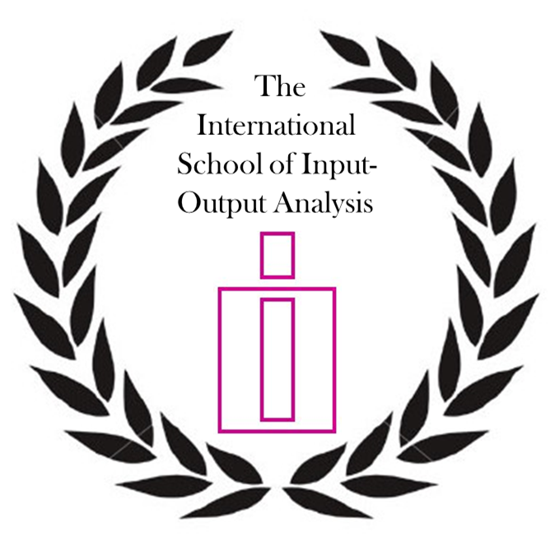
Modules of the 6th Edition of the International School of I-O Analysis
4 July 2016, Korea, Seoul
Programme

Opening and welcoming to the School
(Sunday, July 3, 2015 – 18:00 – Conference venue)

Modules Programme
(Monday, July 4, 2015 – 9:00 – Conference venue)

Module list:

- E3ME Global Macro-Econometric Model
- Construction of OECD Inter-country Input-Output (ICIO) Database
- Dynamic IO analysis
- Structural Decomposition Analysis
- Environmental impacts of consumption-based policies

Submission FAQ

- The number of participants is limited to 15, but observers are allowed to attend the courses to a maximum of 5. Observers do not have any commitment regarding the module certificates, but are required to register for the courses.

- To register for the courses
- Complete the following form: http://tinyurl.com/jctw4ys
- Email a brief CV to Christian Reynolds (christian.reynolds@unisa.edu.au) with copy (CC) to Rosa Duarte (rduarte@unizar.es).
- Please put “[ISIO 2016] *your surname*” in the email subject heading
- The deadline for the submission of an application is May 30, 2015.
The final list of participants will be published one month prior to the conference on its website (Early June 2016). In order to be eligible for the final list, participants should have paid the registration fee for the conference by June 03rd, 2016.

For further details on the registration and submission deadlines, please check often the website of the conference at: https://www.iioa.org/Conferences/24th/school_of_io.html

