REDUCING CARBON EMISSIONS VIA STRUCTURE CHANGE ALONG A CONSUMPTION TURNPIKE: A REMESEY-TSUKUI-LEONTIEF DYNAMIC ENVIRONMENT SYSTEM OF CHINA
XUE FU^{a*}
ª School of Economy and Management, Nanchang University, Nanchang, China;

Replacing applicable capital turnpike model (Tsukui and Mutakami, 1979) completely resolved by linear programming, an environmental oriented consumption turnpike is firstly presented, with maximum residents’ real welfare represented by accumulated long-term utilities (Remesey, 1928), however, it irresolvable before the development of a new dynamic programming model. Along this effective sustainable growth path, changes in industry structure might enable China to meet its 2020 goal for reduction in its carbon emissions., By implementing an environmental oriented dynamic input-output system in China, formatted using a dynamic programming with given national carbon targets, this would serve to achieve the aim of maximizing national utilities (or consumptions) over accumulation periods. Possible constrains for this model is both the balance in the demand-supply dynamic and the magnitude of output and energy-use changes within realizable and practical limits. The novels of Remesey-Tsukui-Leontief turnpike model are integrating the dynamic input-output model with a new dynamic programming with both constraints under given terminal conditions and national carbon targets, as well as establishing an objective in maximizing the accumulated final demand (excluding investment) over the planning time, rather than that maximizing the terminal capital in Tsukui’ capital turnpike. Utilizing a new reverse algorithm, a solution to an effective sustainable growth path finds inter-industry shifts of production and investment enable China, with reasonable ratio of consumption to investment accumulation on the long term, to reduce carbon emissions per Growth Domestic Production (GDP) by at least 40% of its 2005 levels before the year 2020. The model suggest that increasing service share by 5% without panel manufacture growth, increasing consumption annually by ten point percentage than actual economy performance would help China’s economy growth more effectively.
Keywords: dynamic input-output analysis, carbon emissions, economic structure, turnpike theorem
1. INTRODUCTION
With heavy industrialism and urbanism over a past couple of decades, China’s economy is characterized by heavy-industrial structure dominated by coal-consumption so that a lot of carbon energy production and consumption and related carbon emissions have largely rose. In 2011 China discharged 8.715 billion metric tons of carbon dioxide, accounting for 26.7% of the world’s total emissions and surpassing the US as the world's largest emitter (EIA, 2012). In structure, Agriculture, Construction, and Wholesale and retail trade have the lowest carbon emissions shares, i.e. 3.7%, 1.5%, 2.6%, but the largest GDP shares (13.1%, 16.6%, 16.3%); in contrast, Heavy industries—like Metal processing and manufacturing, Chemical and pharmaceutical, Building materials and non-Metallic Materials Industry—release the greatest shares of carbon emissions (28.9%, 13.5%, 9.5%) but yield fairly low shares of GDP (2.9%, 6.7%, 4.8%). The diversity implies that a strategy of industrial shifts is a plausible way of reducing carbon emissions substantially without harming the nation’s continued GDP growth.
In December of 2015, the 21st Conference of the Parties to the UN Framework Convention on Climate Change (UNFCCC), and the 11th Conference of Parties to Kyoto Protocol was held and 200 contracting party to consistently unanimous approval “Paris Agreement”. In April of 2016, Presidents Xi Jinping and Barack Obama signed the Paris Agreement during the first day of signatures for an international agreement. Also, it is succession of U.S.-China Joint Announcement on Climate Change, the 2014 meeting of Asia-Pacific Economic Cooperation [APEC], and the promise of the United Nations Climate Change Conference of Copenhagen in 2009. Besides, the join agreement in 2016 includes Australia, Argentina, Cameroon, Canada, France, Mali, Mexico, Philippines. The Paris Agreement sends a clear signal that business and investors must put climate at the heart of decision-making. Today is a remarkable, record-breaking day in the history of international cooperation on climate change and a sustainable future for billions of people alive today and those to come. The Paris Agreement marked a watershed moment in taking action on climate change. After years of negotiation, countries agreed to limit global temperature rise to well below 2 degrees Celsius, while pursuing efforts to keep temperature rise to 1.5 degrees.
In response to international pressures, China stated years before to mitigate the nation’s carbon dioxide emissions per GDP (carbon density) by at least 40% of its 2005 levels till the year 2020. It also expects to produce 15% of its primary energy from nonfossil sources in 2020. An effective strategy to reduce such carbon emissions reduction goals should be rationally grounded on an efficient trajectory of economic structural changes, accumulating residents’ final demand and capital maximally. It is necessary to introduce a concept which economists call “turnpike”, a term that describes the speedy road of economic development. It provides an economy path that develops and grows rapidly through health structure with the government regulating economical components at the beginning and end of this pathway toward an ideal structure according to proposed industrial policies or macro-regulations.
Developed countries have access to vital tools to mitigate carbon emissions, such industrial shifts, energy saving, and exploration for green and energy conservation; however, China must address energy security concerns due to its heavy reliance on coal and fossil fuel which makes the mixture of energy resources impossible to vary within a short-term frame. In general, Natural gas and oil emit less carbon dioxide than coal, renewable energy discharge no carbon dioxide. Lately China has been emphasizing renewable energy options. Indeed, in 2012 China spent $65 billion US (the U.S. spent $36 billion that same year) while also expanding its coal production and consumption, commissioning 40 Gwh of coal-fired electricity generation plants, requiring on the order of 0.86 billion tons of more coal production by 2015 (EIA, 2013). According to Arnold Cohen (2014) of Breakthrough Institute, China added 1 Gwh of solar energy in 2013with another 27 Gwh of coal-fired electric power; this over 600 percent of its investment in new wind energy. So we also examine the sensitivity of the economy to changes in energy mix, which could diminish the pressure to alter industry structure in order to attain carbon reduction targets.
Moreover, differing from most highly-developed countries, China is in possession of a substantial portion of state-owned energy plants and heavy manufacturing. Besides market-oriented regulations like taxation, emissions trade mechanism, and environmental controls, shifts in China’s industrial structure would enable mitigation of carbon dioxide emissions. Actually, the 18th Central Committee held the Third Plenary Session to confirm the significance of reconfiguration, reallocation, and retooling of production capacity among a variety of industries to reduce pollution and save energy, instead of simply focusing on the improvement of economic growth (China Central Television, 2013).
FIGURE 1. An environment oriented turnpike Leontief input-output system
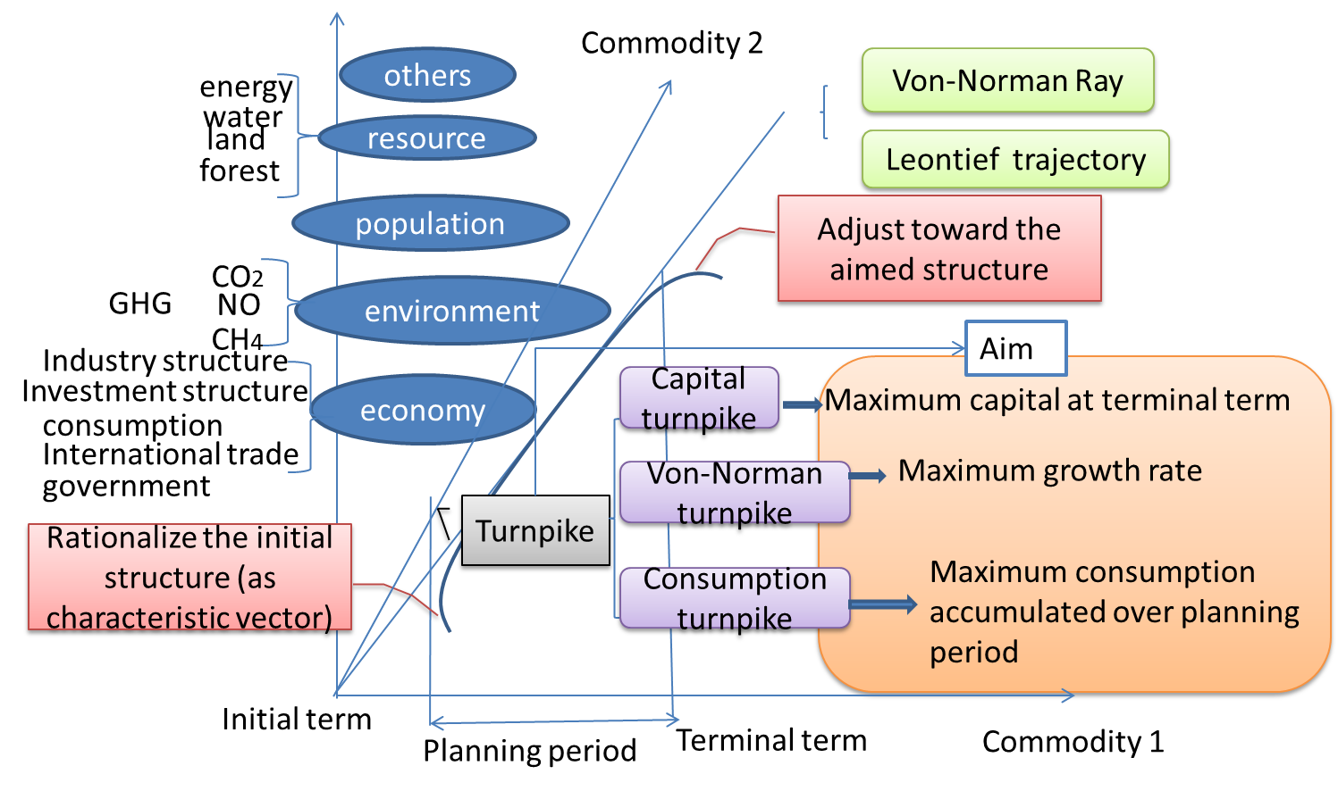
Figure 1 indicates a perfect growth in theory of environment oriented turnpike for acountry
In light of the proposed plan to reduce carbon emissions through industry restrutcture this paper presents a practical guide on how industry shifts in production and increased investment among key sectors may help meet China’s simultaneous targets of reducing emissions and developing their economy. By simulating the GDP growth of China, this paper assumes growth is maintained best by raising production and investment shares in services and high technology sectors. Restructuring is plausible through aggressive development in electronic commerce, tracking and courier delivery services, and civil infrastructure—specifically high-speed intercity railways and local rail transit. These sectors have shown to contribute to GDP growth while discharging less carbon emissions during production. Through this end, China’s reduction of carbon emissions may be achieved by working with industries that provide value to the GDP and utilize fewer energy resources for their manufacturing.
A strategy to reduce carbon emissions on a long-term basis should be based on a trajectory of restructuring economic development that evaluates the interconnected relationship of the industry structure and rational ratio of consumption and capital accumulation. The consumption means the current benefit of people have, while the capital brings to the future consumption and future welfare. The rational ratio of consumption to capital is consumption share of the present to the future. Final demand, including consumption and capital together can induce current production directly and indirectly, which directly and indirectly use the energy and discharge carbon dioxide. However, the capital will generate the future carbon emissions through enlarged production. So the ration ratio of consumption and capital accumulation is vital for long-term planning. China’s trend toward higher income levels and lifestyle changes will cause an increase in energy consumption by households (Lin & Liu, 2010) ^{[2]}. People have higher income than before and trend to consume more house, private vehicle, heater and air-condition, which are utilize more energy, and discharge more carbon dioxide. More people immigrant to the metropolitan, and cities, they change the lifestyle as city people with higher consumption of goods and service, rely on more transportation due to the enlarged radius of commute. It brings to more carbon dioxide. On the other hand, the compact habitancy, office building and public transportation save energy consumption per capita.
In spite of increasing literatures applying input-output techniques on energy economy and carbon emissions in China, most of them attempted to identify and analyze drives of carbon emissions as well as the effects of China’s economic behavior on carbon emissions by structural analysis (Peters et al., 2010, Weber, et al., 2008, Guan, et al., 2009, Feng, et., 2009, Minx, et al., 2011), even through multi-regional input-output analysis (Feng et al., 2013 Meng et al., 2013). It is very difficult but more important to specify the government strategy of industrial update policy and to guide abating carbon emissions when keeping sustainable econmic growth.
A few studies made long-term analysis by applying dynamic programming to static input-output models (Tahvonen, 1991, Perrings, 1998, Stevens and Rose, 2002). However, there are little dynamic input-output models that incorporate the global warming policy. Since Dorfman, Samuelson, Solow (1949) first presented the turnpike theorem, the most efficient economy growth could be found through Leontief dynamic input-output model combined with a linear program. After six decades, the turnpike theorem is still theoretically relevant but rarely gets application.
As Ramsey’s consumption turnpike maximizes the utilities accumulated over the plan term, it is particularly significant in promoting industrial strategy to preserve resident welfare and for putting forward plausible environmental taxes on consumers. However, it is difficult to be applied as it requires exploring dynamic programming. Up to now, the unique practical work is the application of capital turnpike theorem through linear programming by Tsukui and Mutakami (1979), who gave a great contribution on turnpike theorem in a computable dynamic Leontief system applied to the planning for efficient capital accumulation in Japan (Jinkichi Tsukui, 1968a, b) and then with consideration of international trade (Jinkichi Tsukui & Yasusuke Mutakami, 1979). The turnpike model with the maximum capital stock in final term and with maximum Von-Norman balance growth rate could be searched by linear programming.
The consumption turnpike, with the maximum consumption accumulated over time, requires dynamic programming, to which the solution is difficult to obtain for several reasons: first, slow computation speed results in dimension disaster for decision-making in large scale systems; and second, dynamic programming lacks a standard algorithm like linear programming so must to be resolved case by case. The modern intelligent determination analysis demands perspective of long-term, consumer-center and environment friendly, thus, consumption turnpike model in environment economy system needs to be developed which should be applicable for search the efficient sustainable growth path for abatement of carbon emissions.
An entirely new consumption turnpike in an environment dynamic system will be developed and applicable for a long-term planning of restructuring production and investment and of rationalizing the ratio of consumption to accumulation, to the goal of maximum of consumption accumulation on planning period and also in a binding constraint of a 40%-45% decline in carbon intensity by 2020 comparing it to levels during 2005.
In an effort to build a solid theoretical base of this new consumption turnpike model, i.e., the Mixed Consumption Environmental Turnpike, this paper discusses features from the capital turnpike theorem, Von-Norman’s turnpike theorem and Ramsey’s consumption turnpike theorem; the ultimate goal is to incorporate the dynamic input-output models combined with optimization and emphasizes the plausibility of these models. The capital turpike and Von-Norman’s turnpike theorems utilized the linear programming for the maximizing objective such as the final capital stock and the balance growth rate. However, the Ramsey’s consumption turnpike theorem reflects welfare improvement on long term utility. Its objective is embodied in the accumulated consumption over the target period.
In general, this type of consumption turnpike model requires developing dynamic programming algorithms.. The previous consumption turnpike theorem--Tsukui’s turnpike in a computable dynamic Leontief system, was unable to focus on this issue. Later, comparing to Tsukui’s turnpike, a new optimal dynamic input-output model considering international trade and environmental issues will be presented, and then a specific-issue of dynamic programming will be deduced in the reverse algorithm, of which the general meaning exists in resolving the dynamic programming in the framework of consumption turnpike.
Different with the Leontief’s, Von-Norman’s turnpike theorem, consumption turnpike optimality is carried in an energy-carbon-economy input-output dynamic model (ECEIOD model), where the maximizing accumulation of GDP (instead of utility accumulated continuously in Ramsey’s turnpike) represents the desideratum for the problem. A new reverse algorithm gives solution of the turnpike optimality; in addition, it is a general version able to be applied to the consumption turnpike models of all types.
The final section applies this model to restructure production and investment and rationalize the ratio of consumption to accumulation for efficient growth path with a binding target of reduction of carbon emissions. In application, a set of self-compiled ECEIOD tables links industrial production and household consumption to fossil energy consumption and embodied carbon dioxide emissions. Integration of RAS method and time series is able to update the ECEIOD tables and carbon emissions intensity by industries. Specifically, in using the Chinese capital formation matrix issued by Chinese National Statistics Bureau, the modification will be done involving Chinese technology coefficients and capital formation matrixes.
The government should find an effective growth path, the economic structure of which is consistent with eigenvalue of input-output over the planning years. Once the central government adjusts the economy toward this lane, the economy will develop automatically and smoothly alone the speedy path. Approaching the ultimate lane, the government can adjust the economic structure towards its target. It is the fast and effective way to realize the objective. Thus, the optimal dynamic input-output model, maximizing accumulation of GDP under constraints of production and carbon emissions, gives optimal industry structure based on carbon emissions intensity reduction.
2 The dynamic input-output technique and classic turnpike theorem
This path of structure adjustment can be efficient only if consumption turnpike theorem is applied, which demands a new dynamic programming algorithm. To build a solid foundation, this section relate and distinguish all related the previous work with the new consumption turnpike theorem and its new reverse algorithm.
The theoretical input-output model (Leontief, 1936) is developed adequately as well as it applied comprehensively on the economy, trade, environment (Leontief, 1970, Miller & Blair, 1985, Wood and Lenzen, 2009) and demography issue (Stone, 1970). The environment input-output models recently focused on the policy analysis of energy, resource and GHG emissions and pollutants, but rarely did environment dynamic input-output model. It is deserved to probe more deeply into the path of economy efficient growth for the target of carbon emissions reduction.

FIGURE 2. The development of input-output technique.
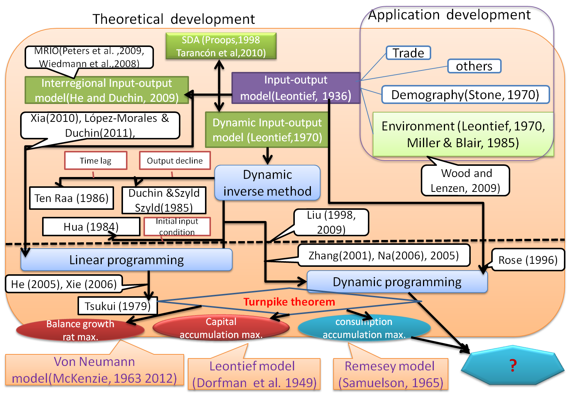
Its main stream includes structure decomposition analysis (Proops, 1988, Tarancón et al 2007, 2010), multi-regional input-output model (Peters et al., 2009, Han et al, 2004, Wiedmann et al., 2008) and dynamic input-output model (Leontief, 1970). Leontief dynamic input-output model introduces the capital coefficient which connects the investment of various industries with next-year production of those industries, so it has apparent advantage in long-term planning. Its core is using dynamic inverse to search Leontief trajectory.
Because the capital formation requires many years, ten Raa’s (1986) multi-period model reflected working capital complement; considering human capital cultivation for many years from the element education to high education, Aulin-Ahmavaara presented multi-year lag during both production and investment so that his multi-year input-output model combined various characteristic (Aulin-Ahmavaara, 1989, 1990).
Corresponding to these models, many kinds of the general dynamic inverse gave the generalized solution for multi-period model (ten Raa, 1986), for Leontief-Duchin-Szyld dynamic model in case of output expanding and decline (Duchin & Szyld, 1985), and for the multi-year education-economy input-output model with assets (Fu, 2009).
Another branch of dynamic input-occupied-output (IOO) technology (Chen et al, 2005) used dynamic inverse to make human capital development plan (Liu, 1996), determined human capital requirement linking to national economy growth (Zhang and Chen, 2004) and rationalized the education structure consist with China’s economy development based on a multi-year lag IOO model (Fu, 2009).
Dynamic input-output model has two properties: (1) the largest Perron-Frobenius characteristic root (eigenvalue) corresponding the balance growth rate, (2) the prerequisite of long-term production stability is the initial output structure fitting the eigenvector of input coefficient; otherwise, the controlling method of economy system is to adjust the production structure to the share of eigenvector (Hua, 1984, a, b, c, d, e, 1985, a, b).
Hua (1984) stated that, in a close model, input coefficient is irreducible nonnegative matrix, and it has a positive eigenvalue of maximum which corresponds to a unique positive eigenvector. If the economy system isn’t arranged its production according to share of eigenvector, the system will lose balance and resulted in collapse. So the dynamic inverse method will be invalid if Hua’s initial condition is unsatisfied. Planning or regulation can be made to adjust the output structure to fit eigenvector. In Leontief trajectory, the initial output may not fit eigenvector of input coefficient, government should promote technical progress and structure adjustment make economy system to meet the Hua’s theorem. To avoid the system collapse, the input-output equation usually is integrated into optimization and taking nonequivalent constraint format, in further, linear programming make the dynamic input-output system has the solution of growth. Thus the Hua’s perplex can be handled.
The static IO optimal model, combined with linear programming even dynamic programming, is gradually mature in application. Starts from the case of the static model with slacken input-output constraints. Xia(2010) have investigated how best to adjust national industrial structure in order to minimize energy consumption. Water regional policy was studied (Lopez-Morales & Duchin, 2011). Linear programming are prevailing-most technology. Fu (2012) proposed inter-industry shift to meet the goal of reduction of carbon emissions. Nevertheless, the dynamic programming possesses the advantage in the long-time planning. Rose (1996) employed it to simulate the five long-term strategies for stabilizing China’s carbon dioxide emissions; owning to lack of capital flow matrix, the static input-output model was combined with capital stock vector linking to capital flow vector.
Leontief dynamic model connects the current production to the future output across industries through capital flow matrix by industry. In virtue of technology limitation, the dynamic input-output model was nowadays merely united in linear programming rather than dynamic programming for making some long-term decisions. Na (2006) and Zhang (2001) made the multi-goal programming on the basis of the dynamic input-output model for economic long-term forecast. All of above models are aimed at maximizing the sum of output over the planning term, but simplicity application of linear programming have no consideration the efficient growth theory (i.e“turnpike theorem”); indeed, their objectives and constraints with the time sequence ought to be used the sequential constrained technique in dynamic programming in place of simply linear programming.
Using the optimal technology to overcome the unbalance system can be also traced back to the origin of turnpike theorem. The Dorfman, Samuelson, Solow (1958) first combined the linear programming with dynamic input-output model in “Linear Programming and Economic Analysis” and demonstrated that the solution is exactly Leontief trajectory, which is the efficient growth path, so called turnpike.
Turnpike theorem is concerned with efficient paths of accumulation of economic expansion. Efficiency is defined with reference to the terminal stocks paths, namely, a path of accumulation lasting N periods is efficient if no other path, starting from the same initial stocks and complying with the technical restrains, reaches larger terminal stocks after N periods. Their concept is contrast to von-Norman (1932), who proofed the existence of a balance, where the price just compensate the cost so as to no profit exist, stimulatingly, the expand of economy activity make the capital stock expanding at maximum rate, meanwhile the optimal model with objective function takes no effect.
Samuelson (1949) thought that it is necessary to introduce optimal in the case of economy unbalance. He also first put the concept of turnpike forward from von-Norman model, in which exist a turnpike, and of which the maximum objective function is the scale of capital stock in final term. Put another way, turnpike is the speediest path of capital balance growth, so-called von-Norman equilibrium. Later, Dorfman, Samuelson, Solow (1958) demonstrated the turnpike theorem in the model with two capital goods, and found the efficient capital growth path is consist with Leontief trajectory. The technology advance make the Leontief trajectory became a curve.
The long-term restructuring economy was adequately studied by the turnpike theorem in theory. Turnpike models are concluded into three types: von Neumann model, Leontief’s model, and Ramsey’s model (McKenzie, 2012, Samuelson, 1965, Tsukui, 1980, Kiedrowski, 2001).
First type from von Neumann model (Neumann, 1937) is a closed linear model of production in which the output of one period furnish the inputs of the next period, and combining with turnpike theorem to get the path of proportional expansion of stocks which achieve the largest possible rate of expansion, so called Neumann rays (McKenzie, 1963, 2012).
Second type from Leontief’s model is a general form. Hicks (1961), Morishima (1961) and Mckenzie (1963) make the turnpike theorem became the global for disaggregated industries production with variable production coefficients and durable capital goods. It is similar to turnpike in Leontief’s model (Dorfman, Samuelson, Solow, 1949), which is to find the efficient path for maximum of the terminal stocks.
Third type linking to Ramsey model (Ramsey, 1928) consider consumption turnpike theorem in continuous form (Samuelson, 1965, McKenzie, 2012). Comparing to the above two thermo, utility of consumption can represent the desideratum for the problem, instead of largest growth rate in von Neumann model, or largest terminal stock in Leontief model.
In application, Jinkichi Tsukui (1966) used the turnpike theorem in a computable dynamic Leontief system to the planning of economic growth, for example, planning for efficient accumulation in Japan (Jinkichi Tsukui, 1968a, b) with consideration of international trade (Jinkichi Tsukui & Yasusuke Mutakami, 1979).
He presented three types of turnpike theorem, i.e., maximizing growth rate, final stock, and the accumulated consumption respectively. The first two theorems are related von Neumann model and Dorfman, Samuelson, Solow’s model (1949), considering balance growth rate and terminal stock maximum, and are applied in Japan (Tsukui, 1968, 1979) by linear programming.
An analogy turnpike models are: He (2005) used linear programming with maximizing GDP at final term for turnpike on shadow water price based on dynamic input-output model; Xie (2006) lay a five-year planning in Beijing using linear programming in a dynamic input-output model. The existing few applications of the former two types of turnpike theorem provided the long-term lane of structure change by mainly being transferred into a linear programming.
However, the core of turnpike theorem is the accumulated welfare maximums, for example, accumulated consumption or GDP over the planning years. It requires dynamic programming substituting for linear programming to find the turnpike lane of consumption—“Ramsey model”, which usually takes continuous form. Tsukui’s took discrete consumption turnpike theorem providing the computable foundation of planning.
Compared to the former two turnpike models, the consumption turnpike, in adoption of maximizing the utilities accumulated over the plan term in replacement of capital maximum in final term, indeed embodies human long-term welfare improvement, and particular meaningful for government strategy concentrating on consumer.
However, consumption turnpike requires dynamic programming, unresolved under previous technology limitation: dimension disaster in large-scale system due to slow speed calculation and computation complexity; second, lack of standard algorithm as linear programming so as to resolve case by case. Therefore, this type of turnpike requires exploring dynamic programming to make planning instead of linear programming.
Perron Frobenius theorem - Harvard Mathematics ...
3 A type of turnpike theorem in environment dynamic system
A new consumption turnpike within an environment input-output system will be developed, of which the linkage to and distinguish with the previous models is shown in Table 1. The current research on planning by means of dynamic input-output model is classified into four catalogs according to relation of their theory to turnpike theorem and whether the methodology utilizes linear programming or dynamic programming.

TABLE 1. Present research on planning by means of dynamic input-output model.
theorem  Methods | turnpike theorem | no turnpike theorem
linear programming | Tsukui (1968); Tsukui & Murakami(1979); J. He (2005), Xie (2006) | H. Zhang (2001);R. Na (1998,a,b, 2006), Tang (2001)
dynamic programming |  | G. Liu (1998,2009)

(1) Most researches on dynamic input-output model for the long-term planning utilized linear programming (H. Zhang, 2001, R. Na, 1998). But it is unable to find a turnpike--the most efficient way to growth.
(2) G. Liu (1998, 2009) gives some reverse algorithms of dynamic programming in unconstraint dynamic input-output model, unrelated to turnpike thermo, also another pattern considering price variable. It is shown as follows and has two aspects to improve
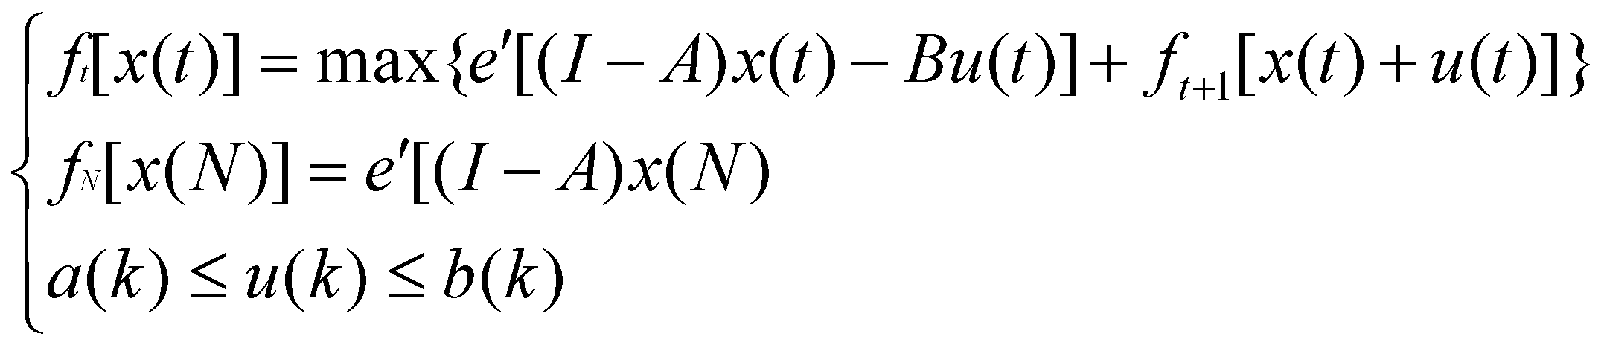 _{(3.1)}
The model can have constraints: the production and investment as dynamic IO model, capacity of resource and environment, and international trade factors.
The theoretical foundation of efficient growth path on basis of turnpike theorem determines the reasonable industrial structure of production and investment, and the rational ratio of consumption to output.
(3) Turnpike theorem is applied in dynamic input output model by Tusukui & Mutakami (1979) through linear programming with maximizing the capital of terminal year.
Three theoretical Tsukui’s turnpike models (1968, 1979) are shown in Table 2. The two types are taken into practice. Their objective function is respectively capital accumulation (a time invariance of final year) and Von Neumann’s balance growth rate (a time independent variance), so these models only require linear programming. The third type is inapplicable by linear programming. The objective function is maximizing accumulated welfare over the planning year, related to time invariance over planning time, so it requires dynamic programming. It will belong to the type model in the following paragraph.
TABLE 2. Tsukui’ models and their application.
Type of Tsukui model | Model pattern | Turnpike theorem | Algorithm
Model of capital accumulation | 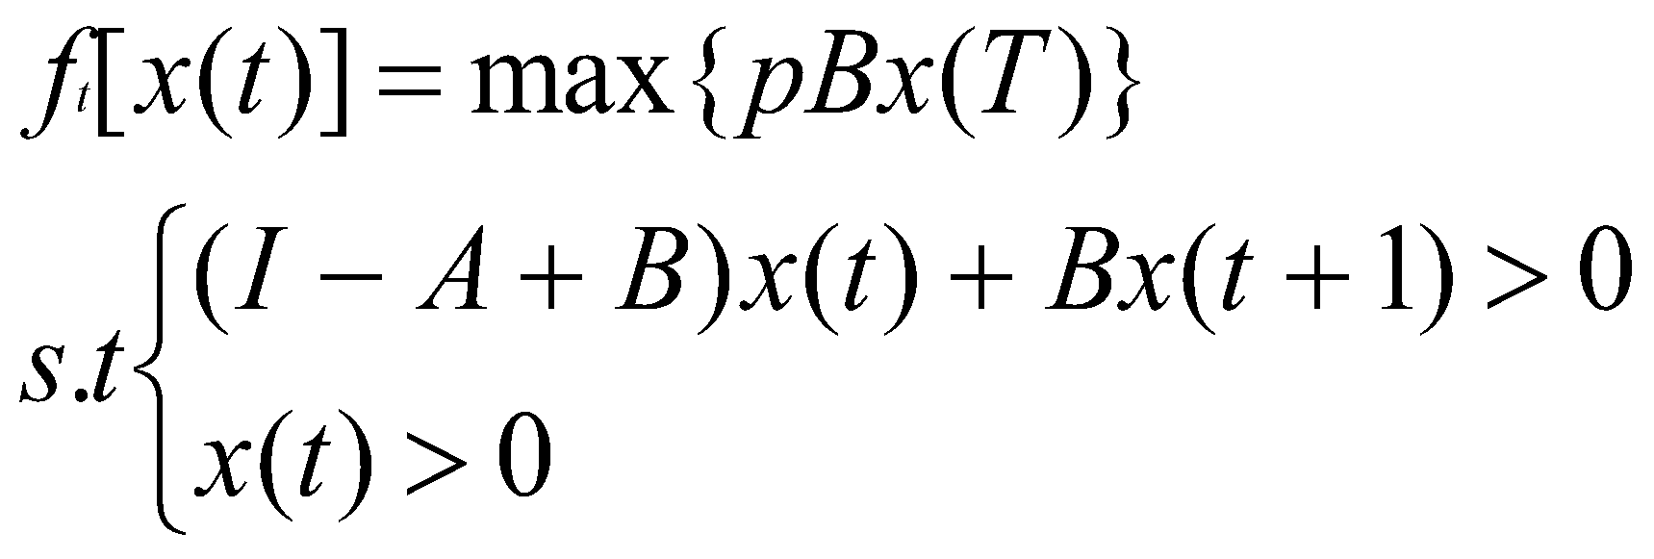 | Leontief dynamic model | Linear programming; (has algorithm and application)
Model of balance growth rate | 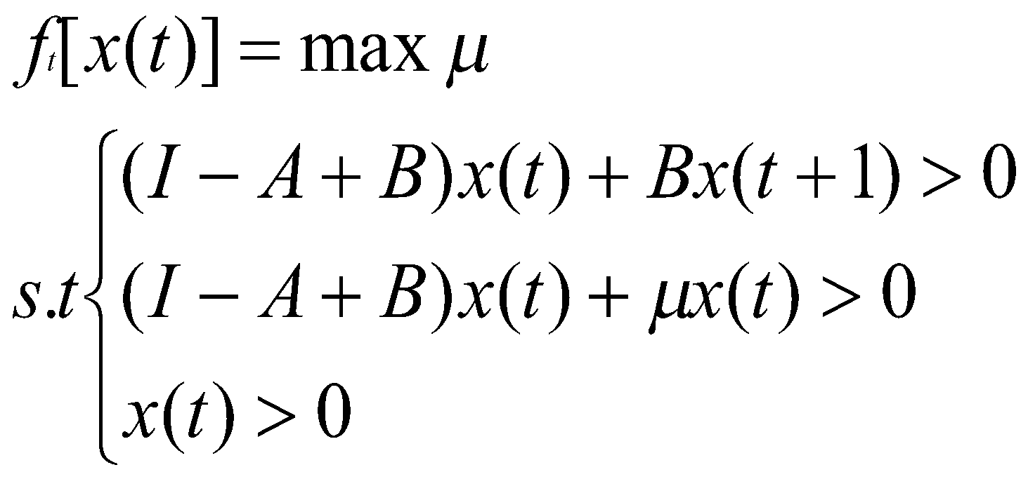 | Von Neuman’s | Linear programming; (has algorithm application)
Model of consumption | 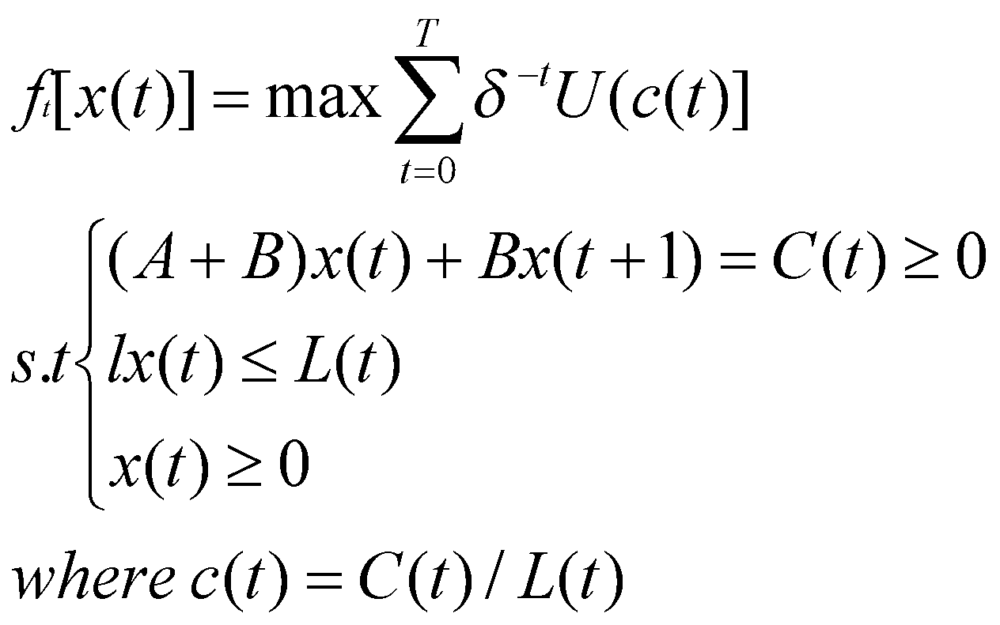 | Remesey’s model | Dynamic programming; (no algorithm application)

(4) A consumption turnpike model, combined Leontief dynamic input-output model with the dynamic programming, is currently in the blank. Here, a new consumption turnpike, within an environment input-output system, will be developed aiming at accumulated consumptions maximum under carbon constraints; dynamic programming is plausible to run by a new reverse algorithm. Absorbing Ramsey’s model (Ramsey, 1928) maximizing the utility over time, it is on virtue of the consumption turnpike theorem (Samuelson, 1965), and analogous to the Tsukui’s consumption model. Consumption-center is vital due to:
accumulated consumption embodying the long-term welfare improvement,
the consideration of consumption making tax and regulation plausible, thus considering the environmental tax and regulation on consumer side more than on production side,
rationalizing the ratio of consumption to output,
restructuring production, investment and consumption alone turnpike lane under constraint of environment and capital capacity,
The model finds an efficient growth path with maximizing accumulated consumption over the planning period, assumed that all economy structure grow at the same speed if economy develop along the turnpike lane. In application, it takes the various structure coefficients at certain year, combining them with the analysis of econometrics and experience of other countries, to modify them to reasonable coefficients. The next paragraphs give the IO technical for long term planning by linear programming and dynamic programming.

4. Turnpike Optimality based on dynamic input-output model by dynamic programming
Let finite time T, the Mixed-consumption turnpike model achieve the goal of maximum of capital in time T and accumulated consumption from time 1 to time T. This model has novel characteristics:
- The consumers have maximum benefit on the long time. Previous turnpike model mainly maximize the final capital (Dorfman et al., 1958, Tsuki, 1969) and generate more theoretical research than application (Zaslavski A.J., 2009). Considering China’s duplicated construction, high investment which results in serious pollution and excessive energy consumption, shrinking consumption at the low level of welfare. The utility accumulated reflects welfare improvement in consumption turnpike of Tsuki (1969) and McKenzie, L. W. (1986), but it is a variable that is notoriously difficult to define and let alone measure. Here, the accumulated consumption rather than the capital stock embodies an actual social benefit. Specifically, it takes the consumption identification from Leontief dynamic model in demand direction.
- The model objective maximize both the accumulated GDP (or final demand), excluding investment, from the initial year until the final year and the capital in final term.The first term is consistent with the consumption turnpike defined in Tsuki (1969) and McKenzie, L. W. (1986), and the second term in accordance with the capital turnpike define in as (Dorfman et al., (1958) and Tsuki (1969), so it can be called mixed consumption turnpike model. The objective can be transformed
.
Set terminal condition as GDP in final term, including consumption and capital of final year:
, Here denoted as the price index of final year.
Then the objective is transformed into an accumulation process in which the capital in final term plus the part of consumption which is accumulated reversely from final year. Each step of this process is defined as
t=1,…,T-1
As shown in turnpike models, the objective is bounded by Leontief dynamic input-output equations from initial to final year. So mixed-consumption turnpike can be formed as a set of objective functions with corresponding constraints.
- It is an international turnpike model, including exogenous export and import. Thus,
Here, ,,are respectively domestic consumption, import, and export.
- The model gives green sustainable growth by including constraints of carbon emissions and other pollutants. It concerns about carbon emissions and other pollutants embodied in both production and consumption. Through input-output coefficient and coefficient of CO2 (), SOx () and NOx (), the embodied pollutants in trade can be integrated into mathematical programming, which can completely reflect direct and indirect emitted CO2, SOx and NOx.
The carbon emissions and other pollutants source from fossil energy consumption can be accounted according to the quasi-dynamic model and Fu (2012). The intensity of carbon emissions and other pollutants by industry is estimated according to the time series of historic data and referred to the related industrial carbon emissions intensity of UK.
An efficient growth path is found which maximizes both accumulated consumption over the planning period and terminal capital in economic structure along the speedy growth lane. That means that the industrial structure is in consistent with the shares reflecting eigenvector of economy system. Moreover, it enable to obtain a rational the ratio of consumption to capital accumulation, investment structure alone turnpike path. The government only rationalizes the economic structure in the initial period to make economy grow alone the turnpike and adjusts economic structure toward the aimed structure in terminal of planning time. Figure 1 indicates a perfect growth in theory of environment oriented turnpike for a country.
- In regard to the accumulated consumption over planning time, the model should give a new algorithm of dynamic programming, instead of linear programming which is used in capital turnpike. As shown in Table 4, dynamic programming Mixed-Consumption Turnpike (MCT) model solved by a dynamic programming supplies a gap. Static IO models integrated into linear programming aim at maximum GDP or value added of one year (Liu et al., 2009, Fu Xue, 2012) or for equivalent dual problem at minimum cost of water resource (Lopez-Morales & Duchin, 2011) and energy use (Xia, 2010). Without capital matrix, static IO table is combined with dynamic programming target at accumulated GDP (Rose, 1996). After introducing China’s capital matrix, dynamic IO model is combined with multi-stage linear programming to find the long-term planning with attempt of a maximum accumulated GDP but no consideration of turnpike theorem (Zhang, 2001, Na Risa, 2000). When involving in the turnpike lane, the dynamic IO model was in framework of linear programming for maximum balance growth rate (He Jin, 2003), maximizes GDP (He at al.[36], He at al.[37]), or maxmium capital at terminal year (Tsukui[73],Tsukui & Murakami[72], Dorfman, et al.[25]). However, the core of the MCT dynamic model is maximum accumulated consumption, so it does not enable any more to apply linear programming, but dynamic programming to resolve. Reverse algorithm should be deduced to get solution, which is generalize algorithm for all kinds of discrete consumption turnpike model.
- Mixed-Consumption Turnpike (MCT) model is technology advanced dynamic model. The model uses a series of energy-pollutant-economy IO Tables with capital matrix. Comparing to the classic input-output model, it has two distinguish properties. First, it allows change in structure coefficient to embody technology advance. The technology change is embodied in material saving (the input-output coefficient) and capital composition improvement(capital coefficient). Second, it considers the change of energy mixture and corresponding pollutants removal efficiency.

Table 4: Comparison of MCT model with other optimal IO models

Theorem  Method |  | Turnpike theorem |  |  | Non-Turnpike theorem
 |  | model | objective | constraints | model | objective | constraints
Static IO model | Linear programming | - |  |  | Xia(2010) | Minimum Energy consumption | IO equations; Constraints of industry structure
 |  |  |  |  | Fu Xue(2012) | maximum GDP in expenditure approach | IO equations; Carbon constraints
 |  |  |  |  | Liu et al. (2009) | maximum GDP in income approach (value-added) | IO equations; Water use constraints
 |  |  |  |  | Lopez-Morales & Duchin(2011) | Minimum cost of water, dual problem | Water use constraints; water resource endowment
 | Dynamic programming | - |  |  | Rose (1996) | maximum accumulated GDP in expenditure approach | IO equations; resource endowment; investment accumulation equation
Dynamic IO model | Linear programming | Tsukui[73],Tsukui & Murakami[72], Dorfman, et al.[25] | Capital in final term; balance growth rate | Dynamic IO equations; resource endowment | Zhang (2001) | maximum accumulated GDP ; minimum pollutants | Dynamic IO equations; pollutants constraints; balance growth; final-term condition
 |  | J. He[1], He at al.[36], He at al.[37] | Final-termGDP | Dynamic IO equations; water resource endowment; final-term condition | Na,[7][8]
 |  |  |  |  | Yu et al.[84] | Accumulated value-added | Dynamic IO equations
 | Dynamic programming | Mixed-Consumption Turnpike (MCT) Dynamic model* |  |  | Liu[4] | Dynamic IO equations | final-term condition

4.1 Model
The dynamic model is established in equation (4.1) as objective function, and equation (4.2) as constraints.
_{(4.1)}
(4.2)
Here, is the input-output coefficient matrix, is the coefficient matrix of capital formation, is the output vector, is the change in output,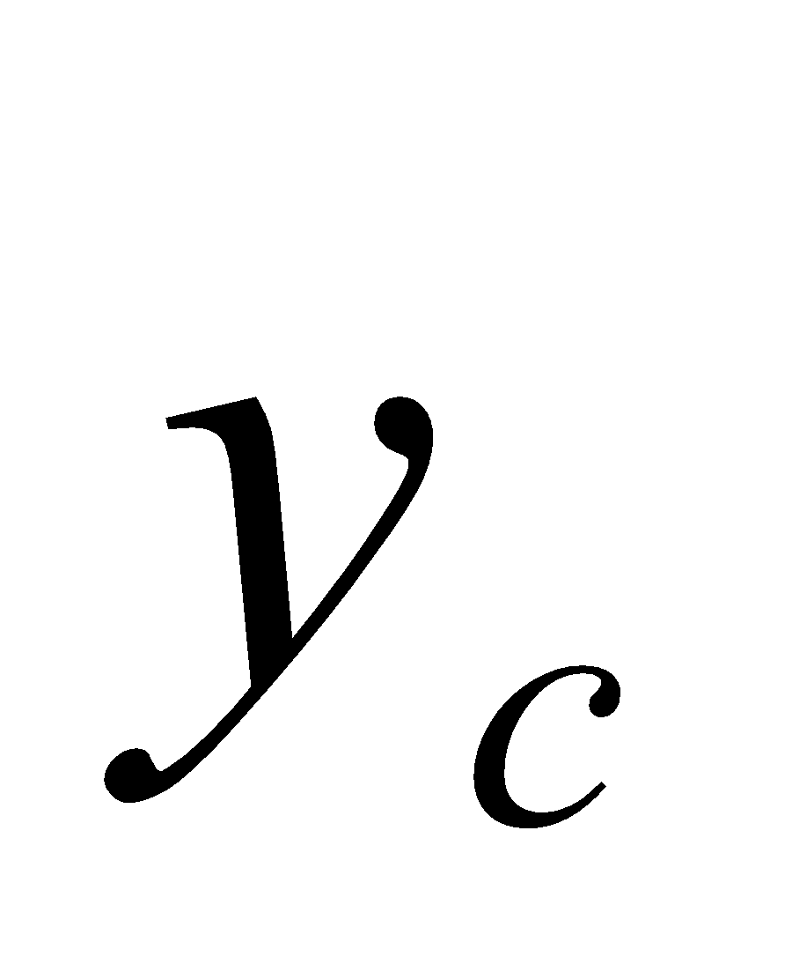is the consumption of household, is the export vector, is the import vector, is the vector of carbon intensity of industry, is the vector of carbon emission of household, is the carbon emission at target year, is unit vector, the subscript u is the up bound of the variable, the low script is the low bound of variable, t is the time variable, t=1,…,T, T is the planning year.
is the terminal constraint at time T, is the objective, i.e. cost function at time t, 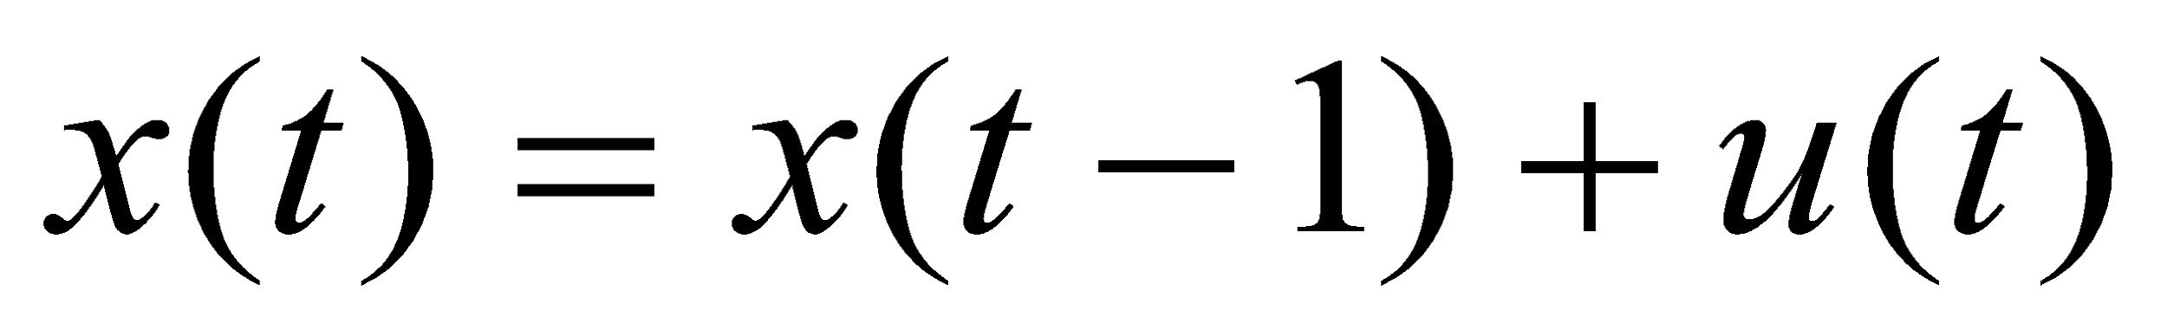is the state variable, is the control variable, control variable in this model. We deduce a reverse algorithm to get solution of this dynamic IO model in the following section 4.
4.2 The determination of total carbon emission of each year TC(t).
Target of carbon emission reduction is assumed to be achieved through linear decline. The reduction of carbon emission intensity at t year to the based year is . Target of reduction of carbon intensity decrease 40% for 15 years so the constraints of reduction of carbon emission is: the reduction of carbon emission intensity in 2020 to that in 2005. The carbon emission intensity is denoted as 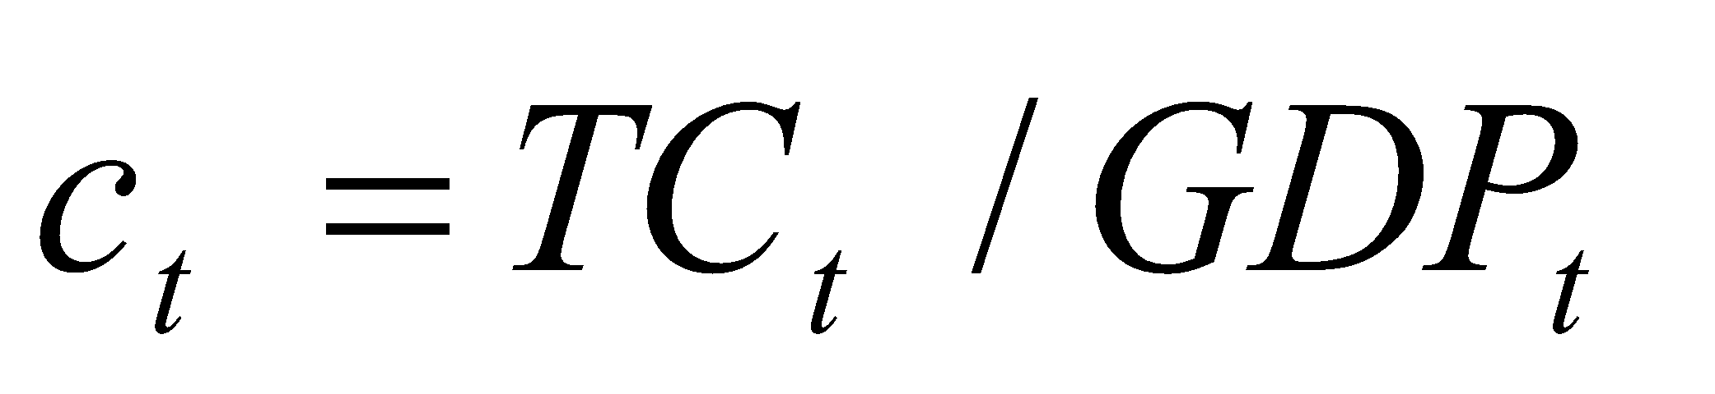, the reduction of carbon emission intensity between 15 years is,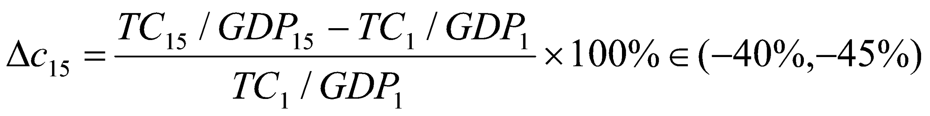. The reduction of carbon emission per year in average from 2005 to 2020 is 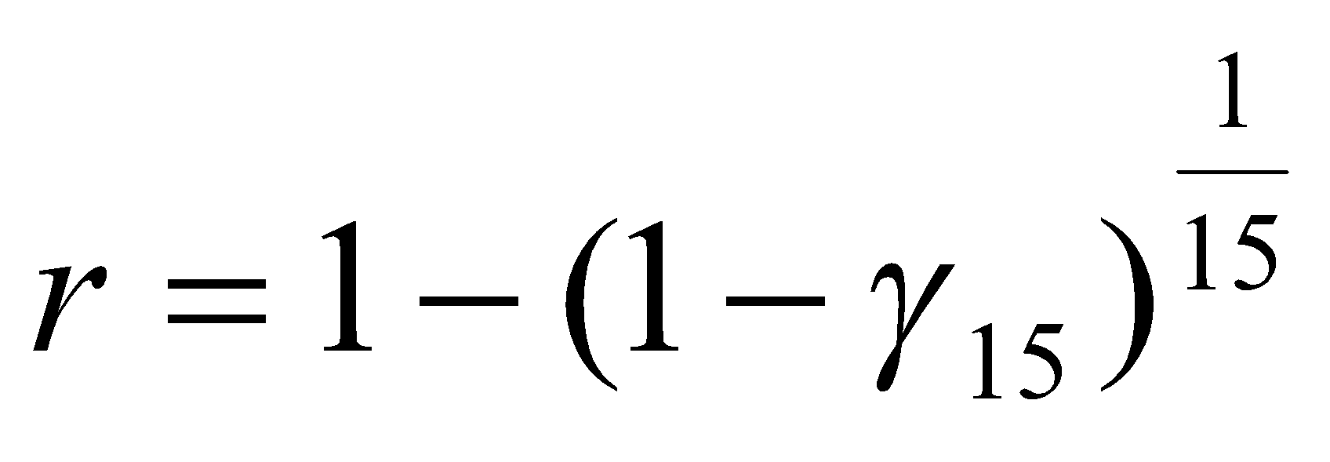, 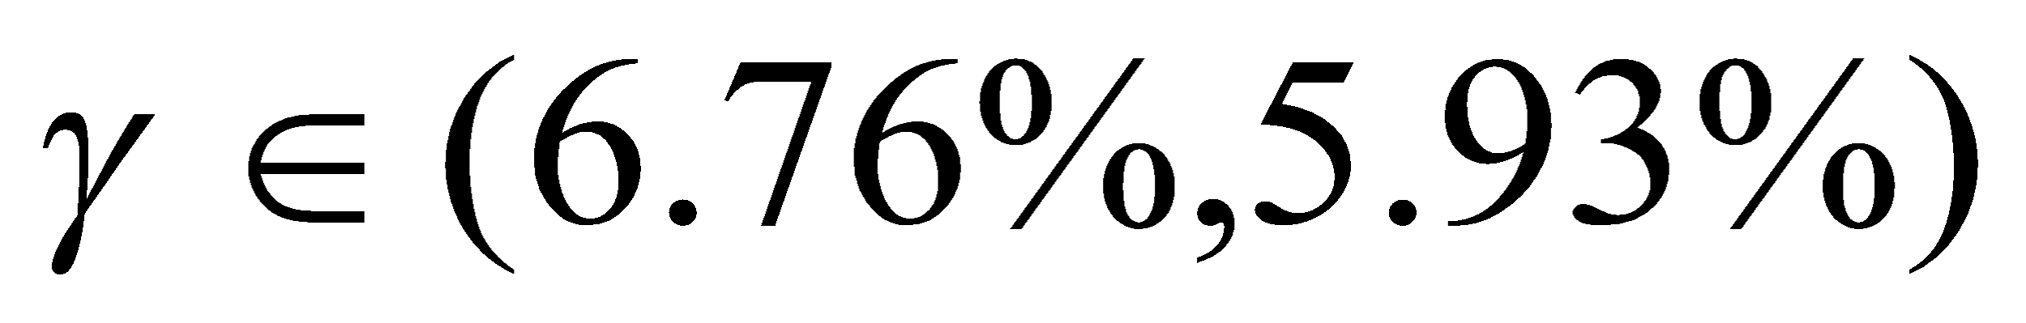. Reduction of carbon emission for t years is 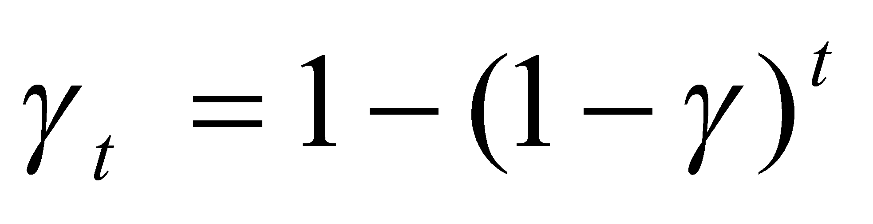, for example,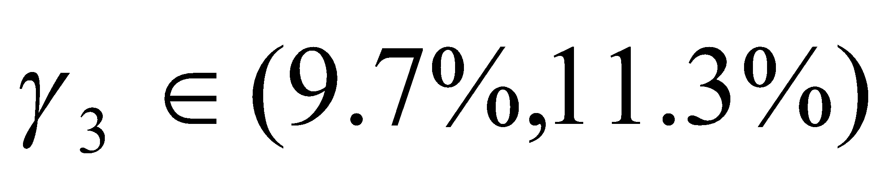. The computation process is as follows (up script l means low constraint, up script u means up constraint),
- Intensity reduction per year: 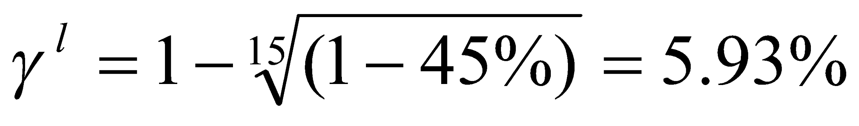, 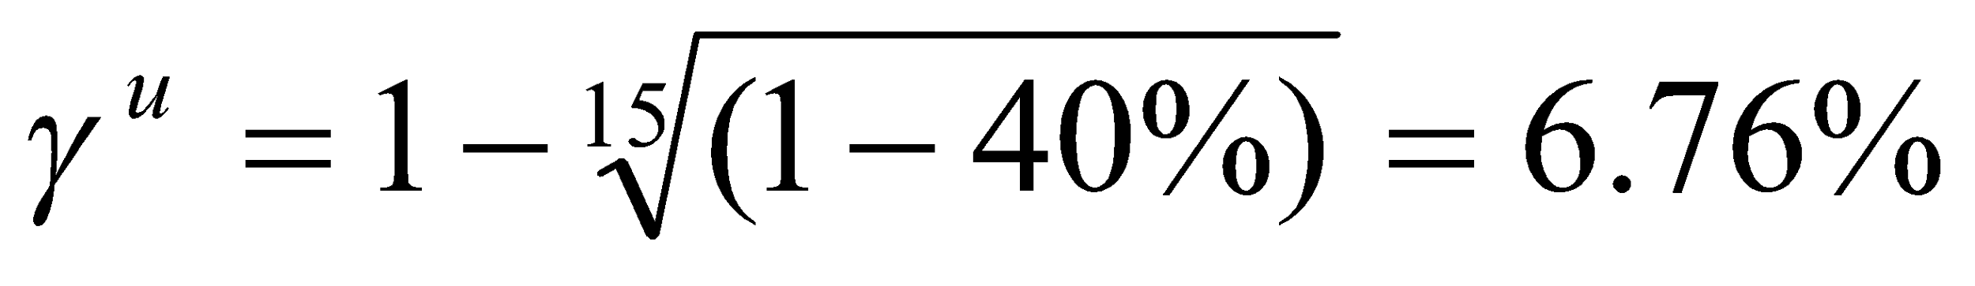,
- Intensity reduction for three years: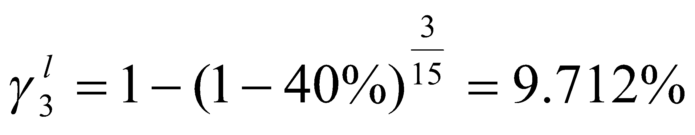, 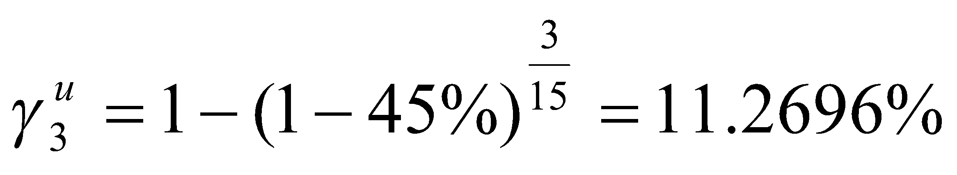

The carbon emission constraint in time is
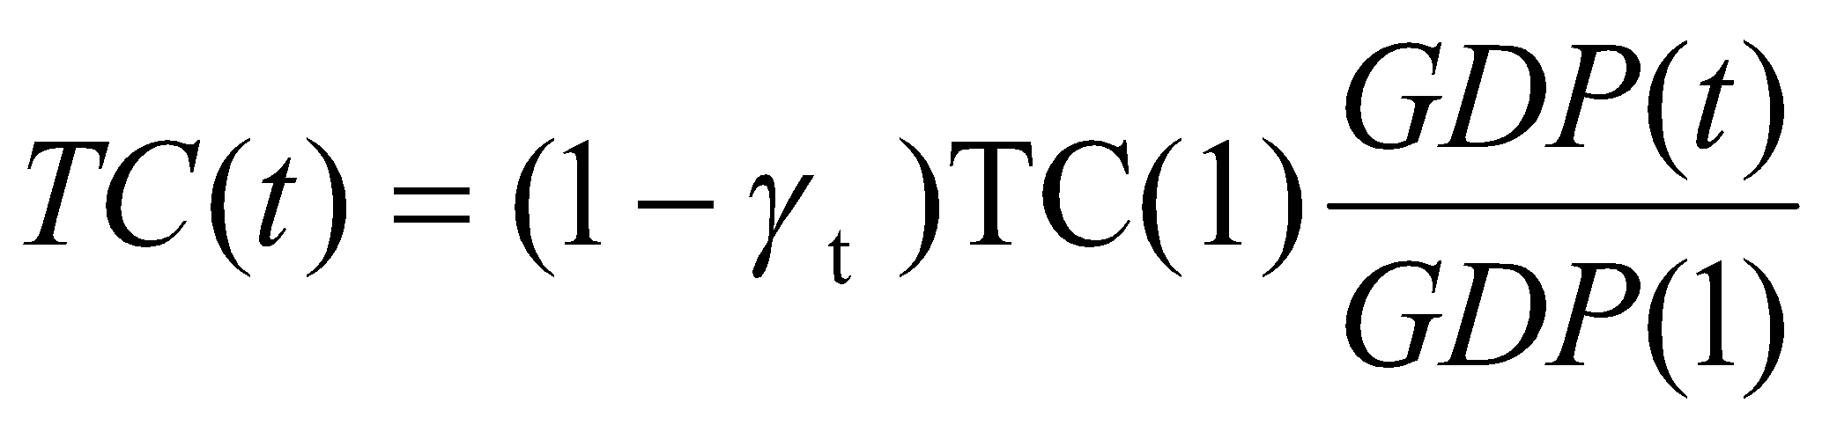
4.3 Reverse Algorithm in Turnpike Optimality in Environment-Input-Output System
Assumed the initial output as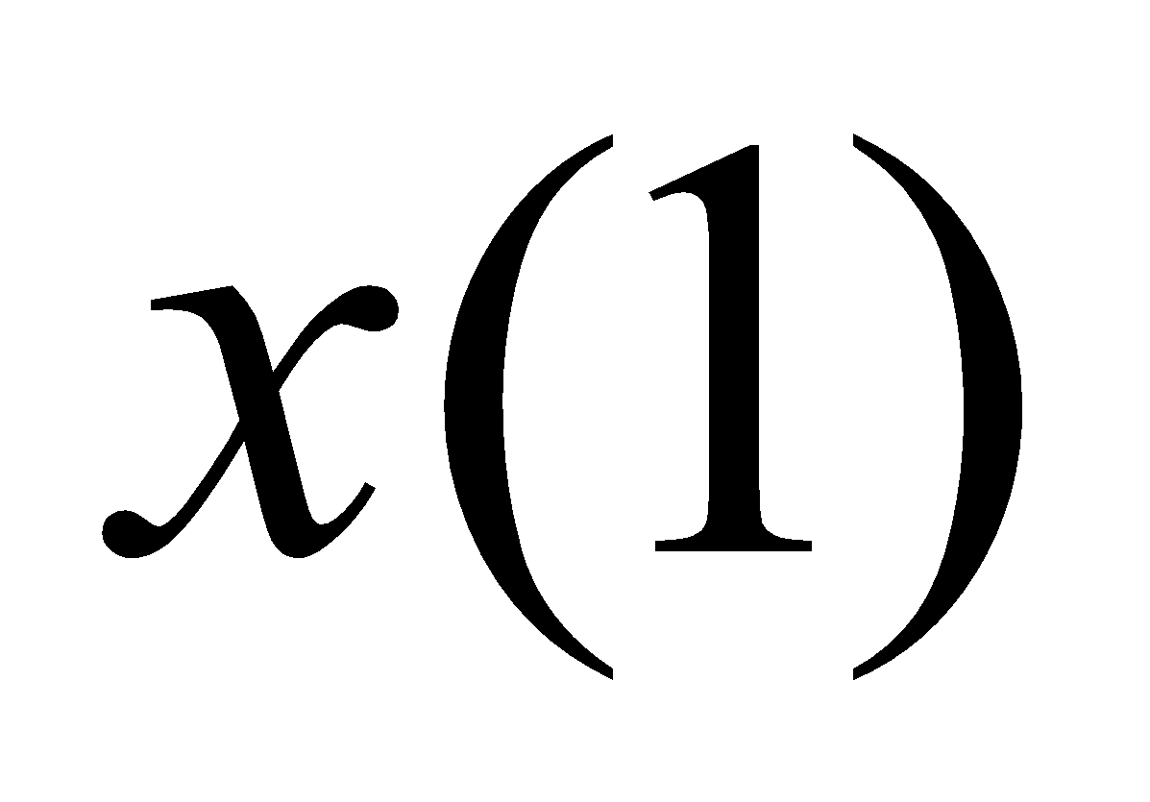, the control variable is defined as the increase of output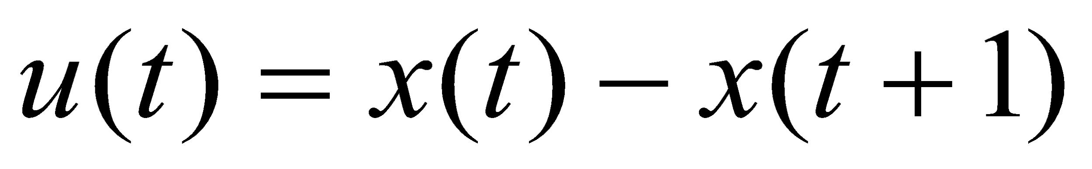, 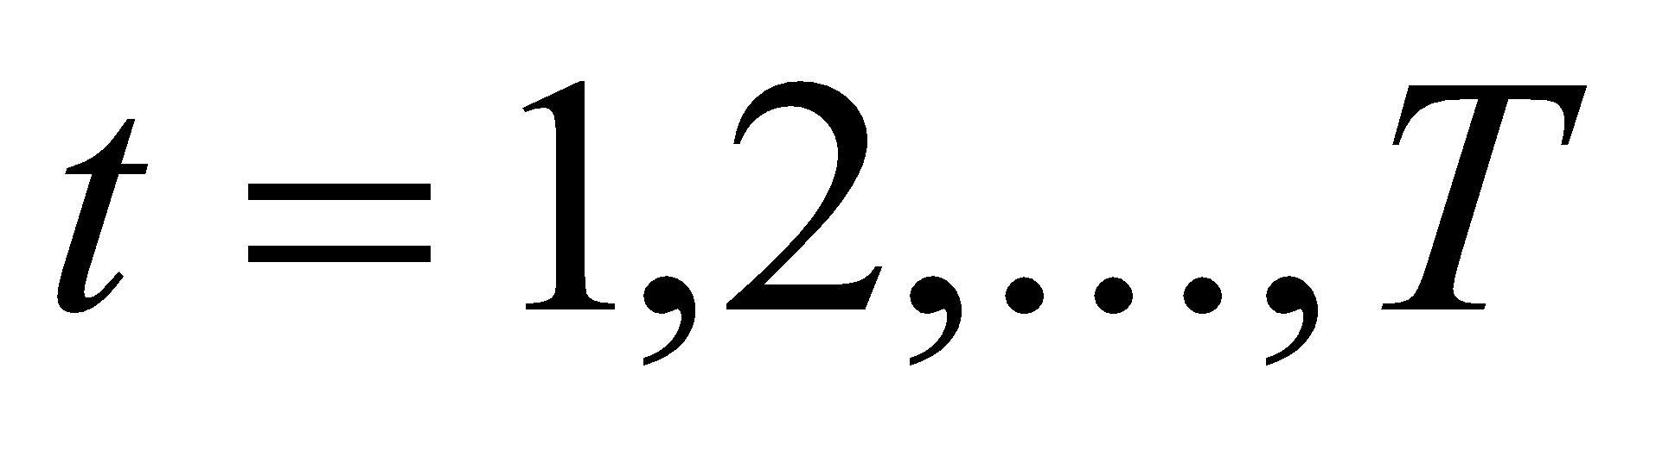. The output at time t is state variable, , so we denote 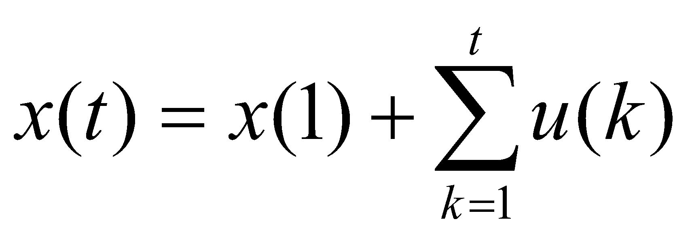. Then we rewrite the equations (4.1) and (4.2) into equations (4.3) and (4.4).
_{(4.3)}
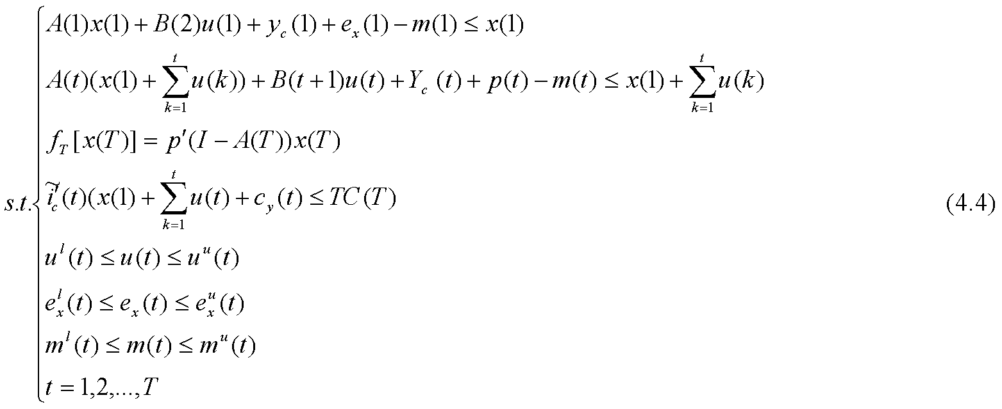 We simplify the constraints (4.4) as the following equation
We make use of reverse algorithm to obtain the solution of dynamic IO model. Computation starts from the year T-1. Then cost function (4.3) and constraint (4.5) at time T-1 is written as
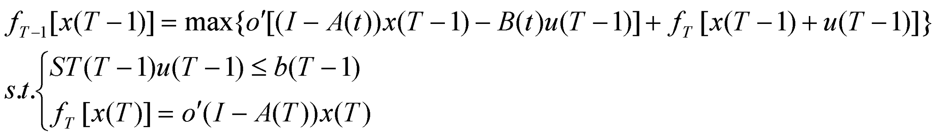 (4.6)
According to the deduction which combines the cost function at time t with terminal condition, equation (4.6) can be written
_{(4.7)}
From equations (4.7), we induce the control vector,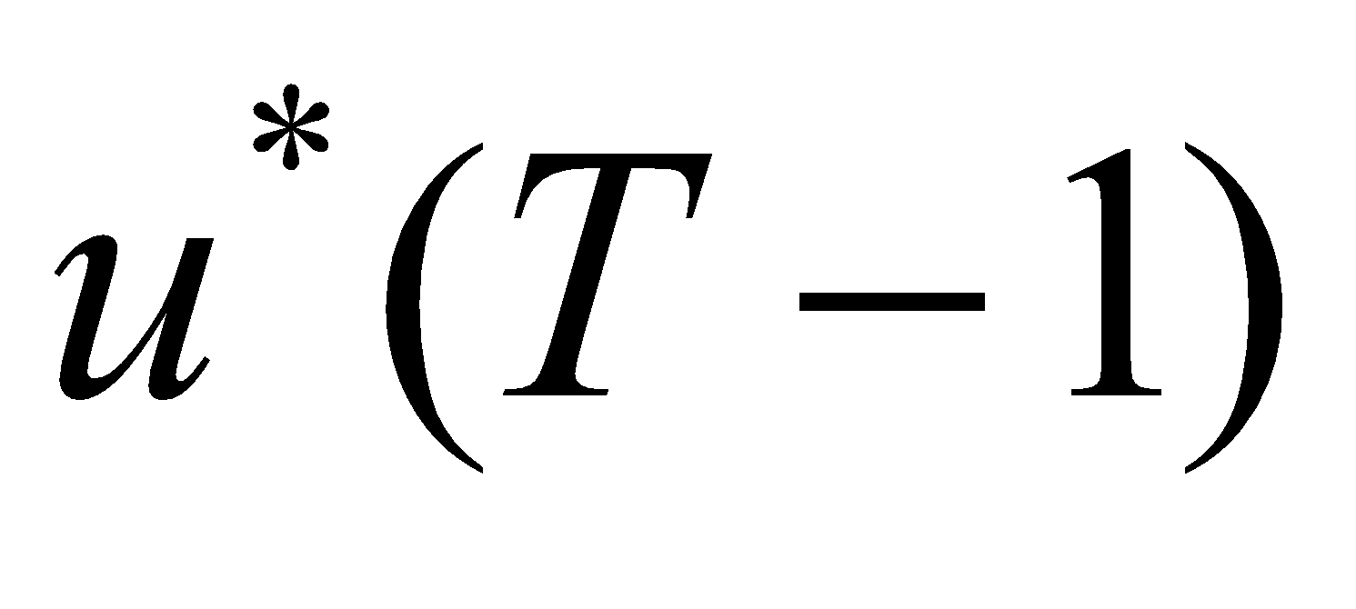, and cost function at time T-1,
_{(4.8)}
Here, (4.9)
Next, we come to the cost function and constraints at time T-2,
_{(4.10)}
The equations (4.10) can be simplified, so that we can introduce control variable,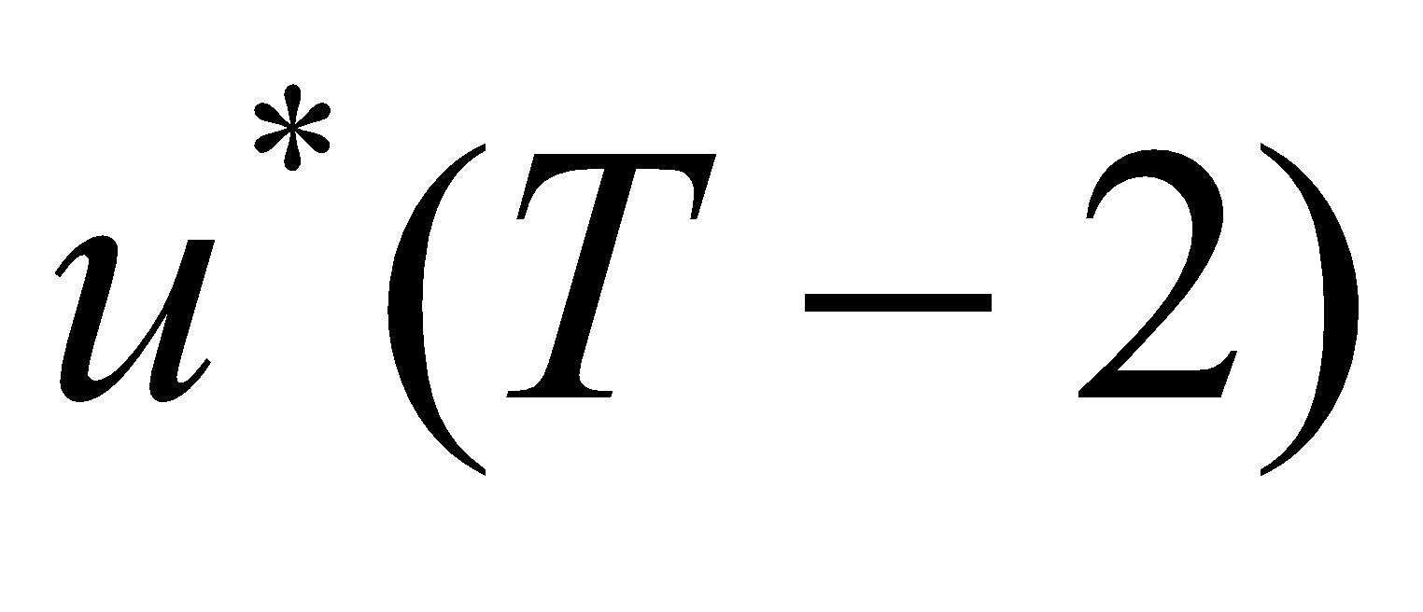, and the cost function at time T-2 in equation (4.11)
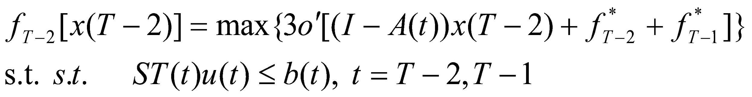 _{(4.11)}
Here
Introducing control variable,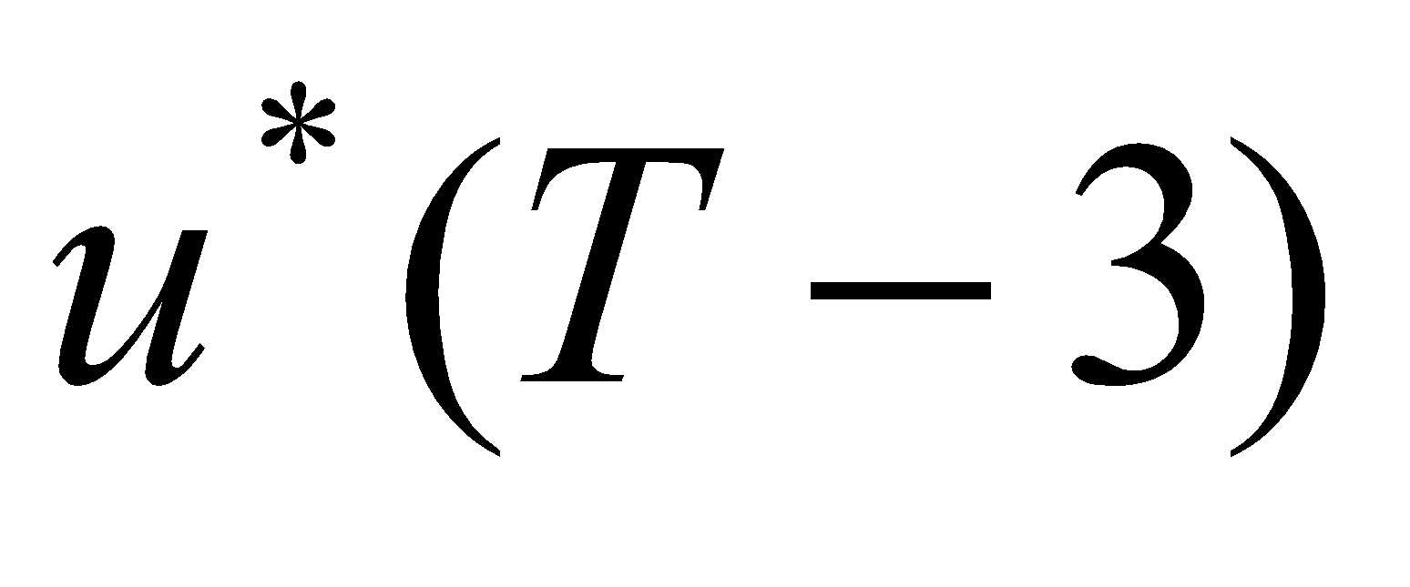, we come to the cost function and constraint at time T-3, and can obtain simplified version of cost function.
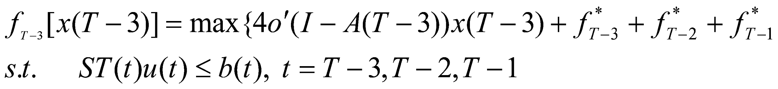 (4.12)
Here,
, (4.13)
From above deduced equations, we further get the model at step. Given 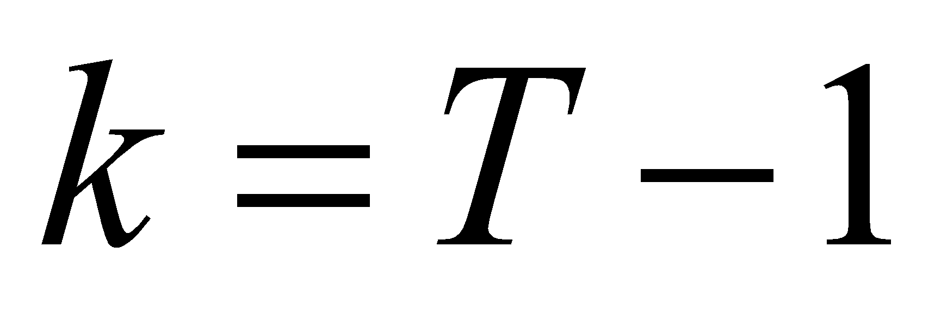, the cost function and constraints at time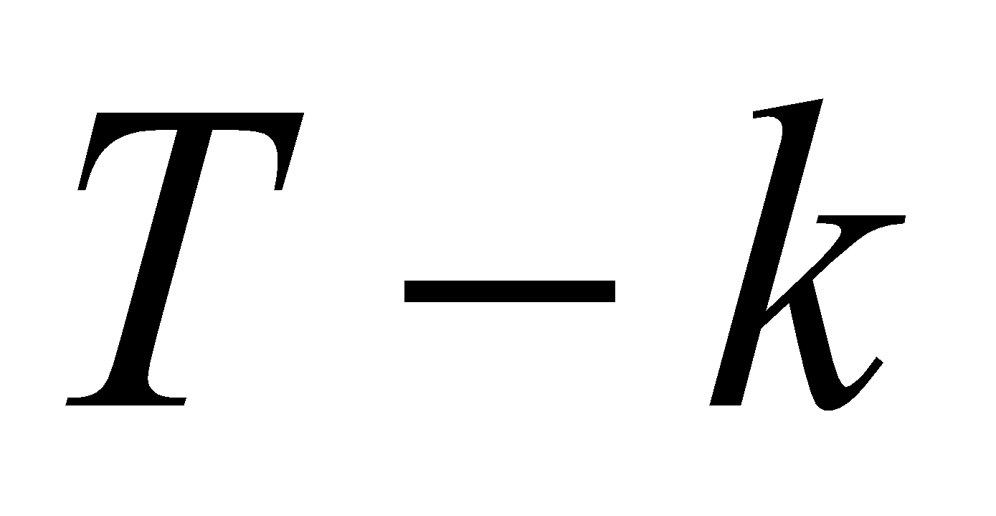 is shown as in the equation (4.14).
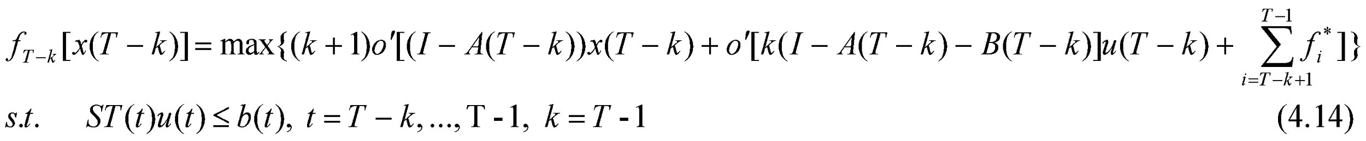Here,
Cost function with constraints at time () as format of (4.14) satisfies all models at time 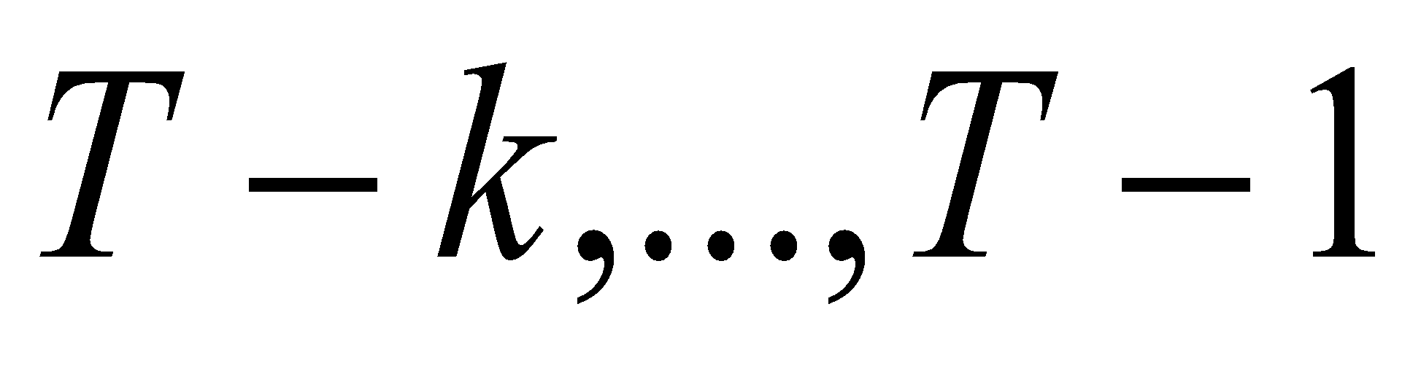.
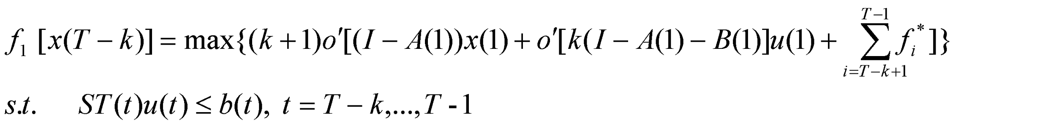(4.15)
From equation (4.15), we determine the optimal strategy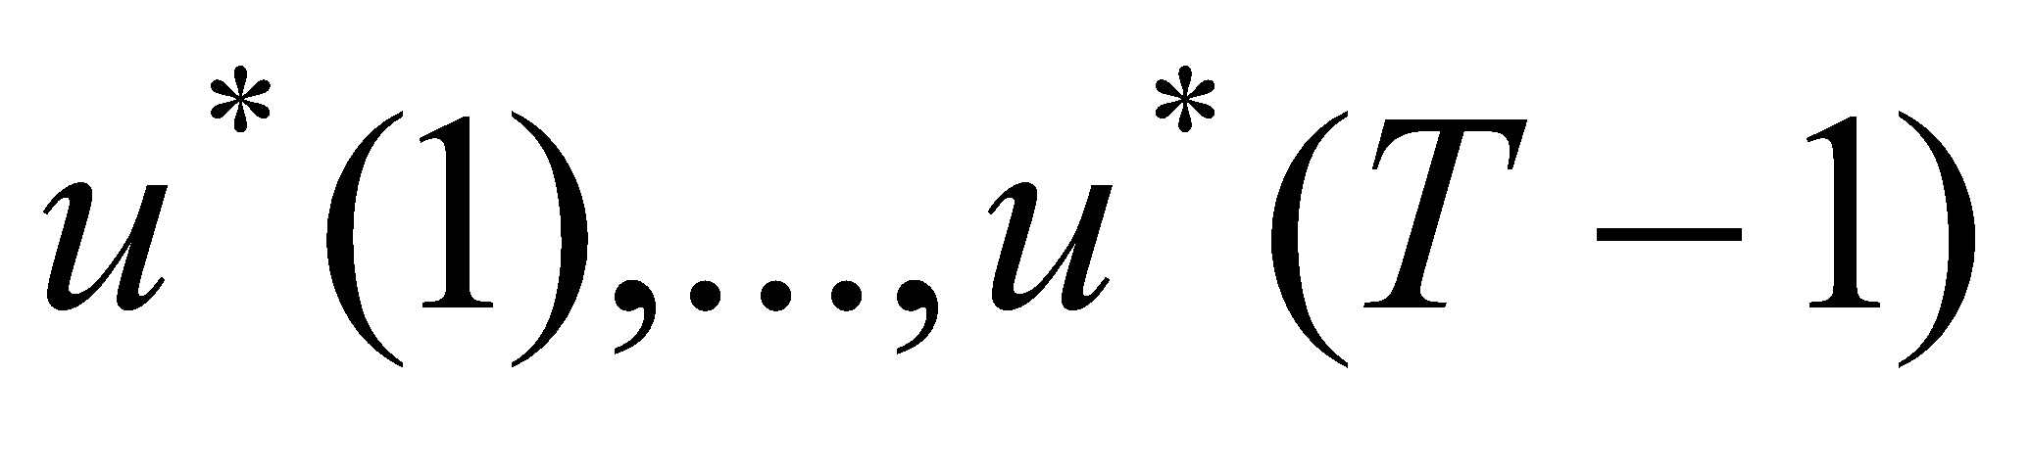. Given the initial output, we know the vector of output at each year, 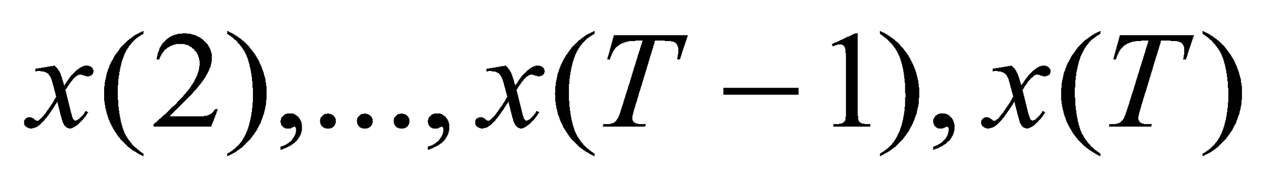, , 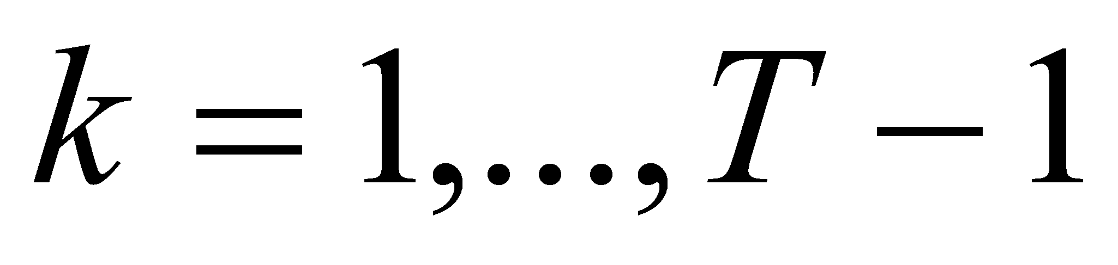. The detail format is shown in equation (4.16).
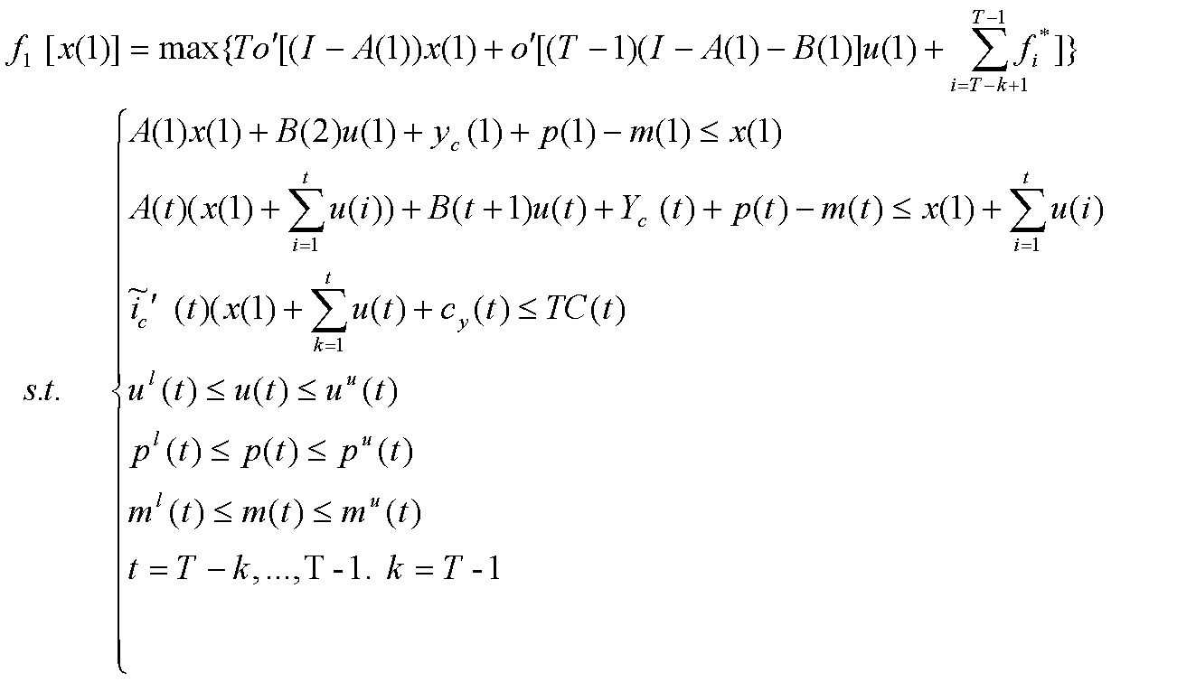 (4.16)
Here,
The process of resolving solution is shown in Appendix 1.

_{5 Application}

5.1 Data and structure coefficients in dynamic model
We take the date from the Energy-carbon-economy input-output table, shown as appendix 2. The core of environment dynamic input-output model is non-linear coefficients. We modify the direct input coefficient, capital coefficient and carbon emission coefficient. Leontief dynamic input-output model requires capital coefficient matrix, while input-output table issued by the Statistic Bureau in various countries merely reflect the capital formation vector. So the dynamic model was studied theoretically, but not applied in general (Duchin & Szyld, 1985). Some application is in Ten Raa (1986a, b) and education (Zhang, H.,2003, He, J., 2005, Fu, X.,2006). In general, input-output table issued in various countries merely reflect the capital formation as column vector. Chinese Statistic Bureau investigated the capital formation matrix in 2000, which is also fit the requirement of Leontief dynamic model. Moreover, Chen X(2005) also built input-occupied-output model, which investigate the fixed capital occupied matrix. The capital formation is flow while the fix capital is the stock. The capital formation coefficient is the kth capital product at time t for the jth output increased at time t 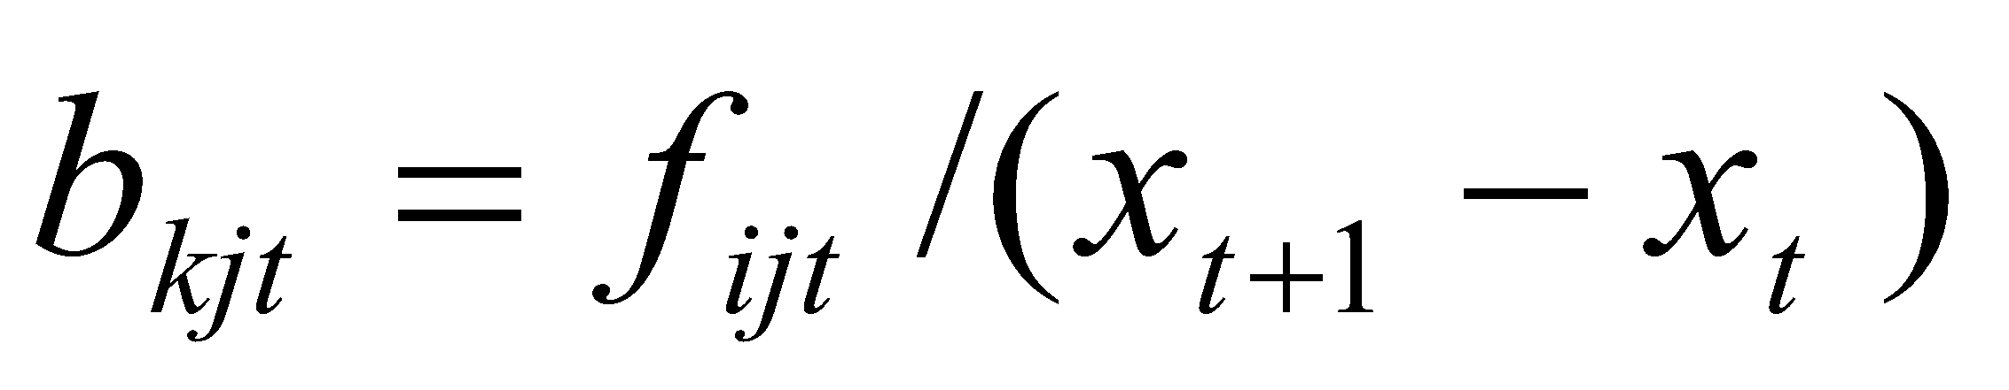. The fixed capital occupied coefficient 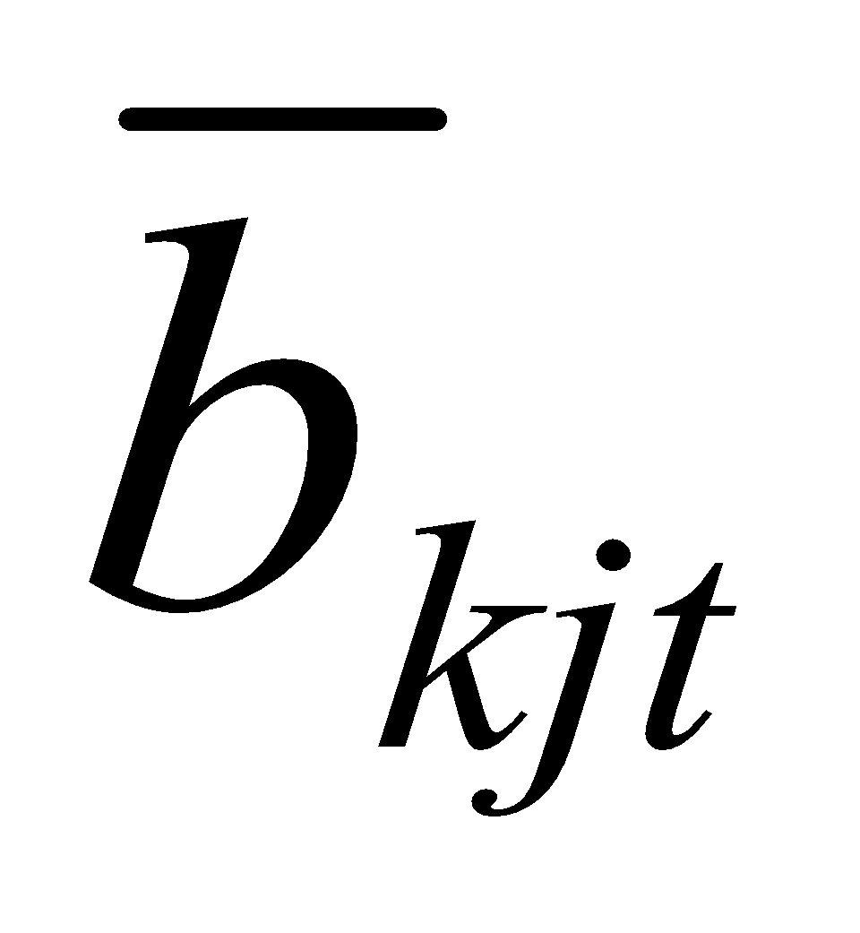is the kth capital occupied at time t for the jth output at time t 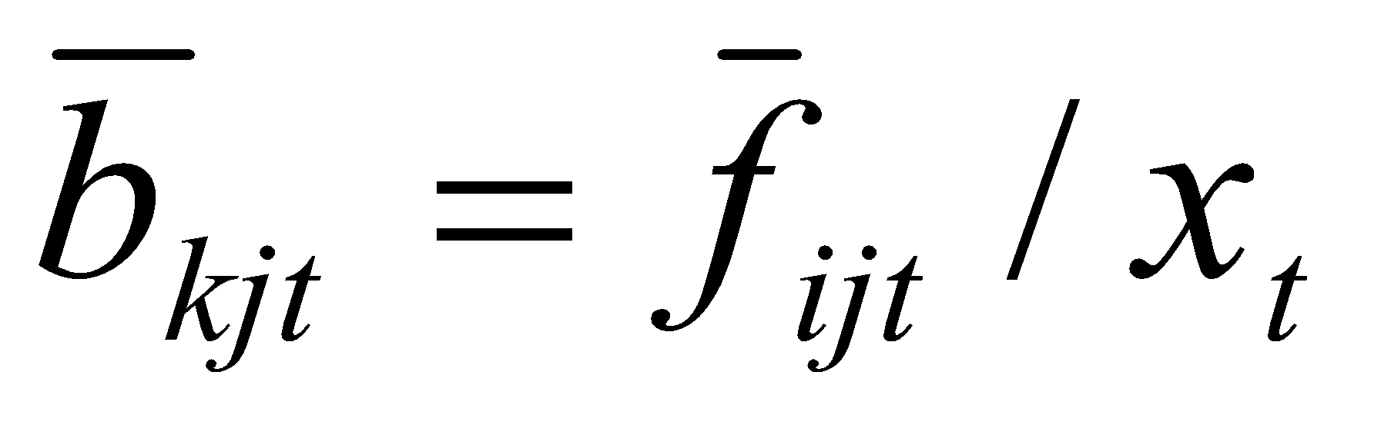. Fixed capital occupied is the fix capital is acuminated capital, so the capital coefficient in average. Take the occupied capital coefficient to adjust or replace capital formation coefficient, it will help to establish the dynamic model.
Because of capital formation data is available in 2000, we apply RAS method to estimate the capital formation matrix in 2002, 2005. According to the data from China Statistic Bureau, we estimate the IO table series from 1990 to 2007. Then we apply the update data into a new model to find the turnpike optimality in environment-input-output system from benchmark year 2002 and 2005. The indirect coefficient and capital coefficient are fix in this model, and the initial output and final demand is the real data from two group IO table. The first group are 2000, 2001, 2002 and 2003 input-output table; the second group are 2005, 2006, 2007 input-output table. The 2000, 2002, 2005, 2007 input-output table are obtain from the Chinese Statistics Bureau. 2001, 2003, 2004, 2006 input-output table are extended tables we compile according to combination the date from national accounting.

5.2 Turnpike Optimality in Environment-Input-Output System

We find the turnpike optimality from the environment-input-output system. Table 3 gives the adjusted output, which is compared to original output, table 4 gives the adjusted industry structure is compared to original output.

The optimal structure from 2001 to 2003 was different with the structure in 2000; and the optimal structure from 2006 to 2008 was different with the structure in 2005.
(1) We compare the turnpike lane from 2001 to 2003 and that from 2006 to 2008. Optimal structure of manufacture in 2001 (60%) is less than the actual structure in 2001 (68%); however, optimal structure of service in 2001 (28%) is larger than the actual structure in 2001 (22%). The optimal structure of manufacture in 2006 (66%) is less than the actual structure in 2006 (69.9%). However, the optimal structure of service in 2006 (26.7%) is larger than the actual structure in 2006(23.7%).
(2) Optimal consumption in 2001 and 2002 are 0.5 billion and 0.4 billion larger than the actual comsumption in 2001 and 2002. It means that China should increase the consumption instead of merely dependency on the investment and export. Optimal consumption in 2006 and 2007 are 0.15 billion and 1.4 billion larger than the actual comsumption in 2006 and 2007. It means that China should increase the consumption instead of merely dependency on the investment and export.
(3) Optimal total output in 2001 and 2002 are 1.3 million larger than and 0.03 billion less than the actual total output in 2001 and 2002. Optimal total output in 2006 and 2007 are 0.2 billion and 0.8 billion less than the actual total output in 2006 and 2007. The output expand less than actual output for two reasons. (1) constraint of carbon emission. (2) fix structure coefficient in the model. Moreover, 2000 investment coefficient is used to deduce the investment coefficient in 2002 and 2005. Without consider technical advanced, under the condition of decline of carbon emission, the turnpike lane will espande less than the actual economic with technology advance. If referring to the capital coefficient matrix in UK, Canada, etc. (OECD, http://www.oecd.org/ , and WIOD, http://www.wiod.org/ ), we can revise the coefficient in 2005. It will help to get the more actual simulation. It means the turnpike lane will improve the economy much better.

Tabel 3. The turnpike lane of China in the period of 2001-2003 and 2006-2008

actual data | 2000 | 2001 | 2002 | 2003
agriculture | 2644 | 2585 | 2857 | 3579
manufactures | 17296 | 18891 | 19055 | 23867
services | 6537 | 6221 | 9429 | 11810
output | 26479 | 27697 | 31343 | 39257
consumption | 3755 | 6383 | 7928 | 64532
Growth Rate (current term) | 5% | 13% | 25%
Cons./output= |  |  | 31% | 28.9%
adjustment
agriculture | 2644 | 2697 | 2751 | 2806
manufactures | 17296 | 17642 | 17995 | 18355
services | 6537 | 7496 | 7645 | 10704
output | 26479 | 27836 | 28393 | 31866
consumption | 3755 | 11273 | 11957
Growth rate(current term) | 5% | 2% | 12%
Cons/output= |  |  | 38%

actual data | 2005 | 2006 | 2007 | 2008
agriculture | 39450 | 41058 | 48892 | 60010
manufactures | 358261 | 452105 | 535790 | 657621
services | 145050 | 153319 | 192385 | 236130
output | 542762 | 646483 | 777068 | 953762
consumption | 107714 | 134160 | 160607 | 314045
Growth Rate (current term) |  | 19.1% | 20.2%
Cons./output= | 19.8% | 20.8% | 20.7% | 32.9%
adjustment
agriculture | 39450 | 45368 | 52173 | 52225
manufactures | 358261 | 412000 | 473800 | 544870
services | 145050 | 166807 | 166974 | 167141
output | 542762 | 624176 | 692948 | 764237
consumption |  | 149552 | 299113 | 336392
Growth rate (current term) |  | 15.0% | 11.0% | 10.3%
Cons/output= |  | 29.6% | 24.0% | 43.2%

Table 4: The adjusted industry structure comparing to original output

actual data | 2000 | 2001 | 2002 | 2003
agriculture | 10% | 9% | 13% | 9%
manufactures | 65% | 68% | 87% | 61%
services | 25% | 22% | 43% | 30%
output | 1.0 | 1.0 | 1.0 | 1.0
adjustment
agriculture | 0.1 | 0.1 | 0.1 | 0.1
manufactures | 65% | 60% | 60% | 60%
services | 25% | 28% | 28% | 28%
output | 1.0 | 1.0 | 1.0 | 1.0

actual data | 2005 | 2006 | 2007 | 2008
agriculture | 7.3% | 6.4% | 6.3%
manufactures | 66.0% | 69.9% | 69.0%
services | 26.7% | 23.7% | 24.8%
output | 1.0 | 1.0 | 1.0 | 1.0
adjustment
agriculture | 7.3% | 7.3% | 7.5% | 6.8%
manufactures | 66.0% | 66.0% | 68.4% | 71.3%
services | 26.7% | 26.7% | 24.1% | 21.9%
output | 1.0 | 1.0 | 1.0 | 1.0

Adjustment | Output |  |  |  | Share
 | 2000 | 2001 | 2002 | 2003 | 2000 | 2001 | 2002 | 2003
AGR: Agriculture | 264482670 | 26180.6 | 285787423 | 368230995 | 0.103 | 0.071 | 0.091 | 0.079
CMN: Coal mining | 20237523 | 3733.7 | 40109089.4 | 62218857.3 | 0.008 | 0.010 | 0.013 | 0.013
PMN: Oil and nature gas mining | 43815759 | 3612.7 | 32633054.0 | 48843939.8 | 0.017 | 0.010 | 0.010 | 0.010
OMN: Other mining | 16784181 | 2875.1 | 30429747.6 | 47028472.5 | 0.007 | 0.008 | 0.010 | 0.010
FTW: Food manufacture,Textile, Wood processing and Manufacture of Articles for Culture | 381451082 | 42831.9 | 411153385.4 | 607021526 | 0.148 | 0.116 | 0.131 | 0.130
PCN: Petroleum Processing, Coking and Nuclear Fuel Processing | 79433513 | 15043.7 | 60846185.5 | 106029767 | 0.031 | 0.041 | 0.019 | 0.023
CPM: Chemical and Pharmaceutical and Medicine Manufacturing | 215871883 | 40364.4 | 215726168.2 | 384863555 | 0.084 | 0.109 | 0.069 | 0.082
BNM: Building materials and non-Metallic Materials Industry | 62751301 | 11626.3 | 58045337.2 | 363841790 | 0.024 | 0.031 | 0.019 | 0.078
MPM: Metal processing and manufacture | 157266045 | 18116.3 | 213653418 | 125449049 | 0.061 | 0.049 | 0.068 | 0.027
MEM: Mechanic manufacture | 88751399 | 21055.2 | 129973097.2 | 178336351 | 0.034 | 0.057 | 0.041 | 0.038
TEM: Transportation equipment manufacture | 95153272 | 17827.9 | 96466982.9 | 150817283 | 0.037 | 0.048 | 0.031 | 0.032
EEM: electronic equipment manufacturer | 214300521 | 24506.2 | 200990025 | 381279156 | 0.083 | 0.066 | 0.064 | 0.082
INO: Instrumentation and other manufacturer | 36316964 | 4579.7 | 45817939.7 | 74488140.1 | 0.014 | 0.012 | 0.015 | 0.016
EHW: Electricity, heat power and water production and supply | 95992600 | 9836.8 | 88419337.7 | 187726797 | 0.037 | 0.027 | 0.028 | 0.040
CON: Construction | 221570467 | 45919.4 | 281326817.3 | 341061353 | 0.086 | 0.124 | 0.090 | 0.073
TSI: Transportation, storage, and information service | 105707979 | 17266.1 | 146064292.1 | 219066866 | 0.041 | 0.047 | 0.047 | 0.047
WRT: Wholesale and retail trades | 169342750 | 28593.2 | 242910018.1 | 271200723 | 0.066 | 0.077 | 0.078 | 0.058
RFO: Real estate finance and other service | 306297920 | 36551.7 | 553952698.6 | 758961797 | 0.119 | 0.099 | 0.177 | 0.162
 | 2575527831 | 370521.0 | 3134305017 | 4676466418
_{Unit: Billion Yuan}
 | Actual data |  |  |  | Adjustment
 | 2000 | 2001 | 2002 | 2003 | 2000 | 2001 | 2002 | 2003
AGR: Agriculture | 264.5 | 261.8 | 285.8 | 368.2 | 264.5 | 370.3 | 377.7 | 385.2
CMN: Coal mining | 20.2 | 37.3 | 40.1 | 62.2 | 20.2 | 20.6 | 21.1 | 21.5
PMN: Oil and nature gas mining | 43.8 | 36.1 | 32.6 | 48.8 | 43.8 | 44.7 | 45.6 | 46.5
OMN: Other mining | 16.8 | 28.8 | 30.4 | 47.0 | 16.8 | 17.1 | 17.5 | 17.8
FTW: Food manufacture,Textile, Wood processing and Manufacture of Articles for Culture | 381.5 | 428.3 | 411.2 | 607.0 | 381.5 | 389.1 | 396.9 | 404.8
PCN: Petroleum Processing, Coking and Nuclear Fuel Processing | 79.4 | 150.4 | 60.8 | 106.0 | 79.4 | 81.0 | 82.6 | 84.3
CPM: Chemical and Pharmaceutical and Medicine Manufacturing | 215.9 | 403.6 | 215.7 | 384.9 | 215.9 | 220.2 | 224.6 | 229.1
BNM: Building materials and non-Metallic Materials Industry | 62.8 | 116.3 | 58.0 | 363.8 | 62.8 | 64.0 | 65.3 | 66.6
MPM: Metal processing and manufacture | 157.3 | 181.2 | 213.7 | 125.4 | 157.3 | 160.4 | 163.6 | 166.9
MEM: Mechanic manufacture | 88.8 | 210.6 | 130.0 | 178.3 | 88.8 | 124.3 | 126.7 | 129.3
TEM: Transportation equipment manufacture | 95.2 | 178.3 | 96.5 | 150.8 | 95.2 | 97.1 | 99.0 | 101.0
EEM: electronic equipment manufacturer | 214.3 | 245.1 | 201.0 | 381.3 | 214.3 | 300.0 | 306.0 | 312.1
INO: Instrumentation and other manufacturer | 36.3 | 45.8 | 45.8 | 74.5 | 36.3 | 37.0 | 37.8 | 38.5
EHW: Electricity, heat power and water production and supply | 96.0 | 98.4 | 88.4 | 187.7 | 96.0 | 97.9 | 99.9 | 101.9
CON: Construction | 221.6 | 459.2 | 281.3 | 341.1 | 221.6 | 310.2 | 316.4 | 322.7
TSI: Transportation, storage, and information service | 105.7 | 172.7 | 146.1 | 219.1 | 105.7 | 107.8 | 110.0 | 112.2
WRT: Wholesale and retail trades | 169.3 | 285.9 | 242.9 | 271.2 | 169.3 | 198.8 | 202.8 | 206.9
RFO: Real estate finance and other service | 306.3 | 365.5 | 554.0 | 759.0 | 306.3 | 428.8 | 437.4 | 446.1
output | 2575.5 | 3705.2 | 3134.3 | 4676.5 | 2575.5 | 3069.4 | 3130.8 | 3193.4

consumption | 3755 | 6383 | 7928 | 64532
Growth Rate (current term) | 5% | 13% | 25%
 | 26479 | 27697 | 31343 | 39257

_{6 Conclusion}

This article works out the China’s potential in industry structure adjustment for carbon emission reduction. We present turnpike optimality in dynamic input-output models and give the reverse algorithm to get the turnpike Optimality of China’s industry adjustment considering carbon emission reduction target on Copenhagen Conference based on a compiled Energy-Carbon-Emission-Economy Input-Output tables and modified technology coefficients and capital formation matrixes. It finds that the turnpike line have better economy performance. Industry structure is improved by increase in the service and decrease in manufacture. The optimal consumption and total output should increase much more than the actual data. If we modify the structure coefficient, the results will be improved.

_{Acknowledge}
Supporting foundation: “Dynamic Programming on Industry Structure of Low carbon Economy based on Multiregional Input-Output Model”, National Social Science Foundation, 2010, 7, No.10CJL033, (hosting); “Research on the strategy of low carbon development during China’s urbanization”, Key grant of project of National Social Science Foundation, 2010, 7, No. 10zd&032, (participating).”
_{Reference}
Aulin-Ahmavaara, P. (1989) A complete dynamic input-output model including the production of human capital and labour, Economic Systems Research, 1(1), pp.121-129.
Aulin-Ahmavaara, P. (1990) Dynamic input-output and time, Economic Systems Research, 2(14), pp.329-343.
Chen, X., Guo, J. and Yang, C. (2005) Extending the input-output model with assets, Economic Systems Research, 17, pp. 211-226.
Chen, X. (1990) Input-occupancy-output analysis and its application in China, in: Manas Chatterji et al. (eds), Dynamics and Conflict in Regional Structural Change (London, Macmillan Press), pp. 267-278.
Dorfman, R., P. A. Samuelson, and R. M. Solow: Linear Programming and Economic Analysis, New York, McGraw-Hill, 1958, Chapter 12.
Robert Dorfman, Paul A. Samuelson, Robert M. Solow, Linear Programming and Economic Analysis, Courier Dover Publications, 1987.
Inada, K.: "Some Structural Characteristics of Turnpike Theorems, Review of Economic Studies, Vol. XXXI (1), No. 85, 1964, pp. 43-58.
Duchin, F., Szyld, D. (1985) A dynamic input-output model with assured positive output, Metroeconomica, 37, pp. 269-82.
Edler, D., Ribakova, T. (1993)The Leontief-Duchin-Szyld dynamic input-output model with reduction of idle capacity and modified decision function, Structural Change and Economic Dynamic,. 4, pp. 279-297
HE Jing.Calculation of Chinese Shadow Price of Water Resource Based on Dynamic Computable Equilibrium Models.Systems Engineering —Theory & Practice, 2005,25(5):49-54
He, L. and F. Duchin. 2009. Regional Development in China: Interregional Transportation Infrastructure and Regional Comparative Advantage, Economic Systems Research, 21(1).
Hua R. the theory of optimality of planning economy , Chinese Science Bulletin，1984, 29( 12) : 705- 709; 1984, 29( 13) : 769- 772; 1984, 29 ( 16) : 961 - 963; 1984, 29 ( 18) : 1089 - 1092; 1984, 29( 21) : 1281- 1282; 1985, 30( 1) : 1- 2; 1985, 30 ( 9) : 641- 645
华罗庚, 计划经济大范围最优化的数学理论 科学通报, 1984, 29( 12) : 705- 709; 1984, 29( 13) : 769- 772; 1984, 29 ( 16) : 961 - 963; 1984, 29 ( 18) : 1089 - 1092; 1984, 29( 21) : 1281- 1282; 1985, 30( 1) : 1- 2; 1985, 30 ( 9) : 641- 645
Kiedrowski, A turnpike theorem in the closed dynamic Leontief model with a singular matrix of capital coefficients, Roman, Economic Systems Research. 2001, 13(2) p. 209-222
Leontief, W. (1970) The dynamic inverse, in: A.P. Carter & A. Brody (eds) Contributions to Input-Output Analysis (Amsterdam, North Holland).
Liu X. (1996) Dynamic input-occupancy-output model for human capital, Quantitative & Technological Economics, 3, pp. 40-45.
F. Ramsey, "A Mathematical Theory of Saving," Econ. Jour., Dec. 1928, 38, 543-59.
McKenzie, L. W., Turnpike theory. The New Palgrave Dictionary of Economics. Online Edition. Eds. Steven N. Durlauf and Lawrence E. Blume. Palgrave Macmillan, 2012. From The New Palgrave Dictionary of Economics, Online Edition, 2012, Edited by Steven N. Durlauf and Lawrence E. Blume.
McKenzie, L. W., Turnpike Theorem for a Generalized Leontief Model, Econometrica, Vol. 31, No. 1-2, 1963, pp. 165-180.
Morssm A, M. Proof of a Turnpike Theorem: The 'No Joint Production' Case, Review of Economic Studies, Vol. XXVIII, No. 76, 1961, pp. 89-97.
Narisa Zhao,Tang Huanwen,Luo Xiaona,Research on non-linear Input-Output model based on production function theory and a new method to update IO coefficients matrix, Applied Mathematics and Computation, Vol. 181, Issue 1, 2006, pp 478-486
张红霞，唐焕文，林建华，多目标动态投入产出优化模型应用研究，大连理工大学学报，Vol. 41, No. 5, 2001
那日萨、唐焕文，一个多目标动态投入产出优化模型及其算法（I），系统工程理论与实践，1998a , Vol.18, No.8, pp49-52。
那日萨、唐焕文，一个多目标动态投入产出优化模型及其算法（II），系统工程理论与实践，1998b, Vol.18, No.9, pp91-95。
Xie Yuantao, Computable non-linear dynamic input-output analysis in Beijing, Capital University of Economic and Business, 2006.
北京市可计算非线性动态投入产出分析，首都经济贸易大学，硕士论文，2006。
Ten Raa, T. (`1984) The distributed approach to Spatial Economics, Journal of Regional Science, 24(1), pp.105-117.
Ten Raa, T. (`1986a) Dynamic input-output analysis with distributed activities, The Review of Economics and Statistics, 68(2), pp.300-310.
Ten Raa, T. (`1986b) Applied dynamic input-output analysis with distributed activities, European Economic Review, 30, pp. 805-831.
Ten Raa, T., Chakraborty, D., Das, T. (1989) Working capital in an input-output model, Economic Systems Research, 1(1), pp. 53-68.
Tsukui, J.: Efficient and Balanced Growth Paths in a Dynamic Input-Output System-A Turnpike Theorem, Rironkeizaigaku, Vol. XIII, No. 1, 1962, pp. 1-14 (in Japanese).
Tsukui, J., Turnpike Optimality in Input-output Systems: Theory and Application for Planning, Jinkichi Tsukui, Yasusuke Murakami, Contributions to economic analysis, 122, Nort-Holland Publ., 1980
Paul A. Samuelson , A Catenary Turnpike Theorem Involving Consumption and the Golden Rule, The American Economic Review, Vol. 55, No. 3 (Jun., 1965), pp. 486-496
VON Neumann, J., Uber ein 6konomisches Gleichungssystem und eine Verallgemeine-rung des Brouwerschen Fixpunktsatzes," Ergebnisse eines mathematischen Kol-. loquiums, No. 8 (1937), pp. 73-83, translated as, A Model of General Economic Equilibrium, Review of Economic Studies, Vol. 13, No. 33, (1945-46) pp. 1-9.
Zhang, H. and Chen, X. (2004) An extended input-output model on education system and its applications, in: Xu, X. and Liu, Q. (eds) Selected Papers on Analytical Purposes of Input-Output Techniques in China, (Beijing, China Statistics Press).
IPCC, 2007. Climate Change 2007. The IPCC Fourth Assessment Report,/http://www.ipcc.ch/S.
A. P. Carter , Applications of input-output analysis to energy problems. Science, 1974, 19: 324–325.
X. Chen, Input-occupancy-output analyses and its application in China, In: Manas. Chatterji & Kuenne R.E.(eds) Dynamics and Conflict in Regional Structural Change, London, Macmillan, 1990.
X. Chen, Input-occupancy-output analysis and its application in Chines economy, The Current State of Economic Science, 1999,(1): 501-514.
X. Chen, J. Guo, C. Yang, Extending the input-output model with assets, Economic Systems Research, 2005(17):211-226.
X. Chen, X. Liu, X. Fu, Some important evolution of input-occupancy-output analysis theory and methods and their main applications, Bulletin of National Natural Science Foundation of China, 2008, 4: 224-227.
J. He, X. Chen, Calculation of Chinese shadow price of water resource based on dynamic computable equilibrium models, Systems Engineering-Theory and Practice, 2005(25): 49-54.
Y. Huang, Input-output model of education system and its application, Theory and Applications of Systems Engineering, 1991, 11(2): 51-58.
X. Liu, X. Chen, Nonlinear Input-occupancy-output Model on Important Coefficients, Journal of Nanjing University of Science and Technology, 2005, 3: 371-374.
X. Liu, X. Chen, The Non-linear Important Coefficients Input-Holding-Output Model, International Journal of Applied Economics and Econometrics, 2005, 13 (3): 429—438
Y. Gao, S. Li, Construction of Extended CGE model with resource and environment accounting, China Population Resources and Environment, 2008, 3: 20-23.
X. Fu, X. Chen, Chinese Education Structure for Sus- tainable Development:A Multiyear Lag Education-Economy Extended I-O Model with Asset .International Journal of Applied Economics and Econometrics, 2006, 14 (1) : 61—78 .
Q. Liu, M. Xia, H. Zhang, Reasons for Chinese phase change of energy-consuming: an input-output analysis, Economic Theory and Business Management,, 2007, 7: 5-10.
X. Xu, C. Qi, C. Yang, T. Zhao, The inter-industrial linkages of energy Sectors in China-study on the improved structural coefficients by using 2002 Input-Output Table of China, Statistical Research, 2007, 24(5): 3-6.
X. Liu, Human capital dynamic input-output model with asset, Quantitative and Technical Economics, 1996, 3: 40-45.
J. Li, X. Chen, An input-occupancy-output analysis on water conservancy of Yangtze River Valley, Journal of Yangtze River Scientific Research Institute 2004,21(2)：44-47.
R. Tong, Y. Liu, J. Xu, The Input-Output Analysis of the Circular Economy, The Journal of Quantitative & Technical Economics, 2008, 1: 40-52.
X. Jang; R. Tong, A FES Method of Construction of Chinese Regional Input-output Tables, Systems Engineering, 2008, 76(3): 75-80.
X. Jiang, R. Tong, J. Xu, The Key Sector Identification: A Sectoral Elasticity Method, Systems Engineering-Theory & Practice, 2006, 4: 14-19.
H. Zhang, The theory and application of education economy input-output model with assets, Graduate School of Chinese Academy of Science, 2004.
H. Zhang, Study on education-economy input-occupancy-output model and its application, Chinese Journal of Management Science ,2004 (b) ,12(5): 97-101.
A. V. Kneese, U. R. Ayres, R. C. D'Arge, Economics and the Environment: A Materials Balance Approach. Contributors, Resources For The Future, Inc., Place of Publication: Washington, 1970.
A. P. Carter , Applications of input-output analysis to energy problems. Science, 1974, 19: 324–325.
V. Alcántara and J. Roca, Energy and CO2 emissions in Spain: methodology of analysis and some results for 1980–1990, Energy Economics, 1995, 17 : 221–230.
V. Alcántara and E. Padilla, Key sectors in final energy consumption: an input-output application to the Spanish case, Energy Policy, 2003, 31: 1673–1678.
I.Butnar, B. Gallego, M. Llop, F. Castells, Atmospheric emissions and structural path analysis in the Spanish economy, Mimeo, 2006.
I. Butnar and M. Llop, Composition of greenhouse gas emissions in Spain: an input–output analysis, Ecological Economics, 2007, 61: 388–395.
M.A. Cadarso, A. Fernández-Bolaños, Patterns of growth and consumption and their influence on the environment in Spain. Paper presented at Fourteenth International Conference on Input–Output Techniques, Montreal, Canada, 1995.
J.M. Gowdy and J.L. Miller, Technological and demand change in energy use: an input–output analysis, Environment and Planning A, 1987, 19 : 1387–1398.
L., Hea-Jin, Y., Seung-Hoon, K., Seung-Jun, Industrial CO2 emissions from energy use in Korea: A structural decomposition analysis ，Energy Policy， 2009, 37(2): 686-698
W. Isard , Interregional and regional input-output analysis: A model of a space economy. Rev. econ. Statists, 1951, 33: 313–328.
M. Lenzen, Primary energy and greenhouse gases embodied in Australian final consumption: an input–output analysis, Energy Policy, 1998, 26: 495–506.
M. Lenzen, L.L. Pade and J. Munksgaard, CO2 multipliers in multi-region input–output models, Economic Systems Research , 2004, 16: 391–412.
W. Leontief, Environmental repercussions and the economic structure: an input–output approach, Review of Economics and Statistics , 1970, 52: 262–271.
Q.M. Liang, Y. Fan and Y.M. Wei, Multi-regional input–output model for regional energy requirements and CO2 emissions in China, Energy Policy, 2007,35 (3): 1685–1700.
S. Kagawa and H. Inamura, A structural decomposition of energy consumption based on a hybrid rectangular input–output framework: Japan's case, Economic Systems Research, 2001, 13: 339–363.
J. Labandeira and J. Labeaga, Estimation and control of Spanish energy-related CO2 emissions: an input–output approach, Energy Policy , 2002, 30: 597–611.
G. Machado, R. Schaeffer and E. Worrell, Energy and carbon embodied in the International Trade of Brazil: an input–output approach, Ecological Economics, 2001, 39: 409–424.
I. Mongelli, G. Tassielli and B. Notarnicola, Global warming agreements, international trade and energy/carbon embodiments: an input–output approach to the Italian case, Energy Policy, 2006, 34: 88–100.
F.T. Moore and J.W. Peterson , Regional analysis: an interindustry model of Utah. The Review of Economics and Statistics 1955, XXXVII: 368–383.
A. Pajuelo, Equilibrio general versus análisis parcial en el análisis input–output económico-ambiental, Revista del Instituto de Estudios Económicos, 1980, 3: 3–57.
J.L.R. Proops, Energy intensities, input–output analysis and economic development. In: M. Ciaschini, Editor, Input–Output Analysis: Current Developments, Chapman and Hall, London, 1988: 201–215.
K.A. Reinert and D.W. Roland-Holst, Industrial pollution linkages in North America: a linear analysis, Economic Systems Research, 2001, 13: 197–208.
A. Rose, J. Benavides, D. Lim and O. Frias, Global warming policy, energy, and the Chinese economy, Resource and Energy Economics, 1996, 18(1): 31-63.
A. Rose, B. Stevens, A dynamic analysis of fairness in global warming policy: Kyoto, Buenos, Aires, and beyond, Journal of Applied Economics 1998, 1(2): 329-362.
J. B.Rosser, Jr., Complex ecologic–economic dynamics and environmental policy. Ecological Economics, 2001, 37: 23–37.
O. Tahvonen, On the dynamics of renewable resource harvesting and pollution control. Environmental Economics and Management, 1991, 1: 97–117.
O. Tahvonen, J. Kuuluvainen , Economic growth, pollution, and renewable resources, Journal of Environmental Economics and Management, 1993, 24: 101–118.
C. Perrings, Resilience in the dynamics of economy–environment systems, Environmental and Resource Economics, 1998, 11: 503–520.
B.Stevens, A. Rose, A dynamic analysis of the marketable permits approach to global warming policy: a comparison of spatial and temporal flexibility. Journal of Environmental Economics and Management, 2002, 44(1): 45–69.
M.A. Tarancón and P. del Río, A combined input–output and sensitivity analysis approach to analyse sector linkages and CO2 emissions, Energy Economics, 2007(a), 29: 578–597.
M.A. Tarancón and P. del Río, CO2 emissions and intersectoral linkages. The case of Spain, Energy Policy 2007(b),35: 1100–1116.
K. Turnera, , M. Lenzenb, T. Wiedmannc and J. Barrettc, Examining the global environmental impact of regional consumption activities — Part 1: A technical note on combining input–output and ecological footprint analysis Ecological Economics, 2007, 62(1): 37-44.
A. Tukkera, E. Poliakova, R. Heijungsb, T. Hawkinsc, F. Neuwahld, J. M. Rueda-Cantuched, S. Giljume, S. Mollf, J. Oosterhaveng and M. Bouwmeesterg, Towards a global multi-regional environmentally extended input–output database ,Ecological Economics, 2009, 68 (7): 1928-1937.
M. Wier, Sources of changes in emissions from energy: a structural decomposition analysis, Economic Systems Research, 1998, 10: 99–112.
R. Wood and M. Lenzen, Structural path decomposition, Energy Economics, 2009, 31(3): 335-341
J. Fan, J. Shen, Z. Bao, Z. Zhou, The multiple criteria optimal model and computation for an ecological and economic Input-Occupancy-Output Model, Systems Engineering-Theory and Practice, 2001 21(5) : 75-81.
M. Lei, Analysis of China’s comprehensive input-output table of resource-energy-environment and accounting of green expresses of taxation, Southeast Academic Research, 2001, 4: 64-74,
D. Li, C. Wang, Panel Data Analysis on the relationship between economic growth and air pollution in China, Finance and Economics, 2007:43-57.
X. Liu, F. Ru, Study on the relation between China’s energy consumption and the growth of national economy, Industrial Technology and Economy, 2007, 9: 55-58.
J. Sun, Improvement on the theory and method of the resource-economy-environment input-output, The Journal of Quantitative and Technical Economics, 2005, 4: 44-50.
Z. Tang, X. Fu, Z. Zhou, Identify important coefficients in China’s Sectors of discharge amount of industrial wastewater, China Population, Resources and Environment, 2008, 5: 123-127.
Y. Ren, C. Wang, D. Tang, Forecast of the SO2 pollutants the Western Coal Factory based on Rains-Asia model, Science and Technology Management Research, 2009, 4: 171-178.
D. Wang, D. Ruan, H. Wang, A Study on Green GDP Accounting: A Case For Shanghai Industrial Sector 2002, Journal of Finance and Economics, 2005, 2:66-75.
H. Zhang, Q. Liu, The relative efficiency of the key energy used industries among different regions and its effect on energy intensity, Statistical Research, 2008, 4: 50-55.
W. Chen, P. Gao, J. He, Impact of carbon mitigation on China's energy system using China MARKAL-MACRO model, Journal of Tsinghua University(Science and Technology), 2004, 44(3): 342-346.
H. Zhang, Z. Wang, Implementation of CO_2 Abatement Policies on Different Time of China and US Based on Model Simulation, China Population, Resources and Environment, 2008, 6: 87-93.
P. Li, The General Equilibrium Analysis of China's Energy and Environmetal Policies, Dissertation, Xiamen University, 2008.
C. Wang, J. Chen, Y. Zhou, Impact assessment of CO_2 mitigation on China economy based on a CGE model, Journal of Tsinghua University(Science and Technology), 2005, 12: 1621-1624.
W.W. Leontief, 1970, Environmental repurcussions and the economic structure: An input-output approach, Review of Economic and Spastics 52, 262-271.
V. Alcántara and J. Roca, Energy and CO2 emissions in Spain: methodology of analysis and some results for 1980–1990, Energy Economics, 1995, 17 : 221–230.
V. Alcántara and E. Padilla, Key sectors in final energy consumption: an input-output application to the Spanish case, Energy Policy, 2003, 31: 1673–1678.
I.Butnar, B. Gallego, M. Llop, F. Castells, Atmospheric emissions and structural path analysis in the Spanish economy, Mimeo, 2006.
I. Butnar and M. Llop, Composition of greenhouse gas emissions in Spain: an input–output analysis, Ecological Economics, 2007, 61: 388–395.
M.A. Cadarso, A. Fernández-Bolaños, Patterns of growth and consumption and their influence on the environment in Spain. Paper presented at Fourteenth International Conference on Input–Output Techniques, Montreal, Canada, 1995.
J.M. Gowdy and J.L. Miller, Technological and demand change in energy use: an input–output analysis, Environment and Planning A, 1987, 19 : 1387–1398.
L., Hea-Jin, Y., Seung-Hoon, K., Seung-Jun, Industrial CO2 emissions from energy use in Korea: A structural decomposition analysis ，Energy Policy， 2009, 37(2): 686-698
W. Isard , Interregional and regional input-output analysis: A model of a space economy. Rev. econ. Statists, 1951, 33: 313–328.
M. Lenzen, Primary energy and greenhouse gases embodied in Australian final consumption: an input–output analysis, Energy Policy, 1998, 26: 495–506.
M. Lenzen, L.L. Pade and J. Munksgaard, CO2 multipliers in multi-region input–output models, Economic Systems Research , 2004, 16: 391–412.
W. Leontief, Environmental repercussions and the economic structure: an input–output approach, Review of Economics and Statistics , 1970, 52: 262–271.
Q.M. Liang, Y. Fan and Y.M. Wei, Multi-regional input–output model for regional energy requirements and CO2 emissions in China, Energy Policy, 2007,35 (3): 1685–1700.
S. Kagawa and H. Inamura, A structural decomposition of energy consumption based on a hybrid rectangular input–output framework: Japan's case, Economic Systems Research, 2001, 13: 339–363.
J. Labandeira and J. Labeaga, Estimation and control of Spanish energy-related CO2 emissions: an input–output approach, Energy Policy , 2002, 30: 597–611.
G. Machado, R. Schaeffer and E. Worrell, Energy and carbon embodied in the International Trade of Brazil: an input–output approach, Ecological Economics, 2001, 39: 409–424.
I. Mongelli, G. Tassielli and B. Notarnicola, Global warming agreements, international trade and energy/carbon embodiments: an input–output approach to the Italian case, Energy Policy, 2006, 34: 88–100.
F.T. Moore and J.W. Peterson , Regional analysis: an interindustry model of Utah. The Review of Economics and Statistics 1955, XXXVII: 368–383.
A. Pajuelo, Equilibrio general versus análisis parcial en el análisis input–output económico-ambiental, Revista del Instituto de Estudios Económicos, 1980, 3: 3–57.
J.L.R. Proops, Energy intensities, input–output analysis and economic development. In: M. Ciaschini, Editor, Input–Output Analysis: Current Developments, Chapman and Hall, London, 1988: 201–215.
K.A. Reinert and D.W. Roland-Holst, Industrial pollution linkages in North America: a linear analysis, Economic Systems Research, 2001, 13: 197–208.
A. Rose, J. Benavides, D. Lim and O. Frias, Global warming policy, energy, and the Chinese economy, Resource and Energy Economics, 1996, 18(1): 31-63.
A. Rose, B. Stevens, A dynamic analysis of fairness in global warming policy: Kyoto, Buenos, Aires, and beyond, Journal of Applied Economics 1998, 1(2): 329-362.
J. B.Rosser, Jr., Complex ecologic–economic dynamics and environmental policy. Ecological Economics, 2001, 37: 23–37.
O. Tahvonen, On the dynamics of renewable resource harvesting and pollution control. Environmental Economics and Management, 1991, 1: 97–117.
O. Tahvonen, J. Kuuluvainen , Economic growth, pollution, and renewable resources, Journal of Environmental Economics and Management, 1993, 24: 101–118.
C. Perrings, Resilience in the dynamics of economy–environment systems, Environmental and Resource Economics, 1998, 11: 503–520.
B.Stevens, A. Rose, A dynamic analysis of the marketable permits approach to global warming policy: a comparison of spatial and temporal flexibility. Journal of Environmental Economics and Management, 2002, 44(1): 45–69.
M.A. Tarancón and P. del Río, A combined input–output and sensitivity analysis approach to analyse sector linkages and CO2 emissions, Energy Economics, 2007(a), 29: 578–597.
M.A. Tarancón and P. del Río, CO2 emissions and intersectoral linkages. The case of Spain, Energy Policy 2007(b),35: 1100–1116.
K. Turnera, , M. Lenzenb, T. Wiedmannc and J. Barrettc, Examining the global environmental impact of regional consumption activities — Part 1: A technical note on combining input–output and ecological footprint analysis Ecological Economics, 2007, 62(1): 37-44.
A. Tukkera, E. Poliakova, R. Heijungsb, T. Hawkinsc, F. Neuwahld, J. M. Rueda-Cantuched, S. Giljume, S. Mollf, J. Oosterhaveng and M. Bouwmeesterg, Towards a global multi-regional environmentally extended input–output database ,Ecological Economics, 2009, 68 (7): 1928-1937.
M. Wier, Sources of changes in emissions from energy: a structural decomposition analysis, Economic Systems Research, 1998, 10: 99–112.
R. Wood and M. Lenzen, Structural path decomposition, Energy Economics, 2009, 31(3): 335-341
Alcántara and Duarte, 2004 V. Alcántara and R. Duarte, Comparison of energy intensities in European Union countries. Results of a structural decomposition analysis, Energy Policy 32 (2004), pp. 177–189.
European Commission (EC), 2002 European Commission (EC), 2002. Council Decision 2002/358/EC of 25 April 2002 concerning the approval, on behalf of the European Community, of the Kyoto Protocol to the United Nations Framework Convention on Climate Change and the joint fulfillment of commitments thereunder. OJ L 130 of 15.05.2002.
European Commission (EC), 2003 European Commission (EC), Directive 2003/87/EC of the European Parliament and of the Council of 13 October 2003 establishing a scheme for greenhouse gas emission allowance trading within the Community and amending Council Directive 96/61/EC, Official Journal L 275 (2003) 25/10/2003.
Gregory and Russo, 2004 Gregory, M. and Russo, G., 2004. The employment impact of differences in demand and production structures. DEMPATEM, Working paper 10. http://www.uva-aias.net/lower.asp?id=186.
International Energy Agency (IEA), 2005 International Energy Agency (IEA), CO2 emissions from fuel combustion, 1971–2003, OECD, Paris (2005).
Nieto and Santamarta, 2007 J. Nieto and J. Santamarta, Evolución de las Emisiones de Gases de Efecto Invernadero en España (1990–2006), CC.OO, Madrid (2007).
Pasinetti, 1973 L. Pasinetti, The notion of vertical integration in economic analysis, Metroeconomica 25 (1973), pp. 1–29.
Pasinetti, 1986 L. Pasinetti, Sraffa's circular process and the concept of vertical integration, Political Economy 2 (1986), pp. 3–16.
Pasinetti, 1988 L. Pasinetti, Growing subsystems, vertically hyper-integrated sectors and the labour theory of value, Cambridge Journal of Economics 12 (1988), pp. 125–134.
Rampa and Rampa, 1982 G. Rampa and L. Rampa, Sulmutamento tecnologico nell'economia italiana, Ricerche Economiche 4 (1982), pp. 303–341 XXXVI.
Reinert and Roland-Holst, 2001 K.A. Reinert and D.W. Roland-Holst, Industrial pollution linkages in North America: a linear analysis, Economic Systems Research 13 (2001), pp. 197–208.
Rocherieux, 1983 F. Rocherieux, Filières du système productif et sections macroéconomiques, Économie et Prévision 58 (1983), pp. 21–34.
Sánchez Chóliz and Duarte, 2003 J. Sánchez Chóliz and R. Duarte, Analysing pollution by vertically integrated coefficients, with an application to the water sector in Aragon, Cambridge Journal of Economics 27 (2003), pp. 433–448.
Scazzieri, 1990 R. Scazzieri, Vertical integration in economic theory, Journal of Post Keynesian Economics 13 (1990), pp. 20–46.
Sinisalco, 1982 D. Sinisalco, Il sistema produttivo: anàlisi per industrie e susbsistemi, Ricerche Economiche 4 (1982), pp. 475–488 XXXVI.
Sraffa, 1960 P. Sraffa, Production of Commodities by Means of Commodities, Cambridge University Press, Cambridge (1960).
Tarancón and del Río, 2007c M.A. Tarancón and P. del Río, Structural factors affecting land-transport CO2 emissions: a European comparison, Transportation Research part D: Transport and Environment 12 (2007), pp. 239–253.
Punzo, L.F., (1995), “Some Complex Dynamics for a multisectoral Model of the Economy”, Revue. Economique, 46, pp. 1541-1558.
_{Appendix 1}
We will resolve the solution of the following model,
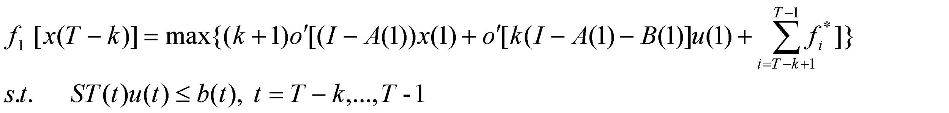
As for the dynamic IO model, we can compile the matlab program to resolve the solution of the model (4.16). The method is realized through some transformation of this model.
_{Set} 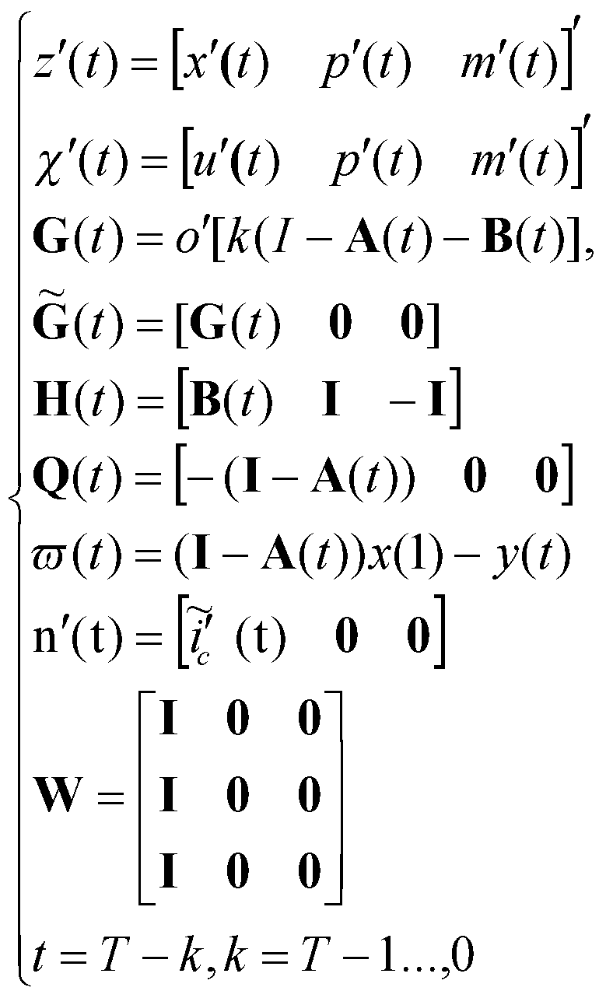
Equation (4.16) is rewritten as
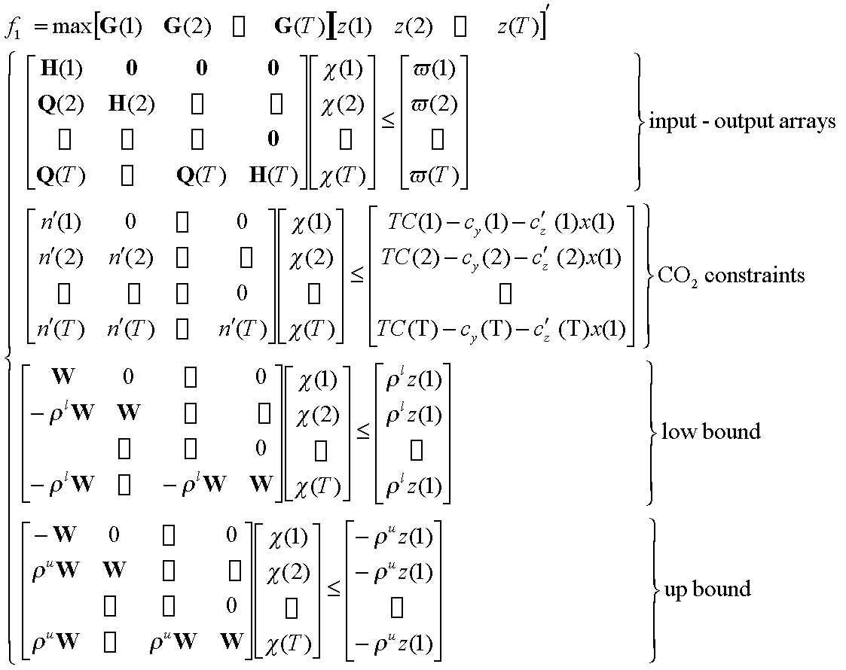

Taking 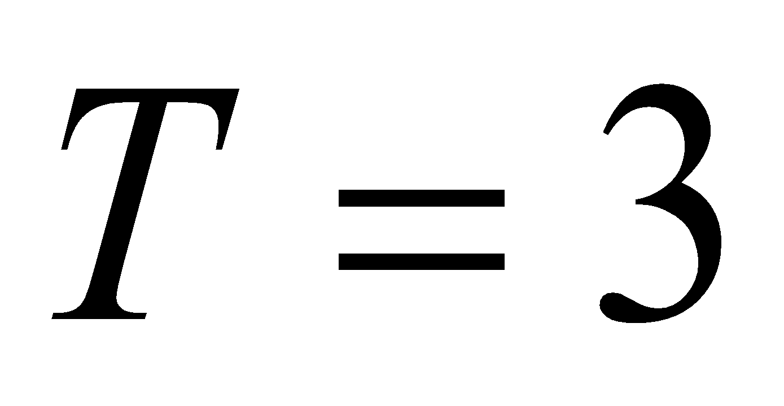 , n=3 for example, the model is shown as follows:

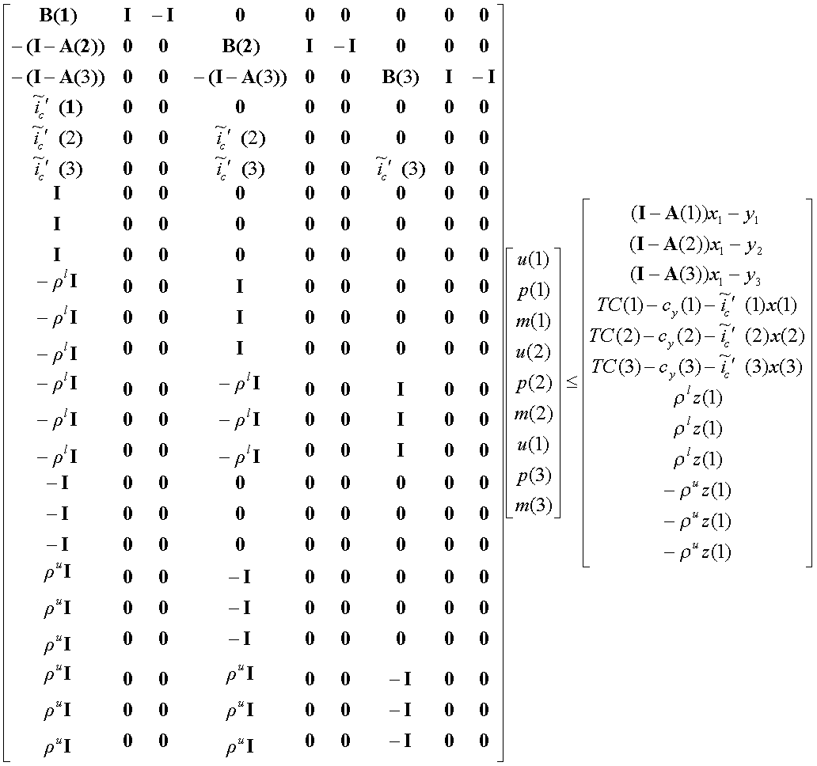

_{Appendix 2 Tables and figures}
Table A.1 Energy-carbon emission-economy input-output table
output  input |  |  |  |  | Intermediate usage |  | Final usage |  |  |  |  | Total output
 |  |  |  |  | energy | Non-energy | Consumption  of household |  | energy | Non-enery | …
input | Intermediate input | Energy industry | Coal producing and selection | 10⁴ Yuan | 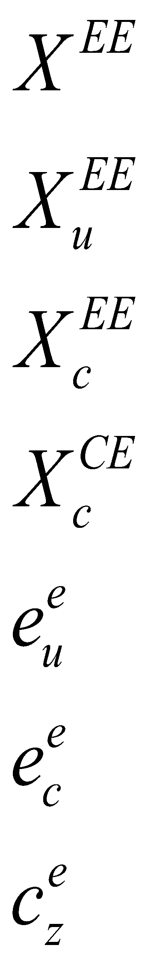 | 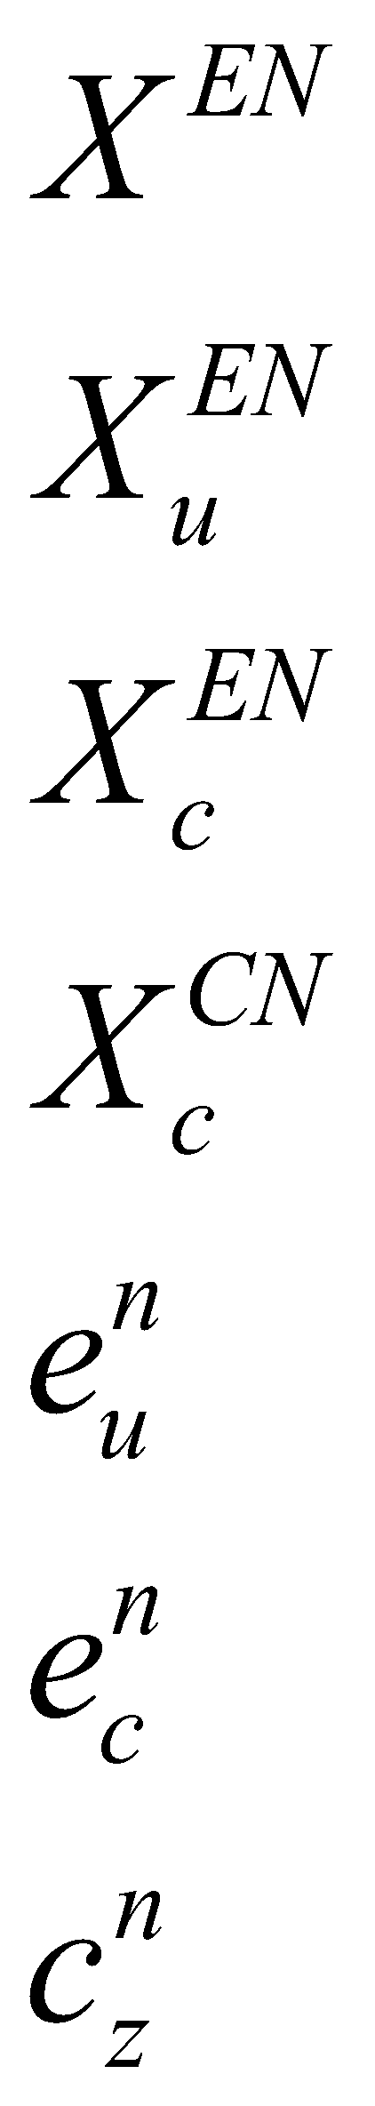 | 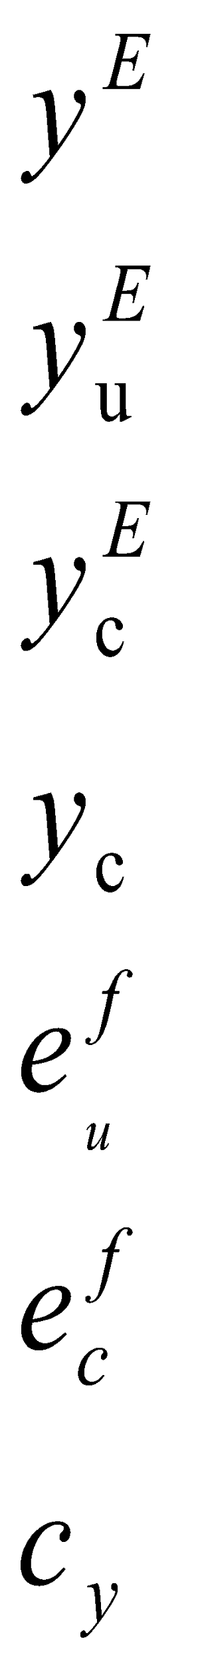
 |  |  | Coal(usage/consumption)  Carbon | ton/ton standard coal  metric ton
 |  |  | … | …
 |  |  | … | …
 |  |  | Gas production and supplying | 10⁴ Yuan
 |  |  | Gas(usage/consumption)  Carbon | M³/ton standard coal  metric ton
 |  |  | Total Usage of energy  Total consumption of  energy  CO2 emission | ton standard coal  ton standard coal  metric ton
 |  | Non energy industry | agriculture | 10⁴ Yuan | 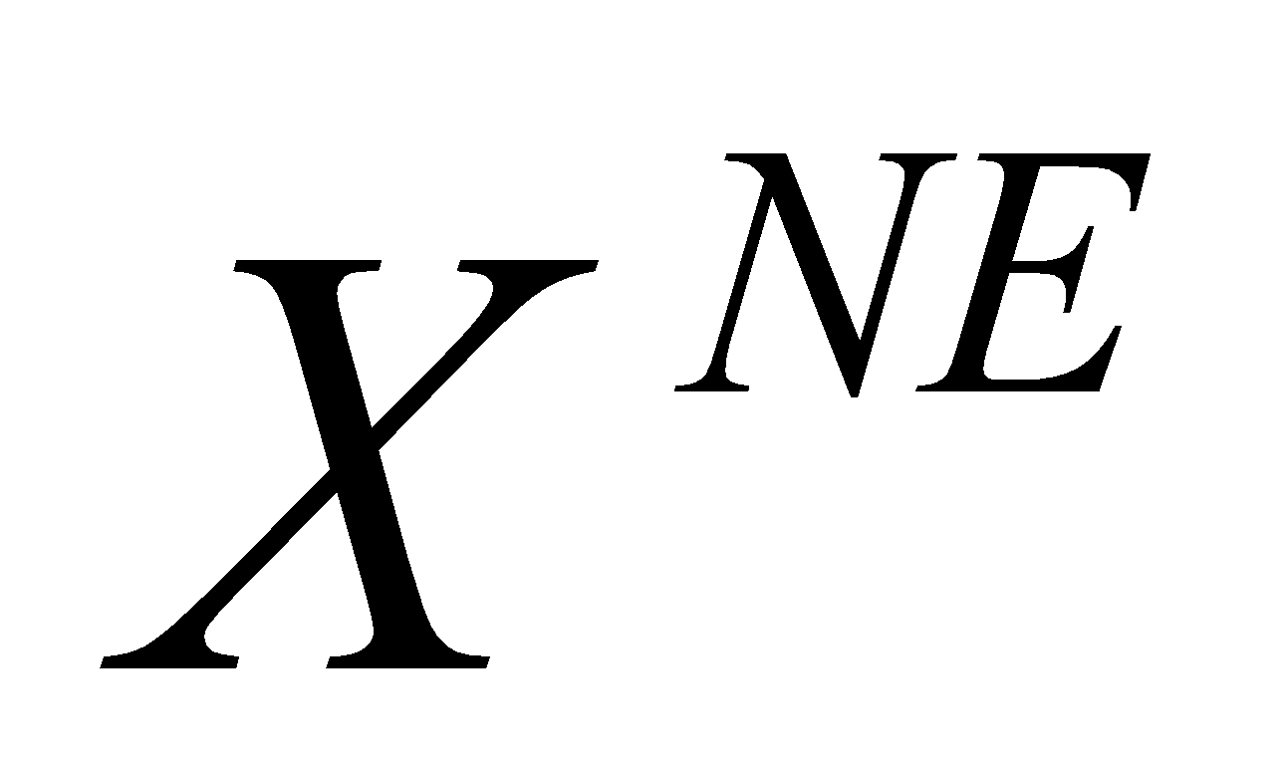 | 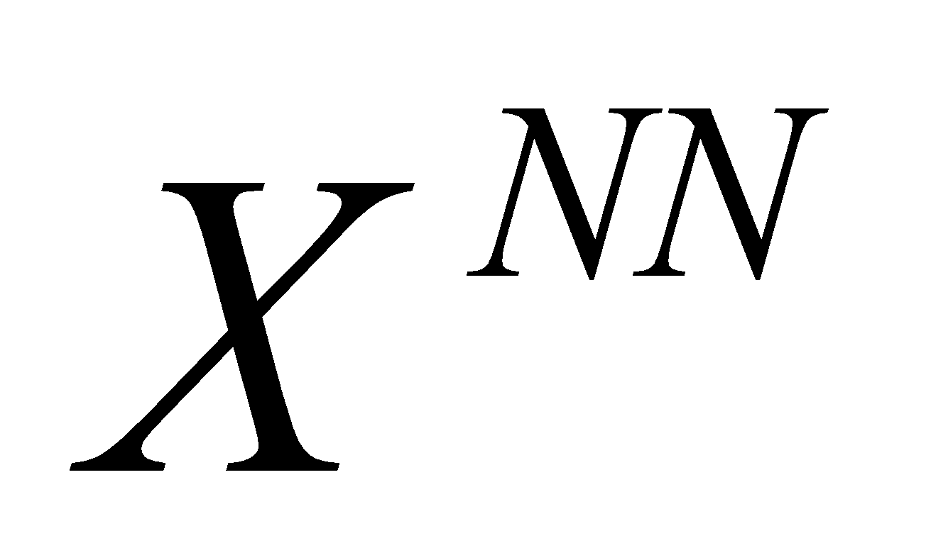 |  |  |  |  |  | 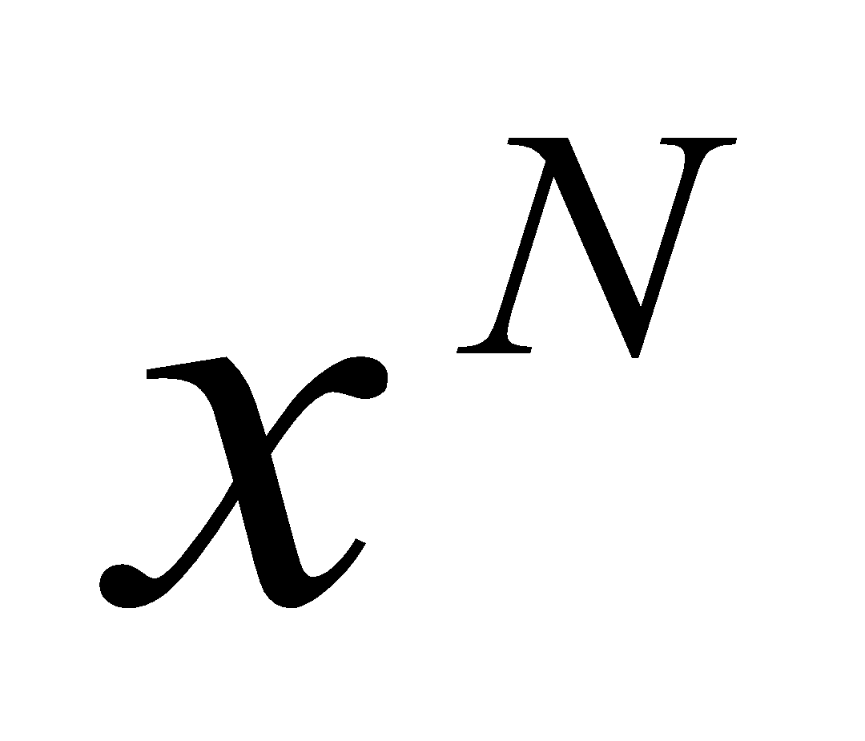
 |  |  | … | …
 |  |  | … | 10⁴ Yuan
 |  |  | The third industry
 |  | Intermediate input in total |  | 10⁴ Yuan
 | Value added | Fix capital depreciation |  | 10⁴ Yuan |  | 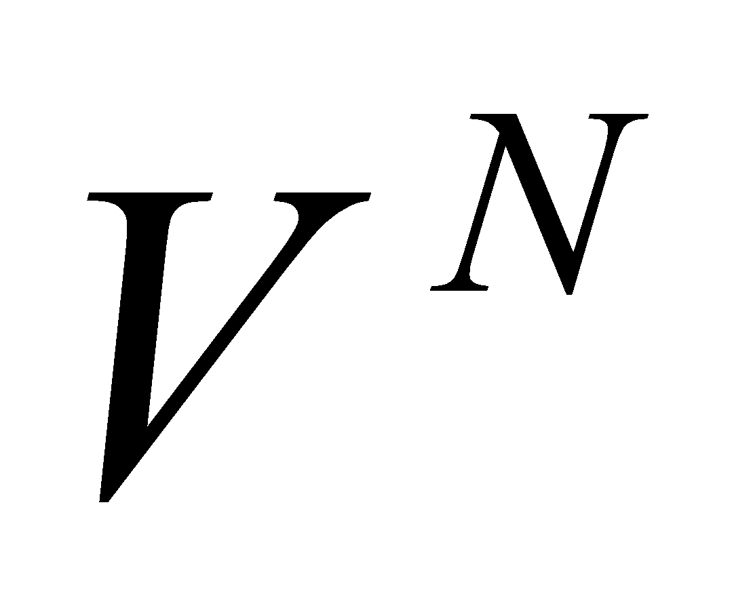
 |  | Remuneration of labor |  | 10⁴ Yuan
 |  | Tax and profit |  | 10⁴ Yuan
 |  | Value added in total |  | 10⁴ Yuan
 | Total input |  |  | 10⁴ Yuan | 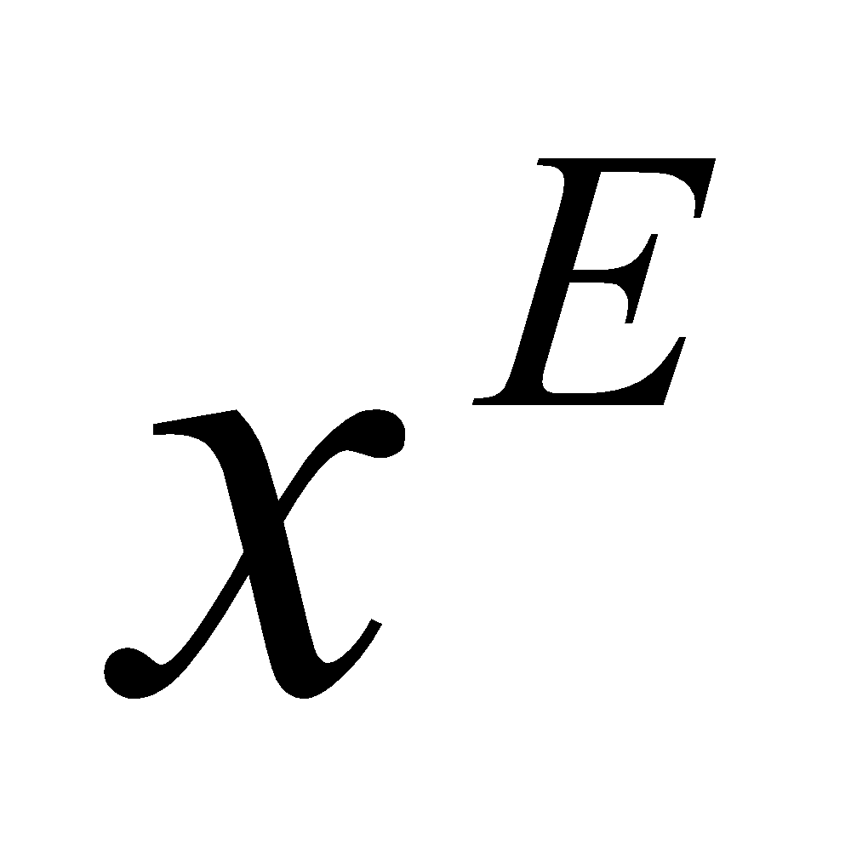

Figure A.1， Industry adjustment for carbon emission reduction, China 2007
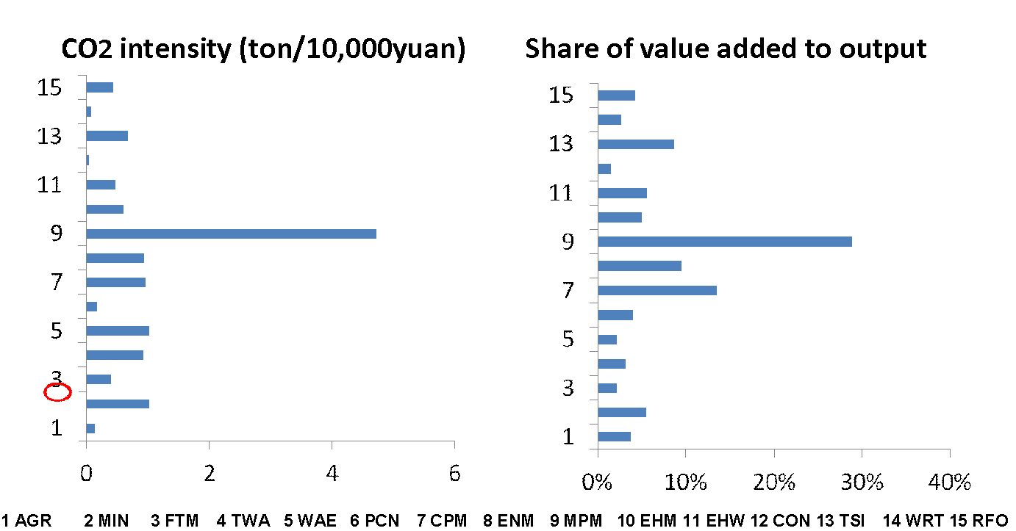
3.1 Linear programming in IO model for long term planning
Xue Fu (2012) use linear programming is used to address the optimal output structure for maximizing GDP with the constraint of carbon emission in the plan year with the assumed input-output system.
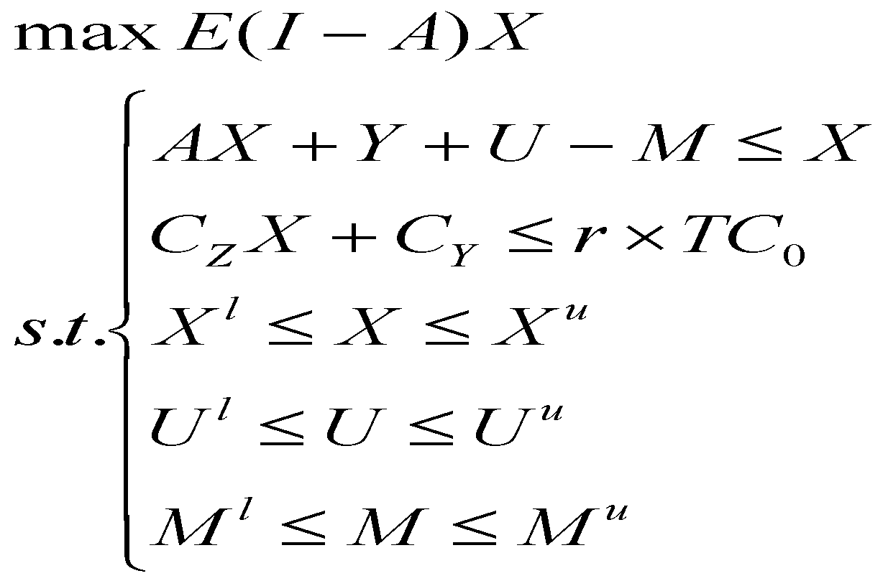_{(3.1)}
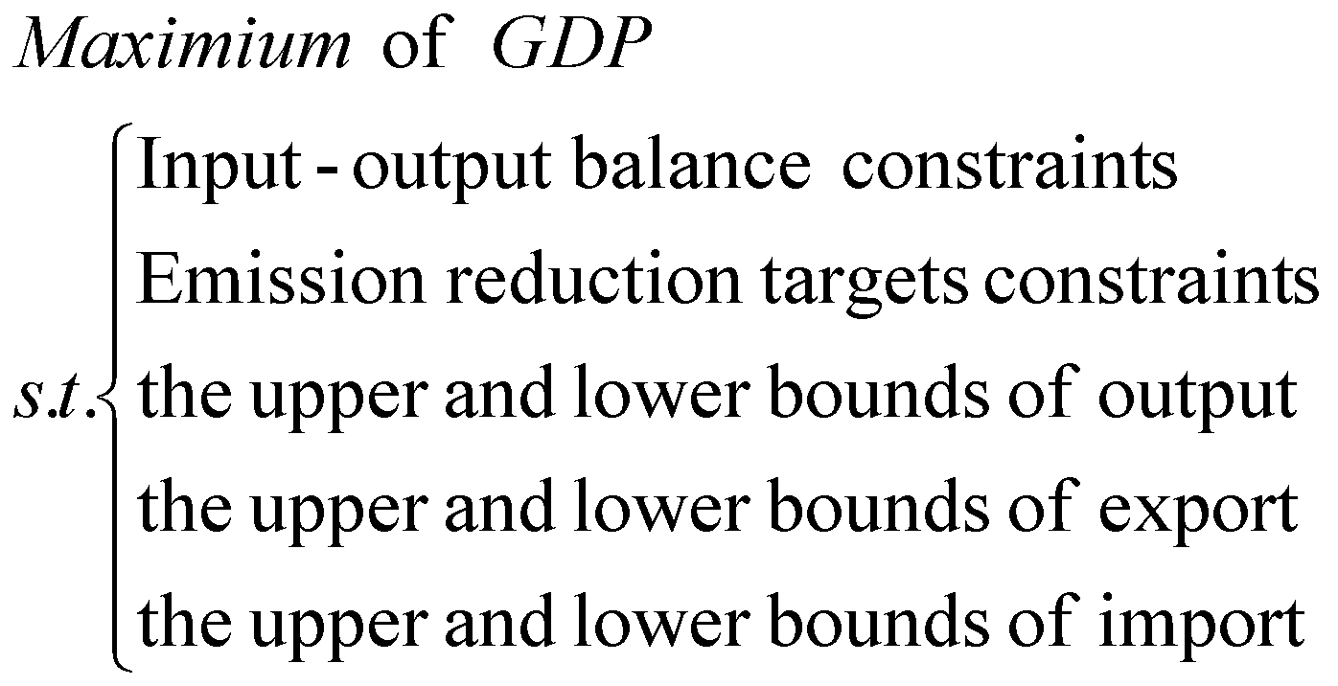

From equations (1), the output of each industry and their import and export with given domestic consumption is obtained in 2008 when taking the coefficient 2007, inferring the intermediate flows, value added. More detail is shown in Fu (2012).
Forecast result

The output, value added, and elasticity by industry are forecasted by SPSS software, and the results are significant for every industry.

According to the results, the value added in 2020 is 130240.1764 billion RMB at variable price, 5.090 times of that in 2007, which means value added grow 13.3 % per year. In constant price, value added reach 7530.0745 billion RMB at 2007 price, 3.175 time of that in 2007, which means it grow 9.3% per year.
Output in 2020 is 446319.858 billion RMB at variable price, 6.15 times of that in 2007. It means the annual growth rate 15% in average.

Elasticity here means the carbon emission per output, not carbon emission per value added as other literature shows. The forecast result of elasticity is 0.085 thousand Yuan per ton in 2020, 30% of that in 2007.

 | 1 | 2 | 3 | 4 | 5 | 6 | 7 | 8 | 9 | 10 | 11 | 12 | 13 | Total  industry | Manufacture
2007 | 48838.11 | 29180.90 | 69196.87 | 21074.56 | 61998.09 | 22804.37 | 78801.45 | 104829.17 | 33773.10 | 62721.74 | 32430.87 | 43647.98 | 116306.27 | 725603.48 | 421658.52
2020 | 73218.94 | 178415.66 | 112574.26 | 241889.82 | 424994.58 | 77321.91 | 447967.18 | 625593.10 | 376168.36 | 380748.62 | 254135.61 | 226218.68 | 1162817.43 | 4463198.58 | 3368055.19
growth rate in 2020 comparing to 2007 | 1.50 | 6.11 | 1.63 | 11.48 | 6.85 | 3.39 | 5.68 | 29.68 | 12.89 | 18.07 | 7.84 | 5.18 | 10.00 | 6.15 | 48.67
growth rate per year | 1.03 | 1.15 | 1.04 | 1.21 | 1.16 | 1.10 | 1.14 | 1.30 | 1.22 | 1.25 | 1.17 | 1.13 | 1.19 | 1.15 | 1.35
growth rate in 2007 comparing to 1991 | 6.00 | 15.31 | 6.90 | 31.06 | 15.10 | 11.93 | 22.19 | 15.19 | 30.23 | 16.87 | 14.51 | 9.01 | 18.81 | 13.12 | 13.96
growth rate per year | 1.12 | 1.19 | 1.13 | 1.24 | 1.18 | 1.17 | 1.21 | 1.19 | 1.24 | 1.19 | 1.18 | 1.15 | 1.20 | 1.17 | 1.18

Value added
 | 1 | 2 | 3 | 4 | 5 | 6 | 7 |  | 8 |  | 9 | 10 | 11 | 12 | 13 | Total  industry | industry at constant price of 2007 | Total Manufacture
2007 | 28659.17 | 13799.79 | 15116.27 | 3752.11 | 12592.82 | 6264.53 |  | 15615.68 |  | 33082.21 | 9579.96 | 14513.45 | 14982.86 | 22899.16 | 65007.34 | 255865.358 | 237892.761 | 109803.375
2020 | 37032.75 | 92780.35 | 26702.97 | 25465.74 | 65761.00 | 16483.07 |  | 71897.02 |  | 213835.09 | 108106.41 | 75150.94 | 90475.26 | 120687.57 | 614486.19 | 1302401.764 | 755300.745 | 616413.490
growth rate in 2020 comparing to 2007 | 1.292 | 6.723 | 1.935 | 6.787 | 5.222 | 2.631 |  | 4.604 |  | 6.464 | 11.285 | 5.178 | 6.039 | 5.270 | 9.453 | 5.090 | 3.175 | 5.614
growth rate per year | 1.020 | 1.158 | 1.052 | 1.159 | 1.136 | 1.077 |  | 1.125 |  | 1.154 | 1.205 | 1.135 | 1.148 | 1.136 | 1.189 | 1.133 | 1.093 | 1.142
growth rate in 2007 comparing to 1991 | 5.419 | 18.747 | 6.085 | 20.855 | 11.277 | 10.167 |  | 17.590 |  | 17.487 | 23.773 | 13.141 | 11.967 | 10.314 | 19.789 | 11.920 | 5.062 | 13.205
growth rate per year | 1.111 | 1.201 | 1.119 | 1.209 | 1.163 | 1.156 |  | 1.196 |  | 1.196 | 1.219 | 1.175 | 1.168 | 1.157 | 1.205 | 1.168 | 1.107 | 1.175
value added rate in 2020 | 0.506 | 0.520 | 0.237 | 0.105 | 0.155 | 0.213 |  | 0.160 |  | 0.342 | 0.287 | 0.197 | 0.356 | 0.533 | 0.528 | 0.292 |  | 0.183
value added rate in 2007 | 0.587 | 0.473 | 0.218 | 0.178 | 0.203 | 0.275 |  | 0.198 |  | 0.316 | 0.284 | 0.231 | 0.462 | 0.525 | 0.559 | 0.353 |  | 0.260

elasticity
 | 1 | 2 | 3 | 4 | 5 | 6 | 7 | 8 | 9 | 10 | 11 | 12 | 13 | total
2007 | 0.0879 | 0.2997 | 0.1774 | 0.3431 | 0.3593 | 0.5750 | 0.5685 | 0.0791 | 0.2726 | 0.0422 | 0.3968 | 0.1245 | 0.1759 | 0.0290
2020 | 0.0388 | 0.0983 | 0.0502 | 0.1613 | 0.1582 | 0.232 | 0.2586 | 0.022 | 0.1702 | 0.0146 | 0.1623 | 0.05 | 0.0433 | 0.0085
decline rate | 0.4411 | 0.3279 | 0.2833 | 0.4703 | 0.4401 | 0.4035 | 0.4549 | 0.2785 | 0.6242 | 0.3471 | 0.409 | 0.4017 | 0.2462 | 0.2937

Carbon intensity forecast

Forecast the carbon intensity by industry in 2020:

 | 1 | 2 | 3 | 4 | 5 | 6 | 7 | 8 | 9 | 10 | 11 | 12 | 13
China in  2020 | Agriculture | Mining | Food, textile, paper and furniture | Petrol processing and Coking | chemical and pharmacy | building industry and non-metal mineral | metal processing and manufacture | mechanism, electronic equipment | electricity, heat power and water supplying | construction | transportation, post and storage | business and catering | finance, real estate and other service
China in 2020 (ton/ 1oooo RMB) | 0.0434 | 0.0306 | 0.0072 | 0.0406 | 0.0161 | 0.0208 | 0.0241 | 0.0053 | 0.0627 | 0.0094 | 0.0434 | 0.0306 | 0.0072
China in  2007 | 0.08777 | 0.29970 | 0.17738 | 0.34306 | 0.35935 | 0.57503 | 0.56845 | 0.05307 | 0.27261 | 0.04220 | 0.39681 | 0.09247 | 0.06601
UK in  2008(ton/ 1000 pound=ton/ 10000 RMB) | 0.250989 | 0.143318 | 0.302688 | 0.604104 | 0.663864 | 1.356493 | 2.218040 | 0.041796 | 7.215972 | 0.045814 | 0.232927 | 0.051118 | 0.011365

Regression results:
1.Agriculture
Compound：Y = (9.439*10^(94))*0.896^^{T} (R^2 0.834, F 75.223)
2.Mining
Compound：Y =(8.735*10^(136))*0.854^^{T} (R^2 0.896, F 128.856)
- Food, textile, paper and furniture
Compound：Y = (9.667*10^(173))*0.818^^{T} (R^2 0.825, F 70.764)
- Petrol processing and Coking
Growth：（Y = e^{(974.86-0.488*t)}）(R^2 0.859, F 54.796)
5 chemical and pharmacy
Compound：Y = (9.329*10^(300))*0.706^^{T} (R^2 0.802, F 60.871)
6 building industry and non-metal mineral
Compound：Y =2.73*10^(122)*(0.868)^t (R^2 0.529, F 16.828)
7 metal processing and manufacture
Compound：Y =(5.457*10^(257))*0.743^^{T} (R^2 0.799, F 59.617)
8 mechanism, electronic equipment
S curve（Y = e^{(-718.630+(1.434*10^6)/t)}）； (R^2 0.889, F 120.640)
9 electricity, heat power and water supplying
Compound：（Y = (1.179*10^(219))*0.777^^{T}）(R^2 0.886, F 116.214)
10 construction
Compound：（Y = (6.317*10^(173))*0.818^^{T}） (R^2 0.841, F79.612)
11 transportation, post and storage
Compound：（Y = 9.437*10^(92)*0.898^t）(R^2 0.78, F 53.149)
12 business and catering
Compound：（Y = (1.262*10^(94))*0.896^^{T}）(R^2 0.685, F32.653)
13 finance, real estate and other service
Compound：（Y= (6.025*10^(107))*0.883^^{T}）(R^2 0.874, F 104.215)

Table A.2 Inferred IO table in 2006 after structure adjustment (GDP increase by 114.3%)
 | 1 | 2 | 3 | 4 | 5 | 6 | 7 | 8 | 9 | 10 | 11 | 12 | 13 | 14 | 15
1 | 729 | 8 | 1091 | 220 | 176 | 1 | 113 | 1 | 1 | 2 | 1 | 248 | 38 | 222 | 33
2 | 20 | 63 | 14 | 9 | 24 | 720 | 173 | 114 | 354 | 49 | 326 | 70 | 23 | 11 | 63
3 | 324 | 0 | 481 | 33 | 3 | 0 | 35 | 0 | 0 | 0 | 0 | 3 | 8 | 337 | 61
4 | 4 | 8 | 6 | 730 | 92 | 1 | 20 | 9 | 7 | 29 | 4 | 12 | 15 | 34 | 178
5 | 22 | 15 | 64 | 27 | 624 | 3 | 55 | 47 | 130 | 114 | 6 | 110 | 62 | 112 | 415
6 | 49 | 53 | 9 | 8 | 27 | 51 | 123 | 44 | 99 | 46 | 84 | 65 | 464 | 66 | 92
7 | 307 | 56 | 95 | 192 | 267 | 15 | 1159 | 75 | 58 | 517 | 14 | 116 | 39 | 69 | 545
8 | 14 | 18 | 18 | 4 | 15 | 3 | 19 | 100 | 54 | 110 | 4 | 643 | 5 | 8 | 45
9 | 17 | 71 | 26 | 9 | 115 | 8 | 50 | 62 | 1070 | 1054 | 14 | 524 | 28 | 13 | 81
10 | 54 | 109 | 24 | 34 | 71 | 21 | 70 | 54 | 100 | 2358 | 175 | 219 | 534 | 216 | 681
11 | 51 | 142 | 34 | 36 | 64 | 27 | 181 | 93 | 167 | 116 | 113 | 51 | 80 | 112 | 168
12 | 9 | 3 | 1 | 1 | 3 | 0 | 2 | 1 | 2 | 4 | 2 | 5 | 53 | 47 | 270
13 | 108 | 76 | 95 | 62 | 119 | 45 | 120 | 71 | 144 | 263 | 60 | 264 | 405 | 189 | 499
14 | 102 | 42 | 119 | 85 | 140 | 26 | 102 | 57 | 96 | 261 | 56 | 133 | 120 | 194 | 524
15 | 114 | 74 | 110 | 83 | 86 | 21 | 108 | 57 | 70 | 265 | 77 | 127 | 225 | 417 | 957
Value added | 2727 | 643 | 870 | 457 | 756 | 228 | 667 | 305 | 631 | 1352 | 503 | 890 | 1696 | 1984 | 4757
Output | 4651 | 1380 | 3058 | 1991 | 2581 | 1169 | 2997 | 1089 | 2983 | 6541 | 1439 | 3481 | 3795 | 4028 | 9370
industry structure | 9% | 3% | 6% | 4% | 5% | 2% | 6% | 2% | 6% | 13% | 3% | 7% | 8% | 8% | 19%
change | 2% | -1% | 1% | -1% | 1% | 0% | -1% | -1% | -2% | -4% | -1% | -1% | 1% | 2% | 4%

Figure A.2 Carbon emission change in 2006 after structure adjustment (CO2 increase by 101.9%)
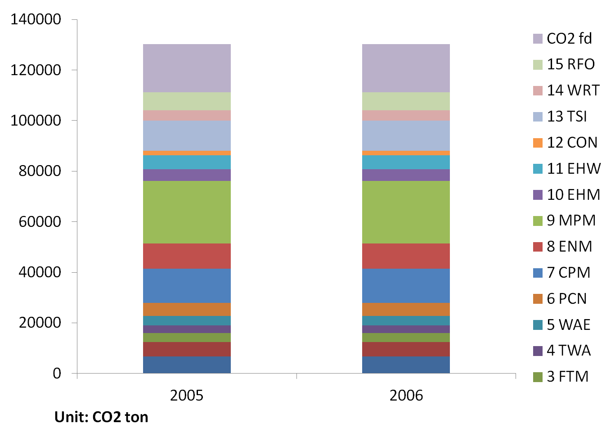
Table A.3: Classification of industry in IO table
1 | AGR: Agriculture | 9 | MPM: Metal processing and manufacture
2 | MIN: Mining | 10 | MEM: Mechanic, electronic equipment and other manufacturer
3 | FTM: Food manufacture and tobacco processing | 11 | EHW: Electricity, heat power and water production and supply
4 | TWA: Textile, Wearing Apparel | 12 | CON: Construction
5 | WAE: Wood processing and Manufacture of Articles for Culture, Education and Sport Activities | 13 | TSI: Transportation, storage, and information service
6 | PCN: Petroleum Processing, Coking and Nuclear Fuel Processing | 14 | WRT: Wholesale and retail trades
7 | CPM: Chemical and Pharmaceutical and Medicine Manufacturing | 15 | RFO: Real estate finance and other service
8 | BNM: Building materials and non-Metallic Materials Industry
Energy industry: (2), (6), (11) |  | Non energy industry: (1), (3), (4), (5), (7), (8), (9), (10), (12), (13), (14), (15)

Figure A. 3 Share of carbon emission by industry
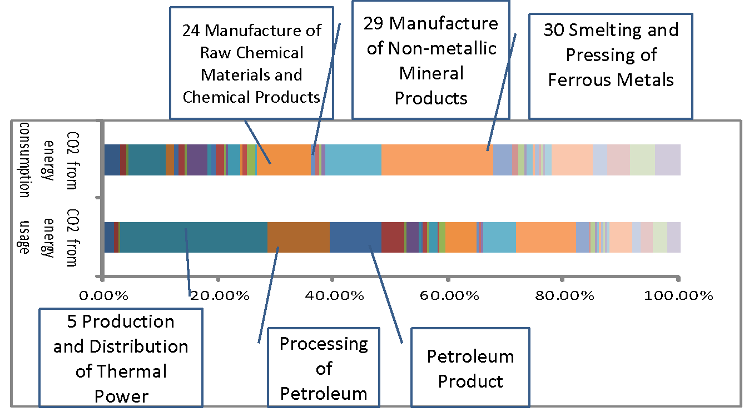

Table A.4 Potential adjustment of industrial structure and reduction of carbon emissions
Industry |  |  | Industry |  |  | Industry
1 | -0.39% | -8.70% | 16 | 0.04% | 33.75% | 31 | -0.61% | -19.75%
2 | 0.07% | 33.75% | 17 | 0.20% | 33.75% | 32 | 0.14% | 33.75%
3 | 0.01% | 33.75% | 18 | 0.09% | 33.75% | 33 | 0.21% | 33.75%
4 | 0.04% | 33.75% | 19 | 0.06% | 33.75% | 34 | 0.11% | 33.75%
5 | -0.98% | -19.75% | 20 | 0.08% | 33.75% | 35 | 0.23% | 33.75%
6 | 0.14% | 33.75% | 21 | -0.38% | -19.75% | 36 | 0.21% | 33.75%
7 | -0.09% | -19.75% | 22 | 0.04% | 33.75% | 37 | 0.36% | 33.75%
8 | -0.02% | -19.75% | 23 | 0.03% | 33.75% | 38 | 0.05% | 33.75%
9 | -0.05% | -19.75% | 24 | -0.53% | -19.75% | 39 | 0.06% | 33.75%
10 | 0.51% | 33.75% | 25 | -0.19% | -19.75% | 40 | 0.01% | 33.75%
11 | 0.02% | 33.75% | 26 | -0.18% | -18.76% | 41 | 0.55% | 33.75%
12 | 0.02% | 33.75% | 27 | 0.11% | 33.75% | 42 | 0.32% | 33.75%
13 | 0.03% | 33.75% | 28 | 0.23% | 33.75% | 43 | 0.44% | 33.75%
14 | 0.24% | 33.75% | 29 | -1.01% | -19.75% | 44 | 1.15% | 33.75%
15 | 0.05% | 33.75% | 30 | -1.45% | -19.75%

Table A.5 The detailed industries of 2005 ECEIO table
 | Energy Industry |  | Non-energy Industry |  | Non-energy Industry
1 | Mining and Washing of Coal | 10 | Agriculture | 29 | Manufacture of Non-metallic Mineral Products
 | Raw Coal (104 ton/104 ton standard coal) | 11 | Mining and Processing of Ferrous Metal Ores | 30 | Smelting and Pressing of Ferrous Metals
2 | Extraction of Petroleum | 12 | Mining and Processing of Non-Ferrous Metal Ores | 31 | Smelting and Pressing of Non-ferrous Metals
 | Crude Oil (104 ton/104 ton standard coal) | 13 | Mining and Processing of Nonmetal Ores and Mining of Other Ores | 32 | Manufacture of Metal Products
3 | Extraction of Natural Gas | 14 | Manufacture of Foods | 33 | Manufacture of General Purpose Machinery
 | Nature Gas (108 Cu. M3/104 ton standard coal) | 15 | Manufacture of Beverages | 34 | Manufacture of Special Purpose Machinery
4 | Production and Distribution of Hydro Power and Nuclear Power | 16 | Manufacture of Tobacco | 35 | Manufacture of Transport Equipment
 | Hydro Power and Nuclear Power (108 kW•h/ 104 ton stand coal) | 17 | Manufacture of Textile | 36 | Manufacture of Electrical Machinery and Equipment
5 | Production and Distribution of Thermal Power | 18 | Manufacture of Textile Wearing Apparel, Footware, and Caps | 37 | Manufacture of Communication Equipment, Computers and Other Electronic Equipment
 | Thermal Power (108 kW•h/ 104 ton stand coal) | 19 | Manufacture of Leather, Fur, Feather and Related Products | 38 | Manufacture of Measuring Instruments and Machinery for Cultural Activity and Office Work
6 | Processing of Petroleum | 20 | Processing of Timber, Manufacture of Wood, Bamboo, Rattan, Palm, and Straw Products and Manufacture of Furniture | 39 | Other Manufacturing
 | Petroleum Product(104 ton/104 ton standard coal) | 21 | Manufacture of Paper and Paper Products | 40 | Production and Distribution of Water
7 | Coking | 22 | Printing, Reproduction of Recording Media | 41 | Construction
 | Coking Products(104 ton/104 ton standard coal) | 23 | Manufacture of Articles For Culture, Education and Sport Activity | 42 | Transportation, storage, Storage and Post
8 | Production and Distribution of Heat Power | 24 | Manufacture of Raw Chemical Materials and Chemical Products | 43 | wholesale and retail trades
 | Heat (104 million KJ/104 ton standard coal) | 25 | Manufacture of Medicines | 44 | Real estate finance and other service
9 | Production and Distribution of Gas | 26 | Manufacture of Chemical Fibers | 45 | Rural households
 | Gas (108 Cu. M3/104 ton standard coal) | 27 | Manufacture of Rubber | 46 | Urban households
 |  | 28 | Manufacture of Plastics

* Corresponding author Email: fuxue@amss.ac.cn
Source from energy-carbon-economic input-output (ECEIO) table in 2007 (Fu et al., 2012)
We know the index function (4.3) at time T-1 as _{(D-1)} _{From the terminal condition,} _{(D-2)} we get the index function at time T-1 as _{(D-3)} Thus the index function (4.3) and constraints at time T-1 is (D-4)
The index function at time T-2 in equation (4.3) is simplified after introducing equation (4.8)as _{(D-5)} Hence, the index function at time T-2 and constraints in time T-2 are shown as. _{(D-6)} Here _{and}
The index function at time T-2 in equation (4.3) is simplified after introducing equation (4.11) as (D-7) _{Let}, , and, _{Then} (D-8)
We can get the general version of the model at step, the index function at time T-k. From the above deduction, we further know the cost function (D-9) Hence, Here, From (D-4),(D-6), (D-8) and (D-9), we can assumed the cost function at step as (D-10) Here, When k=T-1, From equation (4.3) we get the cost function at step as _{(D-11)} Let , then the model at step take the version as
The actual data of output by industry and consumption is from the Statistic Year book in 2001, 2002 and 2003, 2005, 2006, 2007, 2008 and the input-output table in 2000, 2002, 2005, 2007. The input-output in 2001, 2003, 2006 is the extended table.
It is the same with the former.
The energy unit of value is 104 Yuan. The energy unit of volume is measured both as physic quantity and transferred standard unit. Physic quantity unit is denoted for raw coal, crude oil, Petroleum products, Coking products as ton, for natural gas, oven gas, LPG as cube meter, for hydro power and nuclear, and thermal power respectively as kW•h, heat kJ. Consistent unit, energy of various types can be measured as standard coal. The carbon dioxide unit is metric ton.
Industries classification refers to Table A3.
Unit is billion CNY, Structure adjustment according to 2005 IO table. Industries classification refers to Table A3.
Industries classification refers to Table A3.
The carbon emission increases by =1.4 million ton carbon dioxide (carbon emission intensity decrease 6.35% per year). is the ratio of industry to total output. means the change in the amount of carbon emission. Positive (+) means increase, and minus (-) means decrease. Computation from optimal input-output table based on 2005 ECEIO table.

