A Web-Based Regional Economic Simulation Tool for U.S. Army Corps of Engineers’ Civil Works Program
Authors:
Wen-Huei CHANGª, Yue CUI^{b}, Edward MAHONEY^{c}
^{a.}Institute for Water Resources, U.S. Army Corps of Engineers, Casey Building, IWR, 7701 Telegraph Road, Alexandria, VA 22315, U.S.A. Email: Wen-Huei.Chang@usace.army.mil
^{b.}College of Agriculture and Natural Resources, Michigan State University, Ease Lansing, MI 48824, U.S.A. Email: cuiyue@msu.edu
^{c.}College of Agriculture and Natural Resources, Michigan State University, Ease Lansing, MI 48824, U.S.A. Email: Mahoneye@msu.edu

Keyword:
Economic Impacts Analysis, Web-based Simulation Tool
Abstract:
The U.S. Army Corps of Engineers (USACE) is one of the world's largest public engineering, design, and construction management agencies, and its Civil Works mission areas include navigation, flood risk management, hydropower, water supply, recreation, and environment. To be able to fully capture the economic benefits of its water infrastructure and programs, USACE Institute for Water Resources (IWR) has developed the REgional ECONomic System (RECONS) that provides accurate and defensible estimates of regional and national jobs and other economic measures such as income and sales associated with its civil works program. Economic impacts and contributions are estimated for two types of economic activities associated with USACE programs: 1) Direct federal spending on infrastructure and operations and maintenance and 2) Other economic activities resulted from the primary users of infrastructure constructed and maintained by USACE. The full contribution of these activities to the economy is estimated using Input-Output modeling techniques, and includes linkages back to the industries, businesses, and households supplying the goods, services, as well as the household spending recalculated to the region’s economy.
RECONS is a web-based dynamic simulation system, and is developed with PHP/MySQL applications with the server hosted on Cloud Computing Services. RECONS also utilizes mapping function which allows users to portray the areas benefited by USACE programs, and includes more than 1200 built-in regional models that correspond to USACE’s Civil Works Programs. This tool is designed for easy accessibility while in a controlled environment. It also allows frequent modifications/updates and new add-ons to be made through the server and to be instantly distributed. This tool provides a convenient and consistent way to estimate jobs and conduct economic impact analyses including the effects of either increased and decreased expenditures by the USACE, while enables users to conduct valid and reliable economic impact analyses, even those without experience in Input-Output analysis required by IMPLAN or other comprehensive I-O models. The users can also simultaneously estimate economic impacts at different geographic scopes (e.g., local, state, national) and to aggregate those impacts across various political and geographical boundaries. RECONS also increases the rigor of the process (e.g., spending profiles, identification of impact areas) in the manner in which economic impact analyses are conducted by the USACE. As a result, over 80 USACE economists from various mission areas across the country have used this simulation tool and conducted over 5,000 analyses for USACE-related economic activities. This paper describes the capabilities of RECONS.

1. Introduction

The US Army Corps of Engineers (USACE) is the largest public agency for water resources management in the US, with civil works mission areas in navigation, flood risk management, hydropower, water supply, recreation, and environment. Water resources projects funded by the Federal Government and implemented by the Corps are subject to detailed benefit-cost analysis which includes quantification of benefits accrue at the national and regional levels. The Corps has well established methods to estimate the economic benefits at the National level associated with its projects. Given the complexity and magnitude USACE’s projects, it was difficult to use readily available models to estimate economic regional impacts of Corps projects for over 1000 projects across United States with various economic activities.

The traditional economic impact analysis tools are typically with high level of complexity and require extensive amount of data (e.g., multipliers) that needs to be updated frequently. Related economic theories, knowledge, and special training to use the model are also required to conduct the analysis properly and efficiently. The most widely used tools can be categorized into the commercialized off-the-shelf package like IMPLAN (Impact Analysis for Planning) and REMI model (Regional Economic Models, 2016), or custom made model for a specific purpose or agency such as National Park Services’ Money Generation Model ( MGM, Stynes, 2008). These tools are usually designed as executable programs that run on a desktop operation system such as Windows or Mac OS. The model can only be accessed through the specific computer. The data used in the model might not be updated regularly due to the setup of individual computers. With the development of the Internet and the World Wide Web, there are new opportunities to deploy tools for economic impact analysis on web-based platform. Web-based simulation models are the integration of the Internet with the field of simulation and have been growing rapidly during the past twenty years (Page et al., 2000). However, they have not been widely applied in economic impact analysis tools.

Mahoney, Stynes, & Cui (2007, 2009) developed a series of web-based boating economic impact models, which are open to public to estimate boating-related economic impacts. Policy makers and planners from boating-related industries and local communities have conducted over ten thousands analyses through these two websites during the past eight years. In recent years, the developers of economic impact tools also have started adopting web technologies to enhance the accessibility of the general purpose economic impact analysis models. For example, IMPLAN (2016) developed an on-line platform as part of supplementary access for its desktop model.

USACE has developed a desktop based economic impacts simulation model for estimating economic impacts associated with its recreation program in the early 2000 (Chang, Jackson, & Stynes, 2005). USACE has also used various economic impacts tools, such as REMI and IMPLAN, to estimate the economic impacts of its activities. In 2011, USACE started to develop a web-based economic impact simulation tool named RECONS (REgional ECONomic System). From users’ perspectives, this tool allows economists, planners, and practitioners from various mission areas in USACE across the country to estimate economic impacts simultaneously. Based on USACE’s established methods and works, RECONS is developed to reduce the complexity and data analysis requirement, and provide reliable and consistent estimates of jobs, incomes and other economic impacts associated with USACE programs. As a web-based platform, the data used in this tool (e.g., multipliers, CPI, social-demographic information, etc.) can be updated in real time and will be available to all the users without having to update individual’s software. The Object-oriented structure of the web-based platform can also enable new modules to be integrated without changing the framework.

2. Previous work on computer simulation model and economic impact analysis

There are several benefits of web-based simulation models summarized by scholars and practitioners. Fortmann-Roe (2014) stated that web-based simulation tools are especially beneficial to non-experts because of low knowledge barriers for new users and high accessibility. These kind of tools can engage more people in modeling and simulation, potentially leading to societal benefits as a result of an increased usage and understanding of modeling. As one of the largest engineering entities, a web-based economic impact analysis tool enable researchers in USACE are from all over the country with the same accessibility to a standardized model. Page et al. (2000) examined how data was affected by web technologies in computer simulation modeling. They found that the data can be kept up-to-date by dynamically interacting with databases across the network which speeds up the modeling and decision-making cycle by an order of magnitude. This feature is extremely beneficial to economic impact analysis since the estimates are highly dependent on the up-to-date economic and social-demographic data. In terms of structure of web-based simulation tools, and the duties and balances between servers and clients, Byrne, Heavey, and Byrne (2010) classified the models into seven categories: local simulation, remote simulation, hybrid simulation, web-based simulation documentation, web-based simulation model repository, component-based simulation, and distributed simulation. RECONS applies the hybrid simulation and visualization structure to optimize the balance between server and clients.

For computer-based simulation for economic impact analysis, the tool should be structured by a fully transparent robust economic model built on proven methods and theory (Anastasopoulos, 2007). RECONS estimates the impacts of USACE-related activities to the economy by utilizing Input-Output (IO) modeling techniques, calculating the multiplier effects that USACE expenditures or industry revenues create through backward linkages to the industries, businesses, and households supplying the goods, services, and labor. Specifically, IMPLAN data and structures were adopted for the estimates. Therefore, this tool also needs to dynamically reflect the responsive economic and socio-demographic changes based on IMPLAN data. Corresponding to the arguments of Page et al. (2000) and Anastasopoulos (2007), RECONS incorporates the dynamic features to update related data in time. Anastasopoulos (2007) further indicated that customization is a crucial feature for economic impact analysis in terms of economic activities and regions.

3. System design for RECONS model

RECONS adopted hybrid simulation and visualization model, which combines the approaches of remote simulation and local visualization (Figure 1). Under this framework, users use the web browser on their computer to connect to the server and load the model settings (e.g., economic impacts region and spending profiles). The server-side functions include building and maintaining baseline data and the expenditure structures, adopting and storing IMPLAN related data, managing user account and the customized models created by users, etc. The core function, economic impact analysis computation and logics, runs remotely on the server. Users choose economic activities, the impact regions from client side. The server runs the model and sends the results back to users’ client side in a dynamic nature.
Data:
1. Baseline values for expenditure structures for all USACE-related activities
2. Multipliers for each region associated with USACE-related activities
3. Other support data

Simulation Engine:
Computation of Economic impacts based on Input-Output Model

Server Side
Client Side

Input:
1. Type of Economic Activities
2. Impact Region
3. Expenditures

Output:
1. Visualization and Animation
2. Comparison
3. Exports

Input

Internet

Output

Figure 1: Web-based hybrid simulation and visualization structure for RECONS

For technical consideration, RECONS chooses open-source platform, database and programming language to reduce the cost and increase the portability of the data and system. The server runs on an open-source system, Linux. Data are stored and managed through MySQL database. The open-source language PHP and the open-source content management system WordPress System are utilized for communication, user account management, model computation, and data/system maintenance and updates.

4. Demo of the RECONS simulation tool
RECONS simulation tool can be accessed through any web browsers. Figure 2 is the index page of RECONS that allows users to access to different modules. Currently RECONS offers models for Civil Work Expenditure, Stemming-From Impacts for Navigation, FUSRAP (Formally Utilized Sites Remedial Action Program), and Recreation business line. As a dynamic system, other models, e.g., hydropower impact estimates will be able to be integrated into the system once they are developed.

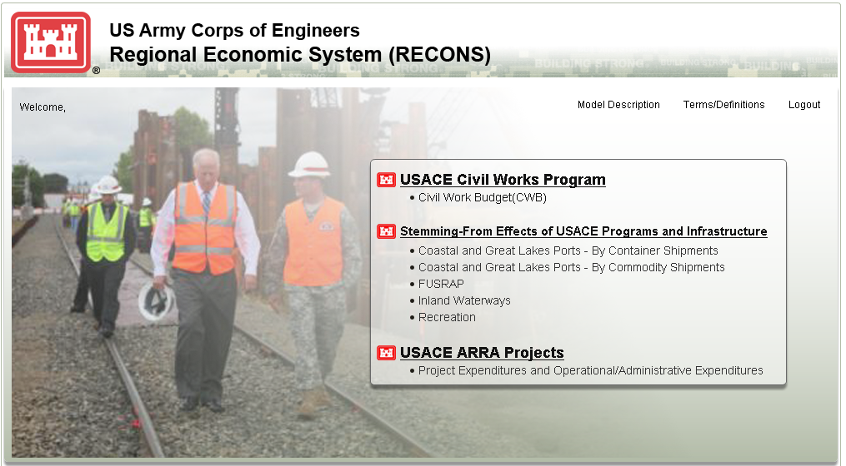
Figure 2: The index page for RECONS simulation tool
For impact regions and associated multipliers, about 1,500 economic impact regions at local and state levels were created in RECONS. These regions represent the meaningful economic areas where the impacts associated with USACE activities throughout the United States. The geographic information (e.g., the combination of counties, the spatial information, and local economy indicators) and the corresponding multipliers are stored and maintained in RECONS server. As a part of visualization process, a web-based GIS interface is utilized in RECONS simulation tool to facilitate users’ viewing experience, and the understanding of the spatial structure (Figure 3) and economic indicators (Figure 4) for the study regions.

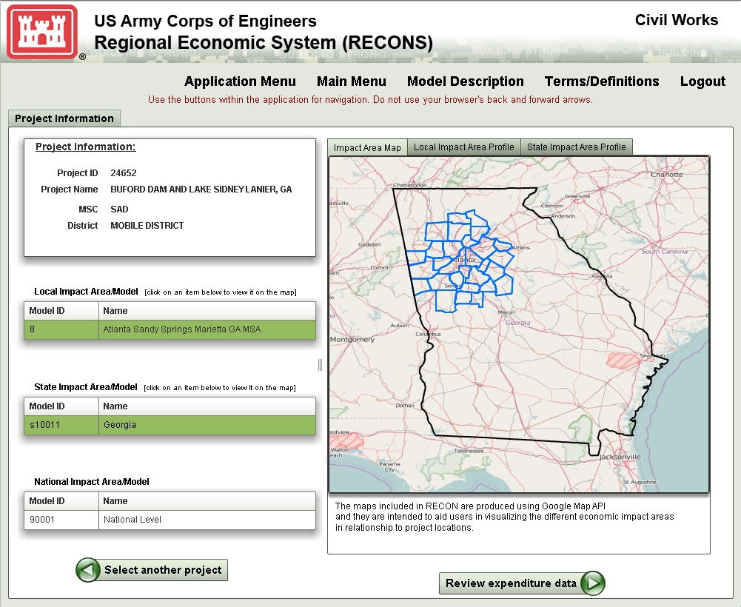
Figure 3: A web-based GIS page to visualize the economic impact regions
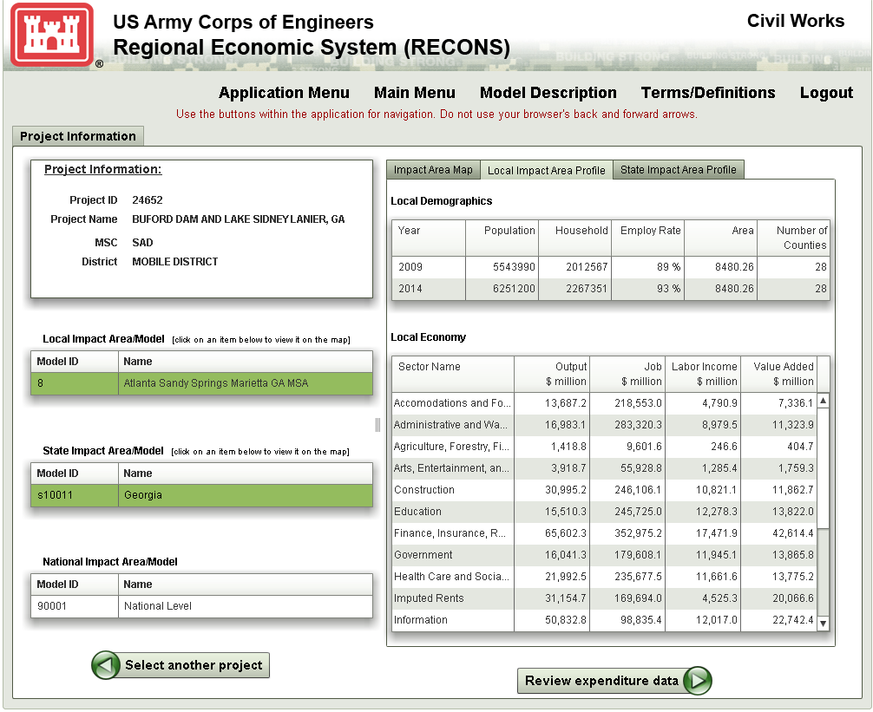
Figure 4: A profile of local and state level economy associated with the GIS map

Besides the multiplier and economic impact regions, RECONS has developed over 200 expenditure structures and associated baseline values, which represent economic activities in USACE’s eight major mission programs. Figure 5 is an example of the expenditure structure for USACE operation and maintenance activity of a recreation project at Lake Lanier in Georgia. The total expenditures are disaggregated into a series of categories that are linked to IMPLAN sectors. Users can edit the amount allocated to different categories through the web interface. By doing this, the model can be used to simulate changes in total budget and its allocation across line items.
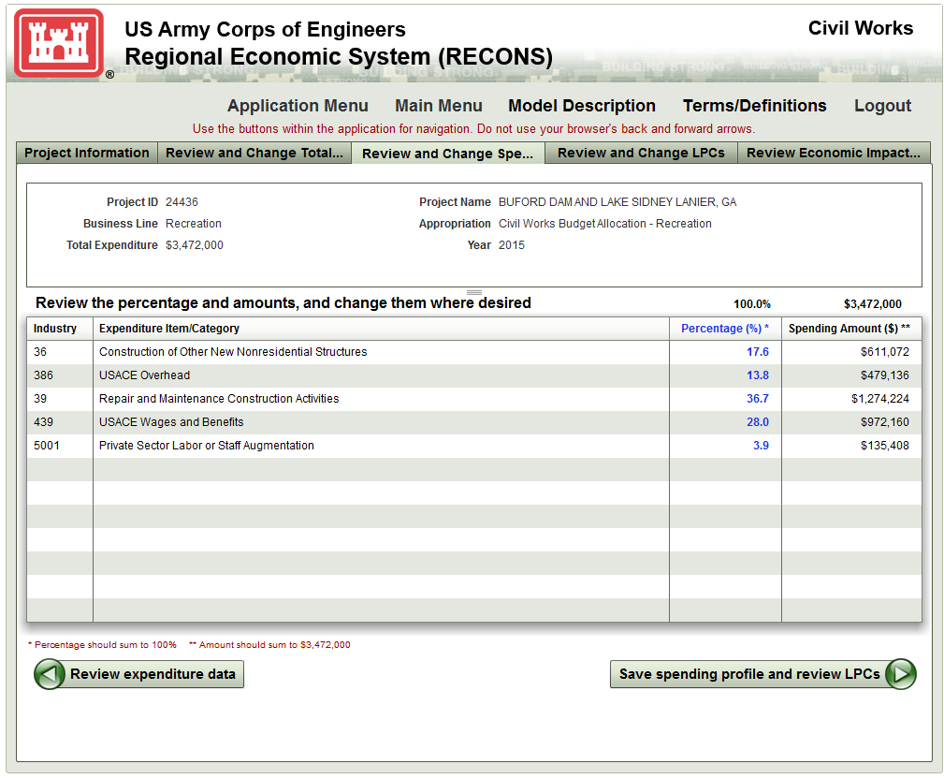
Figure 5: An expenditure structure of USACE civil work activities for operation and maintenance of recreation project at Lake Lanier, Georgia

RECONS also provides the user with national, state and Local Purchase Coefficients (LPC) for each of the expenditure categories. These measure the portion of revenues that accrue to the region as final demand. It is the share of revenue initially injected into a local economy after subtracting the cost of related imports. Figure 6 is the interface that allows users to modify the LPC if they have other information that can better estimate these purchase rates.
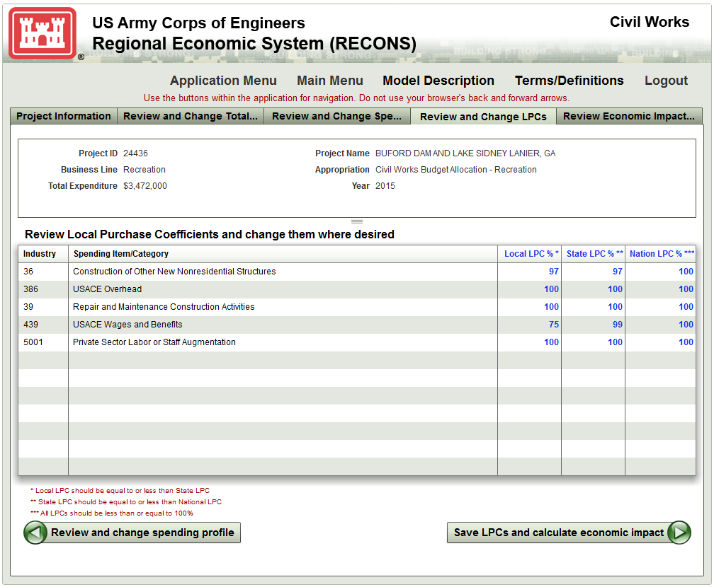
Figure 6: The interface to present local purchase coefficients by industries

RECONS simulation model runs within a single web browser window. When a simulation is completed, results are displayed within the same browser window. RECONS server produces results and sends them back to the client side. Figures 7 and 8 show the results of the estimates of economic impacts for operation and maintenance work on recreation project at Lake Lanier. The results include an overall summary of the estimate of both direct and total jobs, labor income and GDP supported by this activity. The details of economic impacts by industries and different impacted regions (local, state and nation) are displayed in multiple tabs on the web page. In addition, RECONS automatically generates reports in MS Excel format to present all data in the steps of computation of economic impacts. This include model inputs, intermediate computations, and final results. Users can also customize this report for reporting purpose.

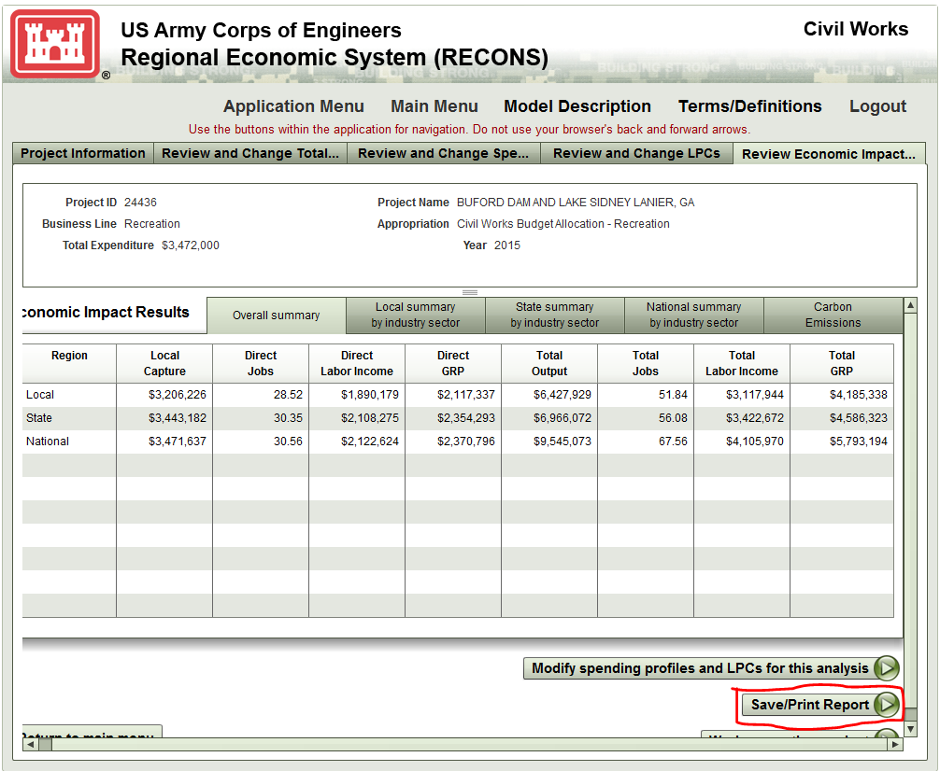
Figure 7: Report generated by RECONS simulation tools in result page

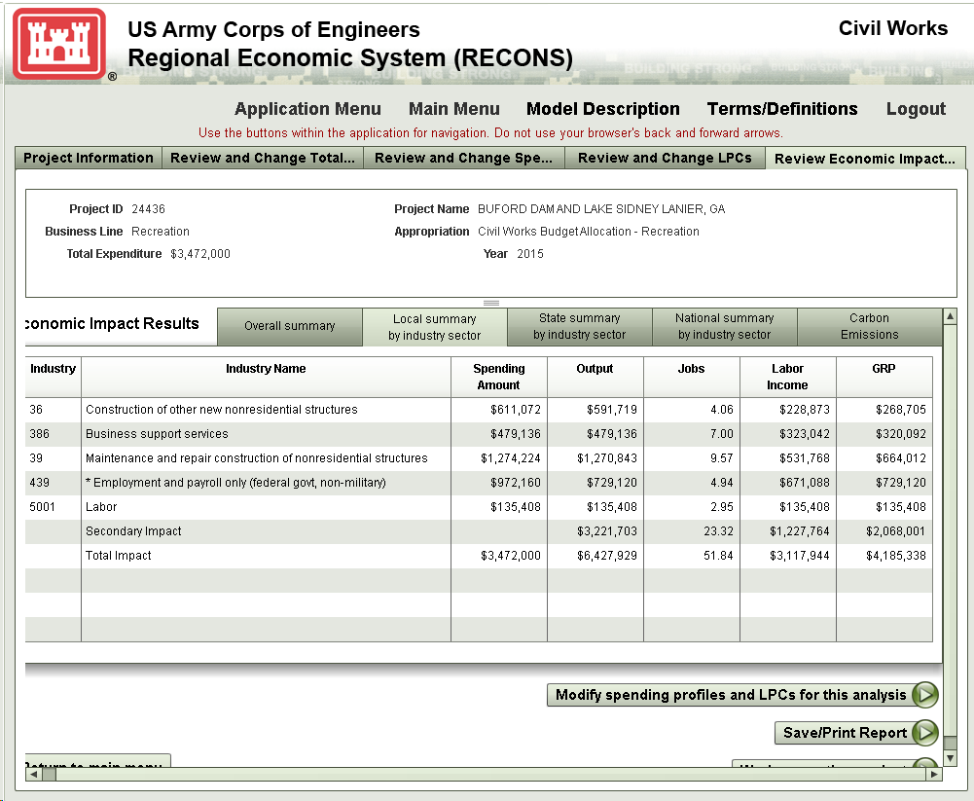
Figure 8: Report generated by RECONS simulation tools by industry sectors

5. Conclusion
This paper demonstrated RECONS, an economic impact simulation tool using web-based technologies to support the estimates of regional economic effects of USACE-related economic activities across United States. RECONS platform has and will continue to be enhanced to serve additional purposes with special focus on estimating and evaluating the economic impacts of the direct investment and operational spending of the Corps budget, as well as all the associated economic activities that are directly linked to Corps’ infrastructure and programs. This model provides a consistent means for estimating regional economic impacts across the nation, allows a direct comparison of budgetary proposals or managerial actions in different locations or for different purposes. The use of RECONS continues to grow, with over 80 unique users in the Corps from various mission areas and over 5,000 analyses conducted and stored in the system. This paper also demonstrates the benefits and trends of using web-based economic impacts simulation models for large scale agencies or cross region decision making applications. Furthermore, this model provides a consistent means for estimating regional economic impacts associated with Corps’ Civil Works program across the nation.

6. Reference
Anastasopoulos, Panagiotis. (2007). Regional Economic Simulation Models - Policy Inside. Retrieved April 10, 2016, from https://engineering.purdue.edu/~srg/book/files/PDF/Extra%20Presentations/Economic%20Development%20Impacts%20-%20Supplementary%20Presentation.pdf
Byrne, James, Heavey, Cathal, & Byrne, Peter J. (2010). A review of Web-based simulation and supporting tools. Simulation modelling practice and theory, 18(3), 253-276.
Chang, Wen-Huei, Jackson, Scott, & Stynes, Daneil. (2005). Estimating Economic Impacts of Corps of Engineers Visitor Spending on Regional Economies. US Army Corps of Engineers.
Fortmann-Roe, Scott. (2014). Insight Maker: A general-purpose tool for web-based modeling & simulation. Simulation Modelling Practice and Theory, 47, 28-45.
Mahoney, Ed, Stynes, Daneil, & Cui, Yue. (2007). Marina Economic Impact Calculator. Retrieved April 12, 2016, 2016, from http://www.marinaeconomics.com
Mahoney, Ed, Stynes, Daneil, & Cui, Yue. (2009). Florida Boating Economic Impact Model. Retrieved April 10, 2016 from http:// www.floridaboatingeconomics.com
MIG, Inc. (2016). IMpact analysis for PLANning. Retrieved April 12, 2016
Page, Ernest H, Buss, Arnold, Fishwick, Paul A, Healy, Kevin J, Nance, Richard E, & Paul, Ray J. (2000). Web-based simulation: revolution or evolution? ACM Transactions on Modeling and Computer Simulation (TOMACS), 10(1), 3-17.
Regional Economic Models, Inc. (2016). 2016, from http://www.remi.com/
Stynes, Daneil. (2008). Money Generation Model 2.

