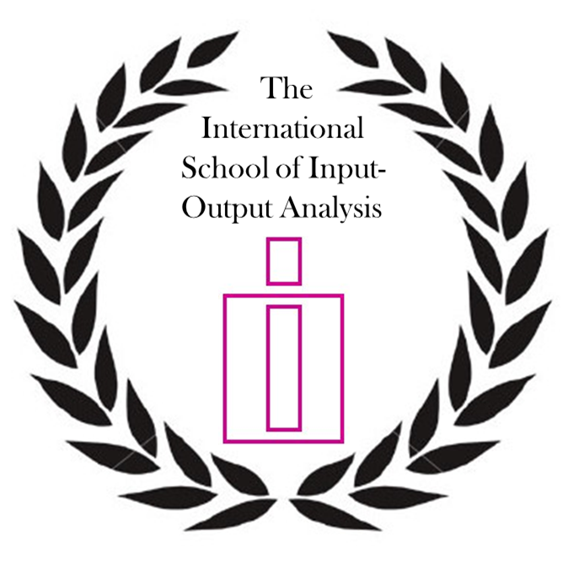

THE INTERNATIONAL SCHOOL
OF INPUT-OUTPUT ANALYSIS

1. OBJECTIVES OF THE SCHOOL 2
2. ACTIVITIES OF THE SCHOOL 2
3. MODULE CERTIFICATES 2
3.1. Module Certificate of Studies in Input-Output Analysis 2
3.2. Requirements 3
3.3. Structure of the modules 4

OBJECTIVES OF THE SCHOOL

The International School of Input-Output Analysis aims at meeting the following main objectives.

- Training scholars in the use of standard tools of input-output analysis in a broad sense, both from the perspective of the producer and the user of input-output tables;
- Encouraging direct communication and/or collaboration between scholars and renowned researchers/lecturers in the field.

ACTIVITIES OF THE SCHOOL

The School will attempt to achieve its objectives through the following activities.

a) The organization of teaching sessions on core topics in input-output analysis at the annual International Input-Output Conference (hereafter IO conference). These sessions are part of a Module for which the participants receive a Module Certificate once they have fulfilled all criteria.

b) The support of international workshops for groups of scholars and/or researchers coming from areas in the world with a low tradition in input-output related studies and with manifested interest in advancing the field in a broad sense.

MODULE CERTIFICATES

Module Certificate of Studies in Input-Output Analysis

The teaching activities of the School will revolve around modules. At each annual IO conference, at least three modules will be offered. Each module is led by one lecturer. Each module consists of four teaching sessions to be held at the annual IO conference. As examples of modules, one may think of topics such as: Environmentally Extended Input-Output Analysis; Construction of NAMEA Accounts; Construction of Supply-Use and Input-Output Tables; Tourism Satellite Accounts; Structural Decomposition Analysis; Measuring Productivity Growth; Estimation of Multi-regional Input-Output Tables; Multi-regional Input-Output Analysis. Participants who have fulfilled all the requirements of a module will receive a “Module Certificate of Studies in Input-Output Analysis”.

Requirements

1. The student must attend all four sessions of a single module. In case (s)he does not attend one of the sessions, the lecturer will evaluate whether the participant’s absence can be compensated. This option does not hold for an absence of two or more sessions.

2. Once attended the four sessions or completed the teaching part of the module otherwise, the student must send a draft of an assignment to: the Certification Coordinator, the Director of the School; and the Lecturer of the module. The deadline for this is set at six months after the end of the annual IO conference. In general, the assignment will take the form of a scientific paper. Exceptions are those cases where the topic addressed in the module recommends a different task (e.g. the construction of an input-output table), about which the participant will be notified at the start of the teaching sessions.

3. The draft assignment may be co-authored by no more than three people (i.e. including the participant) and may be submitted for presentation at next year’s annual IO conference. The final version of the assignment is revised on the basis of the comments and suggestions provided by the lecturer and submitted for the final approval at the latest three months after the submission of the draft assignment. The final version must be approved by: the Certification Coordinator, the Director of the School; and the Lecturer of the module. Just in case, the student should always inform the School whether assignments (no matter whether drafts or final versions) have been accepted for publication and in which journal.

Only if the participant has fulfilled all these three requirements (attendance, assignment, and approval), (s)he will receive the corresponding "Module Certificate of Studies in Input-Output Analysis" in the year (s)he has obtained the approval of the final version of the assignment. The successful participants may receive the certificate at the annual IO Conference or by ordinary mail.

The Module Certificate will state: "This is to certify that Mr./Mrs. XXX has attended the Module on YYY given by Dr. ZZZ on “date”, completed the assignment by submitting his/her paper "Random Title" on “date”, which was approved by the School Directorate on “date”.

Structure of the modules

Each module will consist of:
- Four sessions of 1.5 hours each. For instance:
09:30 – 11:00 Session 1
11:00 – 11:30 Break
11:30 – 13:00 Session 2
13:00 – 14:30 Lunch
14:30 – 16:00 Session 3
16:00 – 16:30 Break
16:30 – 18:00 Session 4

- One common introductory session (1.5 hour) the day before the module aiming to:
a) introduce the lecturers
b) prepare anything related to the module (e.g., software, laptops)
c) have a short outline of the modules by the lecturers.

DIRECTORATE

Director: Rosa Duarte (University of Saragossa - Spain)
Sub-director: Erik Dietzenbacher (University of Groningen – Netherlands)
Certification Coordinator: Antonio F. Amores (European Commission, DG Joint Research Centre,IPTS Seville-Spain)
Management and Admission Coordinator: Christian Reynolds (University of Sheffield)
Coordinator for International Workshops: Albert E. Steenge (University of Groningen – Netherlands)

